

School of Computing and Mathematics

PRCO303

Final Stage Computing Project

BSc (Hons) Software Engineering

N.N.D.G. Liyanage

10707256

**Real Time Courier Tracking Mobile Application**

2020/202

Contents

1. Introduction 4

1.1 About Us 4

1.2 Introduction 5

1.3 Background & Motivation 6

2. Business Case 6

2.1 Business Need 6

2.1.1 Underlaying Problem 7

2.2 Business Objectives 7

3. Project Objectives 9

4. Chapter 4: Initial Scope 10

5. Method of Approach 12

6. Project Plan 13

6.1 Control 13

6.2 Communication plan 13

7. Initial Risk List 17

8.Initial Quality Plan 20

9.References 21

# Introduction

## About Us

E-commerce has grown exponentially over the years. Growth has been reflected in strong consumer demand and a growing number of different products available online. This creates a transportation problem and increases the need for an efficient courier service to support growing markets. It is very important for the courier service provider that the delivery of the parcel is done as soon as possible. One of the most important and important courier business processes is the delivery of parcels. This is where effective service delivery will be paramount. An efficient system needs to be built to facilitate interaction between the courier service provider and the buyer to accurately determine the complete package delivery route. In this proposed project, a real-time Android and iOS mobile tracking app will be developed. A mobile app that helps mail delivery staff find their way to deliver parcels to a customer's door. The app will direct courier staff to obtain courier data such as addresses and contact information and then navigate to selected customer addresses. It will select the best route to the address and inform customers before it arrives so that they are ready to receive the package. This parcel delivery tracking will provide the basis for an effective courier service system. (Courier Tracking System Project, n.d.; Okemiri et al., 2017)

## Introduction

These days, e-commerce stores have been growing as a result of changes in consumer behaviour as more consumers choose to shop online. The latest figures show that Sri Lanka has 6 million online shoppers, comprising 29 percent of the population, and 35 percent of mobile users shopping online. The growth of online shopping requires the modernization of parcel delivery services, especially for day-to-day delivery. In Sri Lanka, the number of courier service companies has been increased to support the need for parcels.

In the Courier Tracking Mobile app, parcels must arrive on time in place to satisfy customers. To ensure prompt delivery of packages to customers, it is necessary to find the fastest route with the least amount of traffic from the delivery point to the destination customer. At the same time, customers should be notified during continuous delivery or on time.

Responsive communication between the two organizations will improve the efficiency of the messenger service and customer satisfaction. The purpose of the mobile app is to develop an Android and iOS mobile system that can help build a more intelligent package delivery system by integrating the use of current communication technologies such as Google API, QR Reader, Push Notifications, and Android-iOS Tools. It will help to track the mobile app to intelligently manage the parcel delivery process and deliver the parcels in a timely manner to the customers.

In developing the application, a delegation tracking system was discussed. However, the system courier service provider will be able to indicate the number of parcels to be delivered per day in a simple way that can be delivered on a map in order of address and distance. The proposed sender tracking mobile app can be easily used to provide better user information to consumers to track and collaborate with a delivery service provider to avoid unnecessary hassles. (Mohd et al., 2019)

## Background & Motivation

One of the main reasons I'd like to take on the proposed project is to learn about and become acquainted with new trends. Another reason is that the project holds an interesting plot for which critical thinking is necessary. Information in relation to the applications needed to build the project is scarce. As likely as it is to have its risks, it is also an innovative approach to the defined problems.

# Business Case

## Business Need

Currently, the package or courier tracking process involves the process of packaging local packages and packages separately during screening and delivery. Although the main problems of local mail delivery services are late delivery and goods delivered in an unacceptable condition, Competitive Prices, Poor Customer Service, and General Service Issues.

The concept of required delivery is an ongoing trend that is popular among customers around the world. Customers are initially looking forward to successful delivery, and if your business can supply them in the same way, you may have some loyal customers for the rest of your life. Organizations striving for excellence must come up with strategies that will improve the overall performance of the business. An effective tracking system helps an organization to regain its normal performance, improve customer experience, and remove additional steps while allowing them to operate faster and more efficiently. It is always important to have a strong commitment to delivery managers, customers, and business operators. The technological advancement of tracking systems enables us to provide professional delivery to our customers, improve performance management, and, ultimately, delight our customers. This not only helps to give customers a better sense of delivery but also helps the growth and development of the organization. Having an effective courier tracking system not only ensures business growth but also creates a strong customer base for a lifetime. (Mohd et al., 2019)

### Underlaying Problem

As a result of globalization, businesses are rapidly expanding, and the book industry is growing at its best. The demand for fast, efficient, and trackable delivery is growing, and competition is fierce when it comes to delivery. Such situations present many challenges to the book industry. especially for those entering the market and even those experiencing the transition from conventional to modern services. The big question is how they can play shoulder to shoulder with great bullies, effective technology and brand ownership.

Other problems with local mail delivery services are late delivery and goods delivered in an unacceptable condition, competitive prices, poor customer service, and general service issues. (Gulc, 2017)

## Business Objectives

* **No Problem Online Booking**: Clients will want to book their download and transfer data in full quantity with this help. Clients alike can analyze the level of transfer of internet transfers from their new location to the target. So, they did not worry about the cost.
* **Real-Time Tracking**: In the past, firms will talk to Courier expert organizations to determine the situation in bulk. However, they can perform this action using the requested application by checking the default send marker or using the in-app GPS. Similarly, clients of your dispatch shipping application will want to track their packages continuously.
* **Push Notifications**: If drivers experience problems during the trip, the app will notify you immediately. Additionally, by sending push notifications, you can keep your customers up to date on all aspects of your delivery services, such as order recovery, download, process, dispatch, and delivery, and so on. Customers will feel greatly appreciated if they are kept up to date.
* **Reduced Papers**: Each item you provide comes with a host of texts that are difficult to manage. The application submission application, then, significantly saves the administrative function by storing each piece of hidden object and tracking it until it is transferred. Likewise, the portable app robs everything while at the same time getting a good deal of fix.
* **Multiple payment methods**: Users in today's generation prefer safer, easier, and faster payment methods. Make sure the standard payment gateway is integrated during the book delivery application development phase. This will allow your users to perform tasks using plastic cards, online payments, net banking, and other methods. You can also monitor and control everything you do online, eliminating the fear of late or failed payments.
* **Proof of Delivery**: It also makes sense to confirm the status of the transfer or suspicion of Pod Proof of Delivery. This feature can often be found on the Order Details screen as it combines details (eSignature, image, code) into a specific application. There are probably a few ways to get confirmation that a request has been successfully forwarded and approved by a client:
  + 1. eSignature is a customer.
    2. Scan QR code; code is generated by the client application.
* **Route-Route Improvement**: As a guide, it is similar to a standard application map where clients can build a smooth course between two focuses. Receipt and disposal sites can be physically accessed by the messenger or set naturally by the app as per hidden request. Also, the feature is a complete requirement to promote a glossary posting framework. It keeps the co-operative's professional co-operatives continuously updated somewhere in your dispatch. , the organization of the draft delivery specialist will really want to indicate the number of packages to be delivered each day in a practical way that can be conveyed by the guide in the address and distance request. As such, they can without taking long to check the driver's distance to the landing area or immediate assistance due to the critical situation.

# Project Objectives

1. Project development consists of several phases with the aim of providing a comprehensive courier tracking service that will increase the efficiency of courier service in terms of cost and customer information. An application server integrated with the database system was upgraded to support the Internet management system.

2. The navigation function of the app is based on Google Maps, while the notification or notification function will be sent using the SMS (Short Message System) service. All of these functions are integrated into the customer package package database in the management system

1. The principal objective of the project on courier tracking systems is to deal with the subtleties of courier tracking, tracking number, customer, and address. It deals with all the data about couriers, delivery, addresses, and couriers. The undertaking is completely worked at the authoritative end, and along these lines, just the director has ensured the entrance. The goal of the task is to put together an application program that will reduce the amount of manual work involved in dealing with the courier, tracking, delivery, and tracking number. It tracks every one of the insights regarding the tracking number, customer, and address.
2. Analyze the customer, the location of the parcel, the date and time of delivery, the current location of the courier service provider on a map, and so on.
3. To analyze the convenience of the courier service providers' analysis of the number of parcels to be delivered in a working hour, customer details and special messages, and the number of parcels to be delivered in the easiest way.
4. Analyzing how to get track of the delivery service provider's current location to map out the location of the customer's location.

# Chapter 4: Initial Scope

The starting point for my project is a study of simple courier service companies based in Sri Lanka and identifying patterns for customers and the cooperation of postal service providers.

Although the scope and functionality of a product may vary depending on the business model and specification, there are certain basic features that every package delivery tracking application should have. Here are some of them.

With the customer tracking app:

* QR reader
* Customer profile, including address and personal information, preferences, orders, payment data, etc.
* Optional: Add a personal package (compact only) package tracking system with map view.
* Package management in real time: ability to change location address, recipient or delivery time, etc.
* In-program chat: the ability to communicate by courier or ask for help from sponsors.
* GPS-enabled tracking system with map view.
* Real-time tracking: Real-time tracking is one of the most important features of a parcel delivery service. This feature is common in the admin panel, driver app, and client application. In the client app, the user can track the location and status of their package in real time. This tracking feature plays a major role in improving customer satisfaction as it gives users the assurance that their package is delivered. Similarly, this feature also helps the controller to match the nearest driver available to deliver the package. Additionally, it supports multiple routes that allow the user to add multiple addresses to the list.
* Payment gateway integration: Payment gateway is another important feature that you should include in your desired mail delivery application. Payment gates such as wallets and credit / debit cards, bank transfers must be integrated with the system. This payment gateway offers the user many payment options such as COD, card, and wallet. Not only this, with this feature, users also get a digital bill receipt with all the important information like time and date of delivery, order ID, item description, shipping cost, etc.
* Administrator chat: This feature allows the administrator to chat with the user and the delivery person to improve service quality and customer satisfaction. This feature helps to maintain continuous communication with both delivery guys and customers.
* App notifications: App notifications help users to get live updates of their delivery status directly from the app. These app notifications provide users with important information such as the current delivery phase, the estimated delivery time, and changes to the delivery timeline if available. Not only this, but users also get contact details of the driver and the control panel with these notifications. Push notifications are also an important means of communication between stakeholders. App notifications are used to inform customers about various offers and promotions. This plays an important role in customer retention.
* courier reviews and updates: This feature allows the customer to rate the service and write a review based on their experience. Ratings and reviews are important features as they help you evaluate your services.

Through the courier app:

1. Login (using information provided by the administrator)

2. Courier account, which includes personal information, user rating, in-app wallet, etc.

3. List of available orders sorted by location, overtime, package size, etc. Alternatively, the system can use the same algorithm and automatically assign the order to the nearest messenger with the option to accept / reject the order.

4. Delivery status management - manually or automatically 5. Customer delivery status verification (eg, signature or scanning QR code generated by the customer application)

5. In-message messaging: the ability to communicate with the customer and discuss details of the time / place of delivery.

6. Completed order history

After feasibility study, the design, development, and implementation process will follow the steps listed below.

Stage A: Administrators application that provides a grid report on the flexibility of messenger information and connects that to the website, and then uploads some data from the UI to the UI.

Customer's destiny according to the mark found in the real world.

Stage B: Tracking the current location of the postal service provider and showing it on a map.

Category C: Managing the app in a way that the customer can work with on arrival.

Additional features that could be used as future implementation would be system utilization across all platforms and having a more detailed and easier-to-use GUI. Maintaining a database here will be easier as it is online and in one place. An app on the client side, the app will be used by the public about the manager while it is private.

# Method of Approach

The improvement of the undertaking while primarily zeroing in on a more established form of a model, the waterfall, will likewise follow the coordinated methodology in plan and execution. Intending to utilize an overabundance to appraise assignments

I need to finish and know about it; I can guarantee a useful stand-up and review. The waterfall model will empower to give me the bit-by-bit process all through the improvement of the task. The improvement will utilize a steady methodology zeroing in on the route and information the executives of the association. Beginning from Stage An as referenced in the past and finishing it with the last.

Possible technologies used would include,

* React Native and NODE.JS
* Firebase as the Centralized Database
* Tracking system as the Google API
* Figma for UI development
* An app navigation function based on the Google Maps or Navbar bar

Figure 1. A diagram that can explain your project

# Project Plan

## Control Plan

* Using different methodologies, I will be using a Jira based control plan.
* Highlight Reports with the use of sprint reviews at the end of each Stage (A, B, C).

(Would include reviews on the stage and its completion)

* Weekly review meetings with my project Supervisor (Dr Rasika Ranaweera) to review progress and plan for thereafter
* Risk management (see section 7)
* Communication plan (see section 6.2)
* Quality Plan (see section 8)
* Exception reports and plans if necessary

## Communication plan

In addition to the interim director's meetings as required, scheduled review / response meetings will be held at the end of each phase to discuss the Final Phase report, the next Phase plan, and to review any technical submissions produced during the stage. Response meetings will also be held following the submission of two interim reports.

|  |  |  |  |  |
| --- | --- | --- | --- | --- |
| **Stage** | **Est.Start date** | **Est.End date** | **Deadline** | **Deliverable** |
| 1.Initiation | 01/11/2021 | 15/11/2021 | 17/11/2021 | P.I.D |
| 2.Investigation and Requirements | 01/09/2021 | 10/11/2021 |  | Analysis of similar projects, analysis of current process in convenient stores, analysis of the step by step build of the applications. |





# Initial Risk List

What can go wrong and what management strategies are you adopting now to deal with these.

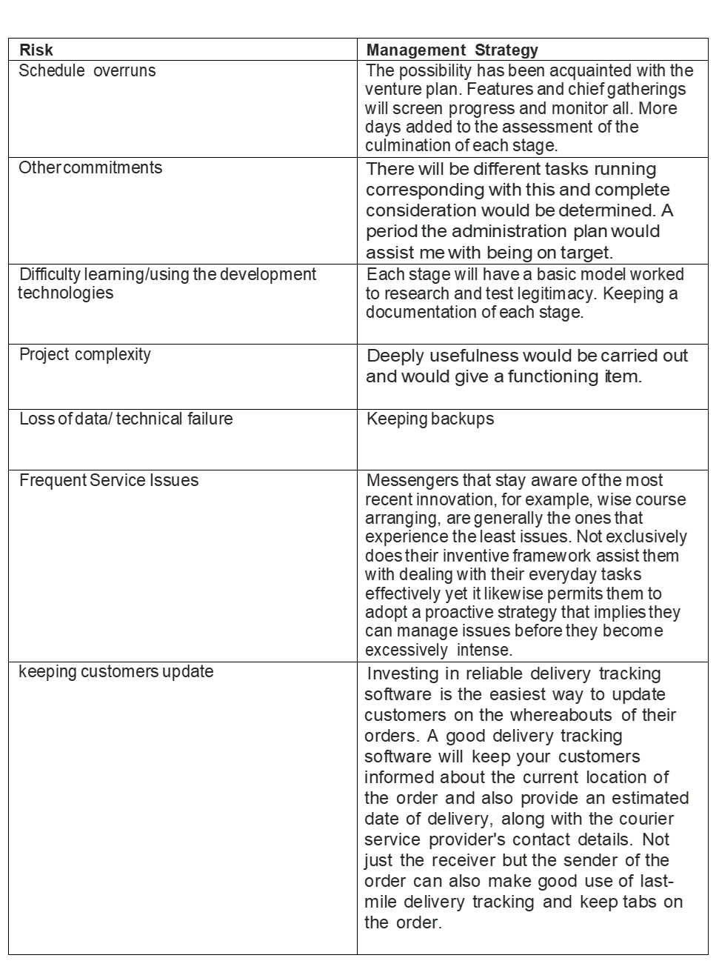

# 8.Initial Quality Plan



# 9.References

*Efficient Courier Tracking System Project*. (n.d.).

Gulc, A. (2017). Courier service quality from the clients’ perspective. *Engineering Management in Production and Services*, *9*(1), 36–45. https://doi.org/10.1515/emj-2017-0004

Mohd, A., Rashid, R. A., Abdul Hamid, A. H. F., Sarijari, M. A., Rahim, M. R. B. A., Sayuti, H., & Abdul Rashid, M. R. (2019). Development of android-based apps for courier service management. *Indonesian Journal of Electrical Engineering and Computer Science*, *15*(2), 1027–1036. https://doi.org/10.11591/ijeecs.v15.i2.pp1027-1036

Okemiri, H., Henry, O., Nwogbaga, N. E., & Nwebonyi, F. N. (2017). Critical Review Of Courier Service Management System With Empasis To Its Relevance If Adopted In Nigeria Queuing Theory View project Smart home control system View project Critical Review Of Courier Service Management System With Empasis To Its Relevance If Adopted In Nigeria. In *Journal of Multidisciplinary Engineering Science and Technology (JMEST)* (Vol. 4). www.jmest.orgJMESTN423516887738

 pdfcoffee.com. (n.d.). *Project Report of Courier Tracking System*. [online] Available at: https://pdfcoffee.com/project-report-of-courier-tracking-system-pdf-free.html.

‌ (Anon, n.d.)

(pdfcoffee.com, n.d.)*Efficient Courier Tracking System Project*. (n.d.).

Gulc, A. (2017). Courier service quality from the clients’ perspective. *Engineering Management in Production and Services*, *9*(1), 36–45. https://doi.org/10.1515/emj-2017-0004

Mohd, A., Rashid, R. A., Abdul Hamid, A. H. F., Sarijari, M. A., Rahim, M. R. B. A., Sayuti, H., & Abdul Rashid, M. R. (2019). Development of android-based apps for courier service management. *Indonesian Journal of Electrical Engineering and Computer Science*, *15*(2), 1027–1036. https://doi.org/10.11591/ijeecs.v15.i2.pp1027-1036

Okemiri, H., Henry, O., Nwogbaga, N. E., & Nwebonyi, F. N. (2017). Critical Review Of Courier Service Management System With Empasis To Its Relevance If Adopted In Nigeria Queuing Theory View project Smart home control system View project Critical Review Of Courier Service Management System With Empasis To Its Relevance If Adopted In Nigeria. In *Journal of Multidisciplinary Engineering Science and Technology (JMEST)* (Vol. 4). www.jmest.orgJMESTN423516887738

TryCartwheel.com. 2021. *Cartwheel On-demand Delivery Management Software*. [online] Available at: <https://trycartwheel.com/?network=g&placement=&adposition=&utm_term=courier%20tracking%20software&utm_campaign=delivery_world&utm_source=google&utm_medium=cpc&utm_content=549881954131&hsa_acc=5257596931&hsa_cam=11669439785&hsa_grp=114814538378&hsa_ad=549881954131&hsa_src=g&hsa_tgt=kwd-6113732314&hsa_kw=courier%20tracking%20software&hsa_mt=e&hsa_net=adwords&hsa_ver=3&gclid=Cj0KCQiAys2MBhDOARIsAFf1D1dIRClaM48V7EAhhE_KvkHzygYgp1AM0SxW9sBvFFLtQ7Iu63EaVAkaAoGOEALw_wcB> [Accessed 16 November 2021].