
JZGMNHS
Student Management System
  - User Guide for Admin, Teacher, and Student

Version 1.0 | July 2026
Prepared from the live system interface

About this guide
This guide explains how each user role signs in, navigates the portal, and completes the most common tasks. Screens may differ slightly when modules are disabled, permissions are restricted, or school settings change.
Before you begin: Use a current browser, a stable internet connection, and the account issued by the school administrator.

Role access at a glance
Role | Sign-in ID | Main purpose | Typical access
Admin | Username | Configure and maintain the system | All administrative modules
Teacher | Username | Manage assigned classes and learning records | Assigned classes and students
Student | Student number | View personal academic information | Own records only

General sign-in and account safety
STEP 1 Open your assigned portal — Use the portal address provided by the school.
STEP 2 Enter your sign-in ID and password — Teacher and Admin users enter a username; Students enter their student number.
STEP 3 Change the initial password when prompted — Choose a private password that is not shared with anyone.
STEP 4 Log out after every session — Use the Logout button, especially on shared computers.
Privacy: Screenshots show sample or test data. Never place real passwords in screenshots, guides, or support messages.

Contents
- 1. Admin Guide — dashboard, students and staff, academic setup, attendance, payments, and system configuration
- 2. Teacher Guide — classes, students, grades, assignments, attendance, schedules, and profile
- 3. Student Guide — dashboard, class and grades, assignments, attendance, payments, and profile
- 4. Troubleshooting and support checklist

ADMIN
Admin Guide
  - Set up the school, maintain records, and oversee system-wide activity.

In this section
- Sign in and open the dashboard
- Manage students, teachers, and staff
- Configure academic and operational modules
- Maintain secure and accurate records

1. Sign in
STEP 1 Open the Admin portal — Navigate to the Admin sign-in page.
STEP 2 Enter the Admin username and password — Use the credentials issued by the system owner.
STEP 3 Select Remember me only on a trusted device — Do not use this option on public or shared computers.
STEP 4 Select Log in — The system opens the Admin dashboard after successful authentication.
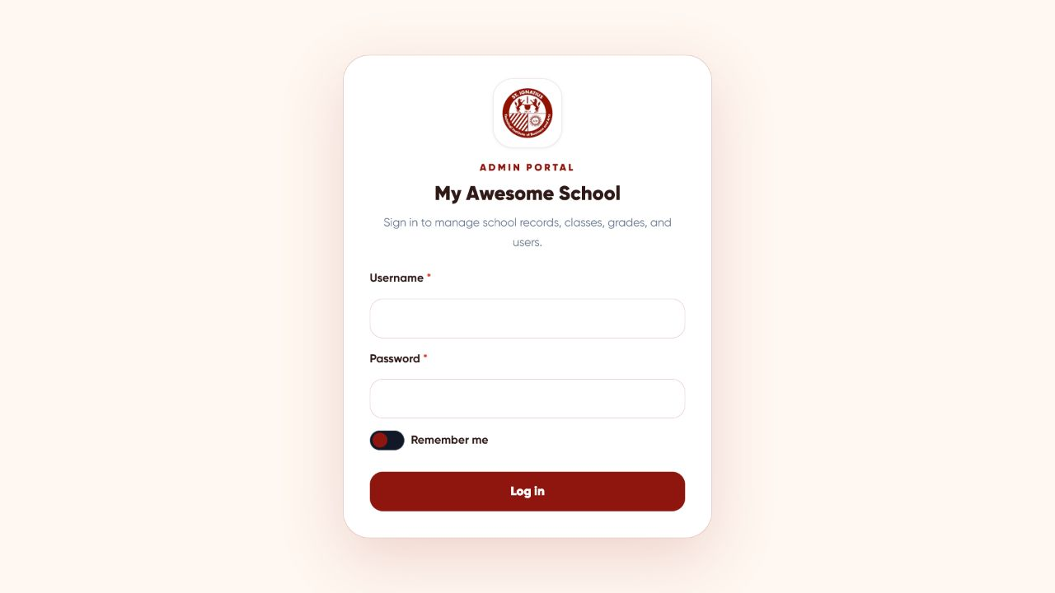
Figure 1. Admin portal sign-in screen

2. Use the dashboard
STEP 1 Confirm the active School Year — Choose the correct year before reviewing totals or opening records.
STEP 2 Review the summary cards — Check enrolled students, active classes, attendance days, daily attendance, and tardy arrivals.
STEP 3 Use the left navigation — Open Announcements, Attendance, Academic/School Year, Students & Staff, Curriculum, College Management, Payments, or System.
Good practice: Verify the selected school year before adding, editing, importing, exporting, or archiving records.
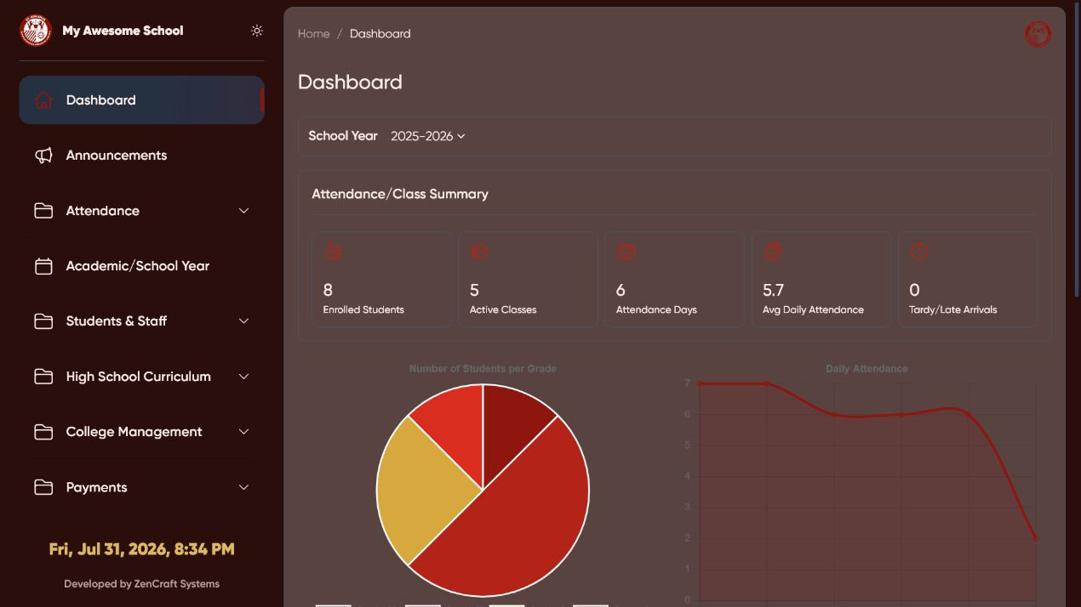
Figure 2. Admin dashboard and navigation

3. Manage students
STEP 1 Open Students & Staff > Students — The student list and record actions appear.
STEP 2 Create one record — Select Create, complete the required identity and enrollment fields, then save.
STEP 3 Import many records — Select Import, download or follow the approved spreadsheet template, preview the file, correct errors, and confirm the import.
STEP 4 Find and update a student — Use Search or Filters, then select the view or edit action beside the correct record.
STEP 5 Export records — Use Export for the student workbook or Export QR Codes for printable student codes.
Caution: Check the student number and full name before editing, archiving, deleting, exporting grades, or generating a QR code.
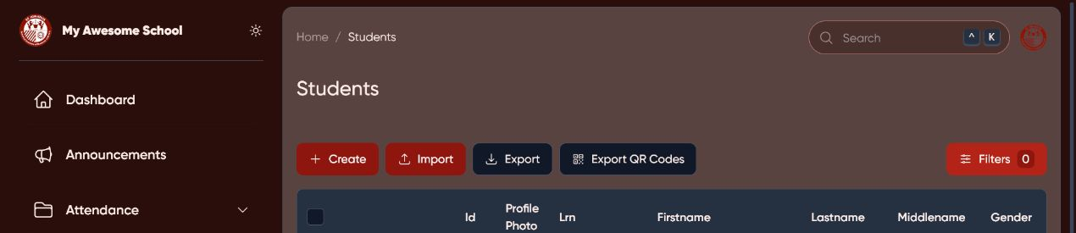
Figure 3. Admin student-management controls; student rows are excluded for privacy

4. Teachers, staff, and accounts
- Open Students & Staff > Teachers to create or update teacher/adviser records and account access.
- Open Students & Staff > Staff to maintain non-teaching staff when the Staff module is enabled.
- Assign the correct role, username, class/adviser information, and active status.
- Use password reset or default-password procedures only after verifying the user’s identity.

5. Academic setup and operations

Academic/School Year
STEP 1 Create or open a school year — Set the label, dates, and status as required by the school.
STEP 2 Activate the correct year — Only one current year should drive day-to-day records.
STEP 3 Archive carefully — Confirm that grades, attendance, and enrollment records are complete before closing a year.

High School Curriculum and College Management
- Maintain grade levels, subjects, classes, advisers, class schedules, and subject assignments.
- For college use, maintain programs, courses, course offerings, enrollments, and instructor assignments.
- Avoid duplicate subjects, classes, or offerings; search existing records before creating new ones.

Announcements
STEP 1 Open Announcements — Create a clear title and concise message.
STEP 2 Choose the audience — Target Teachers, Students, or both, then set an expiry date when appropriate.
STEP 3 Save and verify — Confirm that the announcement appears in the intended portal.

6. Attendance, payments, and system settings

Attendance
- Use the Attendance menu to review student and staff attendance dashboards.
- Use the RFID checker when verifying a card assignment or investigating a scan problem.
- Confirm class start times so the system can calculate tardy or late arrivals correctly.

Payments
- Maintain payment types and student payment records only when the Payments module is enabled.
- Use authorization controls for restricted payment actions and Export for approved reports.
- Reconcile the exported report with official school records before final posting.

System
- Maintain school identity, logo, portal appearance, feature switches, and default account settings.
- Change one setting at a time, save, then verify the related portal.
Security: Do not publish default passwords, payment authorization credentials, or system keys. Restrict Admin access to authorized personnel.

TEACHER
Teacher Guide
  - Manage assigned classes, learning records, attendance, and classroom activities.

In this section
- Sign in and choose the correct class
- Maintain student and grade records
- Create and send assignments
- Review attendance and schedules

7. Sign in
STEP 1 Open the Teacher portal — Use the Teacher portal address provided by the school.
STEP 2 Enter your username and password — Use the account created by the Administrator.
STEP 3 Select Sign in — If the account uses an initial password, follow the prompt to change it.
STEP 4 Review announcements — Important school messages may appear on the sign-in page and notification icon.
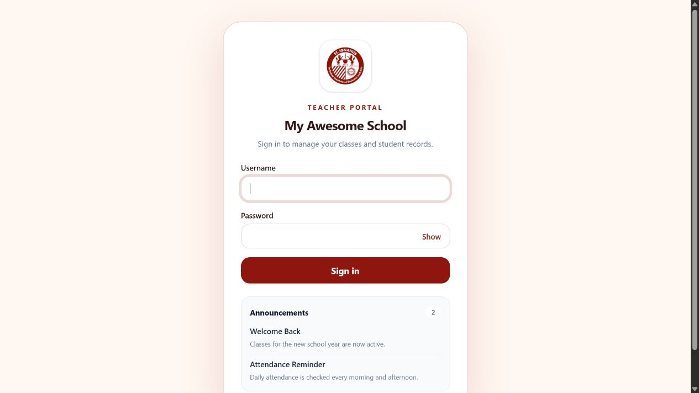
Figure 4. Teacher portal sign-in screen

8. Dashboard and class context
STEP 1 Select the School Year — Choose the year for the records you need.
STEP 2 Select the Advisory Class — The selected class controls the displayed students, attendance, grades, assignments, and schedules.
STEP 3 Review the cards — Check enrollment by gender, today’s attendance, tardy arrivals, birthdays, and pending submissions.
STEP 4 Use the left menu — Move between Dashboard, Students, Assignments and Activities, Attendance, Schedules, and Profile.
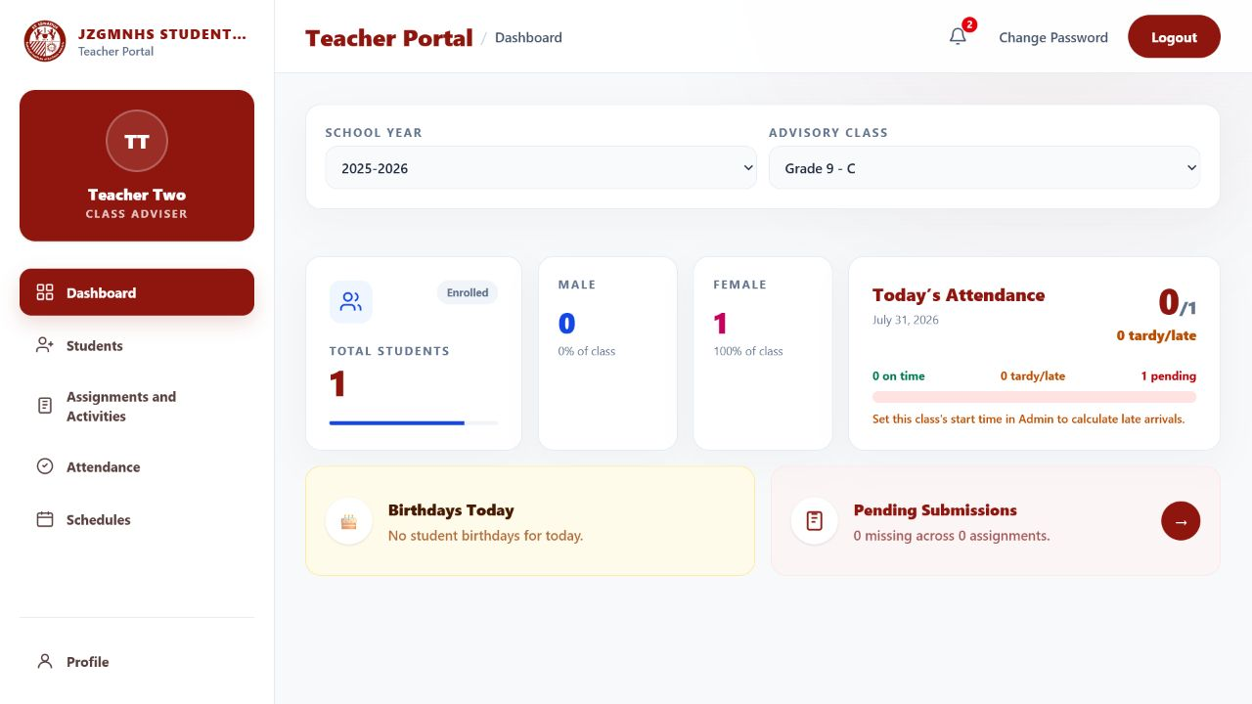
Figure 5. Teacher dashboard with school-year and class selectors

9. Students and grades
STEP 1 Open Students — Confirm the School Year and Advisory Class shown above the list.
STEP 2 Search or filter — Find a student by name or student number and optionally filter by gender or archived status.
STEP 3 Add or edit a student — Use Add Students or Edit, complete the required details, and save.
STEP 4 Enter grades — Select Grades beside the correct student, enter quarter grades for the assigned subjects, review, and save.
STEP 5 Export or archive — Use Export for approved class, grade, or QR reports; archive only after year-end checks.
Accuracy check: Before saving grades, confirm the student, subject, quarter, school year, and class shown on screen.
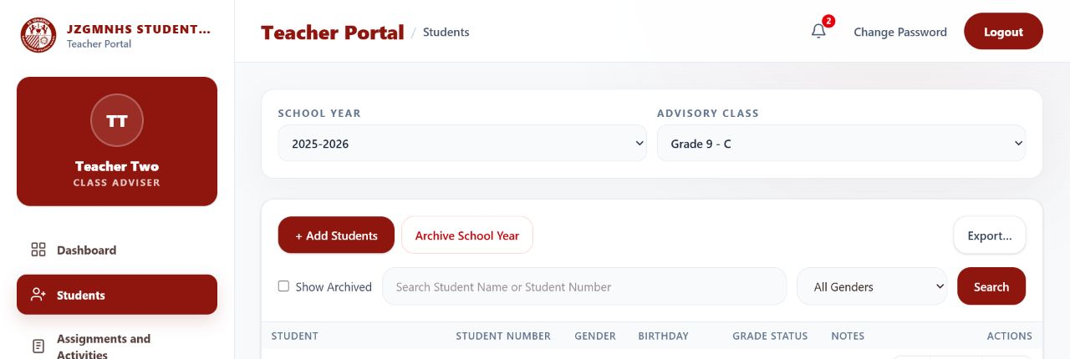
Figure 6. Teacher student list and class-management controls; student rows are excluded for privacy

10. Assignments and activities
STEP 1 Open Assignments and Activities — The selected class and school year remain the active context.
STEP 2 Create an assignment — Enter a clear title, instructions, due date, and optional attachment.
STEP 3 Review before sending — Confirm the class, file, due date, and instructions, then use Send Assignment.
STEP 4 Monitor submissions — Open the assignment summary to see submitted and missing work.
STEP 5 Download carefully — Open only the intended student submission and follow school privacy rules.

Attendance
- Open Attendance and confirm the correct class and date.
- Review time-in/time-out records and tardy indicators; report scan issues to the Administrator.
- Do not alter an attendance record without an approved correction process.

Schedules and profile
- Use Schedules to review or add class schedule entries allowed for your account.
- Use Profile to review your teacher information and Change Password to update your account security.

STUDENT
Student Guide
  - View your academic information, submit work, and monitor attendance and payments.

In this section
- Sign in with your student number
- Review class and grades
- Download and submit assignments
- Check attendance, payments, and profile

11. Sign in
STEP 1 Open the Student portal — Use the Student portal address provided by the school.
STEP 2 Enter your Student Number — Use the number assigned to your official student record.
STEP 3 Enter your password and select Sign in — Change the initial password when prompted and keep it private.
STEP 4 Read announcements — Review notices shown on the sign-in page or notification icon.
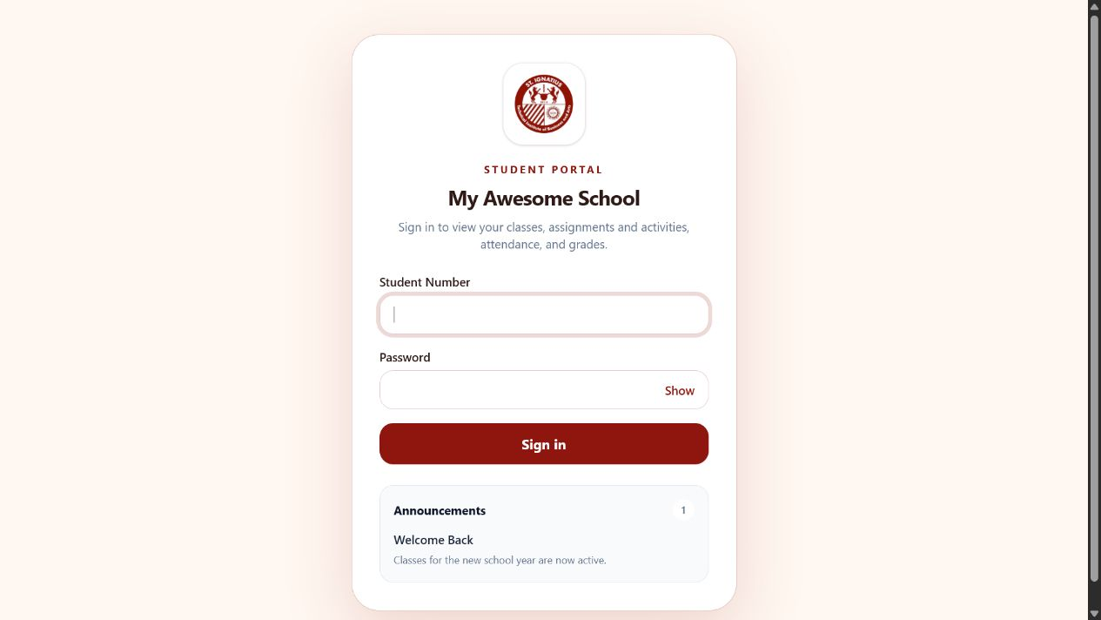
Figure 7. Student portal sign-in screen

12. Use the dashboard
STEP 1 Confirm your identity and class — Check your name, school year, grade, section, and student number.
STEP 2 Review the summary cards — See classes enrolled, attendance records, pending assignments, and academic status.
STEP 3 Use the left navigation — Open Class, Assignments, Attendance, Payments, or Profile.
STEP 4 Protect your QR code — Show or use it only for authorized school processes.
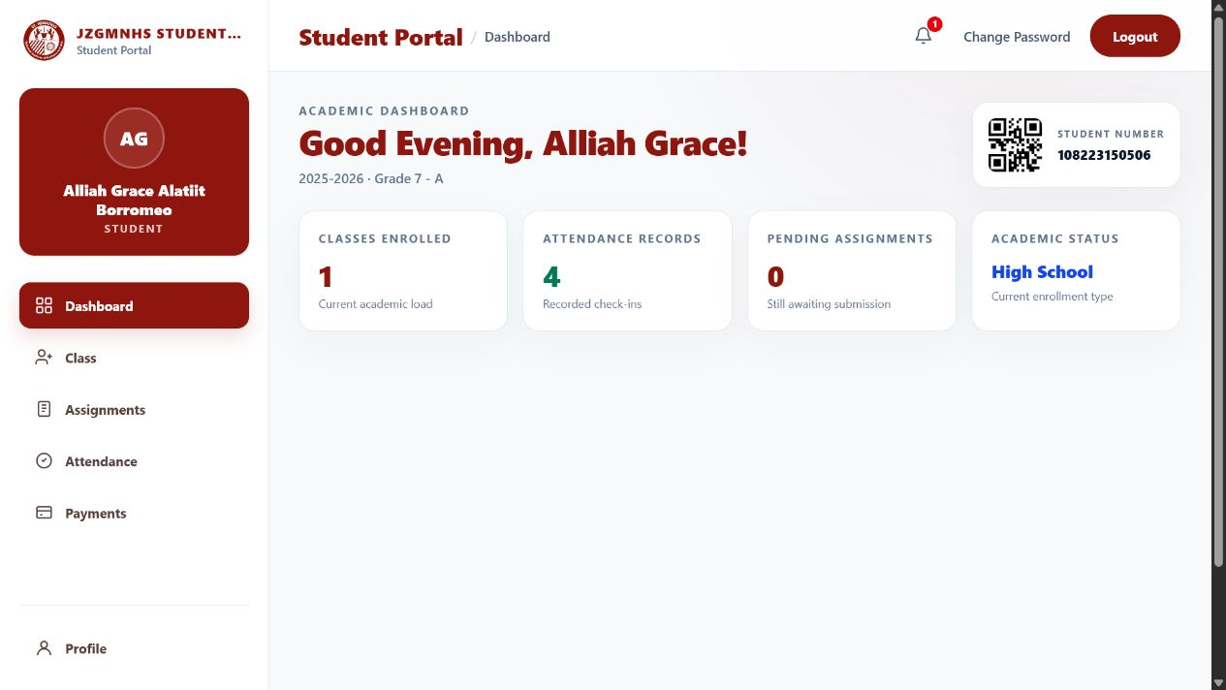
Figure 8. Student academic dashboard; values shown are sample data

13. Class and grades
STEP 1 Open Class — Your active enrollment, adviser, grade, section, and school year appear.
STEP 2 Select View — Review the grades shown for the selected enrollment.
STEP 3 Select Download PDF — Save or print the grade report only when needed.
STEP 4 Report a discrepancy — Contact your Teacher or the school office; do not alter the downloaded report.
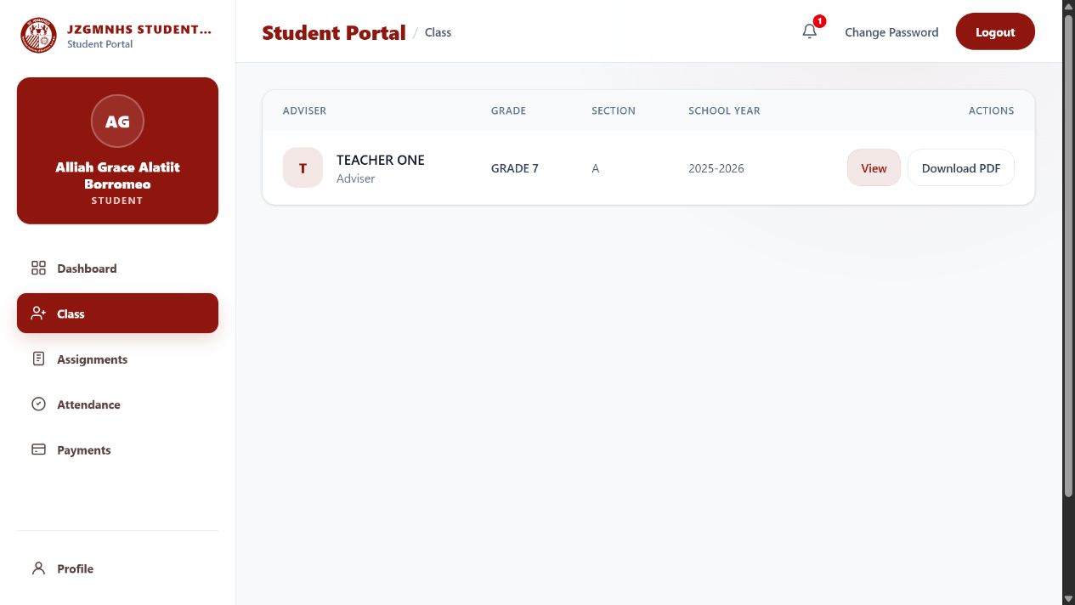
Figure 9. Student Class page with View and Download PDF actions

14. Assignments, attendance, payments, and profile

Assignments
STEP 1 Open Assignments — Read the title, instructions, due date, and attachment.
STEP 2 Download the teacher file if provided — Save it to a known folder and complete the required work.
STEP 3 Upload your submission — Select the correct file and wait for the upload to finish.
STEP 4 Submit and verify — Confirm the submission status and file name before leaving the page.
Important: Uploading the wrong file or closing the page before completion may leave the assignment unsubmitted.

Attendance
- Open Attendance to review recorded check-ins and attendance history.
- Report missing or incorrect records promptly using the school’s correction process.

Payments
- Open Payments to review your own payment information when the module is enabled.
- Keep official receipts and contact the school office if a transaction is missing or incorrect.

Profile and password
- Use Profile to review your personal and academic details.
- Use Change Password to create a private password; log out after using a shared device.

15. Troubleshooting and support

Cannot sign in
- Confirm that you are using the correct portal for your role.
- Check the username or student number and re-enter the password carefully.
- If the account is locked, inactive, or still fails, ask the Administrator to verify access.

Page or data looks wrong
- Refresh the page once, then confirm the selected school year and class.
- Capture the page title and a screenshot that does not expose passwords or unrelated personal records.
- Report what you expected, what happened, and the approximate time of the issue.

Upload or download fails
- Check the internet connection, file type, file size, and download permissions.
- Rename the file with a simple, descriptive name and try once more.
- If it still fails, send the error message and file name to support—never send your password.
Support checklist: Role and portal; page or module; school year/class; action attempted; exact error; time observed; privacy-safe screenshot.

Daily logout checklist
- Finish or save the current task.
- Close student records and downloaded files.
- Select Logout in the upper-right area.
- Close the browser on a shared device.

