Introduction to Data Mining
  - Lab 2: Evaluation

Be a classifier

In the second class, we are going to learn how to use datasets to evaluate data mining algorithms in Weka. (See the lecture of class 2 by Ian H. Witten, [1])
Interactive decision tree construction
- Follow the instruction in [1] to see how decision trees are created for different combinations of attributes in a dataset. Firstly, a dataset and a training set are selected. Secondly, we choose and start running UserClassifier to see a decision tree in the Tree Visualizer. In the Data Visualizer, thirdly, the attributes to use for X and Y are selected, we then select instances in a region in the graph and submit. At this point, the Tree Visualizer shows the tree.
- Examine iris.2D.arff dataset to draw a decision tree for the following pair of attributes by selecting and submitting classes one by one, then remark how many instances are predicted correctly.
Attributes | Split on petallength and petalwidth
Decision Tree | 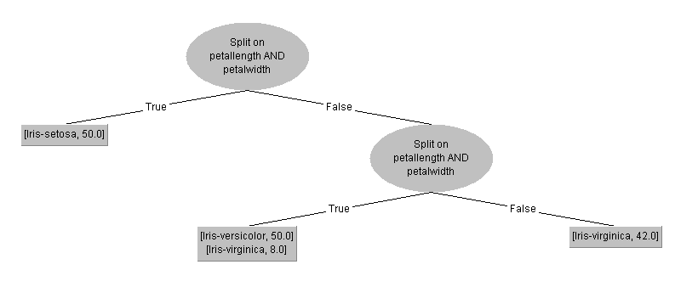
Remark | 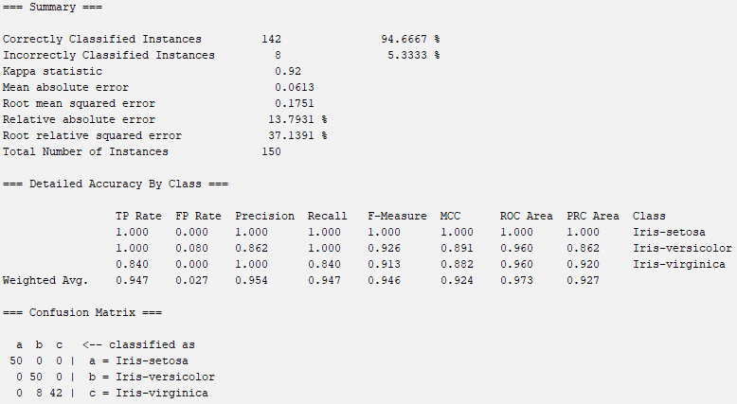

Build a tree, what strategy do you use?
I used a top-down, greedy partitioning strategy:
- First, I identified Iris-setosa as the easiest class to separate — all setosa instances have petallength < 2.5, which is far below the other classes. I drew a rectangle covering the low petallength/petalwidth region and submitted it as Iris-setosa.
- Next, for the remaining data, I split on petalwidth ≈ 1.75 to separate Iris-versicolor (lower petalwidth) from Iris-virginica (higher petalwidth).
- This strategy mimics the greedy approach used by decision tree algorithms like C4.5/J48.

Can you build a “perfect” tree?
Not quite. While Iris-setosa is perfectly linearly separable from the other two classes, there is overlap between Iris-versicolor and Iris-virginica in the petal length/width space. Approximately 3–6 instances from these two classes lie in the overlapping region. A tree with ~96% accuracy is achievable, but a perfect 100% tree is very difficult (if not impossible) with only these 2 attributes.

Training and testing
The lecture of evaluation (see [1]-2.2)
Follow the instructions in [1]-2.3: use J48 to analyze ionosphere.arff dataset, and write down how accuracy it can achieve with different seeds. (If a random number seed is provided, the dataset will be shuffled before the subset is extracted.)
Random number seeds | Percent accuracy (x) | Random number seeds | Percent accuracy (x)
1 | 84.8739% | 6 | 89.0756%
2 | 88.2353% | 7 | 86.5546%
3 | 86.5546% | 8 | 84.8739%
4 | 90.7563% | 9 | 89.916%
5 | 89.0756% | 10 | 93.2773%
Evaluation | Sample Mean | 88.3193%
Evaluation | Standard deviation | 2.6706%

Note:
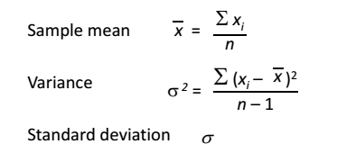

Remark? -
The accuracy varies from 84.87% to 93.28% depending on the random seed, a range of ~8.4 percentage points. This demonstrates that the random partitioning of data significantly affects the measured accuracy. A single holdout experiment gives an unreliable estimate because:
- Some splits may put "easy" instances in the test set (higher accuracy)
- Some splits may put "hard" instances in the test set (lower accuracy)
This variability motivates the use of cross-validation (Section 2.4) for more reliable evaluation.

Baseline accuracy
Follow the instructions in [1]-2.4 to run some classifiers for breast-cancer.arff dataset:
Classifier | Accuracy
J48 | 75.5245%
NaiveBayes | 71.6783%
IBk | 72.3776%
PART | 71.3287%
ZeroR | 70.2797%
What is Baseline accuracy? -
Baseline accuracy is the accuracy achieved by the simplest possible classifier - ZeroR - which always predicts the majority class. For breast-cancer.arff:
- The majority class is no-recurrence-events with 201 out of 286 instances (70.28%)
- ZeroR achieves 70.28% accuracy by predicting every instance as "no-recurrence-events"
A useful classifier must beat the baseline. If a complex algorithm doesn't outperform ZeroR, it provides no value. In this case:
- J48 beats baseline by +5.24 percentage points (75.52% vs 70.28%) — the best performer
- NaiveBayes and IBk beat baseline by only ~1.5–2 points
- PART barely beats baseline (+1.05 points)
These relatively modest improvements suggest that breast cancer recurrence is difficult to predict from the available attributes.

For unbalanced.arff dataset
Classifier | Accuracy
ZeroR | 98.5981%
J48 | 98.5981%
NaiveBayes | 90.771 %
IBk | 97.6636%
PART | 97.5467%

Why do the classifiers achive lower accuracy? –
- ZeroR achieves 98.60% because the dataset is extremely unbalanced — the majority class makes up ~98.6% of all instances, so simply predicting the majority class gives near-perfect accuracy.
- No classifier beats ZeroR. In fact, J48 ties with ZeroR (98.60%), while NaiveBayes, IBk, and PART all perform worse than the baseline.
- Why is this? When a dataset is highly unbalanced:
  - The minority class has very few training examples, so classifiers struggle to learn its patterns
  - Predicting the minority class introduces errors on the overwhelming majority class
  - Algorithms can achieve higher accuracy by ignoring the minority class entirely (which is what ZeroR does)
- NaiveBayes drops to 90.77% - it tries to learn the minority class and ends up misclassifying some majority-class instances, resulting in worse overall accuracy.
Key takeaway: Raw accuracy is a misleading metric for unbalanced datasets. When 98.6% of data belongs to one class, accuracy doesn't tell you whether the classifier learned anything useful. Other metrics like precision, recall, F-measure, or AUC are more informative.

Cross-validation
The holdout procedure: a certain amount is held over for testing and the remainder used for training.
Stratification: each class is properly represented in both training and test sets.
The repeated holdout method of error rate estimation: In each iteration a certain proportion, say two-thirds, of the data is randomly selected for training (using different random-number seeds), possibly with stratification, and the remainder is used for testing. The error rates on the different iterations are averaged to yield an overall error rate.
The lecture of cross validation, 10-fold cross-validation, stratified cross-validation (see [1]-2.5).
In cross-validation, you decide on a fixed number of folds, or partitions, of the data. Suppose we use three. Then the data is split into three approximately equal partitions; each in turn is used for testing and the remainder is used for training. That is, use two-thirds of the data for training and one-third for testing, and repeat the procedure three times so that in the end, every instance has been used exactly once for testing. This is called three-fold cross-validation, and if stratification is adopted as well—which it often is—it is stratified three-fold cross-validation.
Weka does stratified cross-validation by default.
Follow the instructions in [1]-2.5, and examine J48 on credit-g.arff dataset.
Holdout (10%) | Percent accuracy (x) | 10-fold cross-validation | Percent accuracy (x)
Random seed: 1 | 74% | Random seed: 1 | 70.5%
-- 2 | 77% | -- 2 | 72.3%
-- 3 | 70% | -- 3 | 71.2%
-- 4 | 74% | -- 4 | 71.2%
-- 5 | 67% | -- 5 | 71.3%
-- 6 | 67% | -- 6 | 71.5%
-- 7 | 70% | -- 7 | 71.1%
-- 8 | 71% | -- 8 | 70.9%
-- 9 | 69% | -- 9 | 72.1%
-- 10 | 72% | -- 10 | 70.4%
Sample Mean | 71.10% | Sample Mean | 71.25%
Standard deviation | 3.21% | Standard deviation | 0.61%

Examine PART on credit-g.arff dataset:
Holdout (10%) | Percent accuracy (x) | 10-fold cross-validation | Percent accuracy (x)
Random seed: 1 | 77.0% | Random seed: 1 | 70.2%
-- 2 | 77.0% | -- 2 | 71.0%
-- 3 | 65.0% | -- 3 | 72.0%
-- 4 | 73.0% | -- 4 | 70.4%
-- 5 | 69.0% | -- 5 | 69.0%
-- 6 | 67.0% | -- 6 | 70.0%
-- 7 | 66.0% | -- 7 | 70.4%
-- 8 | 72.0% | -- 8 | 68.8%
-- 9 | 75.0% | -- 9 | 72.8%
-- 10 | 75.0% | -- 10 | 70.8%
Sample Mean | 71.60% | Sample Mean | 70.54%
Standard deviation | 4.55% | Standard deviation | 1.22%

Examine NaiveBayes on credit-g.arff dataset:
Holdout (10%) | Percent accuracy (x) | 10-fold cross-validation | Percent accuracy (x)
Random seed: 1 | 76.0% | Random seed: 1 | 75.4%
-- 2 | 78.0% | -- 2 | 75.8%
-- 3 | 80.0% | -- 3 | 74.8%
-- 4 | 78.0% | -- 4 | 75.7%
-- 5 | 71.0% | -- 5 | 74.8%
-- 6 | 78.0% | -- 6 | 74.8%
-- 7 | 72.0% | -- 7 | 74.8%
-- 8 | 73.0% | -- 8 | 75.3%
-- 9 | 77.0% | -- 9 | 75.0%
-- 10 | 77.0% | -- 10 | 75.2%
Sample Mean | 76.00% | Sample Mean | 75.16%
Standard deviation | 2.98% | Standard deviation | 0.38%

http://www.cs.waikato.ac.nz/ml/weka/mooc/dataminingwithweka/

