Introduction to Data Mining
  - Lab 3 – Simple Classifiers

Simplicity first!

In the third class, we are going to learn how to examine some data mining algorithms on datasets using Weka. (See the lecture of class 3 by Ian H. Witten, [1])
In this section, we learn how OneR (one attribute does all the work) works. Open weather.nominal.arff, run OneR, look at the classifier model, how is it?
Correctly Classified Instances 10 71.4286 %
Incorrectly Classified Instances 4 28.5714 %
Kappa statistic 0.3778
Mean absolute error 0.2857
Root mean squared error 0.5345
Relative absolute error 61.5385 %
Root relative squared error 111.4773 %
Total Number of Instances 14

=== Detailed Accuracy By Class ===

TP Rate FP Rate Precision Recall F-Measure MCC ROC Area PRC Area Class
0.778 0.400 0.778 0.778 0.778 0.378 0.689 0.748 yes
0.600 0.222 0.600 0.600 0.600 0.378 0.689 0.503 no
Weighted Avg. 0.714 0.337 0.714 0.714 0.714 0.378 0.689 0.660

=== Confusion Matrix ===

a b <-- classified as
7 2 | a = yes
2 3 | b = no

- Remarks: Correctly Classified Instances - 10 - 71.4286%

Use OneR to build decision tree for some datasets. Compared with ZeroR, how does OneR perform?
Dataset | OneR - accuracy | ZeroR - accuracy
weather.nominal.arff | 71.4286% | 64.2857%
weather.numeric.arff | 71.4286% | 64.2857%
glass.arff | 63.0841% | 35.514%
iriss.arff | 96% | 33.3333%
labor.arff | 84.2105% | 64.9123%
diabetes.arff | 76.4323% | 65.1042%
vote.arff | 95.6322% | 61.3793%
soybean.arff | 40.8492% | 13.47%
breast-cancer.arff | 72.7273% | 70.2797%
credit-g.arff | 74.3% | 70%

Overfitting
What is “overfitting”? - overfitting occurs when a statistical model describes random error or noise instead of the underlying relationship, b/c of complex model, noise/error in the data, or unsuitable applied criterion, poor prediction. To avoid this, use cross-validation, or pruning... [ref: http://en.wikipedia.org/wiki/Overfitting]
Follow the instructions in [1], run OneR on the weather.numeric and diabetes dataset…
Write down the results in the following table: (cross-validation used)
Dataset | OneR | ZeroR
weather.numeric | Classifier model: outlook: sunny → no, overcast → yes, rainy → yes (10/14 training correct)  Accuracy: 42.8571% | Classifier model: Always predicts yes  Accuracy: 64.2857%
weather.numeric w/o outlook att. | Classifier model: humidity: < 82.5 → yes, ≥ 82.5 → no (10/14 training correct)  Accuracy: 50% | Classifier model: Always predicts yes  Accuracy: 64.2857%
diabetes | Classifier model: splits on plas (10 thresholds, ~587/768 correct)  Accuracy: 57.1615% | Classifier model: Always predicts tested_negative  Accuracy: 65.1042%
Diabetes w/ minBucketSize 1 | Classifier model: splits on pedi (200+ micro-thresholds, zigzags yes/no)  Accuracy: 57.1615% | Classifier model: Always predicts tested_negative  Accuracy: 65.1042%

MinBucketSize? - It sets the minimum number of training instances that a bucket (value interval) must contain. Smaller values = more specific rules = risk of overfitting. Larger values = broader rules = less overfitting.
Remark? - When minBucketSize is very small (=1), OneR creates very specific rules that fit the training data too closely → the 10-fold CV accuracy may be lower than with default settings, demonstrating overfitting.

Using probabilities
Lecture of Naïve Bayes: [1]
- All attributes contribute equally and independently no identical attributes
Follow the instructions in [1] to exame NaiveBayes on weather.nominal
Classifier model | Performance
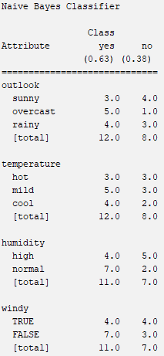 | 92.8571%

Decision Trees
Lecture of decision trees: [1]
How to calculate entropy and information gain?
Entropy measures the impurity of a collection.
$$Entropy\left(S\right)=-\sum_{i=1}^{c}{p_{i}\log_{2}}p_{i}$$
Information Gain measures the Expected Reduction in Entropy.
Info. Gain = (Entropy of distribution before the split) – (Entropy of distribution after the split)
$$Gain\left(S,A\right)≡Entropy\left(S\right)-\sum_{v∈Values\left(A\right)}{\frac{\left|S_{v}\right|}{\left|S\right|}}Entropy(S_{v})$$
Values(A) is the set of all possible values for attribute A and S_{v} is the subset of S for which attribute A has value.
Build a decision tree for the weather data step by step:
Compute Entropy and Info. Gain | Selected attribute
All 14 instances, 9 yes / 5 no: Entropy(S) = 0.940. Gain(outlook) = 0.247, Gain(humidity) = 0.152, Gain(windy) = 0.048, Gain(temp) = 0.029 | outlook
Sunny branch (5 instances, 2 yes / 3 no): Entropy = 0.971. Gain(humidity) = 0.971, Gain(temp) = 0.571, Gain(windy) = 0.020.  Rainy branch (5 instances, 3 yes / 2 no): Entropy = 0.971. Gain(windy) = 0.971, Gain(temp) = 0.020, Gain(humidity) = 0.020. Overcast → pure leaf (all yes, entropy=0) | humidity (sunny) windy (rainy)
All remaining branches are pure leaves (entropy = 0). Tree is complete. Sunny + High → no, Sunny + Normal → yes, Rainy + FALSE → yes, Rainy + TRUE → no | (no more splits needed)
 | 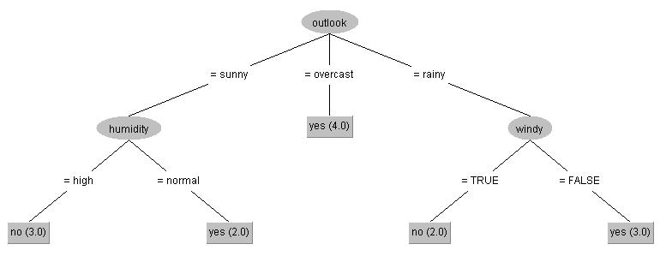

Use Weka to examine J48 on the weather data.

Pruning decision trees
Follow the lecture of pruning decision tree in [1] …
Why pruning? - Prevent overfitting to noise in the data.
In Weka, look at the J48 leaner. What are parameters: minNunObj, confidenceFactor?
- minNumObj: Minimum number of instances a leaf must have. Higher = simpler tree (less overfitting).
- confidenceFactor: Controls pruning aggressiveness. Lower value (e.g., 0.1) = more pruning = simpler tree. Default = 0.25.

Follow the instructions in [1] to run J48 on the two dataset, then fill in the following table:
Dataset | J48 (default, pruned) | J48 (unpruned)
diabetes.arff | 73.8281% | 72.6563%
breast‐cancer.arff | 75.5245% | 69.5804%

Nearest neighbor
Follow the lecture in [1]
“Instance‐based” learning = “nearest‐neighbor” learning
What is k‐nearest‐neighbors (K-NN)?
– KNN classifies a new instance by finding the K closest training instances (neighbors) and using a majority vote. No model is built — classification happens at prediction time (lazy learning).

Follow the instructions in [1] to run lazy>IBk on the glass dataset with k = 1, 5, 20, and then fill its accuracy in the following table:
Dataset | IBk, k =1 | IBk, k =5 | IBk, k =20
Glass | 70.5607% | 67.757% | 65.4206%

http://www.cs.waikato.ac.nz/ml/weka/mooc/dataminingwithweka/

