Description of the out put

Program1

Color in window is brighter than those outside the window.

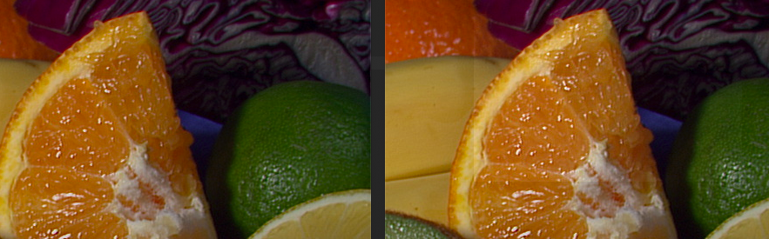

Program2

Color in window is brighter than those outside the window. And there is more contrast in the window.

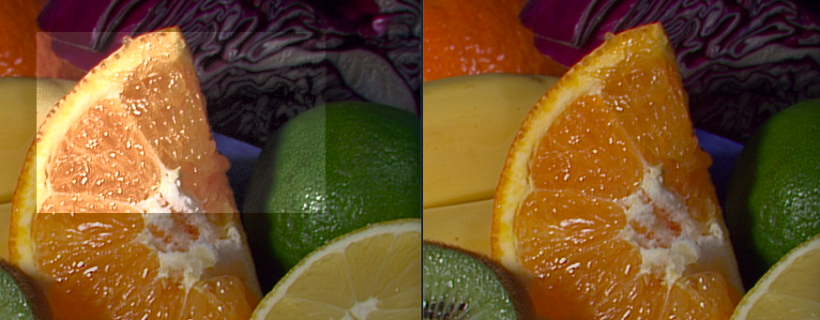

Program3

Color in window is brighter than those outside the window. It’s similar to first picture.

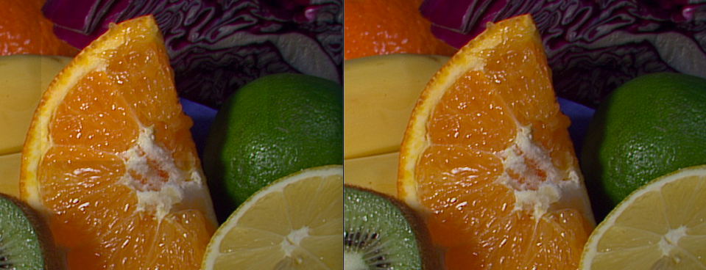

Bad pictures:

I got bad pictures cause by assigning double value to integer (shows red on original green items which means green is 0).