haarcascade_frontalface_alt2.

Both eys

scaleFactor = 1.1 # range is from 1 to ..  
minNeighbors = 3 # range is from 0 to ..

ROI, 1.1, 20, 0 | cv2.CASCADE_SCALE_IMAGE, (10, 20))

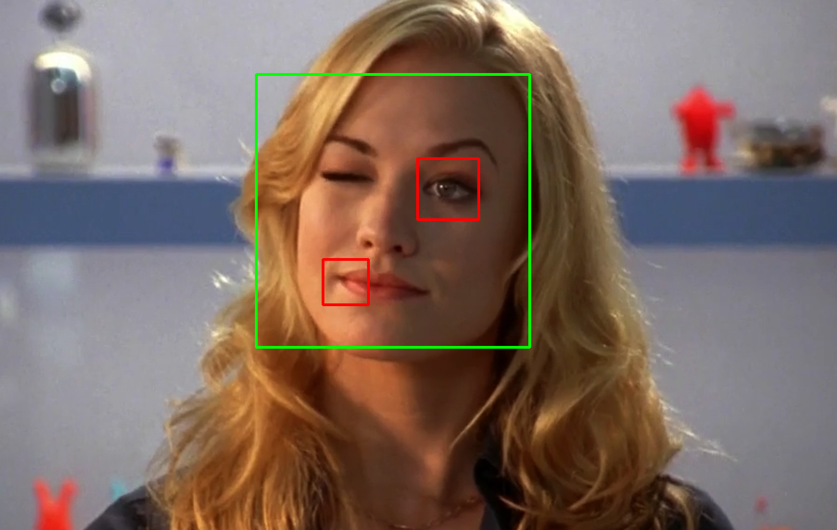

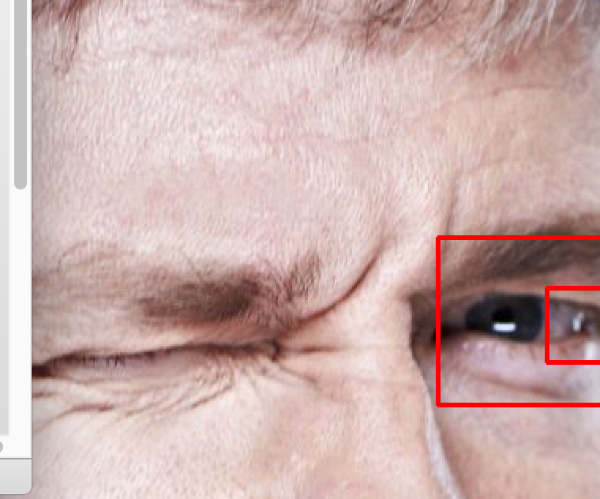

还有一个人的人脸检测不出

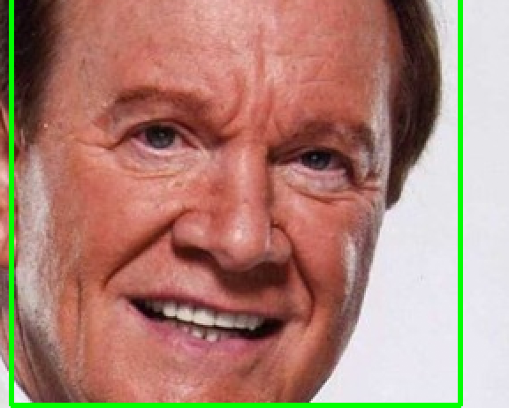d

只看脸的偏上的部分

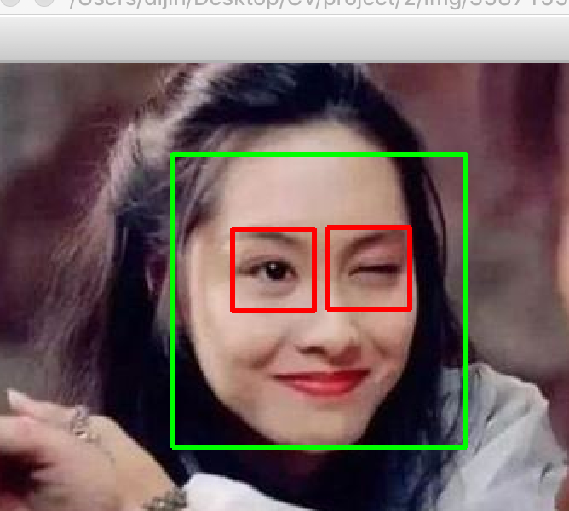

def detectWink(frame, location, ROI, cascade):  
 eyes = cascade.detectMultiScale( ROI, 1.1, 20, 0 | cv2.CASCADE_SCALE_IMAGE, (10, 20))  
 if len(eyes)==0:  
 eyes = glass_cascade.detectMultiScale(ROI, 1.05, 1, 0|cv2.CASCADE_SCALE_IMAGE, (5, 10))  
 if len(eyes)>=2:  
 eyes = glass_cascade.detectMultiScale(ROI, 1.1, 4, 0|cv2.CASCADE_SCALE_IMAGE, (5, 10))  
  
 for e in eyes:  
 e[0] += location[0]  
 e[1] += location[1]  
 x, y, w, h = e[0], e[1], e[2], e[3]  
  
 cv2.rectangle(frame, (x, y), (x + w, y + h), (0, 0, 255), 2)  
 return len(eyes) == 1 # number of eyes is one