1.

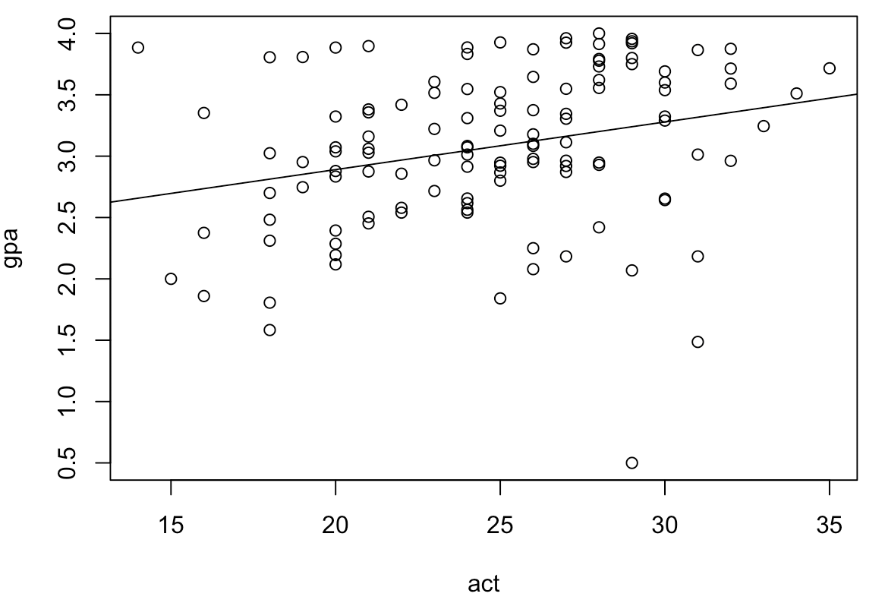

The scatterplot of gpa against act doesn’t concentrate much on the linear line, which means low connection.

Use boot and cor function to get the following result.

Point estimate of ρ:

original bias std. error

t1\* 0.2694818 -0.0003749965 0.1070859

Intervals :

Level Normal Basic

95% ( 0.0600, 0.4797 ) ( 0.0662, 0.4685 )

Level Percentile BCa

95% ( 0.0704, 0.4728 ) ( 0.0611, 0.4683 )

From the result, we can conclude that gpa has little connection with act, since the correlation of these two data is low.

2.

a)

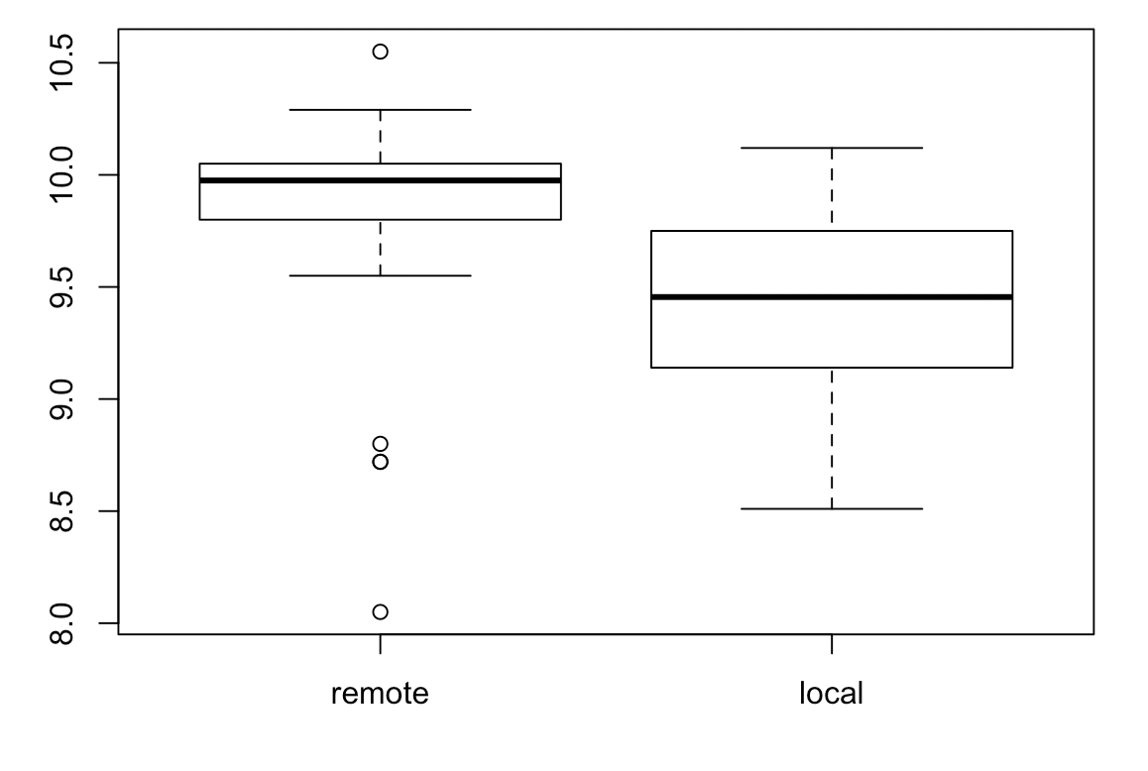

Two distribution seems different since voltage in remote area is obvious higher than local one with more outliers and local one is more symmetric.

b)

Assumption: Each sample comes from a normal distribution.

Verify: Use bootstrap to verify each sample.

REMOTE:

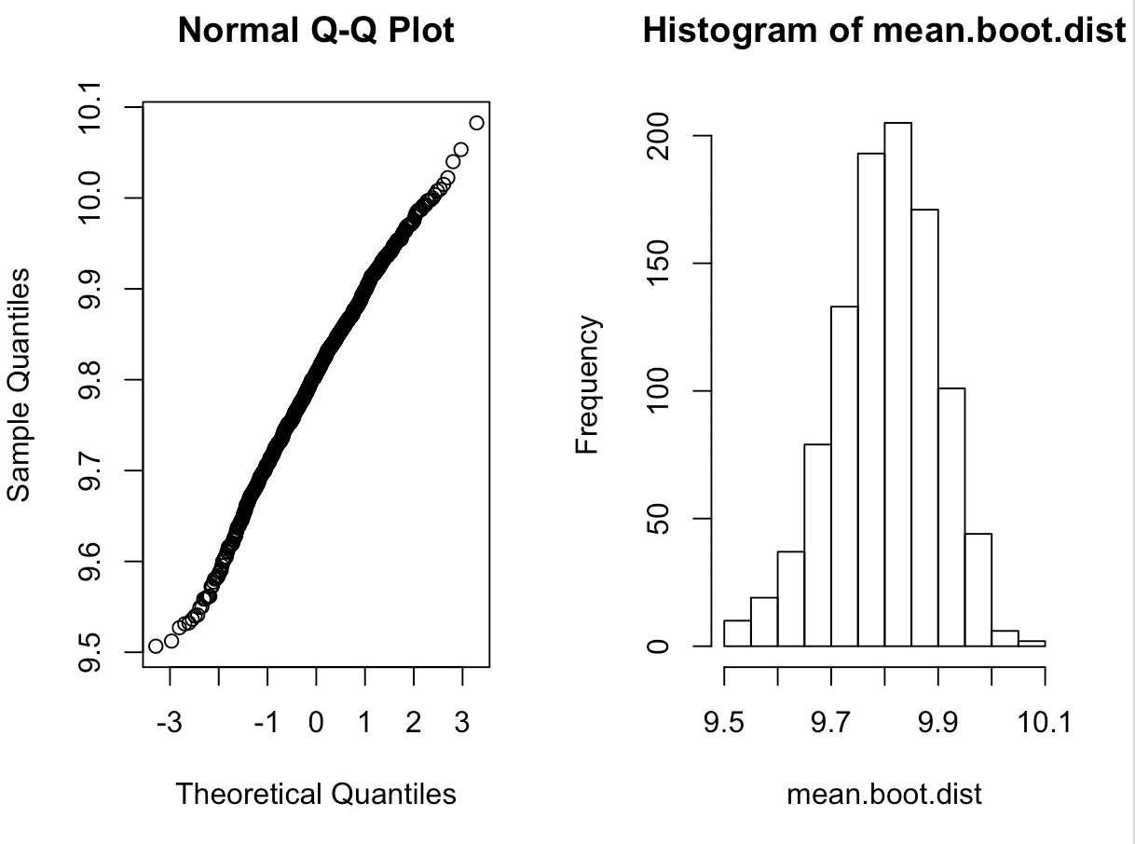

LOCAL:

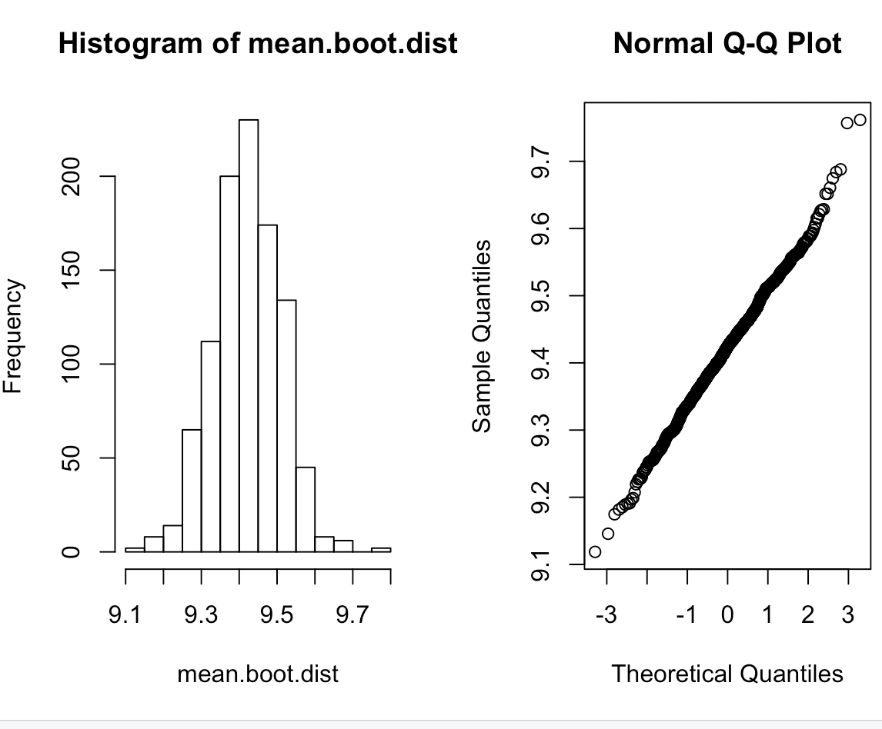

So they remote and local data come from normal distribution.

Then use t.test to calculate the CI:

Null hypothesis: true difference in means is equal to 0

data: remote and local

t = 2.8911, df = 57.16, p-value = 0.005419

alternative hypothesis: true difference in means is not equal to 0

95 percent confidence interval:

0.1172284 0.6454382

sample estimates:

mean of x mean of y

9.803667 9.422333

Assume 1% level of significance Null hypothesis is rejected and alternative hypothesis is accepted that difference of the mean is different.

c)

Conclusion in b) matches the exploratory analysis in a.

3.

Analysis strategy:

1. Use boxplot and plot to see the similarity of the data.
2. Assume data comes from normal distribution and use t.test to calculate the confidence interval and verify the assumption.
3. Use bootstrap to compute confidence interval.

Draw boxplot to see distribution.

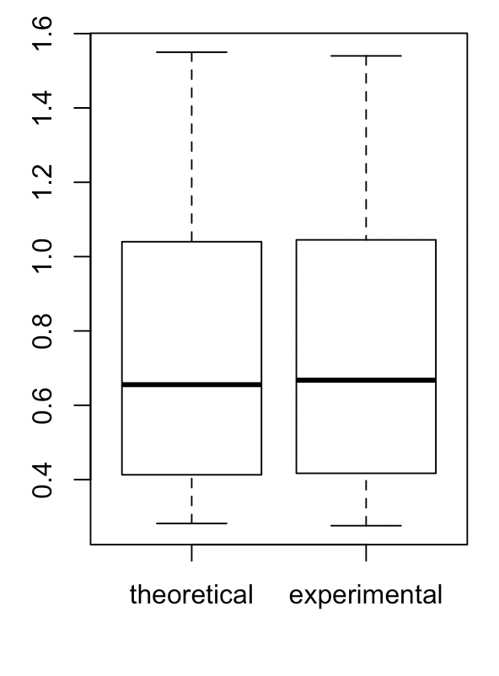

Draw scatter plot separately to see the relation.

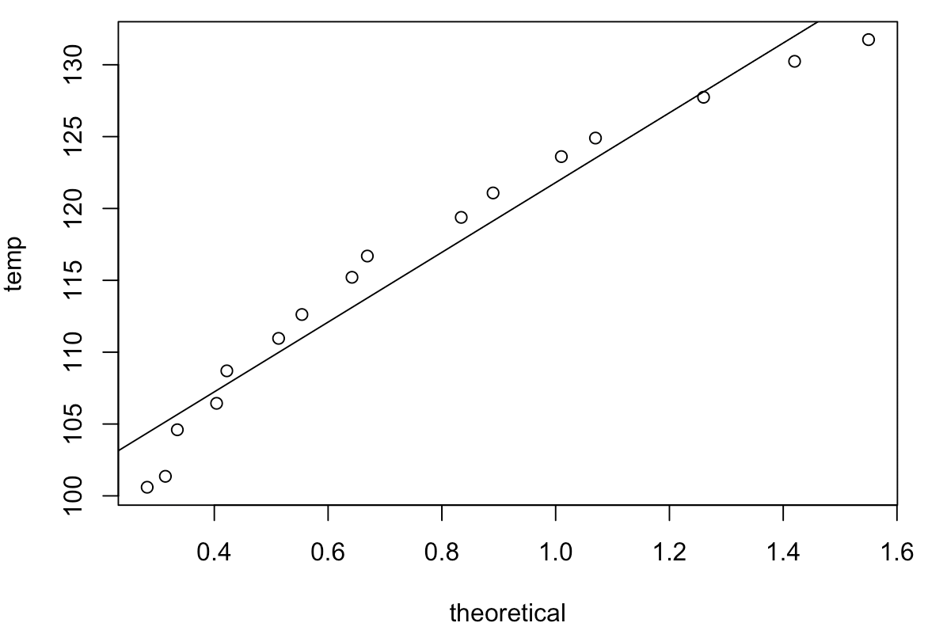

Coefficients:

(Intercept) data[, 3]

97.46 24.39

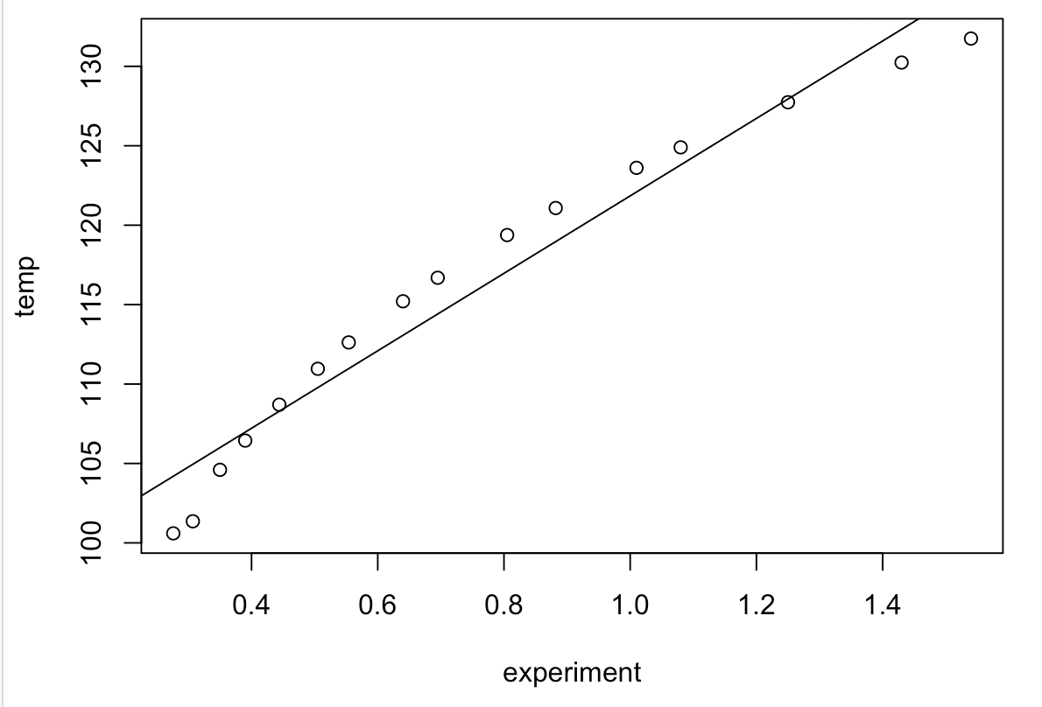

Coefficients:

(Intercept) data[, 2]

97.53 24.28

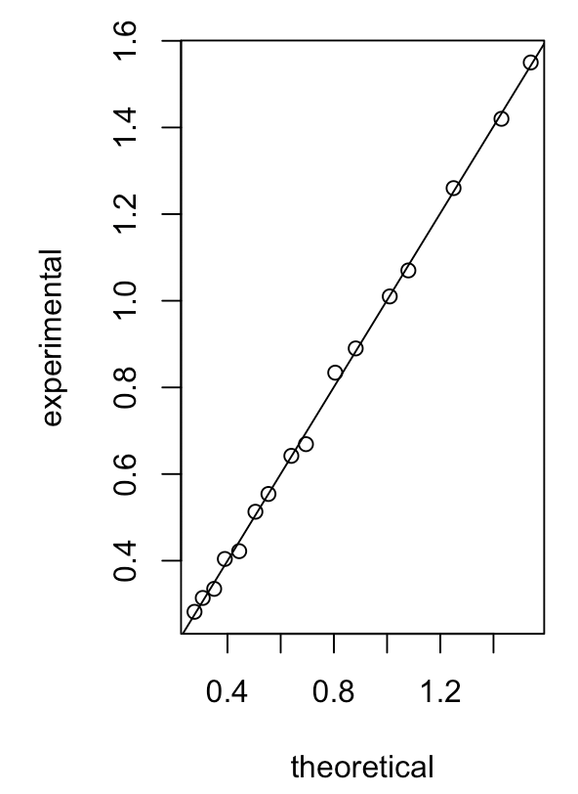

Coefficients:

(Intercept) data[, 3]

-0.001279 1.002588

Evidence: Similar mean in boxplot and plot.

Use bootstrap to analysis difference of mean between theoretical and experimental value.

Intervals :

Level Normal Basic

95% (-0.0062, 0.0077 ) (-0.0059, 0.0081 )

Level Percentile BCa

95% (-0.0067, 0.0072 ) (-0.0067, 0.0072 )

Evidence: The experimental value has similar mean with temperature as theoretical value.

Use hypothesis method to compare the mean of theoretical and experiment value.

Null hypothesis: true difference in means is equal to 0

One Sample t-test

data: diff

t = 0.19344, df = 15, p-value = 0.8492

alternative hypothesis: true mean is not equal to 0

95 percent confidence interval:

-0.006887694 0.008262694

Assume 1% level of significance Null hypothesis is accepted that difference of the mean is same.

Evidence: These value have same mean.

According to proof above, the theoretical model for vapor pressure is a good model of reality.

CODE: