1. Use L<-m-qnorm(0.975)\*s/sqrt(length(data))

R<-m+qnorm(0.975)\*s/sqrt(length(data)) calculate confidence interval for z interval

Use boot to resample from sample for 999 times and get quantile of them.

L<-quantile(boot,0.025)

R<-quantile(boot,0.975)

b)

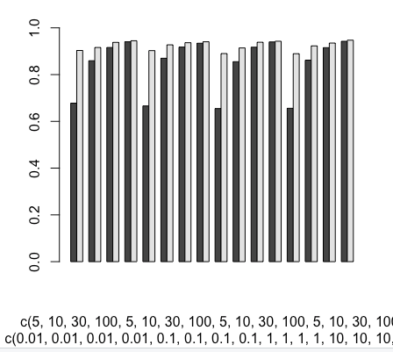

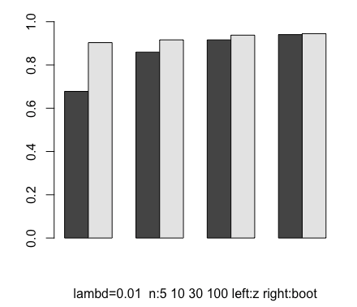

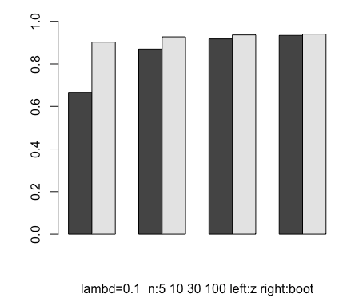

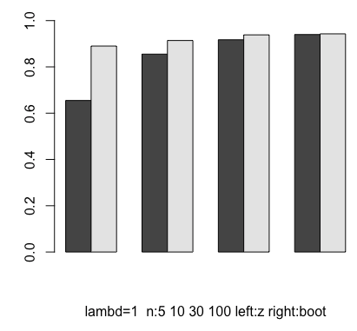

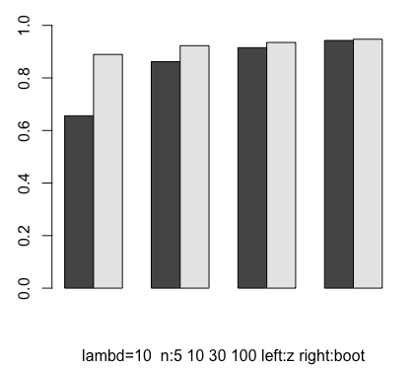

lembda: 0.01 n: 5

[1] 0.6778

[1] 0.9032

lembda: 0.01 n: 10

[1] 0.8594

[1] 0.916

lembda: 0.01 n: 30

[1] 0.916

[1] 0.9378

lembda: 0.01 n: 100

[1] 0.9404

[1] 0.9448

lembda: 0.1 n: 5

[1] 0.666

[1] 0.9026

lembda: 0.1 n: 10

[1] 0.87

[1] 0.9274

lembda: 0.1 n: 30

[1] 0.9178

[1] 0.9364

lembda: 0.1 n: 100

[1] 0.9342

[1] 0.9404

lembda: 1 n: 5

[1] 0.6548

[1] 0.89

lembda: 1 n: 10

[1] 0.8552

[1] 0.914

lembda: 1 n: 30

[1] 0.9172

[1] 0.9384

lembda: 1 n: 100

[1] 0.9398

[1] 0.9428

lembda: 10 n: 5

[1] 0.656

[1] 0.8894

lembda: 10 n: 10

[1] 0.8618

[1] 0.9228

lembda: 10 n: 30

[1] 0.9152

[1] 0.935

lembda: 10 n: 100

[1] 0.9426

[1] 0.9472