Smart Parking System
An IoT Architecture for Occupancy Monitoring, Allocation and Short-Horizon Forecasting
Akil Ansari A · 25BCE2777
Vellore Institute of Technology
Final project review · 15 October 2026

Abstract
Parking guidance systems need timely occupancy information, a consistent way to assign available spaces, and a reliable interface between roadside devices and server software. This project implements a five-slot smart-parking prototype architecture with a FastAPI and SQLite backend, RFID-based vehicle entry and exit, a configurable camera occupancy service, three allocation heuristics, and server-side occupancy forecasting. The repository's completed software experiments use a deterministic synthetic 14-day timeline sampled every five minutes (4,032 buckets and 27 features); these are simulated records, not observations from a deployed lot. The same chronological 70/15/15 split and training-only standardization are used for LSTM, GRU, and temporal Transformer regressors. On the untouched synthetic test partition, GRU achieved MAE 0.098055 and RMSE 0.117862, compared with persistence MAE 0.120875; the result is dataset-specific and does not establish general superiority. In 120 optimizer scenarios with three repeat seeds, GA matched the enumerated single-slot optimum in mean cost (0.378194), while PSO and ACO had mean optimality gaps 0.048264 and 0.003586. Exact enumeration remained the appropriate reference for this small five-candidate problem. Controller and camera firmware, a JPEG polling service, and interactive ROI calibration are supplied with a proposed wiring design. Further evaluation should use locally collected occupancy labels, measured device response under network faults, and larger lots; those assessments are outside the current software-only evidence. Both firmware projects compile for their selected board targets, but no physical prototype, camera classification accuracy, microcontroller inference, or power measurement is claimed.
Keywords: smart parking, Internet of Things, RFID, camera occupancy, allocation optimization, occupancy forecasting, LSTM, GRU, Transformer

1. Introduction
Parking search is a coordination problem: drivers need current availability, operators need a consistent record of arrivals and departures, and a guidance policy must select from the spaces that remain free. Sensors and networked systems can make that state visible, but the quality of a result depends on the sensing method, communication reliability, and whether the allocation and forecasting methods are evaluated against appropriate baselines [1].
This project separates device I/O from server computation. An ESP32 controller reads an RFID tag and calls the existing vehicle lifecycle API. A camera module can provide JPEG snapshots to a Python polling service; that service forwards valid frames to the backend's existing occupancy endpoint. FastAPI coordinates persistence, occupancy, allocation, prediction, and the browser dashboard. TensorFlow/Keras forecasting runs on the server; neither the ESP32 controller nor the ESP32-CAM performs neural inference.
The software contributions are (i) an idempotent API lifecycle and shared allocation objective, (ii) a privacy-conscious simulated time-series dataset and comparable neural forecasting experiment, (iii) a reproducible GA/PSO/ACO benchmark with deterministic and exact references, and (iv) a hardware integration path that fails closed when allocation cannot be confirmed. Hardware results remain unmeasured until the specified boards and circuit are physically assembled and tested.

2. Literature Survey
Prior work spans sensing, RFID-mediated access, vision datasets, forecasting, and allocation. The comparison below distinguishes the evaluated scope of each source from the narrower five-slot simulated experiments in this project.
Study | Venue | Method / reported contribution | Relevance and limitation
Lin et al. [1] | 2017 · IEEE Transactions on Intelligent Transportation Systems | Survey and taxonomy of smart-parking services, sensing, communications and deployment issues. | Broad architectural framing; it is a survey rather than a new benchmark. This project joins a small prototype backend to sensing and forecast APIs.
Tsiropoulou et al. [2] | 2017 · Cyber-Physical Systems | Studies passive RFID tag-to-tag communication and joint routing/reader-power minimization in a parking context. | Focuses RFID coverage and power, not the present system's database-backed entry/exit lifecycle or physical gate validation.
de Almeida et al. [3] | 2015 · Expert Systems with Applications | Introduces PKLot: 695,899 labeled space images from two lots and three views; evaluates texture descriptors with SVM. | Reports strong same-view results and a cross-lot drop, exposing camera/view generalization risk. This project has no labeled real-camera evaluation set.
Yang et al. [4] | 2019 · Transportation Research Part C | Combines graph convolution and recurrent LSTM with parking, traffic and weather inputs for block-level prediction 30 minutes ahead. | Uses real city data at a different scale/horizon. Its MAPE is not directly comparable with this project's five-minute synthetic regression MAE/RMSE.
Thomas and Kovoor [5] | 2018 · Procedia Computer Science | Presents a genetic-algorithm approach to vehicle-to-bay scheduling for a smart vehicle parking prototype. | Motivates heuristic allocation; its scenario and objective differ from the shared four-term objective and exhaustive five-slot reference here.

The recurrent units follow established sequence-model designs: LSTM [6] and gated recurrent units [7]. The temporal Transformer uses self-attention and feed-forward residual blocks following the attention architecture introduced by Vaswani et al. [8]. These sources define model families, not evidence that a model trained on this synthetic corpus will transfer to a physical parking site. The gap addressed here is an end-to-end, reproducible comparison with matched inputs and explicit simulation limitations, rather than a claim of a new state-of-the-art method.

3. Problem Statement and Objectives
The system must keep a consistent record of which configured parking spaces are occupied, associate a vehicle's entry and exit with idempotent operations, select only a free slot, and expose current and short-horizon occupancy through a dashboard/API. A camera-based heuristic may suggest occupancy transitions, but its output is confidence-filtered and temporally smoothed before persistence. A forecast is a regression estimate over aggregated server history, not a direct image classifier.
Objective | Status and evidence
Identify configured-slot occupancy | Software implemented: JPEG ROI edge-density detector, confidence filter, consecutive-frame smoothing, SQLite persistence. Real-camera accuracy is not measured.
RFID entry/exit | Backend API complete and tested; controller firmware implements polling, idempotent retry and response validation. Physical reader tests remain open.
Compare GA, PSO, ACO allocation | Complete: 120 scenarios, three repeat seeds, common objective, first-available and exhaustive references.
Forecast next-interval occupancy | Complete on deterministic synthetic data using LSTM, GRU, Transformer and persistence baseline.
Dashboard visibility | Existing dashboard and API are implemented; browser screenshot and physical-device indicators were not captured in this environment.
Low-cost hardware integration | Firmware projects and proposed connection design supplied. Boards and wiring were unavailable; no assembled prototype claim.

4. System Architecture
The backend remains the system coordinator. Camera capture and RFID access use distinct flows so a camera outage does not invent a vehicle operation and a network failure cannot trigger a gate opening. SQLite is the local system of record. The dashboard consumes backend routes rather than reading device state directly.
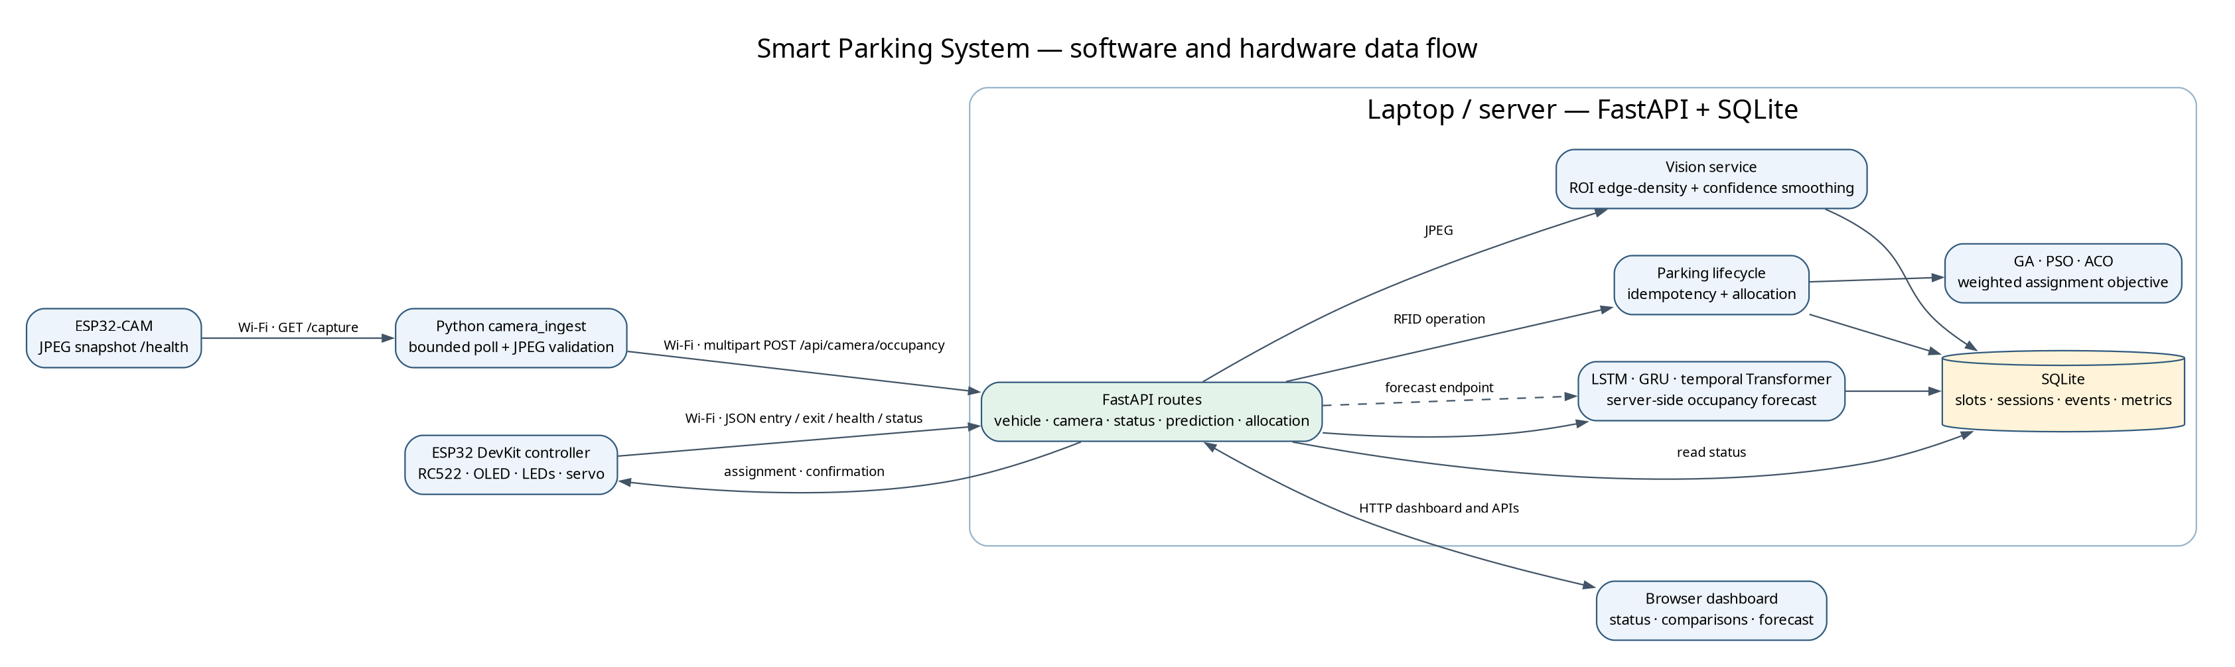
Figure 1. System data flow; compute-intensive vision aggregation, allocation, forecasting and persistence run on the server.
Camera flow: ESP32-CAM GET /capture → camera_ingest validates size, MIME type and JPEG decode → multipart POST /api/camera/occupancy → configured ROI detection → confidence and consecutive-frame checks → persisted accepted occupancy transition → status/dashboard and feature aggregation. Controller flow: RC522 UID → GET /api/parking/status → POST /api/vehicle/entry or /api/vehicle/exit with a persisted idempotency key → response and subsequent status validation → OLED/LED update and one gate cycle. A timeout preserves the pending key and leaves the gate closed until confirmation.
Forecast flow uses the same PreparedDataset contract for each model. The runtime predictor loads compatible, hash-checked model artifacts and uses a deterministic fallback when unavailable. Allocation uses configured weights and excludes occupied candidates. The small five-slot exhaustive benchmark computes the exact single-slot minimum for each scenario.

5. Hardware Design
The selected compile targets are a generic ESP32 DevKit/WROOM-32 controller and an AI-Thinker ESP32-CAM/OV2640. The repository's original design did not specify purchased board revisions; therefore the controller pin assignment is proposed and the camera firmware explicitly selects the AI-Thinker map. Check the board silkscreen and vendor documentation before power-up. The diagrams are a design proposal, not a physically verified circuit.
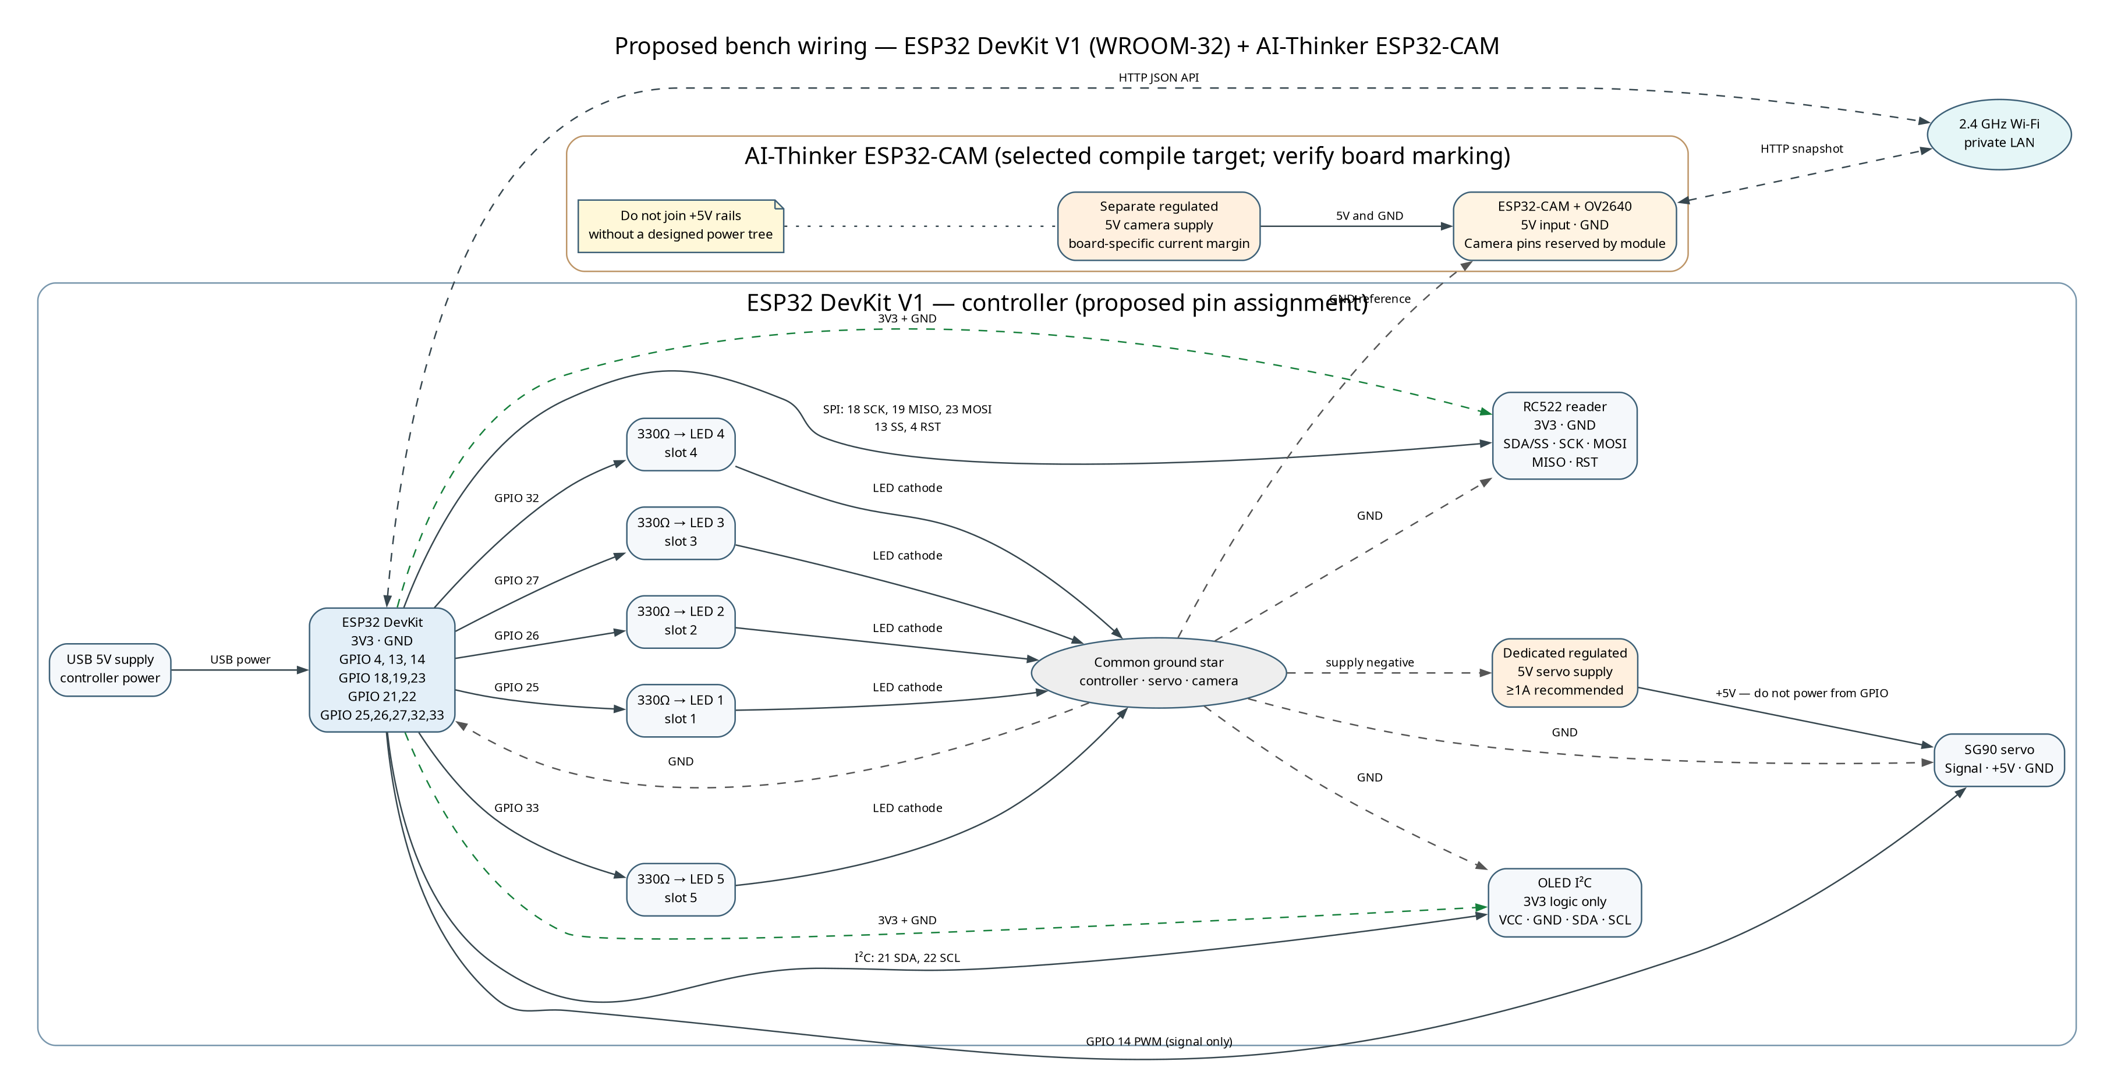
Figure 2. Proposed electrical wiring with separate servo/camera power rails and a common ground reference.
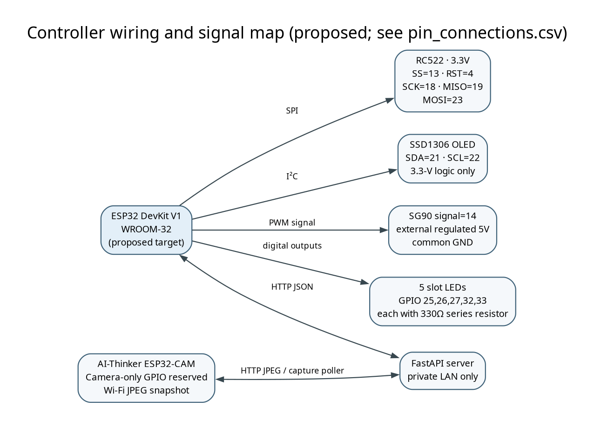
Figure 3. Proposed signal map for controller peripherals and Wi-Fi-connected camera.
Component | Signal | ESP32 pin | Voltage | Connection note
RC522 | SCK / MISO / MOSI | 18 / 19 / 23 | 3.3 V logic | VSPI; dedicated bus
RC522 | SS / RST | 13 / 4 | 3.3 V logic | Avoid strap pins for SS
OLED | SDA / SCL | 21 / 22 | 3.3 V logic | Use compatible pull-ups; I²C address 0x3C
Slot LEDs 1–5 | Anodes via 330 Ω | 25, 26, 27, 32, 33 | 3.3 V outputs | Each LED has its own resistor; cathodes to GND
SG90 | PWM signal | 14 | 3.3 V signal | Servo +5 V from a separate regulated supply; common GND
AI-Thinker ESP32-CAM | OV2640 camera bus | 0, 5, 18, 19, 21–27, 32, 34–39 | Module-internal | Reserved by camera; no external peripherals on these pins

The controller pin proposal avoids classic ESP32 strapping pins (0, 2, 5, 12, 15), flash-reserved pins (6–11), and input-only GPIO34–39. The selected RC522 bus uses 18/19/23; the OLED uses 21/22; LED and servo signals use output-capable GPIO. Espressif documents these GPIO restrictions and boot-strap considerations [9]. Camera GPIO assignments follow the AI-Thinker reference map in Espressif's esp32-camera project [10]. The pin map has been reviewed against those references but not checked with a multimeter or actual board revision.
Use the controller's USB input, RC522/OLED 3V3, a separate regulated 5-V supply for the servo, and a separately regulated 5-V camera input. Connect grounds at a common reference while keeping positive 5-V rails isolated. A 330 Ω series resistor limits each indicator LED current. A servo can draw a transient/stall current beyond a GPIO or dev-board regulator budget; size the external supply to the exact SG90 variant, and keep the barrier model lightweight and supervised. A hobby servo is not a safety-rated real gate: loss of servo power may leave the arm where it stopped.
The bill of materials, full per-signal CSV pin map, wiring sequence, calibration notes and troubleshooting table are included in final_submission/hardware/ and docs/hardware/validation.md. The complete hardware validation status is NOT TESTED on physical boards.

6. Software and Machine-Learning Design
Technology | Role in implementation
Python 3.14.8 | Backend, data preparation, benchmarking, camera ingestion, calibration, report tooling on the measured host.
FastAPI and SQLite | HTTP contracts, lifecycle state, occupancy transitions, prediction/optimizer metrics and dashboard data.
NumPy and Pillow | Feature arrays and bounded JPEG decode/ROI edge-density detection.
TensorFlow/Keras | Server-side LSTM, GRU, and temporal Transformer regression models.
Arduino framework + PlatformIO | ESP32 controller and AI-Thinker ESP32-CAM builds; no device was attached.
Graphviz and python-docx | Editable architecture diagrams and generated single-column DOCX/PDF submission.

6.1 Dataset and Preprocessing
The deterministic corpus is explicitly synthetic: 4,032 five-minute timeline buckets across 14 days, 27 model input features, and 6,274 privacy-safe source observations. It covers five configured slots from 2026-08-01T00:00:00Z through 2026-08-14T23:55:00Z; seed 20260908. Features include occupancy ratio/change and rolling means, cyclic hour and weekday terms, simulated weather categories, holiday/event flags, entry/exit/allocation counts, active sessions, privacy-safe vehicle aggregates, and normalized allocation context. The target is occupancy ratio at the next five-minute interval.
The existing preprocessor creates a 12-bucket (60-minute) lookback and one-step forecast horizon. It divides the timeline chronologically into 70% training, 15% validation and 15% test before sequence construction; sequence counts are 2,810, 592 and 594. Continuous-feature means and scales are fitted on training data only. The same immutable PreparedDataset is passed to all three neural models, and no RFID UID is part of model inputs. This prevents future observations from entering earlier sequences or fitted scaling statistics.
Missing-value handling follows the existing feature builder: eligible short gaps are forward-filled and longer gaps remain missing and are excluded from training examples. Bounded/cyclic/one-hot inputs retain their established contract; the continuous feature scaler is shared by all models. The last timeline bucket has no next-step target and is not used as a supervised target row. The data is useful for exercising code paths and comparing models reproducibly; it cannot estimate field performance, actual weather effects, arrival rates, camera accuracy or transfer to another lot.
Dataset files and metadata are in review_outputs/2026-10-15/dataset. A public, version-pinned ZIP download is available from GitHub: download simulated dataset

6.2 Forecasting Architectures
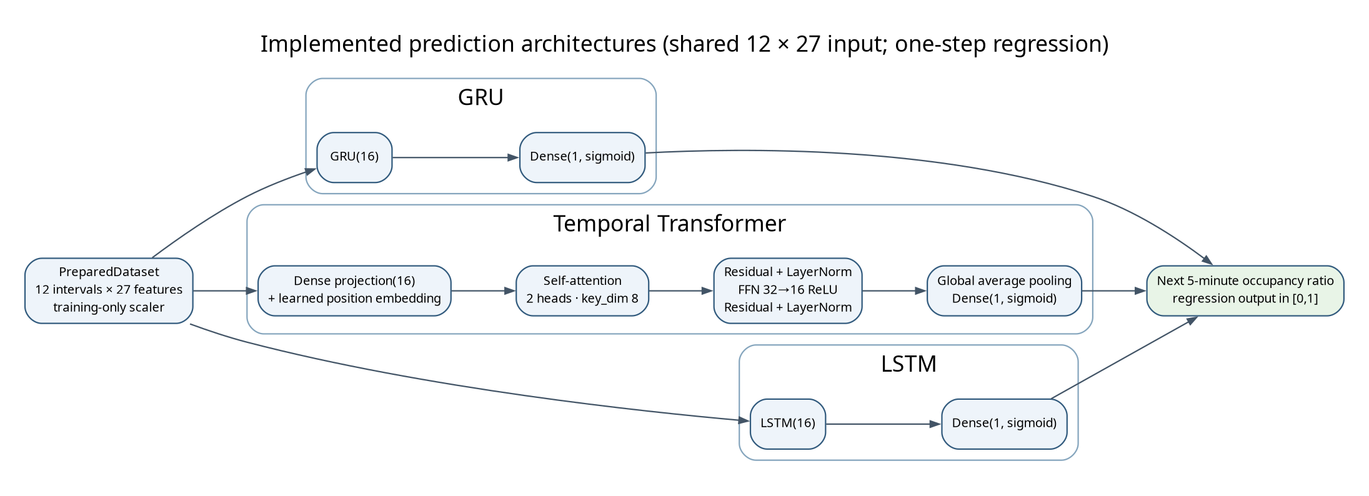
Figure 4. Implemented neural architectures; each receives the same scaled 12×27 sequence and predicts a bounded scalar.
LSTM and GRU models each apply one 16-unit recurrent layer to the 12-step sequence, followed by a one-unit sigmoid output. The temporal Transformer projects each 27-feature step to width 16, adds learned positional embeddings, applies two-head self-attention (key dimension 8), residual/LayerNorm, a 32-unit ReLU then 16-unit feed-forward block, a second residual/LayerNorm, global average pooling, and a sigmoid scalar output. Training uses mean-squared-error loss with Adam at 0.001, 12 maximum epochs, batch size 32, early-stopping patience 3, recurrent units 16, Transformer width 16 and two heads. Seeded TensorFlow/Keras deterministic operations are enabled where supported. The target is continuous occupancy ratio, so classification accuracy, F1, ROC and confusion matrices are not applicable.
Model files use content-addressed Keras artifacts with manifests containing feature order, split identity, scaler values, configuration, software versions and SHA-256. The artifacts execute in the server runtime. TensorFlow Lite, quantization and pruning were not implemented because inference is intentionally server-side; no ESP32 inference claim is made.

6.3 Allocation Objective
For candidate slot i, the shared normalized scalar objective is J(i) = 0.35 dᵢ + 0.30 cᵢ + 0.20 wᵢ + 0.15 fᵢ, where distance d, congestion c, waiting contribution w, and fairness penalty f are read from parking configuration. Occupied slots are excluded before search. The benchmark provides a first-available deterministic policy and exact enumeration across free candidates. GA, PSO, and ACO are evaluated on identical scenario records and weights. Convergence curves are not included because the existing optimizer interface does not expose valid per-iteration histories.
The controller-side request sequence is:
read and normalize UID in RAM
if a saved operation exists: retry its same idempotency key
else: inspect current server status; choose entry or exit
persist operation + key in NVS before HTTP POST
validate response identity and gate_action; re-read status
if committed status matches: persist gate_done before one gate cycle
on timeout/conflict/malformed reply: keep gate closed

7. Implementation Details
The backend lifecycle API accepts JSON fields rfid_uid and idempotency_key. A key is generated from the controller chip identifier and an NVS-persisted sequence number, then stored with the pending operation before transmission. A restart reuses the same key and payload, allowing the server's existing idempotency behavior to replay a completed response safely. The UID is not printed to Serial. As the existing API has no device authentication or TLS provision in this project, these requests must remain on a trusted private LAN.
Allocation follows one shared weighted_cost function. A no-available-slot response is HTTP 409, which the controller treats as a closed-gate result. For successful entry, the firmware validates the returned UID, slot identifier, slot name, gate_action and current status before display and actuation. For exit it requires that the session no longer appears active. The slot LEDs reflect accepted server occupancy: ON means occupied, OFF means free, and all blink when status is unknown. OLED messages cover initialization, Wi-Fi/backend state, scanning, assignment, parking-full/conflict, completion and errors. The timed gate state machine closes after its configured open interval; it does not use an unbounded delay.
The ESP32-CAM exposes GET /health and GET /capture. AI-Thinker pin assignments are isolated in camera_board.h; unknown board variants fail compilation unless a mapping is explicitly selected. JPEG capture uses VGA and JPEG quality 12 by default, with PSRAM-aware buffers. The Python camera_ingest process validates image/jpeg, bounds payload size and response size, decodes the JPEG with Pillow, posts to the existing multipart occupancy API, limits operation to one in-flight frame, and exponentially backs off after errors. The minimum capture interval is two seconds.
ROI calibration captures a live JPEG or accepts a previously saved real JPEG, presents an interactive Tk/Pillow rectangle selector, validates one in-bounds non-overlapping ROI per configured slot, writes the same ROI schema used by the detector, and saves a visual overlay. This environment cannot supply a real lot image, so no calibrated field ROI file is included. The current detector computes edge density for each crop and applies the configured score threshold; confidence and three consecutive candidate frames are required before persisting a transition. It remains a heuristic, not a validated vehicle classifier.

8. Experimental Setup
The prediction experiment uses the generated synthetic timeline and the unchanged chronological split. All neural models use common preprocessing and the untouched test partition; the persistence baseline predicts the latest occupancy ratio. Inference latency is measured as median warm prediction time divided by example count on the server CPU. The results are from TensorFlow 2.22.0-rc0/Keras 3.16.0.dev2026101404 under Python 3.14.8 on Linux x86_64 with an Intel Core i7-14650HX host. No accelerator or microcontroller timing is reported.
Optimizer tests use 120 distinct scenarios, three repeat seeds per scenario, 30 iterations per heuristic, and configured weights {"congestion": 0.3, "distance": 0.35, "fairness": 0.15, "waiting": 0.2}. Scenario occupancy spans empty, light, moderate, heavy, near-full and full categories. Seed derivation is `20261015 + scenario_index * 101 + repetition`. Each policy receives identical scenario inputs. Runtime is measured with a monotonic clock. Full-capacity rejections are separated from successful cost statistics. This is a simulated one-slot objective, not traffic throughput or physical wait time.
The host's development environment provides 16 logical/physical core accounting as reported by lscpu (Intel Core i7-14650HX, 24 CPUs online) and 15 GiB RAM; benchmark latencies are software measurements from this machine and vary with system load. The software repository has no available physical ESP32 boards, RC522, camera, OLED, LED wiring or servo connected for this report.

9. Results and Discussion

9.1 Forecast quality
Table 2 compares the persistence reference with the three trained neural regressors on the same test windows. GRU is the best measured model for MAE and RMSE on this generated split. This is an empirical ranking for one synthetic dataset and seed, not evidence of universal superiority or real-lot forecast quality. All inference timing is server CPU timing; model size is serialized Keras size.
Model | MAE | MSE | RMSE | Latency ms/example | Size bytes
persistence_baseline | 0.120875 | 0.028620 | 0.169173 | 0.000015 | N/A
lstm | 0.104062 | 0.016818 | 0.129685 | 0.245910 | 60481
gru | 0.098055 | 0.013891 | 0.117862 | 0.223783 | 52615
transformer | 0.109173 | 0.018098 | 0.134531 | 0.232451 | 110684

Policy | Success / attempts | Mean cost | Median runtime ms | Mean gap | Invalid
first_available | 300 / 360 | 0.487125 | 0.000331 | 0.108931 | 0
exhaustive_optimum | 300 / 360 | 0.378194 | 0.014984 | 0.000000 | 0
GA | 300 / 360 | 0.378194 | 0.807225 | 0.000000 | 0
PSO | 300 / 360 | 0.426458 | 1.157470 | 0.048264 | 0
ACO | 300 / 360 | 0.381779 | 1.162547 | 0.003586 | 0

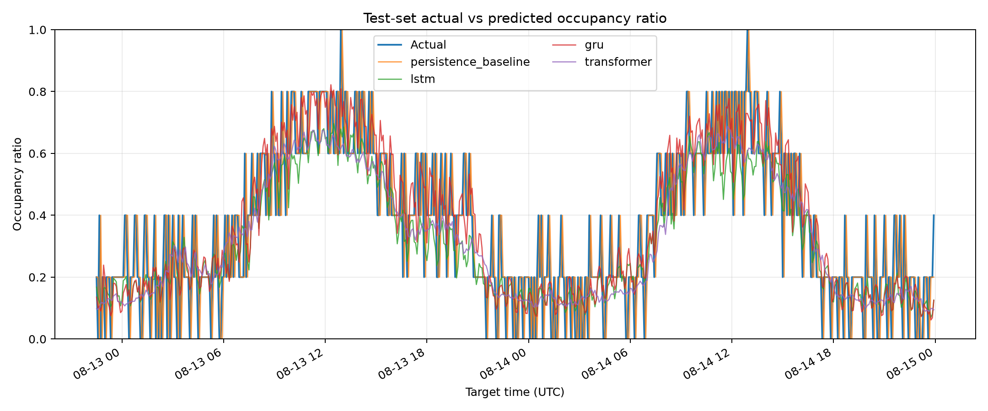
Figure 5. Test-window actual versus predicted occupancy ratio from the executed model comparison.
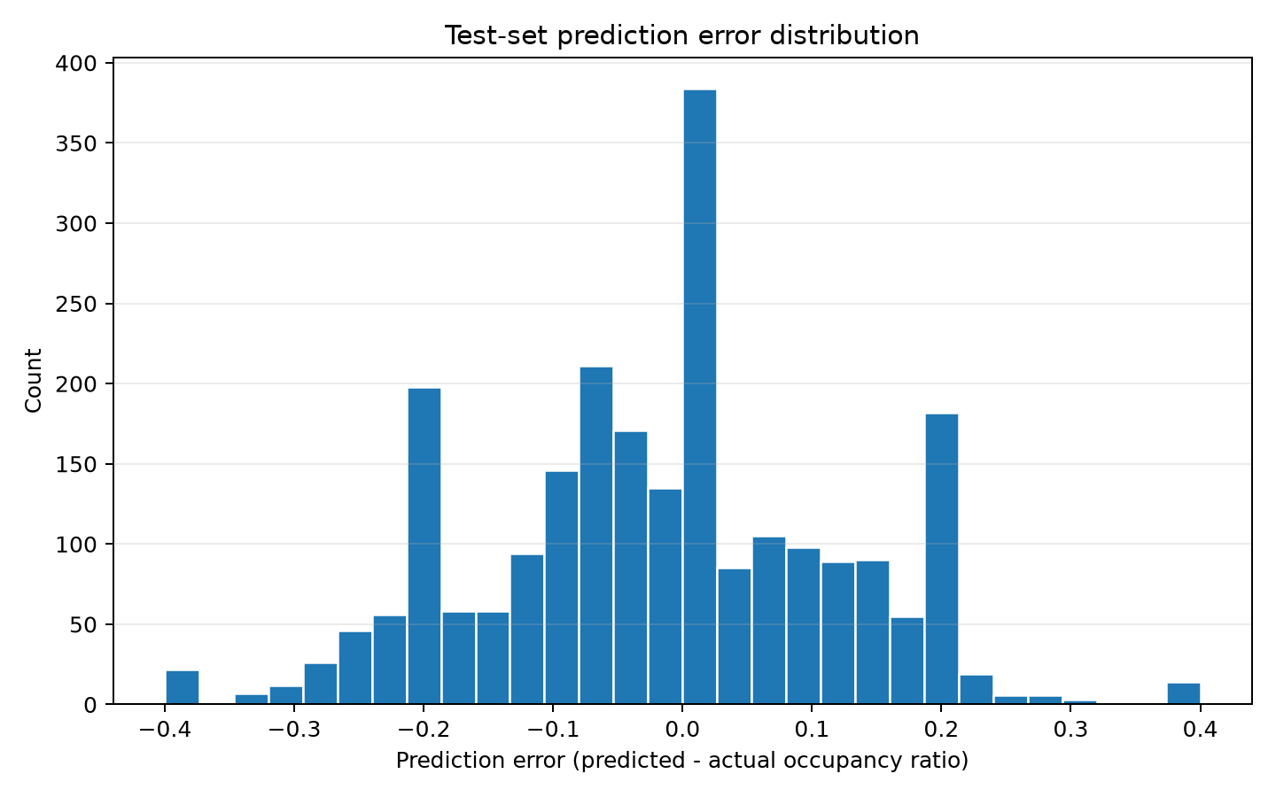
Figure 6. Prediction error distribution; errors are regression residuals, not class labels.
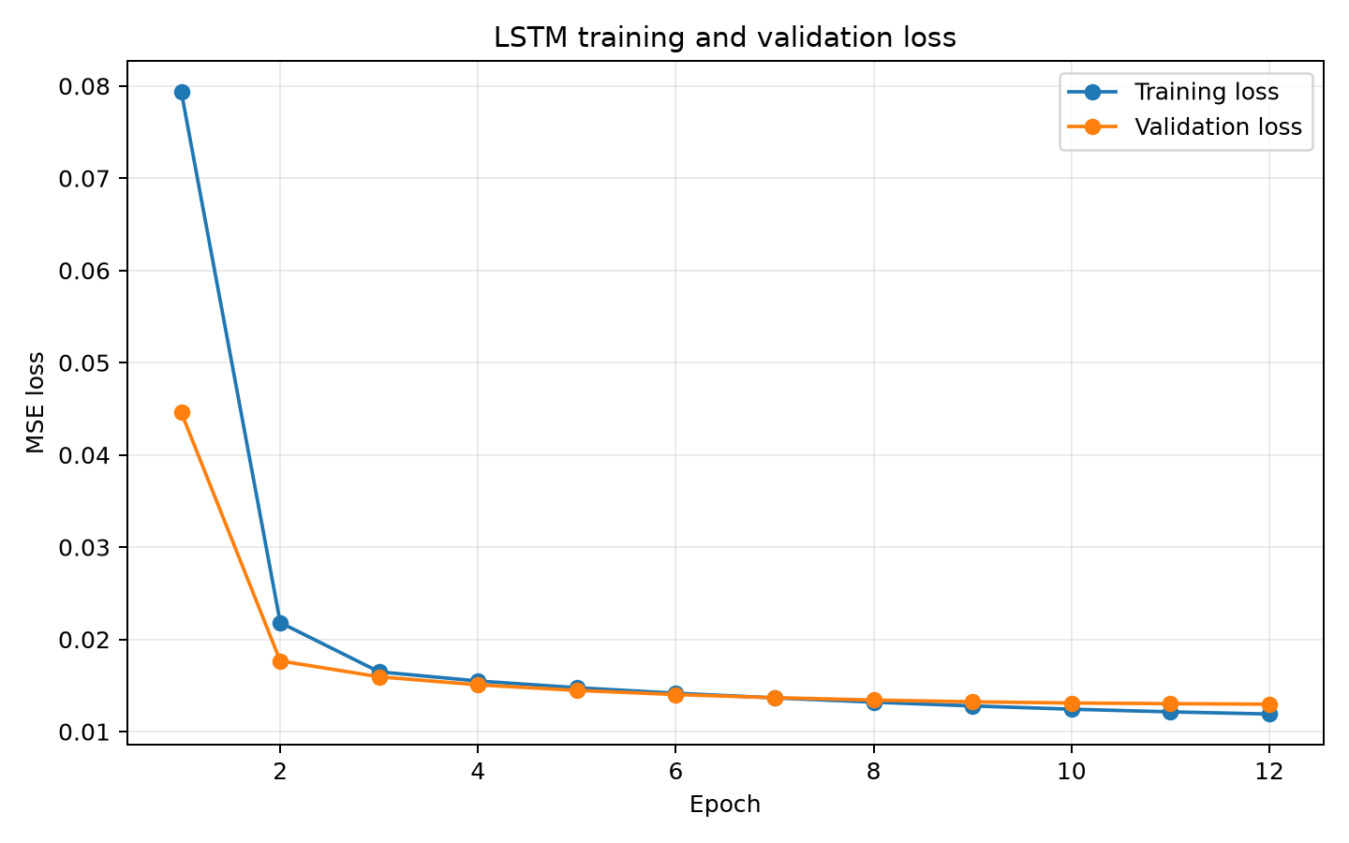
Figure 7.LSTM. Training and validation loss for the fitted LSTM run.
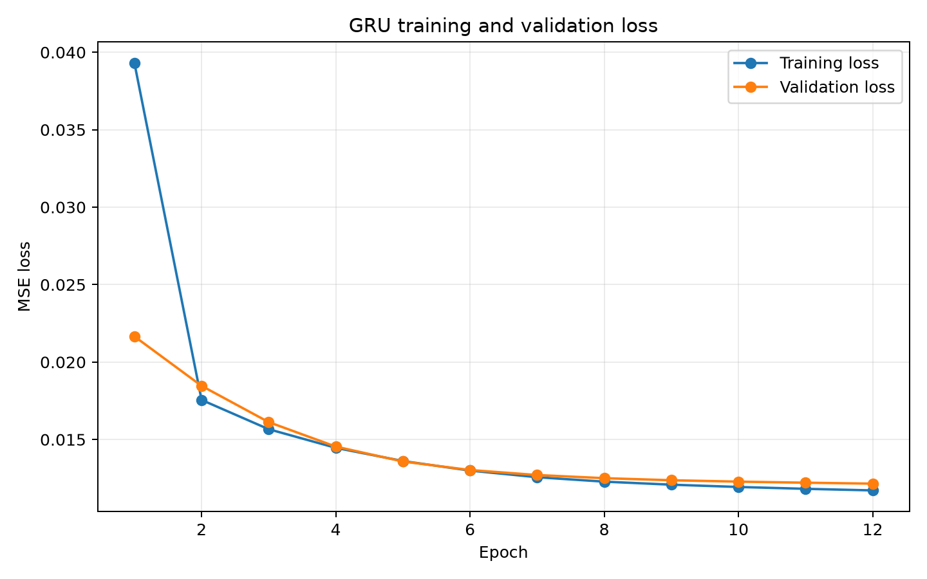
Figure 7.GRU. Training and validation loss for the fitted GRU run.
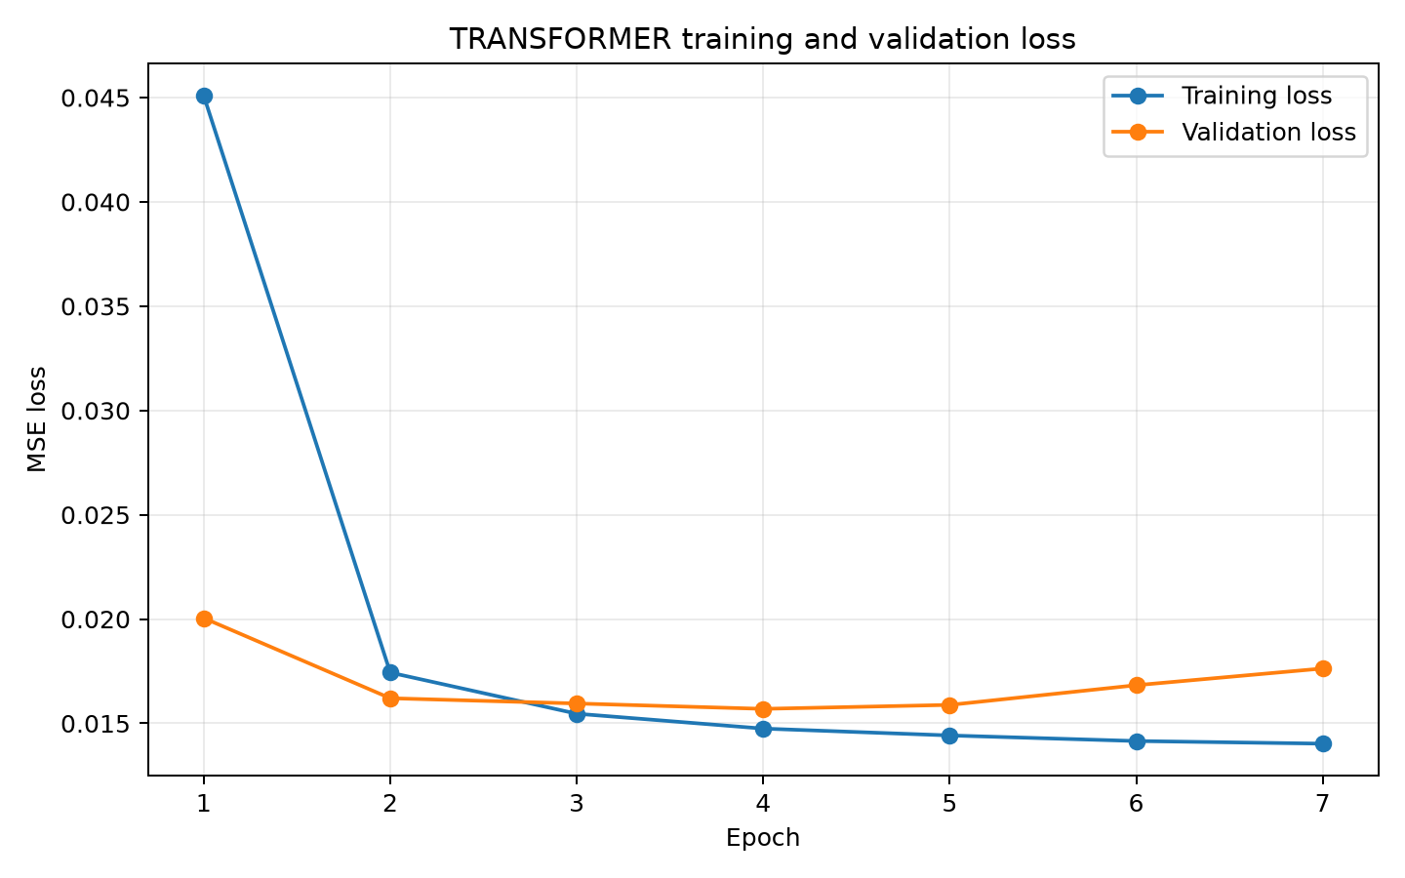
Figure 7.Transformer. Training and validation loss for the fitted Transformer run.
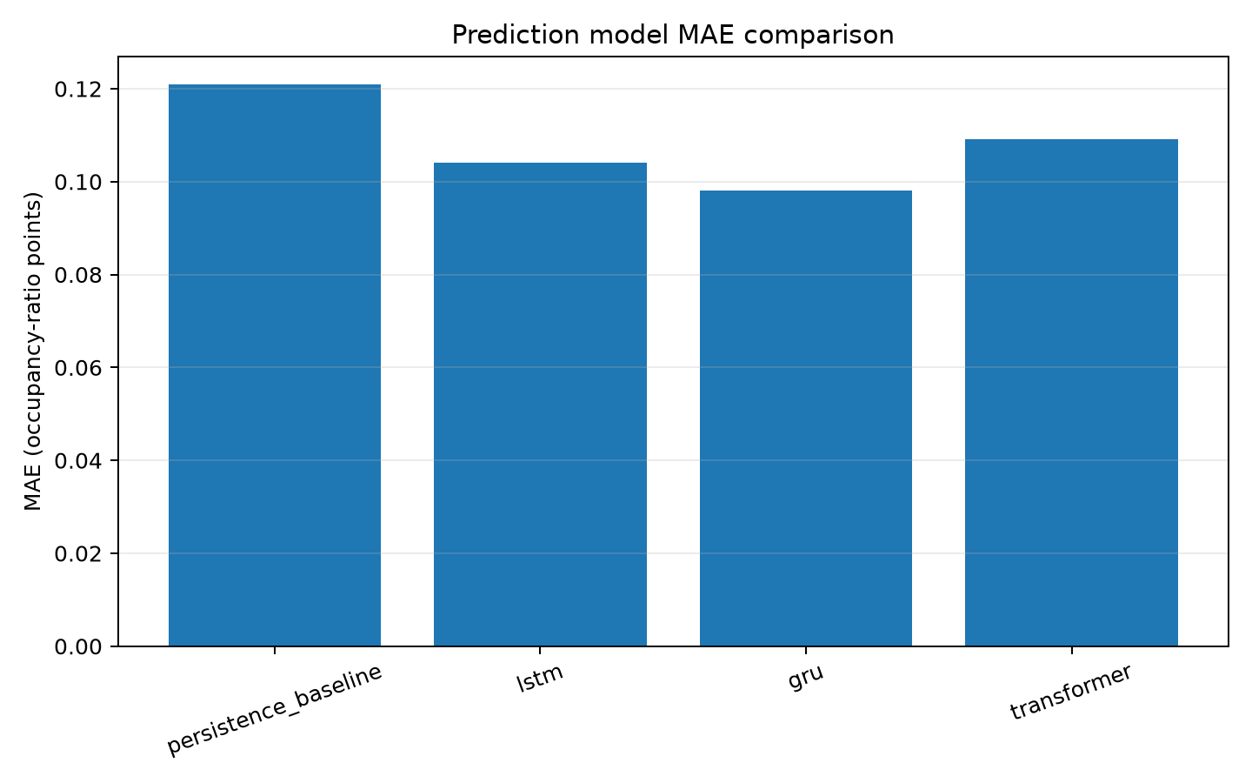
Figure 8. Measured model MAE comparison on the shared chronological test partition.
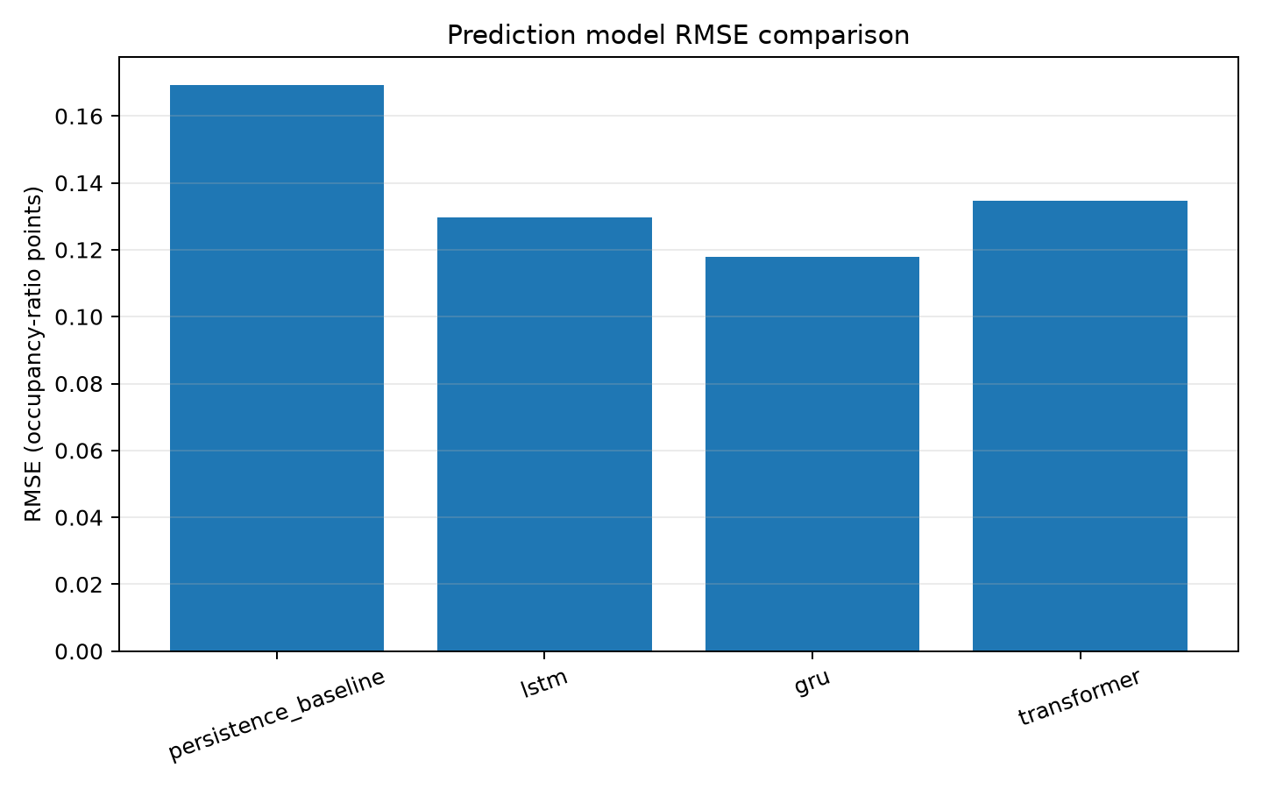
Figure 9. Measured model RMSE comparison on the shared chronological test partition.
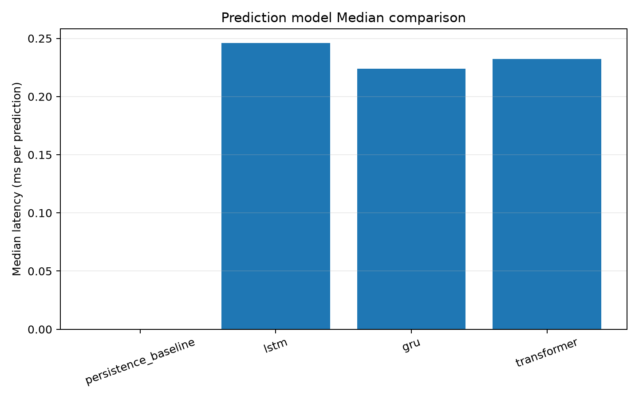
Figure 10. Measured per-example inference latency on the server host.
The measured GRU test MAE is 0.098055, versus persistence MAE 0.120875. The 27 features include simulated calendar/weather/event context, but synthetic context may encode generator-specific patterns. Real measured samples, external-site validation and repeated independent dataset seeds are needed before drawing deployment conclusions. No camera accuracy metric is reported because no labeled image evaluation set is available.

9.2 Allocation optimization
Table 3 summarizes successful allocation runs; each policy also rejected 60 of 360 attempts at full capacity. There were zero invalid slot assignments. The exhaustive policy is the exact single-slot minimum for each scenario. GA matched this mean cost in this run but required substantially more Python runtime than enumeration; ACO was close to optimal and PSO had a larger mean gap. The first-available baseline was fastest but had higher mean cost. Heuristics are not expected to beat exact enumeration when at most five candidates exist.
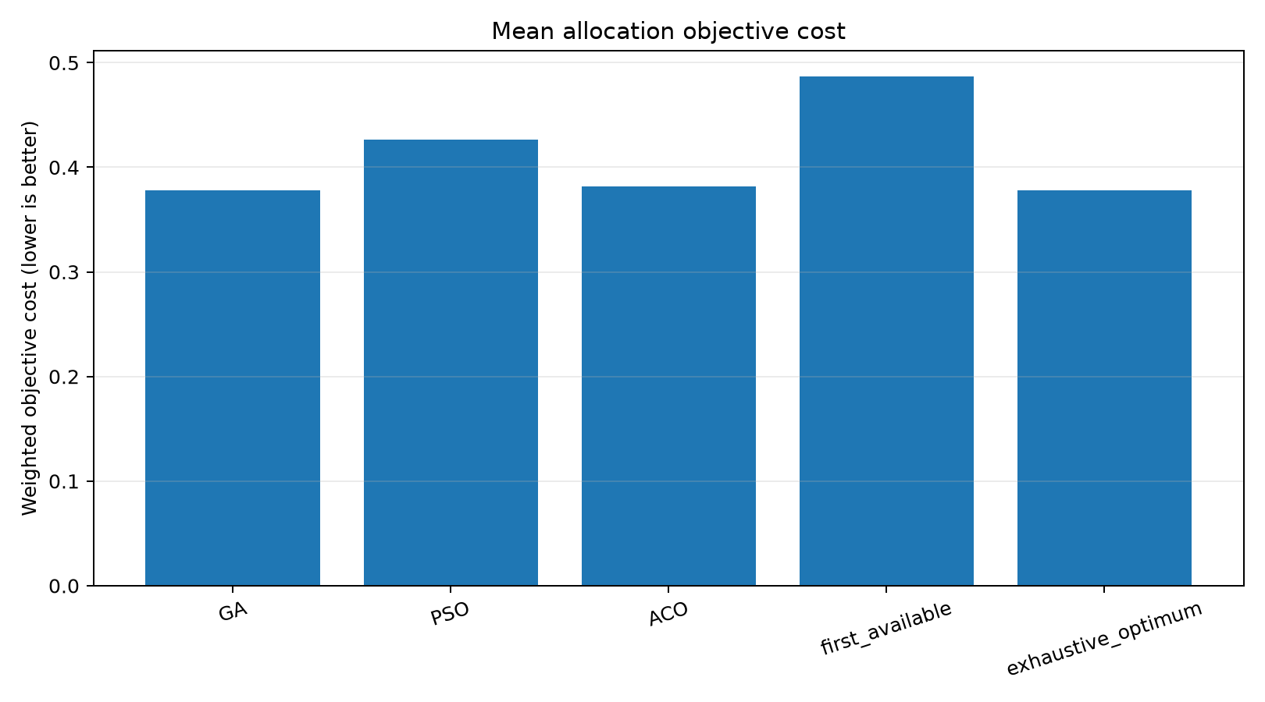
Figure 11. Mean allocation objective cost by policy and exact/baseline reference.
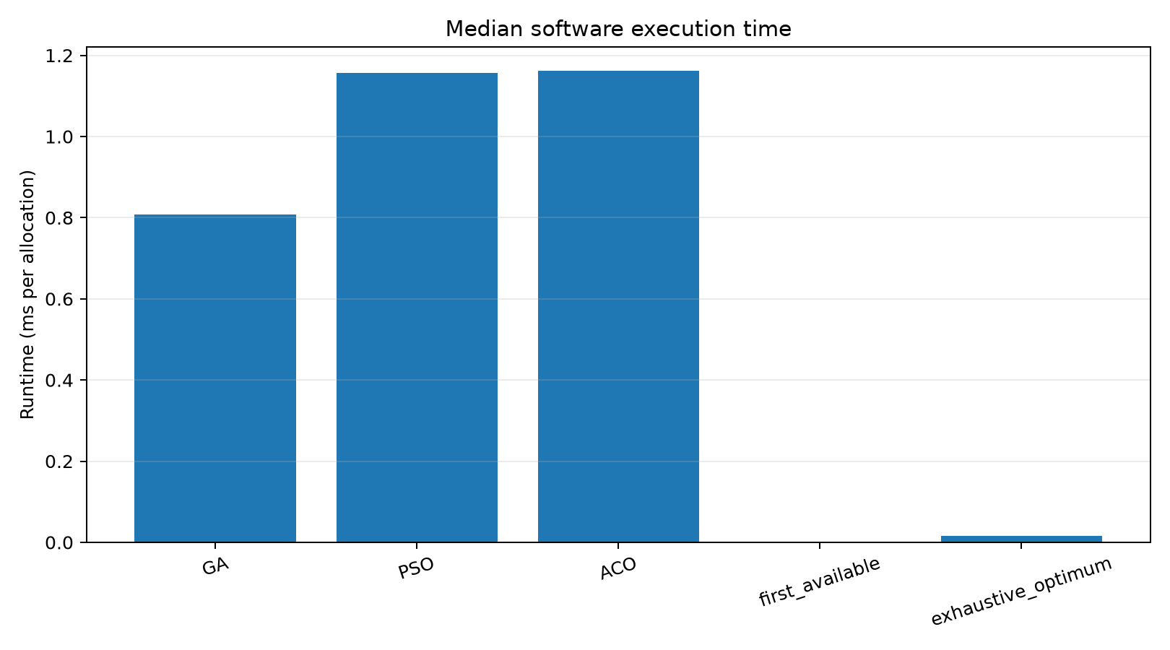
Figure 12. Software execution-time comparison; logarithmic scaling is labeled in the figure.
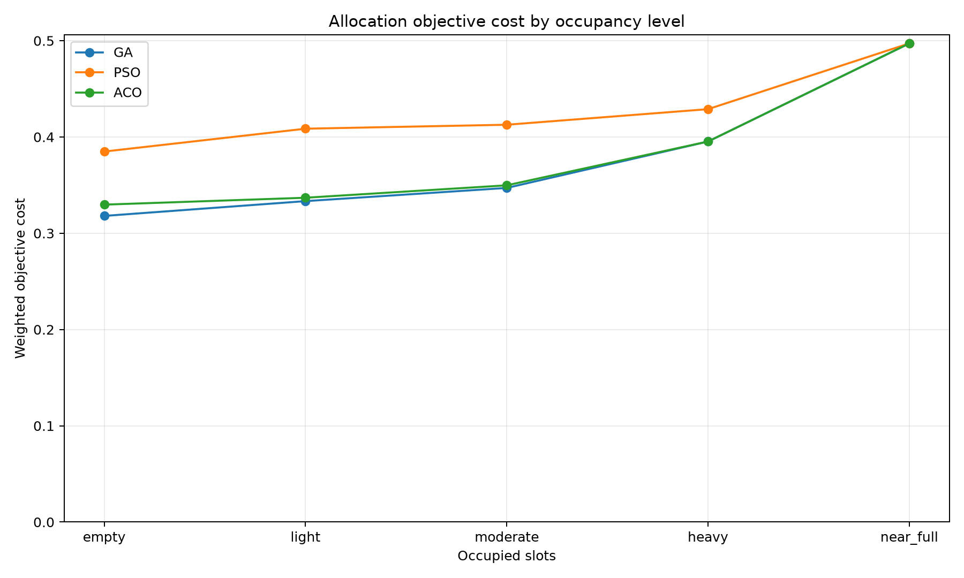
Figure 13. Objective cost by simulated occupancy category.
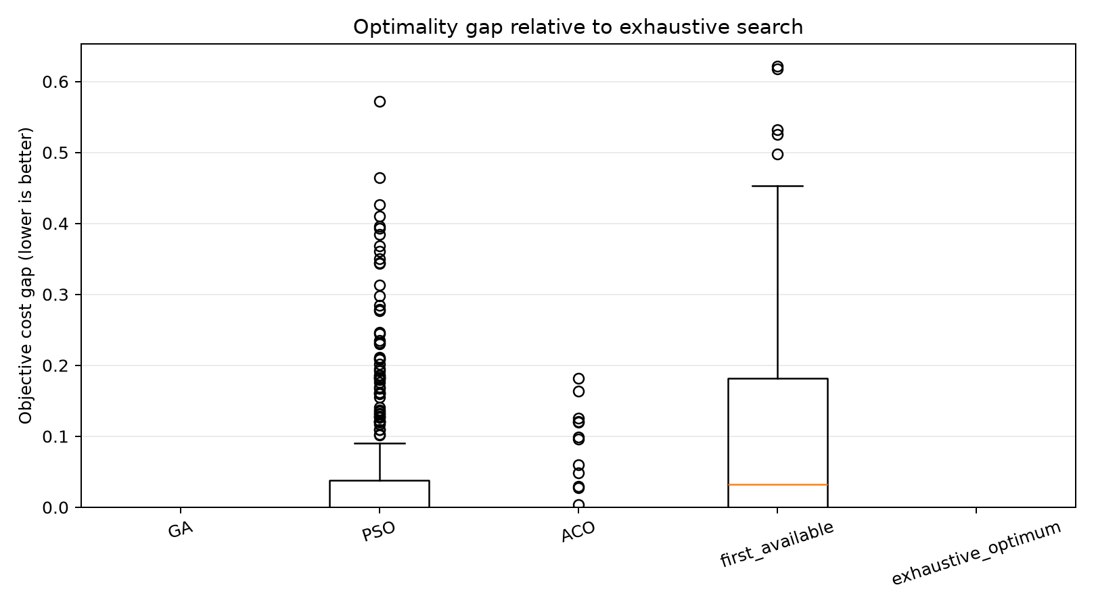
Figure 14. Per-run nonnegative gap from exact enumeration.
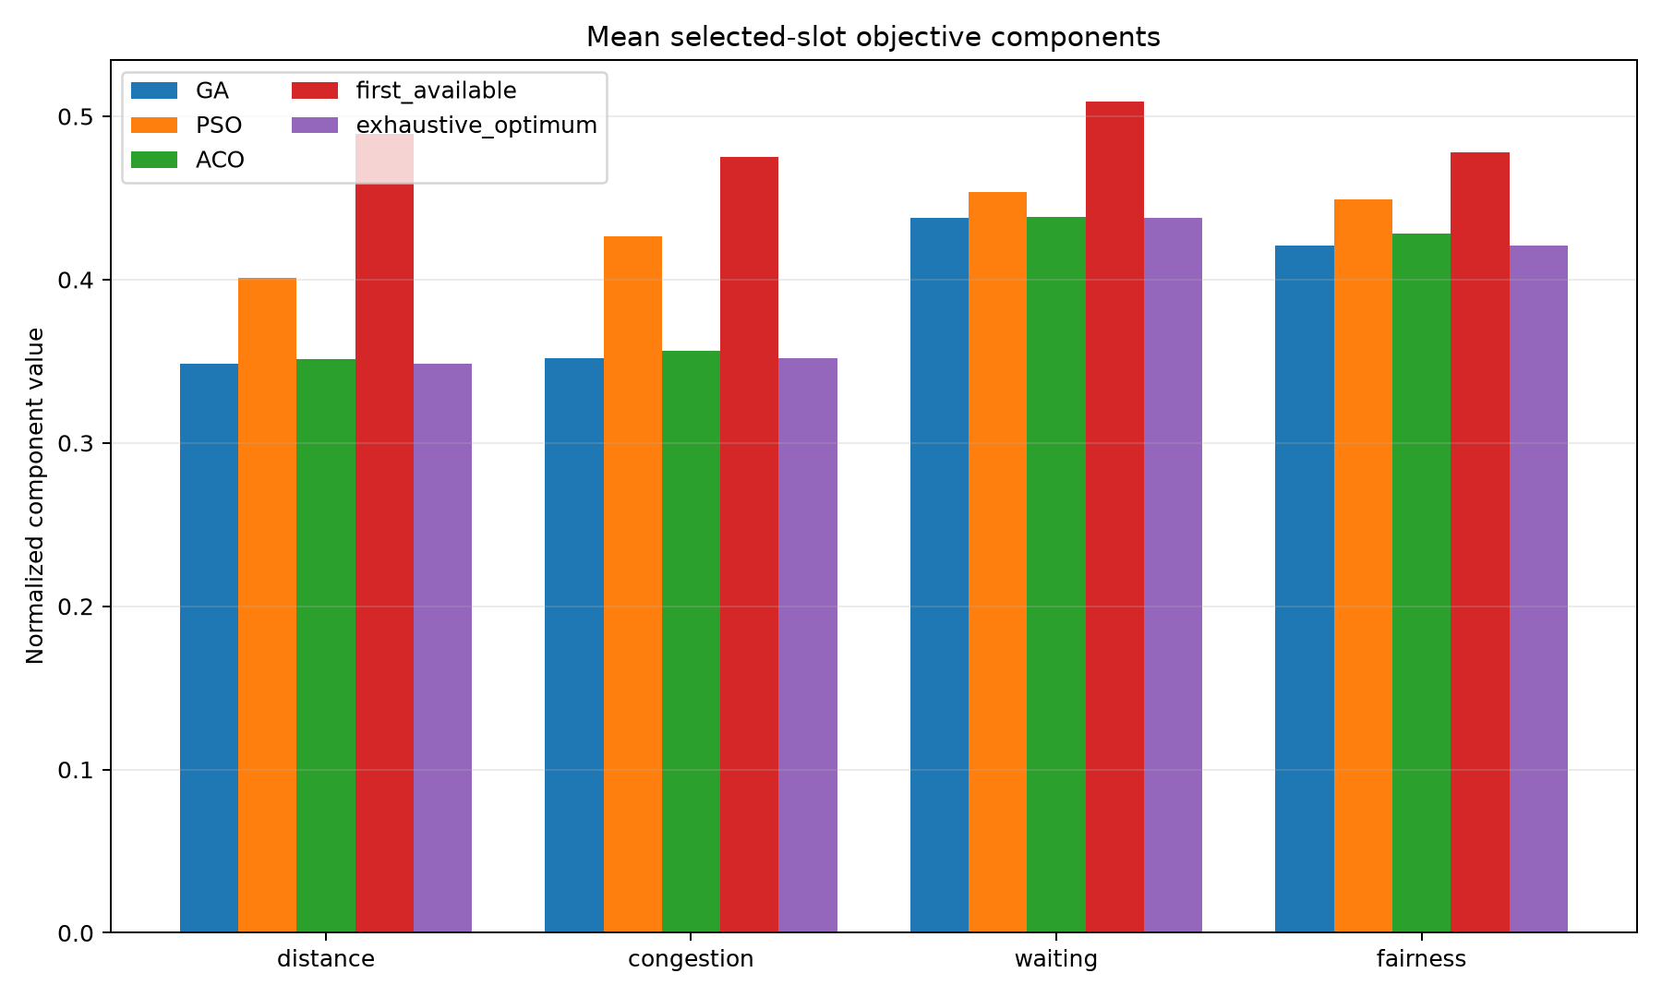
Figure 15. Mean weighted objective components among successful allocations.
Occupancy category | First available | Exact | GA | PSO | ACO
empty | 0.508157 | 0.318020 | 0.318020 | 0.384866 | 0.329726
light | 0.481549 | 0.333373 | 0.333373 | 0.408601 | 0.336888
moderate | 0.446407 | 0.347081 | 0.347081 | 0.412717 | 0.349788
heavy | 0.502314 | 0.395297 | 0.395297 | 0.428909 | 0.395297
near_full | 0.497197 | 0.497197 | 0.497197 | 0.497197 | 0.497197

The occupancy-stratified table uses 60 repeated successful runs per category and policy. Full-capacity cases are excluded from these cost means and are reported separately. Runtime values describe Python algorithm execution on the host and are not estimates of physical vehicle wait or lane throughput.

9.3 Hardware and integration test status
PlatformIO successfully compiled the controller for esp32dev and the camera for AI Thinker ESP32-CAM. The controller image used 27,220 bytes of RAM (8.3% of 327,680) and 474,549 bytes of flash (36.2% of 1,310,720); the camera image used 49,628 bytes of RAM (15.1% of 327,680) and 836,777 bytes of flash (26.6% of 3,145,728). No device was connected during this review; therefore no measured RF range, camera frame rate, servo angle accuracy, OLED readability, current draw, energy use, gate cycle timing under load, hardware API latency, or physical occupancy accuracy is available. The occupancy API has software tests with generated images and status-transition assertions, not a labeled real-camera set.
Quantity | Reported result
Camera occupancy accuracy / precision / recall | Not measured; no labeled real-camera test set.
ESP32 inference latency / memory | Not applicable to current server-based TensorFlow inference; not measured on device.
Servo current, power or mechanical safety | Not measured; physical servo not connected.
Physical camera frame rate / Wi-Fi reliability | Not measured; no camera board connected.

10. Testing and Demonstration
Automated software coverage includes backend lifecycle retries/conflicts, no-free-slot behavior, JPEG input validation, ROI bounds, confidence smoothing, state persistence, prediction fallback/artifact compatibility, simulated demo API ordering, and the new camera-ingestion and ROI-geometry tests. The build checklist distinguishes those results from firmware compilation and physical tests. The hardware scenario checklist marks all physical behaviors NOT TESTED until the board-level procedures are performed.
A separate host-runtime smoke test copied the review database, selected the saved GRU artifact through the existing predictor setting, and called GET /api/prediction. The response was model=gru, fallback_reason=null, occupancy_ratio=0.136493 for the synthetic timeline. This verifies server-side artifact loading and inference; it is not an ESP32 measurement.
For a simulated review: activate the project's virtual environment and run `make test` and `make lint`; start the API with `make run`; execute `python -m scripts.run_simulated_demo --base-url http://127.0.0.1:8000 --rfid-uid 04A1B2C3 --idempotency-key final-review-entry-001`; open http://127.0.0.1:8000/dashboard; then show `review_outputs/2026-10-15/EXPERIMENTAL_REPORT.md` and the figures under `review_outputs/2026-10-15/final_submission/figures/`. The simulated JPEGs and RFID label must be described as simulated. Do not run `make review` during the presentation because it retrains models and regenerates result files.
For a physical demo after wiring validation: use the private-LAN addresses in local_config.h, confirm GET /health, GET http://CAMERA-IP/health, run camera_ingest with a five-second interval, and scan one test tag. Verify status and gate action before proceeding to subsequent cards. Keep a hand-operated emergency power disconnect available for the lightweight servo fixture. The detailed startup, cleanup, and failure procedure appears in DEMO_INSTRUCTIONS.md.

11. Limitations and Future Work
Primary limitations are the synthetic dataset, five-space scale, one-step horizon, generator-specific correlations, edge-density camera heuristic, absent labeled real imagery, absence of physical hardware evidence, and nonauthenticated HTTP control API. The architecture assumes a fixed camera and calibrated static ROIs. Lighting, weather, vehicle type, partial occlusion, perspective, shadows and camera motion may invalidate the baseline detector. Prediction accuracy on synthetic samples cannot establish field generalization.
Next work should acquire permissioned, labeled images and real occupancy timelines; split evaluation by day/site and repeat seeds; compare the heuristic with a measured vision baseline; validate the AI-Thinker and controller board revisions; conduct current-limited bench tests for RFID, display, LEDs and a lightweight servo; add transport authentication for device requests before any wider network exposure; and measure field latency and availability. A real gate requires a safety-rated actuator/controller and independent interlocks; the SG90 prototype is not that system.

12. Conclusion
The repository provides a reproducible software smart-parking prototype with lifecycle, occupancy, allocation, forecasting, dashboard, synthetic experiment outputs, and new ESP32 controller/camera firmware plus a camera ingestion and ROI calibration path. The measured synthetic experiment ranks GRU lowest in test MAE among the tested predictors, while exhaustive enumeration is an efficient exact reference for five-slot allocation. These results demonstrate functioning software and an experimental workflow, not deployment performance. Firmware compiles for the selected targets; hardware mapping remains proposed, and physical camera, RFID, display, LED and servo behavior remains unverified. The report and final submission materials preserve these distinctions.

References
[1] T. Lin, H. Rivano, and F. Le Mouël, “A Survey of Smart Parking Solutions,” IEEE Transactions on Intelligent Transportation Systems, vol. 18, no. 12, pp. 3229–3253, 2017. doi: 10.1109/TITS.2017.2685143.
[2] E. E. Tsiropoulou, J. S. Baras, S. Papavassiliou, and S. Sinha, “RFID-based smart parking management system,” Cyber-Physical Systems, vol. 3, nos. 1–4, pp. 22–41, 2017. doi: 10.1080/23335777.2017.1358765.
[3] P. R. L. de Almeida, L. S. Oliveira, A. S. Britto Jr., E. J. Silva Jr., and A. L. Koerich, “PKLot – A robust dataset for parking lot classification,” Expert Systems with Applications, vol. 42, no. 11, pp. 4937–4949, 2015. doi: 10.1016/j.eswa.2015.02.009.
[4] S. Yang, W. Ma, X. Pi, and S. Qian, “A deep learning approach to real-time parking occupancy prediction in transportation networks incorporating multiple spatio-temporal data sources,” Transportation Research Part C: Emerging Technologies, vol. 107, pp. 248–265, 2019. doi: 10.1016/j.trc.2019.08.010.
[5] D. Thomas and B. C. Kovoor, “A Genetic Algorithm Approach to Autonomous Smart Vehicle Parking system,” Procedia Computer Science, vol. 125, pp. 68–76, 2018. doi: 10.1016/j.procs.2017.12.011.
[6] S. Hochreiter and J. Schmidhuber, “Long Short-Term Memory,” Neural Computation, vol. 9, no. 8, pp. 1735–1780, 1997. doi: 10.1162/neco.1997.9.8.1735.
[7] K. Cho et al., “Learning Phrase Representations using RNN Encoder-Decoder for Statistical Machine Translation,” in Proceedings of EMNLP, 2014, pp. 1724–1734. doi: 10.3115/v1/D14-1179.
[8] A. Vaswani et al., “Attention Is All You Need,” in Advances in Neural Information Processing Systems 30, 2017. arXiv:1706.03762.
[9] Espressif Systems, “GPIO & RTC GPIO — ESP32,” ESP-IDF Programming Guide v5.1. https://docs.espressif.com/projects/esp-idf/en/v5.1/esp32/api-reference/peripherals/gpio.html (accessed 14 Oct. 2026).
[10] Espressif Systems, “ESP32-CAM / AI-Thinker camera pin map,” esp32-camera repository. https://github.com/espressif/esp32-camera/blob/master/examples/camera_example/main/camera_pinout.h (accessed 14 Oct. 2026).
[11] Smart Parking System repository, implementation and experimental outputs. https://github.com/dumbly-smart/smart-parking (accessed 14 Oct. 2026).

Dataset Availability
The privacy-safe simulated dataset archive is publicly downloadable from the project's GitHub repository. The version-pinned ZIP contains parking_raw.csv, parking_features.csv, dataset_metadata.json, and dataset documentation. A Google Drive mirror is also provided, but its current permission is restricted to the vit.ac.in Google Workspace domain; use the public GitHub link if you do not have VIT access.
Public dataset ZIP (GitHub)
Google Drive dataset ZIP (institution-only)
Google Drive model artifacts (institution-only)

