Program Structures and Algorithms

Spring 2024

NAME: Gaurav Popat Gunjal

NUID: 002820367

GITHUB LINK: https://github.com/gunjalga/INFO6205

**Task: RandomWalk**

**Relationship Conclusion:** The relationship between d and m is “d=am1/2” where a could be any constant value

**Evidence to support that conclusion:**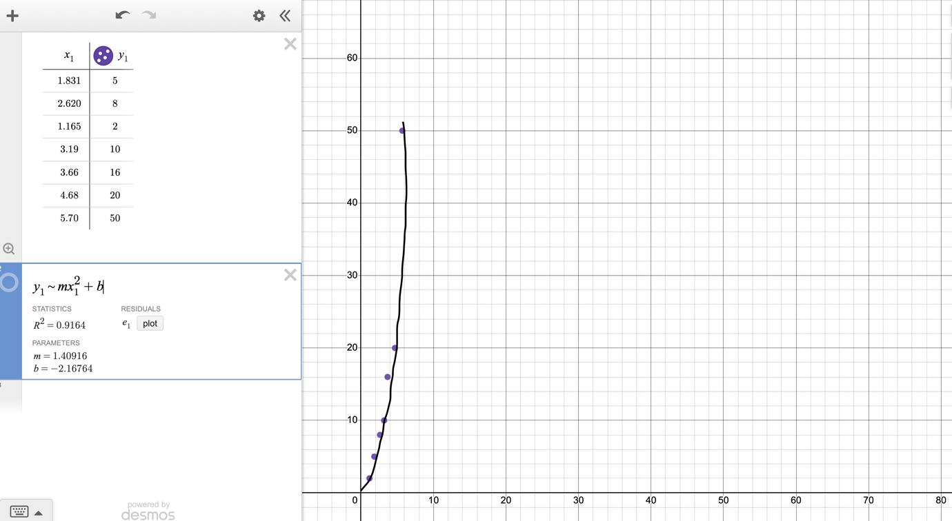

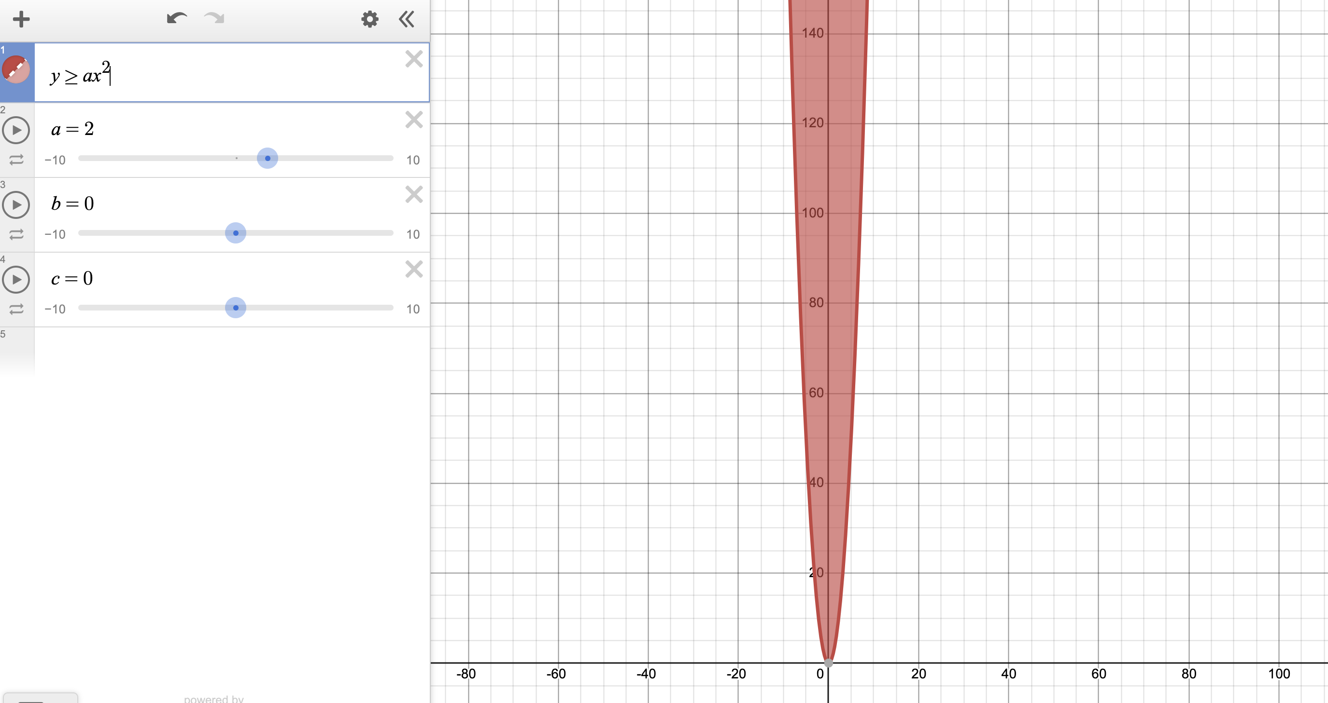

**Unit Test Screenshots:** 