‘data.xls’ file contains following data table. Write a Python program that read the ‘data.xls’ file and produce the outputs given below.

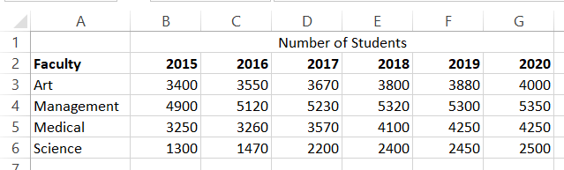

1. Display following window with the given buttons and entry box.

Column chart

Total 2020

Line chart

Pie chart

2020

1. Your program should produce following outputs when you click each button as given below.
   1. **Column chart button**: Show a column chart that illustrates number of students in each faculty in different years.
   2. **Line chart button**: Show a Line chart that illustrates number of students in each faculty in different years.
   3. **Pie chart 2020 button**: Show a pie chart that illustrates number of students in each faculty in the year 2020.
   4. **Total 2020 button**: Calculate total number of students in all the faculties in year 2020 and display the answer in the entry box given below the button.