1.

(a).

F1 =

(b).

//Commutative

$F_{2}=\left(A+D+E\right)\left(\overline{A}+B+\overline{D}\right)\left(AB+\overline{C}\right)$//Distributive+Complement+Idempotent+Simplification Laws

$F_{2}=\left(A+D+E\right)\left(AB\overline{D}+AB+\overline{A}\overline{C}+\overline{C}\overline{D}+B\overline{C}\right)$//Distributive+Complement

$F_{2}=\left(A+D+E\right)\left(AB+A\overline{C}+\overline{C}\overline{D}\right)$//Consensus+Simplification Laws

$F_{2}=AB+A\overline{C}+\overline{C}\overline{D}E$//Distributive+Simplification Laws

2.

$F=$ $\overline{A}B+A\overline{C}=\overline{\overline{(\overline{A}B+A\overline{C})}}=\overline{(\overline{\overline{A}B})(\overline{A\overline{C}})}$

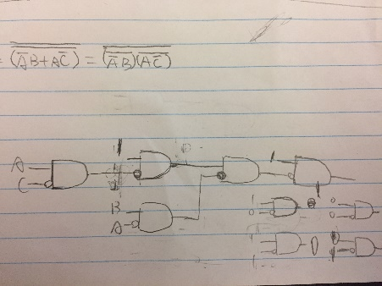

3.

F= $\overline{A}\overline{B}\overline{D}+\overline{B}\overline{C}\overline{D}$

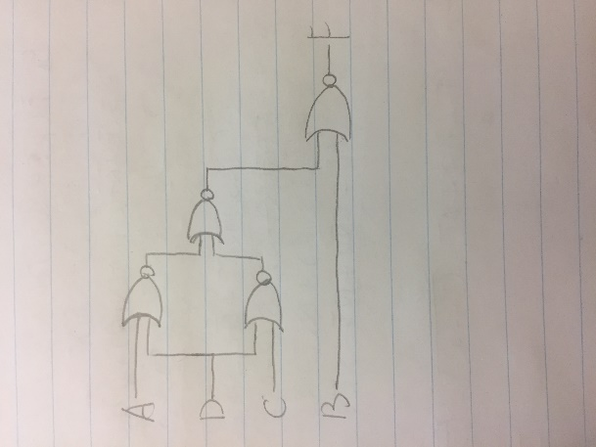

4.

Z $=AB\overline{E}F + \overline{C} \overline{E} F+ \overline{D} \overline{E}F+ GH$

Z $=\overline{E}F(AB+\overline{C}+\overline{D})+ GH$

Z $=\overline{E}F(AB+\overline{CD})+ GH$

Z $=(\overline{E}F)((\overline{\overline{AB})CD})+ GH$

Z $=\overline{(\overline{\overline{E}F)((\overline{AB})(CD)})(\overline{GH}})$

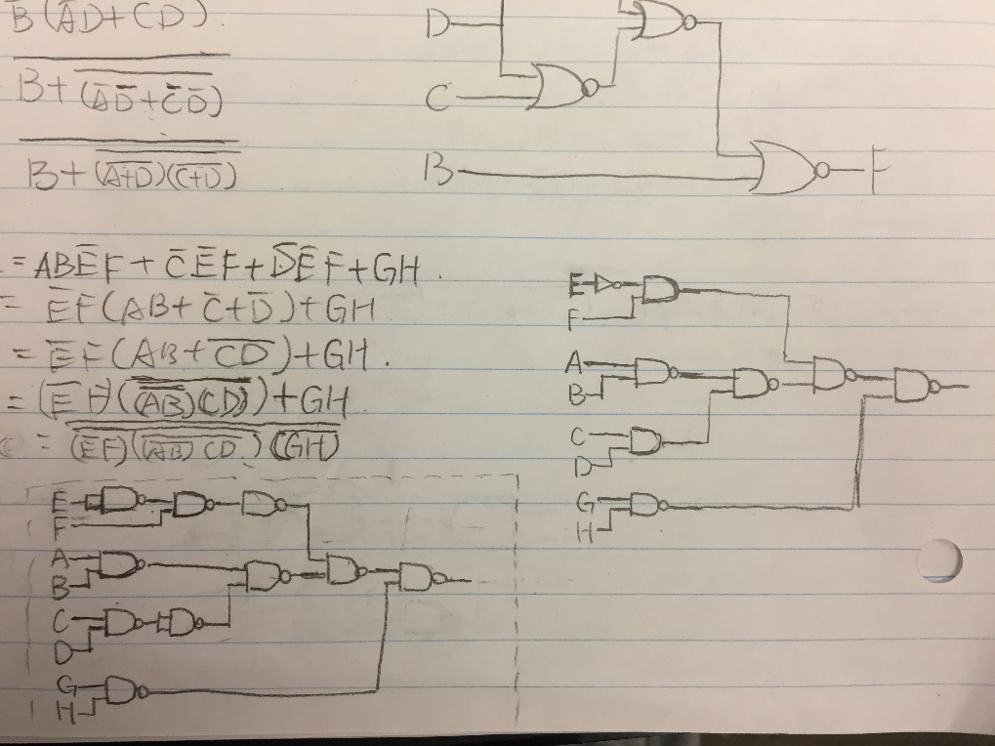

5.

(a).

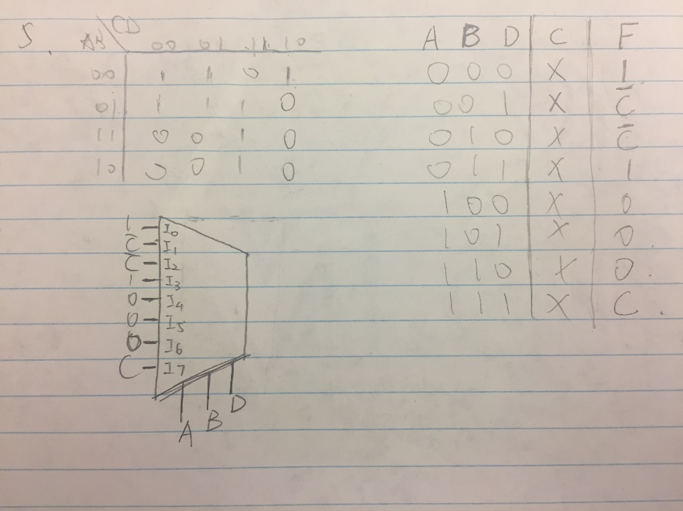

(b).