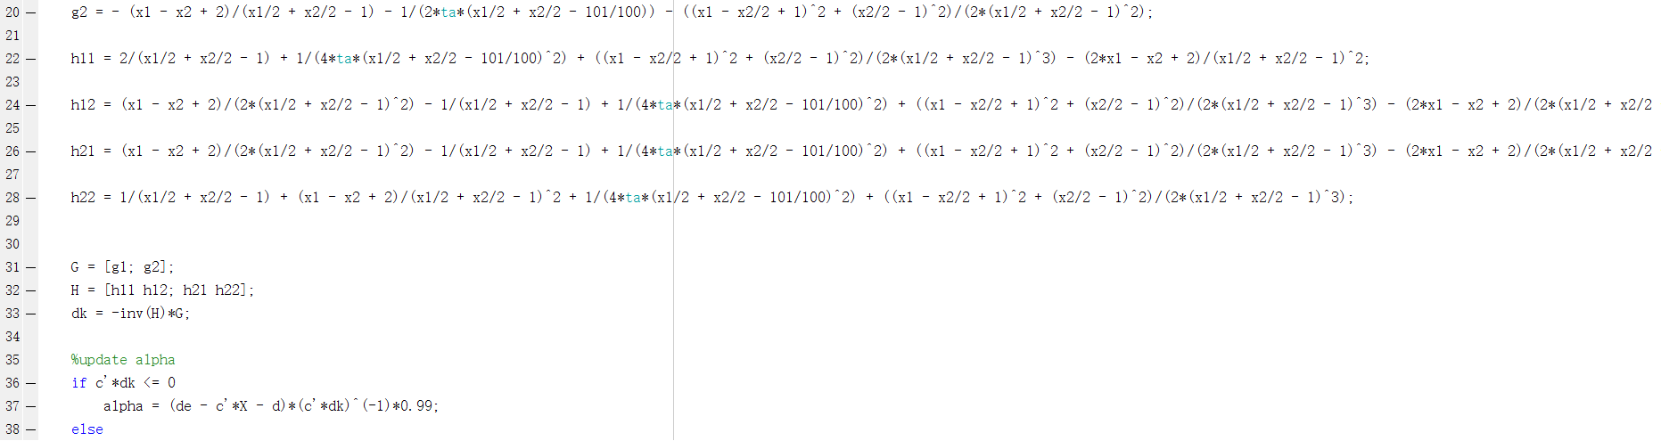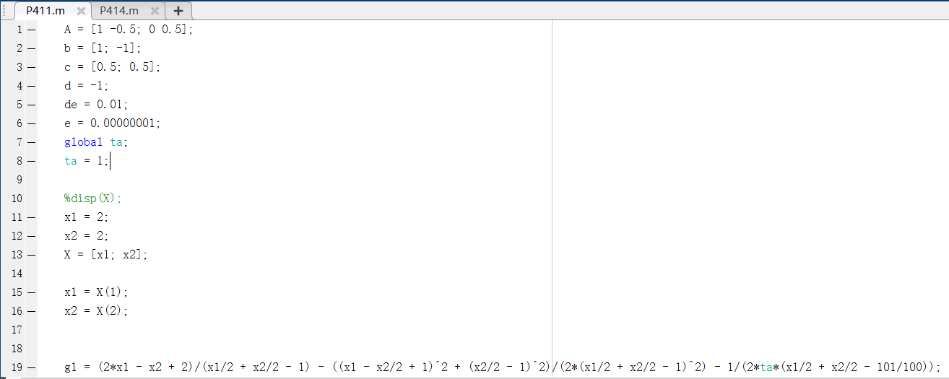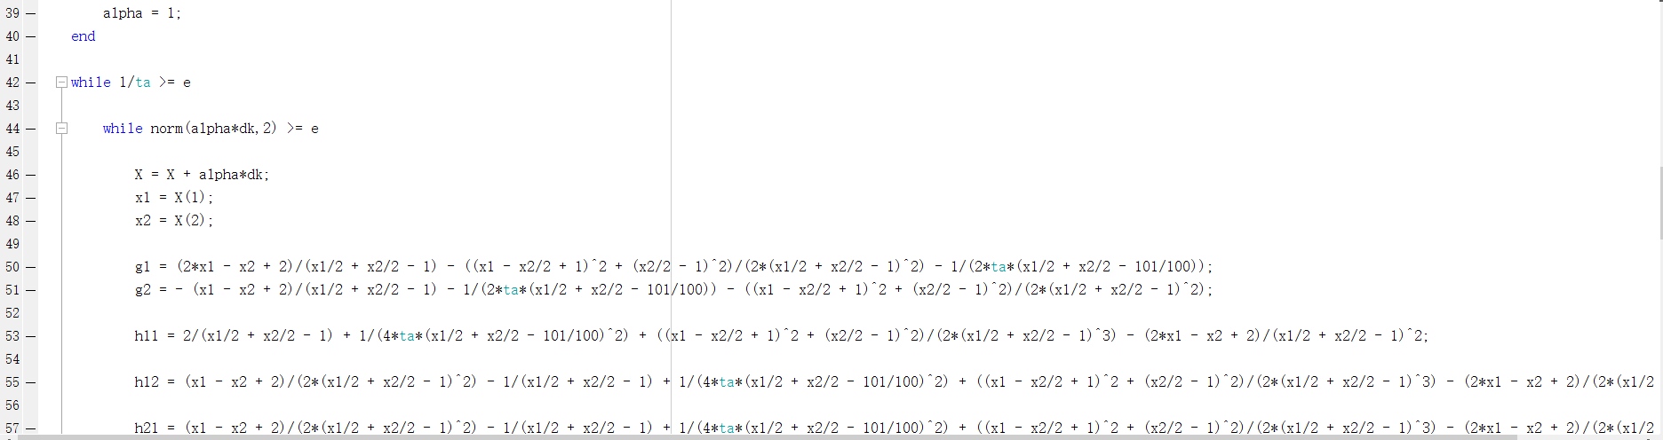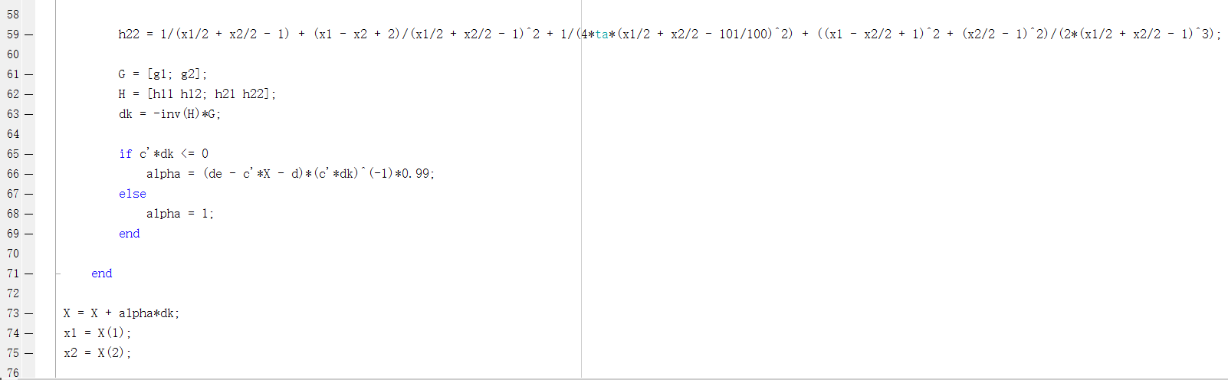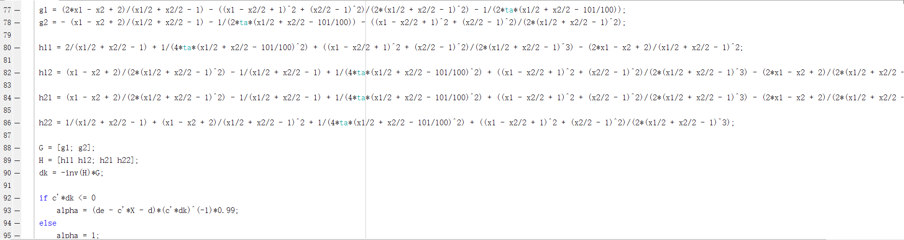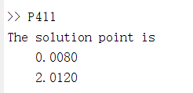

P414

Generate a plot that displays the data curve u versus t

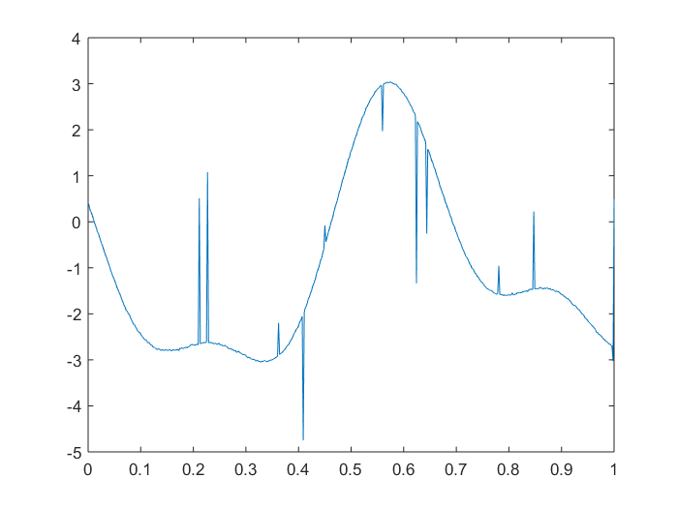

Generate a plot to show both x1 and its estimate x1_tilda

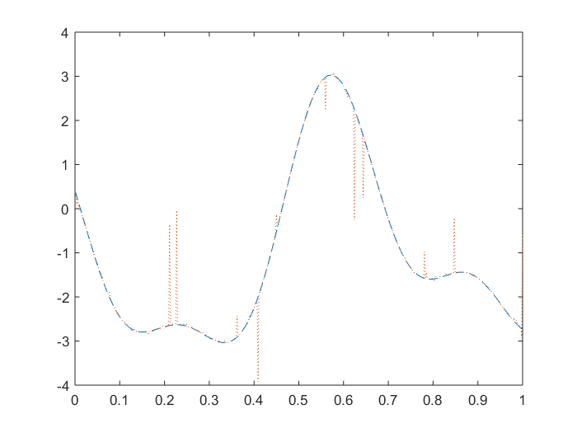

Generate a plot to show both x2 and its estimate x2_tilda

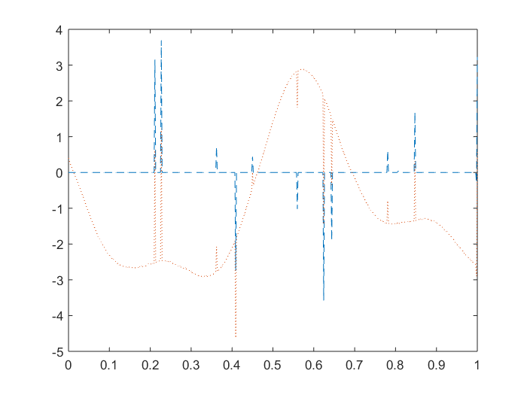

Compute average 2-norm estimation errors with n = 512

