The Triangle2 Program

Written in C#, by Dumitru Corobceanu, inspired by “The Triangle” written by James Bach(1996),
based on an exercise in The Art of Software Testing, by Glenford Myers.

Purpose of the program
This program is intended for use in testing classes and job interviews to aid in education and evaluating software testing skill.

Specification
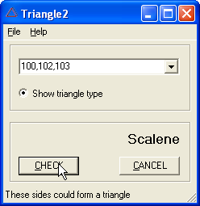
The program takes 3 positive integers, separated by commas. When the CHECK button is pressed, the program interprets the integers as the length of the sides of a triangle. The program show if sides of of this length could form a triangle. Also, in case “Show triangle type” option is selected, program displays the type of the triangle:
- “Equilateral” (all sides of the triangle are equal)
- “Isosceles” (two of the sides are equal)
- “Scalene” (no side is equal to any of the others)
When the CANCEL button is pressed all the text is cleared, input data and the result.
All this actions are available through the menu.

