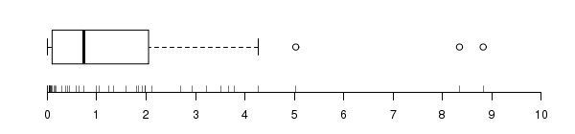

Media 1.5958
Mediana 0.7436
IQR 1.9529
sd 2.0714

