南方科技大学材料科学与工程系
实验报告模版及相关要求

一、格式总体要求
- 语言：英文。
- 页边距：上、下、左、右均为 2.5 cm。
- 字体 ：Times New Roman；字号：小四或12磅。
- 行间距: 固定值 20磅 (Exactly 20 pt) 或 1.5倍行距 (1.5 lines)。
- 对齐方式：两端对齐。
二、提交要求
- 文件命名：SID+姓名+实验名称关键字。
- 文件格式：PDF。（附预习报告和原始数据记录，整理成一份PDF文档）
- 提交途径：BB系统
三、评分规则
报告封面（title page）占比5%，
报告格式占比25%，
报告内容占比70%。
报告迟交扣分说明：迟交1日扣0.5分，最多扣10分（一份报告按100分计）

以下是报告模板，注意报告模板的红色字为解释和注释，请大家撰写报告时去掉红色字体！！！

Experiments for Advanced Materials Science and Engineering Ⅰ
Lab Report

Experiment X : X X X X X X
（X为实验序号，XXXXXX为实验名称）

Name：
Student ID:
Date of experiment:
Date of submission:
Team member (if any):

1. Objectives
（简述本次实验要验证的理论或要掌握的知识点，参考实验讲义）
举例：
- To understand the principle of thin film preparation by the sol-gel method.
- To understand the principle of the measurement method of the optical energy bandgap.
- To prepare ZnO films with different thicknesses by sol-gel method.
2. Principles
（简要解释原理，列出实验所依据的主要公式、实验原理图或电路图/光路图，参考实验讲义并将讲义的内容进行适当缩减提炼，原理不要超过一页纸）
举例：
2.1 ZnO thin film
Zinc oxide (ZnO) is an n-type semiconductor with a direct bandgap of 3.44 eV. The electrical properties of ZnO have made the compound attractive in the area of thin film transistors and light-emitting diodes. Due to its non-toxic, wide bandgap, and electrical conductivity, it is thought to be ideal for use in solar cell devices.
2.2 UV-Vis spectroscopy
UV-Vis spectroscopy is the measurement of the absorption of near-ultraviolet andvisible light by a sample. UV-Vis spectrometer can be used to measure the absorbance of UV or visible light by a sample, either at a single wavelength or perform a scan over a range in the spectrum. The UV region ranges from 200 to 400 nm, and the visible region from 400 to 800 nm. A schematic diagram of a UV-Vis spectrometer is shown in Fig. 1, which consists of light sources, a monochromator, sample and reference cells, detectors, and recording devices.
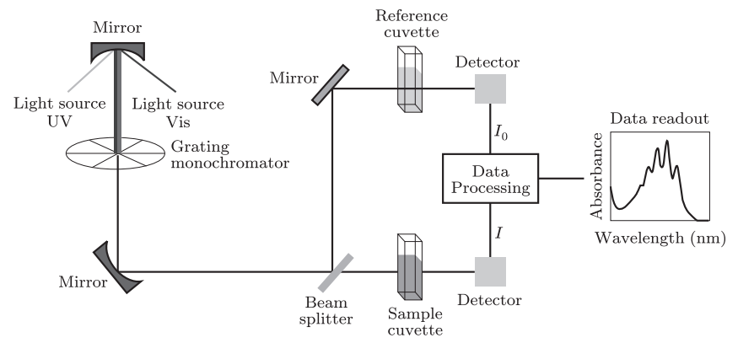
Fig. 1 The working principle of the UV-Vis spectrometer.

3. Experimental materials and setups
（参考实验讲义，化学式请注意上下标的规范书写，单位请注意规范表达）
举例：
- Chemicals: zinc acetate, 2-methoxyethanol, ethanolamine, acetone, ethanol
- Apparatuses: the reaction apparatus (consists of an electromagnetic stirrerwith a heating plate, an oil bath, a ball condenser, a 250 mL three-necked glass flask), UV-Vis spectrometer (PerkinElmer Lamda 850), ultrasonic cleaner, electronic balance, hot plate, muffle furnace
- Tools: quartz glass substrates with a size of 20 mm × 20 mm, pipettes
4. Experimental procedures
（实验步骤采用顺序编号，清晰列出操作步骤，参考实验讲义，注意实验讲义部分参数可能与实际上课不同，请按照课上要求修改）
举例：
4.1 Preparation of ZnO film by sol-gel method and spin coating.
- Ultrasonically clean the quartz glass substrates for 10 min in deionized water, acetone, and ethanol, sequentially.
- Dissolve 6.59 g zinc acetate dihydrate with 60 mL of 2-methoxyethanol in the 3-necked flask.
- Connect the flask with the condenser. Immerse the flask into the oil bath on the electromagnetic stirrer with a heating plate.
- Heat the solution to 60 ℃ and stir for 0.5 h.
- Slowly drop 2 mL ethanolamine into the solution under stirring.
- Increase the solution temperature to 70 ℃. Keep stirring for 1.5 h. Then cool down the solution to room temperature.
- Spin coat the above solution onto a quartz glass substrate at the speeds of 500 rpm for 10 s and 2400 rpm for 30 s.
- Heat the sample at 200 ℃ for about 3 min on the hotplate.
- Repeat steps (7) and (8) to prepare thin film samples, on which the thin films are deposited by spin coating for 4, 8, and 12 times, respectively.
- Heat the samples at 600 ℃ for 2 h in the muffle furnace.
5 Results and discussion

对表格的基本要求：
课堂记录的原始数据不能通过拍照抠图直接作为数据，需要重新整理绘制成表格。表格使用三线表格，表格上方有表序（如Table 1）和表题（精炼准确地概括表格内容）。所有物理量必须标明符号、单位。
举例：
Table 2 Physical properties of Composite A and Composite B
Material | Density (g/cm³) | Tensile Strength (MPa)
Composite A | 1.25 | 85.2
Composite B | 1.42 | 112.8

对图的基本要求：
图（包括坐标图、照片、示意图等）用于直观地展示数据的分布、趋势和关系。图应清晰、大小适中。坐标图需线条均匀，主辅线分明。每个图下方必须有图序号和图题，图题应简明描述图的内容，可在图题下方添加注释，解释图中的缩写、统计信息（如误差线代表标准误，n=5）、标注的箭头等含义。照片图/显微图应清晰并包含标尺（Scale bar）和放大倍数）
举例：

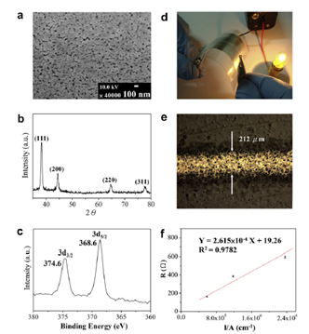
Fig. 9 Characterization of conductive silver features on the flexible PET substrate: (a) SEM image of the silver film; (b) XRD patterns of the silver film prepared by the chemical reduction method using 80% N2H4 aqueous solution; (c) portion of the ESCA spectrum showing Ag 3d5/2 and 3d3/2 components; (d) conductive silver film; (e) test line of silver wire; (f) linear plot of resistance vs l/A (l, length; A, area of cross section).

讨论内容包括：
误差分析: 定量或定性分析误差来源（系统误差、偶然误差），并说明减小误差的措施。
现象解释: 解释实验中出现的异常现象。
对比分析: 将实验结果与理论值或预期进行对比，并分析差异原因）
（请参考实验讲义，实验讲义列出需要分析讨论的问题）
举例：
Discuss the effect of heat treatment (normalizing, quenching and tempering) on the hardness of saw blades.

- Normalization: lay a good foundation for the final performance
Normalizing is usually used as a preparatory heat treatment process. It can refine the grains and uniform structure by heating the saw blade to a certain temperature and then air cooling, laying the foundation for subsequent quenching to obtain excellent performance.
- Annealing: reduce hardness to facilitate processing
The main purpose of annealing is to reduce the hardness of the steel, eliminate internal stress, and facilitate the cold processing of the saw blade such as stamping and cutting. After annealing, the hardness of the steel is significantly reduced.
- Quenching: to obtain a core with high hardness
Process core: Quenching is the most critical step in achieving high hardness of the saw blade. The principle is to heat the saw blade above the austenitic temperature and then cool it rapidly, transforming austenite into martensite, a very hard but brittle tissue.
- Tempering: Find a balance between hardness and toughness
Performance regulator: The hardness of the quenched saw blade is very high, but it is also brittle and cannot be used directly. The tempering process is designed to solve this problem, by heating and insulating the quenched saw blade at different temperatures, it is possible to reduce the hardness in a controlled manner, while greatly improving toughness and plasticity to meet the needs of different applications.

- Conclusion
（通过对实验进行简要概述来引出结论。概括实验过程，总结实验中所得到的结果，你可以将实验结果与理论值进行对比。文字锻炼描述，1-2段，通常300字左右，不需要太长）
举例：
In conclusion, this experiment synthesized a series of TiO₂-based photocatalysts and evaluated their photocatalytic activity through the degradation of methylene blue. The results reveal that both crystal phase and dopant concentration significantly influence performance. Specifically, the anatase phase demonstrated superior inherent activity over the rutile phase. Moreover, Zn doping exhibited a concentration-dependent effect: a low doping concentration enhanced performance by suppressing charge recombination, whereas excessive doping proved detrimental. Consequently, the Zn1-TiO₂-400 sample was identified as the optimal catalyst, achieving the highest degradation efficiency.
- Questions
（根据讲义中的题目，按题目序号作答，回答问题时附上题目，借用 AI回答问题要进行归纳总结并判断AI的答案是否正确）
举例：
- Please suggests several other techniques for preparing the TiO2.
Answer:
- Sol-Gel Method
- Hydrothermal/Solvothermal Synthesis
- Chemical Vapor Deposition (CVD)
- Physical Vapor Deposition (PVD)
- Electrochemical Anodization
- References
（如果有请附上，无则去掉这部分；参考文献格式需要统一）

举例：
[1] S.A. Stanley, T. Kawate, N. Iwase, M. Shimizu, A.E. Clatworthy, E. Kazyanskaya, J.C. Sacchettini, T.R. Ioerger, N.A. Siddiqi, S. Minami, J.A. Aquadro, S.S. Grant, Z. Liu et al. / Colloids and Surfaces B: Biointerfaces 145 (2016) 679–687 687 E.J. Rubin, D.T. Hung, Diarylcoumarins inhibit mycolic acid biosynthesis and kill Mycobacterium tuberculosis by targeting FadD32, Proc. Natl. Acad. Sci. U. S. A. 110 (2013) 11565–11570.
[2] D.L. Clemens, B.Y. Lee, M. Xue, C.R. Thomas, H. Meng, D. Ferris, A.E. Nel, J.I. Zink, M.A. Horwitz, Targeted intracellular delivery of antituberculosis drugs to Mycobacterium tuberculosis-infected macrophages via functionalized mesoporous silica nanoparticles, Antimicrob. Agents Chemother. 56 (2012) 2535–2545.

