This Example describes the way to display Hello message using RMI. By RMI we mean Remote Method Invocation. RMI serves as a basic technique for supporting distributed objects in java. The steps involved in displaying message Hello are described below:-

**Step1.**Create a Remote interface named HelloInterface.java in the Directory.

**HelloInterface.java:-**

|  |
| --- |
| **import**java.rmi.*;  **public interface**HelloInterface **extends**Remote {   **public**String say() **throws**RemoteException; } |

**Step2.**Create an Remote Class implementation for HelloWorld named Hello.java in the Directory.

**Hello.java**

|  |
| --- |
| **import**java.rmi.*; **import**java.rmi.server.*;  **public class**Hello **extends**UnicastRemoteObject  **implements**HelloInterface {   **private**String message;   **public**Hello (String msg) **throws**RemoteException {   message = msg;   }   **public**String say() **throws**RemoteException {   **return**message;   } } |

|  |
| --- |
|  |

**Step3.**Compile the above two Source file named HelloInterface.java and Hello.java.

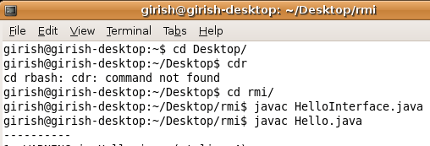

**Step4.**After compiling the above two classes type the following command i.e-"rmic Hello" in console just like displayed below.

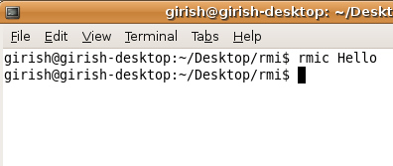  
  
  
Your Directory Structure will be like this.By running the "rmic Hello" command a new class will be created i.e "Hello_Stub.class" in the directory  
  
  


**Step5.**Create Server application named HelloServer.java

**HelloServer.java**

|  |
| --- |
| **import**java.rmi.Naming;  **public class**HelloServer  {   **public static void**main (String[] argv)    {   **try**{   Naming.rebind     ("Hello", **new**Hello ("Hello,From Roseindia.net pvt ltd!"));   System.out.println    ("Server is connected and ready for operation.");   }    **catch**(Exception e) {   System.out.println ("Server not connected: " + e);   }   } } |

|  |
| --- |
|  |

**Step6.**Create Client application named HelloClient.java

**HelloClient.java**

|  |
| --- |
| **import**java.rmi.Naming;  **public class**HelloClient  {   **public static void**main (String[] argv) {   **try**{ HelloInterface hello =(HelloInterface)  Naming.lookup ("//192.168.10.201/Hello");   System.out.println (hello.say());   }    **catch**(Exception e){   System.out.println ("HelloClient exception: " + e);}   } } |

|  |
| --- |
|  |

**Step6.**Compile both of the files.

**Step7.**Type "rmiregistry" on commandprompt and press ENTER.

**Step8.**Type java HelloServer in commandprompt and press ENTER.The following message will be displayed on console.

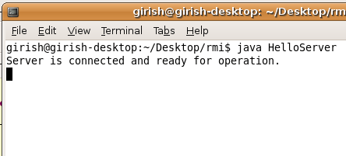

**Step9.**Now,open another separate command terminal,and run the client application like shown in the figure given below:-

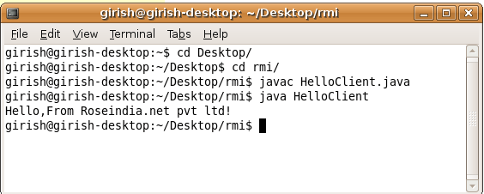

**Step10.**If the message similar to the above appears in figure comes means that you have implemented your RMI application.