Github Desktop walkthrough

# Step 1. Create your Github account

1. Visit **https://github.com/**
2. Click “Sign up”
3. Enter a username, email and password.
4. Verify you are human, click “Create account”
5. “Choose your subscription” = Free
6. “What is your level of programming experience” and “What do you plan to use Github for” you can click “skip this step” at the bottom
7. Please verify your email address – open your email, click on the link provided in the email you will have received from Github.
8. When the “create a new repository” screen appears you are done. Don’t create a repository through the online site.

# Step 2. Create your project repository

The first time you open GitHub Desktop, it will require you to sign in

1. “Sign in to Github.com”
2. Enter your username or email, and password, click “Sign in”
3. “Configure Git” screen, enter your name and email, click “Continue”
4. “Make Github Desktop better” – Up to you, but I turn off the “submit periodic usage stats”. Click Finish.

Once you are signed in

1. “Let’s get started”.
2. Click “Create a new repository on your hard drive” (note: a repository is slightly different to a project folder. It is a project folder, but it also contains additional Git data). It does not matter if you have an existing project folder you wish to turn into a repository, or if you have not started your project yet and wish to create an empty working space.

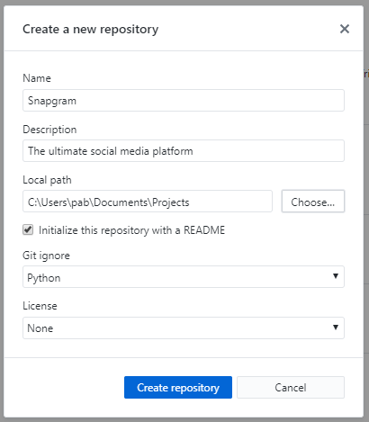

Name of repository and project folder.   
The folder will be created if it does not exist.

Folder to contain your project folder.

Recommended to create a README. You can change it later.

Set the “Git Ignore” to the option that best describes the technology your project uses.

Now continue working on your project until you are ready to upload.

# Step 3a. Use Github Desktop to upload your project repository to Github.com

If your project is being uploaded for the first time

1. 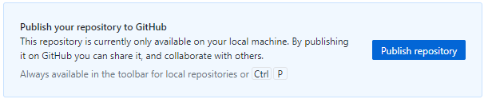

Click “Publish repository”

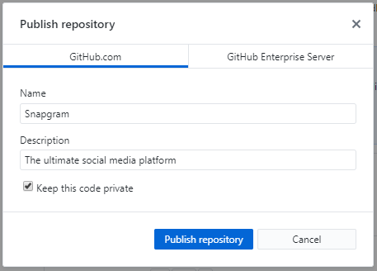  
Ensure “Keep this code private” is ON  
Click “Publish repository”

# Step 3b. Use Github Desktop to upload updates to Github.com

If you need to update the online copy of your project

1. 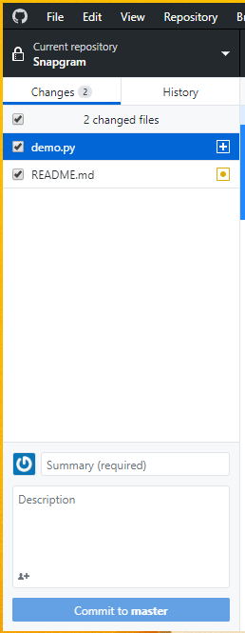

You will be presented a list of files that have been added or altered. You may review the changes.

You MUST enter a summary. I usually just make a comment like “Updated 14-08-2019”.

Click “Commit to master” to confirm these changes.

1. 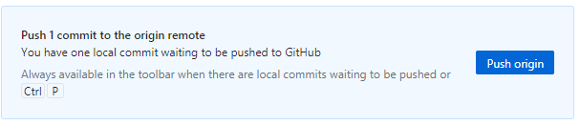  
   Click “Push origin” to actually perform the upload.

# Step 4. Share project with me

1. From Github Desktop top menu, select “Repository” and “View on Github” to open the online version of your project.
2. 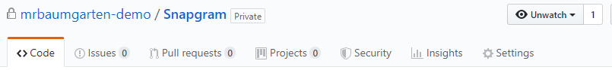Click Settings
3. 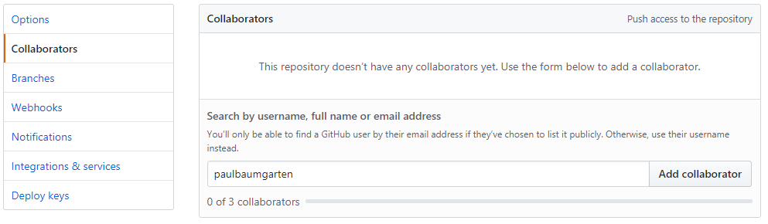

Click Collaborators

Enter “paulbaumgarten” as a collaborator, click “Add collaborator”.