Rm file_name : for deleating file

Echo $UID : to check root user is logged in or not if it gives zero then it is root user

Rm -rf file/directoryname: to forcefully delete file or directory

Shutdown: to shutdown linux

Fg : to run a stopped command using ctr-z on command prompt

At givetime: this will generate an automate task

Atq : list all jobs using at command

Atrm jobnumber : to delete job (Jobnumber can be found using atq command)



Usermod -G groupname username : to assign a user to a group

gpasswd -d username groupname: to remove the user from group

deluser username groupname: to delete the user from group (ubuntu)

sudo gpasswd -A username groupname: Assign a group administrator (who can add/remove members)

Useradd username: to add new user

Passwd username : to set password for new user only root user can do this do this after useradd command

useradd -m -s /bin/bash newusername: to add newuser (not recommended) instead use adduser command to add newuser since it is more user friendly and it creates home directory automatically with all suitable owners and permissions

useradd -g groupname -s /bin/bash -c “description” -m -d /home/username username : to create user with extra options

Userdel username: to delete user , if written along with -r deletes the home directory as well, written with -f will delete the user forcefully even if it is logged in

Usermod -l newusername oldusername : to change the username

Usermod -a -G groupname username : to add user to a new group default group remains same, -a is used to add user in a group without removing them from any other group they are added to

sudo gpasswd -a username groupname: alternate of above command add user to group

Usermod -g groupname username: to change the default group

Usermod command can be used with -s to change shell type -L -U to lock unlock user so that they will not able to log in

Usermod -m -d newnamelocation oldname : to change the name of home directory of user

Groupdel groupname : to delete group

Id username :to check added user

Groupadd groupname: to create a group using root user only

Chage -m -M -d -I -E -W username

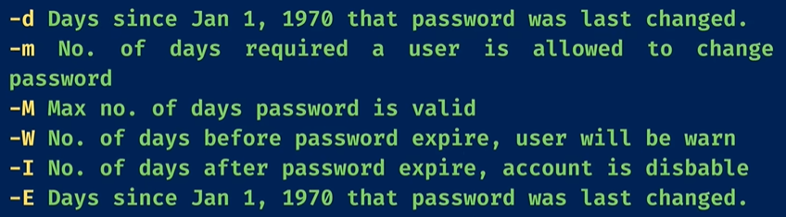

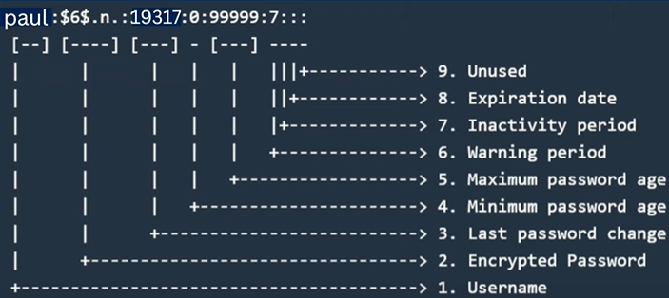

**To check the above values reach out to the /etc/shadow file**

now to change the above values by default after user creation we need to make changes in /etc/login.defs file

to give any user superuser privileges edit /etc/sudoers file or just simply add them to wheel group using usermod command write visudo using root user to edit sudoers file

to allow any user to do only specific superuser commands update sudoers file and write this is sudoers file username ALL=command_name

Cat /etc/group : to check whether group is created or /etc/passwd

Traceroute website.com: to check route path

Ping websitename.com : to check website accessible or not

Netstat -putan : to see all internet connections

Stat filename : to see every detail of filename

Kill -9 processid: to kill process by id

Jobs : to see active jobs terminal

Bash scriptname.sh : to run the script

Cat /etc/os-release : to know system information

Lsblk: to see the list storage devices or disk partition

Df -h : to know filesystem

Df -Th : to know filesystem precise way

Lscpu: to know system information

Du -h filename : to know the total store space of file

Free -th: to see total ram usage and remaining ram

Total: to check percent memory and cpu utilization

Chgrp groupname filename : to change the group of a file

Chown newusername filename: to change the ownership of the file

Chwon olduser:newuser filename : to change the ownership of the file

Ls -l filename : to check the permissions of the file

Chmod a+rwx filename: to give permission to all here a means all users instead of ‘a’ one can give u=user g=group o=other here + means to give permission to remove the permission write – sign

Chmod u+s filename: to assign suid to file g+s for group

Chmod o+t filename: to assign sticky bit to the file if you assign this only file owner can delete the file no one else can

Umask u+rw,g+rw,o-r : to change the default permissions of the file once this is set next time you will create any file this settings will be affected to the file by default this is temporary once you close the shell it will be set to previous one to make permanent change edit .bashrc file of user and write the same command at the end of file don’t forget to source it

chmod -R u=rwx directoryname: to change the permissions of all files inside any directory

chmod 777 filename : to change the permission in numeric way here three numbers represents users, groups and others respectively here numbers have their own meaning 0 meaning no permission at all 1 meaning only execute 2 meaning only write 3 meaning execute+wirte(2+1) permission 4 meaning only reading 5 meaning read+execute (4+1) 6 meaning read+write(4+2) 7 meaning read+write+execute (1+2+4)

Ls -ltr : rwx readwriteexecute rw- readwrite r—readonly

The permission you see in front of the file is in set of three parts like rwx r-x rw- here first set is for user permission second group for group permission and third permission is for other permission

Cut -c1 csvfilename : to display only first character for -c1-2 to show two characters

Ls -lh: to see exisiting file size

Truncate -s 100M filename: to change the filesize shrink or increase

Tr [:lower:] [:upper:] <conti.csv: to change lowercase to upper case

Tr -d % <filename: to remove any part from file here %

Tr % $ <filename: to replace any thing from file here % to $

Ls -la :to open every file on current folder

Less filename :for reading file use / for searching content in file from top and ? use for bottom

Awk -F , ‘{print $column number,$another column}’: to print specific column from a particular csv file

Export java_home=”jdkpath” : to set environment variables on linux after that check java version if it is not showing enter export PATH=$java_home/bin:$PATH but this method is temporary

Go to home and edit .bash_profile using vi editor go to last and enter testvar=”value” and then write export testvar and then write source .bash_profile to permanently add environment variables if you want to see it in every tab than also add it in .bashrc file and do not forget to source it

Systemctl status : to check status of the package

Systemctl list-units --type=service --all : to know every servicing running

Systemctl start/stop serivicename: to start or stop a service

Systemctl restart servicename: to restart service

Systemctl disable servicename: to disable service

Stystemctl mask/unmask servicename : to mask or unmask service if we mask service it won’t start

Dnf list installed : to see every package instealled

Apt search pakeagename: to search if any package is available or not to install for unbuntu

Yum/dnf list available: to list every package which are available to download

Curl apilink: to call api

Rpm -qa | grep applicationnafme: to see if application exists on system or not

Wget urloffile: to get file downloaded from internet

Yum or dnf installfilename: to install software on linux centos or redhat use apt for unbuntu

Zip filename filetozip : to zip any file

Zip filename file1 file2 : to zip multiple files

Unzip filename: to unzip files

Unzip -l filename.zip : to know how many files have inside zip folder

Wc filename: to know total number of lines, words, bytes in any file can be used with -l for number of lines -w for words -c for bytes -m for charaters

Touch filename :for creating file

Touch -a -m -t YYYYMMDDHHMM.SS filename : to create file with particular date and time -a means access time -m means modification time and -t means set time

find /path/to/folder -type f -exec touch -t YYYYMMDDHHMM.SS {} + : to find files and change their time

**Use another file's timestamp:** touch -r reference_file filename

More filename :for reading file in pages

Date :for date use date +%m for any thing M T to getdate or time

Whoami :for system name

Vi filename :to create and edit file at the same type once you enter into editor press i to edit it once done editing press escape button and press shift and colon and the press wq to done process

Gzip -k filename: to create a zip gz file

Gunzip gzfilename : to unzip the file

Tar -czf czfilename.tar.gz foldername: to compress whole folder

Tar -xzf czfilename: to unzip folder

Uptime or w : to know number of users and uptime on current server

Cal : to see current month Calander write year after cal to get all months from that year

Ls --help : to know more about any command

History : to know all of the commands you have executed till now

Alias anyname=”command” : to create a shortcut for the given command

Alias -p : to know all created alias on the system

Unalias aliasname : to remove alias

History | grep commandname : to find exact command

Locate filename : to find any file inside system if this is not working this first write sudo updatedb or just updatedb before executing the above command

Cat filename :to read file

Script : to save your activity in command line once done press clt D to stop and a typescript file will be generated inside home directory

Find ./ -name filename : to find any particular file inside system

Nano filename :to edit exiting file

Ls p* : it will show files staring from letter p

Ls *p : it will show files ending from letter p

Touch file{1..5} : to create multiple files in one go

Cmp file1 file2 : to compare two files

Diff file1 file2 : to know difference between two files

Mkdir newdirectoryname :to create a new directory

Egrep “firstword|secondword” filename :to find multiple words in any file

Split -l 3 filename : to split a particular file into three or any given number of files

Grep “findingword” filename: to find any particular word in any file

Rmdir directoryname :to delete directory

Su : to change the current use or root switch user write exit to go out of root users

Rm -rf directoryname :alternate for deleting directory

Cp filename foldernametocopyfile :to copy one file to another folder

Cp ../filename . :this is to copy file from previous dir to current one end dot means current one

Cp currentfile copyfilename : to create a copy of current existing file

Mv filename foldertopaste: to move and paste to a particular folder

Mv filename newname: to rename any file

Ssh yoursystemname: to get ssh connection on remote system

scp nano.txt [centos@192.168.110.140:/home/centos](mailto:centos@192.168.110.140:/home/centos) :to copy file from remote server to linux server or one linux user to another user use -r next to scp to transfer directories

rsync -v –progress filename [centos@192.168.110.145:home/centos7](mailto:centos@192.168.110.145:home/centos7) : to copy file alternate way add -z -a for compress and archive that preserves symbolic links, permissions and time

Head -5 filename: to fetch first lines from any file

Passwd: to change the current password of the user

Tail -5 filename : to fetch last lines from any file

Sort filename : to sort any file using alphabetical order a to z

Sort -r filename : to sort any file in opposite direction z to a

sort filename | uniq : to sort and remove any duplicates

vim filename : to open file in vim not press shiftG to go to end of the file and press gg to go to top of file press / to search any word

ls -l | wc -l : to find total number of files in directory

egrep “word|word|word” filename: to find multiple words in file

fgrap “word” filename : to get exact word from the file

zgrep “word” filename : to get word from zip file

find /path/ -size 50M : to search file based on their sizes for same path use . dot

find /path/ -iname filename: to ignore casesensitive while searching file

find . -user username : to find files associated to user

find . -inum ionod number: to fine using inod number

find . -newer filename : to find number of files created after given filename

find . -empty : to find empty files on given location

find . -empty -exec rm {} \ : to delete all empty filles all at once

find . -size +1M -size -50M : to find all the files between one to fifty mb

find . -perm /u=x : to find all files with give permission

find . -iname a : to find files staring from a

>filename : to empty file without deleting it > filename

Ctr a to go to start ctr e to end line of the command

Ctr u to delete whole command and ctr y to undo it

Ctr r to find past commands

ls -l | wc -l : to count total number of files inside a directory

ls ?anycharacter : to find files based on ending character here ? means only one character behind desired word

ls ???? : to find files based of number of questions marks

ls [av]* : awk to find all files starting from a and v

ls *[1-9]*: to find files containing integers

ls -li : to see the inode of filessystem

ls | grep -v "z" : to find files not containing “z” word

grep ^p filename: to find word starting with p

grep p$ filename : to find word ending with p

ls >> filename: to redirect output to a file without changing its previous content

command 2> filename : to redirect output to the file despite of error only works for errors

command &> filename : to redirect output to the file no matter its error or not

ln -s filelocation filename: to create a shortcut of a file location (this is soft link ) if you delete the main file shortcut will be deleted automatically

ln filelocation filename: to create a shortcut of a file location (this is hardlink) here if you delete main file shortcut will not be deleted unlike softlink

variablename=”content”: to create variable temporary

export variablename=”content”: to show it in printenv

unset variablename : to unset the variable

sudo vi /etc/profile : edit the give file and write any variable and that variable will be globally available to all users in server here sudo is written because we are logged in as user not root user

getfacl filename: to know complete info of the file

setfacl -m u:username:rw filename: to give a new user permissions of a file here “u” means user it can also be g ie. Group,

setfacl -x u:username filename: here instead of -m we can use -x to remove permission of user or any group

setfacl -m mask:rwx filename : to change mask permission

setfacl -b filename : to remove all permissions which are changed

setfacl -Rm u:username:rw directoryname: to give the user permission from any directory

ps -ef: to know info about current services

ps aux : same as above

kill -l : to see all signals available

kill -1 processid : to restart the process

kill -2 processid : interrupt from keyboard like ctrl+c

kill -9 processid: forcefully terminate the process

kill -15 processid: to kill process gracefully (recommended)

top: to see all running processes

nohup processname & : to run any job or script even if you close the cmd tab

crontab -l : to see any active cronjobs

crontab -e : to create new cronjobs once you enter edit the file and write your date and time to execute the cronjob start with * * * * * first star is minute second star is hour third star is day of month fourth star is month and fifth star is day of the week Sunday starts from 0 for example, 30 14 * * 0 /tmp/basic.py now this cronjob will execute this basic.py file every Sunday at afternoon 2:30 pm

*/2 * * * * to do a job every two minutes

8 8 * 2 1-5 At 08:08 on every day-of-week from Monday through Friday in February.

Using @daily @hourly @reboot for easy scheduling for example @daily script.py

crontab -r : to delete all cronjobs

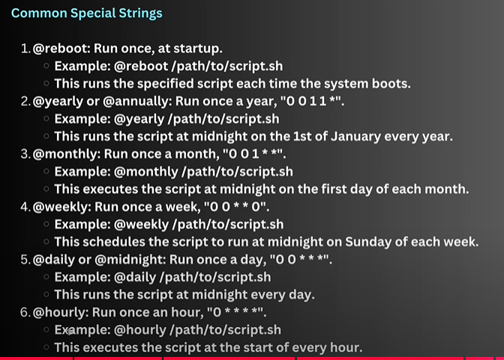

Anacron jobs to run anacron jobs modify file /etc/anacrontab and add your job at the end of the file such as” 15 5 backup_trigger /tmp/backup.sh” here 15 means every fifteen days 5 means five minuets delay and backup_trigger is the jobs name and /tmp/backup.sh is file where script is present

Anacron -f -d -n : to run anacron job before scheduled time forecefully

Awk ‘{print $2}’ filename : to fetch second column form any file only if the columns are separated using whitespaces, write $0 to print the whole data

Awk ‘{print $2,$3}’ filename : to print more then one column

Awk -F ‘,’ ‘{print $2}’ filename: to fetch second column from any file when columns are separated using comma or any other item -F is filed separator

Awk ‘{print $NF}’ filename : to print last column

Awk ‘/word1|word2|word3/{print $0}’ filename : to find specific word in the file

Awk ‘BEGIN{IGNORECASE=1}/word1|word2|word3/{print $0}’ filename : to find specific word in the file while ignoring case (case sensitive)

Awk ‘{print NR ,$0}’ filename : to get line number of each entry

Awk ‘NR==6 {print $0}’ filename : to print specific line, line 6

Awk ‘NR==6, NR==12 {print $0}’ filename : to print specific line range, line 6 to 12

Awk ‘NF==0 {print NR} filename: to print number of blank lines

Awk ‘$2 ~ /a/ {print $0} ‘ filename : to get every entry from second line that contains letter a

Awk ‘$5>10000 {print $0}’ filename : to get records whose salary more then 10000

Awk -F[,|;] ‘{print $2}’ filename : to get values if there is multiple delimiters

Awk ‘{gsub(“word1”,”word2”); print($0)}’ filename: to change the word1 to word2

Awk ‘{print length($2)}’ filename: to get length of particular field

Awk ‘{print tolower($5)}’ filename: to print fields in lowercase tooupper for uppercase

Awk ‘BEGIN{print “--------something--------“{=} {print $0} END{print “-------somethingend---------“}’ filename : to write at top and bottom

Awk ‘BEGIN{sum=0} {sum=sum+$salaryfield} END{print “the total sum of salary is :” sum}’ filename: to print sum of something i.e. salary

Awk ‘NR>1 {if($NF>0)count++} END{print “Total employees are: “ count}’ filename: to find total number of entries

awk -F ';' 'BEGIN {sum=0; count=0} NR > 1 {sum += $NF; if ($NF > 0) count++} END {if (count > 0) print "The average salary is:", sum / count}' emp.csv : to find average salary

awk ‘{if($NF>100000)$7=”High”;else $7=”Low”; print $0}’ filiename: to print salary high if it is more then 100000 or less here $7 is column next to the last column

instead of writing of all this we simply can make a file with .awk extension and run that file in command prompt like this awk filename.awk filename.csv

you can also make script file that is executable like #!/bin/awk and write your script

Sed -n ‘3p’ csvfile: to fetch any particular line here 3 (‘3,5p’ for range data)

Sed ‘s/oldword/newword/g’ csv filename: to change any particular word not permanent change

Sed ‘2 s/oldword/newword/g’ csv filename: to change any particular word on given line here 2 not permanent change

Sed -n ‘/word/p’ filename: to fetch lines containing word

Sed -n -e ‘2p’ -e ‘4p’ filename: to see only 2 and 4 line

sed -n ‘2,+2p’ filename : to see 2 lines after second line

sed -n ‘1~2p’ filename: to see every second line i.e. only even lines

sed -i ‘s/old/new/g’ filename : here -i means to update the values in file permanent

sed ‘/searchword/ s/old/new/g’ filename: to search searchword and replace old word in line with new one

sed ‘1d’ filename: to delete a line 1 $ means last line

sed ‘/^/d’ filename : to delete the empty line from file

sed ‘/word/ w filename’ filename: to search a word and transfer all the entries in filename using w keyword

sed ‘/word/ a hello world’ filename: to add data after specific line containing word can give line number instead word as well

sed -n ‘/^a/p’ filename: to get names starting from letter a , here write a$ to get names end with letter a

sed -n ‘/[ac]/p’ filename: to get names starts from a and c only, write [a-g] to get names from range a to g

sed ‘/word/ q’ filename: to stop searching after finding word

Example: sed -n ‘/[[:digit:]]/p’ filename : to get numbers from file

[:alnum:] [:alpha:] [:digit:] [:blank:] [:lower:] [:upper:] [:punct:] [:space:]

Ssh-keygen : to generate key for ssh login without password

Ssh-copy-id [hostsystem@192.168.xxx.xxx](mailto:hostsystem@192.168.xxx.xxx) to copy key to the hostsystem now enter password for first time and then after that it will not ask for password

Yum install postfix to install postfix on centos apt install postfix on ubuntu based systems

Yum install mailx to install on centos

Once you do this go to /etc/postfix and edit the main.cf file and enter the following

Relayhost = [smtp.gmail.com]:587

Myhostname = <your_hostname>

(to check your hostname run command “hostname -f”)

And then at the end of the file add following lines:

# Location of sasl_passwd we saved

smtp_sasl_password_maps = hash:/etc/postfix/sasl/sasl_passwd

# Enables SASL authentication for postfix

smtp_sasl_auth_enable = yes

smtp_tls_security_level = encrypt

# Disallow methods that allow anonymous authentication

smtp_sasl_security_options = noanonymous

create a file under /etc/postfix/sasl filename : sasl_passwd

and add below line:

[smtp:gmail.com]:587 your_[email@gmail.com:password](mailto:email@gmail.com:password)

Now to create the above password go to your google security and search for app passwords and create one and paste it over here

Once you are done we need to convert sasl_passwd file into db file, now in same folder write following command:

Postmap sasl_passwd

Once this is done we need to start our postfix servies write following commands to run or stop

Systemctl start/enable postfix.service

Systemctl stop/disable postfix.service

Systemctl restart postfix.service

Now to send mail write the following command:

echo ‘This is the first mail from linux centos by Aradhya Ambole’ | mail -s ‘Testing mail- CentOS’ [dummy127.0.1@gmail.com](mailto:dummy127.0.1@gmail.com)

-s means subject of the mail

echo ‘This is the second testing mail from linux centos by Aradhya Ambole!! Please find the attached file!!’ | mail -s ‘Testing mail- CentOS’ -a test_file.txt [dummy127.0.1@gmail.com](mailto:dummy127.0.1@gmail.com)

here -a means attach file and test_file.txt in my file to send **and always use single quotes while writing mails**

dmesg -w : live monitering of any action

dmesg -Hx : to see actions performed by system

hostnamectl set-hostname new_hostname: to change the hostname

to send mail using sendmail package we need to install the following packages in linux

sendmail , sendmail-cf , procmail, mailx

now go inside /etc/mail folder and make one authinfo file and write following :

AuthInfo:smtp.gmail.com “U:your_email@gmail.com” “P:your_app_password” “M:PLAIN”

Now make some changes in sendmail.mc in same directory as follows

define(`SMART_HOST', `smtp.gmail.com')

FEATURE(`authinfo')

Now run following commands

m4 sendmail.mc > sendmail.cf

makemap hash authinfo < authinfo

now write systemctl restart/start sendmail

and to send mail write following

mail -s “your subject” [receiver_mail@gmail.com](mailto:receiver_mail@gmail.com) press enter and write body of mail

and once you are finished press ctrl+d

sudo chfn -f "aaru" username : to change the full name of username on gmail in GECOS Field

sudo usermod -c "aaru" username: alternate of above command to change the GECOS field

getent passwd username: to see the hostname for the user