Decision Tree Classifier Evaluation Report
This report contains the evaluation metrics for the trained model on the test dataset.
Metric | Value
Test Accuracy | 79.0%
Test F1 Macro | 0.7873
CV F1 Macro | 0.7585 +/- 0.0193
Overfit Gap | 0.2127
Cohen's Kappa | 0.6849
MCC | 0.6854
Training Samples | 2400
Test Samples | 600
Features Used | 26

Model Performance

Confusion Matrix
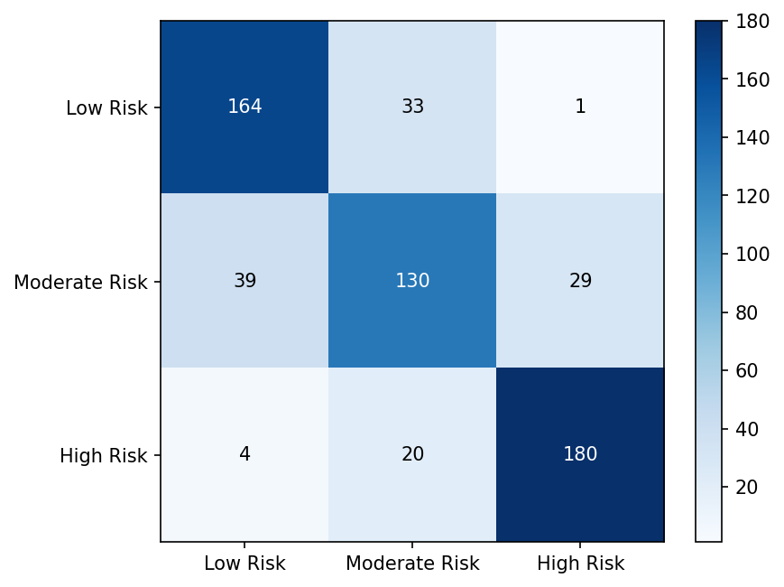

ROC Curves
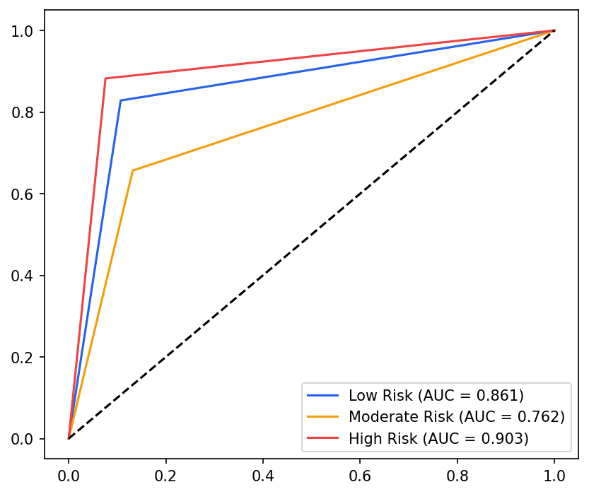

Precision-Recall Curves
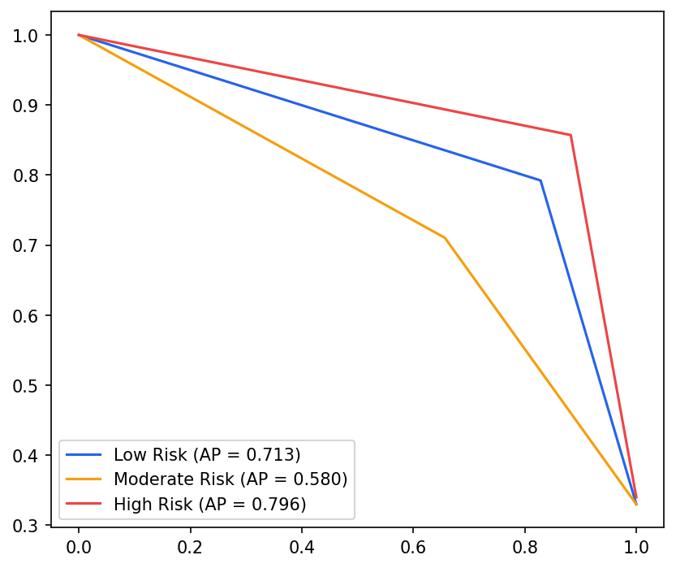

Calibration Curve
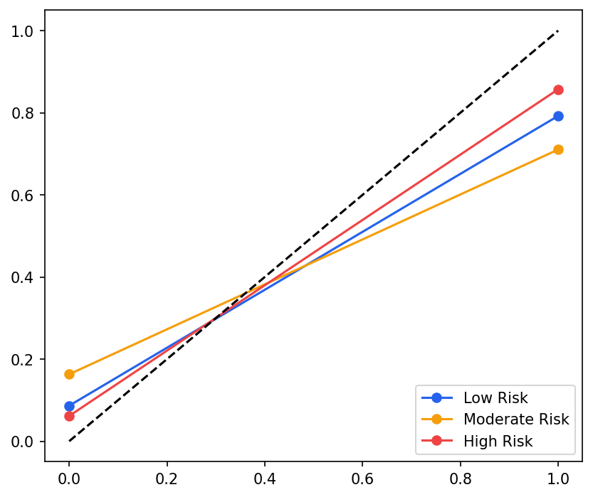

Model Analysis

Feature Importance
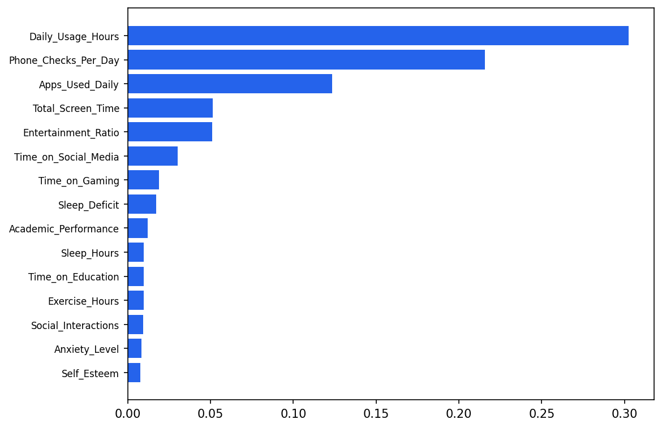

Learning Curves
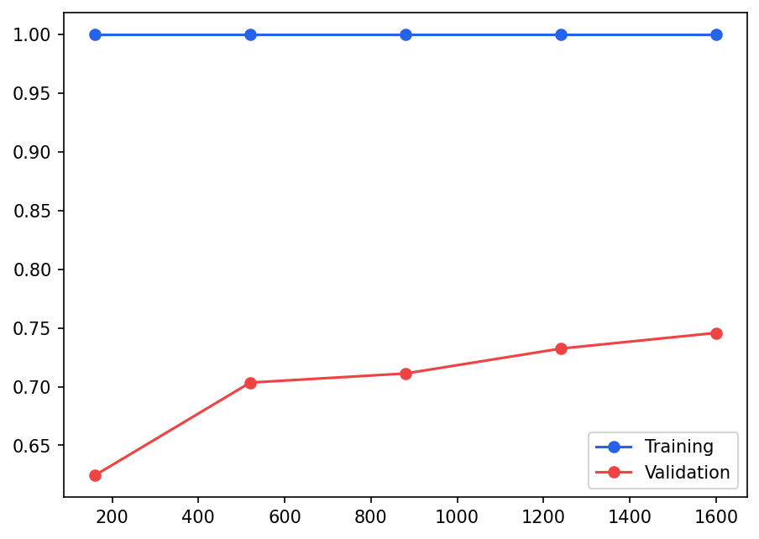

Correlation Heatmap
