Random Forest Classifier Evaluation Report
This report contains the evaluation metrics for the trained model on the test dataset.
Metric | Value
Test Accuracy | 74.5%
Test F1 Macro | 0.7363
CV F1 Macro | 0.7388 +/- 0.0145
Overfit Gap | 0.2637
Cohen's Kappa | 0.6173
MCC | 0.6209
Training Samples | 2400
Test Samples | 600
Features Used | 26

Model Performance

Confusion Matrix
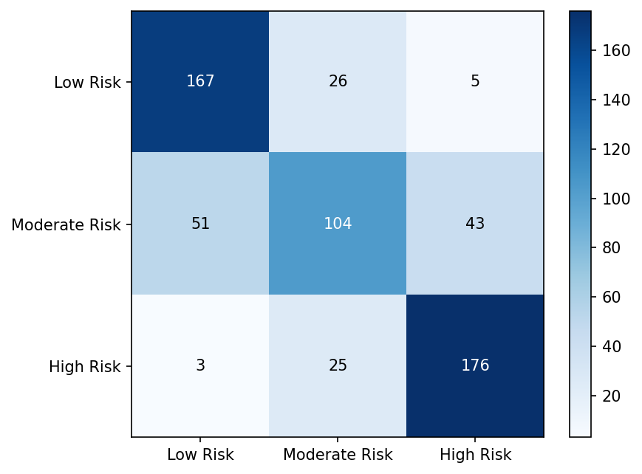

ROC Curves
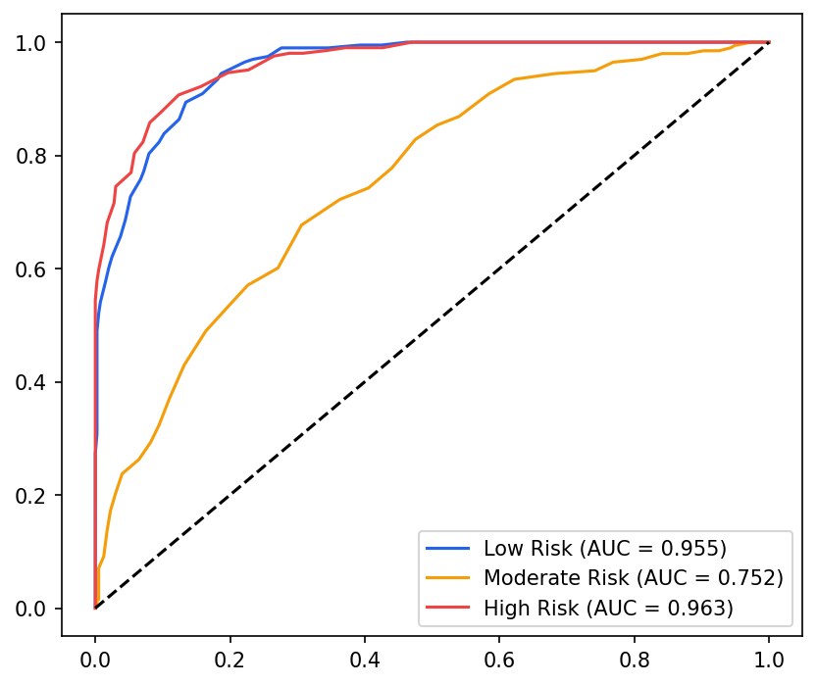

Precision-Recall Curves
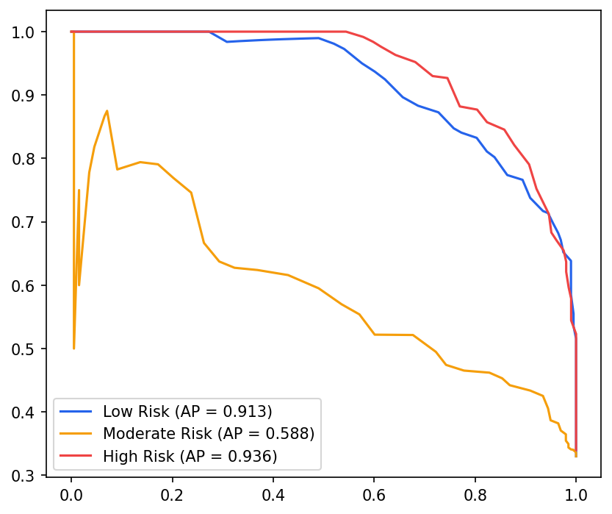

Calibration Curve
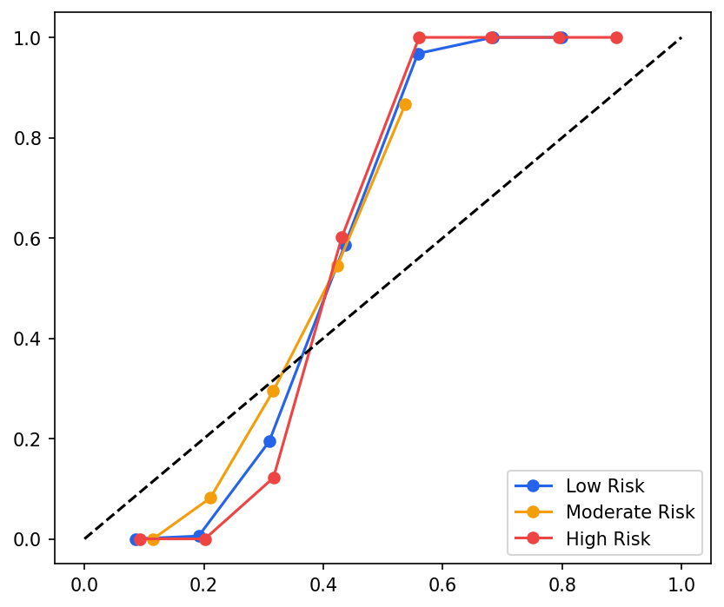

Model Analysis

Feature Importance
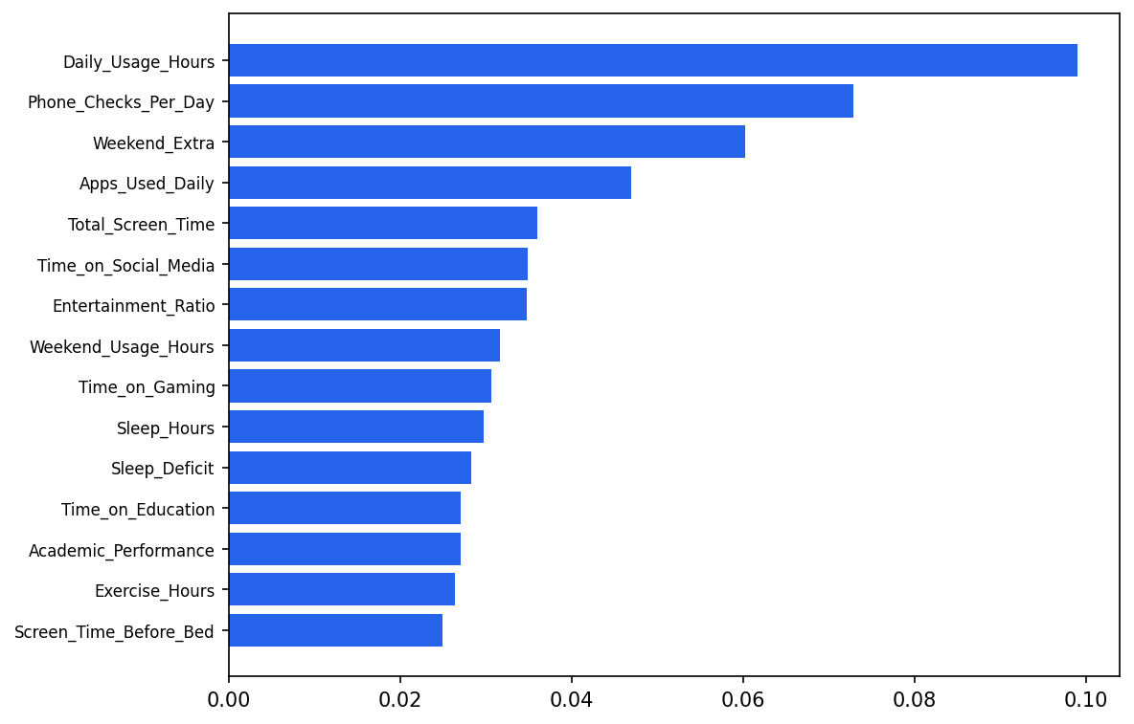

Learning Curves
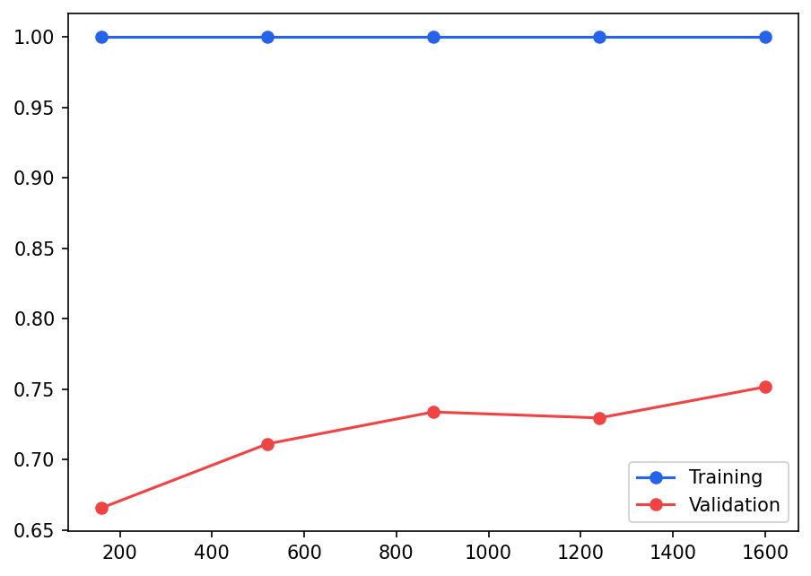

Correlation Heatmap
