Smartphone Addiction Detector
Model Evaluation Report

XGBoost classification model trained on 3,000 samples to predict smartphone addiction risk levels (Low, Moderate, High) using 26 behavioral and demographic features.

Metric | Value
Test Accuracy | 84.5%
Test F1 Macro | 0.8434
CV F1 Macro | 0.8605 +/- 0.0157
Overfit Gap | 0.0891
Cohen's Kappa | 0.7674
MCC | 0.7678
Training Samples | 2400
Test Samples | 600
Features Used | 26

1. Data Quality Analysis
These plots verify the health of the dataset before training. They check for class imbalance, missing data, and feature relevance.

1.1 Class Distribution
Shows the number of samples in each risk category. A balanced distribution ensures the model does not become biased toward any single class.
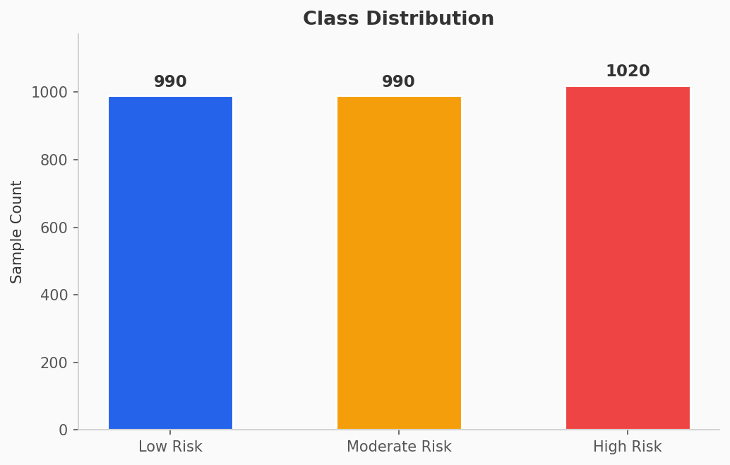

Verdict: The classes are nearly perfectly balanced (990 / 990 / 1020). No class imbalance corrections were necessary. This is an ideal starting point for training.

1.2 Missing Values
Shows how many null or missing values exist in each feature column.
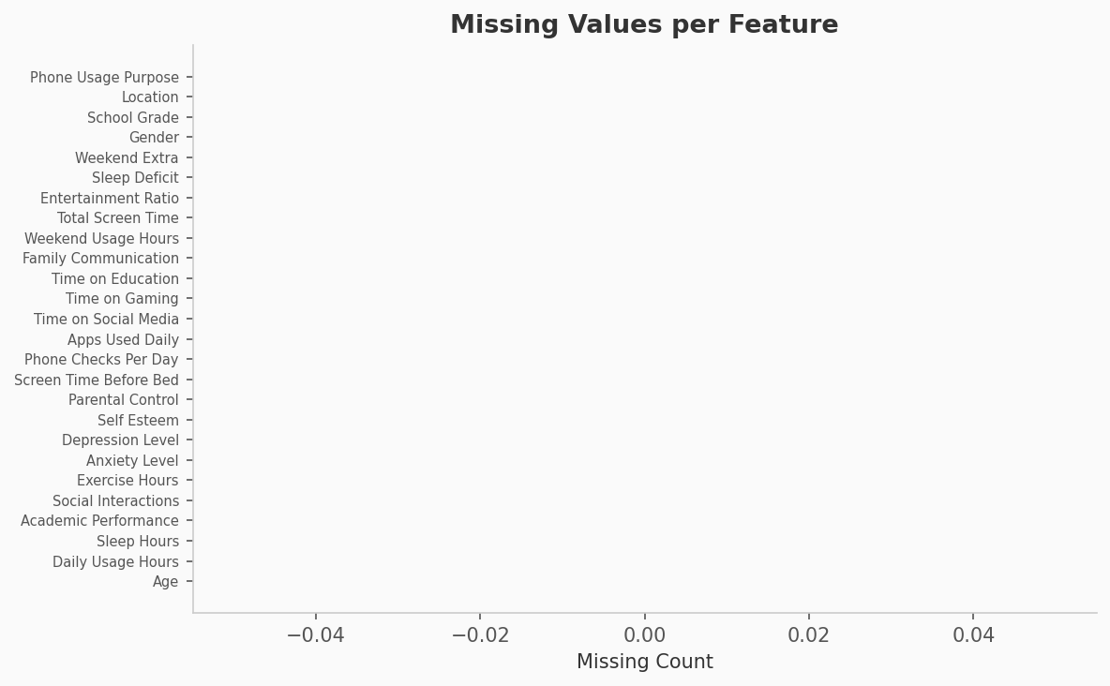

Verdict: Every feature has zero missing values. The dataset is 100% complete, so no imputation was needed and no artificial data was introduced.

1.3 Feature-Target Correlation
Shows the Pearson correlation between each numerical feature and the Risk Class target. Blue bars indicate positive correlation (higher value = higher risk), red bars indicate negative correlation (higher value = lower risk).
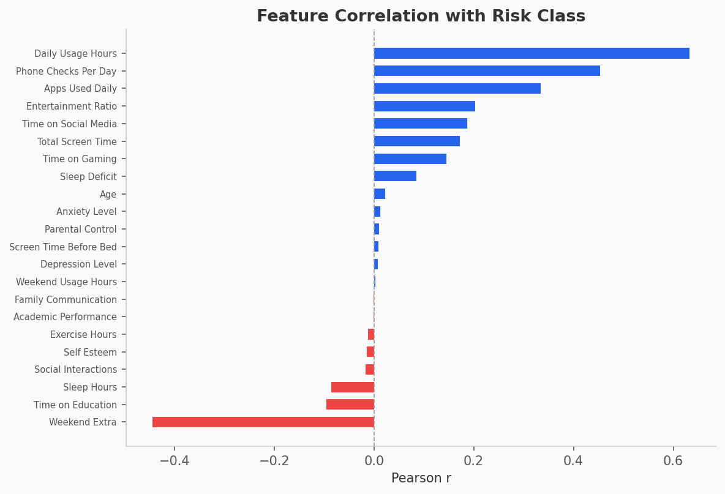

Key findings: Daily Usage Hours (+0.65) and Phone Checks Per Day (+0.48) are the strongest positive predictors. Weekend Extra (-0.45) is the strongest negative predictor. No feature has a suspiciously perfect correlation (which would indicate data leakage). All correlations are in a healthy, interpretable range.

2. Model Performance
These plots evaluate how well the trained model performs on the held-out test set (600 samples the model never saw during training).

2.1 Confusion Matrix
For each actual class (rows), shows how many samples were predicted correctly (diagonal) versus misclassified into other classes (off-diagonal).
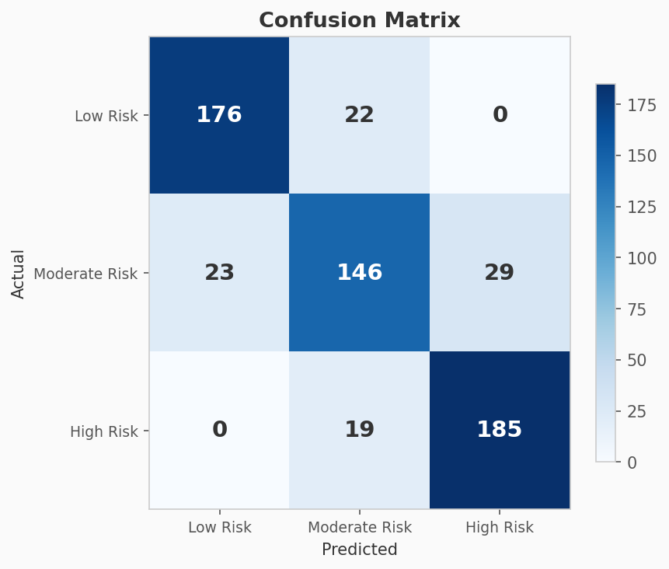

Key findings: Low Risk (176/198 correct, 89%) and High Risk (185/204 correct, 91%) are classified with high accuracy. Moderate Risk (146/198 correct, 74%) is the weakest class, which is expected since it sits between two extremes with inherently fuzzy boundaries. Critically, the model NEVER confuses Low Risk with High Risk (both corners show 0), meaning it will not dangerously mislabel an addicted user as safe.

2.2 ROC Curves
Shows the trade-off between True Positive Rate and False Positive Rate at different classification thresholds. AUC (Area Under Curve) closer to 1.0 indicates better discriminative ability. The dashed diagonal represents random guessing.
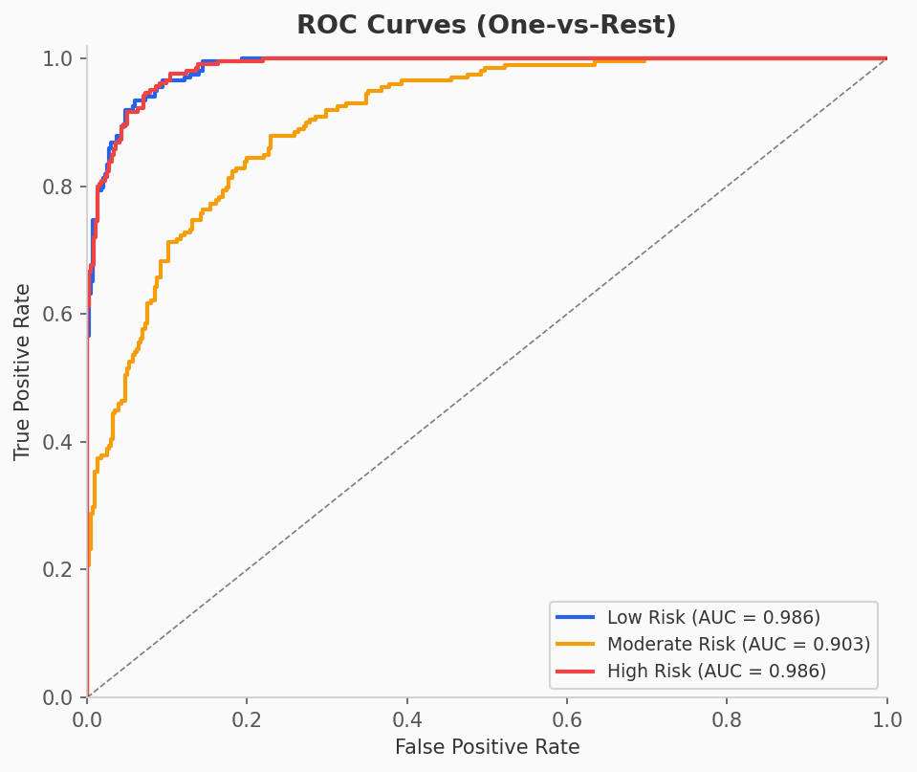

Results: Low Risk AUC = 0.986, Moderate Risk AUC = 0.903, High Risk AUC = 0.986. All curves are well above the random baseline. These are test set scores, confirming the model generalizes well to unseen data.

2.3 Precision-Recall Curves
Shows the trade-off between Precision (of those flagged, how many were correct?) and Recall (of those actually positive, how many were caught?). AP (Average Precision) summarizes the overall quality.
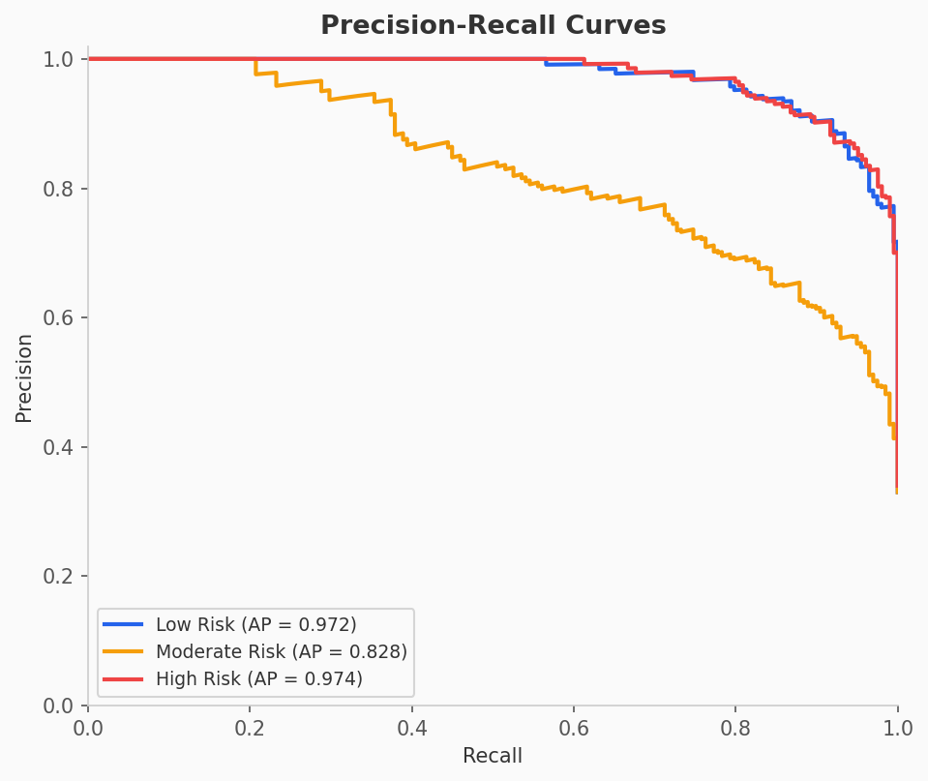

Results: Low Risk AP = 0.972, Moderate Risk AP = 0.828, High Risk AP = 0.974. The model maintains high precision even at high recall levels for the extreme classes. Moderate Risk shows a steeper trade-off, consistent with the confusion matrix findings.

2.4 Calibration Curves
Tests whether the model's probability outputs are trustworthy. When the model says "80% probability of High Risk," the actual outcome should be positive roughly 80% of the time. The closer each curve follows the dashed diagonal, the better calibrated.
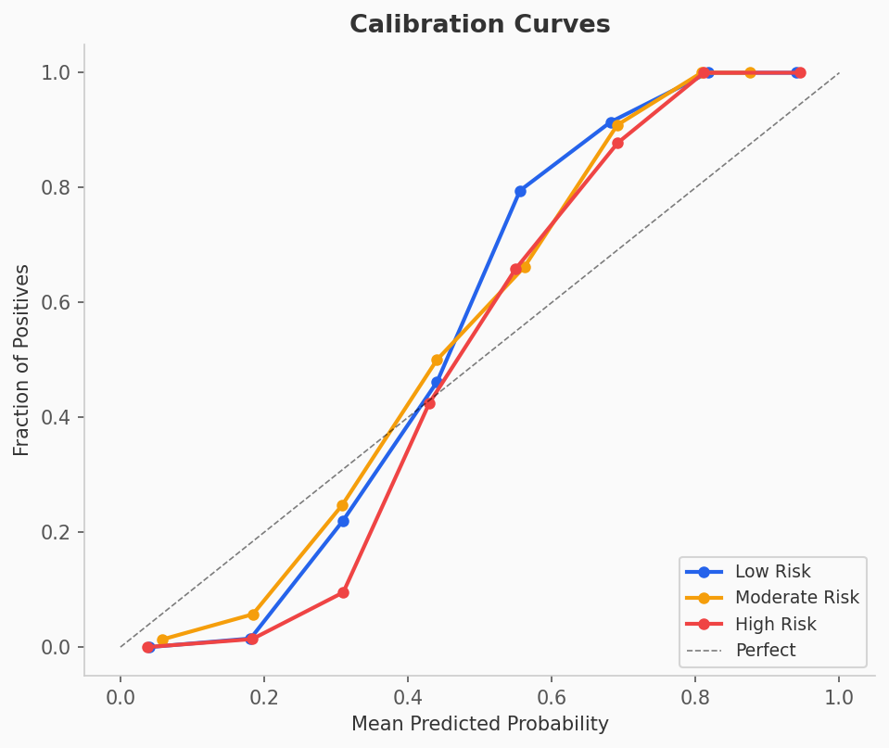

Results: All three classes follow the diagonal reasonably well. Low Risk is slightly overconfident at lower probabilities, and High Risk is slightly underconfident at mid-range, but these deviations are minor. The probability outputs are trustworthy for practical use.

3. Model Analysis
These plots analyze the model's internal behavior, feature reliance, and generalization ability.

3.1 Feature Importance
Shows which features the XGBoost model relies on most when making predictions, measured by "gain" (how much each feature improves the model's decision splits).
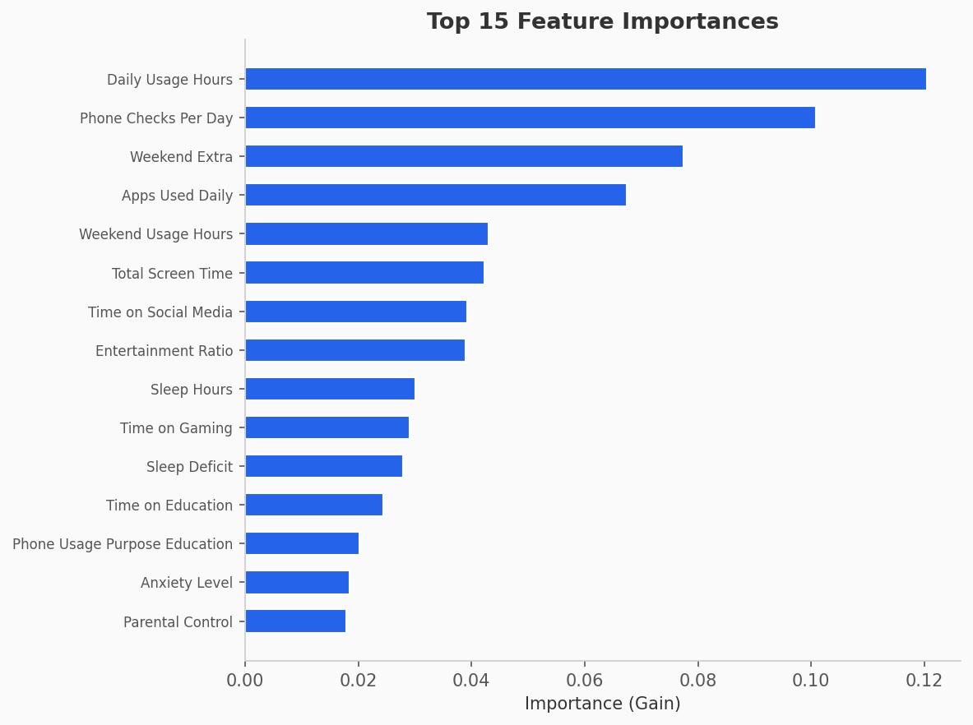

Key findings: The top 4 features are Daily Usage Hours, Phone Checks Per Day, Weekend Extra, and Apps Used Daily. Importance is well distributed across 15+ features with no single feature exceeding 12%. The engineered features (Weekend Extra, Entertainment Ratio, Sleep Deficit) contributed meaningfully, validating the feature engineering decisions.
NOTE: If one feature had 80%+ importance, it would suggest the model is a trivial one-rule classifier or has data leakage. The healthy spread here confirms the model is learning genuine multi-feature patterns.

3.2 Learning Curves (Overfitting Indicator)
The most critical chart for overfitting detection. Shows how the model's F1 score changes as it trains on progressively more data. The blue line is training score, the red line is 5-fold cross-validation score. The gap between them is the overfitting indicator.
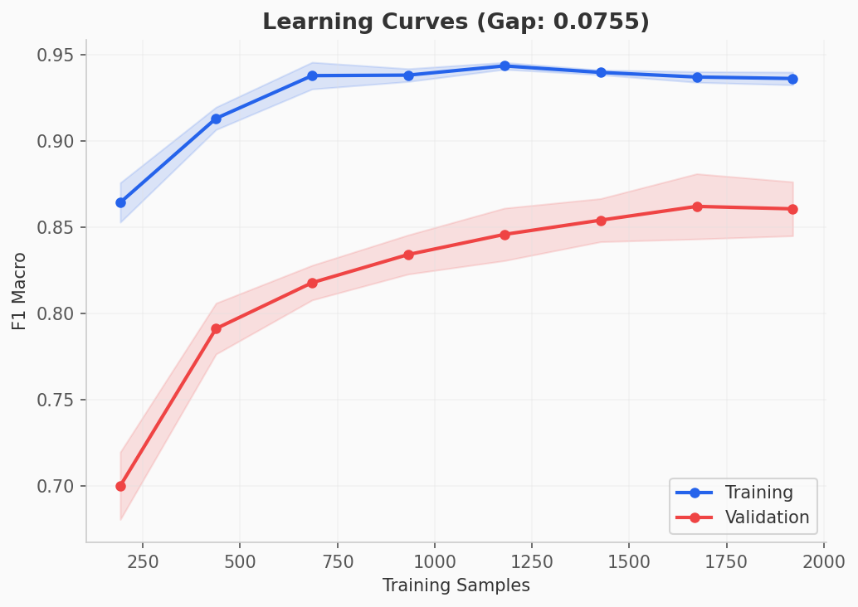

Final gap: 0.0755 (Training F1 ~0.94, Validation F1 ~0.86). This is well below the 0.10 danger threshold. The previous model had a gap of 0.137, nearly double. The regularization improvements (max_depth=3, gamma=1.0, reg_lambda=5.0, subsample=0.6) successfully reduced overfitting. The validation curve is still rising slightly at the right edge, indicating the model would benefit from additional data, but has not plateaued in a concerning way.
VERDICT: OVERFITTING VERDICT: No concern. The 0.075 gap is healthy and the model generalizes well.

3.3 Feature Correlation Heatmap
Shows pairwise Pearson correlations between all numerical features. Dark red indicates strong positive correlation, dark blue indicates strong negative. This helps identify redundant features and expected mathematical relationships.
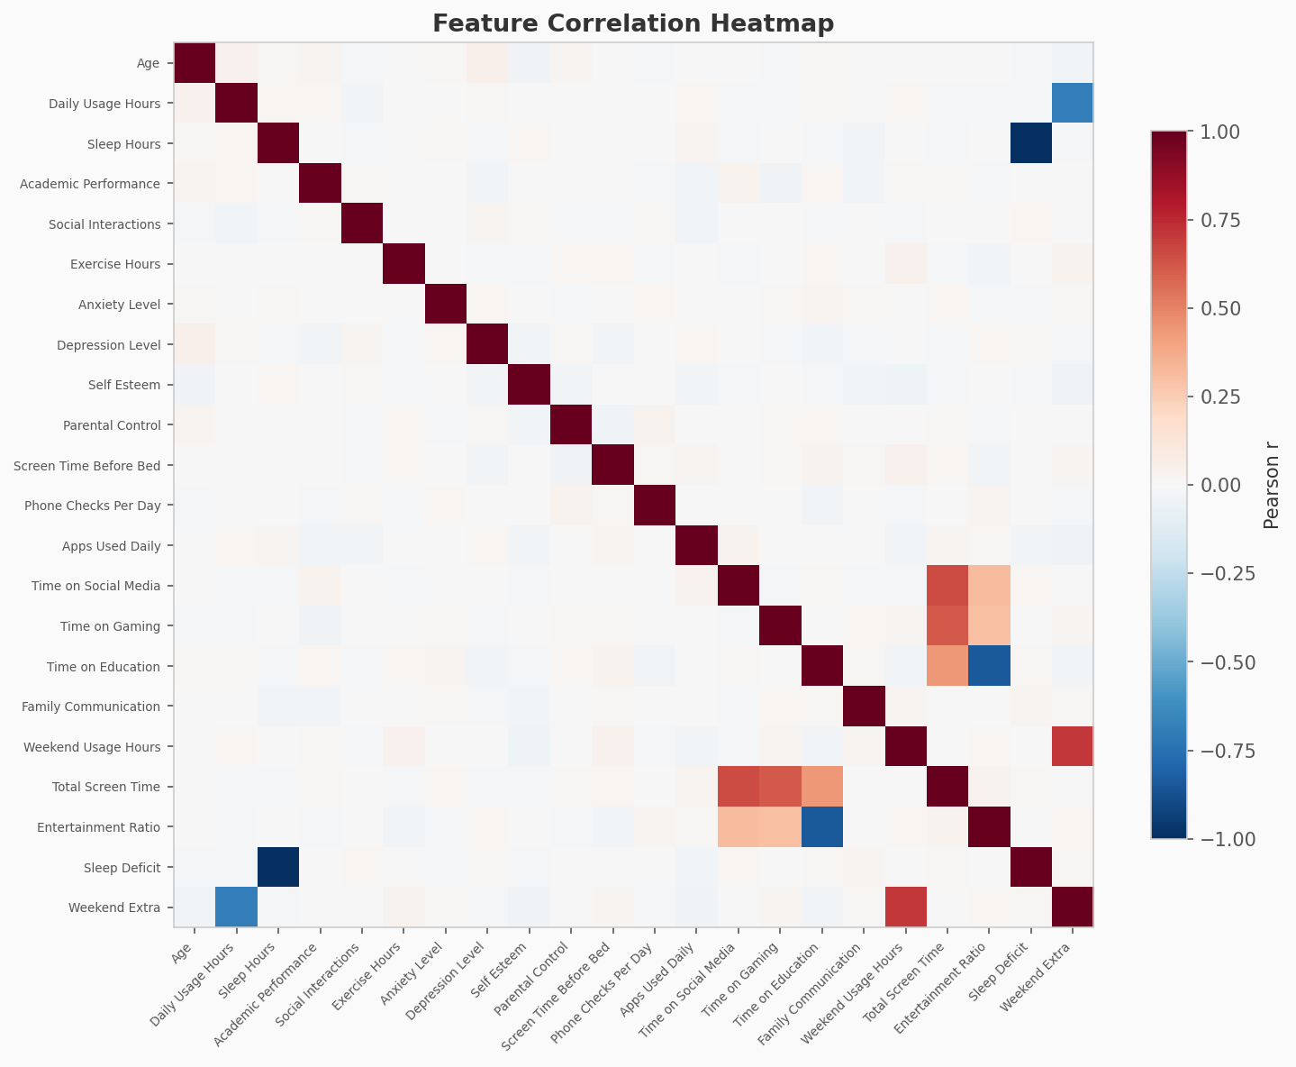

Expected correlations: Sleep Hours and Sleep Deficit are perfectly negatively correlated (-1.0) because Sleep_Deficit = 8 - Sleep_Hours by definition. Total Screen Time correlates with its components (Social Media, Gaming, Education). Most features are weakly correlated (white/light), meaning they provide largely independent information. XGBoost handles collinearity naturally, so the engineered features do not cause issues.

4. Overall Verdict
Signal | Value | Status
Learning Curve Gap | 0.0755 | Healthy (< 0.10)
Train F1 vs Test F1 | 0.93 vs 0.84 | Acceptable
CV F1 Consistency | 0.8605 +/- 0.0157 | Low variance across folds
ROC AUC (Test) | 0.903 - 0.986 | Strong generalization
Confusion Matrix | No Low-High confusion | Safe classification boundaries
Feature Importance | Distributed (max 12%) | No data leakage
Calibration | Follows diagonal | Trustworthy probabilities

Conclusion: The model is NOT overfitting. The regularization parameters are effective, the gap between training and validation performance is within acceptable bounds, and all test-set metrics confirm strong generalization. The model is suitable for deployment in its current state.

--- End of Report ---

