

**Introduction**

* Katalon Studio is a simple and powerful automation solution built for testers everywhere.
* Katalon Studio revolutionizes the use of open-source test automation frameworks such as Selenium and Appium by eliminating their technical complexities to allow developers and QAs to efficiently set up, create, run, report, and manage their automated tests.
* It also offers a viable alternative to commercial test automation solutions that are not affordable to many small and medium-sized teams.

**Installation Guide**

* **Downloading Katalon:**

Go to <https://www.katalon.com/download/>

To download Katalon, will download .zip file.

* **Start Katalon:**

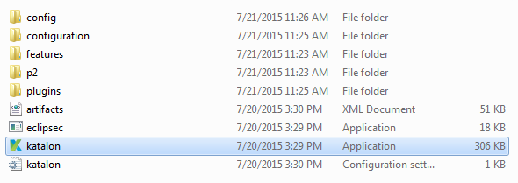

* **Activate Katalon:**

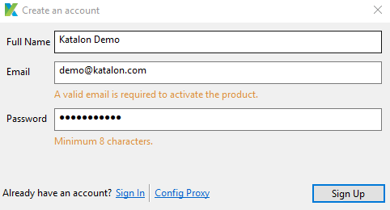

* **Creating a Project:**
* **Creating a Project will give us entire folder structure for Project as below:**

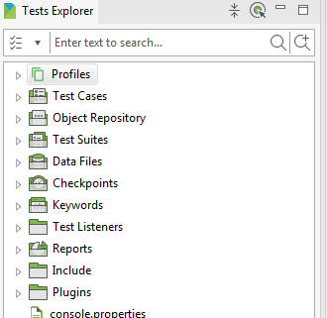

* **Also Katalon has provided option for Importing Sample project to understand Project Structure.**
* **Creating a Test Case:**

The [Web Recorder Utility](http://docs.katalon.com/pages/viewpage.action?pageId=5118055) function captures your actions being performed on the application and converts them into runnable code in the back-end.

* **Record Test with Record web Function**

**Step 1:** Create a new Test Case

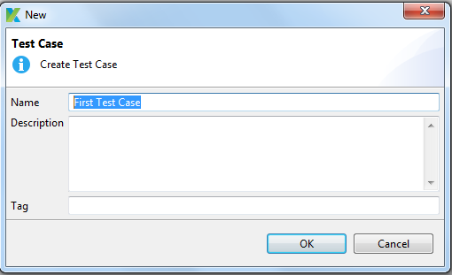

**Step 2: Click on Record Web**

**Step 3: Recorder window will be open**

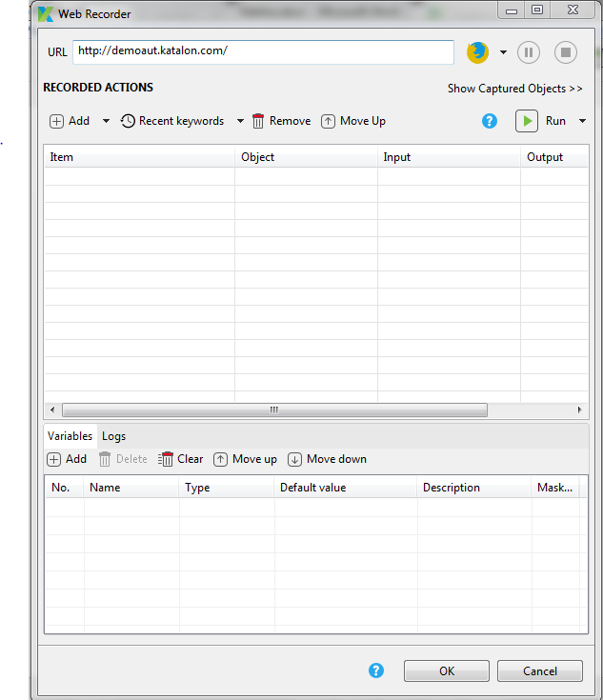

**Step 4: Provide URL and browser from the dropdown option**

**Step 5: Perform the operation on given URL**

Using this step we can perform all operation and the related code will be saved in Test Case files

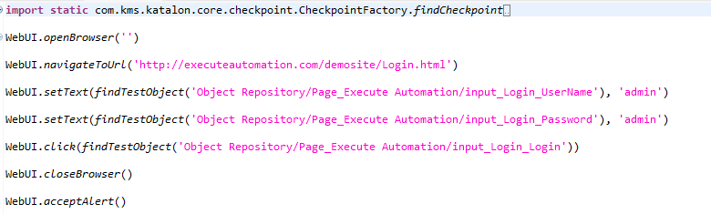

User

* **Creating a Test Suite:**

**Step 1: In the Given folder structure Add Test suite in Test suite Folder**

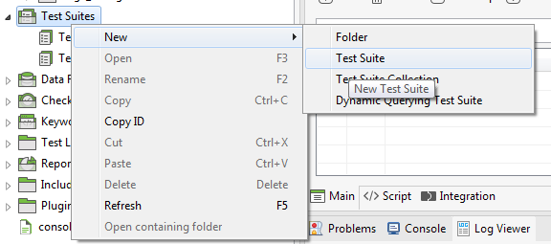

**Step 2: Provide the Suitable name to Test suite.**

**Step 3: Adding Test case to Test Suit**

Open the created Test suite, it will provide default option with all Test cases available in Folder.

Add accordingly relevant Test case in to Test suite and decide whether to execute or not by checking or unchecking run checkbox

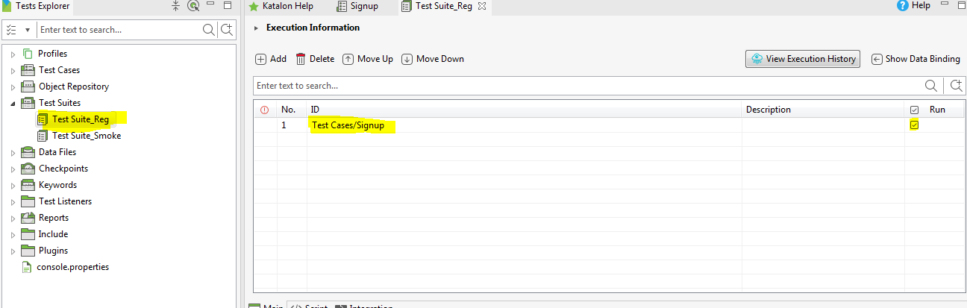

**Step 4: Execute the Test suite**

* **Creating collection of a Test Suite:**

**Step 1: Creating a Test suite collection**

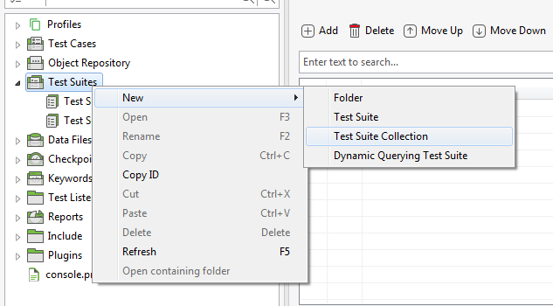

**Step 2: Adding Test Suites to Test suite collection**

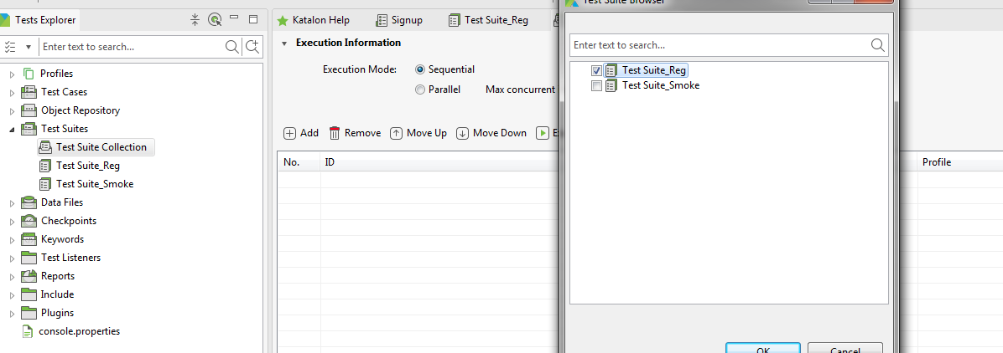

**Step 3: Execute Test suite Collection**

User can define executing Test suite Collection either by sequentially or parallel.

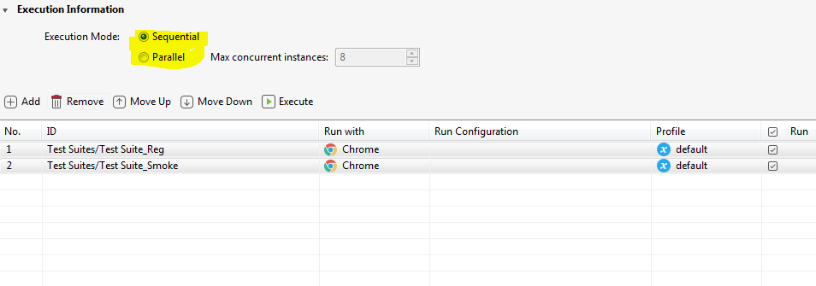

* **Test Case Reports:**

To see reports in Katalon we have to navigateto **LOG Viewer** option

**Default view:**

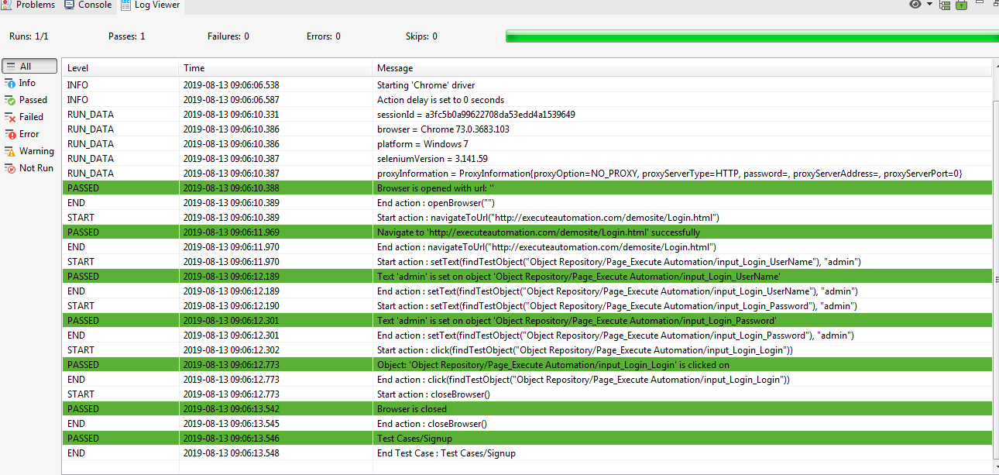

**Tree view:**

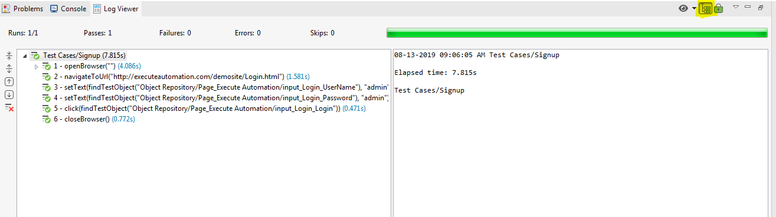

* **E-Mail Configuration:**

**Step 1: To perform Email Settings we need to go**

**Project->Setting->Email**

For Host Name and related setting User can refer

<https://docs.katalon.com/katalon-studio/docs/emails-settings.html#configure-email-settings-in-email-preferences>

**Step 2: Adding Email details to mail reports**

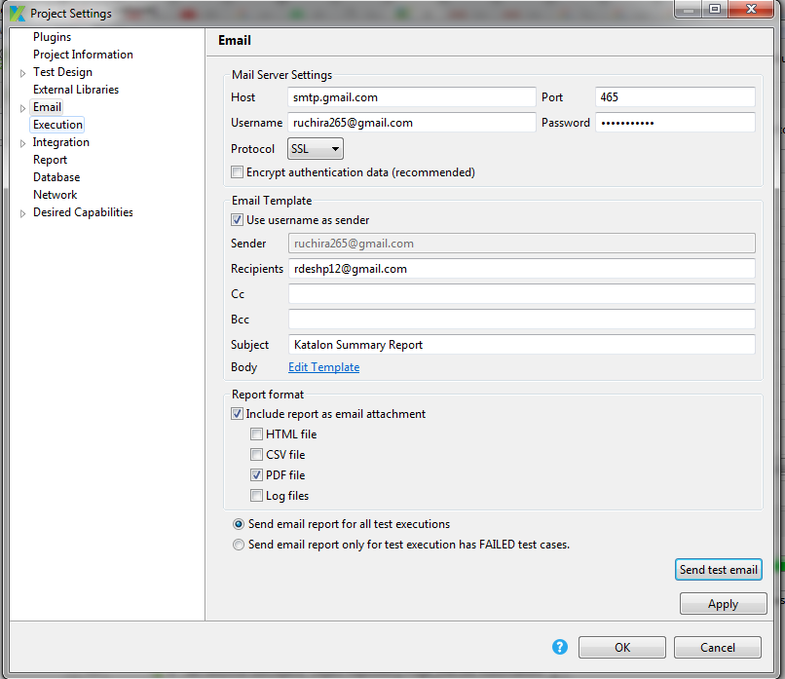

* **Git Configuration:**

**Step 1: Enable Git Configuration**

Window -> Katalon Studio Preferences -> Katalon -> Git

Check **“Enable Git Configuration”.**

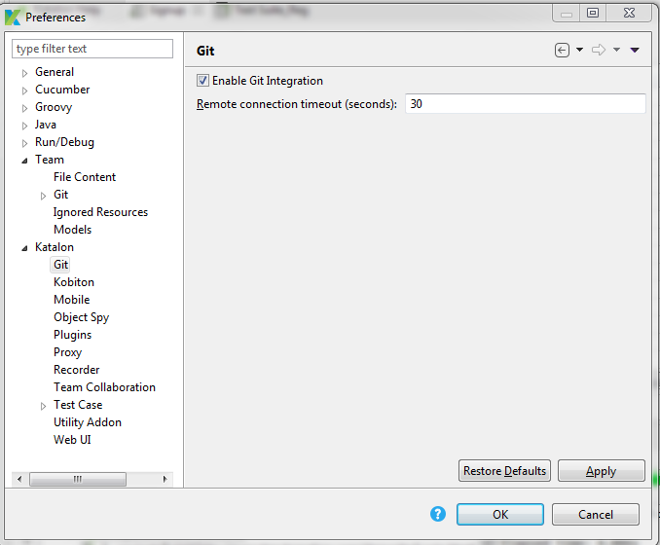

**Step 2: Go to any repository such as GitLab or Bit Bucket**

**2.1 Create a Repository** 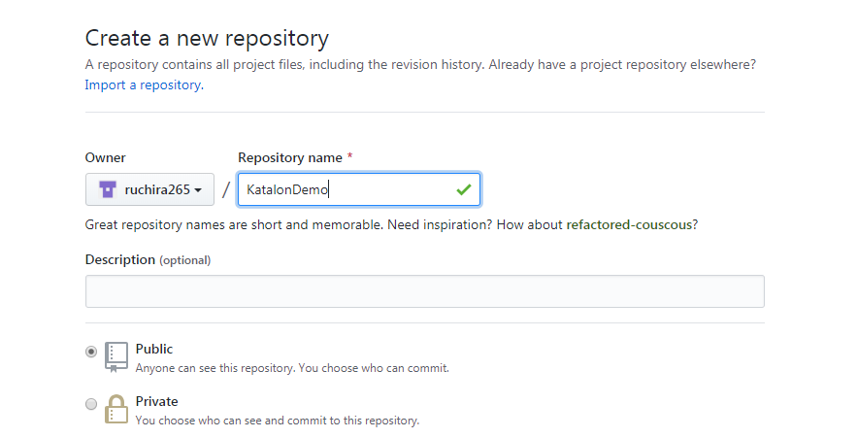

**2.1 Open Katalon Project -> Git Icon -> Clone Project**

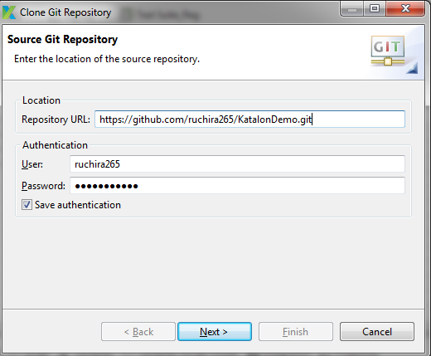

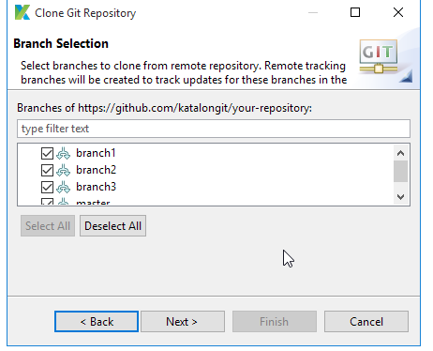

**This will configure git to project , Accordingly we can verify .git file in project**

**2. 2 we can commit our code from git commit option.**

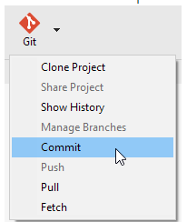

* **Jenkins Configuration:**

**Step 1: Download Jenkins**

**Step 2: Create a Freestyle Project in Jenkins**

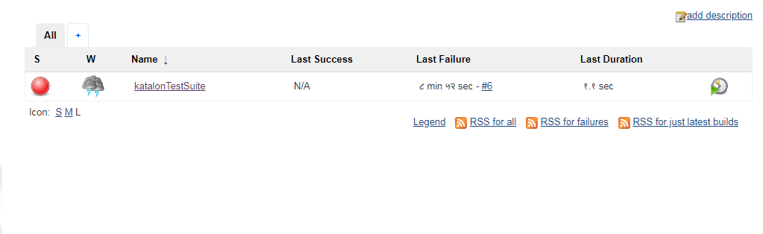

**Step 3: Add build step as “Execute Windows Batch Command”**

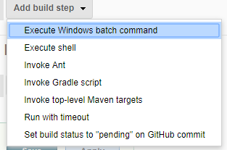

**Step 4: Paste the command in Build Triggers**

katalon -runMode=console -projectPath="C:\Project\Sample Project.prj" -reportFolder="Reports" -reportFileName="report" -retry=0 -testSuitePath="Test Suites/TS_RegressionTest" -browserType="Chrome"

**Step 5 : Perform Build in Jenkins**