# Env:

## Windows 10 64-bit

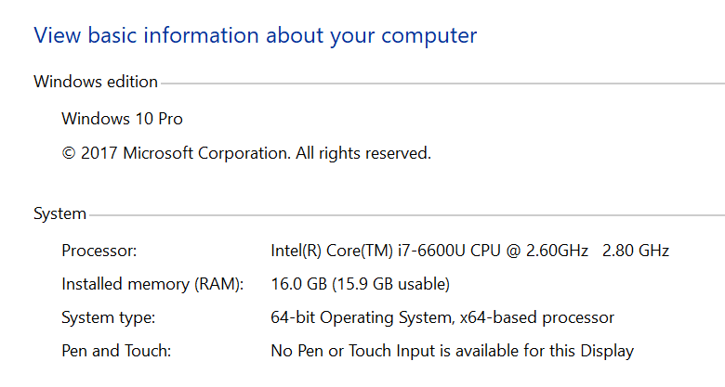

## Python **3.6.4 32-bit** (download and run a python windows version installation package (exe file) from python official website https://www.python.org/downloads/windows/)

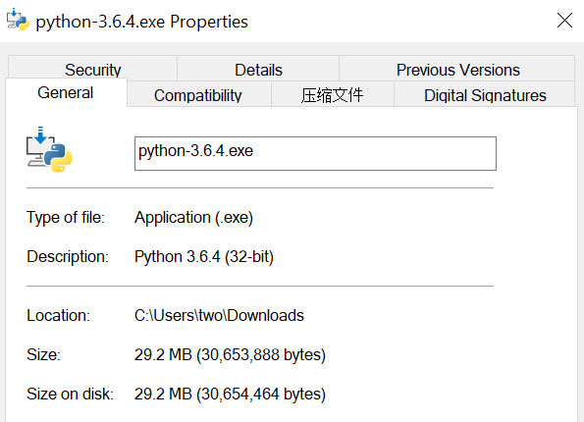

two@TW2016152 MINGW32 ~/Desktop/New folder

$ python --version

Python 3.6.4

two@TW2016152 MINGW32 ~/Desktop/New folder

$ which python

/c/Users/two/AppData/Local/Programs/Python/Python36-32/python

# Install Pip: <https://pip.pypa.io/en/stable/installing/>

## Download get-pip.py

two@TW2016152 MINGW32 ~/Desktop/New folder

$ pip install tensorflow

bash: pip: command not found

two@TW2016152 MINGW32 ~/Desktop/New folder

$ pwd

/c/Users/two/Desktop/New folder

two@TW2016152 MINGW32 ~/Desktop/New folder

$ ll *

-rwxr-xr-x 1 two 197609 1595408 Feb 22 09:38 get-pip.py*

## Run get-pip.py (this will install pip, setuptools, and wheel)

two@TW2016152 MINGW32 ~/Desktop/New folder

$ python get-pip.py

Requirement already up-to-date: pip in c:\users\two\appdata\local\programs\python\python36-32\lib\site-packages

Collecting wheel

Downloading wheel-0.30.0-py2.py3-none-any.whl (49kB)

Installing collected packages: wheel

Successfully installed wheel-0.30.0

two@TW2016152 MINGW32 ~/Desktop/New folder

$ ls c:/users/two/appdata/local/programs/python/python36-32/lib/site-packages

__pycache__/ easy_install.py pip/ pip-9.0.1.dist-info/ pkg_resources/ README.txt setuptools/ setuptools-28.8.0.dist-info/ wheel/ wheel-0.30.0.dist-info/

$ ls c:/users/two/appdata/local/programs/python/python36-32/Scripts

easy_install.exe* easy_install-3.6.exe* pip.exe* pip3.6.exe* pip3.exe* wheel.exe*

## Add pip into PATH

* + 1. Cannot find pip command

two@TW2016152 MINGW32 ~/Desktop/New folder

$ which pip

which: no pip in (/c/Users/two/bin:/mingw32/bin:/usr/local/bin:/usr/bin:/bin:/mingw32/bin:/usr/bin:/c/Users/two/bin:/c/Program Files (x86)/Intel/iCLS Client:/c/Program Files/Intel/iCLS Client:/c/Windows/system32:/c/Windows:/c/Windows/System32/Wbem:/c/Windows/System32/WindowsPowerShell/v1.0:/c/Program Files (x86)/Intel/Intel(R) Management Engine Components/DAL:/c/Program Files/Intel/Intel(R) Management Engine Components/DAL:/c/Program Files (x86)/Intel/Intel(R) Management Engine Components/IPT:/c/Program Files/Intel/Intel(R) Management Engine Components/IPT:/c/Program Files (x86)/NVIDIA Corporation/PhysX/Common:/c/WINDOWS/system32:/c/WINDOWS:/c/WINDOWS/System32/Wbem:/c/WINDOWS/System32/WindowsPowerShell/v1.0:/c/Program Files (x86)/Skype/Phone:/cmd:/c/Users/two/AppData/Local/Microsoft/WindowsApps:/c/Program Files/Microsoft VS Code/bin:/c/Users/two/AppData/Local/Programs/Python/Python36-32:/usr/bin/vendor_perl:/usr/bin/core_perl)

two@TW2016152 MINGW32 ~/Desktop/New folder

$ env | grep PATH

EXEPATH=C:\Program Files (x86)\Git

MOZ_PLUGIN_PATH=C:\Program Files (x86)\Foxit Software\Foxit Reader Plus\plugins\

PATHEXT=.COM;.EXE;.BAT;.CMD;.VBS;.VBE;.JS;.JSE;.WSF;.WSH;.MSC

ACLOCAL_PATH=/mingw32/share/aclocal:/usr/share/aclocal

MANPATH=/mingw32/share/man:/usr/local/man:/usr/share/man:/usr/man:/share/man

PATH=/c/Users/two/bin:/mingw32/bin:/usr/local/bin:/usr/bin:/bin:/mingw32/bin:/usr/bin:/c/Users/two/bin:/c/Program Files (x86)/Intel/iCLS Client:/c/Program Files/Intel/iCLS Client:/c/Windows/system32:/c/Windows:/c/Windows/System32/Wbem:/c/Windows/System32/WindowsPowerShell/v1.0:/c/Program Files (x86)/Intel/Intel(R) Management Engine Components/DAL:/c/Program Files/Intel/Intel(R) Management Engine Components/DAL:/c/Program Files (x86)/Intel/Intel(R) Management Engine Components/IPT:/c/Program Files/Intel/Intel(R) Management Engine Components/IPT:/c/Program Files (x86)/NVIDIA Corporation/PhysX/Common:/c/WINDOWS/system32:/c/WINDOWS:/c/WINDOWS/System32/Wbem:/c/WINDOWS/System32/WindowsPowerShell/v1.0:/c/Program Files (x86)/Skype/Phone:/cmd:/c/Users/two/AppData/Local/Microsoft/WindowsApps:/c/Program Files/Microsoft VS Code/bin:/c/Users/two/AppData/Local/Programs/Python/Python36-32:/usr/bin/vendor_perl:/usr/bin/core_perl

PKG_CONFIG_PATH=/mingw32/lib/pkgconfig:/mingw32/share/pkgconfig

INFOPATH=/usr/local/info:/usr/share/info:/usr/info:/share/info

HOMEPATH=\Users\two

ORIGINAL_PATH=/mingw32/bin:/usr/bin:/c/Users/two/bin:/c/Program Files (x86)/Intel/iCLS Client:/c/Program Files/Intel/iCLS Client:/c/Windows/system32:/c/Windows:/c/Windows/System32/Wbem:/c/Windows/System32/WindowsPowerShell/v1.0:/c/Program Files (x86)/Intel/Intel(R) Management Engine Components/DAL:/c/Program Files/Intel/Intel(R) Management Engine Components/DAL:/c/Program Files (x86)/Intel/Intel(R) Management Engine Components/IPT:/c/Program Files/Intel/Intel(R) Management Engine Components/IPT:/c/Program Files (x86)/NVIDIA Corporation/PhysX/Common:/c/WINDOWS/system32:/c/WINDOWS:/c/WINDOWS/System32/Wbem:/c/WINDOWS/System32/WindowsPowerShell/v1.0:/c/Program Files (x86)/Skype/Phone:/cmd:/c/Users/two/AppData/Local/Microsoft/WindowsApps:/c/Program Files/Microsoft VS Code/bin:/c/Users/two/AppData/Local/Programs/Python/Python36-32

* + 1. Add “C:\Users\two\AppData\Local\Programs\Python\Python36-32\Scripts” into PATH Env Variables

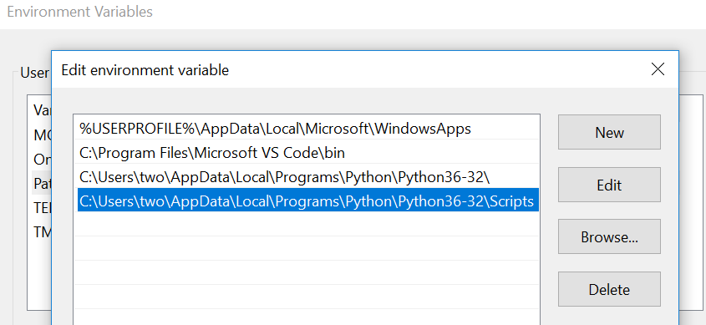

two@TW2016152 MINGW32 ~/Desktop/New folder

$ which pip

/c/Users/two/AppData/Local/Programs/Python/Python36-32/Scripts/pip

two@TW2016152 MINGW32 ~/Desktop/New folder

$ pip --version

pip 9.0.1 from c:\users\two\appdata\local\programs\python\python36-32\lib\site-packages (python 3.6)

# Install Tensorflow: <https://www.tensorflow.org/install/>

## Download TF package (if cannot connect to pip source site)

<http://mirrors.aliyun.com/pypi/simple/tensorflow/>

## Install Manually

two@TW2016152 MINGW32 ~/Desktop/New folder

$ ll

total 79173

-rwxr-xr-x 1 two 197609 1595408 Feb 22 09:38 get-pip.py*

-rw-r--r-- 1 two 197609 14708138 Feb 22 10:54 tensorflow-1.0.0-cp35-cp35m-win_amd64.whl

-rw-r--r-- 1 two 197609 32306886 Feb 22 10:51 tensorflow-1.6.0rc0-cp36-cp36m-win_amd64.whl

-rw-r--r-- 1 two 197609 32307657 Feb 22 10:51 tensorflow-1.6.0rc1-cp36-cp36m-win_amd64.whl

two@TW2016152 MINGW32 ~/Desktop/New folder

$ pip install upgrade tensorflow-1.0.0-cp35-cp35m-win_amd64.whl

tensorflow-1.0.0-cp35-cp35m-win_amd64.whl is not a supported wheel on this platform.