<https://www.reddit.com/r/MachineLearning/comments/15zrpp/please_explain_support_vector_machines_svm_like_i/>

1. We have 2 colors of balls on the table that we want to separate.

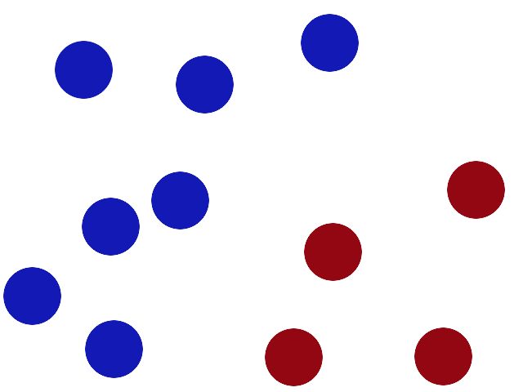

1. We get a stick and put it on the table, this works pretty well right?

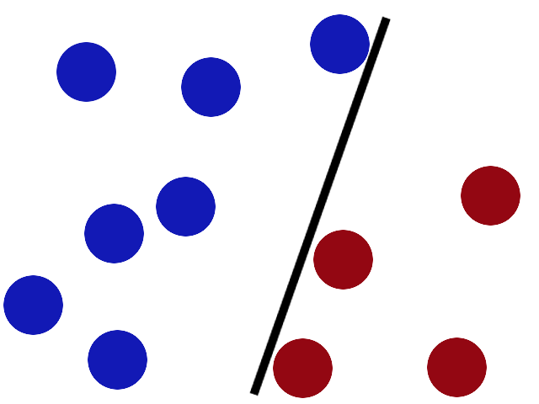

1. Some villain comes and places more balls on the table, it kind of works but one of the balls is on the wrong side and there is probably a better place to put the stick now.

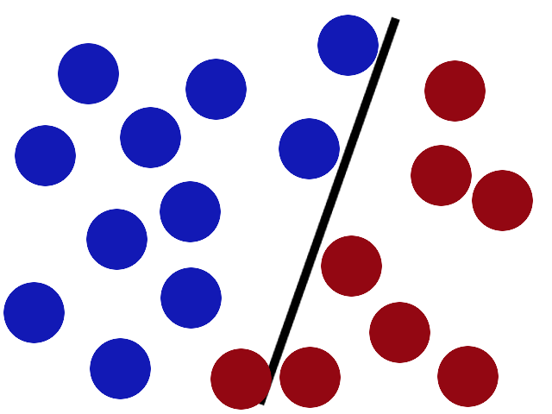

1. SVMs try to put the stick in the best possible place by having as big a gap on either side of the stick as possible.

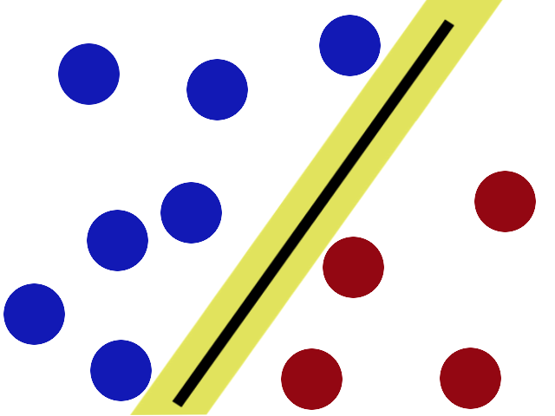

1. Now when the villain returns the stick is still in a pretty good spot.

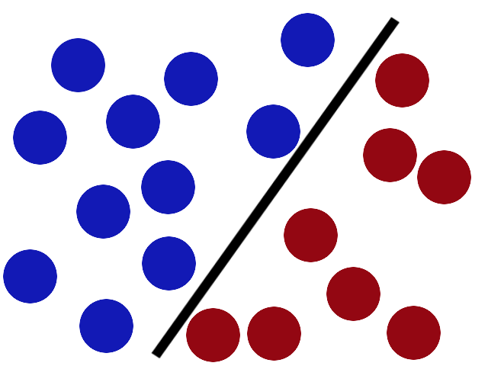

1. There is another trick in the SVM toolbox that is even more important. Say the villain has seen how good you are with a stick so he gives you a new challenge.

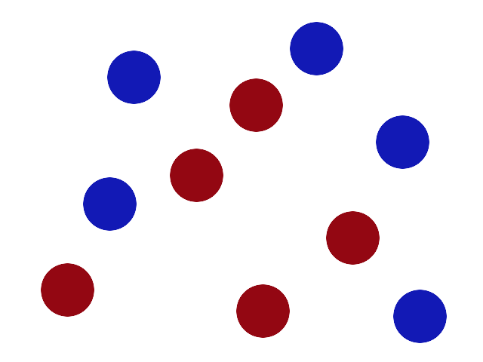

1. There’s no stick in the world that will let you split those balls well, so what do you do? You flip the table of course! Throwing the balls into the air. Then, with your pro ninja skills, you grab a sheet of paper and slip it between the balls.

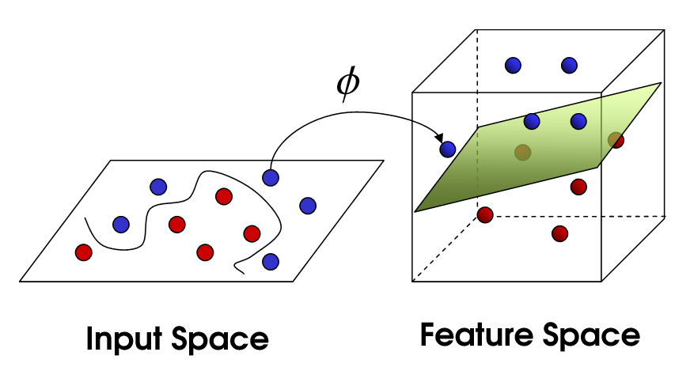

1. Now, looking at the balls from where the villain is standing, they balls will look split by some curvy line.

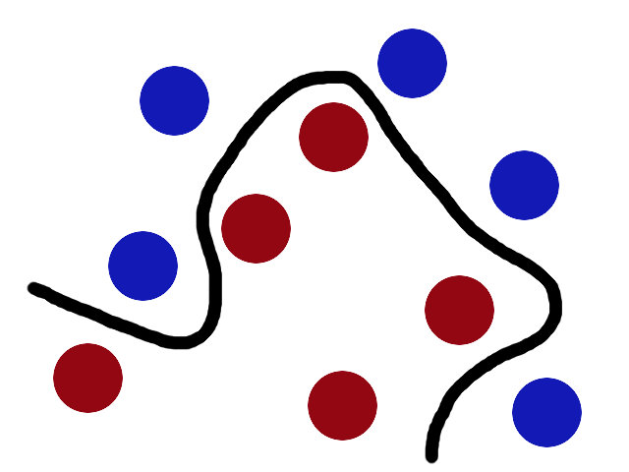

1. Boring adults the call **balls** **data**, the **stick** a **classifier**, **the** **biggest** **gap** **trick** **optimization**, call **flipping** the table **kernelling** and **the** **piece of paper** a **hyperplane**.

**Note:**

**拍桌子那一步的kernel操作，弹起的不光是小球，是整个平面，小球作为landmarks扭曲着整个平面，扭曲程度根据核函数计算，然后用这张纸就能切出一个超平面，这个平面的边缘是一条曲线。**

<https://www.youtube.com/watch?v=3liCbRZPrZA>

