# Env:

## Windows 10 64-bit

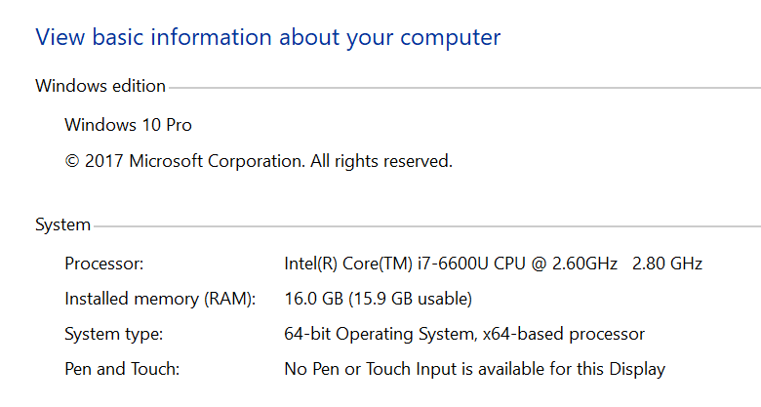

## Python **3.5.4 64-bit** (download and run a python windows version installation package (exe file) from python official website [**https://www.python.org/downloads/windows/**](https://www.python.org/downloads/windows/)**)**

**PATH env will be updated automatically when installing python**

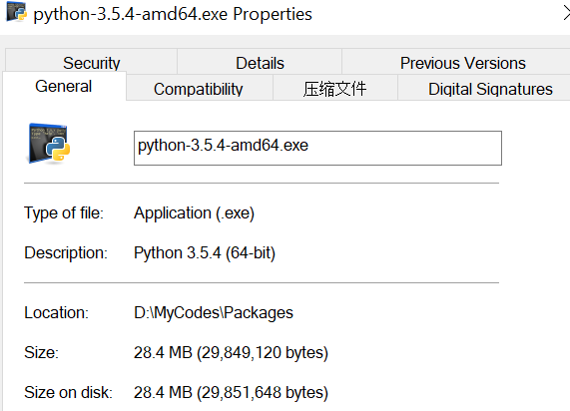

two@TW2016152 MINGW32 /d/MyCodes/Packages

$ which python

/c/Users/two/AppData/Local/Programs/Python/Python35/python

two@TW2016152 MINGW32 /d/MyCodes/Packages

$ python --version

Python 3.5.4

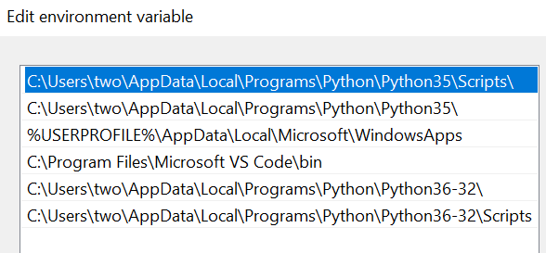

# Install Pip:

## Pip is already installed with python 3.5

two@TW2016152 MINGW32 /d/MyCodes/Packages

$ which pip

/c/Users/two/AppData/Local/Programs/Python/Python35/Scripts/pip

two@TW2016152 MINGW32 /d/MyCodes/Packages

$ pip --version

pip 9.0.1 from c:\users\two\appdata\local\programs\python\python35\lib\site-packages (python 3.5)

two@TW2016152 MINGW32 /d/MyCodes/Packages

$ ll /c/Users/two/AppData/Local/Programs/Python/Python35/Scripts/

total 480

-rwxr-xr-x 1 two 197609 98193 Feb 22 11:22 easy_install.exe*

-rwxr-xr-x 1 two 197609 98193 Feb 22 11:22 easy_install-3.5.exe*

-rwxr-xr-x 1 two 197609 98165 Feb 22 11:23 pip.exe*

-rwxr-xr-x 1 two 197609 98165 Feb 22 11:23 pip3.5.exe*

-rwxr-xr-x 1 two 197609 98165 Feb 22 11:23 pip3.exe*

two@TW2016152 MINGW32 /d/MyCodes/Packages

$ ll /c/Users/two/AppData/Local/Programs/Python/Python35/lib/site-packages

total 22

drwxr-xr-x 1 two 197609 0 Feb 22 11:22 __pycache__/

-rw-r--r-- 1 two 197609 126 Feb 22 11:22 easy_install.py

drwxr-xr-x 1 two 197609 0 Feb 22 11:23 pip/

drwxr-xr-x 1 two 197609 0 Feb 22 11:23 pip-9.0.1.dist-info/

drwxr-xr-x 1 two 197609 0 Feb 22 11:22 pkg_resources/

-rw-r--r-- 1 two 197609 121 Feb 13 2017 README.txt

drwxr-xr-x 1 two 197609 0 Feb 22 11:22 setuptools/

drwxr-xr-x 1 two 197609 0 Feb 22 11:22 setuptools-28.8.0.dist-info/

## Run get-pip.py (this will install ~~pip, setuptools~~, and wheel)

two@TW2016152 MINGW32 /d/MyCodes/Packages

$ pwd

/d/MyCodes/Packages

two@TW2016152 MINGW32 /d/MyCodes/Packages

$ ls

get-pip.py* python-3.5.4-amd64.exe* tensorflow-1.0.0-cp35-cp35m-win_amd64.whl

two@TW2016152 MINGW32 /d/MyCodes/Packages

$ python get-pip.py

Requirement already up-to-date: pip in c:\users\two\appdata\local\programs\python\python35\lib\site-packages

Collecting wheel

Using cached wheel-0.30.0-py2.py3-none-any.whl

Installing collected packages: wheel

Successfully installed wheel-0.30.0

two@TW2016152 MINGW32 /d/MyCodes/Packages

$ ll /c/Users/two/AppData/Local/Programs/Python/Python35/Scripts/

total 576

-rwxr-xr-x 1 two 197609 98193 Feb 22 11:22 easy_install.exe*

-rwxr-xr-x 1 two 197609 98193 Feb 22 11:22 easy_install-3.5.exe*

-rwxr-xr-x 1 two 197609 98165 Feb 22 11:23 pip.exe*

-rwxr-xr-x 1 two 197609 98165 Feb 22 11:23 pip3.5.exe*

-rwxr-xr-x 1 two 197609 98165 Feb 22 11:23 pip3.exe*

-rwxr-xr-x 1 two 197609 98172 Feb 22 11:30 wheel.exe*

two@TW2016152 MINGW32 /d/MyCodes/Packages

$ ll /c/Users/two/AppData/Local/Programs/Python/Python35/lib/site-packages

total 30

drwxr-xr-x 1 two 197609 0 Feb 22 11:22 __pycache__/

-rw-r--r-- 1 two 197609 126 Feb 22 11:22 easy_install.py

drwxr-xr-x 1 two 197609 0 Feb 22 11:23 pip/

drwxr-xr-x 1 two 197609 0 Feb 22 11:23 pip-9.0.1.dist-info/

drwxr-xr-x 1 two 197609 0 Feb 22 11:22 pkg_resources/

-rw-r--r-- 1 two 197609 121 Feb 13 2017 README.txt

drwxr-xr-x 1 two 197609 0 Feb 22 11:22 setuptools/

drwxr-xr-x 1 two 197609 0 Feb 22 11:22 setuptools-28.8.0.dist-info/

drwxr-xr-x 1 two 197609 0 Feb 22 11:30 wheel/

drwxr-xr-x 1 two 197609 0 Feb 22 11:30 wheel-0.30.0.dist-info/

# Install Tensorflow: <https://www.tensorflow.org/install/>

## Download TF package (**if cannot connect to pip source site**)

<http://mirrors.aliyun.com/pypi/simple/tensorflow/>

## Install Manually

two@TW2016152 MINGW32 /d/MyCodes/Packages

$ pwd

/d/MyCodes/Packages

two@TW2016152 MINGW32 /d/MyCodes/Packages

$ ls

get-pip.py* python-3.5.4-amd64.exe* tensorflow-1.0.0-cp35-cp35m-win_amd64.whl

two@TW2016152 MINGW32 /d/MyCodes/Packages

$ pip install tensorflow-1.0.0-cp35-cp35m-win_amd64.whl

Processing d:\mycodes\packages\tensorflow-1.0.0-cp35-cp35m-win_amd64.whl

Collecting six>=1.10.0 (from tensorflow==1.0.0)

Downloading six-1.11.0-py2.py3-none-any.whl

Requirement already satisfied: wheel>=0.26 in c:\users\two\appdata\local\programs\python\python35\lib\site-packages (from tensorflow==1.0.0)

Collecting numpy>=1.11.0 (from tensorflow==1.0.0)

Downloading numpy-1.14.1-cp35-none-win_amd64.whl (13.4MB)

Collecting protobuf>=3.1.0 (from tensorflow==1.0.0)

Downloading protobuf-3.5.1-py2.py3-none-any.whl (388kB)

Requirement already satisfied: setuptools in c:\users\two\appdata\local\programs\python\python35\lib\site-packages (from protobuf>=3.1.0->tensorflow==1.0.0)

Installing collected packages: six, numpy, protobuf, tensorflow

Successfully installed numpy-1.14.1 protobuf-3.5.1 six-1.11.0 tensorflow-1.0.0

two@TW2016152 MINGW32 /d/MyCodes/Packages

$ ll /c/Users/two/AppData/Local/Programs/Python/Python35/lib/site-packages

total 115

drwxr-xr-x 1 two 197609 0 Feb 22 11:44 __pycache__/

-rw-r--r-- 1 two 197609 126 Feb 22 11:22 easy_install.py

drwxr-xr-x 1 two 197609 0 Feb 22 11:44 external/

drwxr-xr-x 1 two 197609 0 Feb 22 11:44 google/

drwxr-xr-x 1 two 197609 0 Feb 22 11:44 numpy/

drwxr-xr-x 1 two 197609 0 Feb 22 11:44 numpy-1.14.1.dist-info/

drwxr-xr-x 1 two 197609 0 Feb 22 11:23 pip/

drwxr-xr-x 1 two 197609 0 Feb 22 11:23 pip-9.0.1.dist-info/

drwxr-xr-x 1 two 197609 0 Feb 22 11:22 pkg_resources/

drwxr-xr-x 1 two 197609 0 Feb 22 11:44 protobuf-3.5.1.dist-info/

-rw-r--r-- 1 two 197609 555 Feb 22 11:44 protobuf-3.5.1-py2.7-nspkg.pth

-rw-r--r-- 1 two 197609 121 Feb 13 2017 README.txt

drwxr-xr-x 1 two 197609 0 Feb 22 11:22 setuptools/

drwxr-xr-x 1 two 197609 0 Feb 22 11:22 setuptools-28.8.0.dist-info/

-rw-r--r-- 1 two 197609 30888 Feb 22 11:38 six.py

drwxr-xr-x 1 two 197609 0 Feb 22 11:44 six-1.11.0.dist-info/

drwxr-xr-x 1 two 197609 0 Feb 22 11:44 tensorflow/

drwxr-xr-x 1 two 197609 0 Feb 22 11:44 tensorflow-1.0.0.dist-info/

drwxr-xr-x 1 two 197609 0 Feb 22 11:30 wheel/

drwxr-xr-x 1 two 197609 0 Feb 22 11:30 wheel-0.30.0.dist-info/

## Test TF Installation

>>> import tensorflow as tf

>>> hello = tf.constant('Hello, TensorFlow!')

>>> sess = tf.Session()

>>> print(sess.run(hello))

b'Hello, TensorFlow!'

>>> a = tf.constant(10)

>>> b = tf.constant(22)

>>> print(sess.run(a + b))

32

# Install NLTK: [http://www.nltk.org/install.html/](https://www.tensorflow.org/install/)

## Install NLTK

two@TW2016152 MINGW32 /d/MyCodes/Packages

$ pip install -U nltk

Collecting nltk

Downloading nltk-3.2.5.tar.gz (1.2MB)

Requirement already up-to-date: six in c:\users\two\appdata\local\programs\python\python35\lib\site-packages (from nltk)

Building wheels for collected packages: nltk

Running setup.py bdist_wheel for nltk: started

Running setup.py bdist_wheel for nltk: finished with status 'done'

Stored in directory: C:\Users\two\AppData\Local\pip\Cache\wheels\18\9c\1f\276bc3f421614062468cb1c9d695e6086d0c73d67ea363c501

Successfully built nltk

Installing collected packages: nltk

Successfully installed nltk-3.2.5

two@TW2016152 MINGW32 /d/MyCodes/Packages

$ ll /c/Users/two/AppData/Local/Programs/Python/Python35/lib/site-packages | grep nltk

drwxr-xr-x 1 two 197609 0 Feb 22 13:35 nltk/

drwxr-xr-x 1 two 197609 0 Feb 22 13:36 nltk-3.2.5.dist-info/

## Test NLTK Installation (install NLTK Data <http://www.nltk.org/data.html>)

>>> **import nltk**

>>> sentence = """At eight o'clock on Thursday morning Arthur didn't feel very good."""

>>> sentence

"At eight o'clock on Thursday morning Arthur didn't feel very good."

>>> **tokens = nltk.word_tokenize(sentence)**

Traceback (most recent call last):

File "<stdin>", line 1, in <module>

File "C:\Users\two\AppData\Local\Programs\Python\Python35\lib\site-packages\nltk\tokenize\__init__.py", line 128, in word_tokenize

sentences = [text] if preserve_line else sent_tokenize(text, language)

File "C:\Users\two\AppData\Local\Programs\Python\Python35\lib\site-packages\nltk\tokenize\__init__.py", line 94, in sent_tokenize

tokenizer = load('tokenizers/punkt/{0}.pickle'.format(language))

File "C:\Users\two\AppData\Local\Programs\Python\Python35\lib\site-packages\nltk\data.py", line 834, in load

opened_resource = _open(resource_url)

File "C:\Users\two\AppData\Local\Programs\Python\Python35\lib\site-packages\nltk\data.py", line 952, in _open

return find(path_, path + ['']).open()

File "C:\Users\two\AppData\Local\Programs\Python\Python35\lib\site-packages\nltk\data.py", line 673, in find

raise LookupError(resource_not_found)

LookupError:

**********************************************************************

Resource [93mpunkt[0m not found.

Please use the NLTK Downloader to obtain the resource:

[31m>>> import nltk

>>> nltk.download('punkt')

[0m

Searched in:

- 'C:\\Users\\two/nltk_data'

- 'C:\\nltk_data'

- 'D:\\nltk_data'

- 'E:\\nltk_data'

- 'C:\\Users\\two\\AppData\\Local\\Programs\\Python\\Python35\\nltk_data'

- 'C:\\Users\\two\\AppData\\Local\\Programs\\Python\\Python35\\lib\\nltk_data'

- 'C:\\Users\\two\\AppData\\Roaming\\nltk_data'

- ''

**********************************************************************

>>>

>>>

>>>

>>> **nltk.download('punkt')**

[nltk_data] Downloading package punkt to

[nltk_data] C:\Users\two\AppData\Roaming\nltk_data...

[nltk_data] Unzipping tokenizers\punkt.zip.

True

>>>

>>> **tokens = nltk.word_tokenize(sentence)**

>>> tokens

['At', 'eight', "o'clock", 'on', 'Thursday', 'morning', 'Arthur', 'did', "n't", 'feel', 'very', 'good', '.']

>>>

# Install SKLearn: http://scikit-learn.org/stable/install.html

two@TW2016152 MINGW32 /d/MyCodes/Packages

$ pip install -U scikit-learn

Collecting scikit-learn

Downloading scikit_learn-0.19.1-cp35-cp35m-win_amd64.whl (4.3MB)

Installing collected packages: scikit-learn

Successfully installed scikit-learn-0.19.1

two@TW2016152 MINGW32 /d/MyCodes/Packages

$ ll /c/Users/two/AppData/Local/Programs/Python/Python35/lib/site-packages | grep sklearn

drwxr-xr-x 1 two 197609 0 Feb 22 14:07 sklearn/

two@TW2016152 MINGW32 /d/MyCodes/Packages

$

# Install SciPy: https://www.scipy.org/install.htmll

two@TW2016152 MINGW32 /d/MyCodes/Packages

$ pip install -U scipy

Collecting scipy

Downloading scipy-1.0.0-cp35-none-win_amd64.whl (30.8MB)

Requirement already up-to-date: numpy>=1.8.2 in c:\users\two\appdata\local\programs\python\python35\lib\site-packages (from scipy)

Installing collected packages: scipy

Successfully installed scipy-1.0.0

two@TW2016152 MINGW32 /d/MyCodes/Packages

$ ll /c/Users/two/AppData/Local/Programs/Python/Python35/lib/site-packages | grep scipy

drwxr-xr-x 1 two 197609 0 Feb 22 14:27 scipy/

drwxr-xr-x 1 two 197609 0 Feb 22 14:27 scipy-1.0.0.dist-info/