**TITLE**

**A SURVEY REPORT**

***Submitted by***

**XXXXXXXXXX – RA1911\*\*\*\*\*\*\*\*\***

**XXXXXXXXXX – RA1911\*\*\*\*\*\*\*\*\***

**XXXXXXXXXX – RA1911\*\*\*\*\*\*\*\*\***

**XXXXXXXXXX – RA1911\*\*\*\*\*\*\*\*\***

**XXXXXXXXXX – RA1911\*\*\*\*\*\*\*\*\***

***in partial fulfilment for the course***

**18PDM101L - PROFESSIONAL SKILLS AND PRACTICES**

**STAFF IN-CHARGE: DR./MR./MS. XXXXXXXXXXXXX**

**ASSISTANT PROFESSOR**

**CAREER DEVELOPMENT CENTRE**

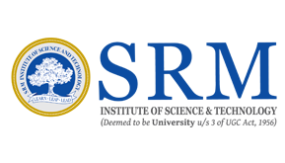

**SRM INSTITUTE OF SCIENCE AND TECHNOLOGY**

**KATTANKULATHUR, CHENNAI**

**OCTOBER 2019**