Digital Logic Trainer: Hands-Free edition

The Digital Trainer project is a means to test a student’s knowledge of logic gates through a series of quizzes on logic gates run on an FPGA development board. An FPGA is a type of computer chip that can be programmed to implement a variety of applications. Normally this project is pre-programmed on a board. The student just powers up the board with a USB cable and tries out a series of quizzes on how well they know Digital Logic. Without a board, the quizzes can still be run with a “remote hands-free” board.

The hands-Free edition of the lab requires that the student download a version of the Quartus Development Tools from Intel Corporation. Although the Quartus Tools are quite complicated, you only need a few commands to run the Trainer.

To download Quartus, visit the following URL:

<https://fpgasoftware.intel.com/20.1/?edition=lite&platform=windows>

Create account as prompted.

Download the 3 boxed downloads and save.

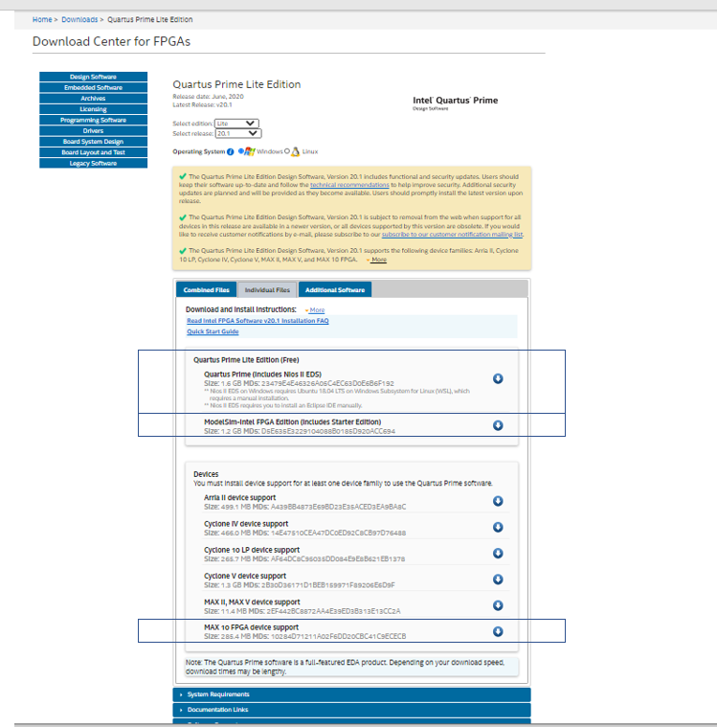

Click on the Quartus setup executable of the form: QuartusLiteSetup-20.1.0.XXX-windows.exe and install.

Go to the following URL for instructions on the Remote Hands-free board usage:

<https://github.com/intel/FPGA-Devcloud/blob/master/main/HandsFree/Devkits/DE10-Lite/LogicSolverHandsFree.qar>

Under the directory devkits 🡪 DE10_Lite you will find a file called LogicSolver_Handsfree.qar. Download this file and double click on the .qar file. Quartus should open ask you if you wish to unarchive the file. Click yes and allow it to unarchive. Press the Play button (right facing triangle). Follow instructions below to operate. Should you need to rerun, go to the directory and type LogicSolverHandsFree_restored/quartus and double click RemoteLab.qpf and hit play.

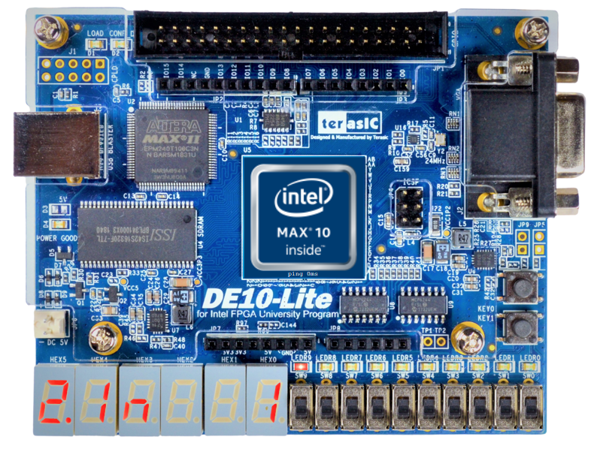

Input Switches

Next Challenge

Previous Challenge

**How to Use the Digital Trainer:** There are 10 challenges programmed into the board. It is your job to decide what the logic function of each challenge is (the challenge number is displayed on the right of the display) by flipping the input switches and observing the output LED (the light on the left of the board). A switch that is flipped “up” is a 1, and a switch flipped “down” is a 0. Likewise, an LED on is while an LED off is a 0. The number on the left indicates whether the function is two input (2In, thus using only the two rightmost switches, or 3In, using the three rightmost switches). You can flip between the different challenges using the buttons on the board: to advance to the next challenge press the rightmost button, or press the button to the left to advance to the previous challenge. Try to circle the correct function for each sequence!

|  |  |  |
| --- | --- | --- |
| Sequence Number | Number of Inputs | Logic Function |
| 1 | 2 | AND OR NAND NOR XOR |
| 2 | 2 | AND OR NAND NOR XOR |
| 3 | 2 | AND OR NAND NOR XOR |
| 4 | 2 | AND OR NAND NOR XOR |
| 5 | 2 | AND OR NAND NOR XOR |
| 6 | 3 | AND OR NAND NOR MUX |
| 7 | 3 | AND OR NAND NOR MUX |
| 8 | 3 | AND OR NAND NOR MUX |
| 9 | 3 | AND OR NAND NOR MUX |
| 10 | 3 | AND OR NAND NOR MUX |

Reset Button

Challenge Number

Number of Inputs (2in or 3in)

Result LED

The Digital Trainer