Representing Humans Characters
in Interactive Games

Greg Pisanich Michelle Prevost
Photo-Genetic Labs Silicon Studios, Inc.
San Jose, CA Mountain View, CA
greg@eos.arc.nasa.gov prevost@sgi.com
(gp@garlic.com) (mprevost@ea.com)

Introduction

Writers and producers have a huge creative and financial investment in the development of the characters that perform in their films and videos. Whether it's Luke Skywalker or Darth Vader, these characters are instantly recognizable to their fans and foes alike. This recognition is not only their physical form, but a feeling or understanding of what they might feel, think, or do in any situation. It's these human qualities, real or imagined, that make characters interesting and sell tickets at the box office.

Game developers also have a large stake in the characters they have developed for their titles. A current push in the industry is to develop game "content" using methods that allow it to be easily transferred in or out of titles. Content is not the game itself, but the parts that make it up, such as 3D models, textures, images, video, audio, etc. Content developed in this way becomes an "asset" that can become part of a new game (reducing costs) or ported to another media (yielding additional revenue). One only has to look at the immense amount of prior material available to the designers of Star Wars and Star Trek games to understand the phrase: " content is king".

But what about the characters in games? Is there some way that we can capture character as content such that it can become a flexible or transferable asset? What we are referring to is the ability to imbue a digital character with the ability to give the game player the same feelings the movie-goer has about the human character he or she sees on the silver screen. A digital character with internal characteristics such as motivation, emotion, and personality might provide game developers with the ability to produce increasingly sophisticated and satisfying game experiences.

Problem

This paper investigates how human characteristics such as emotion, motivation, and personality could be represented in the digital characters of interactive games. It begins with a survey of literature concerning character representation in games and other media. It then provides an overview of psychological research involving aspects of human behavior such as emotion, motivation, cognition, personality, and brain functions. Based these investigations, a preliminary model and architecture for a digital character is presented along with performance and interface considerations associated with game design. The goal is to develop a structured computational model that reflects both established research and game development savvy.

Relevant Work

Bates' research into the development of characters for interactive worlds (Bates, 1992) was groundbreaking. One goal of his Oz project was "the construction of ... autonomous agents that integrate elements of perception, cognition, emotion, (and) action". His group developed a computational architecture of the mind (Tok) and a reactive component (Hap) that allowed his agents to exhibit believable behaviors. Interesting to us was this system's generation of behavior from the emotional state of the agent.

Hayes-Roth (1995) has built upon this work, investigating the use of directed improvisation as "a technique for introducing personality, intelligence, and surprise into computer game characters". She has used this methodology to develop a "virtual theater" where children can interact with computer characters to create their own stories and plays. Hayes-Roth's characters exhibit "variable behaviors within class, ... dynamic moods, and ... life-like variability in their behavior". The intelligence of Hayes-Roth's characters are independent of this system and can be used in many types of applications and media.

Elliot's Affective Reasoner (1994) is a real time simulation which supports multiple agents that are capable of simple "emotional" reactions to situations that arise during the simulation. His current work involves the development of "a model of cognitive components of emotion". This model includes "twenty-four distinct emotion types, a rudimentary mapping of emotion to action with approximately 1000 different action paths, and intensity reasoning based on a pool of approximately twenty different emotion intensity variables". As described in a later publication (Elliot, 1995), these agents can have both goals (desires) and principles (appraisal of right and wrong). Emotions can arise when an agent tries to resolve a conflict between its goals and principles.

There are several groups which have developed systems that model cognition. For the most part, these systems focus on cognition (abstract thinking) and do not consider motivation or emotion. They include ACT-R (Anderson, 1993), Soar (Newell, 1990), and the use of neural nets (Coward, 1990). MIDAS (Corker & Smith, 1993; Pisanich & Corker, 1995) goes beyond these representations by interfacing a human information processing architecture (perception, cognition, decision, action-selection, action) with an anthropomorphic human model and external world. Gevarter's MoCog1 (1991) was an initial attempt to integrate emotion and motivation into a cognitive system.

Crawford (1994) describes several ways in which characters can be used in interactive storytelling and games. A technique used in his game Trust & Betrayal involved creating a group of characters defined using a model of personality. These were then turned loose in a defined environment with the hope that interesting emergent behavior might occur. He found that although the characters generated using this approach might be interesting, the lack of a plot produced a story line that was aimless and uninspiring.

His starting point in a more recent project (Crawford, 1994) was behavior rather than personality. He began by defining a large network of behaviors that his characters could potentially exhibit along with a separate personality model. During the story, characters proceed through the network, choosing alternatives based on their personalities and a set of equations specified for each behavior. Crawford felt that this technique resulted in a more responsive set of characters than could have been defined using linear or tree structured approaches.

Molyneaux (1995) has published several articles on the use of "character animation" to express emotion or personality through facial or physical gestures. PF.Magic uses similar techniques to bring life to their Dogz (1995) computer pets. Pixar and Disney's Toy Story, at 100 minutes long, is the most ambitious project in computer animation to date that conveys the emotions felt by the characters through their physical expressions. It is interesting to note that after four years and countless hours of development, those emotions live only within the minds of the animators.

Human Behavior

The study of human behavior is typically spilt into cognition, emotion and motivation. Although there is general agreement on this division, there is less consensus on how these systems interact. Cognition is that part of the main internal psychological processes involved in making sense of the environment. These processes include attention, perception, learning, memory, problem solving, and thinking (Eysenck, 1993). Research shows that emotion and motivation may "color" this pure thought (Kuhl, 1986; Buck, 1988) and certainly may affect each other (Hoffman, 1986). Therefore, it may be difficult to ever define a purely linear process of human behavior. For this description we will, however, follow a fairly linear process called "motivated cognition" (Gevarter, 1991) where emotions drive motivations, and decision making is used to select behaviors that maximize the achievement of those motivations.

Emotion: The work of Baron (1987), Buck (1988), and Lazarus (1991) indicate that emotions are an individual's reactions to his or her appraisal of how one is doing in the effort to survive and flourish. Reactions to new or threatening stimuli can also be thought of as base level emotions. In Gevarter's work, emotions not only provide an indication of the personal importance of an event, but the associated experience provides feedback for self regulation. This points to the need for some type of evaluative or coping process. Differences in the emotional levels of individuals may elicit different reactions or motivations from the same stimuli. Lazarus (1991) reports that emotion can often be generated by the mere memory of a prior emotional state or occasion.

Motivation: The work of both Buck (1988) and Lazarus (1991) indicate that it is a person's pattern of motivation that gives encounters their importance and the power to provoke feeling or emotion. Individuals may have different goals, for instance, the need for achievement, affiliation, or power. It is a person's motives that determine the focus, sensitivity, and drive toward their goals.

In addition to inborn primes (basic motives) (Buck, 1988), implicit motives, which can't be easily described by the individual, are acquired early in life on the basis of important affective experiences. Self-attributed (explicit) motives, which can be verbally described, are acquired later in life from social, or conceptualized experiences. This indicates that there may also be a multi-level representation of motivation.

Decision Making: Continuing to draw from Buck (1988), Lazarus (1991) and McClelland's (1985) research, decision making and the resulting action can be viewed as a response to an individual's motivations or goals. The importance to the individual of these goals (or motivations) is reflected in their accompanying emotions. Which goal is important is determined by the associated emotional level. Success or failure in achieving these activated goals is accompanied by an emotional response of related strength.

Decision making is a result of not only the goal being pursued, but of the knowledge, resources, and perception that are made salient. The knowledge that is made salient is a function of the schemas or focused attention that are generated by emotional responses. Activated emotions tend to focus attention on some concerns and in the process distract attention from other concerns that are not so pressing (Lazarus, 1991).

Brain Research

MacLean (1975) provides a multiple level perspective of brain research that may allow us to resolve the varied levels we see in emotion and motivation. In its evolution, the human brain has expanded along the lines of three basic patterns (a triune brain) which can be viewed as reptilian, paleomammalian (old mammal brain), and neomammalian (new mammal brain). The reptilian brain is associated with instinctive programming, the paleomammalian brain (which includes the limbic system) is associated with emotional programming derived from experience and socialization, and the neomammalian brain is cognitive, being associated with holistic perception, abstract thought, and language.

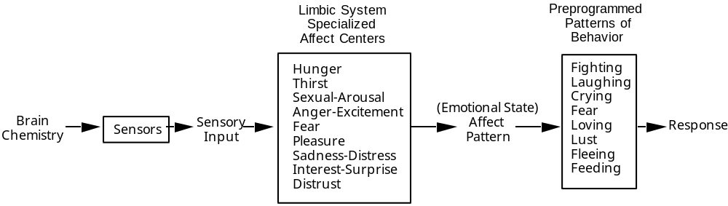

Figure 1. Elementary preprogrammed responses (Gevarter, 1991).

Affects are the motivational systems most commonly associated with emotions. From emotions arise subjective experience and expressive behavior and autonomic physiological response. Humans appear to be born with (or at least with the potential for) basic affect characteristics. Basic affects are associated with the lower levels of brain development, particularly with that of the limbic system.

Based on work suggested by Baron (1987), Buck (1988), and McClelland (1985), Gevarter (1991) developed a simplified flow diagram of what might be considered the basic inborn human responses to internal bodily states (Figure 1). This is supported by Lazarus (1991) who states: "Primary emotions are those that emerge at birth or at least within the first year of life. They express the most important adaptational tasks of animals, such as protection from danger, reproduction, orientation, and exploration".

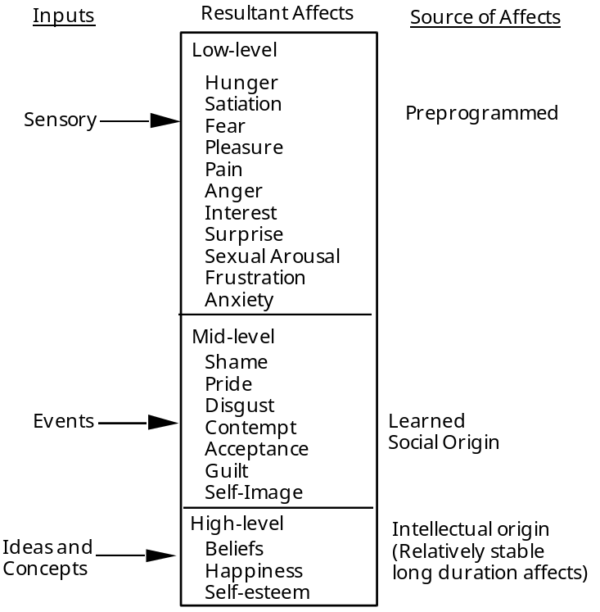

Figure 2. A suggested affect level structure (Gevarter, 1991).

Buck (1987), Baron (1988) and others suggest that affects may differ depending on the level of the brain in which they are generated. Gevarter (1991) developed a taxonomy of the affects that might be encountered as one moves from the lower to the higher levels of the brain (Figure 2). Several of these affects might not develop until later in the maturation process.

Characterizing the Individual

An individual's response is based not only on the stimuli, but also on the individual's inherent nature and life experiences. Gevarter (1991) felt that programming an individual's response required that these or some other attribute set or schema needed to be considered. A person's personality might be thought of as a multi-attribute set of functions that would provide individual differences to the same emotions, motivations, and decisions made.

Descriptive taxonomies of individual differences have been a tradition in personality theory for many years. The Big Five (or Big Five Inventory) are a set of robust factors that most researchers agree form the fundamental dimensions of personality (Harary & Donahue, 1994). The factors in the Big Five include Extroversion, Agreeableness, Conscientiousness, Neuroticism (or its opposite end, Emotional Stability), and Openness (or Culture). The Big Five is attractive because it clearly expresses the full continuum of individual differences on each dimension, while other systems only describe the ends. Each dimension represents a thread of shared meanings that ties together a very large number of more specific traits.

In developing the Berkeley Personality Profile (1994), Harary and Donahue have used the Big Five but have applied more understandable meanings to the dimensions and levels. Extroversion becomes Expressive Style, which may range from being quiet, restrained and introverted, to being energetic, enthusiastic and extroverted, or anywhere in between. Agreeableness becomes Interpersonal Style , which can range from being aloof or cruel at one extreme, to being warm and generous at the other. The remaining three include: Work Style (Conscientiousness), or the extent to which an individual focuses on task and meets responsibilities (ranging from procrastination to intense work); Emotional Style (Neuroticism), which describes an individual's temperament and typical way of dealing with stress (from calm or even-tempered to being moody or emotionally intense); and Intellectual Style, which refers to the extent that a person favors familiar and traditional ideas and experiences, or prefers to be creative or questioning of the norm.

There is some debate as to whether personality is caused by purely nature (you are born with it), nurture (you acquire it from your environment), or a combination of both. Several theories supporting the nurture aspect include the BAS (Behavioral Activation System)(Gray, 1994) and BIS (Behavioral Inhibition System)(Fowles, 1992). In these approaches, a person's personality is altered depending on the positive or negative stimuli to which they are exposed. In BAS, approach traits such as extroversion, impulsivity, novelty seeking, and positive affectivity are heightened based on cues of reward, non-punishment, or familiar stimuli. The BIS system inhibits these behaviors, as well as increasing arousal or attention, when exposed to signals of punishment, non-reward, fear, or novel stimuli.

Finally, Dweck and Leggett (1988) observe that behavior is situation-dependent and is aimed at maximizing the composite positive affect (or minimizing the negative affect) resulting from trying to balance multiple goals in response to the demands of the situation.

A Game Personality

Many tradeoffs need to be considered when producing a model that is computationally light enough to perform well in a fast moving interactive game, but still contain enough substance to provide convincing personality-driven behaviors. The main objectives of the character module are to:

o Provide an intuitive designer-level interface to characters,
o Remain abstract and independent of the character's rendering,
o Be easily portable to many gaming environments,
o Provide multiple levels of mental detail (M-LOD).

An important design goal is to provide an easy and intuitive way for non-programmers to manipulate and design characters. To achieve this goal it was necessary to develop a dedicated editor for composing a character's mental and physical content. This editor is intended as a plug-in to a larger framework such as FireWalker, a next-generation game authoring system produced by Silicon Graphics. Development in this environment places the technical responsibility on the programmer while the artist or writer is free to concentrate on what he or she does best.

Another important goal of the character representation is to remain independent of the rendering substrate. Because of the large investment in content creation, it is important that characters be masterable to as many platforms as possible. By designing characters at an abstract level, and providing a separate mastering process, characters can more readily be ported to other platforms.

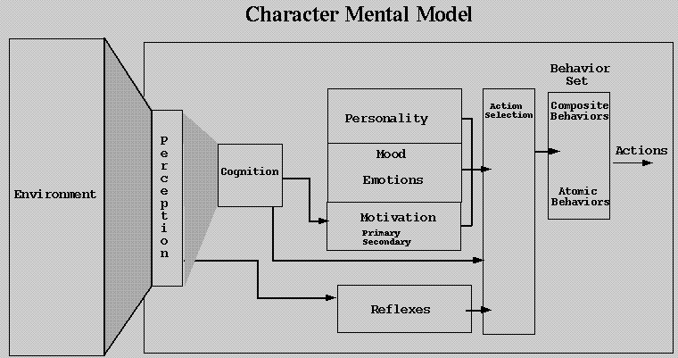

Figure 3. A prototype character architecture.

During game play dynamics, large variations may occur in the amount of graphic complexity displayed. The frame rate may vary as a function of this complexity, which is generally undesirable. To compensate for "graphic stress" programmers use an arsenal of techniques. Levels of detail (LOD), culling, and clipping are just a few of the commonly used methods. These techniques are employed to conserve valuable CPU and graphic rendering resources.

Dynamically, adjustable computational requirements for characters are just as important as for their graphic counterparts. However, these techniques differ from those used for graphics. The basic idea is the same: only compute what is needed. If there are still not enough resources available, compute at a lower level of detail. In terms of characters we are talking about "mental stress". It is important to note that the need to compute a character's mental state is not necessarily dependent on the visibility of its graphics. Characters may continue to think and respond even if their graphical representation is not being displayed.

Character Architecture

The research above suggests that a character's mental model could be partitioned into three main areas: motivation, emotion and personality. Figure 3 shows a general overview of an architecture based on these tenets. The diagram shows a flow of information from the sensed world through the model. This description focuses on the central part of the diagram and does not address cognition or action selection. A designer would typically begin with a character template. This template would be selected from a set of pre-defined personalities with basic default properties and values. The designer would customize the template by further defining the relationships and their strength.

Motivation

Innate drives in characters are described by their motivational properties. These drives center around primary (self preservation) and secondary (self gratification) motives. Motivation values can vary from 0-255 with zero always being the least desirable state for the character. Motivations may vary over the game and are meant to maintain the internal well-being of the character.

Primary motivations are basic to almost any living entity. They depend on little else but raw sensing of the world and the character's internal state. The following are a set of primary motivations including things that would alter the motivational values:

o Depletion Nutrition
(eating food, drinking fluids, breathing air)
o Pain Comfort
(injury, feeling cold/hot, feeling wet/dry)
o Risk Security
(hiding, predator distance, hazardous situation)
o Asexual Propagation
(gender attraction, sexuality)

Motivations are used like short term goals for the characters. As motivational levels vary below the designer's nominal thresholds, behaviors are chosen to regain those levels. This feedback mechanism serves to maintain the character's internal operating stasis. Because motivations with very high levels get less attention, a form of satiation takes effect.

In addition to these primary motivations are a secondary set tied to self gratification. A character would consider these motivations only while all the primary motivations were met. A character could exist without meeting these motivations but its mood might not be as elevated. These motivations might include: Anguish-Pleasure, or Embarrassment-Pride.

Personality

Motivation and emotion may be identical for many characters, but personality would make each character appear different even when everything else, including the environment, is the same. Also, when a game includes many characters that might have only small geometric or color differences, their behavior may be their only noticeable difference. For example, all members of a platoon of soldiers should look very much the same. If ordered to attack, it is reasonable to expect a range of responses, anywhere from a kamikaze run to retreating. Their response to a situation should vary depending on their personality. A character’s personality doesn’t provide any new motivations, but may amplify the importance of relevant ones. A character’s personality could be held constant for the life of the game. While not reflecting true life, this might be a helpful simplification.

The Big Five (B5) set of personality traits was found to be a good candidate for the personality description of the character. The B5 provides an orthogonal set of dimensions in which to categorize individuals. Because many alternative taxonomies provide a mapping to the B5, it should be possible to adapt previous work to this set. The B5 is intended as a starting point and may need to be enhanced to fully define character. Nevertheless, they will be used as a first draft for a character's personality. The personality properties are:

o Expressive Style:
Introverted Extroverted
o Impersonal Style:
Cruel Self-sacrificing
o Work Style
Procrastination Dedication
o Emotional Style
Even Tempered Emotionally Intense
o Intellectual Style
Traditional Creative

The character designer would set values for each personality trait which would determine the point on the continuum where which the character falls. The designer could create a personality by dragging and dropping an existing profile using the editor, or design one from scratch. Standard personalities such as passive-aggressive could be pre-defined and used as a starting point.

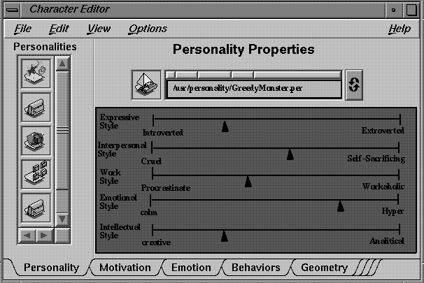

Figure 4. A prototype Character Editor.

Emotion

The emotional level, as defined in our representation, encodes a relationship between how well a character's motivations are being met and how important they are to its personality. The basic idea is that the character will attempt to maintain the highest emotional level possible. Because motivations are defined in such a way that the higher value is always best, the character simply tries to maximize these relations. The designer would access the editor to fine tune the character's emotion (figure 4). The emotional properties could be defined as anything that make sense for the type of content that is being created. For example, they might be defined as:

o Sad Happy
o Afraid Secure
o Frustrated Satisfied
o Calm Angry

As a game runs, it would cycle through all registered game objects (of which characters are one type) and grant them each a portion of CPU time. Given its personality, emotional sensitivities, and motivations, it would be possible to calculate a character’s “mood”. Mood would be a measure of the character's general mental well being and could be a weighted sum of its current emotions. Since emotions are a measure of how well motivations are being met, fulfilling those motivations would result in a higher mood. The action selection mechanism would choose actions that would best meet those goals. Simply maximizing the emotions is a drastic simplification but may be sufficient to create interesting behavior.

Designer's Interface

An integrated editor would allow the designer to set the character’s personality, motivation and emotional characteristics along with more conventional content such as its geometry and animation. The editor is a composer, in that the designer doesn't develop the content in the editor but assembles and tailors it into the desired type of character. No programming on the designer's part is required.

The character editor would present a list of attributes for possible adjustment. These adjustments would be translated into property values which are an artifact of the FireWalker game authoring system. Designers would not need to be aware of specific property values as they would simply set ranges such as nominal, extremely low, or extremely high.

Discussion

This paper has presented a methodology for representing human emotion, motivation and personality as character content in interactive games. As digital characters mature, we expect to see a greater emphasis on the development, manipulation and reuse of their behavioral and personality traits.

Bibliography

Anderson, J. R. (1993). Rules of the Mind. Hillsdale, NJ: Lawrence Erlbaum Associates.

Baron, R. J. (1987). The Cerebral Computer: An Introduction to the Computational Structure of the Human Brain. Hillsdale, NJ: Lawrence Erlbaum Associates.

Bates, J. (1992). The Nature of Characters in Interactive Worlds and the OZ Project. Report CMU-CS-92-200, Pittsburgh, PA: Carnegie Mellon University.

Buck, R. (1988). Human Motivation and Emotion, Second Edition. NY, NY: Wiley.

Corker, K.M., & Smith, B. (1993). An architecture and model for cognitive engineering simulation analysis: Application to advanced aviation analysis. Presented at AIAA Conference on Computing in Aerospace. San Diego, CA: AIAA

Elliott, C. (1994). Multi-media Communication with Emotion-driven 'Believable-agents'. In AAAI Technical Report for the Spring Symposium on Believable Agents. pp. 16-20, Stanford University: American Association for Artificial Intelligence.

Elliott, C. (1995). Getting to the Point: Emotion as a Necessary and Sufficient Element of Story Construction. In AAAI Spring Symposium on Interactive Story Systems Agents. pp. 37-40, Stanford University: American Association for Artificial Intelligence.

Eysenck, M. W. (1993). Principles of Cognitive Psychology. Hillsdale, NY: Lawrence Erlbaum Associates.

Gevarter, W. B. (1991). MoCog1: A Computer Simulation of Recognition-Primed Human Decision Making. NASA Technical Memorandum 103888. Moffett Field, CA: Ames Research Center.

Harary, K. & Donahue, E. (1994). Who Do You Think You Are? Explore Your Many Sided Self with the Berkeley Personality Profile. NY: Harper Collins Publishers.

Hayes-Roth, B. (1995). Directed Improvisation: A New Paradigm for Computer Games, in Proceedings of the 9th Computer Games Developers' Conference. Palo Alto, CA. pp. 36-43.

Hoffman, M.L. (1986). Affect, Cognition, and Motivation, In Handbook of Motivation and Cognition, pp. 244-280, NY, NY: The Guilford Press.

Kuhl, J. (1986). Motivation and Information Processing, In Handbook of Motivation and Cognition, pp. 404-434, NY, NY: The Guilford Press.

Lazarus, R. S. (1991). Emotion and Adaptation. NY: Oxford University Press.

Loyall, A. B., Bates, J. (1991). Hap: A Reactive, Adaptive Architecture for Agents. Report CMU-CS-91-147. Pittsburgh, PA: Carnegie Mellon University.

MacLean, P.D. (1975). On the Evolution of Three Mentalities. Man-Environment Systems. Vol.5, pp. 213-224.

McClelland, D.C. (1985). Human Motivation. Cambridge, MA: Cambridge University Press.

Molyneaux, M. (June, 1995). Pac to the Drawing Board: Losing Control of your Personality, Morph's Outpost, pp. 27.

Newell, A. (1990). Unified Theories of Cognition. Cambridge, MA: Harvard University Press.

Pisanich, G. M. & Corker, K. M. (1995). A predictive model of flight crew performance in automated air traffic control and flight management operations. Proceedings of the 8th International Symposium on aviation psychology. Columbus, Ohio.

PF.Magic (November, 1995). Presentation on Dogz, Your Computer Pet. Software Forum Multimedia SIG, Mountain View, CA.

