Chapter 1 Hardware Interface.

1.1 Interactions of 3-D applications with the hardware.
1.1.1 Displaying images on a computer screen.
1.1.2 Reacting to events.
1.2 Using different architectures.
1.2.1 MS-DOS.
1.2.2 MS-Windows.
1.2.3 X11.
1.2.4 NeXTStep.
1.2.5 MacOS.

3-D computer graphics can exist as a field only due to the existance of actual computer hardware. Methods, algorithm and techniques which has been developped for computer visualization of synthetic scenes are therefore based on and limited by what is achievable by currently available hardware. In this chapter we will discuss the basic principles of interactive 3-D applications, and particularly, how their organization can be supported by a typical computer system. As the very term “interactive 3-D graphics” suggests, there are two components worth considering: “graphics” - representing images on a computer screen, and “interactive” - reacting to a user’s input in the course of an application’s execution. Other components of 3-D graphics applications (which we will discuss in the following chapters): representation of virtual worlds, rendering of primitives, hidden surface removal, lighting etc. are not immediately dependent on the specifics of computer equipment (except in those cases when some basic algorithm, such as rasterization, is directly implemented in hardware). Interfacing the particular display or input device, however, always depends on particularities of hardware. We will discuss such basic interactions of 3-D applications with hardware in the first sections of the chapter. Existing computer platforms and operating systems, which manage an application’s execution, often introduce their specifics and particularities. We are going to examine some details related to several popular platforms and operating systems in the last section of the chapter.

1.1 Interactions of 3-D applications with the hardware.

The premier goal of graphics applications is to represent synthetically created images on a computer screen. We will be talking about raster graphics which today is the dominating technology. The idea behind it is that an image is subdivided into a regular mosaic of small, most commonly, rectangular cells - pixels (pictorial elements), each having a particular color (see Figure 1.1). An image with small enough spacing of pixels is interpreted by human eyes as a smooth and continuous one. In terms of computer hardware this technology demands using some memory to store an array of values which are interpreted by the dedicated circuitry of display devices as colors of screen pixels. Changing these values triggers changes on the screen. Earlier technologies, such as vector graphics, represented an image as a set of primitives: usually line segments. Greater flexibility of the raster image technology made vector graphics quite obsolete today.

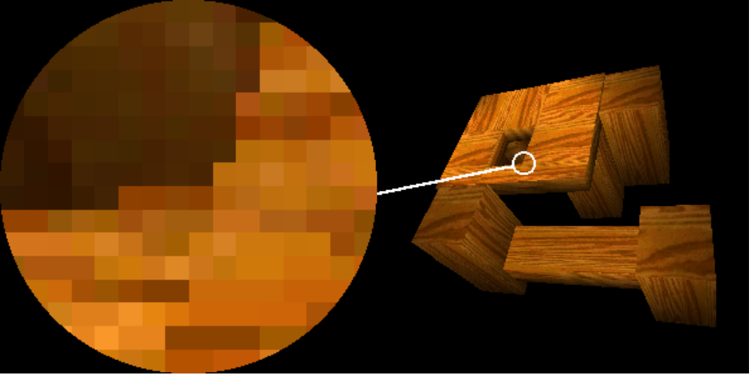

Figure 1.1: A raster image.

Of the variety of applications for computer graphics the ones where constant interaction with a user is required are of a particular interest. Such interactive computer graphics programs must often depict movements in synthetic scenes, either of the viewer moving through the scene, or movements of the scene itself, or even both. This is achieved by displaying a sequence of images called frames. Each frame depicts the scene in a slightly different state. When a sufficient amount of frames is displayed during some short period of time, to the viewer, it creates an impression of smooth movement.

The frames must be completely drawn when they are displayed. In most instances, we don’t want to see the process how polygons or lines appear on the screen one after another building a single frame. Besides, if a frame is to be captured on a film, all the pixels must be visible the same amount of time, otherwise the film will be unevenly exposed. A common solution is to render a new frame into an off-screen buffer while a previously drawn frame is stored in the buffer of the display device and thus is being displayed. Once the new frame has been drawn, the contents of the off-screen buffer is transfered (or blitted, from bit-block transfer) into the memory of the display device and the process is repeated for a consequtive frame. Not surprisingly, the way different systems handle access to the screen memory does indeed vary. In the case of older operating systems such as MS-DOS, the memory of the display device could be accessed directly. On the other hand, when programming MS-Windows, X-Windows, NeXTStep, MacOS or even applications which use some DOS extenders, writing directly into the screen memory is generally impossible. The memory protection scheme prevents us from doing that. Therefore, different operating system resources have to be invoked and delegated some of the low level work related to interfacing with the hardware.

An interactive 3-D application, beside being able to render frames on the screen, must also react to external events, such as keyboard strikes or mouse moves, and has to further use the information about the occurred events to introduce changes in the future frames. For instance, pressing an arrow key should change the angle the scene is being viewed at. Dealing with external events often depends on the execution flow - an order in which different fragments of the code composing a computer program are executed by the particular operating system. The flow of execution and even the structure of applications depend on the operating system.

“Event” based systems often presume that the code must be executed as a function of occurred events. In other words, if a button is pressed, the code associated with this button is executed. This approach is used to the extreme in NeXTStep, to lesser extent in MS-Windows, and to yet much smaller extent in X-Windows. On the other hand, regular MS-DOS, or, in this matter, UNIX applications don’t have the event mechanism unless we implement it ourselves. The code is just being executed from the entry point until it exits (or until the operating system won’t stand humiliation anymore and dumps core on us as UNIX or simply freezes speechless as MS-DOS).

Thus, depending on the platform, handling of external events should be implemented in a sufficiently different way. We may either use various provisions of the particular operating system or, perhaps, directly access the hardware, if that is allowed.

Let us identify which aspects of graphics applications need to be exposed to hardware, and the nature of the interactions involved. Later, we will briefly discuss how these interactions can be implemented for some actual platforms and operating systems.

1.1.1 Displaying images on a computer screen.

As it was mentioned, an image shown in a raster display device is stored in the computer memory. An operating system which provides graphical user interface (GUI) will allocate some portion of the physical screen (a window) for an application program. A graphics application must communicate with the operating system in order to create a window and later to display images in its window. Operating systems which don’t have GUI demand that an application communicates with the display hardware directly, providing no or little help in doing that. In those cases, an application must switch the display device into a proper mode and later keep moving the contents of the off-screen buffer into the memory of the display device in order to display generated images.

We can distinguish several types of interactions a graphics application should perform with the operating system or the hardware in order to display images. The most important ones are: opening and closing the graphics output and blitting images. Should these be implemented as functions, the remaining modules of the application will be shielded from the hardware and would only have to communicate with the off-screen buffer and call the aforementioned functions.

This scoping, beside being a starting point for modular design of an application, also allows for the off-screen buffer to maintain a different data format from that of the display hardware. Of course, the same format will mean that the blitting function won’t have to perform any additional work involved in the format change, yet in a number of situations it may be helpful to be able to render an image using data layout convenient for graphics algorithms and then to transform it into the format which is understood by the display device.

The off-screen buffer contains what is often called as bitmap or colormap of the image - an array of values which represent colors of individual pixels. There are many imaginable ways how we can associate a value to every pixel in the bitmap. The color value can be composed of bits which are located in different parts (planes) of the bitmap - so called “planar” format, or united into bytes or words each containing a color specification for a single pixel - so called “flat” or “linear” format. Figure 1.2 Illustrates which bits contribute to the specification of a single pixel in bitmaps of these two formats.

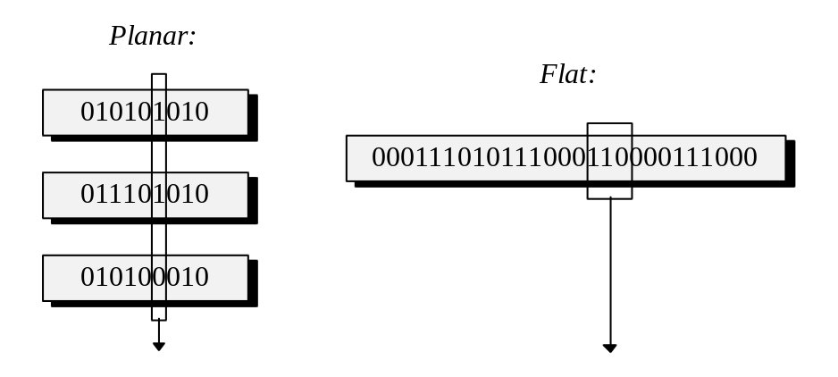
Figure 1.2: Planar verses flat formats of image bitmaps.

Different display devices maintain different formats of representing a bitmap in the display memory. Some devices may support several formats. Flat formats are generally more convenient for the software since only a single memory access is required to set one pixel. However, on a deeper, hardware level this access may translate into several memory accesses performed by the video card, since the card usually works with color channels, and thus might internally support planar representation of the image. We will nevertheless concentrate on the flat formats since modern graphics devices seem to favour them for all external interactions.

A color of a pixel is commonly described as a combination of intensity values for pure red, green and blue (an RGB representation). We are going to examine physical reasons for that in chapter eight, for the moment assuming this to be a reasonable scheme. Thus, to describe a color, a certain number of bits has to be assigned to represent the intensity of each of the three components. If we choose five bits per component, we arrive to 32 intensity levels per each pure color and at least 15 bits required to describe a single pixel. An array of color values composed in this manner forms a flat bitmap. The first value in the bitmap is usually responsible for the upper leftmost pixel of the image, the value in the next cell represents the second pixel in the first line and so on, covering all pixels line by line (see Figure 1.3).

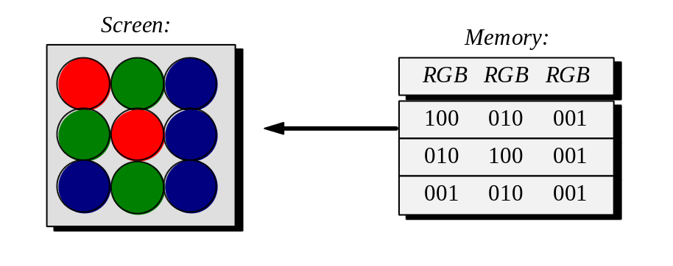
Figure 1.3: Screen memory storing RGB values.

There is one practical disadvantage: the space requirement. A small screen of 320 by 200 pixels requiring two bytes per each pixel (the least number of bytes able to contain 15 bits) will demand 128K of memory. Although today this amount of memory is hardly excessively large, not so long in the past this may have been the total amount of RAM available on a multi-user computer such as PDP-11. The bigger the resolution of the display device, the greater the space requirement. Whenever memory is at a premium in hardware, similar space problems are often solved through some form of virtualization. Rather than to store a complete RGB value we will only store an index in a table (called a palette in this context) where the actual longer color value will be kept.

Of course, it is assumed that the index placed into the bitmap takes less bits than the entire RGB value. For instance, eight bits instead of 16. As a result, the memory requirement is reduced, at a certain cost, however, since only 256 entries can be addressed by an eight bit index, and thus, at every single moment we can have only this number of different colors available out of few tens of thousands possible combinations of the intensity values. Space versus flexibility, a usual trade-off (see Figure 1.4).

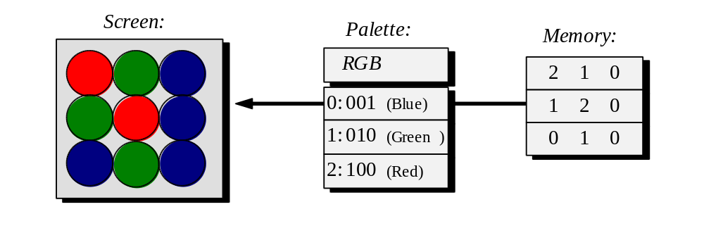
Figure 1.4: Screen memory storing palette indices.

The RGB scheme and the palette scheme require somewhat different handling on the application’s part. We should also note that since the palette is likely to be implemented in hardware, the bit size of the color components, similar to differences in bitmap formats, may differ from one platform to another requiring the application to adjust the intensities before storing them into the palette.

Despite all the existing variance in formats and hardware, the majority of high level aspects of displaying images by an interactive 3-D application can be concentrated within a fairly small set of routines. For instance, we can choose the set presented in Listing 1.1.

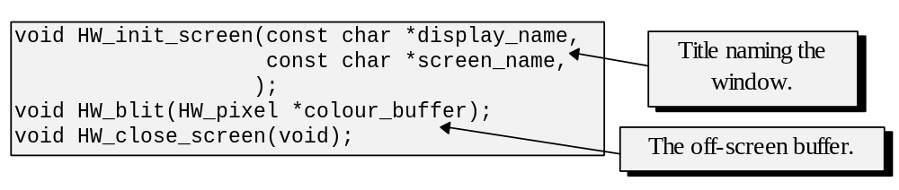
Listing 1.1 Prototypes for display device interfacing functions.

The first function in the set, HW_init_screen, should either initialize a certain screen mode when implemented for some systems, or allocate a window under some other systems. The text string display_name is added to accommodate any architecture supporting multiple displays (such as X11, for instance).

The purposes of HW_blit and HW_close_screen functions are self-explanatory: it is to copy the image bitmap into the physical display device memory in the case of HW_blit and to destroy the window or restore the original screen mode in the case of HW_close_screen.

There are many variations and extensions possible for such sets of interfacing functions. These modifications depend on the types of hardware we wish to target. For instance, if we want to accommodate hardware which supports palette based formats we may need a routine to initialize the palette and perhaps another one to alter the palette in the run-time or even to maintain several palettes. For the purposes of operating systems supporting a graphical user’s interface, we can also parametrize the screen initialization function with the geometry of the window. Some applications may need multiple windows, which introduces a need for further modifications of the proposed routines such as maintaining several off-screen buffers and parametrizing the blitting function with the name of the destination window. However, the fundamental approach for building sets of interface functions should remain the same. It is to first identify what is required by the planned graphics application from the hardware and then to attempt isolating hardware related aspects within a module, most certainly, implementing it differently for all targeted platforms.

1.1.2 Reacting to events.

An interactive application communicates with a user by displaying sequences of generated frames. The user communicates back to the application by acting on the input devices. Let us identify what these interactions entail for the structure of the applications.

Let us consider first how different 3-D applications work. In an interactive game events on the screen are happening continuosly. Whether acting on the input devices or not, the player can still see the ground approaching with increasing speed, or poignant creatures tearing the player into pieces. This is an indication that such an application is rendering frames all the time. Actions on the input devices performed by the user only introduce changes to some internal variables describing the state of the 3-D world and the parameters of viewing the scene. Thus, changes in the state of the world and of the viewing parameters cause the application to render different frames in the future.

Other 3-D applications don’t involve constant motion. These may render a new frame only responding to an event arriving from an input device and be idle otherwise. For example, in the visualization of an object built with a Computer Aided Design (CAD) tool, pressing an arrow key to turn this object would cause the application (otherwise idle) to act and rerender the scene as viewed at a changed angle.

The apparent difference between the two kinds of applications is that in the first case the state of the 3-D world can be changed by both the viewer and the application itself thus requiring constant generation of frames. In the second case, only the viewer can change the state, and the display needs to be updated only when that has happened. To summarize, as far as the control flow for the two kinds of applications is concerned, we need the ability for constant execution of some fragment of the code and the ability to execute some other fragment, this time, only responding to occurred events.

In the previous section we have already discussed that different operating systems provide applications with different facilities to manage the control flow. GUI based systems usually include special provisions for event handlers - functions, which are called when there is an event occurring with a certain input device. Other systems may not have this mechanism and require the programmer to directly query the state of a particular input device and perform different actions depending on its current state. Since the implementations will differ considerably, we can unify the interactions with the operating system on a somewhat higher level and create, for instance, the following set of interface functions (see Listing 1.2):

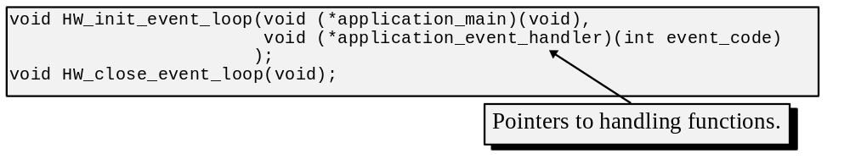Listing 1.2 Prototypes for control flow functions.

The first interface function expects pointers to two handling functions which are going to be executed for the duration of the application’s run. One of the handling functions is designated to be executed constantly, and the other one only responding to external events. The second interface function from the set in Listing 1.2 is used to terminate the execution and should be called from either of the two handling functions passed to HW_init_event_loop.

Back to described before the two kinds of graphics applications. When we don’t want to render frames all the time, application_main may contain no code at all, and application_event_handler will first respond to the event by changing the internal state of the application and then rerender the frame.

HW_init_event_loop is likely to be implemented as a loop inside of which application_main is unconditionally called, then the check for occurred events is made, and if there are indeed events awaiting to be handled, application_event_handler is called to do just that. The nature of this implementation strategy explains why the name of the function and the associated scheme is an “event loop”. The second function of the proposed set should signal the event loop to exit by, for example, changing a variable in the loop’s condition.

The set of interface functions in Listing 1.2 should also be accompanied by a convention on the classification of events, such as enumeration of keys. This is also quite important as far as portability of applications is concerned since, in general, different operating systems and hardware platforms will have different conventions on the key enumeration.

The proposed set of the interface functions is, of course, quite minimalistic. It should be extended in a number of ways depending on the planned applications. For instance, we can support a more sophisticated collection of events such as mouse events or multiple event handlers responsible for different types of events. If the application is to maintain multiple display windows, it may also be necessary to assign a separate set of event handlers for each and, perhaps, provide facilities for communication between the code responsible for different windows.

These interface functions, similarly to the display device interface functions, shield the application from the details of the particular operating system and the hardware by providing the functionality which graphics applications conceptually need. The implementation of the functionality will differ, of course, from one system to another as we shall see in deeper detail on the examples of actual operating systems presented in the next section.

1.2 Using different architectures.

In the previous sections we have discussed the aspects of graphics applications which are directly exposed to hardware or an operating system. We have defined the necessary types of interactions required by most graphics applications. It has been noted that the interface functions must be implemented differently depending on the targeted platform. Let us discuss some particularities of the implementation for several existing operating systems.

The differences which we will encounter relate to the presence or absence of graphical user interface, the type of the execution flow supported by the system, and the accessibility of the input/output devices to application programs. Some of the complications also steam from the compiler differences. Many compilers have specific features which help programming in some way, yet aren’t part of the standard specification of the language. Often there are also minor differences caused by a slightly different interpretation of the standard.

The, perhaps, most famous difference in C compilers is caused by the differences in the processors. The bit size of fundamental data types often differs from one compiler to another primarily due to the variation in the bit size of processors’ register storages. For example, some compilers assume that a value of type int must be stored using 32 bits, whereas other compilers allocate only 16 bits for this purpose. Since it is important in a number of situations (for instance, during manipulation with image bitmaps) to precisely know the bit size of the data type, we can define several new types with the known bit length and describe them in a particular way depending on the available compiler.

In this section we will consider several different operating systems, some of their features and particularities related to the two areas we are interested the most: displaying images and handling external events. It should be noted that long manuals can and are written about each of these systems, whereas the discussions that follow provide only basic overview and hardly give enough technical information on how to program.

1.2.1 MS-DOS.

Although MS-DOS is no longer a major player on the operating system market it is still interesting to consider in the historical perspective as an operating system with only basic and minimalistic support for the traditional operating system functions. To certain extend, similar situation still takes place in the world of proprietary game platforms where, of course, 3-D graphics is of great importance.

Since MS-DOS controlled very little and allowed to override itself in an astonishing amount of ways, as surprising as it sounds, it gave a considerable boost to development of fast game graphics and became a choice platform for many developers. MS-DOS provides only rudimental support for display and input devices leaving to the application most hardware interface tasks.

Due to the enormous market share of IBM PC compatible computers in the office and home environments, a considerable amount of companies have been developing programmer’s tools for MS-DOS. There is a number of different C/C++ compilers available for PCs, each of them having particular qualities. Of the most popular there are: Borland C/C++ from Borland International, Visual C/C++ from Microsoft, Watcom C/C++, and finally, a personal favourite, DJGPP, a freeware port of unix’s GNU C/C++/Objective C to MS-DOS by DJ Delorie.

A big problem with MS-DOS is that because of Intel 8086 processor it was originally written for, this operating system is essentially a 16 bit one. A program running under it uses segmented memory access so that an address of a location in memory is stored in two registers. The base register carries an index of a 16 byte paragraph within 1M of total allowed memory, and the second register contains an offset from that position. Unfortunately, that meant that if we wanted to address more than 64K of memory (the maximum magnitude of an address one can represent in 16 bits) we had to change the contents of the base register. This scheme was due to historical reasons and appeared at some point in the past to be an acceptable solution to provide a certain degree of compatibility with even earlier Intel 8080 processor. Although similar upgrade changes are done very often in the processor world, in this case, the size of 64K of easily addressable memory was, simply, not big enough. Until not that long ago Borland and Microsoft compilers were capable of producing only 16 bit MS-DOS code. Accessing extended memory (the memory above 1M) from such a program can be tricky; trying to fit an application within 640K of total DOS memory can be tricky too.

More recently, when more advanced processors, starting from Intel 80386, appeared on the market, it became possible to exploit their new protected addressing modes opening the way for 32 bit applications for MS-DOS. Most of the modern compilers functioning on the PC platform are capable, in one way or another, to produce 32 bit applications for MS-DOS. Such applications work under DOS extenders, the system programs which switch the processor into the protected mode and manage memory addressing from then on. 32 bit registers are used for addressing easing many of the past limitations.

In reality, a processor in the protected mode uses even more intricate addressing scheme than that with the plain 8086 mode segmentation. Rather than to point a memory location, segment registers would point to an entry in a table which contains a physical address of the segment’s beginning as well as its length. This complexity, however, is hidden most of the time from application programs allowing them to operate in an externally simple memory space.

As to the available display devices, PC hardware went through a number of upgrade changes from 4 color CGA (Color Graphics Adapter) to 16 color EGA (Extended Graphics Adapter) to 256 color VGA (Video Gate Array) and finally into SuperVGA realm of confusion. Somehow, hardware manufacturers have never established a standard interface specification for SVGA so that video cards differ considerably as far as attractive high resolution modes are concerned.

The original IBM PC hardware mapped the video card memory to the addresses between 0xA000:0x0000 and 0xB000:0xFFFF (base:offset). DOS-extenders which aid execution of 32 bit applications rearrange memory space so that video memory will appear starting at 0xA0000 in the case of dos4gw a DOS-extender from Rational Systems often used by applications compiled with Watcom C/C++, or at 0xD0000000 in the case of go32 extender used in DJGPP Version 1. (DJGPP Version 2 was developed to be much more DPMI (DOS Protected Mode Interface) compliant so that accessing video memory can be established through calls to the DPMI interface.

However, the addresses from 0xA000:0x0000 to 0xB000:0xFFFF cover only 128K of memory and most of SVGA high resolution modes, especially RGB modes, require much more space than that. In order to access this larger memory through a smaller address window, a paging strategy, called “bank switching”, was devised. When we want to access a particular location in the video memory, we have to specify in which of the memory banks of 128K (or less) this location is. Afterwards, this bank becomes accessible through 0xA000:0x0000 window. In other words, each address in this window corresponds to several locations in the video memory, one in each bank, and the bank switching is used to specify the exact one. Some cards provide special considerations for protected modes by providing larger address windows so that bank switching can be avoided. Yet, this feature, bank switching, number and size of memory banks differ from one SVGA card to another. Presently some standardization is being achieved through the VESA standard providing common interface for different SVGA cards.

In order to implement the three display interface functions presented in section 1.2, the video card has to be switched into a particular screen mode. This can be done either by manipulating with the registers located on the card and accessible through the communication ports, or by exploiting a routine which is a part of the operating system and is accessible through the interrupt 0x10. Once this is done, displaying an image is achieved by moving its bitmap into the address window corresponding to the memory of the display device.

Implementations for event handling can either be quite intricate or extremely simple under MS-DOS. The more sophisticated way is to code handlers which are invoked by hardware interrupts generated when the status of an input device changes. In the case of the keyboard, this would mean adding code to handle the interrupt 0x9. A simpler way is to delegate this task to the operating system (or a function of the C standard library which will do the delegating for us). The latter approach will allow the application to query the state of the device by invoking a special routine.

Generally, examples of fast graphics applications (games in particular) developed for MS-DOS demonstrate that it is beneficial, at times, to stay close to the hardware and avoid extra overhead which comes with more advanced operating systems. Although fast, such solutions also tend to be not portable and take considerable amount of time to implement compared with development under operating systems which provide more functionality.

1.2.2 MS-Windows.

MS-Windows dominates today in office and home environments. It was produced by Microsoft and constituted a windowing system functioning on top of MS-DOS. Early versions of Windows inherited some of DOS problems such as 16 bit segmented executables. Only co-operative multitasking was available at first. Since the first release, Microsoft has introduced Windows NT which featured 32 bit executables, and later Windows 95 with better multitasking and improved user interface. In their attempt to make Windows more attractive for fast interactive graphics applications, such as 3-D games, Microsoft is constantly introducing new libraries and features. This, combined with ever increasing processor performance, helps to offset the problem with additional overhead which the presence of the windowing system incurs.

Programs designed to run under MS-Windows have a very different structure compared with the ones designed for MS-DOS. For instance, there must be special provisions for the event messages received from the windowing system. Accessing resources, including allocating windows and displaying images, must be done via the set of API (Application Program Interface) calls. For example, in order to display an image, we must first ask the operating system to allocate a window and then, through another sequence of API calls, to request displaying a bitmap in this window. The following sequence of instructions in Listing 1.3 performs the latter task.

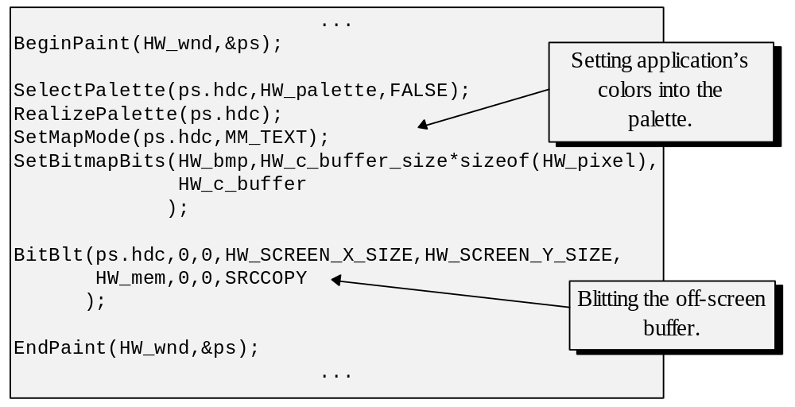
Listing 1.3: Displaying image bitmaps in MS-Windows.

There is also a collection of API functions which are responsible for maintaining palettes, some of these appear in Listing 1.3,. Palette based modes are at times complex for the windowing system to handle. There may be many color intensive applications running at the same time, each demanding a different set of colors to be placed into the master palette, which only has a finite, and usually small, number of locations. To offset this complication, Windows gives API functions for color matching and has a provision for messages signalling about changes in the palette’s state. When there are no available entries in the palette, we can, at the very least, find a close color via the matching routine. When some application radically changes the palette, other applications are notified and may rematch their colors accordingly. The master palette also contains a set of reserved colors used to draw visual interface components such as menus, borders, etc. The reserved colors can be changed also, except for two, pure black and pure white.

Execution flow in Windows follows an event driven paradigm. Certain fragments of code are executed responding to specific events. A usual application would first allocate a window or windows and then enter an event loop which would be responsible for fetching event messages from the queue and forwarding them to specific responding functions. The latter are usually associated with a specific window and describe actions which must be taken in response to events.

The following code in Listing 1.4 demonstrates an event loop.

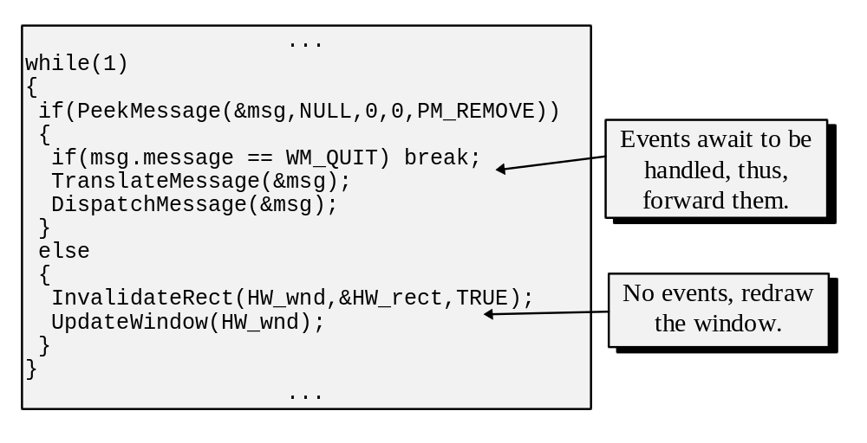
Listing 1.4: MS-Windows events loop.

In the example in Listing 1.4, a message is fetched in the loop by the means of PeekMessage routine. It is to be processed and then dispatched to some responding function. A MSG structure, filled during the call, carries the information describing the event. The field message in this structure specifies the type of the event. For instance, the key presses are identified as WM_KEYDOWN. There are two routines designed for accessing information on the event queue. GetMessage fetches a message or, if none are present, blocks and waits till a message will appear on the queue. PeekMessage is a non-blocking version. If there are no messages, it returns a zero value. This is important for an interactive application which must constantly generate and display new frames, and thus, has to perform some useful work even when there are no events to process. Whenever the PeekMessage function returns zero, the particular implementation of an event loop presented in Listing 1.4 starts sending messages to the handling function. The calls to InvalidateRect and later to UpdateWindow cause sending of WM_ERASEBKGND and WM_PAINT messages respectively. These two messages are, thus, forwarded to the handling function which must erase the window’s background responding to the first message and repaint the window responding to the second one.

Since Windows tries to minimize expensive manipulation with the memory of the display device, an application must advise the operating system which parts of its windows were updated (and thus require refreshing) through a call to InvalidateRect. Only the memory locations responsible for the specified area will be changed in the memory of the display device. Thus, although interactive applications don’t explicitly erase the display in between of the frames (each consecutive one is simply written over the previous), in this case, we must nevertheless call the InvalidateRect function to advise the operating system and later simply ignore WM_ERASEBKGND message instead of physically erasing the background.

The following code in Listing 1.5 illustrates a handling function.

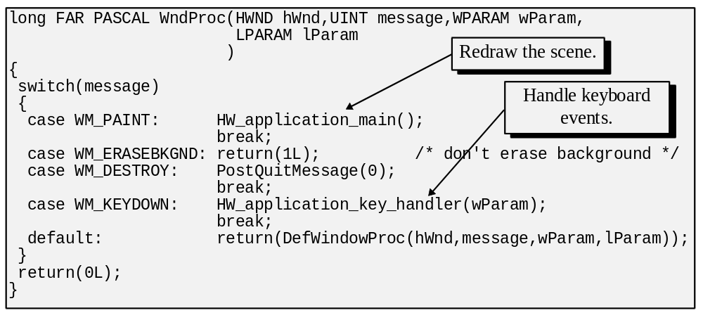
Listing 1.5: MS-Windows events handler.

As the code in Listing 1.5 demonstrates, unprocessed messages are re-routed to a special API function that insures some default handling.

Perhaps, all this machinery and conventions of programming for MS-Windows may seem overwhelming. However, an attractive side to Windows or, in this matter, any other modern operating system, is in the abstraction from the physical hardware which applications enjoy. The trade-off is a probable loss of performance which results from using an extra layer of code as opposed to accessing the hardware directly. Often it is an acceptable price to pay for increased portability and simpler programming. It should also be noted that interface building tools available today for Windows, such as Delphi, hide from the programmers many of the details of communicating with the operating system easing many of the previous difficulties.

1.2.3 X-Windows.

X-windows is a GUI system which is a de-facto standard in research and many educational environments. It was first developed at MIT, and subsequent improvements and standartizations were maintained by the specially created X-Consortium which unites multiple educational and business institutions.

X-windows is available for overwhelmingly diverse platforms from personal to supercomputers. Similar to some other windowing systems, X-windows is not an operating system, but a graphical user interface functioning on top of UNIX, or, in rare cases, other operating systems such as NeXTStep or even MS-DOS.

An application written for X-windows, often referred to as an X client, sends requests to a windowing server running on either local or even remote computer connected via the network. The server interprets the requests and performs the demanded actions, it also maintains on the queues the information about the events received from the local input devices. Applications can request this information and handle the situation accordingly.

The requests to the server are generated when the application calls one of the X library functions. By the convention, all the functions from this library are prefixed with an “X”.

Displaying images in a window can be done through calling the XPutImage function. A usual X application will first open the access to a certain display device by calling a dedicated function XOpenDisplay, then it will allocate the necessary interface components such as windows, for instance, and later enter an event loop fetching messages from the queue and responding to events by specific actions. The following code in Listing 1.6 demonstrates an event loop.

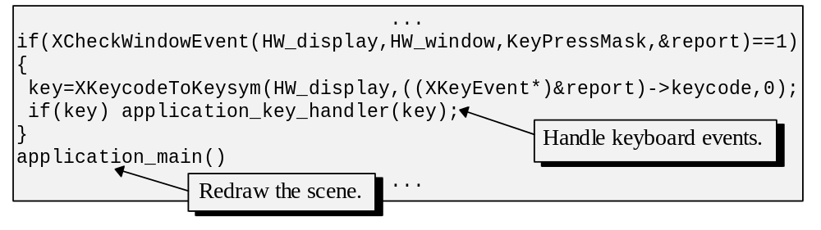
Listing 1.6: Fragment of X-Windows events loop.

Only those events which the application specified to be capable of handling in the call to XSelectInput will appear on the queue. It should be noted that basic X-windows has only fundamental interface components available. However, there is a special provision for extensions which are used by particular manufacturers in introducing helpful features. Additional libraries also exist providing both more advanced interface components and a template to write X applications using an object oriented paradigm. Generally, the conventions and fundamental concepts used in X-windows are very intuitive, often allowing to code in a straightforward manner unlike another previously described windowing system we wouldn’t want (although should) point an accusing finger upon.

1.2.4 NeXTStep.

NeXTStep first appeared accompanied by NeXT inc. proprietary hardware, which was based on 68040 Motorola processors. Quite soon after its introduction, this powerful operating system became available for IBM PC compatible computers with Intel 386 processors and later for HP hardware. NeXTStep contains a windowing system functioning on top of Mach-O, a UNIX-like operating system.

Unlike previously described systems, NeXTStep contains a much more consistent support for object oriented development and code reuse. The primary language for writing applications which take advantage of NeXTStep’s windowing system is Objective C. Very much like C++, Objective C extends the basic Kernighan and Ritchie syntax of C to support object oriented paradigm. There are, however, multiple differences between the two languages both on the conceptual and syntax levels. For instance, a member function call (method call in objective C terminology) is enclosed in square brackets in Objective C whereas C++ employs the syntax similar to what is used to access member variables in a C structure. We are going to return to C++ and Objective C in the last chapter of the text dedicated to application design. NeXTStep supports the development with an array of powerful tools such as multiple developer’s libraries accessible from the Interface Builder, an instrument aiding in visual construction of applications’ front ends.

Early NeXT hardware followed its name (which supposedly stands for Next XT) in providing only 4 shades of grey display, somewhat similar in handling to XT’s CGA (Color Graphics Adapter), only a very big one. However, the operating system provides all the required layers of abstraction from the actual hardware so that a user’s program need not even be aware of the kind of available visuals. For instance, a special interface function displaying bitmaps in the window will adjust format according to the available display hardware. We can render the image using one byte per pixel layout, and the operating system will convert it utilizing dithering, if necessary, to achieve the suitable display on, even, inferior hardware. The following sequence of instructions in Listing 1.7 illustrates displaying a bitmap in a window.

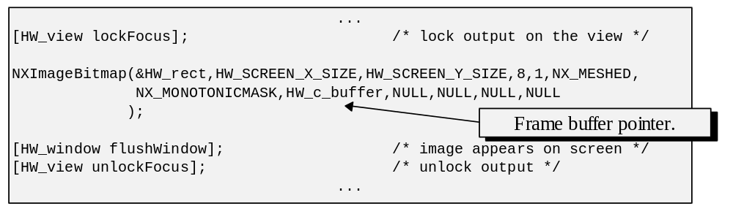Listing 1.7: Displaying image bitmaps in NeXTStep.

In Listing 1.7 note the square brackets of method invocations. The first name in the brackets specifies the object which should invoke the method followed by the method’s name and the arguments to be used in the invocation, if any.

The execution flow of NeXTStep applications differs sufficiently from both MS-Windows and X-Windows applications. An event loop is not present explicitly in the application. There is also no event handler functions of the MS-Windows style. Instead, the windowing system itself invokes necessary methods in the objects representing displayed interface components. A usual application will allocate the required interface components, and then invoke the method run in the NXApp object which is equivalent to starting the event loop (see Listing 1.8).

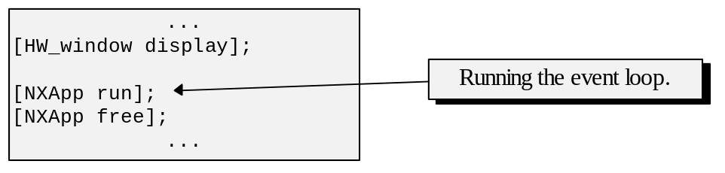
Listing 1.8: Initiation of the event loop in NeXTStep.

During the application’s run, user’s actions cause invocations of methods in the visual interface objects of the application. However, it is also possible for an application to directly check the state of the event queue and undertake actions accordingly.

Many interactive 3-D applications must generate and display frames on a continuous basis. In the case of NeXTStep this can be achieved by telling the operating system to invoke a certain function on the timing basis through, for instance, a call to DPSAddTimedEntry function.

Overall, NeXTStep provides an extremely solid developer’s platform combining the power of UNIX with a very consistent user interface and support for object oriented development which is yet to be overtaken by the competing operating systems. It is only surprising that NeXTStep appears to have never reached significant market share to be properly appreciated by a wider community of computer users.

1.2.5 MacOS.

Apple’s Macintosh occupies a prominent position both in the history of microcomputers, but also on the today’s market. Since its appearance, Macintosh has pioneered many technologies which today are inseparable from any desk-top computer. Graphical User’s Interface is one of such technologies which, perhaps, had the most impact. Consistency of Macintosh’s own graphical user interface made this platform favourite in such area as desk-top publishing.

Traditional Macintosh’s operating system understandably named MacOS consists of a number of modules called “managers” which handle basic functionality. For example, the File Manager is used to access the file system, the Virtual Memory Manager provides services related to the address space, the Device Manager services the attached devices etc. The managers of the operating systems are accompanied by the sets of interface functions from the Toolbox which provide functionality of somewhat higher level for the application programs. For instance, QuickDraw performs all display operations including drawing of graphics primitives, the Window Manager allows creation and managing of windows, the Event Manager gives access to the event queue etc.

On its start-up a Macintosh application is responsible for initializing the managers it is planning to use. The following sequence of instructions in Listing 1.9 illustrates this process.

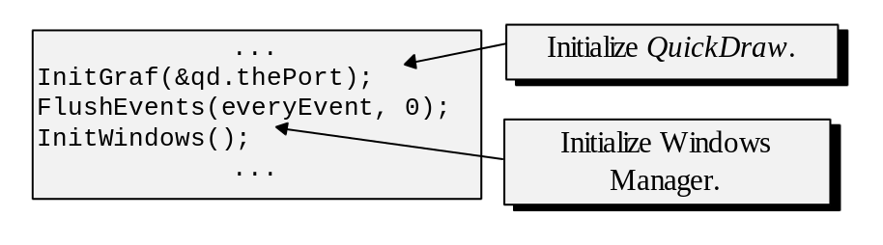
Listing 1.9 Initializing Managers.

Once the managers are initialized an application can create a window through, for example, a call to the NewWindow function. This function will allocate the necessary structure and pass to the application a pointer which can be further used to identify the created window to other interface functions.

Due to its early support of GUI, Macintoshes always had better than average display hardware. For the purposes of graphics applications this hardware can be accessed through the services provided by QuickDraw. These services include support for bitmaps and they were evolving overtime. Currently, handling for off-screen buffers is encapsulated within the GWorld structure and associated routines. The GWorld structure contains all the necessary information on the layout and geometry of an image and keeps a pointer to the actual pixel array. Blitting is achieved by copying this array into frame-buffer of the destination window by calling the CopyBits function.

Handling of events under MacOS is quite similar to that in other event based windowing systems we have considered. An event can be fetched from the queue by the means of a call to the GetNextEvent function which can also filter the events and send to the application only those which it requires to handle (see Listing 1.10).

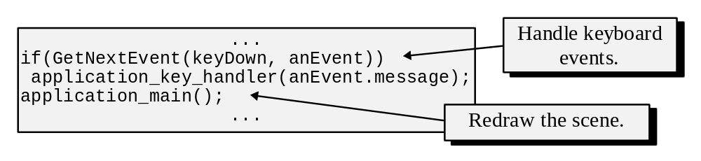
Listing 1.10 Fragment of MacOS’s event loop.

Generally, Macintosh provides a pleasant environment for both developers and users. As a disadvantage of this platform we can name lack of true multitasking since only co-operative multitasking was available with MacOS and lack of proper memory protection. This situation is changing, however, since Apple has introduced PowerMac featuring a RISC processor and is considering on operating system solution for the future use.

To summarise, we have discussed general strategy, graphics applications use, to interface hardware and communicate to the user. Implementations of the strategy differ depending on the particular operating system and the hardware. For the purposes of interactive graphics applications we concentrate on displaying images on the screen and handling user’s responses.

In the following chapters we are going to discuss the algorithms which allow to create images of the virtual worlds. These algorithms are not generally exposed to the hardware, yet depend on the ability to show created images on the screen.

* * *

