Chapter 2 3-D Transformations.

2.1 Euclidean spaces, degrees of freedom and basic transformations.
2.2 Translation.
2.3 Scaling.
2.4 Rotation in the plane.
2.5 Rotation in 3-D.
2.5.1 Coordinate systems.
2.5.2 Transformation order.
2.6 Representing transformations in a matrix form.
2.7 Projection transformations.
2.7.1 Parallel projection.
2.7.2 Perspective projection.
2.8 Implementing transformations using fixed point arithmetic.
2.8.1 Representing integer numbers.
2.8.2 Operations on fixed point numbers.
2.8.3 Implementation of fixed point arithmetic.

True reality is composed of matter. Matter can reflect light making itself visible to humans. Virtual reality, in computer graphics sense of the term, doesn’t exist as matter. It is rather an analytical description of certain abstract entities which, with the help of visualization algorithms and computer hardware, resemble matter and true reality when viewed by humans.

Thus, the very first challenge in computer graphics is finding a way to analytically describe objects and the next one, is finding a mathematical apparatus to support visualization algorithms. Geometry and linear algebra lend their methods for both purposes since in computer graphics, we are dealing with the problems typical for geometry and linear algebra. In this chapter, we will discuss these mathematical methods concentrating primarily on different transformations of coordinates. A transformation is a function which maps points from one coordinate system to another. Movements of an object in the virtual world and its projections onto the screen are computed using various transformations of coordinates. We are also going to consider techniques to represent transformations and methods for their efficient computation

2.1 Euclidean spaces, degrees of freedom and basic transformations.

In geometry, shape of entities is fundamentally based on the coordinates of some points in space. The way we perceive the surrounding world on the local scale, corresponds to what is known in mathematics as Euclidean space.

A single point in a plane, which is a Euclidean space, can be unambiguously specified through its Cartesian coordinates: (x,y) (see Figure 2.1).

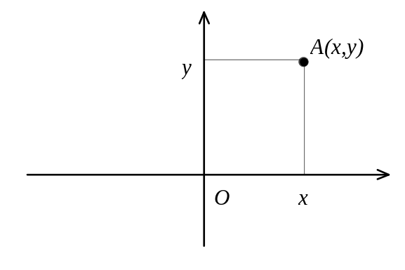
Figure 2.1: 2-D plane with Cartesian coordinate system.

Similarly, world around us, which, for one reason or another, possesses three dimensions, can be modelled by Euclidean three-space which is, generally, referred to as just 3-D space. A single point in this space is uniquely specified by three coordinates: (x,y,z).

We will consider many methods of representing virtual objects in the following chapters. These methods will essentially provide a way how to determine the coordinates (x,y,z) of points which belong to the described object. Some representation methods may also explicitly refer to the coordinates of key points of an object such as the vertices of a polygonal mesh, for instance.

To represent some parameters of the virtual world we can use simple scalar values. A real or an integer are scalars. A scalar can be used, for example, to represent the magnitude of a constant level of illumination which is the same in every direction throughout a virtual scene. Other entities, besides the magnitude, also possess a direction. A traditional example from physics is a force applied to a material point. This entity clearly possess a direction and a magnitude. Similarly, a directional light in a virtual scene possesses a direction and a magnitude. To represent these, we use vectors. A vector can be viewed as a directed line segment where vector’s magnitude is equal to the length of the segment. Clearly, infinitely many equally directed, parallel line segments whose length is the same describe the same vector. However, of these, only one will originate in the beginning of the coordinates, and thus, we can uniquely describe a vector by describing such line segment. A vector in a plane is denoted as 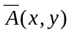. The coordinates 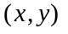 are used to specify the end-point of vector’s line segment whose origin is assumed to be in the beginning of the coordinates (see Figure 2.2).

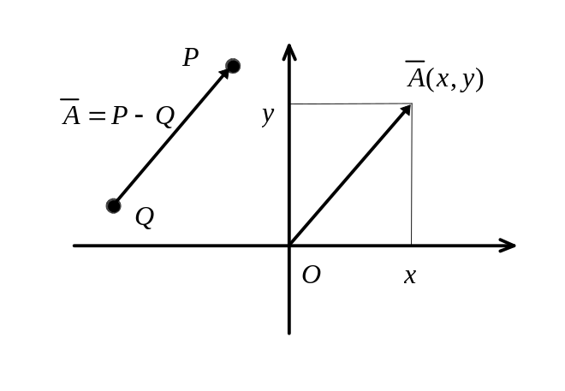
Figure 2.2: Finding vector’s coordinates.

Figure 2.2 also illustrates that when we are given some directed line segment QP we can deduce the coordinates of the vector described by this segment by moving segment’s origin to the beginning of the coordinates. In other words, the coordinates of the vector can be computed by subtracting the coordinates of the segment’s origin Q from coordinates of the segment’s end-point P:

Similar to operations defined for scalar values such as addition and subtraction for reals or integers, there is also a set of operations defined for vectors. The two most important ones are vector addition and multiplication by a scalar. The sum of two vectors is defined as a vector whose coordinates are the sums of the coordinates of the two given vectors:

A vector can be multiplied by a scalar value producing another vector whose coordinates are obtained by multiplying the coordinates of the given vector by the given scalar:

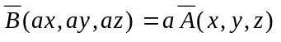

Vector addition allows to express the combined effect of several vector entities. Multiplication by a scalar allows to change magnitude or direction of the vector entity leaving the orientation unchanged. For instance, by multiplying a vector by a scalar -2 we reverse the direction and double the length. Figure 2.3 illustrates the geometric sense of these operations.

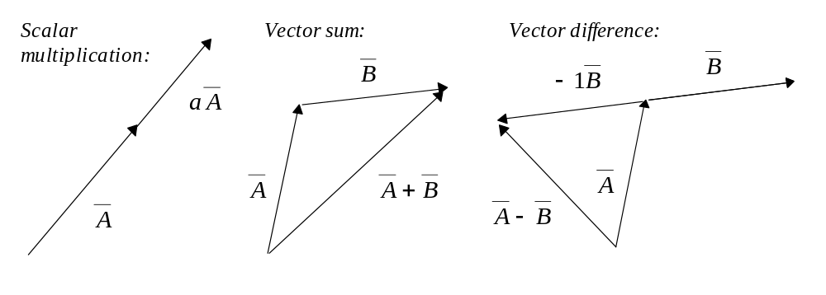
Figure 2.3: Operations on vectors.

Other operations on vectors can be defined as well. For instance, vector subtraction can be defined as addition of one vector and another vector premultiplied by a scalar -1 (see Figure 2.3):

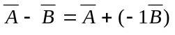

In the following chapters we will also encounter two other operations on vectors. A scalar product and a vector product.

Points, scalar values and vectors allow us to construct a description for a virtual world. Objects in this world move and change their orientation. If we put a restriction on a body requiring the distances between all the points to never change, such a rigid body possesses three degrees of freedom in a plane and six degrees of freedom in 3-D space. A single degree of freedom is a scalar parameter changing which induces changes in the state of the system being described. For instance, a point on a line has a single degree of freedom since any state (a position of this point) can be specified through variation of a single parameter - the linear coordinate. In the case of a rigid body in 2-D space, degrees of freedom are displacements along the two axes (translations) and a rotation around a point. Any transformation of a rigid body from some initial position in space to any other position can be expressed through variation of those three parameters. In the case of 3-D space there are three different independent displacements possible. One along each of the three axes as well as three different rotations around axes which are parallel to the three reference axes forming the coordinate system.

To summarise, any transformation of a rigid body can be expressed through two different types of transformations: the translations and the rotations. For many computer graphics applications, synthetic objects keep their shape and metrics unchanged. In such applications, we mostly need rigid transformations. However, if the shape of objects (distances between points) do change, we need to consider other transformations as well. Perhaps the most common of the non-rigid transformations is scaling which results in changes in size or shape of the transformed object.

Talking of all 3-D transformations, we can consider them either as a transformation of a set of points in a static coordinate system or as a transformation of the space, in other words a change in the coordinate systems. We will see that for some transformations first way of thinking is more convenient whereas for others so is the second one.

2.2 Translation.

Translation transformation, as we have already briefly discussed, moves the points of an object to a new specified position (see Figure 2.4 (a)). We may also think of this transformation as moving the coordinate system (the space) into the opposite direction, (see Figure 2.4 (b)).

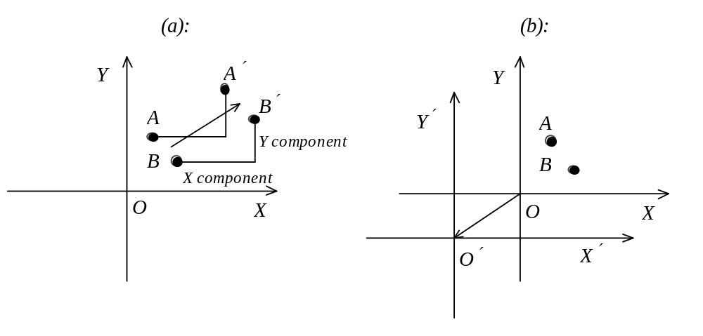
Figure 2.4: Translation of a set of points, translation of space.

As Figure 2.4 shows, if we translate a set of points, distances between these points will not change. Any move across 2-D space can be separated into two independent components - a move along the X axis and a move along the Y axis. It will take three components in 3-D space - along the X, Y and Z axes. An important place where the translation transformation may be needed is in moving beginning of the coordinates of the virtual screen to correspond to the center of the physical screen which often has a system of references placed into the upper left corner. A possible implementation for the translation routine is presented in Listing 2.1.

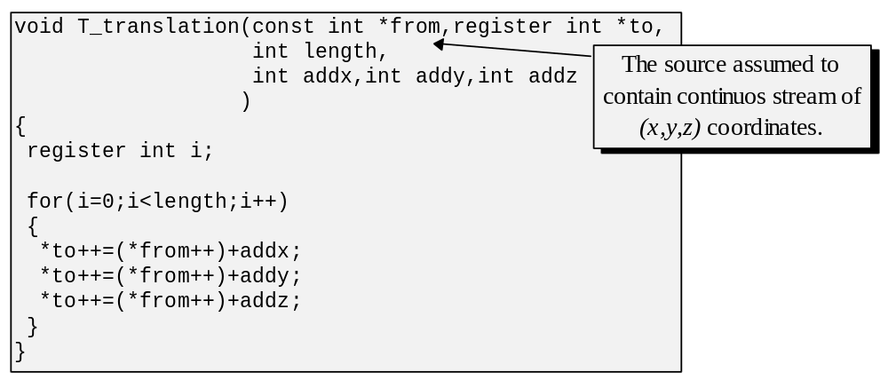
Listing 2.1: Translation transformation.

Note that the function in Listing 2.1 operates on a stream of coordinates which represent a set of points of some object.

2.3 Scaling.

Another important transformation to consider is scaling. It is defined as proportional expansion or contraction of the distances between points. Alternativelly, we can also think of scaling as contraction or expansion of the space itself (see Figure 2.5).

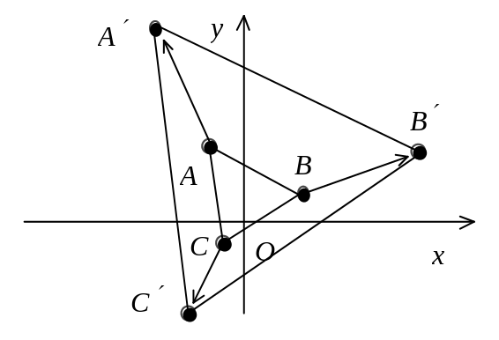
Figure 2.5: Scaling transformation.

One obvious use of this transformation is trying to fit an object of the dimensions A by A into a window of the size B by B. Evidently, every point of the object will have to be scaled in order to fit the window. In this case, the scaling is performed by multiplying the coordinates by the constant . We may have also thought of this transformation as of scaling the window space to enclose the object.

By its very definition, the scaling transformation changes distances between points, thus it is not one of the rigid body transformations.

In general, we can introduce separate scaling factors for every axis, and perform so called non-uniform scaling as opposed to uniform scaling which has the same factor in each direction. In both cases, if the factor is greater than zero and less than one, we will contract the object. If the factor is greater than one, the object will be expanded.

An implementation, which is very much similar in structure to the translation routine, is presented in Listing 2.2.

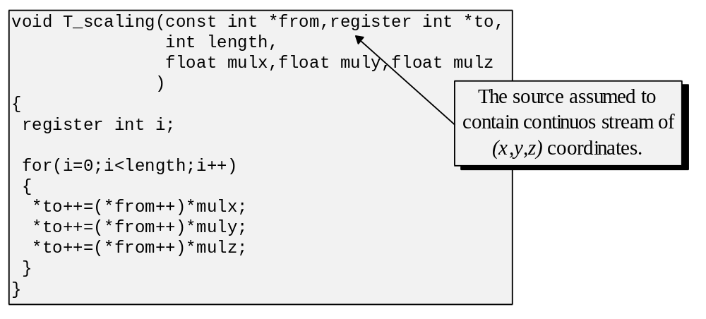
Listing 2.2: Scaling transformation.

2.4 Rotation in the plane.

Of the three transformations discussed, rotation is somewhat more complex. Let’s first consider a planar - 2-D case of the rotation transformation. There is some trigonometry involved, notably sin and cos functions. The functions sin(x) and cos(x) for a right-angle triangle on Figure 2.6 are defined as:

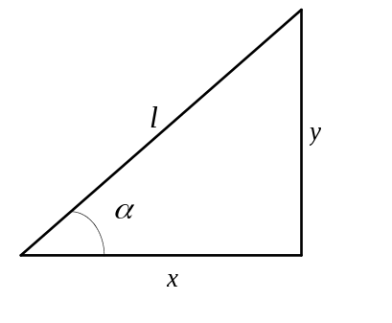
Figure 2.6: Right angle triangle.

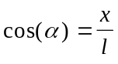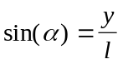

If we do know sin(α) or cos(α) we can compute the segments x and y knowing the length of l:

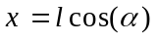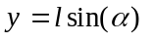

This can be considered as seeking the projections onto two orthogonal axes of the point for which we know the distance from the beginning of coordinates (see Figure 2.7).

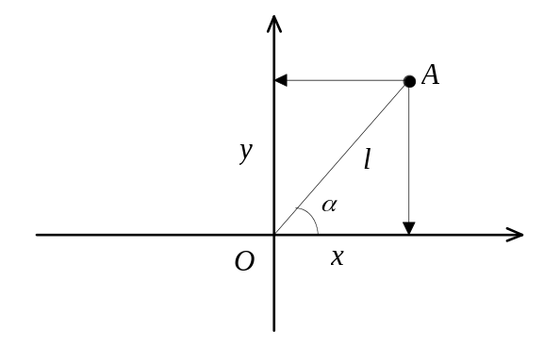
Figure 2.7: Projection of a point onto the axes.

Let’s consider a situation in Figure 2.8 where we rotate the system of references counterclockwise by some angle α. We will have to find the coordinates of the point A in the transformed system of references X'Y' assuming that its coordinates in the original system XY were (x,y).

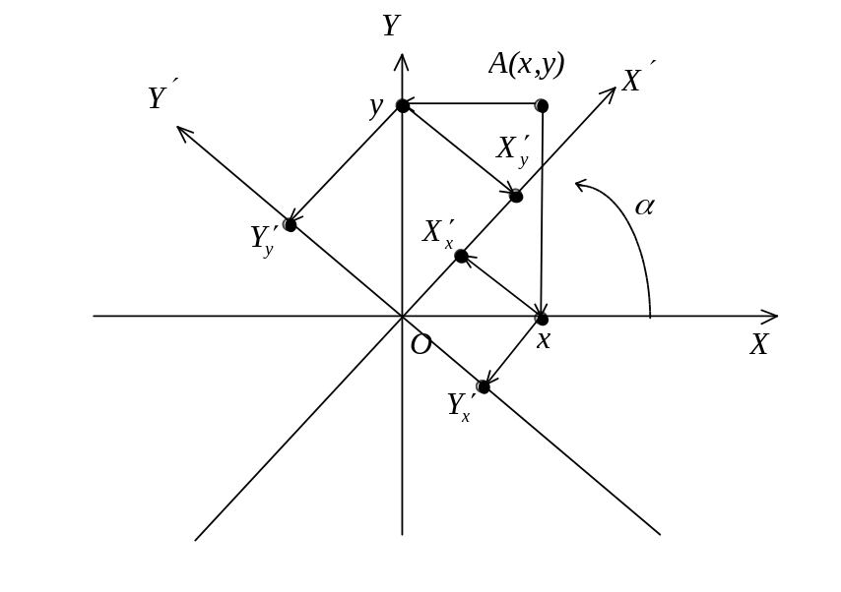
Figure 2.8: Rotating the coordinate system.

Using the sin(x), cos(x) formulas from the above, we can find the projections of x and y (that is, of the coordinates of the point in the original system of references) onto the new axes X' and Y'. Let’s sum the projections of x and y onto X' axis and do the same with the projections of x and y onto the Y' axis. These sums will constitute what we are looking for, the coordinates of the point A in the new system of references X'Y' i.e.:

Note the sign of 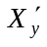. Simply from examining Figure 2.8 one can see that in this case x is projected onto the negative side of the axis Y'. That’s why the negative sign.

Alternatively, we can now consider this, very same, rotation transformation as a point A itself, rotating around zero clockwise with the system of references being stationary.

2.5 Rotation in 3-D.

In the previous section we have deduced the formulas representing planar rotation transformation. Brought into 3-D this transformation will have a sense of rotation around newly added axis Z rather than around a point since the coordinate z isn’t influenced by the formulas and remain the same after their application. We can, in the similar manner, describe rotations around two other axes which will transform a different pair of coordinates leaving the remaining coordinate unchanged.

If we fix one point of some object and designate it to be the beginning of coordinates, any orientation of this object around the fixed point can be described in terms of the three rotations around the axes of the coordinate system we have just set. In other words, 3-D rotation around a point is achieved by sequential application of three rotations around different axes so that each consecutive rotation transforms the coordinates obtained from the previous stage.

There are few important considerations influencing the form in which we will find the 3-D rotation formulas:

- What kind of reference system do we have?
- What are the positive directions of rotations we will be applying?
- In what order do we want the rotations to be applied?

In the following subsections we are going to derive the set of formulas and we will see why the above considerations affect their form.

2.5.1 Coordinate systems.

Generally, we are not constrained by the geometry of the system of references and do have a freedom of choosing the directions of the axes which form the system. Different branches of science and engineering have certain more or less developed conventions and customs on the usual system of references. In most cases, it is either left-handed or right-handed one (see Figure 2.9). For the purposes of this book we will mostly rely on the left-handed notation.

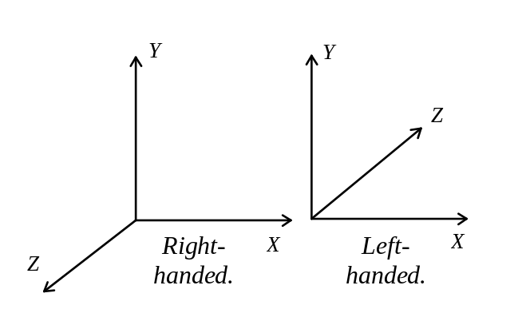
Figure 2.9: Rotating the coordinate system.

We don’t actually have to follow the customs if we really don’t wish to, and, besides, for the purposes of certain applications there may be reasons to choose a particular system of references. It is customary, for example, to have the positive direction of the Y axis pointing upward. However, remembering that in the most typical bitmap the Y axis points downward (which is dictated by the memory layout for the display hardware), this might be a semi-valid reason to choose the corresponding system of references in 3-D space. The contrargument is that it is more natural to have it pointing upward, measuring height in such applications as flight simulators, for instance. Choosing the direction more natural for human perception might prevent us from misunderstandings at the debugging stage in the future, actually saving some time.

Let’s choose the following system of references, with the Y axis pointing upward, X to the right and Z away from us.

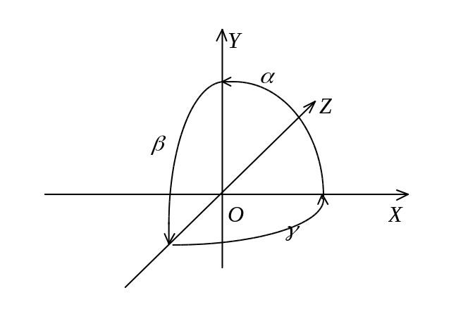
Figure 2.10: Positive direction of rotation angles.

We must also define the rotation angles. It is customary to call the angle to turn XY plane around Z axis (α) as roll, ZY around X (β) as pitch, and ZX around Y (γ) as yaw (see Figure 2.10).

2.5.2 Transformation order.

Defining the order in which to apply the rotation transformations is very important because a point consequently turned by the angles γ-β-α won’t be necessarily at the same position in space where it may be placed if turned by the same angles α-β-γ but taken in a different order. It is said: consecutive applications of rotation don’t commute. The reason is in our original assumption, that each next transformation works on a point already transformed by the previous planar rotations. In other words, we are specifying angles around moving axes. In Figure 2.11 we can see that rotations α-β take the object to a different location compared with the same rotations but in the opposite order- β-α.

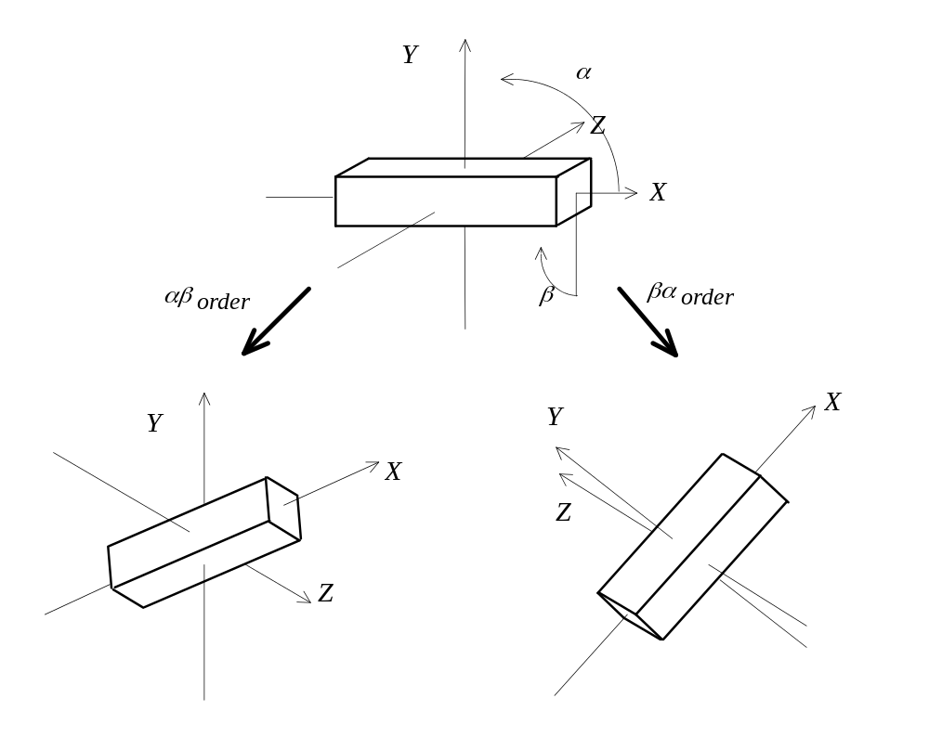
Figure 2.11: Consecutive rotations.

The implication of this fact is that we have to decide with respect to what each consecutive rotation should be performed. That is, what is the order of applications of 2-D rotations. Let’s think about the way how we coordinate the surrounding world. First we think of the direction. Then we can tilt our head up and down, and finally from that position we can move it from left to right. When we are tilting the head we have already chosen the direction. If we would first tilt the head then the directional rotation, to be performed afterwards, will not be in the plane parallel to the ground. It will rather be in the plane perpendicular to the imaginary line being continuation of our tilted neck. (No responsibility is hereby assumed for any direct or consequential damages or injury resulted from experimenting in the aforementioned way). In terms of our system of references, it all comes to the directional rotation - yaw first - γ in our case. Pitch second - β , and roll last - α..

The sequence just found describes, of course, the order of individual rotations applied to the world with respect to the viewer whose orientation changes. In other words, rotation axes are centerd in the viewer’s eye. If we are coordinating an object in the world, with the rotation axes being local to the object, the convenient order is often different, pitch is done with respect to where the object was turned by roll, and yaw is applied last.

Derivations of combined rotation formulas is similar, of course. Let’s consider just the first case in Figure 2.12.

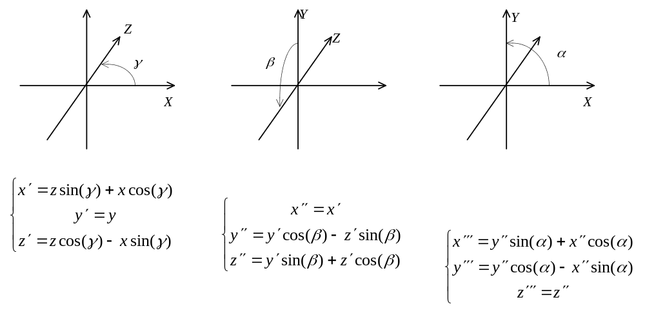Figure 2.12: Three consecutive rotations.

These nine formulas describe the 3-D rotation. We can apply them to the coordinates 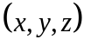 and eventually obtain 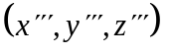. There are 12 multiplications involved. An obvious question one can ask: is it possible to reduce this number? Let’s try to further modify the formulas by getting rid of the temporary variables 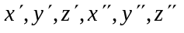. We can do it by substituting their occurrences by the expressions describing their meanings.

First, we obtain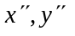and 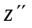 expressed via x,y,z:

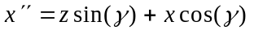

Further, using the above expressions, we can represent 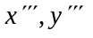 and 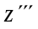 directly via x,y,z:

This set of formulas appears to be more complex than what we originally had. It has much more multiplications than we had. However, if we look closely at the resulting formulas, we can see that all the coefficients in the square brackets can be computed just once so that the transformation of a point will look like:

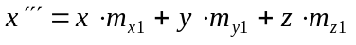
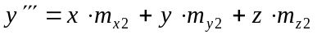
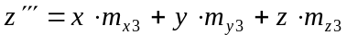

This computation takes nine multiplications. Of course, finding all the coefficients takes another 16 multiplications:

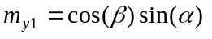
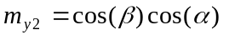
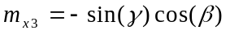
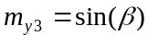
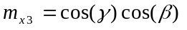

However, if we have a hundred points to take through the rotation transformation, the original method would require 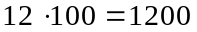 multiplications. The new technique will only take 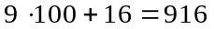 multiplication since the coefficients are computed only once for any number of points to transform.

Assuming that we have minimized the number of multiplications, we should consider speeding up the only other operation which remains in the expressions: Computing the trigonometric functions. Both sin(x) and cos(x) may be computed through evaluation of a power series. Modern processors with support for floating point operations may have special internal provisions for computation of trigonometric functions. When such support is lacking, it is relatively easy to implement it in software. With the aid of Taylor power series, many functions can be expressed as:

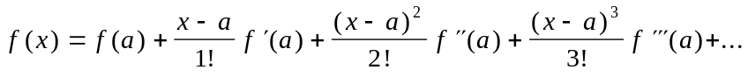

This expression allows to find the value of 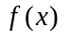 for in the neighborhood of . It demands however to know the values of derivative functions in a point , i.e.: 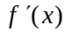- the functions describing the rate of change for , 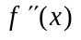- the rate of change of the rate of change for and so on. Computing the derivative functions for an arbitrary is at least as complex a task as the one we are attempting to undertake. To avoid this problem we can select a convinient value of zero for thus obtaining what’s known as Maclaurin power series:

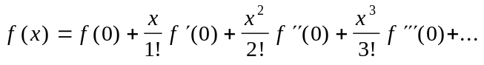

Since the values of the all derivatives of 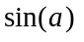 and 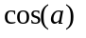 when 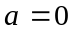 will be either 0 or ±1, it is not difficult to obtain the expressions for particular power series to compute the trigonometric functions:

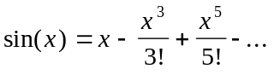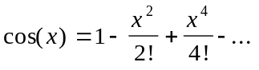

It should be pointed out that these series are infinite in the number of terms, and thus for practical purposes we approximate the functions with only a finite (and preferably the smallest possible) number of terms:

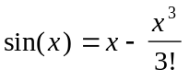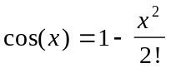

This, however is not without precision penalty. The computation will work only in the immediate neighborhood of zero. Consider Figure 2.13. Note that 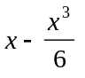 appears to approximate 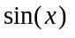 well enough only in a very narrow domain.

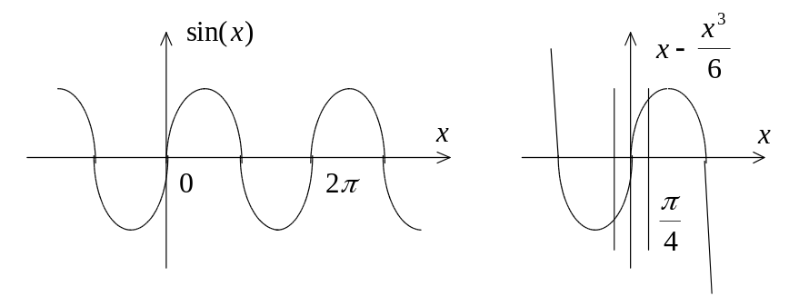
Figure 2.13: Approximating sin(x).

Generally, such an appoximation works sufficiently well in the domain from 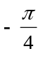 to 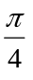 (-45° to 45°). Note that this is also the case with approximation of 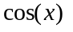 with 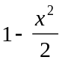 (see Figure 2.14).

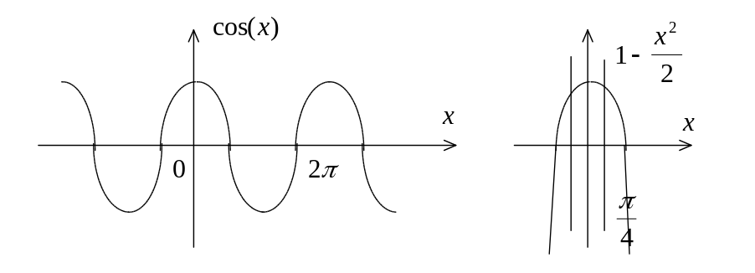
Figure 2.14: Approximating cos(x).

Obviously enough, we need to know values for trigonometric functions outside of this narrow domain as well. To do that we can either increase the number of terms in the expansions, or, what’s even better, take advantage of the regular nature of both and . The values of the functions repeat with the period of 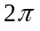 (360°), and hence it is sufficient to be able to compute the value in the domain from 0 to in order to easily deduce it for the entire infinite range of arguments.

From examining Figures 2.13 and 2.14 it is not hard to see that looks like a horizontally shifted and vice-versa. Indeed 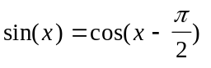. Thus, from to 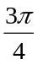 (45° to 135°) can be computed as 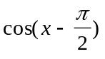 allowing to use: 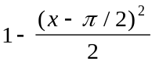. Similarely, the values from to 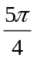 are nothing else but 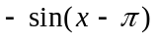 i.e. 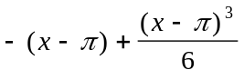 (see Figure 2.13). Proceeding this way, we can compute any value in the range from 0 to (360°).

Knowing how to compute the trigonometric functions let’s consider if there are any other relaxations which we can make. For example, in many cases, it makes sense to consider only integer angles since in many applications it is acceptable to manipulate with fairly rough measures for angles. If that is the case, we don’t need sin(x), cos(x) for the entire real number range and can limit the domain of the functions to a short list of 360 integers. We can compute sin(x) and cos(x) just once for all 360 degrees before any rotations are performed and store the obtained values in arrays. With that done, sin(x) or cos(x) can be found through a simple array lookup and not through a relativelly expensive evaluation of a power series.

Moreover, in some applications we don’t really require 360 degrees. This measure is not very convenient. It is somewhat more efficient to divide the full angle into 256 pseudo degrees. By doing this, we need just one unsigned char (a byte) to store an angle. Whenever we go beyond 255, the value will simply wrap around to zero. This process saves us a conditional statement which may be needed otherwise in the case of measuring angles using 360 degrees.

Coding a 3-D rotation transformation is quite straightforward. The function in the implementation in Listing 2.3 is building a set of the rotation coefficients. Note that floating point variables: T_mx1, T_mx2 etc. are assumed to be global.

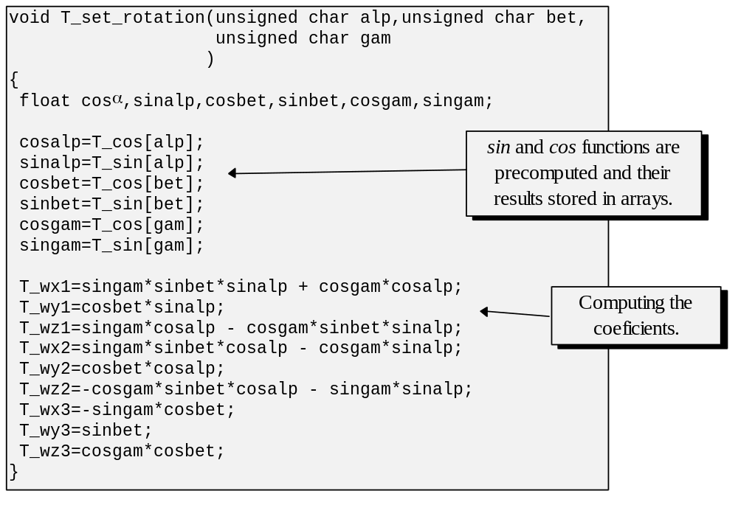
Listing 2.3: Computing rotation coefficients.

Another function: T_rotation, presented in Listing 2.4, uses the coefficients computed in the T_set_rotation function to perform the actual rotation transformation.

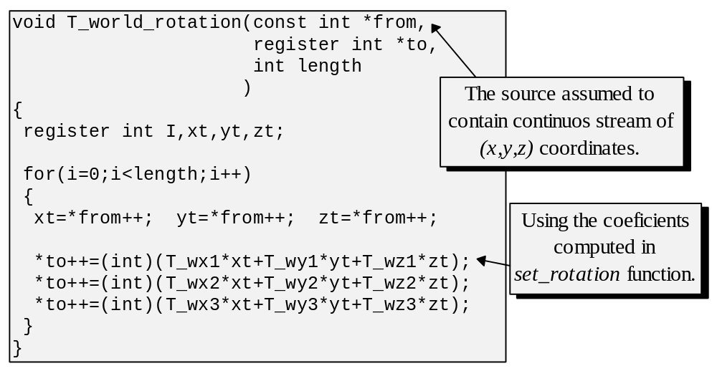
Listing 2.4: Rotation transformation:

2.6 Representing transformations in a matrix form.

A matrix is a table of values:

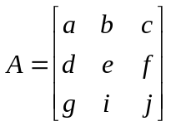

Special cases are row and column vectors:

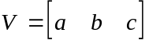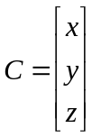

A row can by multiplied by a column producing a scalar value:

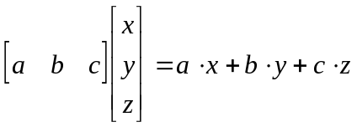

A matrix can be multiplied by another matrix. Each entry of the resulting matrix is obtained by multiplying respective rows and columns of the arguments. Since columns and vectors are to have the same dimension in order for multiplication on them to be defined, it automatically places restrictions on the dimensions of the matrices that can be multiplied. The row size of the matrix on the left has to be equal to the column size of the matrix on the right, in which case, their product can be computed as:

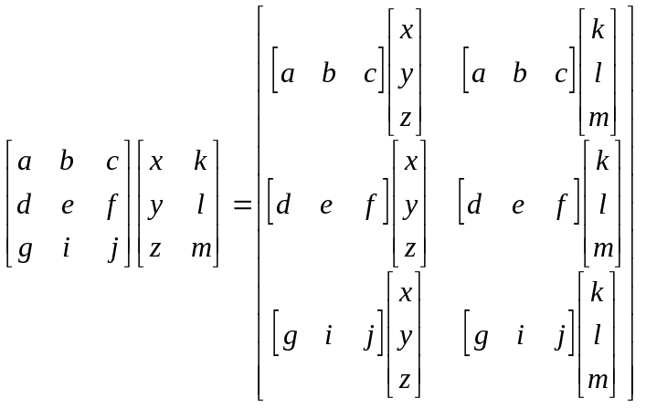

Since we are dealing with three-tuples representing the coordinates of a point, we may be interested in multiplying a row vector by a three by three matrix:

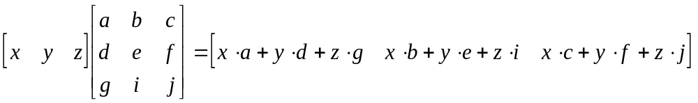

If we look closely at the expression above, it can be seen that the nine rotation coefficients we’ve derived in the last section can be conveniently accommodated in a three by three matrix. We can think of 3-D rotation transformation as matrix multiplication of a “rotation” matrix by a vector producing a result vector.

Similarely, we can attempt representing the translation and scaling transformations in a matrix form. The scaling transformation, presented here as a three by three matrix, can be expressed as follows:

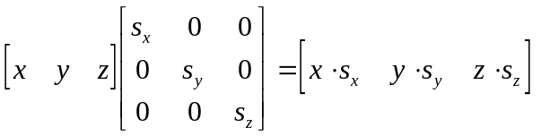

Representing translation in a matrix form is somewhat more difficult. Usual matrix multiplication doesn’t allow for additions which we require in this case. However, we can express this transformation properly by using four by four matrices and somewhat adjusted coordinate vectors. Translation is what is called an affine transformation, whereas rotation and scaling are linear transformations. A general affine transformation can be thought of as a composition of some linear transformation (specified for the case of 3-D space by a three by three matrix) and some translation (specified by an additional matrix dimension).

The following four by four matrix represents the translation transformation:

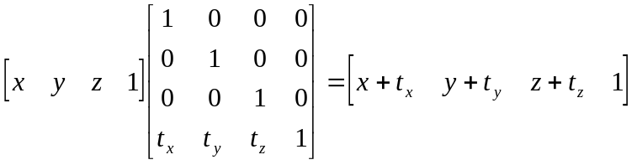

If we have chosen matrices as a formalism to represent transformations, and plan to use translations, other transformations will have to be expressed as four by four matrices as well. When adding a new dimension to a rotation or a scaling matrix, in order to preserve the correctness of the operation, all newly added entries will equal to zero except for the new diagonal item which will have to be set to one.

According to the matrix multiplication rule, it is also possible to multiply a matrix by a column vector on the right in the following way:

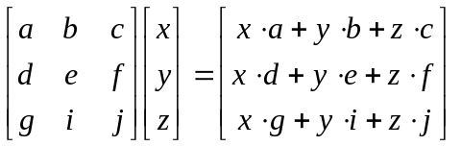

This kind of multiplication is also used as a formalism to express transformations. There is no particular difference between row vector and column vector formalisms but a personal habit to use the first or the second. It is, of course, either the first or the second since matrices in the row vector formalism are transposed matrices of the column formalism and vice versa. (The element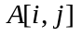of the one is to be found at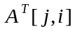 in the other):

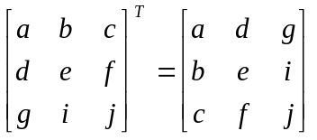

Beside of being mathematically pretty, there is a number of advantages to the matrix approach. It allows a generalized expression of transformations and it gives a computational shortcut for the cases with many consecutive transformations. For instance, let us suppose that we have several transformations each represented in a matrix form:

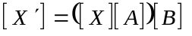

Where [A], and [B] are transformation matrices and [X] an argument vector to be transformed. Since matrix multiplication has a property of associatively which can be stated as:

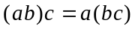

We can express the same transformation as:

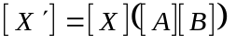

This allows to first find the “concatenated” matrix 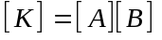 and afterwards each transformation of some coordinate vector can be computed as just:

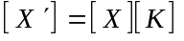

It should be noted that by representing each of the axis rotations in a form of a three by three matrix, we can derive the formulas we have found for 3-D rotation by computing the concatenated matrix. In some sense, we essentially did just that when we found the expressions for the coefficients. We started from the expressions for each rotation and the subsequent derivation basically mimicked two matrix multiplications:

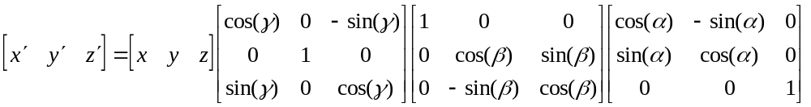

If we will trace expressions being formed as the concatenated matrix is being constructed, it will be seen that we arrive to the very same results we had in section 2.5.2.

It was already demonstrated that rotation transformations don’t commute. That is, depending on the order of applying rotation transformations different result can be obtained. This has an obvious reflection in matrix multiplication. Unlike conventional integer or real numbers multiplication which does commute 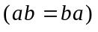, matrix multiplication doesn’t 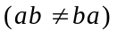.

Consider:

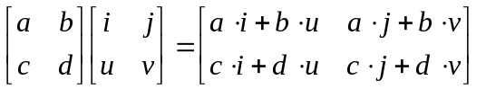

This result is not equal for most a,b,c,d,i,j,u,v to:

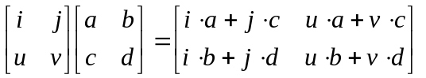

For example in the case when 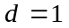and 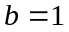whereas the rest are zeros we have:

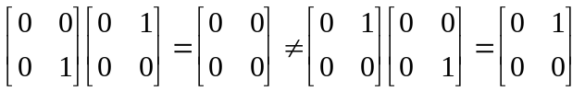

Matrix approaches are very effective in the instances where there is a lot of consecutive transformations. For example, when we have consecutive rotations it makes sense to compute their concatenated matrix and then use it to transform multiple points (It will save us quite a few multiplications; one verses several consecutive matrix multiplications for each point to transform).

We must note, however, that matrix representation generalizes transformations. Multiplication of a three-tuple by a three by three matrix triggers nine scalar multiplications. On the other hand, an individual rotation transformation around one axis which is expressed through two formulas has only four. (Five matrix entries are zeros which, however, doesn’t prevent a processor from spending some cycles on them)

One implication of this generalization is that when we know in advance the transformations to be performed, and their representations are mostly sparse matrices, we can precompute formulas for the coefficients of the concatenated matrix instead of computing this matrix through individual matrix multiplications. With the example of 3-D rotation, calculating coefficients directly cost 16 multiplications, whereas two matrix multiplications cost 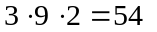 (3 multiplications per entry, 9 entries, 2 multiplications), again due to the fact that a lot of matrix entries in this particular case are zeros.

Matrix representation provides a very effective unifying framework to express transformations. When an application needs an arbitrary set of transformations in the run time, implementation may directly express any transformation as a matrix. On the other hand, in the cases where only a limited amount of transformations is required and their order is known in advance, we may want to take advantage of a more specialized approach such as precomputing the coefficients directly.

2.7 Projection transformations.

The world which we are modelling is three dimensional. Yet, the screen in which the scene appears possesses only two dimensions. The process of mapping 3-D world coordinates into 2-D screen coordinates is called a projection.

Although there are infinitely many imaginable ways to map the 3-D space onto a 2-D plane, linear ones and non-linear ones, of particular interest to us are two methods, parallel and perspective projections. We are going to consider these two in the following subsections.

2.7.1 Parallel projection.

Parallel projection is obtained when we collapse one dimension of the space so that all the points belonging to parallel lines in 3-D space map into a single point in the 2-D plane. Hence the name, parallel projection (see Figure 2.15).

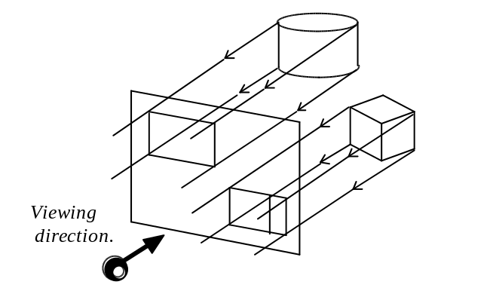
Figure 2.15: Parallel projection.

We can further differentiate the parallel projections based on the angle at which the projection lines cross the projection plane. If it is the right (90 degrees) angle, these projections are called orthographic. The rest are called oblique.

Representations, which are perhaps familiar from engineering drawings, are often based on a set of multiple orthographic projections (top view, front view and side view). We are mostly interested in the orthographic projections, perhaps because they correspond to how we see objects located at some distance away from us.

If we choose the projection plane to be parallel to the plane XY of the coordinate system, then, the projection lines will be parallel to the Z axis, and hence, the parallel projection transformation will only involve discarding z coordinates for all points in space. We are, most of the time, interested in projections created with respect to the viewer’s position and orientation in the world, often referred to as camera position and orientation. For most of these cases, the projection plane will not be necessarily parallel to XY plane of the coordinate system.

There are multiple ways to describe a camera. We can specify the coordinates of the point where the viewer (camera) is located in the 3-D world and the vectors describing orientation of the viewer’s system of references in the world space. Or, rather than to specify vectors we can express the same information through three angles α,β,γ, describing viewer’s orientation. With both of these representations of the camera, an arbitrary parallel projection can be represented as a two-step process. In this process we first perform some affine transformation which will transform the space so that the projection plane is mapped into XY plane, and than, on the second step, we perform the parallel projection of the simplified kind discussed above.

Clearly, the affine transformation to apply during the first step will involve translating the viewer into the center of the world space and of rotating the world according to viewer’s orientation. In chapter five we are going to return to this problem and discuss in detail the viewing process and particularly how to find the affine transformation required during the first step for cameras described in different ways.

As we just saw, discarding z coordinate is fundamental to the parallel projection transformation. However, by discarding it, we lose all depth information of the original 3-D space. In order to somewhat reduce this effect perspective projection should be considered. Despite this drawback, the parallel projections are widely used in many areas, for instance CAD applications. For these, the important qualities of the parallel projection to preserve parallel lines in the images and to preserve actual sizes of objects is more important than a realistic view.

2.7.2 Perspective projection.

Perspective projection creates an image in which sizes of the projections of objects depend on the objects’ distance to the viewer. It is not hard to visualize this effect of perspective transformation. Perhaps the first association a lot of us will have, is an empty straight street with identical buildings on both sides disappearing into infinity. Perspective projection enables us to produce an image with a property of landscape realism. After all, this same street will look quite unnatural if the road will not collapse into a point and buildings further away from us won’t look smaller.

We can model perspective projection transformation by simulating the viewer’s eye as the point where rays reflected from all objects in space converge. Each ray, before being caught by the eye, had intersected the plane located in front of the viewer. If we can find the intersection and plot a point there, the viewer observing it can be deceived into thinking that the ray from the plotted point was actually coming from the original position in space (see Figure 2.16).

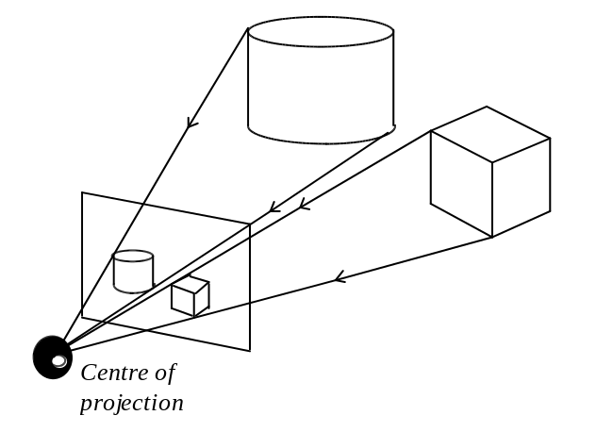
Figure 2.16: Perspective projection.

We can, similar to method in the previous section, choose a projection plane to be parallel to the XY plane of the reference system. In such case, we can observe some straightforward relationships linking the original and the image points (see Figure 2.17).

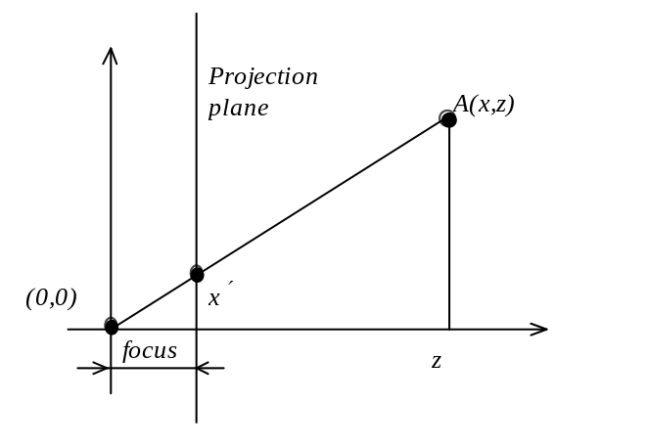
Figure 2.17: Geometry of perspective projection.

Let’s consider a planar case first. The viewer’s eye is located at the origin of the reference system. The distance between viewer’s eye and the projection plane is called the focus distance. The goal is to determine at what point the ray comming from point A into the viewer’s eye will intersect the projection plane. We will have to plot a pixel at that position on screen. Clearly, we have encountered a yet another case of solving similar triangles. From the fact that the angle at the beginning of coordinates is the same for both triangles, the bigger and the smaller one, and the fact that if two angles are the same their tangents will be too, we have:

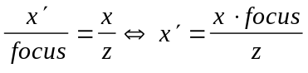

The same consideration applies for the dimension Y. Together, the two formulas describe the 3-D case:

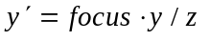
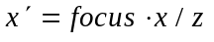

The situation which we considered above applies only for the cases where the viewer is located at the beginning of the coordinates looking along the axis Z. If that is not the case, just as with the parallel projection, we have to first apply an affine transformation to convert the original space to the one required to perform the simple perspective transformation described here. We are going to discuss finding such affine transformations in chapter five.

The situation with the z coordinate requires some clarification. After the perspective transformation, we will render primitives onto the screen which is planar. We need x and y coordinates but not z, so we can discard z. However, when trying to render multi-face objects, we need to know the depth (z) of all polygons so that we can deduce which are visible and which are obscured. (This is going to be discussed in detail in the future chapters). So we may preserve the depth by having z'=z. But, by doing the transformation on x and y and leaving z unaltered, we may actually allow for the depth relation to change. That is, a polygon obscuring another polygon in the original space, before the projection, can actually come out behind or partially behind the other polygon after the perspective transformation (see Figure 2.18).

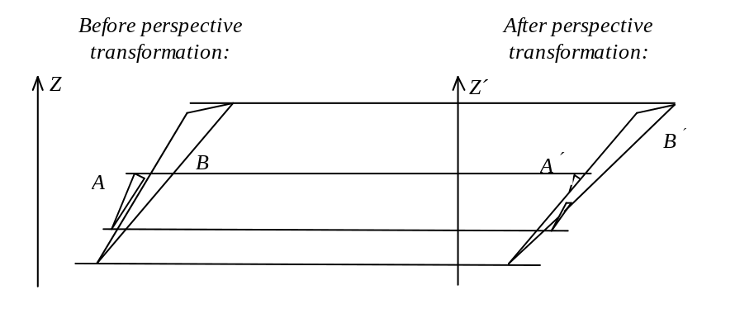
Figure 2.18: The depth relations before and after perspective transformation.

To avoid this undesirable effect, we can apply a non-linear transformation on z as well. For instance, 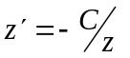, where C is some constant.

The implementation of the perspective transformation is quite straightforward. However, since the computation is parametrized with the focus distance we must understand its physical sense which will allow us to choose the proper numeric value (see Figure 2.19).

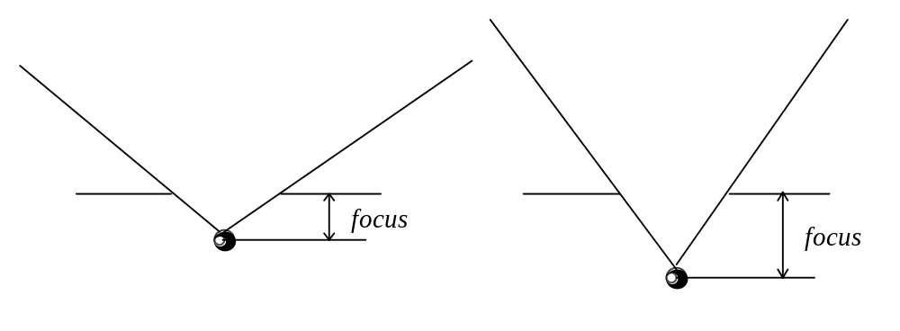
Figure 2.19: Meaning of the focus distance.

The focus distance determines the field of view angle. When the focus distance is smaller - the angle is wider, when it is bigger the angle is narrower. It is helpful to think of this distance as measured in screen pixels. For instance, if the chosen focus distance is 160 pixels and the display is 320 by 320 pixel the resulting view angle is 90 degrees.

The perspective transformation may produce at first, poorly looking images with some unnatural distortions. Experimentation is usually necessary to improve the realism. Focus distances which give the view angle somewhere between 75-85 degrees may be a good place to start, but that, of course, depends on the scene and screen geometries.

It is more difficult to express the perspective transformation in a matrix form. Actually, the usual matrix multiplication deals with only linear transformations, while. perspective, is non-linear. We need another special convention in order to represent it as a matrix. One smaller convention we already have in order to allow for translation, an affine transformation. The convention was to add an extra dimension to the three by three matrices.

The convention that is taken to enable representing the perspective transformation is to maintain homogeneous coordinates. A value of 1 which was added after X, Y and Z into the coordinate vector should remain as 1. If, in the course of applying a transformation, a different value will be obtained at that place, the vector should be renormalized. We should multiply by some constant every entry in the vector so that the last entry will become a 1 again. Assuming this strategy, we can construct the perspective transformation matrix as follows:

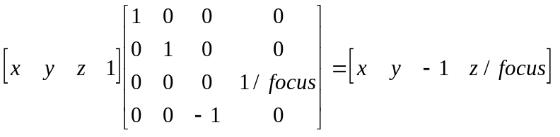

Since the last entry in the result vector is not 1, normalization has to be performed by multiplying each entry by 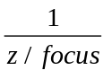:

Depending on what is the requirement for z coordinate, which may even be discarded when we don’t require depth information any further, the above matrix will have somewhat different form:

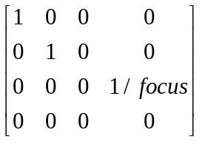

with the transformation producing:

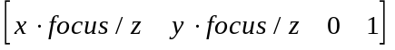

Moreover, if the viewer’s position was not conveniently chosen to be at the beginning of coordinates but at some location with negative z, for instance, the transformation formulas, and hence transformation matrix, would have had yet again different form. We should define the necessary form depending on the particularities of the application where this transformation must be implemented.

Generally, we can differentiate various perspective transformations depending on the number of convergence points (one-point perspective, two point perspective), or depending on the angle between the camera’s view direction and the normal of the screen. We have considered only one-point perspective projection with the direction of view perpendicular to the projection plane because it provides insight into what is special about perspective transformation. For some practical purpose, we may need slightly more complex transformation which, most of the time, is easy to bring to the discussed case by applying first a sequence of affine transformations.

There are several other problems with the perspective transformation. For instance, let us consider where a point with z equal to zero will be mapped by the perspective transformation? Since we are dividing by z that would be infinity, or at least something producing a divide error, in this computer-down-to-earth-world.

Another problem, calculations for points with negative z would produce negative coordinates. What we will see are objects (or even parts thereof) flipped over. But, then again, objects with negative z coordinates are behind the viewing plane and effectively behind the viewer. So, it is something we shouldn’t be able see (at least the greater majority of us).

The only way to deal with these problems, is to guarantee that there is no coordinates with invalid Zs. A way to achieve it is by applying 3-D clipping to the original set of points. (We are going to discuss 2-D and 3-D clipping in deeper detail in future chapters)

Let’s consider again representing perspective transformation as a matrix. Let’s think of all the transformations discussed up to this moment a point will have to go through in order to be rendered. First, we apply some affine transformation based on the viewer’s position and orientation. Before we can apply the perspective transformation, we have to perform clipping and dispose of the vertices which are behind the viewing plane. Only then can we apply the perspective transformation itself. Representing clipping in a conventional matrix form is hardly feasible. As we have already discussed, matrices are useful when we have several consecutive transformations to represented by a single matrix. However, in this case, we need more than one matrix because rotation and perspective are separated by clipping. If we are certain that none of the coordinates will ever get behind the viewing plane, we can avoid clipping. In this instance, we can represent every transformation in a matrix form and compute their concatenated matrix. In other cases, clipping cannot be avoided and we may want to separate transformations into two stages, before and after 3-D clipping.

2.8 Implementing transformations through fixed point arithmetic.

In previous sections in a number of places we didn’t have another choice but to use floating point multiplications (sin(x) and cos(x), after all, are real-valued functions). However, this is still a fairly expensive operation. Considering that 3-D transformations depend very much on multiplication of fractional numbers, it is worthwhile examining possible speedup techniques. An alternative to floating point arithmetic is fixed point arithmetic. To implement the operations of the latter we can use integer multiplication and division. Assuming that integer operations are less expensive, utilization of fixed point arithmetic may give us a certain performance gain.

In this section we are going to consider basic principles of how digital computers represent and manipulate with number. This will provide us with the necessary insight for implementation of the fixed point arithmetic. Further, we will consider specific instances where in 3-D applications this technique can be helpful.

2.8.1 Representing integer numbers.

It is benefitial to understand how we represent integers in digital computers (see Figure 2.20).

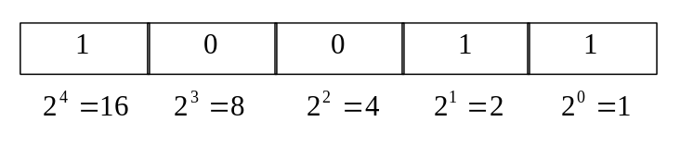
Figure 2.20: Representing integers.

With any counting system, digits in multi-digit numbers have different weight, so to speak. With decimal numbers, this weight is some power of ten. For instance 102 is actually:

The situation is similar with binary numbers, the only difference, the weight is some power of two. Thus the number on Figure 2.20 should be considered as:

It is quite natural to place a decimal point into a decimal number. Placing a binary point into a binary number should not be more difficult. How do we interpret the decimal point? For the digits to the right of the decimal point, we choose increasing negative powers of ten. That is:

In this representation, the point separates negative powers from zero power and the point never changes its position unlike numbers represented in exponential form: the floating point numbers. In the latter case, the point moves depending on the magnitude of the number which is represented.

Let’s consider an example where a binary point is placed into a binary number (see Figure 2.21).

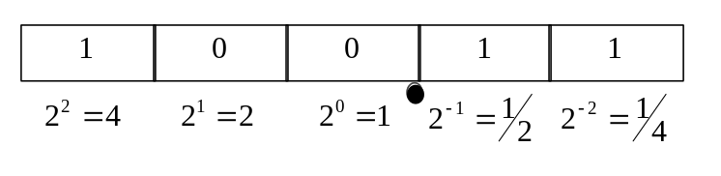
Figure 2.21: Representing a fixed point number.

Using the very same technique, we see that the number represented in the Figure 2.21 can be considered as:

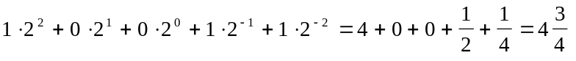

Let’s find the range of numbers which we can represent. Resorting once again to the analogy with the decimal numbers, we can see that two digits to the right of the decimal point can cover the range of 0.99 in 0.01 steps. Numbers smaller than the minimal 0.01 precision step can’t be represented without increasing the number of digits after the decimal point. The same is happening with the binary numbers. In the example in Figure 2.21, since we have two binary digits, the minimal number we can represent is 1/4 ( 0.01 (bin) = 1/4 (dec) ). And again, the numbers with higher precision can be represented only by increasing the number of binary digits after the binary point.

Let us consider representation of the negative numbers. While there are several methods, effectively one has prevailed today. This is so called “two’s complement form”. It requires negating the weight of the leftmost digit (see Figure 2.22).

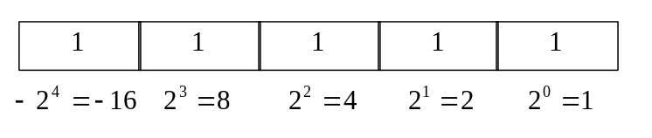
Figure 2.22: Representing negative integers.

The number represented above is considered to be:

The advantage of this approach is that it isn’t neccessery to change addition and subtraction algorithms which work for positive integers in order to accommodate two’s complement numbers. This is due to the natural overwrap of the integer numbers the way they are represented in computers. If we add 1 to the maximum number we can represent, we obtain a carry from the most significant (leftmost) bit, which is ignored, and the value of exactly 0. -1 in the signed representation is the maximum value we can represent in the unsigned representation, and indeed -1+1=0. Although addition and subtraction algorithms don’t have to be changed in order to accommodate two’s complement negative numbers multiplication and division algorithms should, that’s why there are instructions for both signed and unsigned multiplications in most computers.

Since the leftmost digit in the two’s complement representation carries negative weight and because that’s the one with the highest power, the minimum negative number possible to represent in the example above will be 10000 (bin) = -16 (dec). All the other digits have positive weights so the maximum possible positive number will be 01111 (bin) = 15 (dec). This slight asymmetry is not a problem in the majority of cases. However, values of sin(x) and cos(x) functions are in the range between 1 and -1. To represent them we can choose a format with just one integer field:

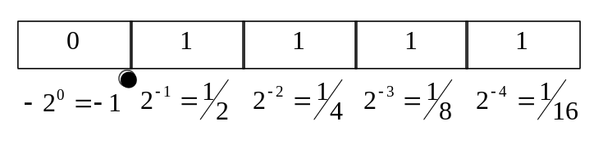
Figure 2.23: Fixed point number with a single integer field.

Thus, due to the asymmetry described above, there will be a value for -1 (10000), however, there will be no representation for positive 1, just its approximation: (01111) = 1/2+1/4+1/8+1/16=15/16 (see Figure 2.23). For most graphics applications when there are, for instance, 15 bits representing fractions such approximation is close enough and won’t cause problems. Yet, for some applications this may become an additional source of accumulated error thus requiring to choose more integer digits.

2.8.2 Operations on fixed point numbers.

We have already discussed that we can use regular integer addition and subtraction to implement corresponding fixed point operations. The situation is somewhat more complex with multiplication and division. Let’s consider what is happening when we are multiplying two decimal numbers. For example, in the case when we have to multiply an integer by a number with a decimal point and need just an integer as a result:

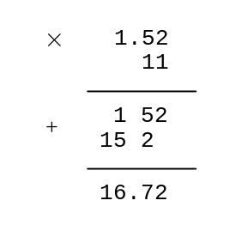

As it can be seen, the actual result of the multiplication has as many digits after the decimal point as there were in both arguments. Since we need just an integer as a result we would discard the numbers after the point, effectively shifting digits to the right by two positions. We should proceed in the similar manner with the fixed point binary numbers. For instance, if we are multiplying an integer by a number having eight bits considered to be after the binary point, the result of multiplication will also have eight bits after the point. If it is just the integer part we are interested in, we have to shift the result right by eight bits destroying all fractional information. Similar technique is applied in the case of divisions. If we want to divide two integers and obtain a fixed point result, the argument to be divided has to be shifted left (added fixed point fields), so that effectively we are dividing a fixed point number by an integer.

2.8.3 Implementation of fixed point arithmetic.

It is often helpful to have a general purpose fixed point arithmetic library. However, the fixed point algorithms depend on the selected precision. Since, it is convenient to use different precision in different parts of the application it may become useful to choose several different formats of fixed point numbers, one for every specific place in the application and implement computations for some particular expressions directly.

It is important to also understand whether we can implement all the operations using just high level C constructs, or whether it will be necessary to descend into the assembly level. In most assemblies, the result of multiplication has twice as many bits as each of the arguments. Since we will occupy some digits with fractions, we require the maximum amount of bits available. Besides, the result of multiplication will often be located in two registers. We can organize operations in such a way so that instead of adjusting result by shifting, we will just take it from the register carrying higher bits, effectively doing a zero-cost right shift by the bit length of the register. On the other hand, compromizing code portability by coding in assembly can be considered as a questionable practice. Obviously, depending on the particular application, the question can be resolved either way.

The fixed point arithmetic is clearly useful for the implementation of 3-D transformations where we require a lot of expensive multiplications. Let’s assume that we store coordinates of points as integers. The result of or functions is clearly fractional and hence so are the coefficients in the transformation matrices. Both of these can be stored using the same fixed point format. If we decide to precompute the results of trigonometric functions and store them in an array, it will be necessary to convert floating point values into fixed point values. If we simply assign a floating value to an integer used for the storage of a fixed point number, the whole part will be transferred but the fractional part will be lost. Since we need to transfer certain amount of fractional information as well, we can attempt moving fractional digits into integer digits in the floating point number before the assignment. The actual shift operation doesn’t have sense and is not defined for floating point numbers. However shifting right by N binary digits has an effect of division by 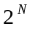. Similarly, shifting left by N binary digits has an effect of multiplying by . Using this fact, it is easy to see that if we want to transfer the amount of fractional information equal to N binary digits from a floating point number into a fixed point number, the former should just be premultiplied by before a simple assignment into the latter representation.

In a typical 3-D application using fixed-point arithmetic, when we construct the transformation matrices, the fixed point numbers will be often multiplied by fixed point numbers. The result will have twice as many fractional digits as required, and thus, will have to be adjusted by right shifts (see Listing 2.5).

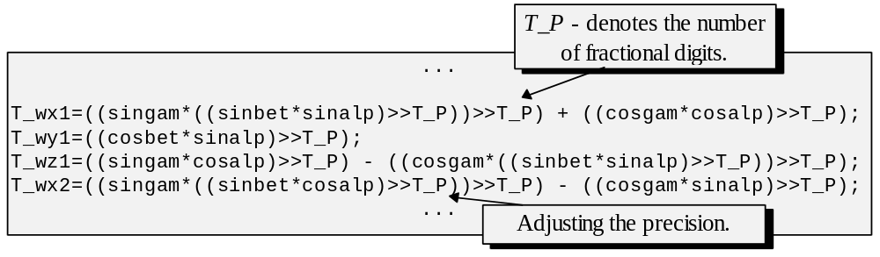Listing 2.5: Using fixed point numbers for building rotation coefficients.

In the routine implementing the rotation transformation we will multiply integers by fixed point coefficients. The result will have the same number of fractional bits as in fixed point coefficients. If we are interested to obtain the result of transformation as an integer (which is not unreasonable since the final destination of these coordinates is to index a discrete bitmap storing the image), then, we will have to dispose of all fractional digits by shifting the result right.

There are several concerns related to implementation of fixed point arithmetic. We have to be careful with the range of numbers the operations will work for. If we are using 32 bit numbers and choose 16 of the bits to represent the fractional part and one bit for the sign bit then only 15 bits can carry the integer part. After multiplication of the two fixed point numbers all 32 bits will actually carry fractions since the result has as many fractional bits as in both arguments. The integer part will be gone in the dark realm of left-carry. When we code the operations in assembly we can avoid this problem entirely since the result of multiplication will physically have twice as many bits as in each of the arguments. However, when implementing fixed point arithmetic using only high level language this may become a serious problem.

And finally, is it really true that integer multiplication plus shifts is faster than floating point multiplication? Although it is definitely true from the point of view of algorithm complexity, on practice, real-life hardware doesn’t behave quite like that.

What follows are the results of some approximate tests where floating point performance a⋅b was compared against fixed point performance (a⋅b)>>15. In one case both a and b were floats in the other both were integers (see Table 2.1).

Sparc | floating faster fixed about 1.3 times
Motorolla 68040 | floating faster fixed about 1.5 times
Intel P5 (Pentium) | floating faster fixed about 1.6 times
rs4000 | floating faster fixed about 1.1 times
rs6000 | floating slower fixed about 1.1 times
Intel 80386sx | floating slower fixed about 5.1 times

Table 2.1: Floating verses fixed point performance.

As one can see, processors with fast floating point units nowadays do floating multiplications faster than integer ones. However, it is not quite the case with additions. Integer additions on most processors are faster than in floating point. It should again be underlined that integer arithmetic algorithms in general are less costly then floating point ones, however, the latter are usually dedicated much more silicon by processor designer, hence higher speed for multiplication. Some of this speed increase can be attributed to pipe-linening and it gives improved throughput only for sequences of floating point instructions. (Which, we should admit, is the case with matrix operations). However, in terms of portability (except for degenerate cases where a processor does integer arithmetic through floating point unit) integer math should always be fast enough whereas floating multiplication especially on processors without FPU may be extremely slow. There are many different trade-offs which make choosing the underlining arithmetic for algorithms difficult at times. If the algorithm is mostly incremental, fixed point is usually a good choice since addition would be the predominant operation. On the other hand, in the case with multiplication being predominant, choosing the calculation scheme may depend on the targeted processor.

To summarise, in this chapter we have discussed how to perform basic geometric transformations. The techniques which were considered allow to describe location, orientation and motion of virtual objects and also their visibility to the viewer.

We are going to rely on the transformations extensively when discussing most of other topics.

* * *

