Chapter 3 Rasterization of 2-D primitives.

3.1 Rasterizing points.
3.2 Rasterizing line segments.
3.3 Rasterizing polygons.
3.3.1 Rasterizing convex polygons.
3.3.2 Rasterizing concave polygons.
3.4 Rendering interpolatively shaded polygons.
3.5 Rendering textured polygons.
3.6 Anti-aliasing.

In the previous chapter we have discussed how to perform different coordinate transformations. The techniques which were considered allowed us to describe various positions of virtual objects in space and also their visibility to a viewer by means of projections.

Projection transformations map the coordinates of object primitives from 3-D space into the 2-D space of the viewer’s screen. These primitives must now be pictured in this planar space to present their appearance to the viewer. Since we are considering raster graphics where an image on the screen is composed from a mosaic of regularly spaced squares (pixels), our task is to decide how an analytical description of a geometric primitive can be turned into a proper set of discrete pixels. This process is called rasterization.

Some primitives are easier to rasterize than others. Line segments and polygonal patches fall into the first category. In a lot of practical applications, a graphics module will support rendering of only basic primitives, such as the above mentioned two. In the cases when the description of some object demands rasterization of more complex primitives, such as cubic curves or bicubic patches, this can be achieved by approximating them with what is available. Curves are often approximated with line segments, and surface patches with polygons. Less commonly, there may be a routine rasterizing some more complex primitives directly, notably some curves.

In this chapter, we are going to consider how to rasterize simpler geometrical primitives: points, line segments and polygons.

3.1 Rasterizing points.

On a somewhat simplistic level, rasterization of points is very straightforward. It only involves setting a specific cell of the bitmap memory to a color value. The difficulty, however, comes with the realization that image bitmap is inherently discrete, whereas the 2-D space we are trying to mimic contains continuous ranges of real numbers. If we try to plot a point whose real coordinates are in between of integer pixel coordinates, a decision has to be taken how to resolve this ambiguity. Perhaps, rounding to the nearest integer is a fairly logical and a very common choice. However, the discrete nature of digital images is an inherent source of errors and imperfections for raster graphics. We will revisit this problem in other contexts in this chapter. For the moment, however, let’s neglect round-off errors assuming that the coordinates of points to be plotted are integer and the area of the point equals the area of the pixel. (When referring to a point in this subsection we actually mean some neighborhood of the point. In its mathematical sense a points doesn’t possess, of course, neither area nor volume).

Let’s recall that the very first location of the bitmap most often describes the top leftmost pixel. The typical arrangement of memory cells describing continuous scan lines of pixels also determines a system of references which is convenient to use in this case. The Y axis is directed from top to bottom and the X axis from left to right (see Figure 3.1).

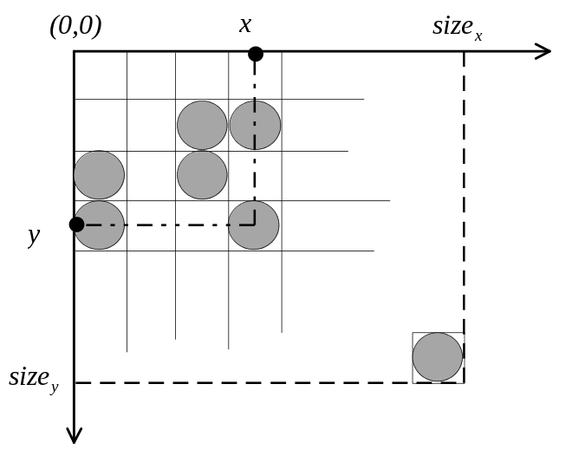
Figure 3.1: Image bitmap layout.

Assuming that each pixel is represented by one unit of memory (byte or word), and that the dimensions of the output bitmap are 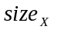 by 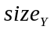, the address of the pixel (x,y) in the image bitmap is computed as 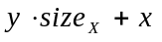. Setting specific color value into the memory location at the found offset from the beginning of the bitmap, results eventually, after blitting this bitmap, in a point appearing at coordinates (x,y) on the screen (see Listing 3.1).

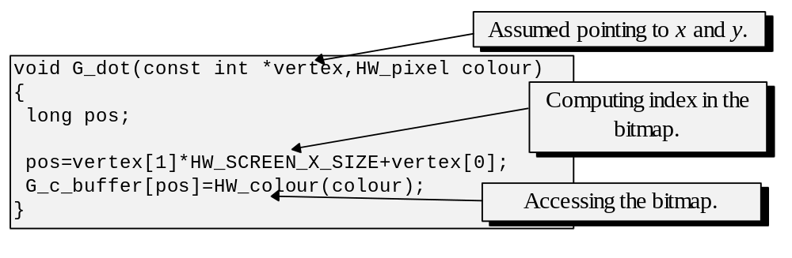
Listing 3.1: Point rasterization.

3.2 Rasterizing line segments.

A line rasterization algorithm is very important in the structure of many 3-D applications. Beside rendering line segments, almost identical algorithms are used for other purposes, for instance in the routines involved in scanning edges during polygon rasterization. Being common as it is, there is a lot at stake to make this algorithm work efficiently.

The goal of line rasterization is, of course, to find all pixels intersected by a given line, or more generally, those pixels which are close enough to the line’s path. A line segment is normally specified by the coordinates of its two endpoints: 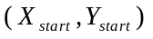and 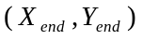 (see Figure 3.2).

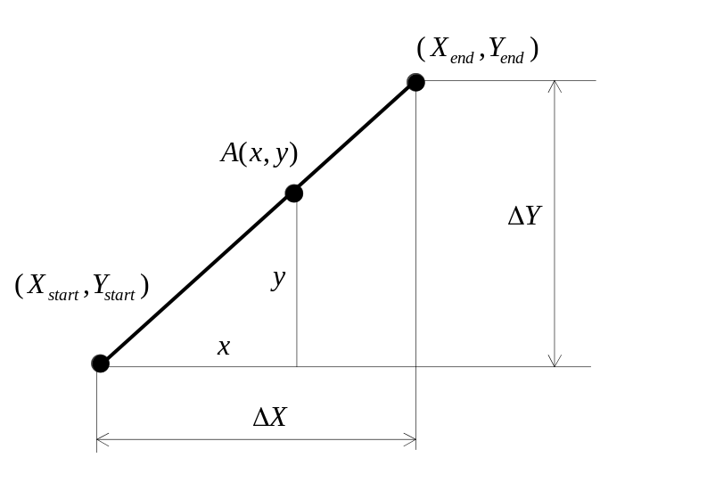
Figure 3.2: Finding points on a line.

From Figure 3.2, which shows some line segment, we can observe the two similar triangles. One is formed by the segments 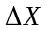 and 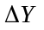 and the another by the segments x and y. The latter represents the coordinates of some point A belonging to the line segment. Observing that these triangles are proportionate it can be seen that if

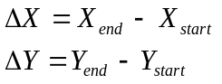

then

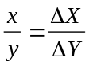 and 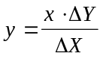

Since we want to find all points along the line’s path, we just have to take all integer X in the domain 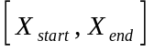 and compute their respective Y. There is a bit of a catch however: we would have only as many as 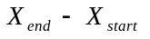calculated points. But if the Y range was actually longer, the points we have just found wouldn’t form a continuous path on the screen (see Figure 3.3). In the most degenerate case of vertical lines, will be equal to zero, making the equation above unresolvable in finite numbers. In those cases we should have been calculating the coordinates taking Y values from the longer domain 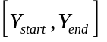 and computing the respective X (see Figure 3.3). This would both guarantee a continuous path and avoid the singular case.

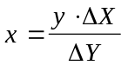

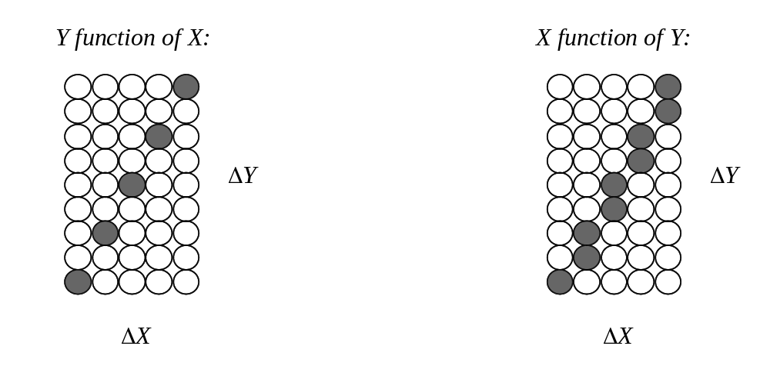
Figure 3.3: Calculating Y function of X verses X function of Y for some line.

Considering the performance of this method, we can see that it takes one multiplication and one division to compute a single point. In practice this is rather expensive and leaves a lot to be desired.

A better technique is obtained when we employ the forward differences to iterartively compute coordinates of multiple points. This techniques is often used to rasterize various polynomial curves, and a line can also be thought of as such a curve with a constant slope. This technique uses a simple fact that a value of a function in some point 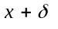 equals to the sum of its value in point x and the forward difference of the function on the interval . That is:

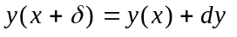

Although in general 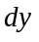 is not a constant, in the particular case of the line it is. Let’s consider the following:

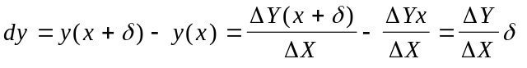

The forward difference describes how much the function changes with respect to the change of the argument, thus, not surprisingly it is computed simply as:

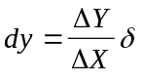

This means that we can compute the value of y(x+1), that is, for the next discrete x (assuming 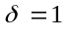), based on the value of y during the previous iteration:

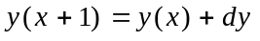

There is just one fractional (floating or fixed point) addition involved per computed point, which is, of course, a considerable improvement compared with the original method. The technique of forward differencing is used on more complex curves as well, with the line just being the most trivial case. In more complex situations (as we shall see in following chapters), function’s forward difference would not be constant. However, being a polynomial function itself, it can be found through forward differencing of its own rate of change.

It should be noted that this algorithm involves fractional numbers, either floating or fixed point. It also potentially involves conversion or rounding to integers, bitmaps are discrete after all. It is at times preferable, for the performance sake, to use only purely integer operations. Another iterative method we are going to consider doesn’t involve either divisions or fractional numbers. It is due to J.E. Bresenham [BRES65].

The idea is to find a bigger range among and , go along points in it, and have a variable signalling when it is time to advance in the smaller range. Let’s consider what is happening at some stage in line rasterization. Let’s assume that is a longer range (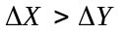) and that in the given line segment 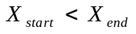and 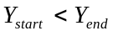.

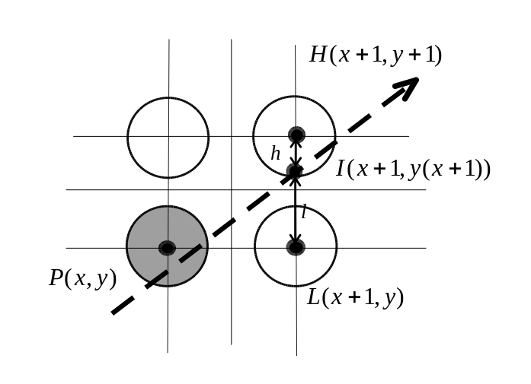
Figure 3.4: Line passing through the pixel grid.

Figure 3.4 shows the situation where we have just rendered a pixel P(x,y) (Previous) at coordinates (x,y) and now have to make a decision where to go to next, to the pixel L(x+1,y) (Lower) or H(x+1,y+1) (Higher). The points P,H,L represent the middles of the respective pixels. Since the actual line would pass somewhere in between of the two points P and L, we must plot the one whose center is closer to the intersection point I(x+1,y(x)). This can be measured by comparing the segments h and l resulting from the intersection. Remembering the dependency used in the original line drawing method, it can be seen that

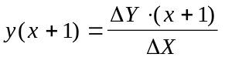

and

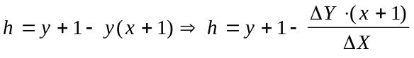

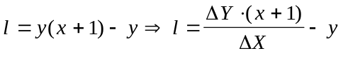

Now, we are interested in comparing l and h which can be done by examining the sign of 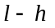 difference:

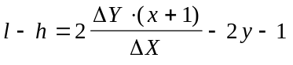

Thus, if l-h>0 it means that l>h, and the intersection point I is closer to the point H. This latter point should be plotted. Otherwise, if l≤h , L should be plotted. Let’s multiply both sides of the equality by ΔX:

Since ΔX is assumed to be greater than zero, the signs of (l-h) and ΔX(l-h) would be exactly the same. Let’s denote ΔX(l-h) by d and find the sign of d and its value at some iteration i and the next iteration i+1:

We can also find the initial value of d. At the very first point, since when x=0 and y=0 , we have:

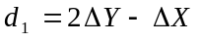

Since the sign of d determines which point to move next (H or L), let’s find the value of d at some step i , assuming that we know its value at i-1 from the previous calculations:

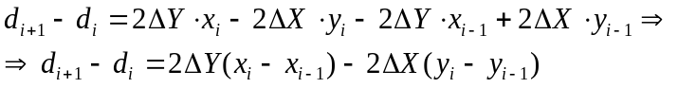

If during the previous iteration we took the decision to plot the point at H, we had: 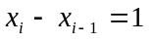and 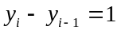which means that

On the other hand, when the lower point, L, was plotted in the previous iteration, we had the case with and 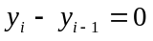, which means that

This derivation may seem a little complicated, but the implementation of the algorithm is certainly quite trivial once it is clear which steps to perform before and inside the loop. Before the iterative part we have to find the initial value of d. Further, inside the loop, depending on the sign of d, we add to it either 2ΔY-2ΔX, or just 2ΔY. Since those two are constants for the duration of the loop, they can be calculated before actual work is started. In the derivation above, we assumed that and , however, in real life we cannot guarantee that. One way to take other cases into consideration is by changing increments to decrements when the above assumptions don’t hold. For the computations inside the loop, we have to keep in mind that when the point L was selected, it is only the coordinate having bigger range that is incremented (decremented); whereas when the point H was plotted, both X and Y have to be changed, since this is the case of simultaneous advancement in both ranges. Listing 3.2 presents a possible implementation for this line drawing algorithm.

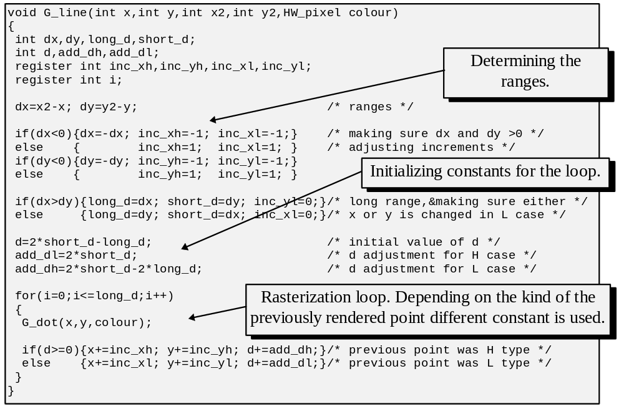Listing 3.2: Line rasterization.

This algorithm doesn’t involve divisions or fractional numbers at all. It does use multiplications by two, but almost any modern compiler will optimize it to the one-bit left shift - a very cheap operation.

Let’s try to analyse the performance of the routine presented in Listing 3.2. Primarily, we are interested in the code inside the loop, since for most line segments this part of the function would be executed multiple times. We can immediately see alongside cheap integer additions a function call to G_dot. However, this function contains at least one multiplication: 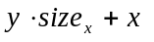, an operation we’ve spent so much effort to avoid.

Let’s recall the representation of the destination image bitmap. If we have just rendered a pixel and want to plot another one next to it, how the addresses in the bitmap of these two pixels would differ? (see Figure 3.5).

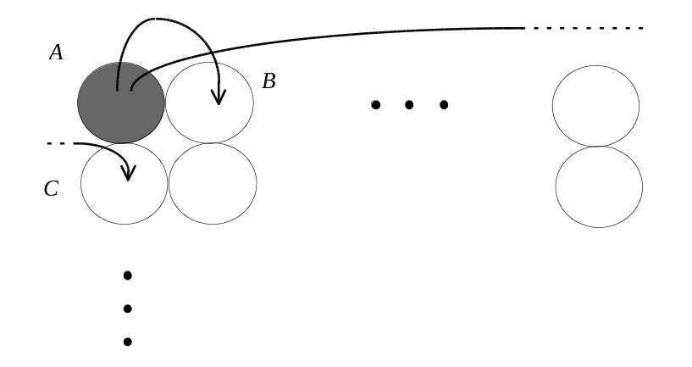
Figure 3.5: Neighboring pixels in the image bitmap.

It is clear from examining Figure 3.5 that if we want to advance horizontally, along X, the address of the pixel B would be equal to the address of A plus one. On the other hand, the pixels A and C are separated by exactly pixels - the width of the bitmap. Thus, in order to advance vertically, along the Y axis, we have to add to the address of A obtaining the address of C. Using this strategy, it is possible to modify the line rasterization routine so that instead of coordinates (x,y) it would directly compute the addresses of pixels in the image bitmap. Listing 3.3 presents just the iterative part of such implementation.

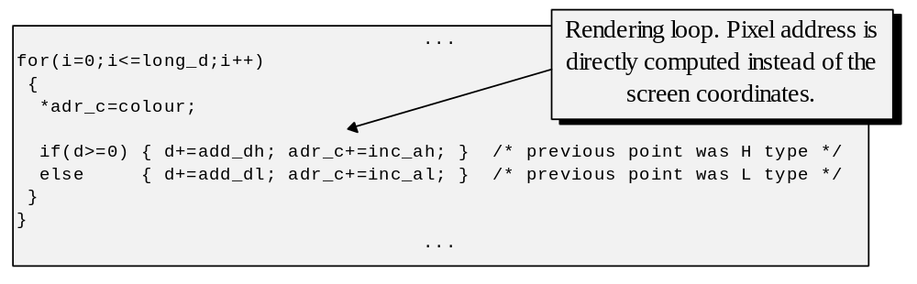
Listing 3.3: Inner loop of the optimized line rasterization.

From the Listing 3.3 we can see that the code inside the loop doesn’t have any expensive operations left.

Incremental algorithms based on the same principle as the one presented above exist also for various curves, notably for circles. At times, especially in 2-D applications, their help gives a fair performance gain. However, curves can be approximated by numerous line segments, which, although perhaps unattractive, is still quite practical for many purposes.

3.3 Rasterizing polygons.

By definition, a polygon is any plane figure enclosed with edges formed by straight line segments. For representation of virtual objects we are interested in non-selfintersecting or simple polygons whose edges are allowed to intersect only in polygon’s vertices. The goal of rasterization is to assign some specified color to every pixel which falls inside this enclosed region. Most of polygon rasterization methods use a variation of a scan-line approach. The idea behind it is to let a scan-line travel vertically along the polygon, at each different heights intersecting it at some line of pixels. When we have found all pixel lines it remains to only draw them one at a time. These lines have to be horizontal only because in the most common image bitmap, pixels forming horizontal lines would occupy consecutive locations in memory, which allows to render them somewhat faster than vertical lines.

The polygons are differentiated into convex and concave ones. By definition, a polygon is convex if the connecting line of any two points which are inside the polygon never leaves the polygon’s boundaries. This is not the case with concave polygons (see Figure 3.6).

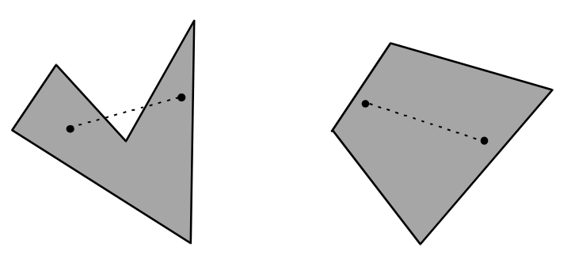
Figure 3.6: Concave and convex polygons.

This differentiation has an implication for scan-line rasterization methodology. Only one continuos span of pixels is required at the level of any horizontal scan-line in rasterization of a convex polygon. Clearly, multiple spans may be necessary during rasterization of a concave polygon (see Figure 3.7).

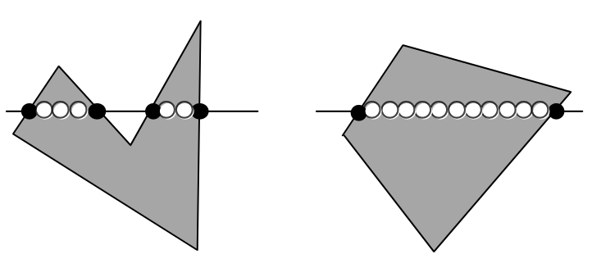
Figure 3.7: Converting concave and convex polygons into pixel lines.

Figure 3.7 illustrates that rasterizing of concave polygons is inherently more complex. Thus, for the purposes of many applications it is suitable to limit allowable polygons to only convex ones whose rasterization and handling is generally much easier. When such relaxation is impossible, we can attempt to split a concave polygon into convex parts. For example we can exploit the fact that any concave polygon can be triangulated and further handled as a set of triangles which are always convex.

The fact that any polygon can be triangulated follows from the Meister’s theorem which states that any simple polygon with at least three vertices has at least two non-intersecting ears. An ear is determined by a vertex of a polygon such that its two neighbor vertices can be connected by a diagonal. For example, vertex A in Figure 3.8 determines an ear. However, vertex C in Figure 3.8 does not determine an ear since the connecting line of its two neighbors leaves the polygon’s boundaries and hence is not a diagonal.

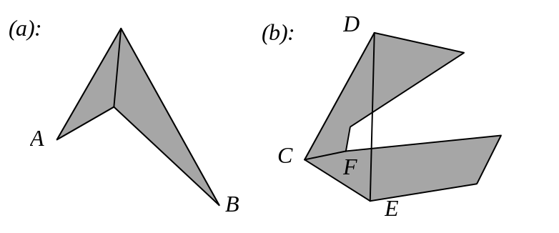
Figure 3.8: Finding ears.

Clearly, the theorem is trivially true for a rectangle (see Figure 3.8 (a)). For polygons with more than four vertices any vertex can either already determine an ear, or if it doesn’t, we can find a diagonal connecting the given vertex to some other vertex and thus split the polygon into two sub-polygons with smaller number of vertices. For example vertex C in Figure 3.8 (b) can be connected by a diagonal to vertex F since the vertex F is the closest to C in the direction orthogonal to the line through C’s neighbors: D and E. Assuming that both resulting sub-polygons have two non-intersecting ears even in the case when some ears were built using the newly introduced diagonal there cannot be more than two such ears, one in each sub-polygon, which leaves the original polygon with at least two other remaining ears. The above essentially presents a compressed sketch of an inductive prove where we first show the hypothesis to be true for base case problems with some small size (rectangles in this case) and further demonstrated that if we assume the hypothesis true for problems of size less than n we can show it also be true for problems of size n+1, and, as a consequence, we conclude the hypothesis must be true for all problems with n bigger than the size of the base case.

Meister’s theorem immediately suggests the following triangulation algorithm: select a vertex, check if it determines an ear. If it does, cut off this triangle and reapply the algorithm on what remains of the polygon. If the selected vertex doesn’t determine an ear use the suggested strategy to split the polygon into two sub-polygons and reapply the algorithm to both pieces.

Another strategy is, instead of using the recursion, to cut the ears iteratively, one at a time. In other words, if a selected vertex doesn’t determine an ear, just check another vertex. By the above theorem sooner or later an ear must be found.

It must be noted that the test whether a vertex determines an ear essentially reduces to testing whether some points are inside or outside a triangle. If all vertices of a polygon are outside of the triangle formed by some given vertex and its neighbors, this given vertex determines an ear. We are going to discuss how to perform polygon inclusion tests in chapter five and will only note here that it is not hard to see that for the purposes of ear determination it is enough to test inclusion of concave or reflex vertices only. A concave or reflex vertex is the one with the angle measure of more than 180 degrees, for example vertex F in Figure 3.8.

Generally, it has been shown that the problem of triangulating a simple polygon requires linear time in the number of vertices. That is, the algorithm will perform the amount of basic operations proportional to the number of vertices. However such a linear algorithm not so long ago proposed by prominent computational geometer B. Chazelle, doesn’t appear to be practical for actual implementation. Most of the time we opt for much simpler (although somewhat more expensive) algorithms similar in style to the ones suggested earlier.

Although attractive, the triangulation approach increases the amount of polygons, and since rendering of each has a certain overhead, it may be cheaper to devise and use a more expensive concave polygon rasterization algorithm instead of calling many times cheaper convex rasterization. In the following subsections we are going to discuss a simple algorithm for drawing convex polygons and a more complex one suitable for any polygon, even concave.

3.3.1 Rasterizing convex polygons.

An algorithm rasterizing convex polygons must find and describe all horizontal pixel lines limited by the polygon’s boundaries. Let us consider how a pixel line can be described. Any 2-D line segment can be represented through four parameters: two coordinates for each of the two endpoints. A horizontal line has an additional constraint and requires only three parameters: common heights and two horizontal coordinates, one for each endpoint. Potentially, a polygon can have a pixel line at every possible height on the screen. Thus, an appropriate data structure for keeping these lines is, for instance, an array with dimensions: screen height by two. For each vertical coordinate possible on the screen, one integer will store the coordinate of the beginning of the pixel line, and the other one its end.

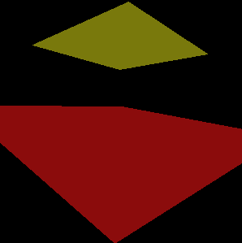

Figure 3.9: Rasterized polygons.

The information on the configuration of pixel lines is described, of course, by the polygon’s edges. The algorithm can take one edge at a time, find all pixels belonging to the current edge, and use this information to set the start and end values for some pixel lines (see Figure 3.10).

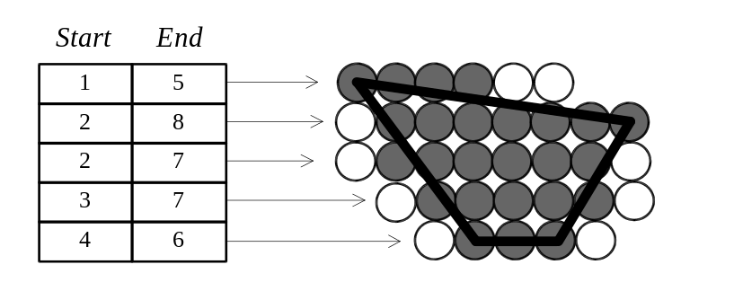
Figure 3.10: Array to store polygon’s pixel lines.

When we have found a point on some edge, we don’t immediately know whether it specifies the beginning or the end of the pixel line at height y. An approach which is somewhat similar to sorting can be employed here. We can use the fact that the start value of the pixel line is less than or equal to the end value.

If the x coordinate of the found point is less than the existing value for the scan-line’s start, the new point is, in fact, the actual start. Similarly, if same x coordinate is greater than the existing value for the end point, this new point specifies the actual end.

By assigning initially the biggest possible value to the start values of all pixel lines and the smallest possible value to their ends, we make sure that the first point found at every height would be placed in both the start and the end locations. (After all, any value should be both smaller than the biggest possible value and bigger than the smallest possible value.) Figure 3.11 Illustrates the process of finding the pixel lines from polygon’s edges.

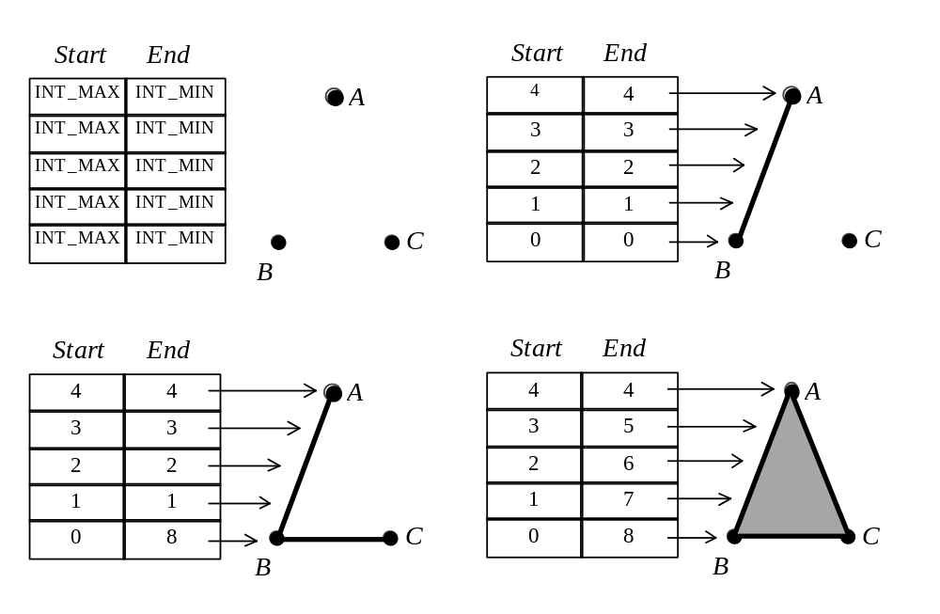
Figure 3.11: Steps in finding convex polygon’s pixel lines.

A convenient place to find the biggest and the smallest integer values is <limits.h>. It is a good programming practice to use INT_MAX and INT_MIN constants defined there. Beside extra clarity in the source code, it also guarantees platform independence (those values depend on the integer bit size, which, in its turn, depends on the platform).

The process of finding points belonging to polygon’s edge, often referred to as edge scanning, is exactly the same as that in rasterization of a line segment. The only difference is that the purpose of found coordinates is not plotting a pixel but setting the pixel line boundaries. We should also note that for the purposes of finding the pixel line’s boundaries we can completely avoid considering the horizontal edges. The boundary information which such edges represent is also carried by their neighbors with whom a horizontal edge shares its vertices. Examine Figure 3.11. Edge BC was used to set the last pixel line, but if we would have neglected this edge, the last pixel line would have been correctly set after processing the edges AC and AB .

Once the configuration of every pixel line is found, the rasterization function has to set necessary locations in the image bitmap to the requested color value. This task is particularly simple since for horizontal lines the memory cells describing neighboring pixels occupy consecutive locations. Listing 3.4 presents a function which implements rasterization of convex polygons.

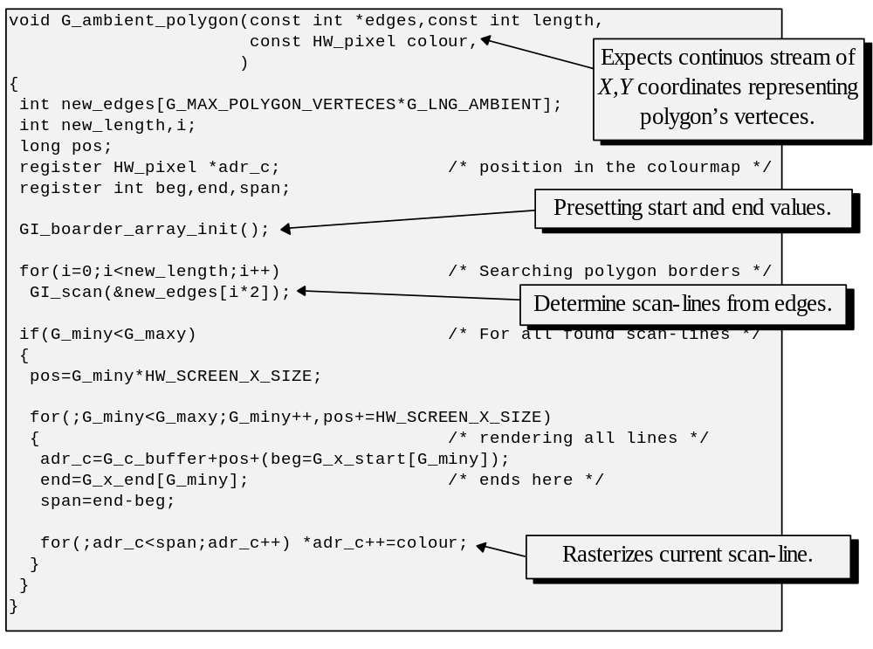
Listing 3.4: Polygon rasterization.

The algorithm which we have considered enables us to draw convex polygons on the screen. However, this algorithm does produce imperfections. If we examine Figure 3.8 we can see that the area occupied by the plotted pixels exceeds that of the actual polygon. Moreover, if there are several polygons which share the same edge, the pixels on the edge will be plotted twice, once for each polygon. A common practice to minimize both effects is by not setting pixels which are on the extreme right of every pixel line and all pixels on the very last line.

As to the optimization of this rasterization algorithm, it doesn’t appear that we can do a lot. The inner loop in the function in Listing 3.5 has only simple instructions inside. An algorithmical shortcut is not obvious either.

However, when performance is of the prime importance, all available texts are read, and friends ran out of ideas, the very last recourse is still hand coding in assembly. On practice, recoding a well written C program into machine instructions might give an extra 10-20% speed increase, which may be considered as a fair gain. The loss of portability and clarity is a price to pay, however.

Rewriting everything into assembly is neither particularly appealing nor practical. Moreover, as we already saw, the complexity of many routines is concentrated within relatively tight loops. Most of the potential performance gain from recoding into assembly is concentrated there. Thus, it is practical to employ assembly only in few specific places.

That’s, perhaps, one of the reasons why modern compilers have such a powerful feature as inline assembly. It allows to mix low-level machine code directly with the C instructions. Different C compilers have somewhat different provisions and syntax for inline assembly. GNU C compiler which is available for a variety of hardware has an elaborate syntax designed for that purpose:

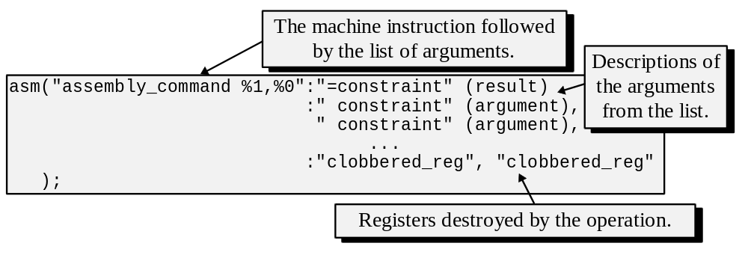

Listing 3.5: GNU C inline assembly.

As it can be seen from Listing 3.5, an assembly instruction is specified with aliases allowing to import arguments from C variables. Aliases start with the percentage sign (double percentage has the literal value of a single percentage sign. It is often the case that a register reference starts with this character in some assembly languages). In many cases, a machine instruction spoils the contents of some registers in the course of its execution. To prevent C code from continuing to relay on values that might no longer exist, we should be careful to specify all the registers clobbered by the instruction. The compiler will make sure that no useful information is in these registers at the moment when the inline assembly code starts to execute. Looking at the polygon rasterization code, we can observe the pixel line rendering loop. This is, perhaps, a good candidate for recoding into assembly since it is executed very often and performs a considerable number of memory accesses, especially if compared with the surrounding code.

For Intel 80x86 processors and GNU C compiler the inline assembly the code substituting the line rendering loop can be implemented as illustrated in Listing 3.6.

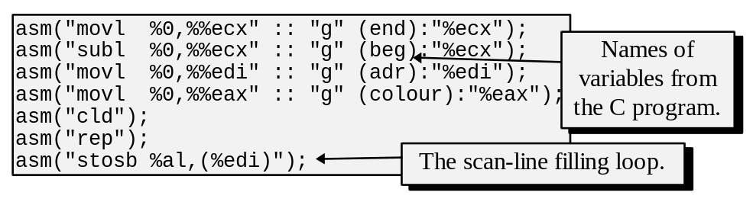
Listing 3.6: Intel 80x86 assembly for the pixel line filling loop.

This code, which is particularly easy to introduce into a C program, gives a certain speed increase since it employs special processor instructions well suited for initializing arrays with a specified value. Then again, instead of involving assembly, we may have used the C library function memset whose purpose is also to fill each element of an array with a certain value. This library function may have been coded in assembly, and in a very similar way to what we just did. This conjecture is quite easy to verify with any C compiler. To do that, we can disassemble the code for memset function and examine its implementation. The code in the Listing 3.7 was obtained from libc.a library of DJGPP (a port of GNU C to MS-DOS).

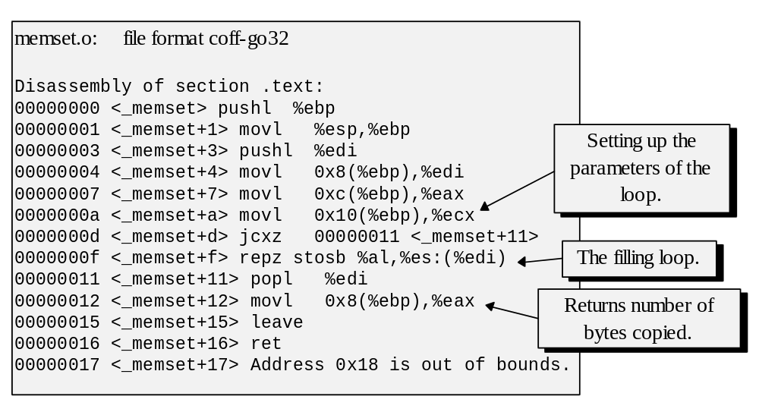
Listing 3.7: Disassembled code for memset.

This code, of course, is very similar to what we wrote, and thus calling the memset function would give us the same performance. Of course, there would be some time spent on the function call itself. But, most likely, the performance of the inline assembly code we wrote and the memset call would be quite similar. It is yet another example of how easy it might be in some cases to achieve results by very simple means instead of spending sleepless hours in front of the glowing box (unfortunately, only sleepless hours teach us how to do things by simple means, but that’s the topic for another story, only marginally dedicated to 3-D graphics).

We should note, however, that both the code that we wrote and the code in Listing 3.8 use byte store instruction stosb. Intel 80x86 instruction set also has a command for a long word store. This instruction will perform the job of 4 byte store instructions and assuming proper memory alignment, the use of word store instruction should give a considerable gain. Thus, whether we end up using memset or not, the exploration of its internals can only help.

In general, moving and filling arrays is very common in computer graphics applications. It is quite important to try achieving good performance for these operations. It is, perhaps, also beneficial to try achieving portable implementation. One approach, which is relatively common, is to have a separate module (probably integrated with our hardware interface) which implements memory operations differently for different architectures, yet providing the same function prototypes to other modules.

3.3.2 Rasterizing concave polygons.

As we already saw, the main difficulty with rasterization of concave polygons is the fact that at each height there may be several spans of pixels to draw. In our consideration of an algorithm to deal with such polygons we will make a practical relaxation: for the clarity’s sake, such a polygon is assumed to be a non-self intersecting or simple. Strictly, this assumption is not required and it will be possible to modify the algorithm which we are about to consider to allow even these.

Clearly, if we do know all the intersections at a given scan-line the remaining process is easy. We sort the intersection points according to their horizontal x coordinates. Further, assuming that the polygon is simple, all even points in the sorted list will specify beginnings of spans followed by spans’ ends. The entire polygon is correctly rasterized when we invoke a filling procedure for each span. As to the first portion of the algorithm which finds the intersection point, the most immediate brute-force solution is to use line equations and check for intersection of the scan-line and every edge in the polygon (we are going to return to intersection calculations in chaper five). This, however, will involve many expensive computations and should be rejected in favour of a better approach.

We can exploit the property of locality which indicates that if a scan-line intersects an edge, there is a good chance that the next scan-line will also intersect the same edge. From looking at Figure 3.12 it can be seen that this property mostly holds and breaks down only in the few instances when a scan-line is passing through a vertex and thus no longer intersects the edge which ended at that vertex.

Thus, an algorithm to find the intersections of a scan-line with the edges, can first pre-sort all edges (excluding useless horizontal ones) according to their least y coordinate. If some edges have the same least y, we will use value of x of the endpoint with bigger y as an auxiliary sorting criterion. (An edge which starts the span will thus appear ahead of an edge which ends the span.) Further, we will maintain a list of active edges by adding into such list the edges from the pre-sorted list. The edges will be added when their y coordinate will be equal to that of the current scan-line (see Figure 3.12).

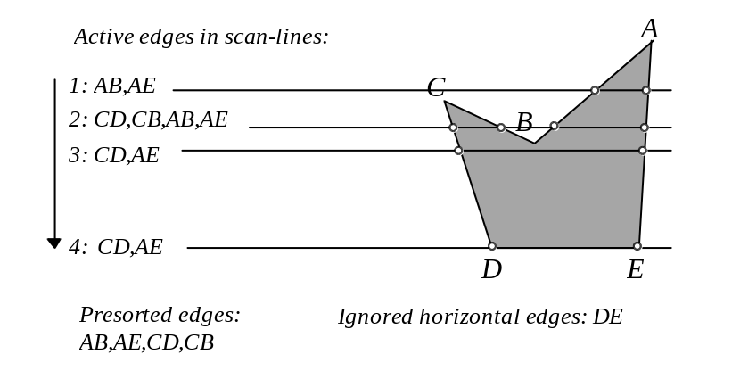
Figure 3.12 Steps in finding convex polygon’s pixel lines.

Figure 3.12 illustrates a concave polygon, with the list of pre-sorted edges. When we start the rasterization at the top of the polygon, the y coordinate of the scan-line will be equal to the y coordinate of the point A and thus, least y of edges AB and AE. These two edges are taken into the active edge list.

For each consecutive scan-line we compute current x of all edges in the active list using some iterative algorithm and delete from this list all edges which have ended at the current scan-line. We further verify if y of some edges in the pre-sorted edge list became equal to y of the current scan-line, and if there are such, import these into the active list which is resorted each time there are insertions. The resorting should be quite cheap since the list is almost entirely sorted and requires only minor adjustments. At that point, we can use current x coordinates for the edges in the active edge list to fill the spans and repeat the iteration.

To illustrate this algorithm on an example, let us examine Figure 3.12. When we started the rasterization, edges AB and AE were in the active edge list till we reached the level of the point C. At that stage, two more edges are inserted and after sorting the list will become: CD,CB,AB,AE. Further, at the level of the point B, two edges will get deleted with the active edge list becoming: CD,AE.

Examining this algorithm we should note that finding which edges to insert from the pre-sorted edge list is quite cheap if we maintain an index to an edge which may be inserted next. Since the edges are sorted, we have to examine y of the currently indexed edge only, and if its y is larger than that of the current scan-line, no other edge has to be examined. When some edge is inserted we advance the index and repeat the examination till the current edge is not suitable for insertion.

Although rasterization of concave polygons clearly seems more cumbersome than that of convex ones and may lead many developers to opt for convex only polygons, there are some other advantages to this algorithm which we will see when examining hidden surface removal techniques. In particular, we will be able to extend this algorithm to handle multiple polygons simultaneously.

3.4 Rendering interpolatively shaded polygons.

Polygons of constant color, or flat polygons, discussed in the previous section, may have been a choice for a long time in many applications due to low cost of their rasterization. They however, present a fairly unrealistic portrait of the virtual world. After all, in the real world we don’t often see polygonal patches of strictly constant coloring across. Lighting introduces shading patterns on even monotonously colored surfaces. Surfaces themselves are not ideally smooth. Most have imperfections such as bumps or encrustations of different material. Ideally, this can be reproduced by a very big number of flat polygons, each having a different, yet constant, color or shade. This approach will, of course, defeat the purpose of modelling scenes with polygons, since the simplicity and small size of components involved in such a representation is crucial. Alternative approach is introducing changes to polygon rasterization routines so that they become more sophisticated and produce more realistic images.

One technique is to consider lighting during rasterization. Another technique is to apply a material texture onto the polygon. Those two give a considerable visual improvement to the images of the modelled scenes. We will consider lighting in much more detail in the following chapters, particularly how to compute illumination for different points in the virtual world. For the purposes of this section we will assume that we can compute values representing intensity of light in the vertices of the polygon. Since variation in illumination largely changes in some smooth way, we can compute the lighting for pixels within the polygon by interpolating the values in the vertices. The fastest and, perhaps, simplest of the interpolating techniques is due to H.Gouraud [GOUR71].

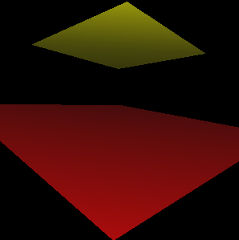

Figure 3.13: Interpolatively shaded polygons.

The idea behind this method is to integrate rasterization and computation of light intensity by keeping a color intensity value or values in every vertex of the polygon and linearly interpolating these values at the time of pixel line computations in order to find the color for each pixel inside the polygon (see Figure 3.14).

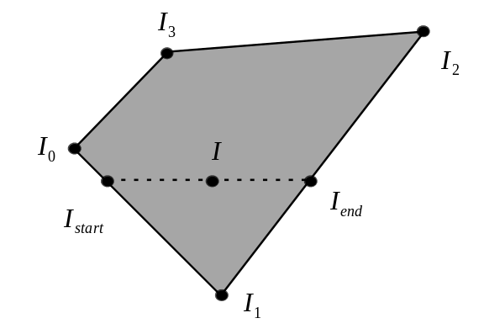
Figure 3.14: Interpolating color intensities.

In other words, assuming that together with the screen space coordinates (x,y) every vertex also carries I, some sort of a color intensity value, we can proceed with the original scan-line methodology, interpolating light intensity as we go. We can obtain values on the left and right borders of a polygon (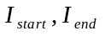 in Figure 3.14) by interpolating the color intensity value along every edge. Afterwards, when rendering any horizontal pixel line, we can further interpolate intensities at start and end points of this line, finding color for pixels in between (I in Figure 3.14).

An obvious implication of this algorithm for the edge scanning function we used for flat polygon rasterization is that vertices now have more information associated with them. Moreover, depending on the lighting scheme used, a single color might be represented by several values (notably, the RGB scheme with three values, one for red color, one for green and one for blue). A possible design implication on the scanning function may be to opt for building of a general purpose scanner for N-dimensional edges. In fact, we are going to encounter very soon at least two other situations where we would want to interpolate another kind of information, different from light intensities, across the polygon. Built generically, the scanning function would be capable to serve multiple purposes.

The function fragment presented in Listing 3.10 uses forward differences in computing values other than x and y, which are still calculated through Bresenham’s iterations.

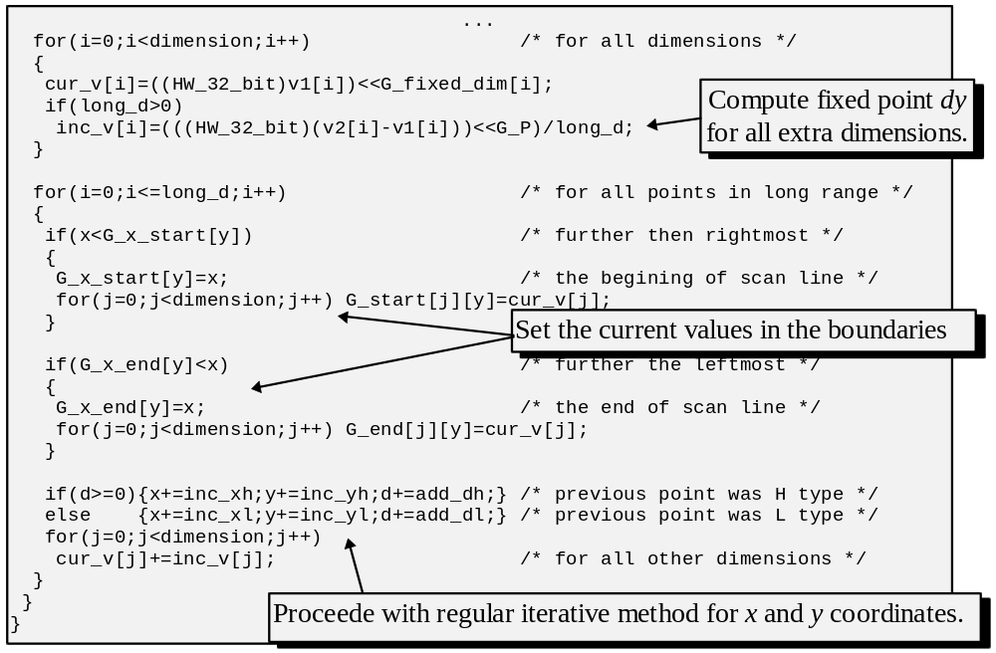
Listing 3.10: Fragment of the edge scanning routine.

Once pixel lines composing the given polygon are recovered, the rasterization function further interpolates the intensity value across each scanline, for instance, using a simple case of forward differencing. Similarly to the scanning function, fractional numbers can be maintained in a fixed point form. The following fragment of code in Listing 3.11 demonstrates the pixel line filling loop of a shaded polygon rasterization.

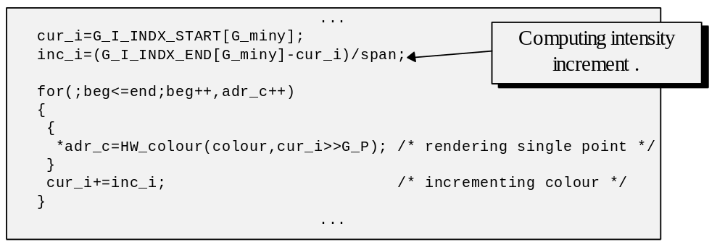
Listing 3.11: Rendering shaded polygons.

There is one small catch however. It was mentioned that intensity can be handled pretty much as an extra dimension. In fact, we can consider a shaded polygon on the screen to take two space dimensions and to have one color dimension. But would all vertices of the polygon belong to the same plane in this 3-D space? If they did not, we would arrive to different shading values depending on which vertices we start the interpolation from. In practice, when we rotate a shaded polygon which has the above mentioned problem, there are visible discontinuities in shading, which also change depending on the polygon’s orientation. One solution is to limit polygons to just triangles. Three non-collinear points always belong to the same plane in 3-D space, thus, linear interpolation will give smooth appearance to such polygon independent of its orientation.

3.5 Rendering textured polygons.

Applying a texture to polygons serves the purpose of improving visual realism of synthetic scenes. Essentially, a texture associates some color value to two parameters (u,v) of polygon’s area. We can distinguish procedural textures, where some function (a procedure) computes a color for arbitrary (u,v) coordinates. Another, perhaps a more common, method, is to store a texture as a bitmap. In this case, colors are explicitly stored for each (u,v) pair inside a two-dimensional array. We can associate a texture to a polygon by specifying the texture coordinates in each vertex of the polygon. (see Figure 3.15).

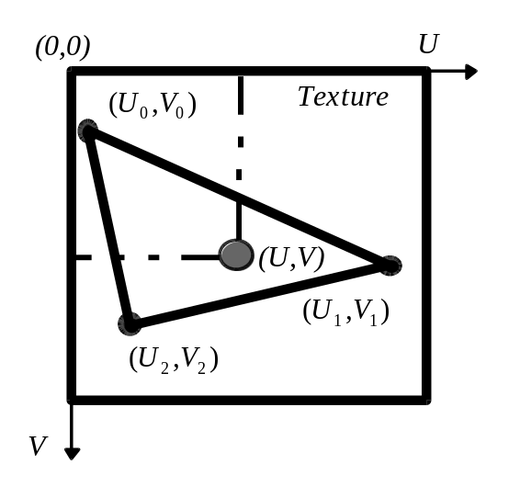
Figure 3.15: A polygon and its texture.

We also can extend the interpolation technique used to calculate color intensity for the interpolative shading to allow for texture mapping. If we just keep texture U and V in every vertex of the polygon, we can interpolate these two along edges during edge scanning, and then along horizontal lines, obtaining this way a texture (U,V) for every screen pixel to be plotted (see Figure 3.16).

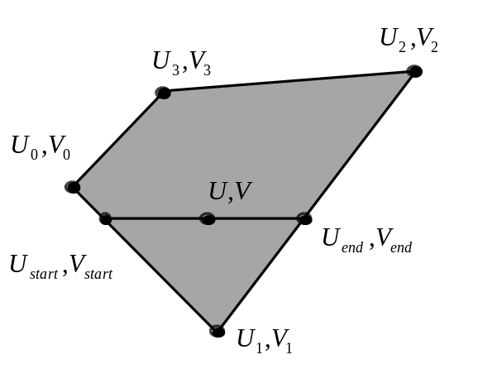
Figure 3.16: Interpolating texture coordinates.

This approach, however, does not quite work. Or, to be more precise, it stops working when the perspective projection was used to find the polygon’s image on the screen. The reason is: the perspective transformation is not linear and hence the change of texture coordinates across the polygon during texture mapping would not be linear and can’t be computed properly by linear interpolation (see Figure 3.17).

One may ask, why did this method work for interpolative shading: after all, we were using perspective transformation all along? The answer is, it did not actually work, but the visual aspect of neglecting perspective effect for shading is most of the time quite suitable. Neglecting it for texture rendering, however, is not. It has to do with the density of visuals perceived by human eyes. A relatively small amount of visual clues is introduced by shading, just a changing intensity across the polygon. There is a very big amount of visual clues present on a textured polygon. Not being realistic is immediately evident in the latter case, but may be completely unnoticed in the former.

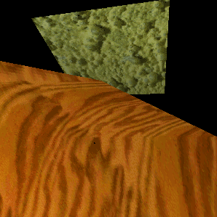

Figure 3.17: Linear texture mapping. Note unnatural warping.

To recognize the effect of perspective distortion in linear texture mapping, just consider the following situation: a rectangular polygon is displayed on the screen so that one of its sides is much closer to us than the opposite one, which is almost disappearing at infinity (see Figure 3.18). To which lines in the texture map do the pixel lines on the screen correspond? Evidently, texture coordinates would be interpolated along the edges AD, AB and DC. However, the edge BC is extremely small in this example. So, no pixel line will ever be mapped close to what BC corresponds to in the texture map (see Figure 3.17).

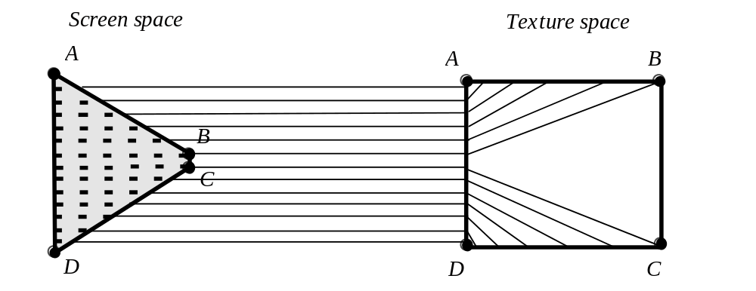
Figure 3.18: Linear texture mapping for a perspectively projected polygon.

In this somewhat extreme case the textured polygon on the screen would be missing a considerable portion of the actual texture, with other parts unnaturally joined and distorted (see Figure 3.17).

However, in less dramatic cases, texture rendered this way may look nicer, being perfect when the effect of perspective transformation is negligible: all points are at roughly the same distance from the viewer, or very far away from the viewing plane. In Figure 3.17 note that the texture of the background polygon doesn’t appear unrealistic, whereas the texture of the foreground polygon, where the effect of perspective transformation is larger, is unnaturally warped. There is an advantage to implementing linear texture mapping: it is less expensive than non-linear mapping which we are going to consider next. For many applications it may be desirable to implement both methods, do a simple analysis on the location of the polygon, and if the situation is suitable, proceed with linear mapping and do the non-linear mapping only in critical situations, that is, when a polygon is too close to the projection plane and thus is quite distorted by the perspective.

As to the non-linear texture mapping (see Figure 3.19), the first, immediate solution is to subdivide the polygon before the perspective projection so that more vertices with precisely known mappings between screen and texture are present and the linear mapping is limited to small polygons on which the distortions are less apparent.

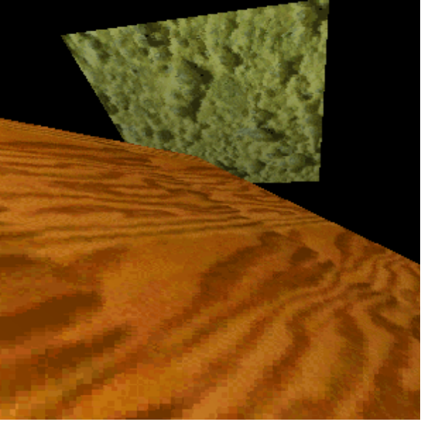

Figure 3.19: Perspective texture mapping.

This solution, however, increases numbers of polygons and thus may not be very attractive. To find a different approach, where subdivisions are not required, let us try to describe what is happening with the polygon and its texture during the transformation stages (see Figure 3.20).

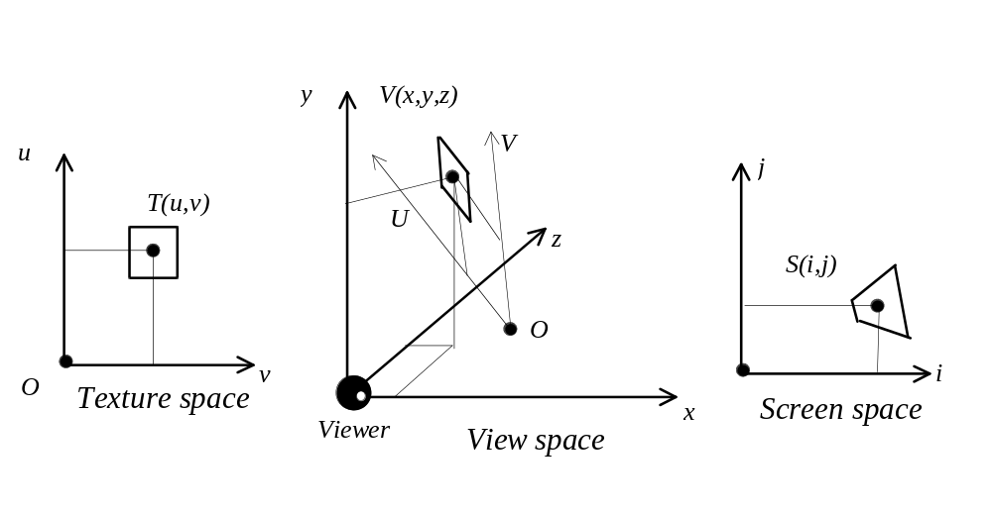
Figure 3.20: Stages in transformations of a textured polygon.

Consider the three spaces pictured above: the texture space, the view space (the one before the perspective projection where the viewer is located in the beginning of the coordinates), and, finally, the contents of the screen - screen or image space. The first space is local to the polygon. Position and orientation of the object and position and the orientation of the viewer in the world determine the affine transformation necessary to transform the polygon into the view space (chapter five will cover this topic in the necessary detail.) The screen space contains the perspective image of the polygon which depends on the focus distance of the perspective transformation.

We have already seen that an affine 3-D transformation is necessary to transform from the world space into the view space. Such a transformation can be represented by a four by four matrix. Thus, the transformation of a point T(u,v) into the view space point 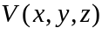can be expressed as

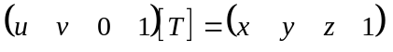

where [T] is a four by four matrix. Let’s suppose that we know two vectors U and V in the view space which are the mappings of the unit length vectors (1,0) and (0,1) from the texture space. These vectors describe how the main axes of the texture became oriented as the result of the affine transformation. Let’s also suppose that we know the mapping of the texture space origin into the view space as the point O. Knowing these we can express mappings of three points from the texture space representing the origin and unit vectors along main axes as

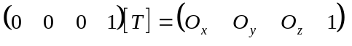

Knowing these mappings, and remembering that texture is only two-dimensional we can somewhat informally recover the transformation matrix [T] as

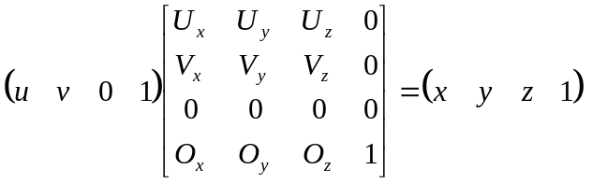

Knowing the transformation we can express individual formulas mapping texture coordinates T(u,v) into view coordinates V(x,y,z) as:

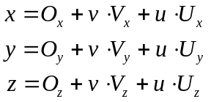

Further, a point from the view space V(x,y,z) is perspectively transformed into the screen space appearing at S(i,j):

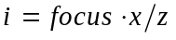
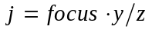

In order to perform the mapping, we need the texture coordinates (u,v) as a function of the screen coordinates (i,j). In other words, we want to know which color to fetch from the texture as a function of the coordinates of a pixel on the screen. To do that, we can start from expressing view space coordinates as a function of screen coordinates:

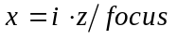
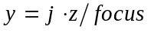

further, by substituting meaning of x,y and z in terms of the texture space, we have:

By trying to express u,v through i,j we obtain:

Further by solving these equation in u and v we arrive to the following reverse mapping equations:

These two formulas allow to compute texture coordinates for any screen pixel using the two vectors describing texture orientation and a point describing the mapping of the origin of the texture space into the view space. These three additional parameters must be obtained before we can employ the formulas. Thus, each polygon possessing a texture can be initially associated with two vectors describing the texture orientation and a point describing the origin of the texture space. At the same time as we perform the transformations on the polygon’s vertices we will also have to apply the very same transformations to the three parameters. The only exception, we won’t have to apply translation transformation to vectors since they are unaffected by such. As a result, we will obtain the necessary view screen parameters enabling the texture mapping computations. Although this method is relatively easy to implement, the additional data per each polygon may be too troublesome to maintain. Moreover, for the purposes of linear texture mapping we require texture coordinates in every vertex and thus, if we want to be able to render the polygon using either of the methods the amount of extra information becomes even larger. In chapter five we are going to return to this problem and devise a strategy which will allow us to use texture coordinates in the vertices to recover the information required for perspective texture mapping.

If we examine the formulas, we can see that some of the sub-expressions are constant for the entire polygon and some are constant for every scan line. Thus, proper arrangement of the computation can give a substantial performance gain. However, even with this consideration it will be necessary to use several expensive divisions per every pixel. Perhaps, the easiest way to optimize the performance of this computation is through horizontal line subdivision. We compute real texture mapping only every N pixels and then linearly interpolate the computed values in between to obtain the mappings for the intermediate points (see Figure 3.16).

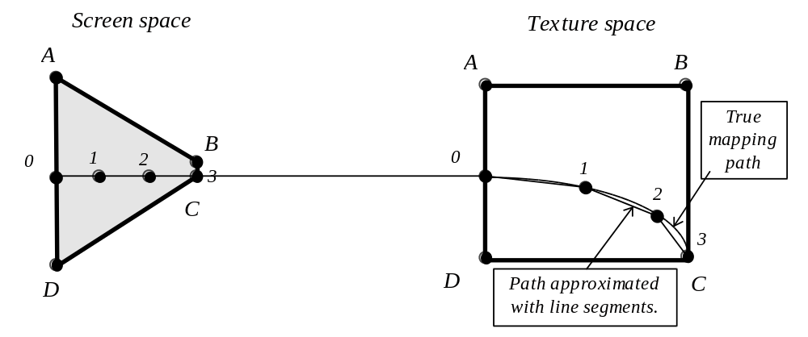
Figure 3.21: Scanline subdivision and linear approximation.

As can be observed from Figure 3.21, we are computing the real texture mapping (u,v) as a function of the screen coordinates (i,j) only at a couple of points along the pixel line. Other points along the line obtain their (u,v) from linear interpolation on the texture coordinates of the neighboring points where we do know the precise mapping. Although we are not achieving the exact result (the true mapping path is only approximated with the line segments as Figure 3.21 illustrates), we can, however, dramatically reduce the number of expensive operations involved, and yet with a big enough number of points where we do compute the exact mapping, the result is very reasonable.

Another possible approach, which may be more attractive under certain circumstances, for instance for implementation in hardware, is to approximate texture mapping path with some polynomial curves. As Figure 3.21 illustrates, sufficiently good approximation with line segments (which can be considered as first degree polynomial curves) requires a lot of subdivions. By employing higher degree polynomials we expect better approximation to the actual mapping path and hence less or no subdivisions required. Quadrics (polynomials of degree two) are good candidates since the true mapping path is relatively smooth. Thus, we can try finding texture coordinates (u,v) along some scan-line by evaluating parametric quadrics:

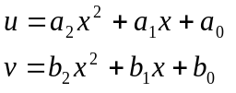

where x is a parameter describing location along the scan-line (see Figure 3.22).

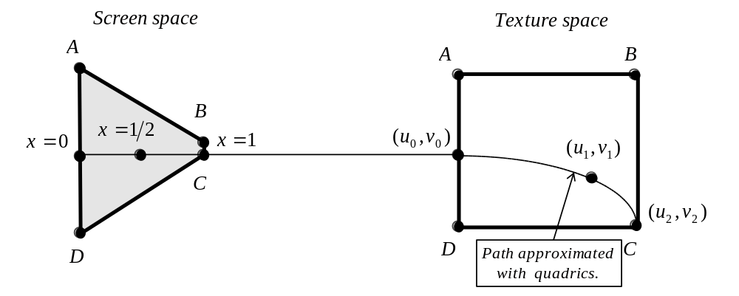Figure 3.22: Quadric approximation.

Clearely, to find six coeficients in the above expressions we need to have six different equations with known left side. This can be done if we have three points where the texture mapping is known precisely (see Figure 3.22). We can find such points by employing the technique of reversed mapping considered previously. Let’s suppose that we know the mapping in the beginning, the middle and the end of the current scan-line. Let’s also suppose that the parameter x varies in the range [0,1] along the scan-line, so that: 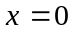 in the beginning: 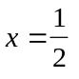 in the middle and: 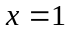 in the end. We can further construct the six equations as:

for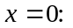 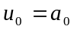 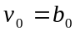
for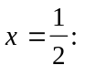 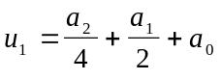 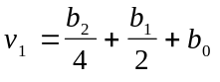
for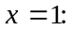 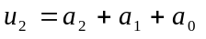 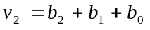

By solving these equations together we can obtain expressions for the coeficients:

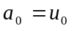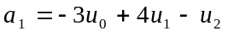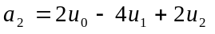
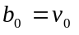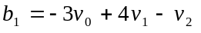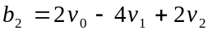

Having these, we are able to find an approximate texture mappings for any pixel along the scan-line by evaluating the quadrics. Of course, the straightforward evaluation does involve several multiplications and is quite expensive. Fortunately, since the pixels along the scan-line are processed in an iterative way we can use iterative technique of forward differencing, which was first considered in the section on line rasterization, to evaluate the quadrics in a very efficient manner. As we saw, the value of a function in some point can be computed if we know the value in the previous point and the forward difference, which, in the case of the u texture coordinate, will mean that:

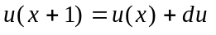

We can find the first forward difference as:

Since the resulting expression is not a constant but a polynomial function we can also efficiently evaluate it using the same technique of forward differences:

Same reasoning applies, of course, for 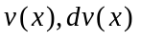 and 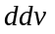. Having these, we can iteratively find the current function’s value by adding first differences to the function values known during previous iteration. At the same time the correct value for the first differences for the next iteration is computed by adding the second differences to the current values of the first differences:

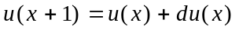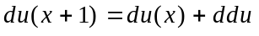

It is also possible to use even higher degree polynomials (such as qubics, degree three) for approximation of the texture mapping path of a scan-line. The method of coeficient derivation and consequtive evaluation will remain exectly the same only requiring more points, more equations and more levels of forward differencing. Polynomials of degrees higher than three are practically never used since the improvment they give isn’t significantly better whereas additional overhead becomes appreciable.

We also can, instead of rendering polygons along the scan-lines, render them along constant Z lines. The advantage gained by the latter method is that along every line in the polygon’s plane where Z is constant, the perspective transformation is linear and thus a mapping path such line corresponds to is also linear (perspective transformation is 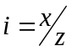 and we can see it as 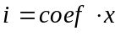 where 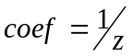 which is linear if z is constant). The disadvantage, of course, is that constant Z lines, in general, are not horizontal on the screen. This may present a problem for rasterization since under straightforward implementation gaps between neighboring lines of pixels will be possible.

3.6 Anti-aliasing.

As we have noted before, there is a source of imperfections inherent to some of the relaxations we have implicitly or explicitly done. For instance, when drawing polygons, a pixel even partially covered by the analytical area of the polygon was nevertheless plotted. This produced familiar “staircase” effect of jagged lines and edges which often result when we use straightforward rasterization algorithms. In another instance, namely, when picking a color value from the texturemap, we considered just one texture cell. The problem is that at a bigger distances from the viewer, due to the perspective foreshortening, not a single color but an area from the texture would correspond to a single pixel on the screen. A popular example of artifacts of this type is a checker board moving away from the viewer. At some point, the projections of the squares become smaller than a pixel on the screen. Naturally, if, for example, both black and white squares project to the same pixel, this pixel should appear as some shade of grey. Unfortunately, the simpler texture mapper will not consider areas, so either black or white pixel would be drawn depending on the rounding. This way, the image can look quite unnatural and in the case of a textures with regularities, such as a checker board, would, in fact, be drawn with artifacts composing curious Moiré patterns.

Both of these examples demonstrate aliasing problems caused by the discrete nature of raster graphics. There exists a wide spectre of anti-aliasing techniques which attempt to alleviate these problems. Such techniques range from very simple ones to extremely sophisticated and complex. They can be roughly separated into two categories. The algorithms from the first category are integrated with the drawing routines. The ones from the second category perform post processing on the rendered images improving their quality.

For example, a texture mapper can consider the actual area of a pixel, and find which area in the texture should be mapped into it, further averaging colors to arrive to a smoother image. Such technique is a rather expensive one however. What is often employed instead is a method of MIP mapping. The idea is to precompute the texture at different scales, and then to use smaller textures for polygons further away from the viewer. Since it guarantees less area difference between pixels in the texture and on the screen, there is less room for aliasing problems. With relatively small associated overhead, the resulting images exhibit considerable improvement.

The techniques of the second category perform filtering on the rendered image so that the resulting image is smoother. The original image is often supersampled, in other words rendered at higher resolution. Filtering procedure will take a group of pixels from the original image and compute the weighted sum of their intensities. The result is placed into the filtered image bitmap. Figure 3.23 illustrates the filtering process. In this example the filter is a three by three matrix with the assigned weights used to compute the intensity of the resulting pixel which is then placed into the filtered bitmap.

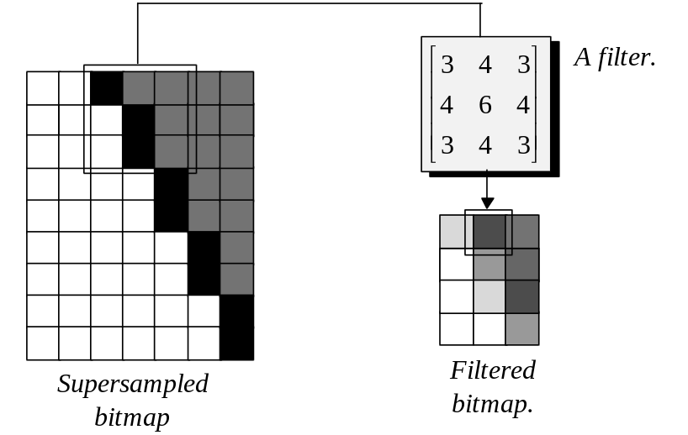
Figure 3.23: Filtering.

The filters are often produced from a variety of analytical functions of which the simplest and the most common ones are Box, Triangle and Gaussian. These functions associate weights to the points of the area spanning across several pixels we want to filter (see Figure 3.24).

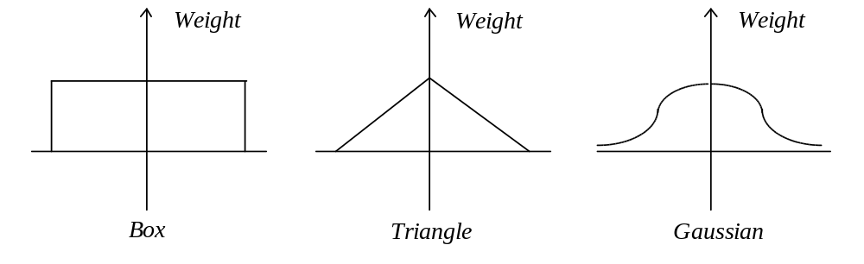
Figure 3.24: Filtering functions.

Another approach, instead of using an analytical filter, is to sample some random points within certain neighborhood. This approach is called stochastic sampling and the results obtain with its help look better because this method tends to leave visual noise and not regular patterns in the filtered image. Human visual system appears to be capable of ignoring visual noise yet exaggerate regular patterns.

As a result of filtering, sharp edges of the polygons and other artifacts which were introduced by unsophisticated rasterization algorithms are smoothed. Although it is generally impossible to completely nullify the problems caused by undersampling, the general appearance of the images can be considerably improved by using filtering. The limitation of this technique is in its usage of supersampling. The image has to be computed at higher resolution which can be limited by both available memory resources as well as processing time required to produce a bigger image.

Beside spatial aliasing which we saw on several examples, interactive computer graphics application which display objects in motion, may encounter the problem of temporal aliasing. The familiar example of such artifacts which are also present in cinematic films is the rotating wheels reversing the direction of their rotation due to higher revolution rate of the wheel with respect to the sampling rate of the camera. One way to attempt combating this problem in computer graphics application is through introduction of motion blur. Similarly to the filtering strategy we used to alleviate problems of spatial aliasing, in this case, we can compute the intensity of the pixel in the image bitmap which is to be displayed by finding the weighted sum of this pixel in several consecutive frames capturing the object at different moments in time. Of course, beside its usage to reduce problems of temporal aliasing, the effect of motion blur is often used in its own right to improve realism of interactive graphics applications.

Usage of these techniques is very much dependent on the application’s objectives and available resources. High end rendering applications may use very sophisticated techniques to improve visual realism, whereas lower end applications, or those having performance constraints, may have to sacrifice realism for speed.

To summarise, the rasterization routines are used to picture geometric primitives in a raster display device. It is expensive to rasterize complex geometric objects and we usually present them as a collection of simpler primitives such as line segments or polygons which are easy to rasterize. In order to enhance appearance of polygons and depending on available resources shading and texture mapping can be added to improve visual realism.

Discrete nature of raster graphics often gives rise to various aliasing problems. Anti-aliasing techniques which are either introduced into drawing algorithms or used as a post-processing step attempt to alleviate these problems.

* * *

