Chapter 4 2-D and 3-D Clipping.

4.1 2-D Clipping strategies.
4.1.1 Clipping points.
4.1.2 Clipping line segments.
4.1.3 Clipping polygons.
4.2 3-D Clipping strategies.

Throughout the discussion of the previous chapter we assumed that the primitives which we rasterized were completely within the screen boundaries. Of course, this cannot be guaranteed in the general case. In real life, a viewing process may produce a primitive which is either completely outside of the screen boundaries, or just partially inside. In both cases, the computation of some pixel’s address may take us outside of bitmap’s allocated storage space. In order to avoid this undesirable effect, we must restrict the coordinates of primitives to the boundaries of the screen.

We have also seen that in the case of perspective transformation there is another constraint on the coordinates. We cannot transform a point with 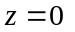 into the screen space. Besides, portions of the object which have negative z, are effectively behind the viewer, and, thus, aren’t visible. In order to avoid problems, such as division by zero, or parts of the object being flipped over by the perspective transformation, we have to make sure that only valid points ever get transformed into the perspective screen space.

The process to locate primitive’s part or parts which satisfy some spatial constraints is called clipping. Of the above two examples in the first case we will have to perform planar 2-D or screen boundaries clipping, and in the second case 3-D or volume clipping. We are going to consider both problems in this chapter and discuss possible approaches and implementations.

4.1 2-D Clipping strategies.

The clipping algorithm receives as an input a description of a certain primitive, as well as a specification for another primitive (an area in 2-D or a volume in 3-D) against which the clipping has to be performed. Similar to rasterization, it is often hard to find a clipping strategy for arbitrary shapes and clipping volumes, primarily due to the cost constraints.

We can define three different approaches to 2-D clipping. First approach is to clip before the rasterization phase. It usually works for simple primitives such as polygons, restricted by a simple clipping area such as a rectangle. In some situations, especially for complex primitives, it may be suitable to clip during the rasterization stage. On obtaining the screen coordinates of a pixel we first check if it is within the proper bounds and proceed with plotting the pixel only when this is the case. When the geometry of the clipping area is complex, the chosen strategy may be to rasterize the primitive into some bigger buffer and then select from the buffer only those pixels which are inside the complex clipping area (see Figure 4.1).

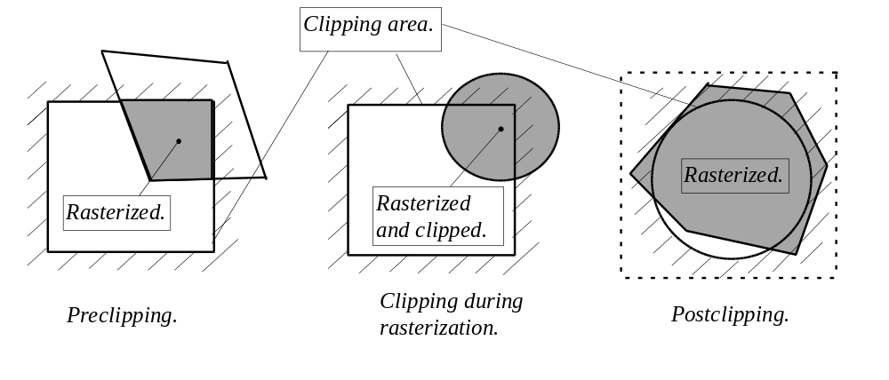
Figure 4.1: Different types of clipping.

As usual, cost considerations govern the decision which clipping strategy to employ. The first strategy works well when it is inexpensive to analytically find and describe a portion of the primitive within the clipping area. When it is relatively expensive to do, for instance to find and analytically describe an intersection of a circle and a rectangle, the second strategy: to clip during the rasterization, can be used. When it is both expensive to preclip and to validate the location of a pixel with respect to the clipping area in the run time, the third strategy can be considered. For example, we can use it when the clipping area is a circle or an ellipse.

Since most of the time we are dealing with the rectangular clipping area - the computer screen, and also, because simple geometric primitives are often favoured by other algorithms, we will concentrate primarily on the first strategy. Thus, let us discuss clipping points, line segments and polygons against a rectangular clipping area.

4.1.1 Clipping points.

The rectangular clipping area, which interests us the most, is described by four infinite lines which limit the least and the greatest horizontal coordinates and the least and the greatest vertical coordinates of the screen. Clipping a point to this area is achieved by checking its coordinates against these four constraints.

Although this is fairly cheap to do as it is, we can slightly improve the performance when the least limiting lines of the area pass through the beginning of the coordinates. Due to the fact that negative numbers reinterpreted into the unsigned representation appear as very big positive numbers (recall chapter two, section 2.8) comparing the point against the other two limiting lines is sufficient to make a correct decision in this particular situation.

4.1.2 Clipping line segments.

We can extend the above method for line clipping and check every time before plotting a pixel whether it is within the boundaries or not. However, by employing the strategy to clip simultaneously with the rasterization, we push up the complexity of the rasterization routine’s inner loop. Moreover, the optimized line drawing works with addresses of points within the image bitmap rather than with the screen coordinates.

The preclipping method analyses the location of the primitive with respect to the constraints and finds primitive’s part which satisfies them. In the case of a line segment, it requires finding an intersection or intersections between the segment and the boarders of the clipping area. Often it is not immediately clear where such intersections occur (see Figure 4.2).

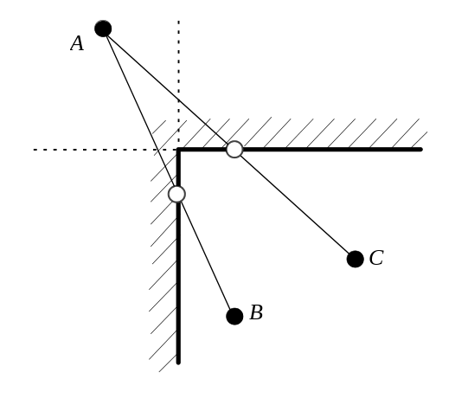
Figure 4.2: Line segments intersecting rectangular clipping area.

A common strategy is to employ one of the variety of divide and conquer clipping algorithms which were first described by Cohen and Sutherland in the early seventies. By clipping against some boundary, possibly locating an intersection, and proceeding to other boundaries with the sub-problem, we are guaranteed to find at the end the line segment which satisfies all the conditions. Consider an example at Figure 4.3. The line segment AB is clipped first by the boundary 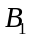. We find the intersection point and further proceed to clip the segment 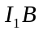 by the boundary 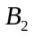which represents a sub-problem of the original. Such a strategy is very general and can be employed for clipping a line against any polygonal area, not necessarily a rectangle.

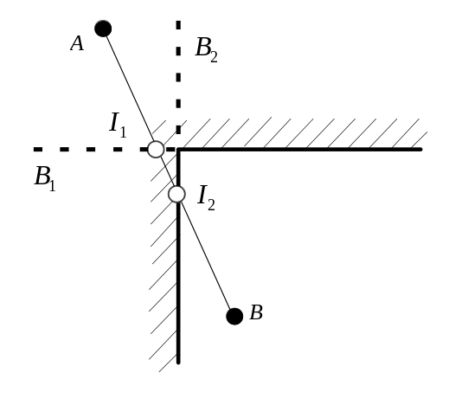
Figure 4.3: A line segment intersecting rectangular clipping area.

As we may need to find multiple intersection points, some of which may be useless, it becomes very important to, whenever possible, avoid doing the calculations. Sometimes, we can trivially reject or accept a line, when it is cheap to deduce that it is definitely outside or inside the clipping area. For instance, when the horizontal coordinates of both endpoints of a line segment are less than the least acceptable screen coordinate, such a segment can be safely rejected. Same reasoning applies for the other boundary and the horizontal coordinates as well.

One approach to trivial acceptance or rejection, which speeds up the chain of comparisons, is based on so called region outcodes. We assign a bit pattern to regions of the plane in a way so that each bit signals the presence of the primitive in a certain region outside of the clipping rectangle (see Figure 4.4).

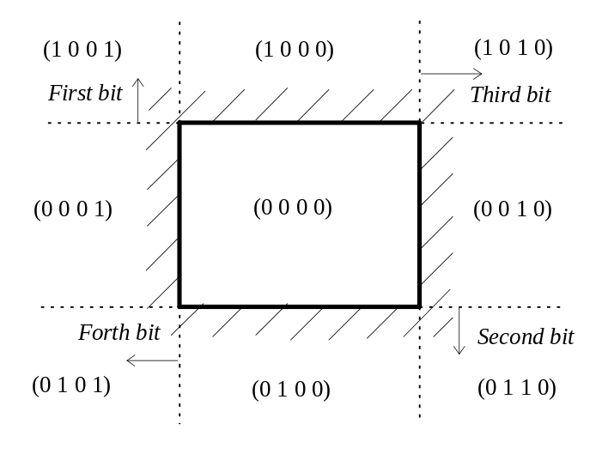
Figure 4.4: Outcodes.

In a typical example of this technique illustrated in Figure 4.4, the first bit of the outcode depicts the region above the clipping rectangle. If we assign the outcodes to the two endpoints of the segment, it becomes possible to use bitwise operations to check their combined location in the plane. If some bits are set for both endpoint it signals that the entire line segment is in that region, and thus, outside of the clipping area. This fact can be verified for all bits using the bitwise “and” operation. If the result is non-zero the segment can be safely rejected. On the other hand, if any bit is set for either endpoint the segment should be taken through the clipping process. Only if there are no set bits the segment can be trivially accepted. This fact can be verified by using the bitwise “or” operation. The outcodes also help to determine which clipping edges the line crosses, and thus the cases where we must compute the intersections.

Whenever a segment cannot be trivially accepted or rejected it must be taken through the clipping process. As we have noted, this process will involve finding intersections. For the cases of the vertical and horizontal clipping edges finding an intersection with the line segment is particularly easy (see Figure 4.5).

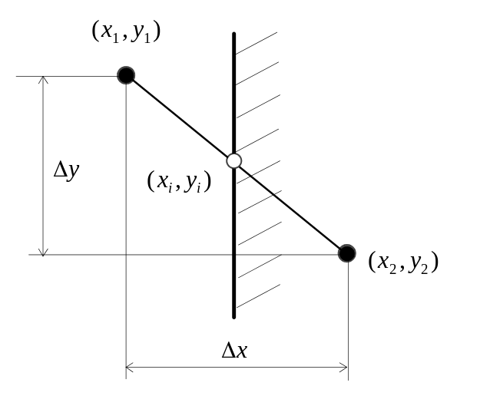
Figure 4.5: Clipping a segment against a vertical edge.

As the example in Figure 4.5 illustrates, the solution involves analysing the relations of two similar triangles. Since the intersection point will belong to the clipping edge for which we know the coordinate 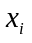, it only remains to find the corresponding 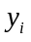coordinate. We can computed it as:

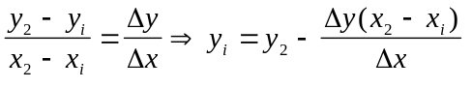

Similar expressions are used also for the vertical edges where we will have to locate of the intersection point knowing its . The cost of clipping a line segment is not particularly high. It only involves a multiplication and a division per intersection point. However, as we have seen in chapter three, in some cases line segments may have multiple values defined in every vertex. For instance, shaded polygons, besides spatial coordinates, also posses light intensity values, and textured polygons, the texture coordinates. Hence, as a result of the clipping process, we must find the correct values for all the coordinates spatial or non-spatial. This can be achieved, of course, by invoking the found formula multiple times, once for each coordinate. However, by doing this, we are pushing up the cost to the degree where it may be worthwhile to consider an alternative solution.

The methods which don’t involve divisions or multiplications are often attractive for graphics applications due to their low cost. In the case of the clipping, we can use the technique of binary search which involves only inexpensive integer operations. (see Figure 4.6).

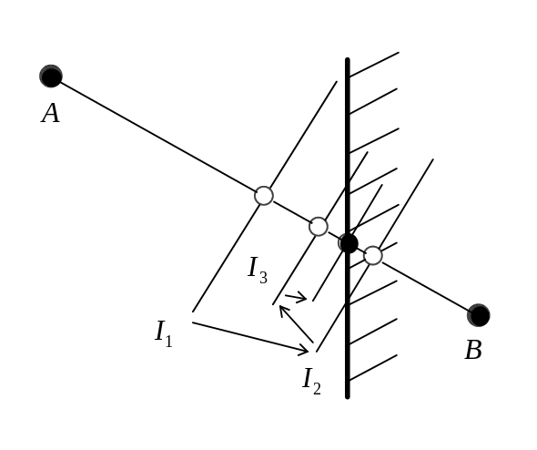
Figure 4.6: Binary search clipping.

The binary search algorithm, which is often used to find roots of equations, iteratively reduces the size of the problem until the solution is found. Applied to the clipping problem, this algorithm finds the midpoint of the line segment and compares its location against the clipping edge. Of the two line segments which are obtained at that stage, one can be discarded and the next iteration can be started for the remaining, smaller than the original, segment. For example, the line segment AB in Figure 4.6 is split into two: from the endpoint A to the midpoint , and from to the endpoint B. By comparing the x coordinate of the midpoint with the x coordinate of the clipping edge we conclude that the edge is located to the right of the midpoint and thus intersects segment 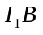. The remaining segment 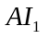 is discarded. The iterations of the algorithm are repeated until the x coordinates of the midpoint and the edge are equal or close enough.

Although, there may be several iterations involved, during each, the size of a new subpoblem is only half of the original, thus the algorithm should terminate promptly. Only very cheap operations are needed for the computation of the midpoint:

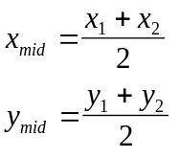

As it can be seen, we only use the additions and divisions by two, the latter as we have already discussed, can be performed by the shifting instruction. Particular attention should be given, however, to the termination condition. Due to the truncation of integer numbers, the algorithm may enter an eternal loop not being able to quite reach the exact equality of the x coordinates. We must carefully consider the particular implementation of the midpoint computation and make sure that the undesirable situation doesn’t occur. What follows in Listing 4.1 is an implementation of the routine which clips against least vertical boundary using binary search technique. Clipping against other boundaries is done in a similar manner, and combining all four, produces an effect of clipping against the rectangular screen area.

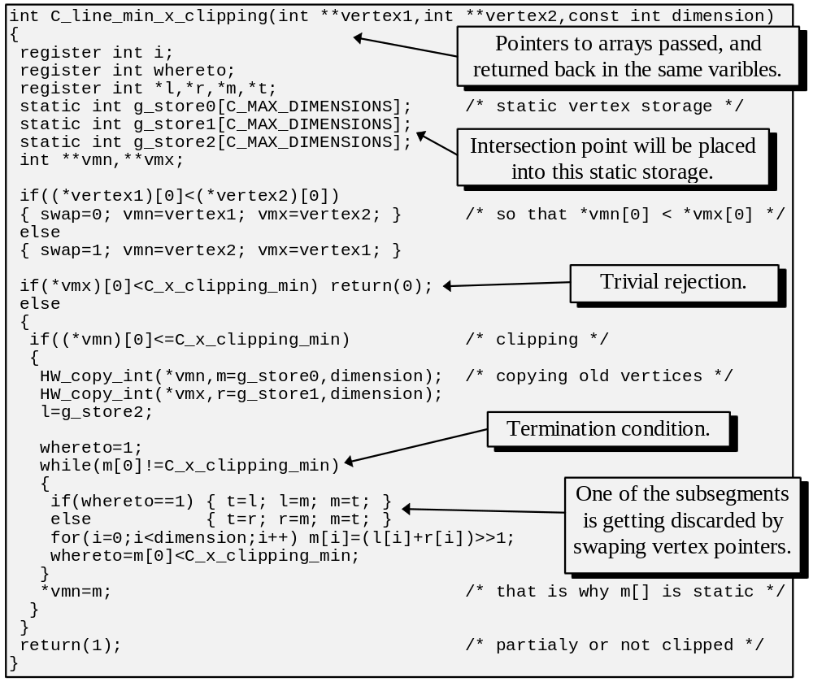
Listing 4.1: Binary search clipping.

Note that the routine in Listing 4.1 is designed to handle multiple dimensions in every vertex so that we can use it, not only for the clipping of line segments, but also for the clipping of edges in shaded or textured polygons. Calls to clipping functions must be placed into the line segment rasterization routine which would then be able to assume that the primitive is entirely within the screen boundaries.

Although we have considered only simple cases of horizontal and vertical clipping edges, the approaches of both computation algorithms we saw are very general and can be used for potentially any kind of polygonal clipping area. This, however, will involve finding an intersection of two arbitrary oriented lines segments. In the next chapter we are going to discuss how to mathematically describe geometric primitives, and how to use the primitive’s equations in the computation of intersections.

4.4 Clipping polygons.

Let us consider clipping a polygon against a rectangular clipping area. Similar to the discussed line segment clipping, the polygon clipping involves searching intersections between the edges of the polygon and the edges of the clipping area. The difficulty compared with the method used for lines, is that a polygon can change its shape quite substantially as a result of clipping. As Figure 4.7 illustrates, the number of edges and vertices may become different as a result.

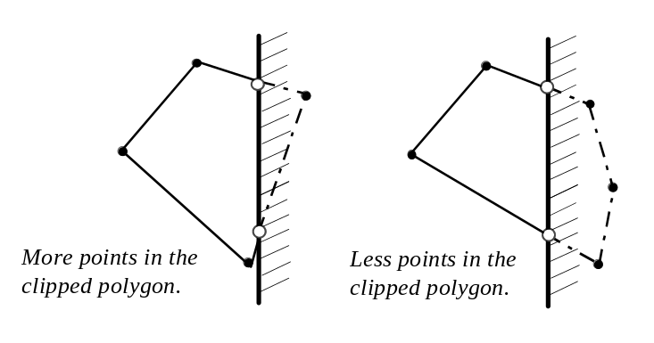
Figure 4.7: Different cases of polygon clipping..

We are going to consider divide and conquer polygonal clipping which was first described by Sutherland and Hodgman [SUTH74]. As is the case with lines, the method we are going to use is very general and allows to clip a polygon against any other polygonal clipping area. In the case of the rectangular screen, we will invoke the clipping routine once for each clipping edge, at the end, obtaining the polygon which meets all the imposed criteria (see Figure 4.8).

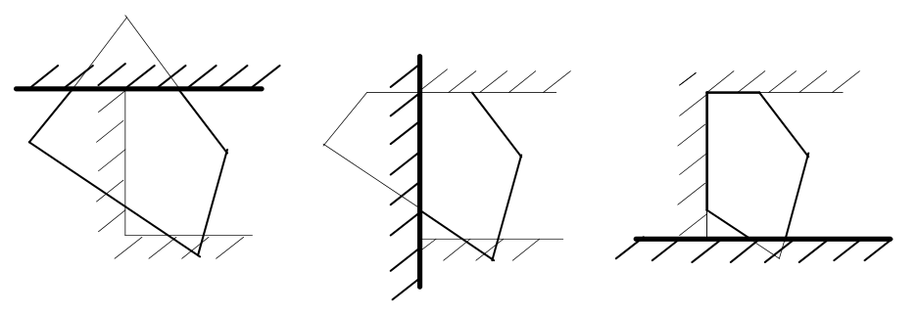
Figure 4.8: Iterating clipping edges.

At each iteration, we obtain a progressively smaller problem, where a new polygon, meeting previously imposed criteria, has been created. We have already considered the technique that allowed to find an intersection of a line segment with a clipping edge. Let us discuss how we can clip a set of edges forming a polygon by a single infinite line. A polygon is commonly represented as a sequence of vertices. Each consecutive pair of vertices describes an edge. Whenever one of the edges intersects the clipping line, we find an intersection point which necessarily becomes a vertex of the clipped polygon (see Figure 4.8).

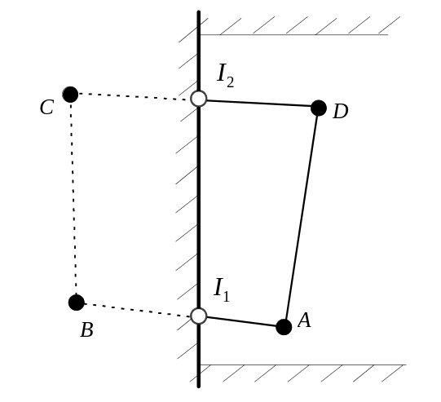
Figure 4.8: Iterating polygon’s edges against a single clipping edge.

As the Figure 4.8 illustrates the polygon ABCD becomes 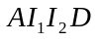 after clipping. In order to deduce this fact, we consider the edges in the order of their appearance in the polygon’s description. When the edge AB crossed the clipping line we add the intersection point into the description of the resulting polygon. Further, following the order of the polygon definition, some edge must cross the clipping line back. In this case, it happened at the intersection point 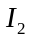. The segment of the clipping line between the intersection points limits the clipping area and thus defines an edge 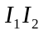 of the clipped polygon. We must also note that the edges which are trivially accepted remain in the new polygon whereas the edges trivially rejected are also discarded from the description.

It must also be recognized that each vertex belongs to two edges and the polygon description is a sequence of vertices where each vertex forms an edge with its successor and its predecessor in the list. Thus, when analysing an edge, we must take into account the fact that the first vertex in each pair may have already been considered by the previous iteration. Let’s list all the possible situations which may occur. When an edge is trivially accepted, we must copy into the resulting list only its second vertex, assuming that the first one has been considered earlier. When the second vertex in the pair is outside of the clipping area, we must find the intersection point and copy it into the result. When an edge is rejected, none of its vertices can be copied. In the last possible situation, the first vertex in the pair is outside the area. We must find the intersection point and copy it into the result together with the second vertex in the pair since the second one has not been considered yet.

The completely clipped polygon is further passed to the rasterization routine which is likely to draw the polygon as a set of horizontal pixel lines. In view of this fact, horizontal edges of the clipped polygon don’t carry any additional information for the rasterization routine. Since any horizontal edge shares its endpoints with two other edges, its only pixel line can be found from the neighboring edges, and thus, we can avoid passing horizontal edges to the scanning routine without loss of consistency (see Figure 4.9).

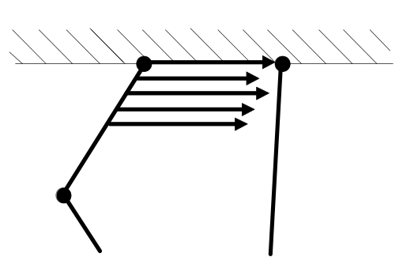
Figure 4.9: A scan-line coinciding with the horizontal edge.

The following routine implements simultaneous clipping of a polygon against two vertical clipping edges. It is interesting to observe that the algorithm deciding which vertices to copy into the result doesn’t require modifications as a result of this change. Further, when we have a vertically clipped polygon its edges are passed, one at a time, to the edge scanning function which finds the parameters of the pixel lines. The scanning function must first clip the edge horizontally since we are interested in only those scan-lines which are inside the screen. This two-step approach also guarantees that the horizontal lines of the polygon will never be explicitly created which slightly improves the overall performance (see Listing 4.3).

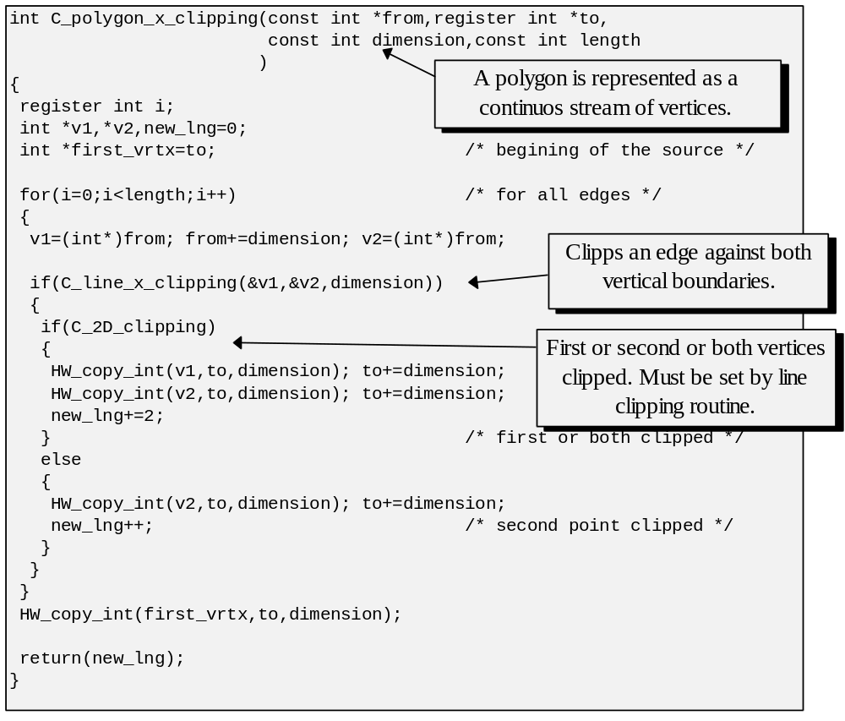

Listing 4.3: Clipping a polygon.

Note that the function presented in Listing 4.3 calls an edge clipping function which must clip against both vertical boundaries and also report which of the vertices were clipped so that the polygon clipping routine was able to copy the right vertices into the resulting polygon description.

It must be mentioned that the suggested algorithm can also be used to clip concave polygons and not only convex ones. However, in many cases a concave polygon may be split by clipping into multiple pieces. For example a polygon in Figure 4.10 is clipped into two pieces: 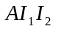 and 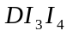. It is not hard to see that the described algorithm will produce as a result in this case a single polygon unifying the two pieces: 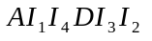 (see Figure 4.10).

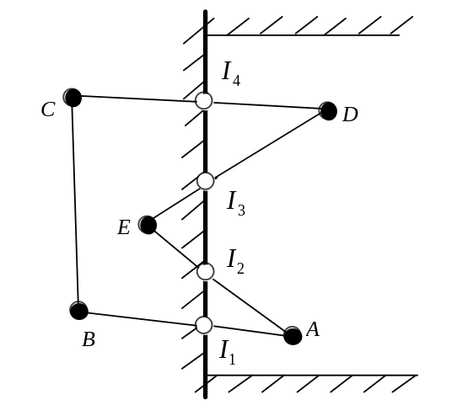
Figure 4.10: A scan-line coinciding with the horizontal edge.

This produced polygon is strictly speaking isn’t simple since edges 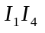 and 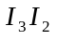coincide at some length. Such polygons however are often called weakly-simple since many comutational geometry algorithms don’t have to be changed to accommodate them. Rasterization algorithms which we considered aren’t exceptions and would be able to correctly draw weakly-simple polygons with no or only minor changes.

4.5 3-D Clipping strategies.

As we have already discussed, the perspective projection is applicable to only a subset of all points in space. Because the perspective transformation employs the inverse of the distance from the viewer, it produces an infinite result for the points with z=0. It also negates the coordinates of the points which are behind the viewer, potentially flipping over parts of a primitive. The goal of 3-D clipping is to ensure that only valid points are getting transformed.

Thus, the perspective transformation restricts the world space to the points in front of the viewer. In the previous section we have already observed the methods for clipping primitives against vertical and horizontal edges. In just a slightly generalized form the same solutions are applicable for the purposes of the view plane clipping. The only difference is that instead of two, three spatial dimensions must be taken into account.

Performing clipping against a plane slightly ahead of the viewer before the perspective transformation discards the points which would have otherwise caused division by zero. However, points which are only slightly in front of the plane will satisfy the imposed restriction, yet they may be mapped into the screen space with big absolute values of the coordinates. In fact, it is not unlikely that some of the transformed coordinates are so big that they overflow the bit size of the variables which store them (see Figure 4.11).

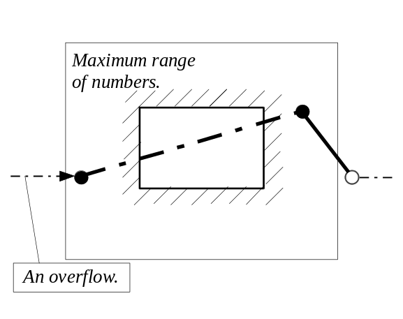
Figure 4.11: Effects of an overflow.

Values stored in signed representation are especially vulnerable to the overflow problems. Because negative numbers are represented as very big positive numbers, numerically big coordinates of a projected point may suddenly change sign and appear in a different region of the plane. If this happens to only a few of the vertices describing some primitive, the consistency of the projection will be lost, and in the most dramatic situations, this primitive may suddenly occupy considerable area of the screen space. For instance, a line, with one of its endpoints overflown, may span all across the screen from left to right or from top to bottom.

A simple fix is to attempt moving the clipping plane further ahead of the viewing plane. It doesn’t solve the fundamental problem, however, only shifting the inevitable to a bigger distance. In the situations with a limited size of the world space this may be sufficient. However the majority of the applications must consider a more fundamental solution.

Observing that the ultimate goal of the rendering algorithms is to present a drawing on the screen, we can separate the points in space by their ability to be projected on the screen. All points which are projected inside the screen are said to belong to the view volume. The points which project to the outside of the screen are also outside the of view volume in space. The problem with overflowing happened for the points that weren’t possibly able to appear inside the screen. If we introduce some constraints into space limiting it to the view volume, we can avoid the said problem.

Let’s consider both parallel and perspective projections and find their view volumes. In both cases, points which are projected to the screen boundaries separate the points which are inside the volume from the rest. In the case of the parallel projection, the projecting lines are mutually parallel and usually orthogonal to the projection plane. The lines that pass through the boundaries of the screen thus define a prism-like view volume limited in the front by the projection plane which may coincide with the screen plane. In the case of the perspective projection, the projecting lines intersect in the viewer’s eye. The projecting lines that pass through the screen boundaries form a pyramid like view volume in space which is also limited by additional clipping plane in the front, slightly ahead of the viewer (see Figure 4.12).

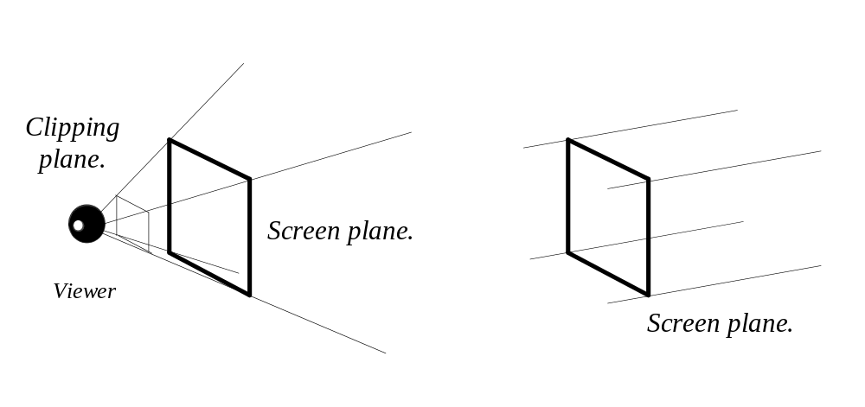
Figure 4.12: View volumes of perspective and parallel projections.

For the applications using parallel projection, 2-D screen boundaries clipping restricts the coordinates to the prism-like view-volume. Applications which use the perspective projection and do restrict, through some method, the coordinates to the pyramid-like view volume, don’t require screen boundaries clipping since the volume clipping step ensures that all primitives are projected to the inside of the screen.

Beside being necessary to ensure the correct functioning of the perspective transformation and rasterization algorithms, volume clipping also limits the number of primitives which are manipulated with. Of course, the earlier we can decide that a primitive cannot appear in the image, the lesser amount of processing we have to do. In the case of perspective transformation, due to the inverse of the distance which is used, the primitives which are far from the viewer appear very small on the screen. In these cases, it is unreasonable to spend processing time to draw them since the visual effect of such objects is quite negligible. We often add a back-clipping plane to the view volume which allows to dispose of such undesirable objects.

Clipping against the perspective view volume has an additional complication: we have to clip against planes some of which are directed almost arbitrary in space. In all previous cases we were able to exploit simple geometry of the clipping edges and planes, here however we are confronted with a fairly general situation. Only two planes of the six limiting the volume have simple orientations. They are the front and the back clipping planes. The other four are located quite inconveniently.

In the next chapter we are going to examine how to mathematically describe geometric primitives such as planes and how to find intersection in the general case. The techniques which would be examined will be also applicable to the clipping problem. The generality of solutions is very often paid for in the loss of performance. This particular case is not an exception. Although we can analytically solve the intersection problems, it may often be too expensive to undertake. Let us examine possible alternatives which can be employed to deal with the volume clipping problem.

The major complication that we face is inconvenient geometry of the view volume. Thus, the first solution is to attempt fixing this situation. Much more convenient view volume results when the angle of the field of view is 90 degrees. In that case the planes forming the perspective viewing pyramid have very simple equations: (see Figure 4.13). It is much easier to clip against such planes.

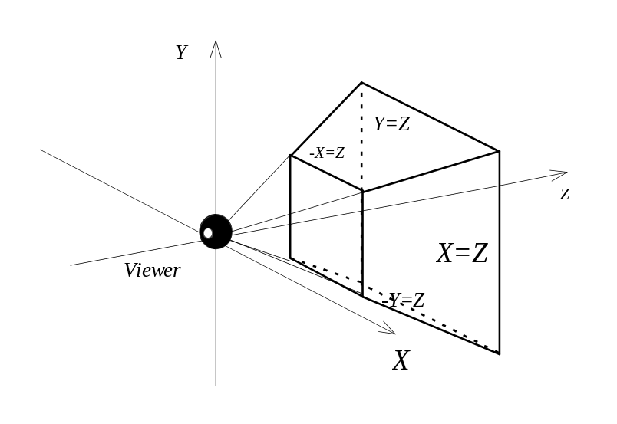
Figure 4.13: Viewing volumes of perspective projection with 90 degrees angle.

However, it is often the case that the chosen field of view angle is less than 90 degrees. In those cases we may attempt scaling the original space to arrive to the view volume with the sought angle. The clipping can be performed against view volume of a simple geometry, and once this is done the space is scaled back into the original configuration.

As an alternative to this multi-step process, we may decide to clip in the simple volume, yet further employ the perspective transformation with a smaller field of view angle. As a result of that, we lose an important quality of 3-D clipping. The projected points may be located outside of the screen and thus 2-D screen boundaries clipping must also be performed.

It is unreasonable, of course, to do two expensive clipping procedures. Thus we can introduce another relaxation. On the stage of volume clipping we clip against the front and perhaps back clipping planes and only perform trivial rejection acceptance tests against the remaining planes. Further, the primitives are going through complete 2-D clipping process in the screen space.

During the first pass, we avoid future problems caused by divisions by zero through clipping against the front clipping plane. We also statistically avoid possible overflow problems since the great majority of the points which caused the overflows are removed through the trivial rejection tests. Only if there are objects which span long distances in the world space being both inside the view volume and on the boundary of the maximum numerical value of the coordinates we can still suffer from the overflows. Most of the time we can assume that such a situation doesn’t occur.

The trivial rejections against the view volume with a 90 degrees angle are very much aided by volume’s simple geometry. Consider Figure 4.13. Since the clipping planes are described by the following equation it is easy to observe that the space outside of the volume can be described as . If all the points of some primitive satisfy the same inequality, the primitive is trivially rejected.

Individual primitives in the world space are often combined into some complex objects. Such objects may consist of many hundreds of primitives. The vertices of these primitives are very often closely located in space. If some vertex is trivially rejected, other vertices are probably going to be rejected as well. We can exploit this property of locality and perform trivial rejection tests on objects as opposed to individual primitives. For these tests we need some exact property of the object which consistently tells if it can be rejected. For instance, the center of the object is not suitable since when the center is outside the volume, some part of the object may well still be inside. A better approach is to enclose the object with a bounding volume of some simple geometry. If the bounding volume doesn’t intersect with the view volume the rejection can be safely done. The bounding volumes which are commonly used are a bounding box or a bounding sphere (see Figure 4.14).

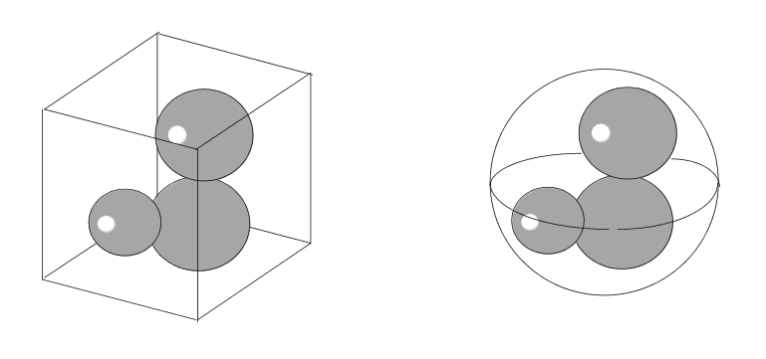
Figure 4.14: Bounding box and sphere for an object of complex geometry.

The bounding box represents minimum and maximum spatial coordinates of the object, whereas the radius of the bounding sphere is determined by the most remote point from the objects center.

Using the parameters of the bounding box, we can check for possible rejections from the view volume. For instance, when the minimum x coordinate is greater than the maximum z coordinate of the box, the object is outside of X=Z plane and can be rejected. Although we have considered the bounding boxes for the trivial rejection of complex objects it may also help in rejecting individual primitives, such as polygons which may have many vertices making a sequence of individual computations cumbersome.

What follows in Listing 4.4 is a routine implementing trivial rejection of some primitive or object specified through the parameters of its bounding box.

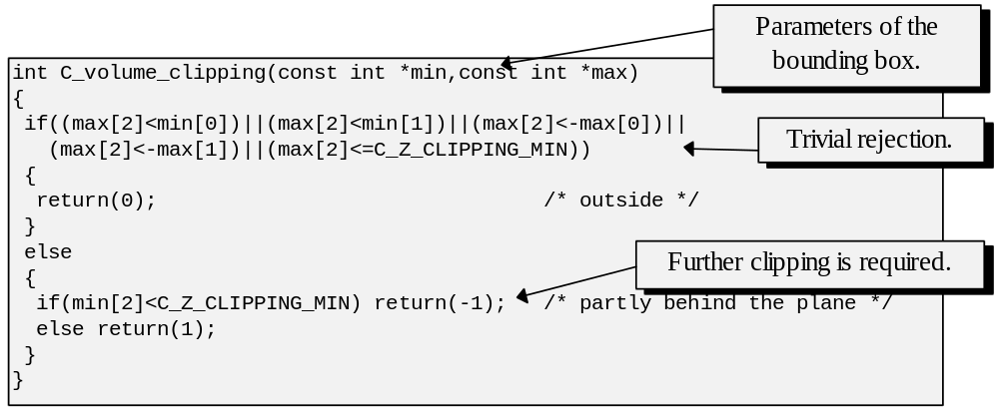
Listing 4.4: Bounding box based approximate clipping.

Bounding spheres can be handled in a similar manner. In that case, however, we will have to compute the distance from the clipping plane to the center of the sphere. If this distance is bigger than sphere’s radius the object can be rejected. We are going to examine the mathematics necessary to compute the distance from a point to a plane in the next chapter.

To summarise, the clipping algorithms, which we have discussed, are necessary to insure consistency of other algorithms such as rasterization or perspective transformation. They are also used to trivially discard the objects in the world space which would not contribute to the generation of the image. It is often expensive to consider general cases of clipping against a polygonal area in 2-D or polyhedron volume in 3-D. Somewhat simplified solutions may be considered instead.

* * *

