Chapter 5 Viewing processes.

5.1 World to Screen methods.
5.1.1 Parameters of the viewing system.
5.1.2 Polygonal pipeline.
5.1.3 Textured polygons.
5.2 Screen to World methods.
5.2.1 Line equation.
5.2.2 Plane equation.
5.2.3 Intersection of a line and a plane.
5.2.4 Intersection of a line and a polygon.
5.2.5 Intersection of a line and a sphere.
5.2.6 Finding a proper intersection.
5.2.7 Optimizing ray-tracing.

The sum of all techniques that contribute towards building an image of a 3-D scene is often referred to as a viewing process. Up to this point we assumed certain viewing technology, without actually defining it. We assumed that rendering is done through projection of geometric primitives, polygons for instance, onto the viewer’s screen space. This approach, however, is not unique. We can distinguish two mainstream viewing methods, often referred to as the world to screen method and the screen to world method. Projection of primitives is world to screen. The second method is also called ray-casting or ray-tracing. The idea of the ray-tracing is quite different: for each pixel on the screen we cast a ray into the representation of the virtual world until it intersects with some surface. The color of the surface in the intersection point is what we are supposed to see on the screen.

Both methods attempt to mimic how the viewing process appears to happen in nature. In nature, the light sources emit scores of particles. Whenever these are reflected by some object their wavelength composition (the color) changes. The viewer captures some of the particles and thus, through analysing their color, can reconstruct the images of objects from which the light particles were last reflected. Although, this process is possible to express as an algorithm, its efficiency in terms of utilization of computer resources will be quite low. Only a tiny portion of all emitted rays ever reaches the viewer, the rest are dissipated in space not contributing to the generation of the image so that their simulation will only waste processor’s time.

The virtual viewing methods which are commonly used in the field of computer graphics differ in their approach to limiting the complexity of the natural viewing. World to screen methods attempt to limit viewing to a set of objects in the scene and handle visibility of primitives as a whole and not through the individual rays that contributed towards it. Screen to world methods limit the amount of rays. By tracing back from the screen we are guaranteed to consider only those rays which were emitted by some light source and actually reached the viewer. We are going to discuss both types of viewing in this chapter, their relative advantages and disadvantages. We will examine some of the reasons why world to screen methods are more attractive for interactive graphics applications despite their relative complexity in implementation compared with the screen to world methods.

5.1 World to Screen methods.

As it has been noted previously, world to screen methods create an image of the virtual world by projecting primitives from the world onto the viewer’s screen space (see Figure 5.1). When considering transformations and processes which compose this viewing method, we have also to examine the general ideas behind the representation of the 3-D world and the viewer’s camera.

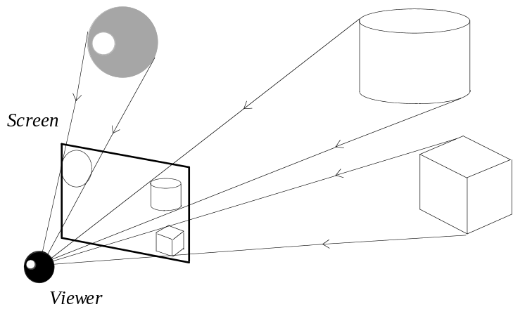
Figure 5.1: World to screen projection.

The 3-D scene is described in terms of geometric primitives, polygons for instance. Individual objects in the scene may be composed of some number of primitives. Since it is feasible that the objects are capable of moving in the virtual world, it is convenient to describe their primitives using some local coordinate system and not the world coordinates. It is often said that this local coordinate system is given in the object space.

Objects assume certain orientation and location in the world space. If we know the location and the orientation we can obtain object’s coordinates in the world space by applying some affine coordinate transformation. We have already discussed the translation and the rotation transformations in chapter two. Further, once we have the coordinates in the world space, we must perform the projection transformation which maps the coordinates to the viewer’s screen space allowing to start the rasterization process and display the image. As we have seen in chapter two, the projection transformation can be thought of as a two step process. During the first stage, we transform the world space in a way so that the viewer will assume the position in the beginning of the coordinates viewing along the Z axis. From such transformed world space, which is often called the view space, it is easy to apply the actual projection transformation and obtain the coordinates in the screen (see Figure 5.2).

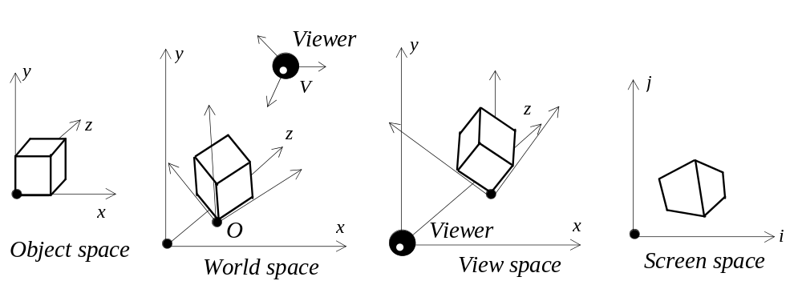
Figure 5.2: Transformations of an object.

Thus, in order to display a primitive of some object, an affine transformation dependent on the object’s position and orientation in the world has to be performed. Further, depending on the viewer’s position and orientation, another affine transformation must be applied producing the coordinates in the view space. Finally, a projection transformation (parallel, or perspective) is applied so that we can obtain the screen space coordinates.

In the case of the first step, assuming that the position of the object in the world is described by a point O, the mapping of the origin of the object space, and the orientation is given through the rotation angles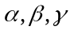 (roll, pitch, yaw), to obtain world coordinates we will have to first apply the rotation transformations using the given angles and further apply the translation transformation using the coordinates of the point O positioning the object in space:

Concatenation of the four transformation matrices produces the sought affine transformation. Further, another affine transformation, dependent on the viewer and taking the coordinates into the view space, must be performed.

It should be noted that the representation of the orientation using the three angles (also called Euler angles) has some problems. Since these angles are given with respect to moving axes, there are some rotations where we can observe the effect of the loss of one degree of freedom called gimbal lock. When it happens, two of the angles suddenly start describing the same rotation. This usually is a complication for applications where a user can interactively specify the orientation for some object. The Euler angles are also not very good for interpolation between two specified orientations. For instance, an animation application way have two positions of some objects with specified orientations and it may need to find the intermediate orientations in between of the given two. If the Euler angles are interpolated to obtain such intermediate orientations the resulting motion may be visually unsatisfactory. The mechanism of quaternions may be alternatively used if the above presents a problem (which we won’t discuss here since it goes outside the scope of this text).

Although a point and the rotation angles is, perhaps, a quite convenient way of specifying an object in the world, many different ways (as we have seen in chapter two) are used to specify the viewer’s camera. In the next subsection we are going to discuss various ways of describing the camera and the methods to retrieve proper affine transformation in each case.

5.1.1 Parameters of the viewing system.

There are multiple ways to specify the viewing camera. To uniquely describe it, we need at least six different parameters which correspond to the number of degrees of freedom for a rigid body in 3-D space. One approach is to specify the coordinates of the point V where the viewer is located, and the rotation angles of the camera’s orientation. In such case, when we want to obtain the view space coordinates, the translation transformation bringing the viewer into the origin of the world space must be performed first, followed by the rotations in a more convenient for world space order: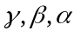 (yaw, pitch, roll):

Concatenated together, the four transformation matrices produce the affine transformation necessary. In its turn, the combined matrix obtained at this stage can be concatenated with the matrix describing the transformation from object into the world space:

Alternatively, the orientation of the camera can be specified through three unit vectors 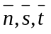describing the direction of view and the orientation of the rectangle of the screen in the world space (see Figure 5.3).

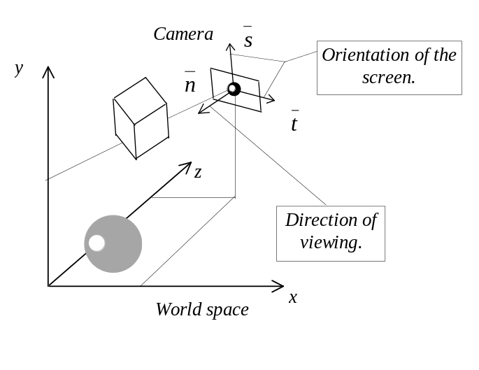
Figure 5.3: Specifying the camera.

We must note that despite the fact that three vectors contain nine scalar parameters, these parameters are not independent. We can add six more equations which govern their dependencies (three equations describing the fact that vectors are unit length, and three equations saying that the vectors are mutually orthogonal). As a result, we are left with only three independent parameters for specifying the camera’s orientation, which combined with the three independent coordinates used to specify the position of the viewer gives the six degrees of freedom of a rigid body in 3-D space.

The first step in finding the transformation is the same for both methods of camera representation: we must apply the translation transformation which will bring the viewer into the beginning of the coordinates of the world space. For the second step, in this case, we don’t have the rotation angles which enabled easy construction of the rotation matrix. Thus, we will have to deduce this matrix by different means. We must note that the rotation is a linear transformation and thus can be stored using a three by three matrix. Let’s try to find it in this form understanding that we will have to increase its dimension when multiplying by the other transformation matrices. If we analyse the available information, we will see that the vector of the viewing direction, which is given to us as, 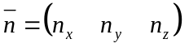 in the world coordinates, must map into 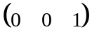 in the view space (recall that in this space the camera is directed along Z axis). The other two vectors describing the screen orientation 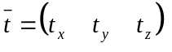 and 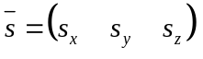 are mapped into 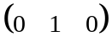 and 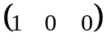 respectively. Using these facts it is not difficult to establish a system of equations

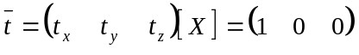
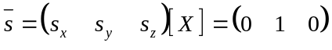
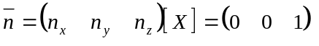

where 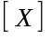 is the unknown transformation matrix. Combined together the above equations can be written as

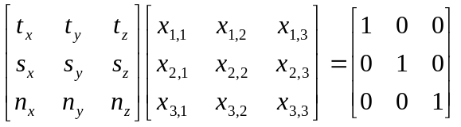

By solving this equation in all x we obtain the sought transformation matrix which would transform any point from the translated world space into the view space.

Perhaps the most popular technique for solving the matrix equations of low dimension of the type 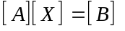 is Gaussian elimination algorithm. By this algorithm the equation is transformed in a way so that the coefficient matrix 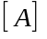 attains the upper triangular form:

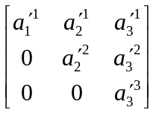

This is done through exploiting a property which allows to subtract different rows times a constant without loosing the consistency of the equation. Consider a simple matrix equation:

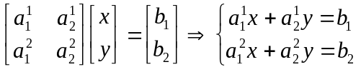

By subtracting the first row times t from the second row we obtain equivalent system of equations which in the matrix form can be represented as

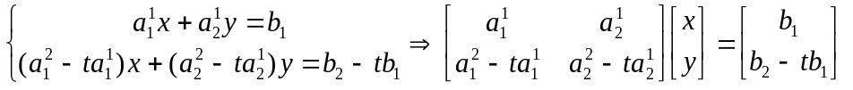

Using this property we can continuously subtract rows from one another in a way so that the coefficients are eliminated in the lower triangle of the matrix . Once the matrix is in the upper triangular form it can be trivially resolved for . Because in the last row of the coefficient matrix we have a single coefficient, it translates into linear equations of the type 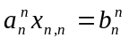 from where we can deduce all x in the last row. With this done, we have enough information to resolve for the row preceding the last one. This process is repeated till all x are resolved. The following routine implements Gaussian elimination algorithm (see Listing 5.1).

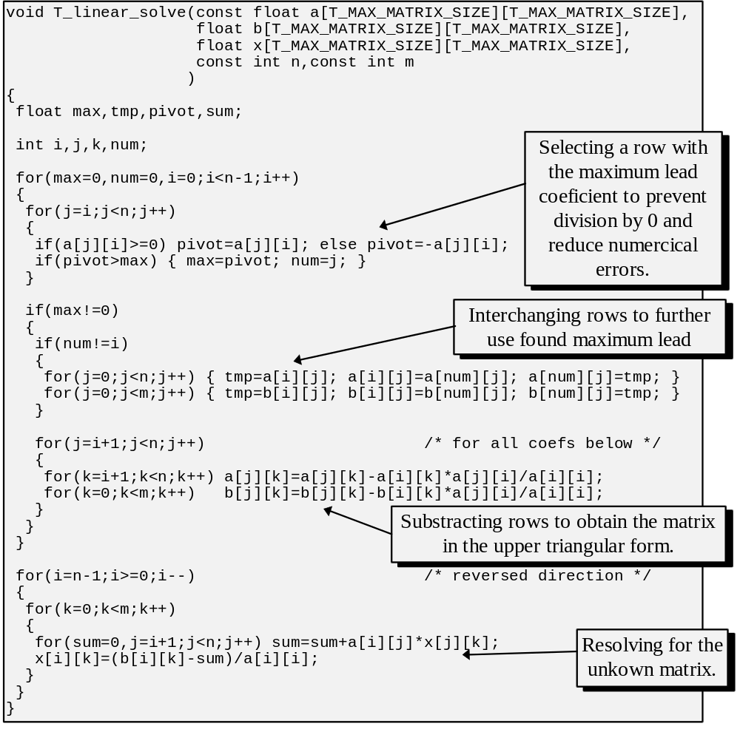
Listing 5.1: Solving system of linear equations using Gaussian elimination.

There are number of problems that may appear while solving matrix equations. Some of them arise from numerical roundoff errors. It is usually not a big problem for low dimension matrices which we are considering. Another set of problems appear because of inconsistencies in the equation itself. We should not have these either, unless we’ve initially selected parallel vectors when formulating the matrix equation. Parallel vectors translate into linearly dependent rows (one row equals to a constant multiple of another row) and this leads to difficulties in finding of a unique solution. Due to the liner dependency, when trying to create a zero in a particular position we create zeros in the entire row. Having the whole row turned into zeros translates into an equation: 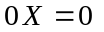 and this one has an infinity of solutions.

Returning to our original problem of finding the rotation part of the transformation from the world to the view space, we can now solve the formulated matrix equation and obtain the rotation matrix which can be concatenated to the right of the translation matrix which takes the viewer to the world space origin producing sought affine transformation matrix.

This approach of formulating a matrix equation and retrieving the transformation matrix is very general and can be applied to cameras whose direction of view is not necessarily orthogonal to the projection plane. In the particular situation when it is, a much simpler solution is available.

If we know that all vectors describing the camera are unit length, the following statements are true (nature of these we will see when considering the scalar product):

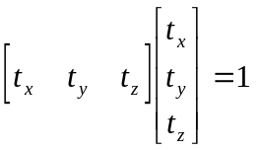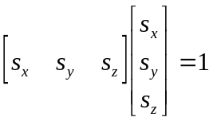

We can also demand all vectors to be mutually orthogonal in which case the following statements are also true:

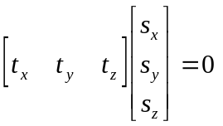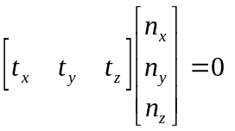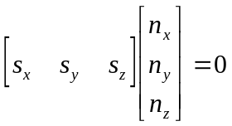

If we consider the matrix multiplication rule it is not hard to see that the statements above describe individual cases of row column multiplication in the equation which we have built. Noting the value which must be produced we can reconstruct the matrix as follows.

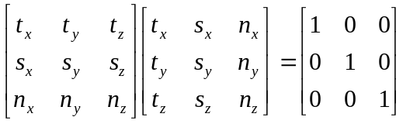

As one can see, the coefficients of the vectors describing the orientation of the viewer should only be placed into a matrix column by column to describe the necessary transformation.

Further, when we know the coordinates in the view space, the projection transformation is applied, which we can also often represent in its matrix form and concatenate with the other transformation matrices if the clipping process was not required. It must be noted that other parameters of the camera such as the focus distance can be made part of the dynamic description and allowed to change in the run-time.

Choosing which of the two methods to use depends on the particular application. For moving viewers, the first method is often more intuitive since it allows to easily express the change in the orientation through increasing or decreasing the rotation angles. The second method is helpful when we must often select the precise viewing direction. If we know the coordinates of the point we want to look at, and the coordinates of the viewer’s position, we immediately have the vector specifying the viewing direction.

We must also note that a more general formalism to express the camera and hence the viewing process is sometimes used, for instance in [FOLE90]. Nevertheless, majority of actual applications seem to opt for a more restricted yet simpler systems of the nature described in this section.

5.1.2 Polygonal pipeline.

A polygon is a fundamental primitive for object representation used with the world to screen method. This primitive is the easiest to manipulate with, especially, during the rasterization stage. It is often the case that other primitives are tessellated into polygons at one stage or another. We have discussed how a single point is transformed from the object space into the screen space. The process taking a polygon from the world space into the screen space is often called the polygonal pipeline. Although there are complications caused by the presence of multiple polygons (some polygons may be obscured by others), let us concentrate for the moment on a single polygon passing all the stages till it appears on the screen.

We have already seen that besides the transformations, a primitive must pass the clipping stages. We must assure that there are no vertices outside of the viewing volume, and if the 3-D clipping was approximate we must also guarantee to the rasterization routine that the primitive is within the boundaries of the screen. In order to do the latter we employ 2-D clipping algorithms.

We have discussed in the previous chapter how to perform the volume clipping immediately before the perspective transformation, that is in the view space. Since another reason of the volume clipping is to reduce the scene complexity it is potentially advantageous to do clipping earlier, that is in the world space. We will have to transform the viewing volume from the view space back into the world space apply clipping there thus possibly rejecting many primitives even before they were transformed into the view space. In many situations this, however, is not practical. For one thing, we will have to clip against planes arbitrary oriented in space which is fairly expensive and which was something we attempted to avoid. Moreover, if a single concatenated matrix is performing the transformations directly from the object space into the view space there is no gain to be made by clipping in the world space since world coordinates are never computed explicitely. In some applications, for instance those picturing interior scenes, there may be a lot of objects described in terms of world space. For instance, static elements of the interior such as walls or floors will be defined in the world space, whereas moving objects will be specified in their own object space. In such applications clipping earlier may bring a potential gain since some vertices would not have to be transformed at all.

Depending on the type of the polygon there may be an extra work to be done. We have considered flat polygons (constant color), interpolatively shaded polygons, linearly textured and finally perspectively textured polygons. There is no extra work to do for the first three types, except that different number of coordinates per vertex have to be pushed through the pipe-line. It is just (x,y,z) coordinates for the flat polygons, (x,y,z,intensity) for interpolatively shaded ones, (x,y,z,u,v) for linearly textured or (x,y,z,intensity,u,v) for the combination of the two.

For the purposes of the transformations we have to worry about just 3-D space coordinates. Clipping, on the other hand, has to be applied to all of the values defined in a vertex. Because all of the values mentioned above represent parameters that change linearly across the polygon, treating intensity or texture coordinates as space coordinates in the clipping algorithms is valid. We have already used the same property when performing polygon scan-conversion. Let us recall, that we have interpolated intensity and the texture coordinates along the edges to obtain the values on the left and right boundary of the polygon, and then linearly interpolated again, that time, along the scan-lines.

An extra complication comes with perspectively textured polygons. In order to do proper perspective texture mapping we need to use a projection of two orthogonal unit vectors from the texture space into the view space since they would be used in the reverse mapping equations. We considered this algorithm in charper three. Because perspectively textured polygons are crucial for creating realistically looking virtual worlds let us consider this problem in deeper detail in the next subsection.

5.1.4 Textured polygons.

As it has been discussed in chapter three, the algorithm performing the perspective texture mapping requires the information about the orientation of the polygon’s plane in the view space. We represented this information by the mappings of two orthogonal unit vectors from the texture space into the view space and the mapping of the texture space origin.

Recovering texture mapping vectors is a very simple task if we are dealing with rectangles. The big advantage is in the property of the edges being orthogonal (see Figure 5.4).

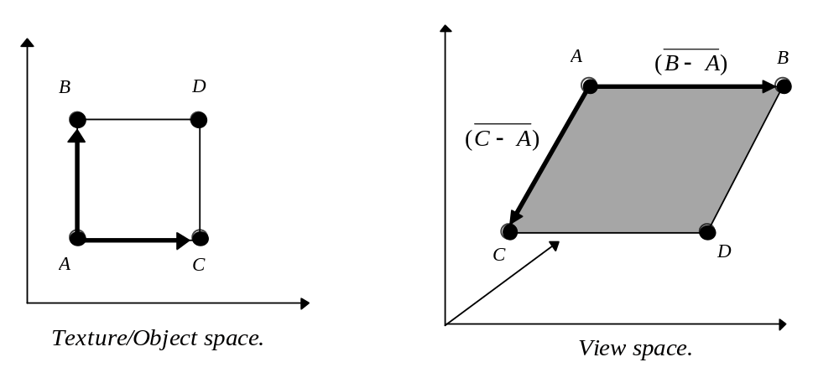
Figure 5.4: Texture mapping vectors for a rectangle.

As Figure 5.4 illustrates, we can recover scaled version of texture mapping vectors as 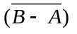 and 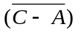 from the view space coordinates. Similarly, the coordinates of the point A may serve as the mapping of the texture space origin. The same strategy can be applied for triangles which have two orthogonal edges.

However, if in a polygon there are no orthogonal edges, the problem becomes somewhat more complicated. One strategy is to keep together with every polygon two vectors which describe texture orientation and a point describing the texture space origin. We will apply transformation to them during the transition from the object into the view space at the end obtaining the proper mappings. This method, however, assumes storing redundant information for every polygon. The same information can be deduced by examining the coordinates of the polygon in the object and view spaces.

Let us recall that for the linearly textured polygons we were keeping texture coordinates in every vertex which allowed to render polygons of any shape. The texture coordinates were treated just as space coordinates for the purposes of clipping, so that arriving to the rasterization stage we had correct texture coordinates in all vertices, whether they were created during clipping or not. Although the situation is different with the perspectively textured polygons, we may want to employ a similar strategy. If we keep the texture coordinates in every vertex we may be able to use this information to our advantage in computing the texture mapping vectors.

Let’s consider again why rectangles were so simple in this respect. Corners of a rectangle correspond exactly to the corners of the texture which is not the case for an arbitrary polygon (see Figure 5.5).

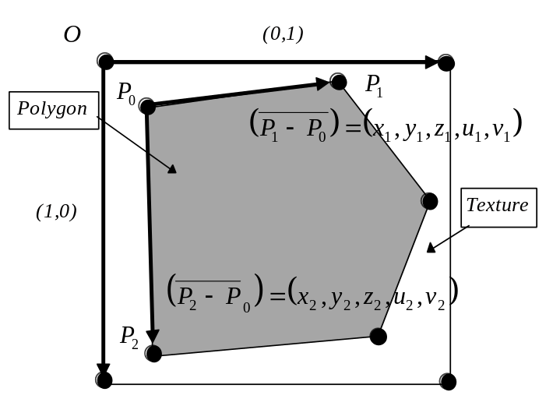
Figure 5.5: A polygon and its texture.

Yet, in the vertices of an arbitrary polygon in the view space we have both: the spatial coordinates as well as the texture coordinates each vertex has originated from. Thus, we can establish a correspondence between some vectors in the texture space and the view space by building these vectors from the coordinates of the vertices (see Figure 5.5).

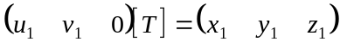
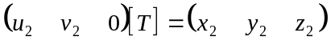

What we require, on the other hand, and were able to find in the case of rectangles without complex calculations were the mappings of the orthogonal texture space vectors and . Obviously, by combining together the two above equation we now have a matrix equation by solving which we can find the transformation matrix 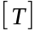 which performs the transformation from the texture into the view space.

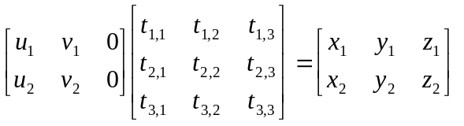

Noting that the texture is two dimensional, the above equation is trivially transformed into

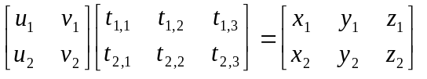

This matrix equation can be resolved by using, for example, the Gaussian elimination algorithm which we examined in the previous section. When the equation is resolved, we have obtained a matrix which transforms any point from the texture space into the world space. Since for the purposes of texture mapping we need the mappings of the unit vectors this can be obtained as follows:

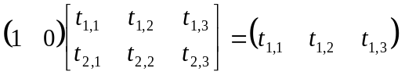
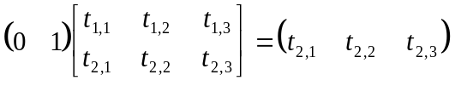

Beside these two, we also require the mapping of the texture space origin, the point O, into the view space. Although we don’t have it explicitly, we can use the mapping in any vertex of the polygon 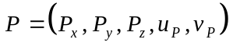 and change the direct mapping equations we derived in chapter three accordingly to reflect the fact that an arbitrary point is used rather than the origin:

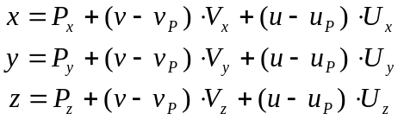

Thus the reverse mapping equations will assume a slightly different form:

The method to rely upon texture coordinates defined in every vertex allows to treat linearly and perspectively textured polygons in a uniform manner as far as the data representation is concerned. Although the final purpose of texture coordinates stored in each vertex is different, their presence allows to render the same polygon using both techniques. This is attractive since linear texture mapping is inherently less expensive and we can use perspective texture mapping only in the situations where the perspective distortion cannot be neglected.

5.2 Screen to World methods.

Screen to world methods, unlike the ones previously considered, find images of the virtual world by tracing back the rays from the viewer’s eye into the space.

A common strategy is to generate a ray passing through each pixel on the screen and to compute the intersections with all the primitives in the world that result. Of all the intersection points, we are interested in the one with the least distance to the viewer since this will be the visible point at the selected screen pixel (see Figure 5.6).

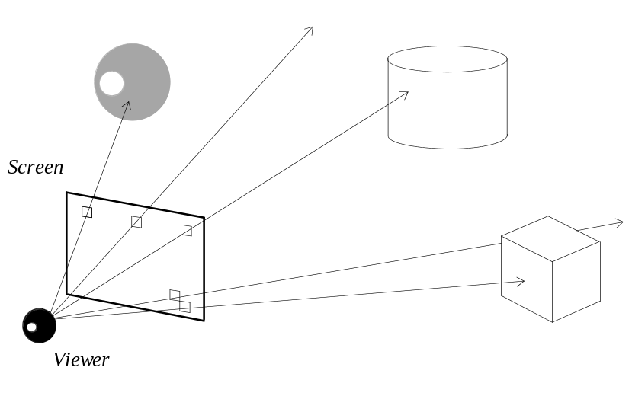
Figure 5.6: Ray casting.

Although this solves the visibility problem, it doesn’t quite help in determining the color which should be assigned to the pixel on the screen. Although we are going to discuss lighting and colors in a dedicated chapter, for the moment, let’s assume that we can deduce the color by examining attributes of the surface intersected by the ray.

We must also note that obtaining the coordinates of individual objects in the world space from their object space coordinates can be done by applying coordinate transformations in exactly the same way as it was achieved in the world to screen method. For this viewing method, however, we don’t have to explicitly transform the coordinates into the view space and then into the screen space. Since the viewing is achieved through intersection calculations we can form the necessary rays directly in the world space and perform all further computations there (see Figure 5.7).

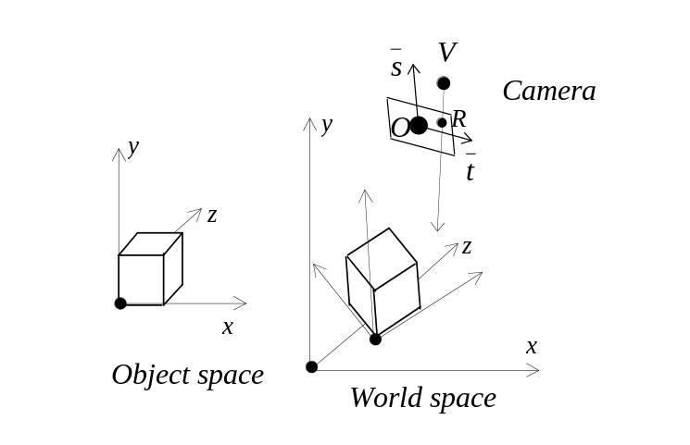

Figure 5.7: Definition of camera for ray casting.

Figure 5.7 illustrates that if the camera is specified through the point O describing the position of the screen center in the world, orthogonal vectors 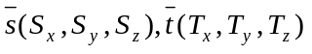 describing screen orientation and the point V specifying the position of the viewer, it is easy to find the world coordinate 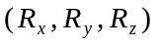of any screen pixel 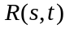 as

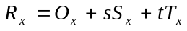
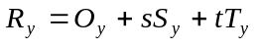
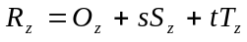

These expressions are obtained in the very same way as it was done in a similar situation we had when considering the perspective texture mapping in chapter two. Further, when we have the world coordinates for a point R we will be able to define a ray which is passing through it having originated in the point V.

Although other ways of defining the camera are possible, in all cases, we can construct the necessary rays in the world space avoiding extra coordinate transformations. Therefore, the major problem which remains is how to find intersections between rays and geometric primitives. Let us consider first the mathematical form of representing basic primitives: lines, planes, polygons and spheres, and then how to compute the coordinates of the intersection points.

5.2.1 Line equation.

There is a number of ways how a line can be specified. Let us suppose that we are given a point Q through which the line passes, and a vector 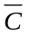 co-directed with the line. Let’s use a variable X to describe any point on the line (see Figure 5.8).

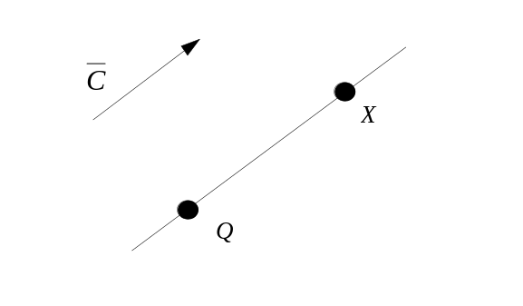
Figure 5.8: A line and its co-directed vector.

It is not hard to see that any other way of representing a line can be brought to the above mentioned case. For instance, if we are given two points 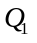 and 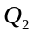 belonging to the line, we can find a vector co-directed with this line as 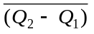. We can take any of the two in addition to the vector in order to complete the description as required.

Using a variable point X and the given point Q we can find another vector co-directed with the line: 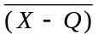. The two vectors 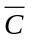 and are parallel and thus linearly dependent, in other words, one is a scalar multiple of the other. This fact gives us the sought line equation:

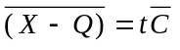

In this equation t is some scalar value, and the equation can be further rewritten into what’s known as the parametric form:

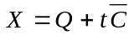

Thus, by varying the parameter t we arrive to a different point belonging to the line. It should be noted that X, Q and are three-tuples and the above equation has, in fact, the following meaning:

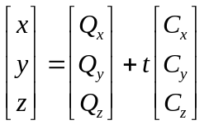

This form gives rise to several different representations written in components as opposed to be written in vector form. For instance: from the fact that if two tuples are equal it follows that their respective components should be equal too. Thus we arrive to three equations. From each of these equations we can express the parameter t.

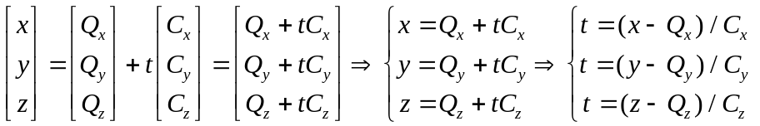

Equality of the three gives another common form of expressing lines:

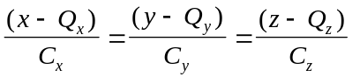

We will mostly use the parametric form, since when looking for intersections of a line with several geometric objects, it is convenient to compare distances between the intersections by analysing the parameters t. At the same time, the ray equation can be obtained by computing the corresponding line equation with the origin of the ray taken as Q, and combining it with an extra condition limiting the parameter t to positive numbers only.

5.2.2 Plane equation.

Before we can derive a formula for a plane equation, we have to consider an important concept of multiplying vectors. Two different kinds of products are defined for the vector space. A vector product and a scalar product. As their names suggest, multiplication of two vectors produces a vector in the first case, and a scalar value in the second case.

By definition, a vector product, denoted as 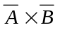, is a vector satisfying these three properties:

- 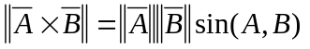 - length of the vector product of two vectors is the product of their lengths’ and the sin of the angle between the vectors (Note the norm notation 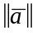 specifying length for vector ).
- is orthogonal to both 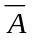and 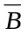.
- , and form right triple of vectors. If we are looking from the end of then the rotation to get from to is counterclockwise (see Figure 5.9).

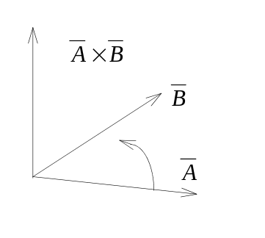
Figure 5.9: Right triple of vectors.

What we are mostly interested in is the property number two: vector product of two vectors is orthogonal to the two given vectors. For a plane, the normal vector can be computed as the vector product of any two vectors which lie in it. Property number three specifies where of the two possible directions vector product will point.

Let’s derive a formula to compute the vector product given two vectors. Any vector can be represented as a linear combination of the basis. The usual basis of the 3-D vector space is formed by a right triple of three mutually orthogonal unit length vectors:

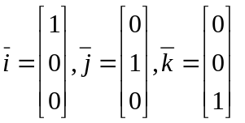

Any vector A can be expressed as

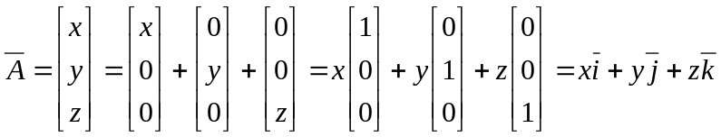

The above is a linear combination of the basis vectors. Just from the definition of the vector product it is easy to see that the product of any two basis vectors is the remaining, third vector or its negative. For instance, the product of and must be orthogonal to them both. Since the length of the product is 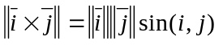 and both and are unit vectors crossed at the right angle, the length of the product must be unit as well. This automatically leaves either or 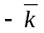. Considering the property number three and the fact that the rotation from to observed from the end of is indeed counterclockwise in the usual basis, we conclude that 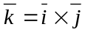.

Similarly, 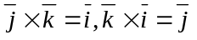. By specifying two arbitrary vectors as the linear combinations of the basis and noting that by the definition of the vector product 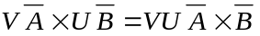 we can see that

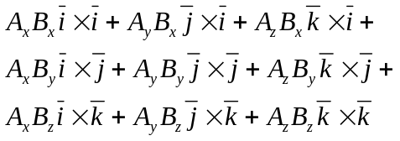

Further, considering the same definition, we conclude that 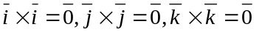 due to the fact that the vector forms a 0 degree angle with itself and 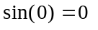. Substituting known products into the expression and combining factors for 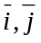 and we obtain the formula which we will use to compute the vector product:

It is customary to represent the above formula with the help of the definition of the matrix determinant since the formula corresponds to how we compute the determinant of a three by three matrix where first row contains and and second and third the scalar factors expressing the two vectors:

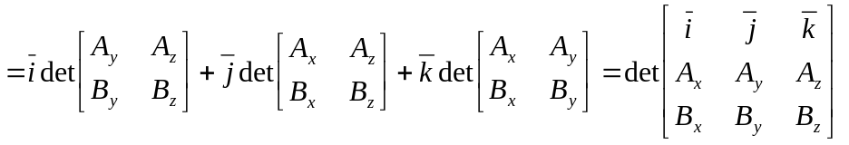

Unlike the vector product, the scalar product of two vectors is a scalar number. By definition this number is a product of vectors’ length and the cos of the angle formed by the two vectors:

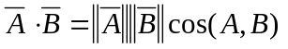

Just as we did for the vector product, let’s consider what is the scalar products of the basis vectors. This time, it is even simpler. Since 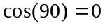 we conclude that 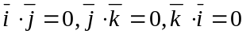. Representing two arbitrary vectors as the linear combinations of the basis vectors we can see that

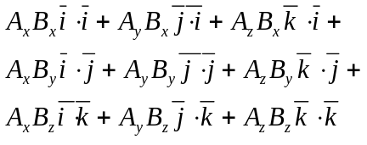

By definition 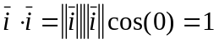. Taking this fact into consideration, the formula for computation of the scalar product can be expressed simply as

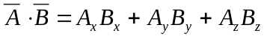

An important property which we will often use is that the scalar product of two orthogonal vectors is 0 since . If we are given a point P located in the plane, we can represent any vector belonging to the plane as 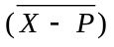 where X is a variable point in the same plane. If we are also given a vector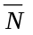, normal to the plane, the plane equation can be expressed as an equality of the scalar product of the two vectors to zero (see Figure 5.10):

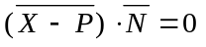

Only those X which lie in the plane will make the above equation to evaluate to 0.

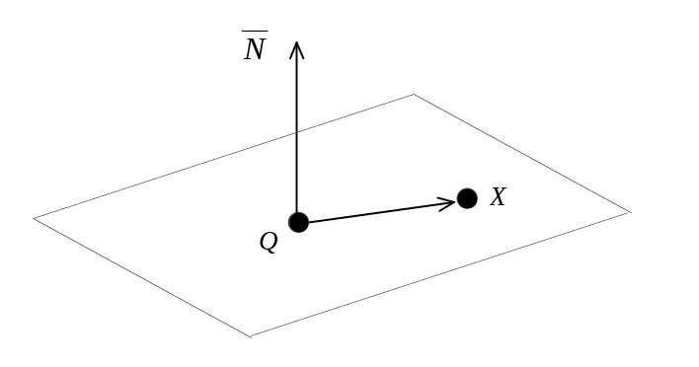
Figure 5.10: A Plane.

In the context of computer graphics, we often need to find an equation of the plane for a given polygon. In that case we don’t immediately have the normal vector, however, we can find two vectors belonging to the plane as a difference of polygon’s vertices. The normal is obtained as a vector product of the two.

As it can be seen, considering the vector and the scalar products made expressing the plane equation to be a trivial task. For the purposes of the ray tracing method, we need to find intersection of a ray and a primitive. Thus, let’s consider how an intersection of a line and a plane can be computed.

5.2.3 Intersection of a line and a plane.

Equation of a geometric object holds for any point in space which belongs to that object. Thus, resolving the system of equations consisting of formulas describing several geometric primitives can lead us to finding the points which belong to all the primitives in the system - their intersection.

Let’s suppose we have a line represented in the parametric form and a plane represented as this system can be resolved in the following way:

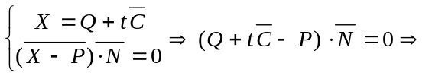

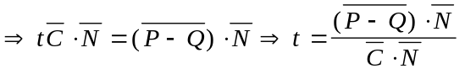

By resolving the two equations together we have found the expression for the parameter t corresponding to the point on the line which also belongs to the plane. The coordinates of the intersection point can be further deduced by substituting t into the line equation.

5.2.4 Intersection of a line and a polygon.

The computation of the intersection of a line and a plane is quite important, however, the 3-D scene is populated by polygons which are only patches of their respective planes. Thus, although we can locate the intersection with the plane, it may be of little use if it doesn’t lie within the polygon’s borders.

Once we have located the intersection, all further computations are essentially planar, proceeding in the polygon’s plane. Even for a purely planar case determining if a point is within boundaries of an arbitrary polygon is somewhat troublesome. A common approach is to use what is sometimes called the plumb-line or odd intersection rule. This rule is an immediate consequence of the Jordan’s curve theorem which states that any simple polygon subdivides a plane into two regions: the interior of the polygon and its exterior. Thus, if we draw, for instance, a horizontal line passing through a given point, this line may intersect the polygon at several edges. If there are odd number of intersections on either side of the point it must be within the polygon. If there are even number of intersections on either side, it must be on the outside. Note that since 0 is considered to be even, the case when the line doesn’t intersect any edge falls into the second category as well (see Figure 5.11).

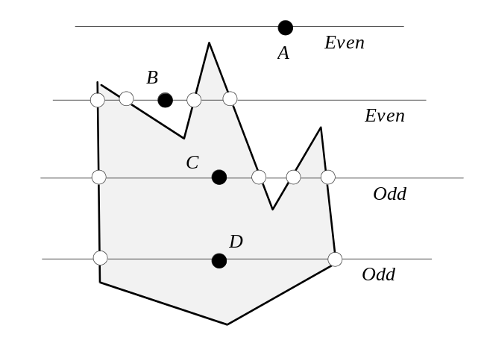
Figure 5.11: Odd intersections rule.

Since this method works entirely in the plane, we need the coordinates of all the points with respect to this plane. We, however, have only the 3-D coordinates. It is possible, of course, to deduce this information by applying the technique that was used in section 5.1.4. There, we have found mappings between some vectors in the two spaces and used their coordinates to deduce the transformation that maps one space into the other. In this particular case we can build a normal to the plane and select two orthogonal vectors in the plane. The goal is to find the transformation which maps the three selected vectors into the usual basis. Further, when we have the transformation matrix, applying it to the point in the world space produces the coordinates, two of which can be further used as the coordinates in the plane.

It is somewhat expensive to employ this strategy. If we look for a cheaper solution it becomes clear that for the intersection calculations we can use projections of all points onto one of the reference planes of the coordinate system. If the point is within the polygon in a given plane, it is within the polygon in any projection of that plane. Reference planes are attractive because the projections onto them are the easiest to find. It only involves discarding one of the three 3-D coordinates in every point. For instance, for a point 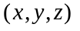 its projection onto the 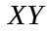 plane is just 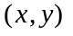(see Figure 5.12).

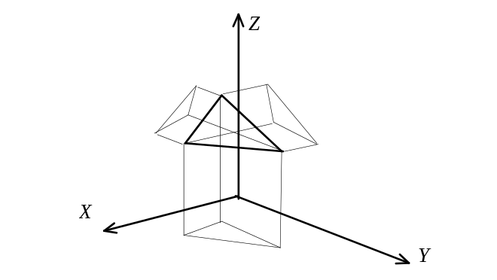
Figure 5.12: Projections of a polygon onto the reference planes.

A small problem, with this approach is that it is not impossible that a given plane maps into a line in some projections. When this happens, all further computations are severely impeded. Thus, before we select which projection to use, we must analyse the positioning of the plane in space and select the biggest of the three projections. The information for this decision is implicitly contained in the normal to the plane. If we find which of the three coordinates of the normal has the greatest absolute value, we can select the projection onto the plane which is orthogonal to that coordinate’s axis.

The method based on the odd intersection rule involves looking for intersection of the line with every edge of the polygon. It is relatively expensive. We can easily derive another technique, very much reminiscent of clipping. This technique however sacrifices generality by limiting the consideration to only convex polygons.

A convex polygon is a set of connected line segments. A line passing through each edge, due to the property of convex polygons, leaves all other vertices on one side. All the points in space to one side of a line define what’s called a half-plane. The area of the polygon is, thus, the intersection of the half-planes formed by every edge. (see Figure 5.13)

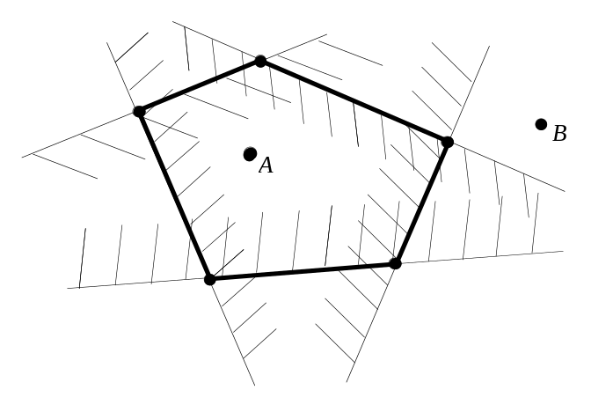
Figure 5.13: Polygon as an intersection of half-planes.

If we can decide whether a point is in the proper half-plane, we can also conclude if it belongs to the insides of a polygon by examining all the half-planes formed by the edges.

It should be noted that this algorithm, similar to the one considered previously, also involves analysing every edge. However, the individual step is somewhat cheaper, since as we shall see, It is relatively inexpensive to find whether a point belongs to a half-plane or not. The latter algorithm can be easily improved and made logarithmic in the number of vertices considered by employing the technique of binary search. Consider a polygon in Figure 5.14. By using a fan-like subdivision shown there we can first use the binary search to find in which of the slices the point is and further test, just as in the previous algorithm, if the point is in the proper half-plane defined by the edge limiting the slice (see Figure 5.14).

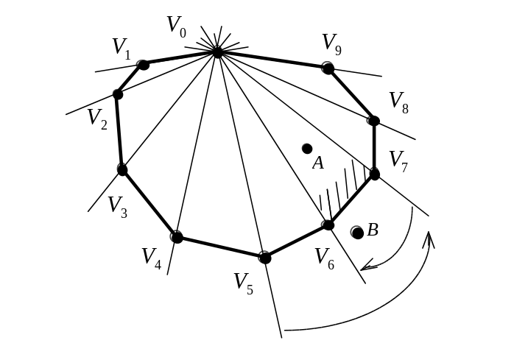
Figure 5.14: Using binary search on a fan-like subdivision.

As Figure 5.14 shows, we first find the median of the list of polygon’s vertices, so that if we connect the first vertex of the list 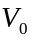 with the median vertex 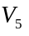, half of the vertices will be on one side of this line and another half on the other side. By checking where the point is with respect to this line, we can reject half of the input and repeat the iteration again till only a single slice remains. It is important to note that in many cases we are dealing with polygons having only few vertices. The advantage of the second algorithm, however, becomes significant only when there is a relatively large amount of vertices in the polygons. In light of this, the first algorithm is often favoured because it is simpler than the second one.

A somewhat similar subdivision strategy can be used for inclusion tests on concave polygons. Figure 5.15 demonstrates a possible slab-like subdivision. With such subdivision, assuming use of a proper pre-computed data structure, we can pre-sort edges within each slab and further use binary search to first locate the slab necessary for the inclusion test and after that perform another binary search within the slab to find whether a given point is within a part of a polygon or its exterior (see Figure 5.15).

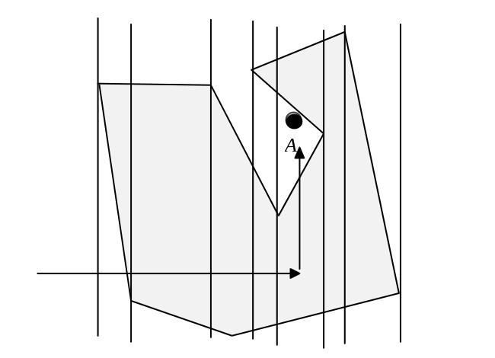
Figure 5.15: Using binary search on slab subdivision.

In all of these techniques, however, we require a way to test whether a point is in a certain half-plane or not. To do that, we need an equation of a line in the plane. We have already derived equations for a line in 3-D space and the current task is even simpler. It is customary and convenient to express an equation of a line in the plane as 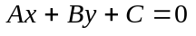 where A,B,C are some constants. There are two equivalent methodologies we can use in order to derive this formula. We have already seen the derivation of a line equation based on the co-directed vector:

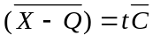

For the planar case this translates into

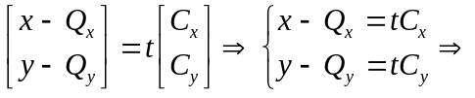

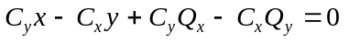

This formula must be used when we need to find the line equations given two points since, in such a case, the co-directed vector is computed as, simply, the difference of these two points. An equivalent derivation method is based on the vector orthogonal to the line. We used a similar approach to find plane equation. It was not useful for the case of a line in 3-D since it doesn’t uniquely describe the situation. Many lines are orthogonal to a vector in 3-D. It is meaningful, however, for the planar case, since a unique line is specified. Thus, similar to the derivation of the plane equation, we have

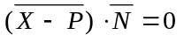

or brought into a conventional form

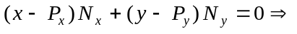

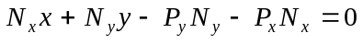

This line equation has a nice property which helps to determine the relationship between an arbitrary point and a half-plane. Since, fundamentally, the equation is expressing some scalar product we can conclude that:

If the angle between the two vectors was less than 90 degrees, cos(x) is positive, and since the lengths are always positive that makes positive the whole expression. However, if the angle is greater than 90 degrees, cos(x) is negative making negative the whole expression. At exactly 90 degrees the expression evaluates to 0. This has the following geometric interpretation: The line equation evaluates to zero for any point on the line (90 degrees). It evaluates to a positive number for the points which are in the half-plane pointed to by the normal vector. For the rest, the equation evaluates to a negative number (see Figure 5.16).

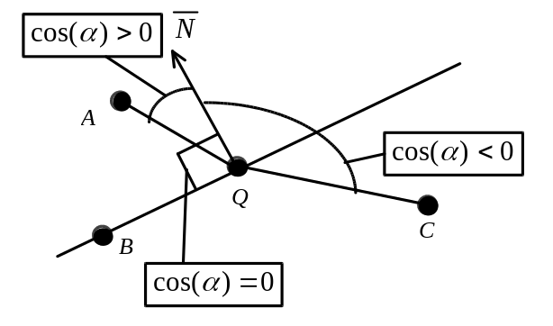
Figure 5.16: Sign of the scalar product.

Thus, whenever one of the algorithm performing polygon inclusion computation requires to test if a point is in a certain half plane, we can first compute the necessary line equation using the first derivation. Since the derivations are equivalent, we can further exploit the property found in the second case to deduce on which side of the line the point is by evaluating the line equation for that point.

Thus, for the algorithm whichs uses the fact that a polygon is an intersection of the half-planes formed by its edges, in the case when all line equations evaluate with the positive sign for a given point, we can conclude that the point is indeed inside the polygon.

5.2.5 Intersection of a line and a sphere.

By definition, a sphere is a surface formed by the points all of which are equidistant from a single point - the center of the sphere. Simple use of this fact allows us to derive sphere’s formula as

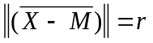

In this formula X is any point on the sphere, M the center of the sphere and r its radius. This equation uses the length of the vector 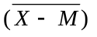. The length of any vector can be derived from the definition of the scalar product. By definition, the scalar product of the vector multiplied by itself is

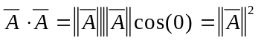

From where the length of the vector can be found as 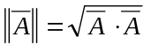. Hence, the sphere equation can be reexpressed as

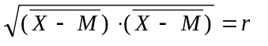 or 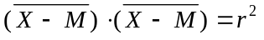

In order to find intersections of a sphere and a line, we must simultaneously solve the two equations representing both primitives:

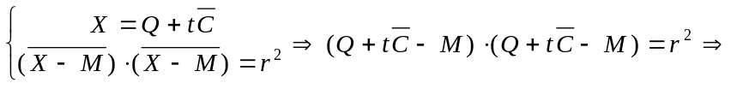

When resolving this quadric equation in t, we can either find a single root which represents the case where the sphere is touched by a line in a single point, or we can find two roots in the case when the sphere is pierced by the line, or there might be no real roots in the case when the intersection doesn’t exist.

5.2.6 Finding the proper intersection.

Of all the intersection points we have found, we are interested in the one with the minimal distance to the viewer since light particles reflected from the surface in that point would travel into the eye unimpeded.

In the previous sections, we resolved the intersections of lines and primitives in the parameter of the line equation t. The parameter t can be considered as a distance along the line from the point Q to the variable point X measured with the vector as a unit. It is easy to show this fact by exploring the line equation expressed as an equality of two vectors:

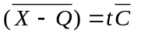

If the vectors are equal their lengths are equal too, thus

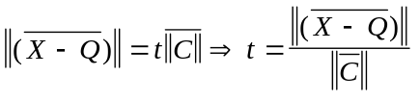

According to the ray-casting algorithm, we project a ray for each pixel on the screen. If we use the coordinates of the viewer and the current pixel for the definition of the ray, the parameter t can be used as a measure of the distance from the viewer (see Figure 5.17).

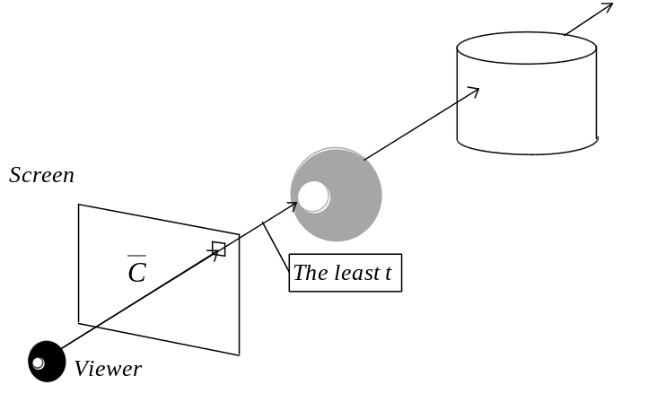
Figure 5.17: Finding proper intersection.

We can further exploit this property and compare parameters t obtained from different intersection points. The least t must define the intersection which is the closest to the viewer. Performing this computation for every pixel allows us to solve the visibility for the entire image. It should also be noted that texture mapping is easily accommodated into this method since in order to do it we basically need to know the coordinates of the intersection point in the object space where the texture is defined. Such coordinates are quite easy to obtain knowing the world coordinates of the intersection points and figuring out the reverse transformation taking us from the world space into the object space.

As it was noted before, additional work must be done to ensure proper lighting. Since this topic is both extensive and extremely important, we are going to discuss it in another chapter. Here, we would instead concentrate on the techniques to improve the performance of the ray casting method.

5.2.7 Optimizing ray casting.

The ray casting method is extremely attractive due to the simplicity of the idea. We are spared from the unpleasant tasks of rasterization and clipping and yet to be discussed at length hidden surface removal. Moreover, we shall see that lighting and generation of shadows can be almost trivially achieved by extending the ray casting methodology.

However, the biggest problem is in the fairly high cost of the individual step of casting a ray. Potentially, we must find an intersection of each ray with every surface in the world. Since there might be thousands of surfaces, it incurs an enormous cost. Straightforward implementation will hardly be able to achieve the real-time frame rates, at least not with the modern hardware.

Thus, ray casting is mostly used for non real-time applications, yet producing stunning images, at times indistinguishable from the photographic pictures. Only considerable relaxations may allow for the real-time performance by the ray-tracer. The applications which achieve that do exist, for instance, in the field of computer games. One such example is DOOM by ID software where instead of casting a ray per each pixel, one ray was cast for a column of pixels. The penalty for the real-time performance was a simplified geometry of the world which only allowed the polygons parallel or orthogonal to the imaginary ground and reduced number of degrees of freedom (no roll or pitch). Such relaxations are suitable for an indoor renderer but not feasible for a flight simulator. Still it signals that we must not completely discount ray casting as a method to use in interactive 3-D applications. Moreover, since computations for rays are mutually independent, there exists an opportunity to parallelize the problem and achieve a measurable speed increase in applications running on multiprocessors.

Let us consider possible algorithmic approaches to improving the performance of a ray caster.

It is not difficult to see that the main cost comes from computing intersections of a ray with every surface in the scene. We may attempt to make the individual calculation cheaper, and may also try to avoid computing the intersection when it is easy to deduce that it doesn’t exist.

One possible approach is to precompute projections of the polygons to the selected reference planes and the equations of their edges in that projection. This would lower the cost of otherwise expensive computation.

The biggest performance gain comes, however, from avoiding unnecessary intersection computation. It is often very easy to deduce that an intersection of a ray and a certain primitive can’t possibly exist. We have already seen the binding volumes approach in the previous chapter. Using this technique we can enclose a complex object of many primitives in a volume of a simple geometry. If the intersection with the volume doesn’t exist we can avoid analysing the enclosed primitives any further. Spheres and boxes are the most commonly used binding volumes.

Another approach, which employs a similar strategy, is that of space subdivision. If the space is separated into cells, we can compute the intersections for only those primitives whose cell is intersected by the ray (see Figure 5.18)

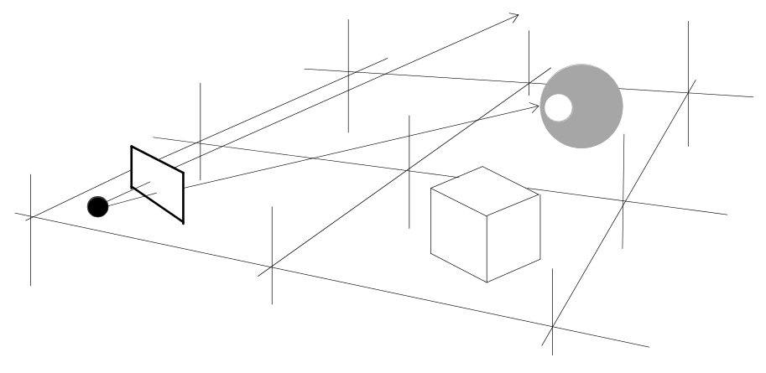

Figure 5.18 : Space subdivision.

The simplest partition strategy is to separate the space into uniform cells. It also allows to employ integer based algorithms to find out which cells are intersected by the ray. We have already seen integer based algorithms when discussing the rasterization techniques. Other partitioning strategies involving trees are going to be discussed in conjunction with modelling and hidden surface removal.

To summarise, we have discussed two fundamental methods of viewing a 3-D scene. World to screen method projects primitives onto the screen, whereas screen to world method casts rays corresponding to screen pixels into the world. Although the latter method is conceptually simpler, it involves a lot of intersection calculations and thus is fairly expensive.

* * *

