Chapter 6 Modelling.

6.1 Wire-frame models.
6.2 Polygonal models.
6.3 Cubic curves and bicubic patches.
6.4 Landscapes.
6.5 Voxel models.

In the previous chapters we have discussed the basics of 3-D computer graphics apparatus. Using the algorithms and techniques, that we talked about, it was possible to view images of an individual primitive from various angles and distances. However, actual objects that we want to display in the virtual world are often complex and consist of many hundreds or even thousands of primitives. We must consider models that will allow us to represent complex virtual objects in 3-D applications.

A data structure to represent a 3-D model is chosen based on a number of factors. We must consider convenience of creation and manipulation, precision, storage efficiency, applicability of rendering algorithms, and other criteria. Since the complete set of the criteria is often unattainable, we are often forced to trade-off one factor for another. It is also often the case that a particular class of objects allows for certain relaxations which induce a distinct choice of a data structure. At other times there may not be a clear favourite.

For instance, consider a modelling scheme which we implicitly used in the previous chapter. For the purposes of ray-casting, we represented a sphere as a mathematical equation. This method of modelling suits very well the ray-casting algorithm, since its basic operation, the calculation of an intersection, is achieved through resolving primitive’s and ray’s equations together. However, an application that employs world to screen rendering technique does not gain from such a representation since a sphere is hard to rasterize. Thus, for that application, modelling a sphere as a set of polygons may be more appropriate. Although this may be a logical choice, it is still an inadequate one as far as other criteria are concerned. The storage efficiency of approximating a sphere with a set of polygons is definitely inferior to the analytical description, and, the higher precision of such an approximation we need, the more polygons we must have. Moreover, natural properties of a sphere such as its radius are trivial to change in the first model, whereas it requires a fair amount of manipulations for the second one.

We are going to discuss several different techniques used by interactive applications from the simplest wire-frames to more complex models which represent a solid body as a set of plane polygons or patches of curved surfaces. Although convenient in rendering, these techniques are often inadequate for representation of models created through automated sampling of the real-life objects. We will briefly consider voxel models which address this problem in the last section of the chapter.

6.1 Wire-frame models.

The wire-frame models represent objects as a set of key vertices connected by key edges. Very few, if any, real life objects can be represented in this manner. Yet, despite their unrealistic appearance, the wire-frames play an important role in many graphics applications. These models are, perhaps, the cheapest to draw using world to screen rendering techniques because their rendering doesn’t involve rasterization of complex primitives or hidden surface removal. When we need only an approximate overview of a complex scene during, for instance, the editing stage, it is often easy to turn the scene’s description into a wire-frame and present it to the viewer. (see Figure 6.1).

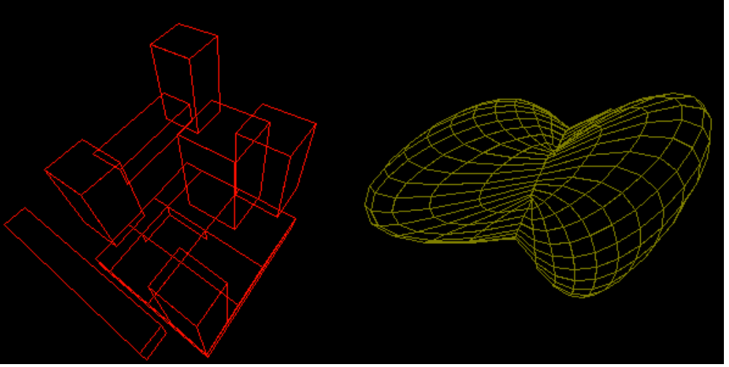

Figure 6.1: Wire-frame models.

We don’t gain however from such a representation when using screen to world techniques since the complexity of this algorithm will remain almost the same. We still have to cast a ray for each screen pixel. It is also true that the computation of an intersection of a ray and model’s edge presents a challenge on both conceptual level and the level of numerical precision. Thus, wire-frame models don’t give much benefit when viewed using screen to world technique.

If we employ world to screen viewing method, the edges of a wire-frame model must pass the coordinate transformation, clipping, projection and rasterization stages. The edges are convenient to describe by specifying two end-points. Since several edges may share some end-points, and the first process in the pipe-line involves only coordinate transformations, it is reasonable to employ a data structure which reflects the sharing. The vertices can be placed separately from the edges which are described as two references to the proper vertices rather than store actual coordinates.

This approach is also beneficial from the editing perspective. If the coordinates of some vertex change, we don’t have to examine every edge to make the adjustments.

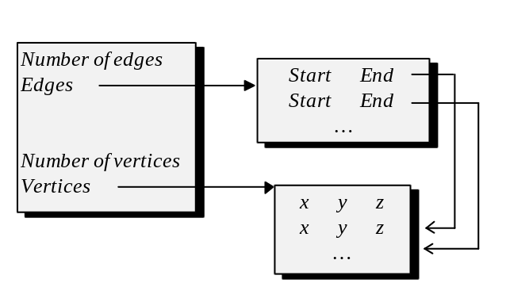
Figure 6.2: A data structure for wire-frame models.

The viewing process for this model involves the coordinate transformations performed on the vertex set. Subsequently, edges must pass the clipping stage where some of the end-points may be discarded and an edge may be limited by a newly created vertex. Thus, starting from the clipping stage we must have an edge description which explicitly contains the coordinates. Clipping, and the last two stages: the projection and the rasterization, are performed for each edge at a time eventually producing an image of the complete model on the screen.

6.2 Polygonal models.

The wire-frame models have inherently unrealistic appearence since most of the objects that we see in the real life are solid. A logical modelling scheme for solid bodies is to describe the surfaces which enclose their volume. Because many of the objects from the real life have planar surfaces representable as polygons, and because we possess a technique to rasterize polygons in a reasonable time, we can model objects as sets of polygonal patches (see Figure 6.3).

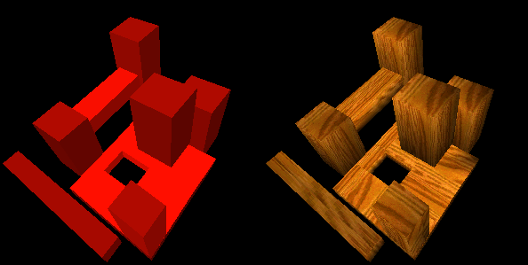

Figure 6.3: A polygonal model.

Both screen to world and world to screen rendering techniques are applicable to the models represented in this manner. In the previous chapters we have discussed ways to implement both rendering methods with respect to individual polygons. In the case of the ray-casting, the most important operations were coordinate transformations and computing intersections between rays and the polygons of the model. In the case of world to screen projection, similarly to the processes discussed for wire-frame models, we must perform the coordinate transformations on the vertex set and further take all the polygons through the rendering pipe-line consisting of the clipping, the projection transformation and the rasterization.

As the polygons are likely to share vertices and since fairly expensive coordinate transformations involve only the vertex set, we often choose a data structure reflecting the sharing (see Figure 6.4).

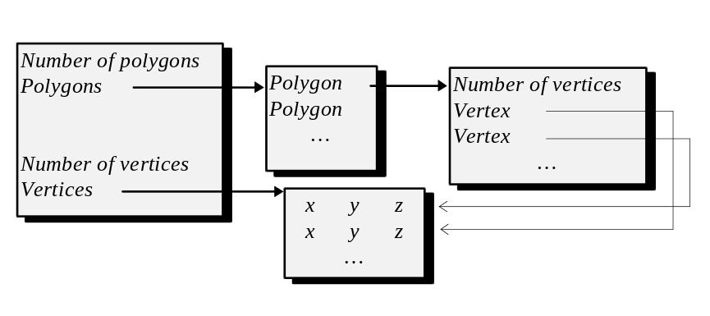
Figure 6.4: A vertex-based data structure.

In the run-time this data structure may be reorganized or augmented to help a particular stage of visualization. For instance, a ray caster may want to compute the bounding box of the object and the equations of the polygons’ planes.

For the purposes of world to screen viewing, we perform the coordinate transformations on the vertex set, and further take each polygon through the rendering pipe-line. Since at the clipping stage the polygon description can potentially change: new vertices can be created and old deleted, we can no longer use shared vertices. Thus, before each polygon enters the clipping stage, we create its full description which contains the actual coordinates.

Considering again the objects which we attempt to represent, we can see that many of the edges can be shared by two polygons. When we clip the polygons, we are effectively clipping the edges twice, once for each of the polygonal patches which are joined at that edge. To avoid doing extra work, we can represent the polygons in terms to their edges rather than the vertices. (see Figure 6.5).

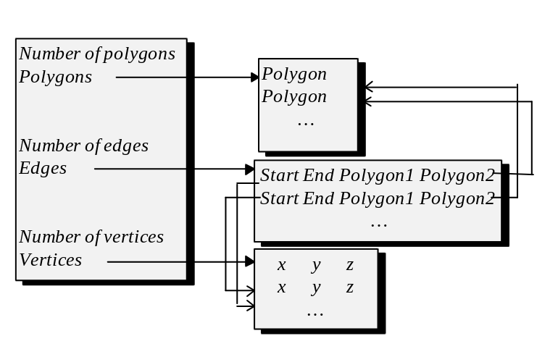
Figure 6.5: An edge-based data structure.

Such a representation has, of course, many implications on the rendering pipe-line and usually means using scan-line based hidden surface removal and rasterization which we are going to discuss in the next chapter. In that method, rendering of all polygons will be done simultaneously rather than one polygon at a time. There is also no apparent gain for the ray-caster in such representation.

6.3 Cubic curves and bicubic patches.

As we saw in the previous section, there is a number of problems which result from representing solid bodies as polygonal meshes. Precision of such representation is the biggest problem. Some real-life objects, which we may want to model, have curved surfaces. To realistically represent the curved surfaces using polygonal patches, which are only planar, we must use increasing numbers of polygons (see Figure 6.6 and Figure 6.7).

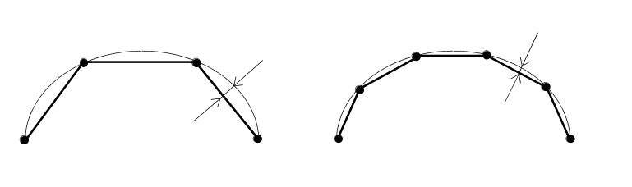
Figure 6.6: Increasing precision of approximation of curves with lines.

A biger set of polygons, beside being expensive in storing and processing, is also a very inconvenient representation for the modelling stage. Discrete points of the polygonal mesh don’t provide a natural handle for the properties of the surface. A change to a single property of the surface, such as curvature, requires changing coordinates of many points in some co-ordinated manner. To both increase precision, offset difficulties in modelling, and reduce numbers of involved polygons, we often use simple curved patches to represent locality of some more complex curved surface. In this section we are going to discuss the apparatus which is necessary to store and manipulate simple curved surfaces.

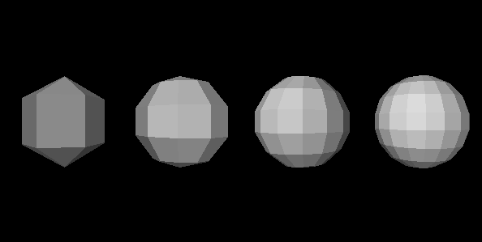

Figure 6.7: Modelling a sphere with 18, 50, 98 and 162 polygons respectively.

To a large degree, the above mentioned approach to modelling is just an extension of approximating curves with plane polygonal patches. Planar patches can, in fact, be considered as curved surfaces of degree one, since when a plane equation is represented in parametric polynomial form, the highest degree of the parameter would be exactly one. By choosing an approximating polynomial of higher degree we expect to achieve much higher quality with the same number of primitives.

Thus, the most popular approximating objects are polynomial curves, specifically cubics (polynomials of degree three):

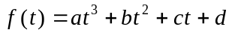

Polynomials of degrees lower than three, notably quadrics (polynomials of degree two describing parabolas), although used at times, often don’t have enough flexibility since they define a curve with just one flexing point. On the other hand, polynomials of degrees higher than three, although giving more flexibility then cubics, are more expensive to evaluate and are often less stable meaning that a relatively small change to a parameter controlling the properties of the polynomial causes a considerable change in the curve itself.

Let us consider first the planar parametric curves which will further serve as a base for consideration of three-dimensional curves and curved surface patches.

Parametric cubics representing a curve in a plane have the following form:

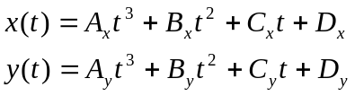

This form is referred to as parametric because instead of giving relationship of y and x directly (y=f(x) or f(x,y)=0), both x and y are expressed as a function of a third variable: the parameter t. By evaluating both formulas for certain t we obtain x from one equation and y from the other. Together (x,y) define the coordinates of a point on the curve. By evaluating formulas in some range of t, we can obtain all points on the curve’s segment. It is often convenient to combine both formulas using vector notation:

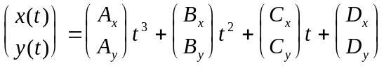

or:

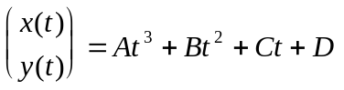

We can immediately see that this form is not very convenient because it is hard to relate the coefficients 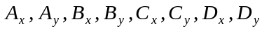to any specific curve.

Different forms of cubics have been derived to give a better handle to the properties of the curves. The forms differ in the kind of controls which are used in order to specify curve’s properties, and as a consequence, the way to derive the coefficients given the controls.

Hermite forms are based on four controls: two points 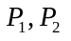 specifying the beginning and the end of the curve and two vectors 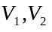 specifying the tangent of the curve in these end points (see Figure 6.8).

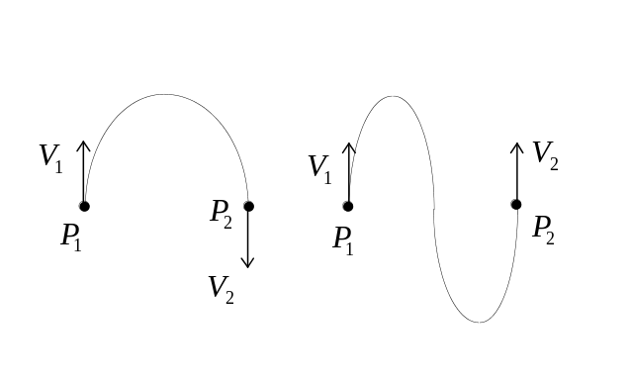
Figure 6.8: Cubic curves.

As Figure 6.8 shows, these controls are quite convenient to use in order to specify exact shape of the curve. They are also convenient for derivation of coefficients used in the cubic equation. Let us consider a possible derivation technique.

We are interested in finding any point on the curve between the endpoints as a function of the parameter t. It is convenient to make this parameter varying in the range of [0,1] on the interval between the end-points so that t equals 0 in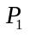 and 1 in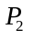. Based on this assumption we can find the expressions which are true in the endpoints:

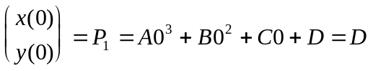

Similarly for the second point we have:

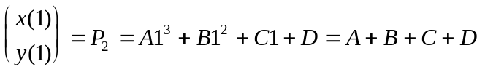

These two equations are not sufficient to resolve for the coefficients A,B,C and D. We must use the remaining vector controls to infer two additional equations. The vectors specify tangents of the curve at and respectively. A tangent of the curve in a point can be computed as a derivative in this point since the derivative is defined to be a ratio of the rate at which the function changes to the rate of the argument change:

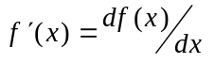

Which has a geometric meaning of the tangent in a point (see Figure 6.9).

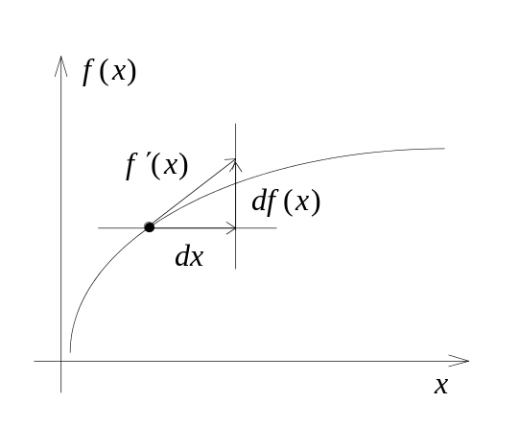
Figure 6.9: Tangent of a curve in a point.

The derivative of a cubic is the following quadric:

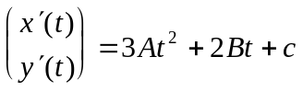

Since we know the tangent at two end-points we can infer that:

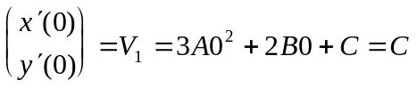

and:

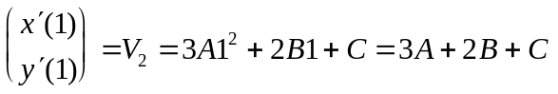

We have obtained four equalities which, in fact, can be combined into a system of linear equations expressed as:

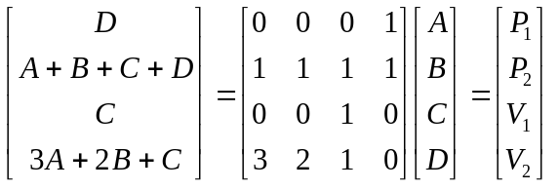

This equation is written in a vector form so that D is, actually, a tuple 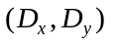, and similarly 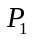 is 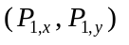. This notation is more convenient then two equations (three in 3-D), one for each respective projection.

Using Gaussian elimination considered in the previous chapter or any other method for solving systems of linear equation it is easy to see that:

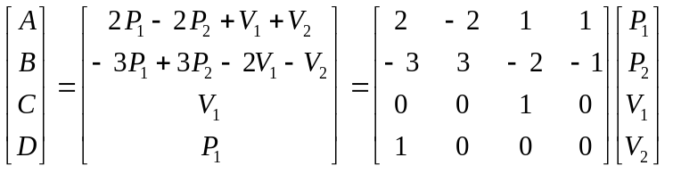

And, in a somewhat artificial yet convenient matrix notation, the cubic itself can now be rewritten as follows:

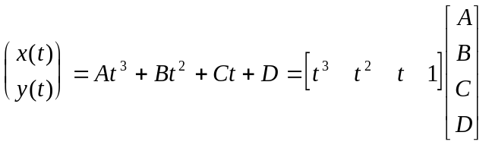

If we put the actual meanings of A,B,C and D into the expression above, we obtain

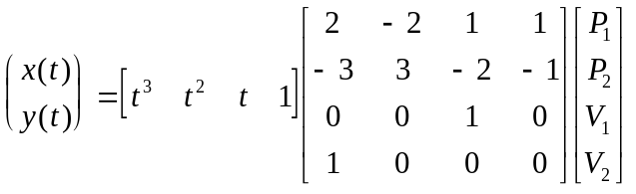

The four by four square matrix is often called a basis matrix. In this case it describes the basis of the Hermite form. Other forms of cubics have somewhat different basis matrices. The purpose of these matrices is to specify what kind of controls we use. The vector containing the controls such as: 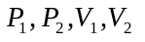 is often referred to as a geometry vector or geometry matrix, and it specifies the properties for a specific instance of the curve.

In practical applications it is at times inconvenient to specify tangent vectors directly. In these cases it is often helpful to use an alternative form of cubics where tangents are specified indirectly. One form of cubics which allows to do that is due to a French mathematician P. Bézier [BEZI72] who worked in the domain of automotive computer aided design. This form is given through four control points:

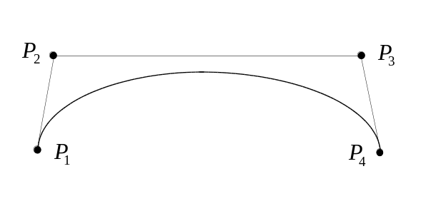
Figure 6.10: Control points of a Bézier curve.

There is a simple relationship of Bézier controls and Hermite controls:

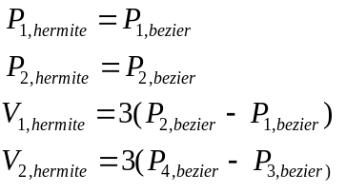

This relationship can be expressed in the matrix form as:

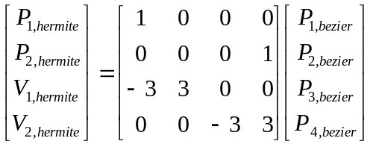

In order to obtain an expression for Bézier form we can substitute the above dependency into the computed formula for Hermite forms:

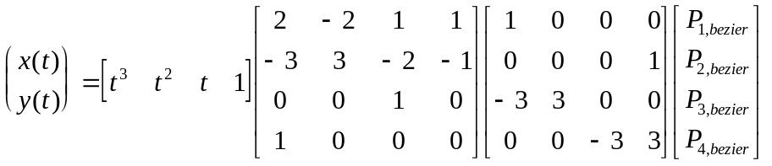

After multiplying matrices we obtain the sought equation for Bézier forms:

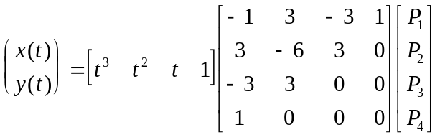

Formulas of this type are relatively straightforward to evaluate in the run time. It is somewhat expensive though, after all, there is a number of multiplications to perform. The very first obvious speedup for cubics is instead of evaluating them as:

to evaluate them as:

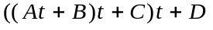

Taking common factor outside the brackets cuts number of multiplications in half in this case. However, even having three multiplications per point is often not good enough. There is a very effective speedup technique developed by de Casteljau which is due to a special property Bézier curves possess. A Bézier curve can be split into two sub-curves by the process described in Figure 6.11.

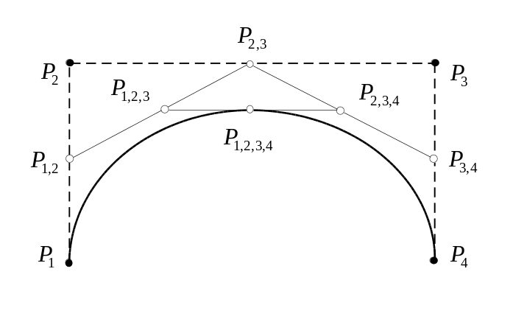
Figure 6.11: Building a cubic curve by iterative sub-division.

In Figure 6.11 the point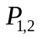 is obtained as the middle of the segment formed by the points and , and similarly, the point 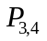 is the middle of the segment 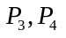. The point 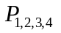 is the middle of the segment 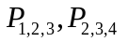. In fact, belongs to the original curve separating it into two sub-curves so that the points 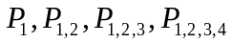 control the first sub-curve, and the points 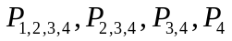 control the second sub-curve.

As it can be seen, the sub-division process only involves finding middles of the line segments. This procedure involves a division by two, which is achievable by shift operations with a very small cost compared with divisions or multiplications. By applying the sub-division process recursively we can obtain arbitrary large amount of points on the curve (see Listing 6.1).

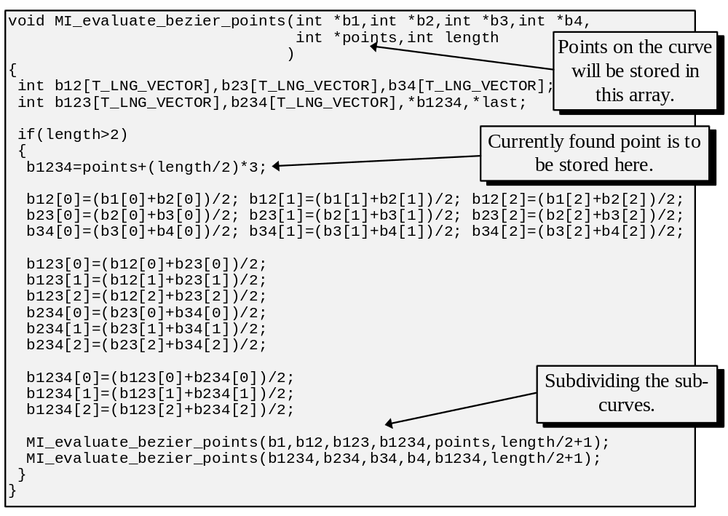
Listing 6.1: Finding point on a Bézier curve using recursive sub-division.

3-D cubic curves are formulated in exactly the same way as the plane curves. They differ only in the size of the tuples - each has three instead of two components. However, even though the curves are at times important primitives, as far as solid modelling is concerned, we are more interested in surface patches. A bicubic patch is formulated as a set of cubic curves. There are 16 controls associated with a patch. And the patch itself is a cubic curve in every section. The formula for the patch can be represented as:

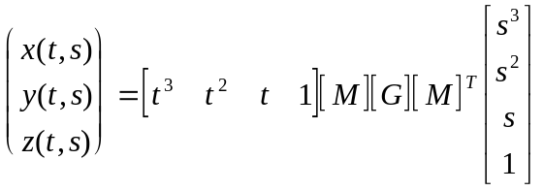

Note that there are two parameters involved: s and t, hence the name: “bicubic patch”. In this formula [M] is a four by four form matrix (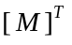is its transpose,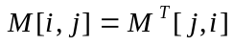), and [G] is a four by four geometry matrix containing tuples which represent the controls of the patch. Although, similarly to cubic curves, different forms can also be given for the patches, for the majority of practical applications we are interested in Bézier forms where all 16 controls are points. Thus, in the formula above [M] will be, in fact, a Bézier basis matrix and [G] will contain 16 points controlling the properties of the patch. Figure 6.12 Illustrates a model build from two Bézier patches and Figure 6.13 shows a patch with a wire-frame mesh of its control points.

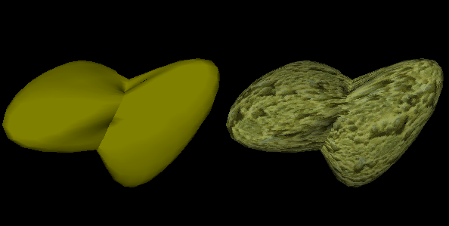

Figure 6.12: An object build from two bicubic patches.

Having an analytical expression for the patch allows us to use this primitive in a screen to world visualization process. Similar to the cases of other discussed primitives, we can evaluate the equation of the patch together with the equation of the cast ray, possibly, finding an intersection and setting a screen pixel to a particular color.

If we employ world to screen methodology, it becomes important to find a set of points belonging to the patch. This procedure is quite straightforward. The formula suggests the following strategy: For some parameter s, we find points 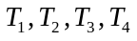 belonging to the four curves on the patch. Thus, we find 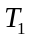 from 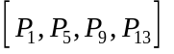, 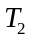 from 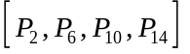 etc. (see Figure 6.14). At that stage the equation becomes:

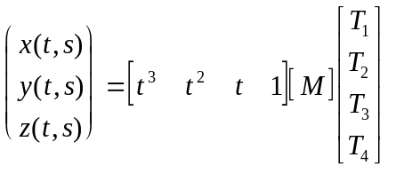

The above equation means that the points are in fact the control points for a 3-D cubic curve with the parameter t. We further proceed with evaluating along the parameter t to obtain points on the patch.

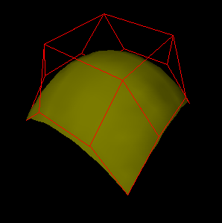

Figure 6.13: A bicubic patch and its control mesh.

By moving along both parameters we find arbitrary big set of points belonging to the bicubic patch (see Figure 6.14).

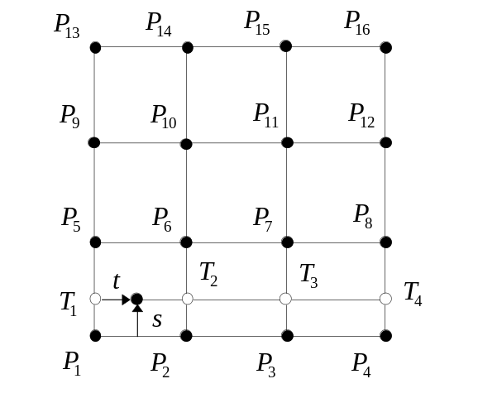
Figure 6.14: Computation of points belonging to the patch.

To speedup this process we can, of course, use the sub-division strategy discussed for Bézier curves.

Even though we are capable, at this stage, to find a set of points belonging to the patch, it still doesn’t give a lot of hints on how to rasterize bicubics on the screen. Surprisingly enough, rasterization of bicubic patches is most often done by approximating them with plane polygons. We find a discretely spaced grid of points belonging to the patch and then build a polygonal mesh using this grid. We further use existing polygonal pipe-line to rasterize the mesh.

There appears to be a bit of a contradiction in this strategy. After all, trying to avoid approximating surfaces with plane polygons was the main motivation for considering bicubic patches in the first place. Unfortunately, we are often forced to use polygonal approximation anyway, first of all, due to the complexity of rasterizing bicubics directly, and even more so, due to the kinds of tools and pipe-lines which are usually available. Most often, we already have a polygonal pipe-line in place, in some cases even implemented in hardware. Alternative solution is to employ forward differences and move across the patch at a small rate plotting the screen pixels as we go. We have discussed a simple case of forward differences in conjunction with line rasterization.

Even though we often do end up using polygons for final rendering of bicubics in world to screen viewing process, at least two big advantages of these primitives remain. The bicubics are very convenient in modelling, both due to simplicity in manipulation and minimal storage requirement. Moreover, during the visualization process we can perform rotations, scalings and translations on the control points and turn the patch into the polygonal mesh only for perspective transformation and rasterization.

Let us consider the last statement in more detail. The reason we are able to do the transformations on the control points is due to the way the cubics composing a patch are formulated:

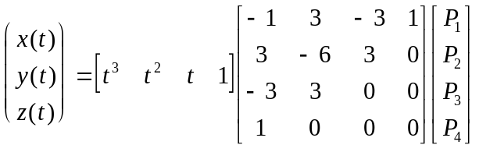

We can rewrite this expression as:

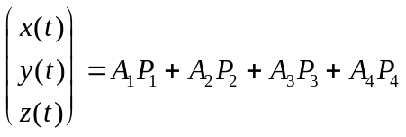

Where 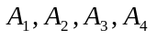 are some scalar values obtained from multiplying basis and parameter matrices where:

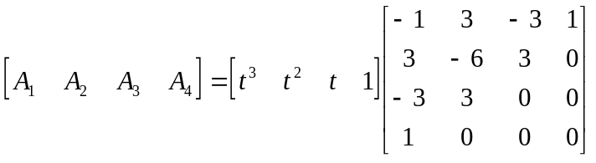

Applying a coordinate transformation represented by a matrix [T] to the control points can be represented as:

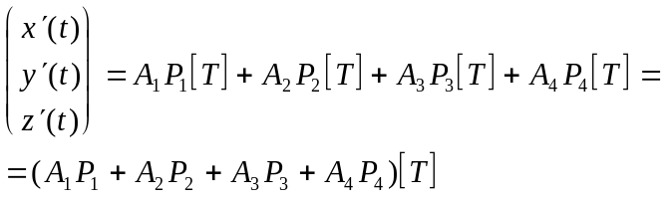

This last expression is equivalent to saying: It doesn’t matter what is performed: affine transformation on the controls followed by computing points on the cubic curve, or computing points on the curve followed by applying the transformation to them. However, this fact is not true for the perspective transformation. The reason is again in perspective transformation (x/z,y/z) not being linear. This difficulty was the basic motivation for developing rational curves which are given as a ratio of two polynomials. However, the rational curves and patches are relatively expensive to work with.

Knowing how to represent and render surface patches and fragments of curves, we are confronted with a question: How do individual pieces combine into more complex surfaces and curves. In the case of polygonal models, neighboring polygons shared vertices and edges, thus forming a continues surface. Similar approach is employed in the case of bicubic patches and cubic curves. Whereas it made little or no sense for polygons, when talking about two connected bicubic patches, we can differentiate various kinds of continuity at their joining. Geometrical continuity is achieved by two Hermite curves when at the joining, the directions (but not magnitudes) of the tangents are the same. If the magnitudes are the same as well as the directions, it gives higher order of continuity in the join. From a purely practical point of view, higher orders of continuity imply smoother transition from one patch to another. Figure 6.15 demonstrates joining of two curves.

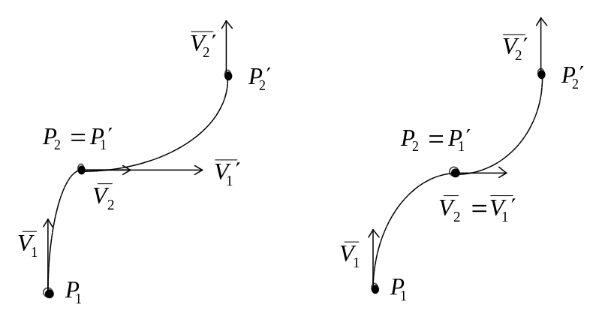
Figure 6.15: Joining of two curves.

As it can be seen, achieving proper continuity becomes important when modelling complex smooth surfaces or curves using multiple individual pieces. If the model is to be created interactively, the decision on the kind of joining is often left to the modeller. On the other hand, if we are trying to create a synthetic model through some sort of sampling process, turning a set of sampled points into a continuos surface might become relatively complex. Cubic b-splines may be considered in this or similar situations. That primitive represents essentially just another form of cubics. However, in it, two neighboring pieces share multiple control points providing high degree of continuity in the modelled curve or patch (see Figure 6.16).

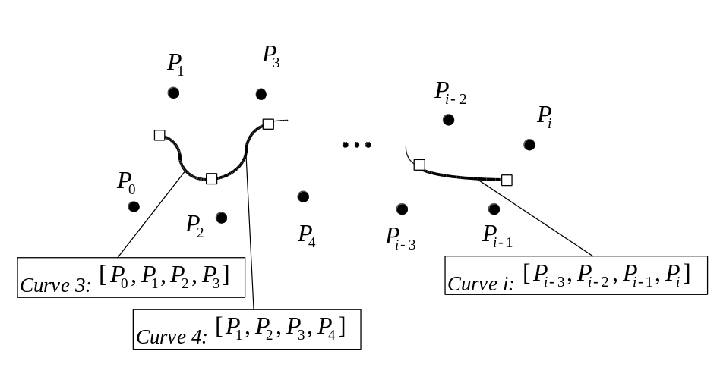
Figure 6.16: Achieving continuity with a b-spine.

Note that in the Figure 6.14 two neighboring curves numbered three and four share three common controls 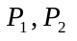 and 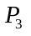. Also note that in the demonstrated b-spline the curves don’t pass through the control points unlike in other cubic forms considered previously. However, even this form is often transformed into multiple Bézier forms for final rendering, since we possess a fast sub-division and hence drawing technique for the latter.

A solid body modelled with bicubic patches may be represented in a data structure similar to that of a multi-polygon model (see Figure 6.17).

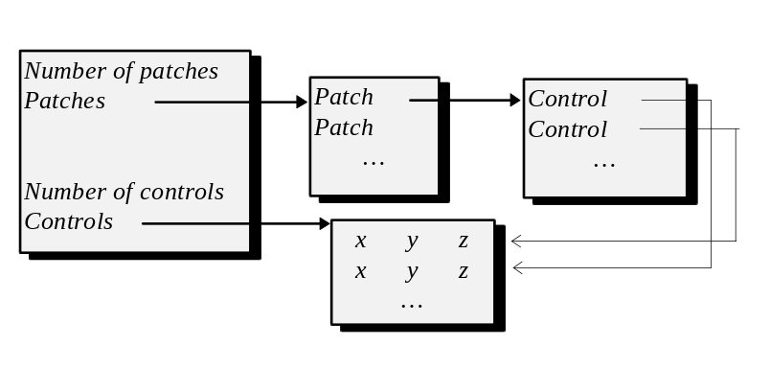
Figure 6.17: A data structure for a model composed of bicubic patches.

The viewing of this model is also similar to that of the polygonal model. In the case of world to screen rendering we first apply the required coordinate transformations to the control points. We further tessellate the patch into the polygons and use standard polygonal pipe-line to draw the object on the screen. In the case of screen to world viewing we will have to find intersection of a ray with a bicubic patch. Since we have the equations for both, such intersection (or intersections) can be found by solving both equations together.

There is a number of refinements and extensions to this scheme which are available. First of all, we can employ some strategy to trivially reject the patch when it is outside the viewing pyramid. A property of the Bézier cubic curves and bicubic surfaces according to which all points of the curve or the patch are within the convex hull of the control points, makes the computation of the binding volume particularly easy. Only control points have to be considered in such computation.

We can also mix in the same model polygons and bicubic patches. Some of the real-life objects can be partially curved and partially planar, and although bicubic patches can represent planes, they have higher overhead. Alternatively, the construction of the polygonal mesh before the rasterization stage can be done adaptively, depending on the curvature. We will do little or no subdivisions if the patch is mostly plane and a lot of sub-divisions if the patch is highly curved.

Overall, modelling using bicubic patches allows us to represent highly sophisticated objects. Although this approach provides some degree of implementational challenge, especially on the level of tools for creation of the models, the rendering process can be done in a fairly efficient and simple manner.

6.4 Landscapes.

In many graphics applications we have to visualize some representation of the out-door world. In the simplest imaginable case we can model the out-doors as an infinite plane populated with different objects which we associate with the out-doors such as, for instance, trees or buildings. However, since the landscapes are not plane in general, for many applications such as flight simulators, we must find a modelling scheme which allows to display images that look closer to reality. In this section we are going to briefly consider several techniques to model landscapes.

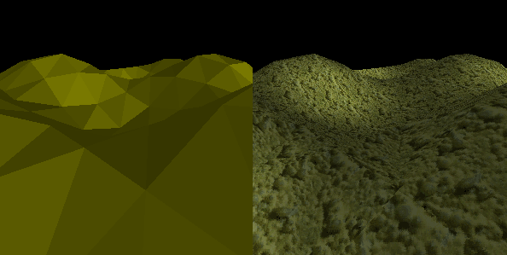

Figure 6.18: A landscape.

When we think of a landscape, we most often imagine some surface (see Figure 6.18). In the previous sections we have considered techniques which allow us to model complex surfaces using planar patches or patches of simple curved surfaces such as bicubics. Although the general strategy, which we have discussed, still applies, due to special properties and requirements which exist in this case, we will consider modelling of landscapes in more detail. Most of the techniques to represent landscapes take advantage of several properties. A landscape is assumed to be a non-self-intersecting surface. We can also assume that it can be represented as a function of two variables (f(x,y)). This means that there is a single value f(x,y) representing heights associated with every (x,y) pair of the area. This assumption is a relaxation since, for one thing, the earth appears to be round rather than flat. Morevover, even locally, in an actual landscape, such a fact may not hold true (see Figure 6.19).

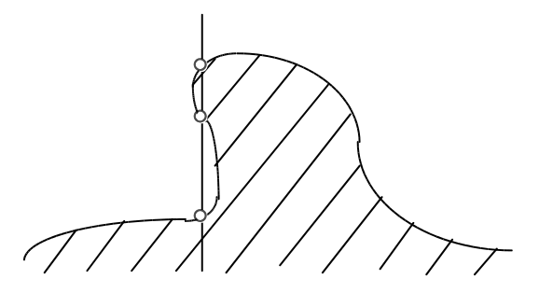
Figure 6.19: Actual landscape may not be a function.

As it can be seen from the Figure 6.19, multiple values may be associated with some (x,y) pairs in the actual landscape. However, since on the larger scale, landscapes are mostly smooth, representing them as functions is an admissible relaxation. Of all the possibilities which arise from this assumption the one which is explored most often is to represent a landscape as a table of heights presampled for some set of (x,y) coordinates, often referred to as height field. The sampled points define a polygonal mesh used to approximate the surface. As an alternative to this approach, we can split the (x,y) plane into some regular cells and define a curved bicubic patch within each cell. This strategy can even allow representing surfaces which are not functions as per Figure 6.17. However, additional overhead and complications in, for instance, hidden surface removal, make the latter strategy somewhat less attractive. We are going to see the reasons for that in the following chapter.

The kind of presampling that we use is defined by a number of considerations. Prime consideration is the ease of storage. A square array is a very convenient data-structure to use in this case. Using it basically implies that we have to do regular sampling and split the surface into square cells. The simplicity of this solution is a definite advantage. A disadvantage is that this method disregards curvature of the approximated surface. When the curvature is low, we may want a larger sampling step whereas in the localities of high curvature we need smaller steps. Sampling in an adaptive manner allows to both increase the precision of the representation and to save some storage space (see Figure 6.20).

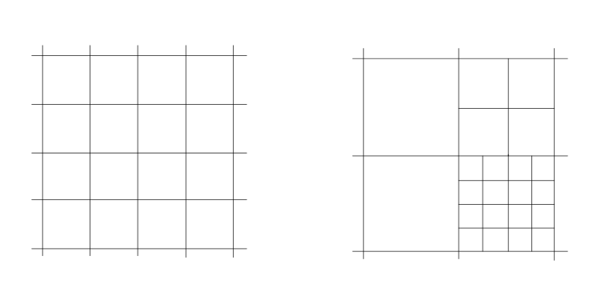
Figure 6.20: Regular and adaptive samplings for landscapes.

To partly address the problem with regular sampling, we can use a recursive approach where each cell can itself contains an array of sampled points (see Figure 6.20). In the cases when the surface within the cell is mostly flat we can use larger sampling step within the cell, whereas when the surface is curved, we use smaller sampling step. A possible complication with this method may be due to the presence of discontinuities at the joining of some cells. If the sampling steps are different within two neighboring cells their edges may not fit (see Figure 6.21).

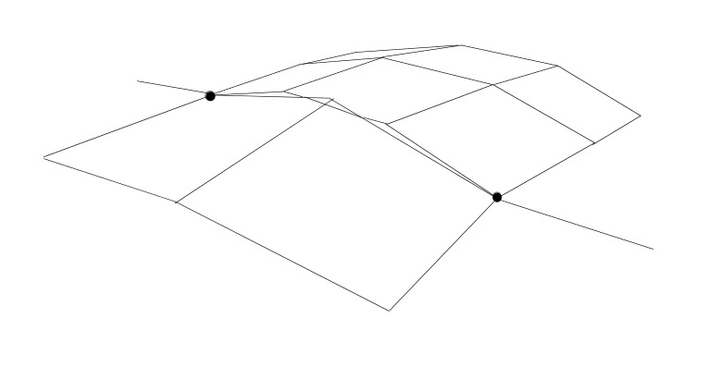
Figure 6.21: Discontinuities at the joining of two cells.

To avoid this complication we may have to make sure that only some numbers of sub-divisions are allowed, and the points on the boundaries of cells with more sub-divisions at least map onto the edges of the neighboring cells.

Since we are using a square array to store the sampled points, it is natural to use square or rectangular cells. However such a cell contains four vertices and four vertices don’t necessarily belong to the same plane, and consequently, may not define a single planar polygon. A common technique to avoid this problem is to split each cell into two triangles. Three vertices which will be present in each of the triangles are guaranteed to be in the same plane (see Figure 6.22).

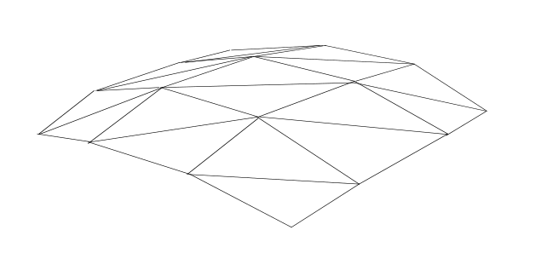
Figure 6.22: Representing cells as two triangles.

The rendering process for these models is mostly similar to the one considered for the general polygonal object with several exceptions. For the regularly sampled representation, we will probably not keep in the data structure the x and y planar coordinates, only the heights. We can easily deduce the former two knowing the sampling step.

The virtual representation of the landscape can model considerable areas of the real world. In the real world we can see only the immediate neighborhood of our location. Similarly in the viewing of an artificial landscape model, we may want to preselect a smaller area from the representation which corresponds to what is considered to be near the observer. Such approach is extremely beneficial with respect to the efficiency of viewing and can be done independently and prior to clipping, which also may trivially reject some primitives.

Once the preselection is done, the selected polygonal mesh passes typical stages in the employed viewing process. Figure 6.23 presents a sketch of a possible data structure. Note that besides storing the height field we may also have to store a square array of structures containing attributes of the cells such as texture maps or lists of objects which are placed onto the surface.

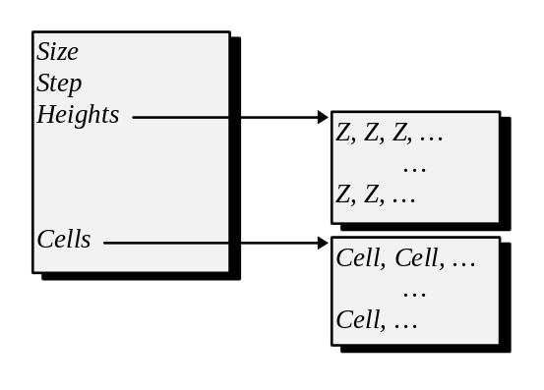
Figure 6.23: A possible data-structure for a landscape.

As it was mentioned, the landscapes are very important for such applications as flight simulators. Numerous refinements and speedups were developed in that area because a landscape is a fundamental object that must be displayed in that kind of applications. One of the techniques used in high end implementations is to sample the same landscape multiple times with different step so that depending on the heights of the viewer above the ground we can present a model of the corresponding scale.

Most of the time we use world to screen methods to display a landscape. The representation that we considered suits very well this viewing process. A need for high frame rates among many applications makes using screen to world method much less attractive. However, considering the growth in performance of the modern hardware, it is conceivable that ray-casting may become important for the applications portraying landscapes at interactive rates, especially those, that can afford using specially designed hardware.

6.5 Voxel models.

A voxel stands for “volume element”, similar to a pixel, “pictorial element”. As can be inferred from the name, the purpose of this object is representing volumetric information. Considering all the previously described ways to model solid objects it can be seen that all of them are relatively labour-intensive. It does involve a lot of man-hours to create a polygonal or bicubic description of a complex shape. On the other hand, sampling devices developed to automate creation of synthetic descriptions of real-life objects produce discrete sets of sampled points rather than polygonal or other analytical surface information.

In this regard voxel techniques come as an alternative to more traditional analytical modelling. The idea of this scheme is to represent an object or a collection of objects through their spatial occupancy. We can use a matrix, each cell in which models a small, often cubic, volume of space. It can be marked as occupied in which case the entry in the matrix would be taken up by a value representing some property of that region of space, for instance a color or density. In the case when the cell is empty, it signals that the corresponding volume in space is not occupied.

This representation is advantageous first of all because it is very simple and almost directly contains the data that devices like CATV scanners would provide us with. Applications in such fields as medical imaging and remote sensing often resort to using voxel techniques.

However, there is a big limitation. The spatial occupancy matrix representation requires a lot of storage and it is wasteful of storage at times. Consider modelling a room with voxels. All the void space will still have an enormous amount of empty, finely spaced cells allocated for it.

There is an effective alternative to spatial occupancy matrix. Indeed, there should be a simple way to mark all the void space and allocate storage only for what we are really interested in. Quad trees and octal trees allow us to achieve just that. Quad (fanout of four) trees are used in planar application. The number of four relates to the number of children each node which is not a leaf will have. 3-D counterpart of a quad-tree is an octal (fanout of eight) tree. The latter has eight children in each node.

Let’s consider quad trees first. The strategy to construct a tree of some planar shape can be expressed in several steps. We first divide the specified region of space into four equal portions. We mark with zeros all empty portions in the corresponding leaf nodes. The partitions which are completely occupied are marked with, for instance, “2”. We then start the algorithm recursively for all partially occupied portions which are marked with “1” at the current level. To avoid potentially infinite decent through recursive calls, we should stop when the current portion of the space becomes too small (see Figure 6.24).

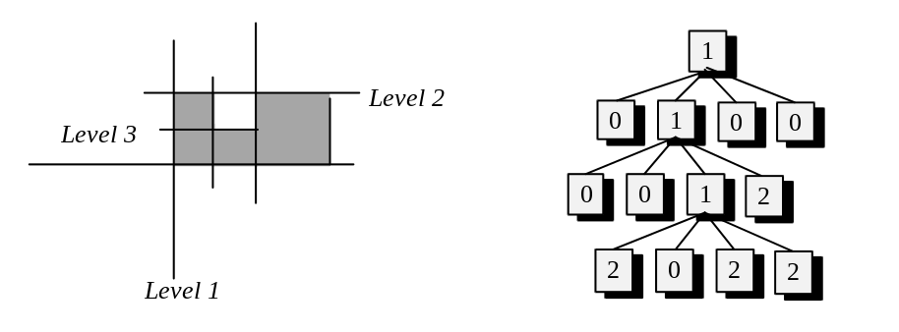
Figure 6.24: Representing spatial occupancy with a quad tree.

Octal trees use the very same strategy. The only difference, unlike quad trees there are eight cubic partitions to work with at every stage.

Comparing space requirements of spatial occupancy matrices and quad/octal trees, it can be seen that for sparsely occupied scenes the latter give a considerable saving in storage. However, this saving was achieved by certain complication of the data structure. In this particular case rendering process would not suffer in any appreciable way, quite the opposite, quad/octal trees may actually help. Yet, if we want to model a dynamic object, an explosion for instance, in which certain parts of the model move with respect to other parts, tree like structure may become relatively awkward to cope with this task efficiently.

In order to visualize voxel based objects we can employ both screen-to-world and world-to-screen viewing processes. In the former case we often want to find a chain of voxels which are intersected by a given ray. Such a requirement may be present in the cases where the voxels are semitransparent and thus many voxels will contribute to the color of a single screen pixel. Considering the fact that each voxel is just a cube, it is not hard to devise a strategy to find the intersections for both occupancy matrix and quad-tree representations.

If we use world to screen visualization strategy, each voxel can be considered as a cube consisting of six faces, and thus, the voxel object can be displayed using regular polygonal pipe-line. This approach requires refinements since the number of faces that we may have to rasterize rapidly becomes too big. Since many voxels which are internal to the model are often completely obscured by the surface voxels, a possible approach is to attempt locating all the surface voxels and limiting rasterization of the model to the surface voxels only. Another approach, which may augment the first one, is to always rasterize a voxel as a rectangular square regardless of the voxel’s orientation. This is a relaxation, of course, because a cube doesn’t necessarily project into a square, however, assuming that the voxels are usually small and their projections are most of the time comparable in size to screen pixels, this is a fairly safe approach to pursue. Squares are very cheap to clip against rectangular screen boundaries and then to rasterize into an image bitmap, and thus, due to a simplified primitive we can achieve higher rendering speed for the entire voxelized model.

To summarise, we have discussed various strategies allowing to represent and visualize virtual models. Depending on the particular application and rendering method, different data representations may be used. Wire-frame models have very unrealistic appearance, yet they are convenient for many tasks. Polygonal approximation suits very well rendering algorithms which we considered before, but it is neither precise nor convenient in representing curves. It is possible to approximate complex surfaces with simple curved patches. Voxel representation is suitable for models obtained through automated sampling but have large storage demands.

We have so far assumed that we can display a model consisting of multiple primitives by just displaying all the primitives independently. Unfortunately, this approach disregards the fact that some primitive may partially or completely hide other primitives. Display of models must be accompanied by a strategy to eliminate hidden surfaces. This is going to be the topic of discussion in the forthcoming chapter.

* * *

