Chapter 7 Hidden Surface Removal.

7.1 Back culling.
7.2 Back to front sorting.
7.3 Order lists and octal trees.
7.4 Portals.
7.5 Binary Space Partition trees.
7.6 Beam trees.
7.7 Scan-line algorithm.
7.8 Z-buffer algorithm.

So far we have completely neglected a whole set of problems: notably, those caused by occlusion on the screen of one primitive by another primitive. For instance, when we represent a model of a 3-D object as a collection of polygonal faces, it is most likely that some parts of the polygons are obscured in some projections. We must display on the screen only those primitives, or portions of the primitives, which are visible to the viewer at a given view angle. For example, in the case of a cube, in any projection we can see at most three faces. We must, thus, devise a strategy to determine which ones of the existing faces we can see.

If we use screen to world viewing method, its very nature assures us that only correct portion of any primitive is pictured. The visibility, in this technique, is found per every pixel on the screen. The surface which is intersected first by the ray which has originated in the viewer’s eye and passed through a given pixel must be visible at that pixel’s position since nothing else is in between the eye and intersected surface. The light reflected from such a surface must have travelled into the eye unimpeded would it be the real world.

In this chapter, we will discuss possible strategies which allow to eliminate hidden surfaces. Since the most common primitive is a polygon, many of the techniques which we will discuss are applicable to the polygonal models only. We will also briefly consider the techniques applicable to polygonal landscapes, voxelized models, and finally a generic algorithm capable of handling any set of primitives.

Although hidden surface elimination is innately achieved in the course of ray-casting, the cost of the computation is quite high. Thus, some of the techniques which we will explore in conjunction with world to screen viewing method can also help in ray casting as a way to reduce number of primitives so that each ray is checked against lesser number of surfaces.

7.1 Back culling.

Many 3-D objects are such that their volume is enclosed by a continuous surface. When viewing such objects, usually we can see the frontal side of the enclosing surface but cannot see the back side. A technique which allows to eliminate from further consideration the polygons composing the back surface of objects is referred to as back culling (see Figure 7.1).

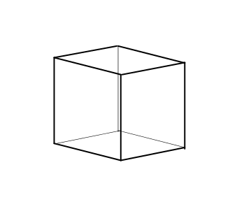
Figure 7.1: Visible and invisible portions of the enclosing surface.

We have already encountered the notion of a convex polygon in the previous chapters. This notion is extendible for the case of a polyhedron - a closed surface consisting of interconnected polygons. If for any two points within the surface their connecting line never leaves the boundaries, such a polyhedron is referred to as convex. Concave polyhedrons don’t possess this property (see Figure 7.2).

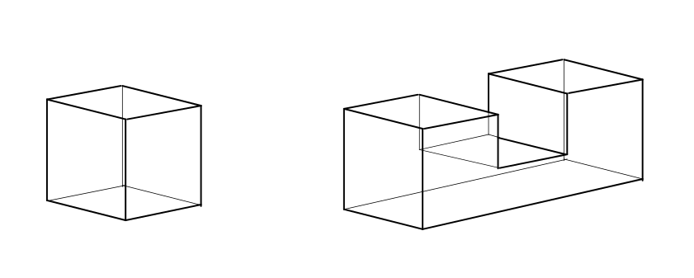
Figure 7.2: Convex and concave polyhedrons.

If we have performed back culling for a polygonal model which is a convex polyhedron, we have also achieved removing of all hidden surfaces. Due to the shape of these models, the only polygons which are hidden are the ones composing the back surface. However, this technique doesn’t help in eliminating the hidden surfaces in a general case of a concave polyhedron. For such objects, it is not unlikely that a polygon which is on the frontal side of the object may be obscured by another polygon also on the frontal side (see Figure 7.3). However, even in this case, the polygons on the back side are definitely invisible and eliminating them helps, if not to solve the problem completely, but, at least, to reduce its complexity.

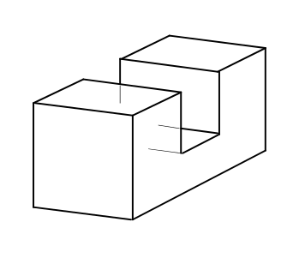
Figure 7.3: Front polygons obscuring one another.

A similar reasoning also applies in the case of ray casting algorithm. Although we do discard the hidden surfaces due to the nature of this algorithm, back culling reduces the scene complexity so that we can avoid considering some of the hidden surfaces altogether. This allows to speed up the viewing process.

Let us devise a technique which will help determining whether a polygon is on the frontal or the back side of the object’s surface. We have already seen normal vectors in the role of describing the polygon’s orientation. In this particular case, a polygon is on the back side if its normal is oriented in a way to form a greater than 90 degrees angle with the direction of viewing.

We have already discussed the vector and scalar products which provide us with the necessary apparatus for the above computation. First, we find the normal as the vector product of some two vectors located in the plane of a given polygon. The two vectors can be found as differences of polygon’s vertices. Subsequently, we compute the sign of the scalar product of the direction of viewing and the normal vectors to determine whether they form a greater than 90 degrees angle. If that is the case, the polygon in question is culled and discarded from any further consideration in the viewing process.

We should note that, by definition, the result of the vector product of two vectors is a vector pointed in a way to form a right triple with the two given vectors. This means that depending on how we form the vectors in the polygon’s plane we can obtain a normal pointing in one of two possible directions (see Figure 7.4).

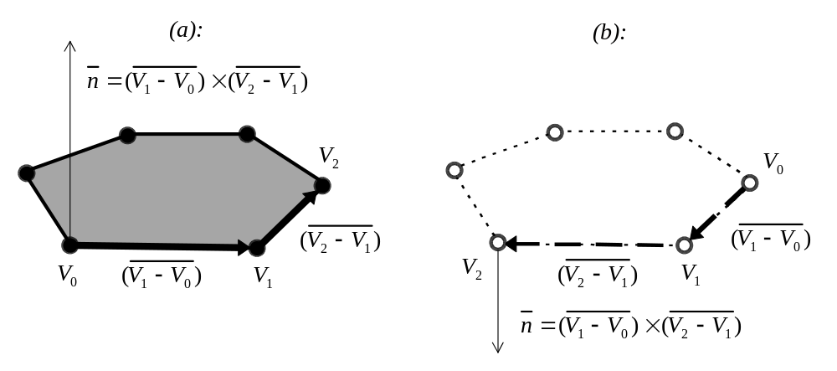
Figure 7.4: Order of vertices and the direction of the normal.

As Figure 7.4 illustrates, if we build vectors on a consecutive vertices 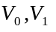 and 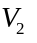, the direction of a normal will depend on the vertices’ order. It is convenient to associate the front surface of the polygon with the counterclockwise order of vertices (see Figure 7.4 (a)) which thus defines the direction of a normal vector.

We have seen two different viewing processes, and also two different projection transformations. Depending on the combination of the techniques used, the back culling is applicable in a slightly different manner and may be performed during a particular slot in the rendering pipe-line.

In the case of the parallel projection, the projecting lines, which correspond to the viewing direction, have the same orientation. Immediately before the projection stage (in the view space) the vector of the viewing direction points along the Z axis and thus can be represented as (0,0,1). This, of course, simplifies the computation of the scalar product which simply equals to the z component of the normal vector. Thus, instead of building a complete normal vector in that space, we can only compute its z coordinate which is achieved by two multiplications and several subtractions.

In the case of the perspective projection, the projection lines intersect in the viewer’s eye and have different orientations. We can find the direction of viewing for any point in the world or view space by constructing a vector originating in the viewer’s eye and pointing towards that point (see Figure 7.5).

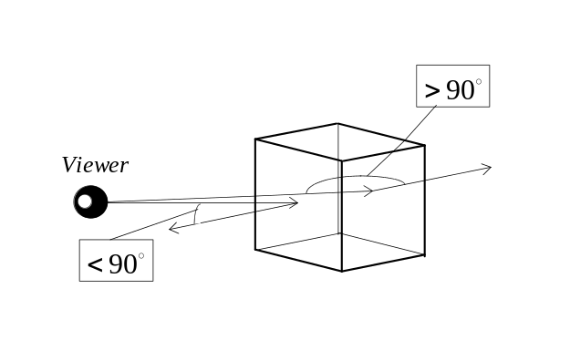
Figure 7.5: Finding a back polygon.

However in this case, once the model was transformed by the perspective transformation from the view space into the screen space, the direction of viewing becomes constant enabling to perform the back-culling as a simple computation of the coordinate z of the normal vector.

The back culling can be potentially performed quite early in the pipe-line, either in the world space or even in the object space. The earlier we discard a back side polygon the less unnecessary operations we have to do. We must also take into account that 3-D transformations are performed on the vertices and thus performing the back culling in the object space is advantageous only if we can discard the vertices which don’t belong to any of the front side polygons. This can be done by associating a Boolean variable with each vertex and setting it to “true” every time any polygon containing this vertex is decided to be on the front surface. After examining all polygons we can discard the vertices for which “true” condition was never set. The saving comes from avoiding performing the 3-D transformation for the discarded vertices. If we choose not to perform the above manipulations, we can as well do back culling in the world space. Performing back culling in the world space allows to avoid pushing some polygons through an expensive clipping stage. However the culling itself is just a bit more expensive than when it is performed immediately before the rasterization.

Alternatively, instead of constructing the normal vectors in the run-time, we can precompute such vectors prior to the application’s rendering loop and associate one with each polygon. In order to obtain the normals in the world space, we can apply the transformation which we used to transform the vertices into this spaces. It should be noted that for the purposes of transforming a vector only linear part of the transformation (that is the rotations and non-uniform scalings) have to be applied. The translations mustn’t be applied since conceptually they don’t affect the vectors. Transforming a normal vector from one space into another is somewhat more expensive than just building one using the points in the destination space. However, unit length normal vectors are also used for the purposes of lighting and thus we can combine computations for both purposes. It is more expensive to build a unit length normal in some space than transform one from the space where it is given.

Similar reasoning mostly applies in the case of the screen to world viewing process which, as we noted, can be modified in a way to avoid seeking an intersection of a ray and a back polygon. Since we don’t explicitly transform the coordinates into the view space in this viewing method, it leaves only world and object space for potential culling application. As we shall see in the following chapter, we may want to generate recursive rays to trace environmental reflection. Since the direction of such rays is hard to foresee in advance they may very well intersect a polygon which is invisible to the viewer. As a result, culling in object space wouldn’t make a lot of sence.

7.2 Back to front sorting.

As we have seen in the previous section, back culling is not sufficient to eliminate hidden surfaces in a polygonal model. In a general case, finding all portions of the polygons which are obscured by any other polygon can be an expensive geometric problem which world to screen visualization is confronted with. It can be solved by iterative clipping of every polygon against all other polygons in their screen projections and examining the depth of the resulting pieces. If any piece is further away along the viewing direction than the clipping polygon, it must be obscured and thus, can be discarded. At the end of this process we obtain a new set of polygons all of which are visible and none of which obscure any other piece.

Without a doubt, this appears to be a fairly expensive solution which may not be suitable to use. A popular alternative takes advantage of the frame buffer architecture of the graphics hardware. Whenever polygons in the scene may partly obscure one another we can achieve proper display by just rasterizing the primitives in the back to front order. The polygons which are closer to the viewer would be rasterized later overwriting pieces of any other polygon which was rasterized previously. This is known as a painter’s method. The specific algorithms in this class differ in their approach to achieve back to front order of rasterization and they range from sorting to space subdivisions.

We must note that in the cases when rasterizing of polygons is too expensive, for instance when using complex texture mapping and lighting, it may be unwise to rasterize in the back to front order since we know that many polygons will get overdrawn and we would have spent resources in vain. It is hard to define a cut-off line when the overdraw problem becomes too severe to ignore, yet we must be aware that at times the initial seemingly inefficient solution may become appropriate to use.

In order to obtain back to front ordering, sorting appears to be a logical choice to range polygons depending on their depth along the viewing direction. If we employ the perspective transformation we cannot apply the sorting in the view space since the viewing directions vary for different polygons. The viewing direction becomes constant just before the rasterization stage and that is where the sorting procedure can be applied.

In order to sort along the viewing direction we must find a criterion for polygon comparison. The simplest solution is to compare the maximum z coordinates (farthest from the viewer) among all vertices in one polygon against that in the other polygon. Comparing an average z coordinate may be an alternative choice.

There exist many different sorting algorithms. The most straightforward ones have complexity of 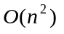. It means that in order to produce a sorted list, these algorithms employ a number of elementary operations which is proportionate to 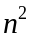. An example of such sorting algorithm is a bubble-sort. In this algorithm, we compare an object in the list with its successor and if the sorting criterion doesn’t hold we interchange their positions. If we perform the comparisons for every object in the list starting from the first one, a single object must travel to the correct position in the list - not unlike a bubble being pushed up to the surface of the water. It roughly takes n-1 comparisons to place a single object into a correct location. This translates into complexity proportionate to about elementary operations to sort the entire list (see Figure 7.6).

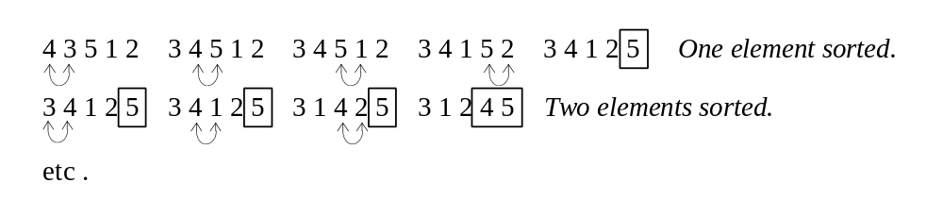
Figure 7.6: Bubble-sort.

An algorithm with square complexity is a fairly costly one. In the case of the sorting problem there exists a class of algorithms which improve on the complexity up to 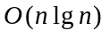. All algorithms in this class employ a variation of a divide and conquer strategy. For instance quicksort algorithm separates a list into two sublist so that in one sublist all the objects are smaller than a certain preselected pivot value whereas in the other list all objects are greater or equal than this value. If we apply quicksort recursively to both sublists, as a result, we get a completely sorted original list. This method gives average complexity which is intuitively understandable since the separations of the list into sublists was following a tree-like pattern (see Figure 7.7).

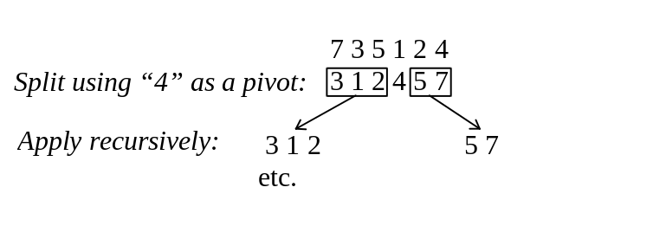
Figure 7.7: Quicksort.

The complexity of is a limit to how efficient a sorting algorithm can be. However, one class of sorting algorithms achieves better complexity indications by exploiting a fact that numbers that we sort, as a rule, come from a limited range. For instance, a representation of an integer number often utilizes 32 bits of storage which places limitations on the magnitudes of numbers which can be represented. Radix sort, an algorithm from this class, works in essentially linear time 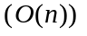 but it is likely to have bigger space requirements or may use different assumption on what an elementary operation or unit of storage space is. Thus, it is not always possible to choose this algorithm over some algorithms.

Radix sort relies on the fact that we can very easily sort an array of numbers which come from a limited range. For instance if the only allowable sorting keys are in the range [0,3] we can place objects tagged with such keys in order by the following process. We count total numbers of elements tagged with each key. These numbers define offsets at which elements of each group must be placed in the resulting list. For instance, objects tagged with ones must follow objects tagged with zeros and thus are located in the resulting list at the offset equal to the number of elements tagged with zeros. We pass through the original list again, this time placing objects into the resulting list at the known offsets. This particular algorithm is known as counting sort and it is feasible for sorting keys in a very small range. Radix sort requires a limited but not necessarily small range and it works by invoking a process similar to counting sort multiple times, each time sorting along different sets of bits in the search keys (see Figure 7.8).

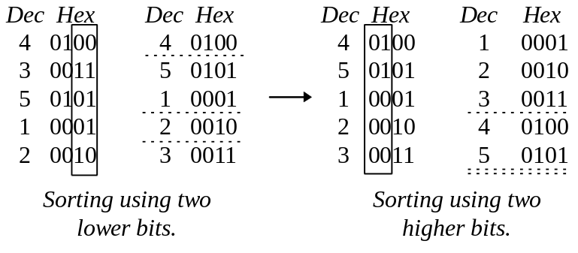
Figure 7.8: Radix sort.

From the example in Figure 7.8 it can be seen that this algorithm is essentially 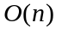, however, it requires multiple passes through the list and thus its effective performance may be worse than that of the quicksort. Generally, quicksort performs better for lists of small or average size. An advantage of radix sort becomes appreciable only in the cases where lists are very long or the range of represented values is very narrow.

Any of the above algorithms can be applied for the purposes of placing polygons into back to front order. However, the performance of the discussed algorithms depends on the level of disorder in the list about to be sorted. Many algorithms work well when the list is almost entirely sorted requiring in this case only few operations to finish the work. Straightforward implementation of a quicksort works well on the lists in the state of high disorder, and radix sort is practical only in the cases of very big lists or narrow ranges. In the case of graphics 3-D applications we often wish to slowly rotate polygonal objects. In these situations it is often the case that the order of the polygons doesn’t change much from frame to frame and we can achieve good performance with a seemingly ineficient in a general case algorithm. On the other hand, if we want to insure good average performance for any situation quicksort is often a logical choice.

It should be streesed that we’ve proceeded to examine sorting algorithms on the assumption that we have some sorting criterion allowing to place polygons in the back to front order. Unfortunately it is not quite the case. The criterion of comparing maximum z coordinates is not correct in general (see Figure 7.9).

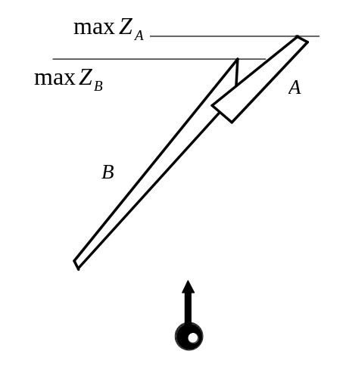
Figure 7.9: Failure of maximum Z criterion.

In Figure 7.9 polygon A should be painted first based on maximum z criterion, yet it obscures polygon B so it should be rasterized later than B and not earlier. Similar situation can be imagined in the case of using average z criterion.

In certain situations we can live with the above problem. When we are guaranteed that polygons in the scene would be of roughly the same size, sorting based on maximum or average z is admissible. This happens, for instance, when we tessellate an analytical shape such as a sphere or a bicubic patch into polygons. In these cases, simple sorting is usually sufficient. In the cases where we can’t guarantee roughly the same size of the polygons, we can attempt to use more complex sorting criteria. If we can find a point which belongs to the intersection of the screen projections of two polygons, we can further compute the depth at that point for both polygons and compare these using the result as sorting criterion. In order to locate such a point, however, we may have to resort to finding intersection of every edge in one polygon against every edge in the other polygon also checking the situation when screen projection of one polygon is contained in the projection of the other polygon. Such a strategy may work relatively well when each polygon has a small number of edges. When this is not guaranteed, we may have to make certain relaxations and use a more sophisticated solution. For example, if we assume that the polygons are convex, we can first find their common tangent, a line which leaves all vertices of both polygons on one side (see Figure 7.10) and further decent the resulting sail or hour-glass polygon to find an intersection or show that such doesn’t exist (see Figure 7.11) [TOUS85].

In order to find a common tangent we can start examining lines continuing edges of the two polygons starting from the vertices having least y coordinates, for instance. Since in a convex polygon a line continuing an edge leaves all vertices in one of its half-planes, such a line is a tangent. We can examine the relationship of such tangents in both polygons. For example, in the situation shown in Figure 7.10 edge d is located in the right half plane of line continuing edge a. We take next edges and conclude that the same situation holds: edge e belonging to the second polygon is in right half plane of b. However, when we take consecutive edges the situation has reversed, edge c of the first polygon is now in the right half-plane of f which belongs to the second polygon. Since the tangents have crossed, in other words when turning from the direction b to the direction c in one polygon and from the direction e to the direction f in the other polygon the relationship has changed, hence there should exist a tangent, common to the two ranges of angles, which leaves vertices in both polygons in its right half-plane. Such a tangent is exactly the line connecting points A and D (see Figure 7.10).

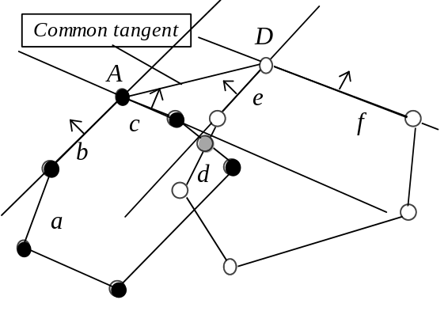
Figure 7.10: Finding bridge between two polygons.

We must note that it is not unlikely that the tangents would never cross. If that is the case we are in the situation when one polygon is contained inside the other one and hence any point of the former can be used for depth comparison.

A common tangent serves like a bridge connecting two polygons. It also defines a sail-like shape formed by two crossing convex chains, one from each polygon (see Figure 7.11).

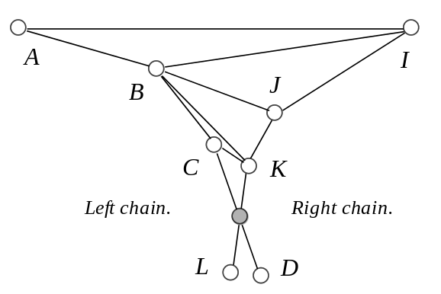
Figure 7.11: Finding the intersection point.

In order to find the intersection of the two chains, we can start iteratively reducing the size of the problem until the crossing is found. Consider, triangles ABI and IJA from Figure 7.11. Clearly either one or the other should be an ear, that is a triangle that doesn’t contain any other vertex inside. We can test this by checking if B is on the inside or on the outside with respect to AJ and, similarly, where J is with respect to IB. Having determined this way that ABI is an ear, we can cut it off and proceed with the sub-problem of the original - a sail with BI on its top. Eventually, CK becomes the current top of the sail, at which point our test will fail for both D being on the inside of CL and L on the inside of DK. This means that we have located the crossing of CD and KL and can further use the techniques from chapter five to find z coordinaes for both polygons in the intersection point.

It should be noted that the two polygons may not intersect in which case instead of sail polygon we will obtain an hour-glass polygon. It is not difficult to adjust the suggested strategy to tell when this is the case.

An obvious speed-up technique for such methods is using binding volumes and avoiding expensive calculations when the relation of the polygons is obvious. If, for example, minimum z of one polygon is further away the maximum z of another one, we can be sure in polygon’s order (see Figure 7.12).

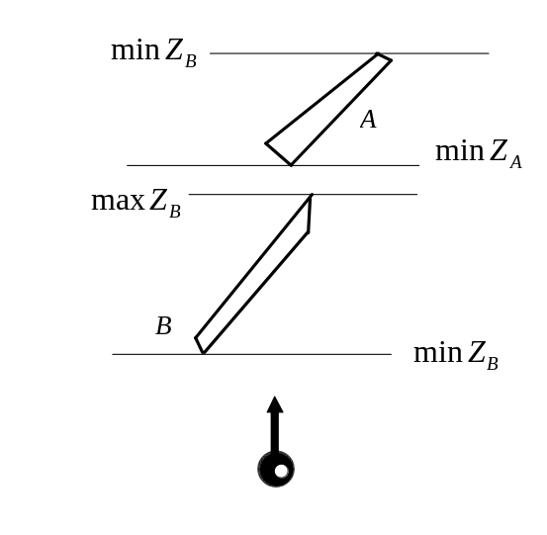
Figure 7.12: Comparing extends of polygons.

When z extends do overlap, only then would we use expensive comparison. Beside being computationally expensive, sorting even with the described above complex way of comparing polygons contains internal problem. We can’t really find criterion of polygon comparison which gives a well founded order. Essentially, well founded order requires that in any set of elements there should be the least one. It is not the case with polygons, and without well founded order principle of induction which sorting is essentially built upon can’t really be applied (see Figure 7.13).

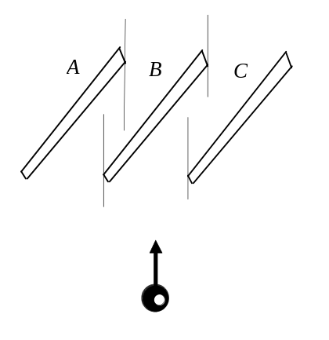
Figure 7.13: Difficulty to compare polygons.

In Figure 7.13 the polygons A,B and C should be rendered in exactly this order A then B then C, since B partly obscures A, and C partly obscures B. However, if during sorting process we would be asked to compare A and C, we would not be able to say much. These polygons have absolutely the same maximum and average z coordinates and their projections on the screen don’t intersect. We will be tempted to say that they are “equal” and that it doesn’t matter for us in what order they should be rendered. But that’s not true: polygon B imposes order on A and C and so their order does matter. The situation is even worse in a mutual overlap problem (see Figure 7.14). The one that illustrates that there might not be the least polygon in a set of polygons.

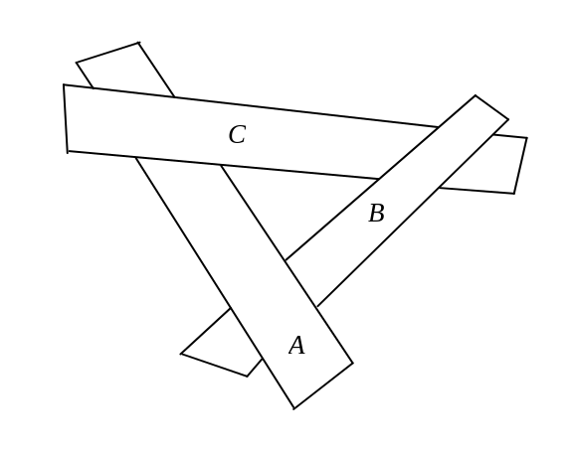
Figure 7.14: Mutual overlap of polygons.

In this example we have A<C and C<B but B<A which of course contradicts to what we expect if the order was well founded, because by transitivity if A<C and C<B we conclude that A<B and arrive to a contradiction with the clause B<A.

As we can see, sorting can’t handle situations with polygons piercing one another as well as some special arrangements of polygons such as the mutual overlap. It is still useable, no doubt, with the described limitations in mind.

7.3 Order lists and octal trees.

As we have seen from the previous section, hidden surface removal for a generic polygonal model can be quite costly. However, in many situations an object that we represent possesses some special property which can be exploited to ease hidden surface elimination. For example, in the case of landscapes represented as height fields, we can easily obtain back to front ordering of polygons. It can be done thanks to the regular nature of the representation method according to which the landscape is divided into a grid of square cells.

Let’s consider a situation where a viewer is located on or above the surface of the virtual landscape within boundaries of some cell. We can divide the whole landscape into four rectangular sublandscapes, as shown in Figure 7.15.

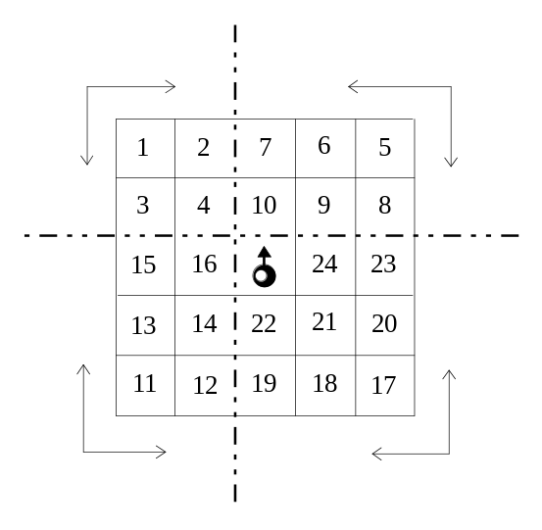
Figure 7.15: Height-field traversal.

Due to the regularity of the representation, the projections of these four sublandscapes onto the viewer’s screen practically do not intersect. The small number of intersections which may appear with perspective transformation can be easily fixed by rendering the sublandscapes in the order dependent on their size: from the smallest to the biggest.

Within each of the partitions, we can obtain the back to front order of polygons by just starting from the corner polygon farthest away and proceeding towards the cell occupied by the viewer, column by column or row by row. The polygons composing a cell which is occupied by the viewer must be rasterized in the last turn. For example, the order of cell rasterization for the landscape in Figure 7.15 is the following:

First 1,2,3,4;
Then 5,6,7,8,9,10;
Then 11,12,13,14,15,16;
Then 17,18,19,20,21,22,23,24,25;

Effectively, this traversal guarantees correct visibility in any projection. However, each cell, as we noted in the previous chapter, is likely to be composed of two triangles. An order of their rasterization will be different depending on the angle the scene is viewed at (see Figure 7.16).

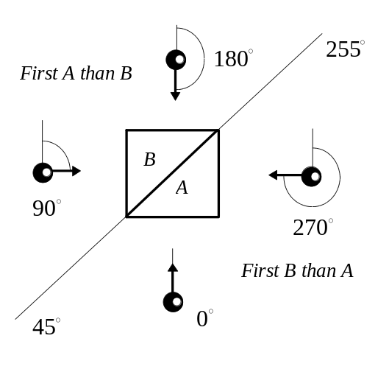
Figure 7.16: Order of triangles in a height-field cell.

From Figure 7.16 it is clear that when the view direction is in the range (45,225) the polygon B should be rendered after the polygon A, otherwise, when the view direction is different, we render polygons in the reversed order: A after B. At exactly 45 or 225 degrees the order doesn’t matter since projections of the polygons would not intersect on the screen.

The very same property of regularity helps to find a back to front sequence of voxels stored using an octal tree, or, in this matter, matrix representation for spatial occupancy both of which we saw in the previous chapter. In both cases we can employ a method very much similar to what we have discussed for height-fields, extended to deal with three dimensions instead of two.

An octal tree is a recursive structure where the same property of regularity is true in each level of subdivision. Thus, the same traversal order can be applied at every level to obtain the back to front order of elements for the entire structure.

A quad-tree is a planar counterpart of an octal-tree. Let’s, for the sake of simplicity, consider traversing a quad-tree pictured in Figure 7.17. Depending on the viewing orientation there are four different traversal orders, each for a particular range of orientations (see Figure 7.17).

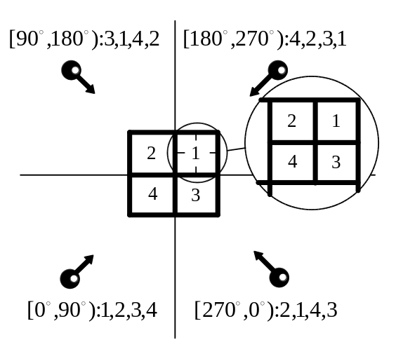
Figure 7.17: Order of quads in traversing of a quad-tree .

As Figure 7.17 illustrates, to traverse any sub-tree, we use exactly the same order which, in its turn, may cause traversals on even lower levels of sub-division but even there we would still use the same order as the one at the top level.

The very same strategy is applicable in the case of octal-trees. By extending the above method into three dimensions, we will have eight different traversal orders, each applicable in a particular ranges of the orientation angles.

7.4 Portals.

Another example of how visibility can be solved in a special situation can be demonstrated on the case of a model describing an indoor scene. Consider a collection of volumes - rooms connected by portals - doors. In the simplest example, the rooms are convex polyhedrons, which can be drawn with correct visibility just by applying the back-culling.

Let’s find what a viewer located in room A in Figure 7.18 will see. Clearly, the polygons composing the room A will be visible, then, all portals leading from the room A will be visible. To draw screen projections of the portals correctly, parts of the rooms where the portals lead have to be drawn; and to draw correctly the parts of these visible rooms, the polygons and portals comprising them have to be drawn as well.

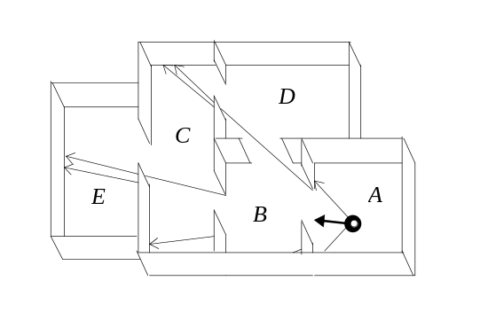
Figure 7.18: Set of indoor volumes.

The very language which describes the strategy above suggests recursion. Let us consider a neighborhood of a room where the viewer is located. We can construct a graph where nodes will represent rooms and edges will represent portals (see Figure 7.19).

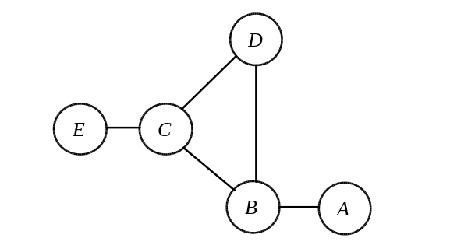
Figure 7.19: A graph of indoor volumes.

By drawing first the polygons in the room where a portal leads, and then drawing all polygons in the current room the correct visibility is assured. This translates into traversal of the graph where we first recursively apply the traversal to the nodes of the graph (rooms) connected to the current node and then applying the visualization algorithm to the current node itself.

It should be noted that, as in any graph traversal, in this algorithm, care should be taken of possible cycling. If the algorithm has been applied to a node, it shouldn’t be reapplied to it the second time. For the particular example in Figure 7.19 this would work as follows: we start at the vertex A, proceed to vertex B, go to vertex C from where we go to vertex D. At that stage we can’t go anywhere else since B is already being used. Since there is nowhere to go, the room associated with D is drawn; we return back to C, from where we go to E first, draw its polygons, return back and draw all polygons of room C. At that point, we return to B draw it and finally draw the room A.

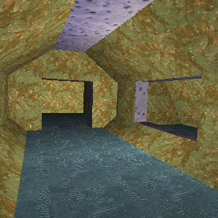

Figure 7.20: An interior scene with portals.

Multiple refinements are available in this scheme. Clearly, the graph can be very big so it may make sense to traverse it with certain depth and just stop when we are, for instance, three or four rooms away from the one we are currently in. Chances are, the rooms which are deeper than that are not visible anyway.

It is also true that we see all the rooms, other than the one we are currently in, only through the portals, nothing else outside the projection of a portal onto the screen can possibly be visible. Thus, when drawing rooms which we see through the doors, we can actually clip their polygons against the screen projection of a portal and considerably alleviate the overdraw problem. However, since the projection of a portal is some arbitrary oriented polygon, such clipping can be fairly expensive. We can improve the situation by clipping against the binding square - the extends of the portal’s screen projection. Although some overdraw will occur, clipping against a rectangle can be done much faster than against an arbitrary polygon. Especially in the cases of texture mapped polygons accompanied by a complex lighting scheme, we can expect a considerable saving from such refinement. It should be noted that if we employ clipping against portal’s boundaries the room traversal algorithm will have to be changed so that we can draw the same room multiple times if we reach it by the way of different portals.

Further we will see a certain generalization of the approach we have taken here to alleviate the overdraw when considering the beam trees in the following section.

7.5 Binary Space Partition trees.

BSP stands for Binary Space Partition. Using this partition scheme allows us to obtain back to front list of polygons in in the run-time using a precalculated tree. It was first described by Fuch and Kedem in 1980 [FUCH80]. The fundamental idea of this method is based on the fact that any plane divides the space into two half-spaces. All points on one side of this plane define one half-space, whereas, all points on the other side define the other half-space. Furthermore, if we have a plane given in any half-space, it would further induce a division of that half-space into even smaller sub-spaces. We can proceed recursively down smaller and smaller sub-spaces using the list of polygons to perform subdivisions and to construct a binary tree. In this tree, a polygon inducing a division will be stored in the node and all polygons in either of sub-spaces would be in their proper sub-trees. This rule, of course, applies recursively to every node in the tree.

Let us consider a set of polygons in Figure 7.21. For simplicity’s sake a planar projection where all polygons map into line segments was chosen. Let us, for example, construct a BSP tree starting from the polygon B (see Figure 7.21).

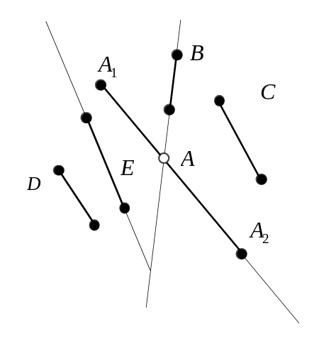
Figure 7.21: A binary space partition.

The plane of the polygon B induces a partition of the space such that the polygons D and E are in the same half-space and the polygon C is in the other half-space. From this example we can also see that the polygon A crosses the partition plane and thus can’t be unambiguously assigned to either half-space. However, if we split this polygon at its crossing with the partition plane naming the parts as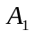 and 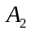, we will be able to place together with D and E and together with C. This stage in building a BSP tree is described in Figure 7.22.

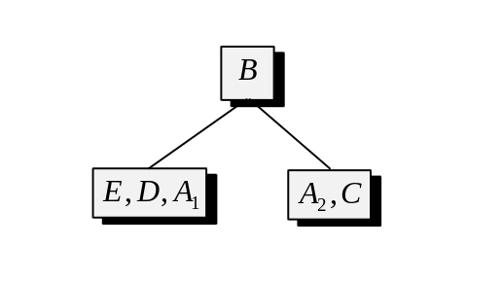
Figure 7.22: A stage in building a BSP tree.

At this point we have clearly split the problem into two subproblems. We can reapply the described algorithms to the lists in the subtrees. For instance, let’s choose E as a dividing polygon in the left sub-tree and let’s choose in the right sub-tree. As a result, we will build a tree having the following structure (see Figure 7.23).

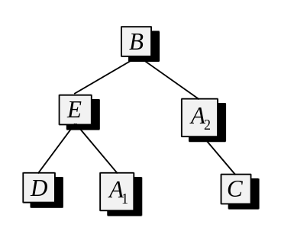
Figure 7.23: Built BSP tree.

It must be noted that any given BSP tree is not unique. We can find multiple valid binary partitions for the same set of polygons. Depending on the order in which we have selected the dividing polygons, we obtain a different tree. For instance, in Figure 7.24 we can see that another tree can be built for the set of polygons we considered previously.

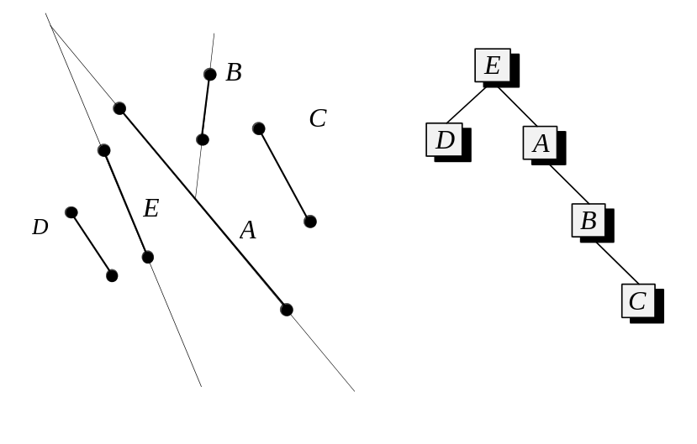
Figure 7.24: An alternative construction.

Although any valid tree suits the algorithm which we are going to use to traverse the tree and obtain the back to front order of polygons, some may be more favourable than others due to the efficiency considerations. Let’s examine first the traversal algorithm and after that the reasons validating specific tree configurations.

Let us consider a scene consisting of a set of polygons with a precomputed BSP tree and a viewer located somewhere in this scene (see Figure 7.25).

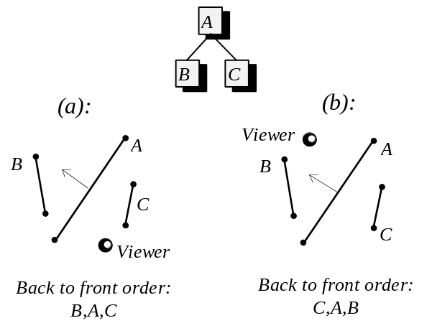
Figure 7.25: Using a BSP tree to obtain back to front order.

Let us examine the relationship between viewer’s position and the polygon in the root of the BSP tree. Clearly, the viewer must be located in one of the half-spaces which were formed when this polygon partitioned the space. It is also true that the polygons which are in the same half space with the viewer are closer to the viewer than the polygons in the other half-space. Due to this fact, the back to front order of polygons is achieved if we first place into the resulting list the polygons from the sub-tree representing the half-space further away; followed by the root polygon; followed by the polygons of the sub-tree which corresponds to the same half-space where the viewer is currently located. This process is repeated for every sub-tree recursively, most likely choosing different relative order of the sub-trees at every level at the end producing the correct back to front order of polygons.

A very attractive quality of this algorithm is that it works for any location and orientation of the viewer in the scene. For instance, in Figure 7.25 (a) the produced list is different from that in the case (b). Both are correct back to front orders of polygons in their particular cases. Thus, if we precompute a BSP tree for a polygonal model, in the run-time we will only need to invoke an inexpensive tree traversal procedure which, depending on the particular location of the viewer, will produce a correct back to front ordering to be used in the painter’s method of hidden surface removal.

In this algorithm, the decision which has to be taken in every node of the tree depends on the determination in which half-plane the viewer is located with respect to the node’s polygon. In chapter five we have already encountered the apparatus necessary for this computation when examining plane equations. Using the discussed facts we can see that if we substitute the coordinates of the viewer’s location into the equation of the plane formed by a given polygon, the positive sign of the resulting value tells us that we are in the half-space pointed to by the plane’s normal used to construct the equation. Negative value indicates the other half-space and the value of zero tells us that we are, in fact, in the plane of the polygon. The latter situation, for the purposes of traversing a BSP tree, means that the projections of the half-spaces on the screen don’t intersect and we can choose any order of sub-trees at that stage in the traversal.

Similar computation is also required at the stage where we precompute a BSP tree. We need to determine in which sub-tree different polygons must be placed. From the implemenational point of view the procedure to precompute a BSP tree can be expressed as follows: Of the collection of polygons we select one polygon. We further compute the plane equation for it. For the remaining polygons we check all their vertices against said equation. If results for all vertices are negative, the polygon goes into one sub-tree, if all results are positive, the polygon goes into another sub-tree. If results are positive for some vertices and negative for other, this polygon should be split so that one piece is unambiguously in one sub-space and the second piece is in the other sub-space. Once we assigned all the polygons to their proper half-spaces, we can call the tree building algorithm recursively for the lists of polygons designated for both sub-trees. We stop when the current sublist consists of a single polygon.

The problem of splitting a polygon by an arbitrary plane can be reexpressed as a clipping problem. It can be solved by an algorithm only slightly different from the one considered in the chapter on clipping. The only significant difference is that during binary search edge clipping, we will use the plane equation of the partitioning polygon to tell the position of the edge’s mid-point with respect to the dividing plane.

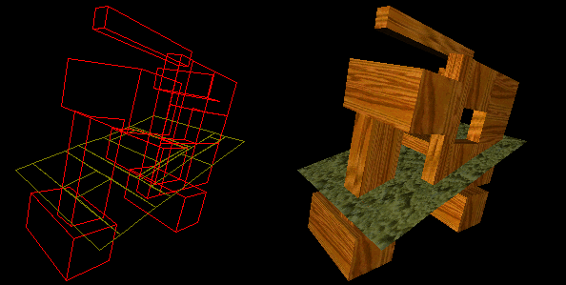

Figure 7.26: A scene rendered using a BSP tree. Note various polygon splits on the left.

In the case of clipping against a vertical edge, we used a binary search technique discarding half of the edge depending on the location of the edge’s midpoint with respect to the clipping edge. In this case, we can proceed using the very same method only changing the criterion for the one which allowed us to tell the location of a point with respect to the partitioning plane by the means of the plane’s equation. The strategy which we used to combine clipped edges into a clipped polygon remains exactly the same.

It should be stressed that since construction of a BSP tree is done prior to the application’s run-time, either at application’s initialization stage or at the time of creation of the data structures, we need not worry excessively about the efficiency of the algorithm building the tree.

Once the tree is created, to obtain a back to front order of polygons, the following steps have to be made: We take a polygon in the root of the tree. We compute the plane equation of this polygons. We further substitute the coordinates of the viewer’s current location into this equation and note the sign of the result. We finally apply the same algorithm recursively to the subtrees in the order dependent on the sign of the noted value.

Let’s recall that we have found the plane equation in the form of

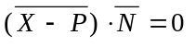

where P is some point in the plane and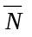 is a normal vector to that plane. It is customary to express the same equation in the form of

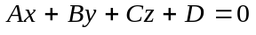.

The latter form is obtained just by performing the scalar multiplication in the original form so that 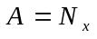, 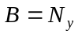, 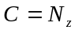, and 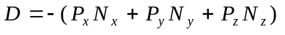.

In the case when we traverse the tree in the view space where the viewer is located at the beginning of the coordinates: (0,0,0), the result of the mentioned substitution equals the coefficient D from the plane equation. Thus, BSP tree traversal can be conviniently performed just prior to the perspective transformation stage.

A sketch of possible tree traversal is presented in Listing 7.1.

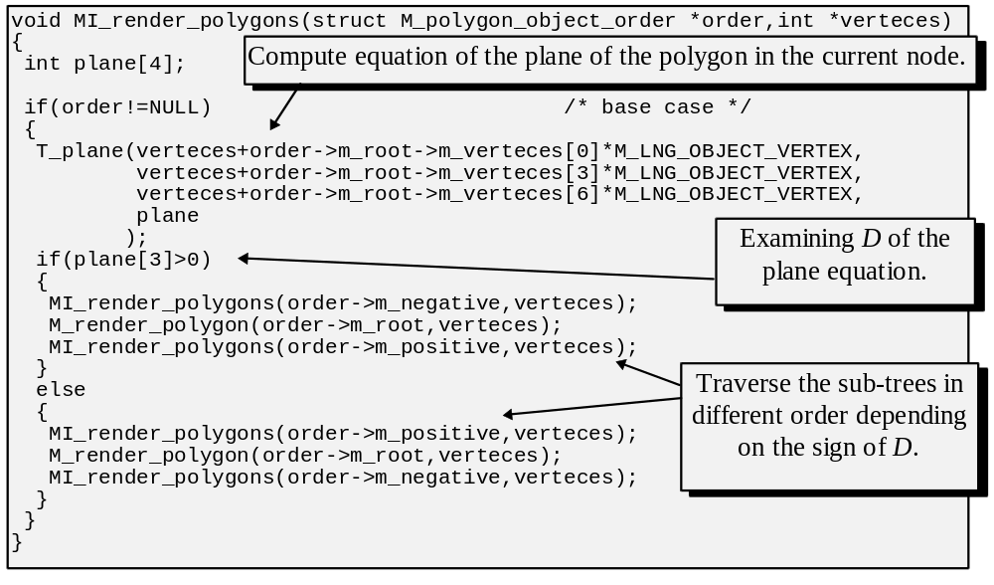Listing 7.1: Traversing a BSP tree.

After we have examined tree creation and tree traversal, there are still questions which remain to be answered. At the time when we construct a tree, we can choose any of the remaining polygons to partition the space. Choosing different polygons causes a construction of a different tree. Thus, we should consider whether specific choice of a polygon can be advantageous for the performance of the algorithm.

Some polygons cause more splits of the remaining polygons (see Figures 7.21, 7.23 and 7.24). Each polygon has certain overhead associated with pushing it through the pipe-line, so the fewer polygons there is, the better. We can use a criterion to select a polygon that causes less splits. Of course, if applied locally this is just a greedy heuristics and it may not result in an optimal tree in general, but it appears to help on practice. As an alternative, selection of a random polygon is not sufficiently worse in an average case.

Using a criterion to balance BSP trees, so that there are roughly the same amount of polygons in sub-trees at every level is not really necessary since it doesn’t affect the running time of the traversal. Traversal of the tree always assumes at least taking each polygon once, hence balancing doesn’t affect the performance - we still have to take each polygon at least once. On the other hand, a balanced tree can be traversed with less recursive calls which may be attractive. We can consider balancing as a criterion secondary to the condition demanding less splits at each stage.

Overall, the biggest advantage of recovering back to front order of polygons based on BSP trees is in a very low run-time complexity of the algorithm. This method also resolves the cases of multiple overlap of polygons and piercing of polygons thanks to the proper polygon splitting during the tree creation stage. However, by using a precomputed structure, we have lost a certain amount of flexibility. If the arrangement of polygons changes in the run-time, the BSP tree must be altered as well. Cost considerations prevent us from doing that and, thus, this algorithm is quite unusable for the scenes which can be radically changed in the run-time.

It should be noted that the tree is only affected when polygons within the set undergo different transformations. If the same affine transformation is applied to all the polygons in the set, the partition remains valid and the tree is unaffected. Thus, an object which is dynamic in a sense that it moves or changes orientation in the world can still use the same BSP tree. If some parts of the object move with respect to other parts, however, we should examine an alternative algorithm instead.

7.6 Beam-trees.

Although by using BSP-trees which we saw in the previous section we can now efficiently create the back to front order of polygons for the use with painter’s hidden surface removal, this latter has a severe flaw which we saw earlier. When we want to draw textured or shaded polygons, overdrawing, which is fundamental in the painter’s algorithm, becomes too expensive to ignore. It was noted earlier that a seemingly inefficient solution where we clip every polygon against all other polygons, examine and discard the obscured pieces may, in fact, be attractive to pursue since it avoids the overdraws. Interestingly enough, BSP trees may considerably help in this latter endeavour as well. A beam-tree method which we are going to consider in this respect, may use a BSP tree for both, ordering of polygons, and tracking which area of the screen has been already drawn to.

In the previous section we have discussed an algorithm allowing us to use a BSP tree to obtain the back to front ordering of polygons. The front to back ordering can be obtained in exactly the same way, requiring only to reverse the order of recursive calls in the BSP tree traversing algorithm. Thus, the half-space which is closer to the viewer will be traversed first, followed by the root polygon and traversing of the half-space further away to produce the sought front to back ordering.

The first polygon in the obtained ordering is the closest to the viewer. Since nothing else can possibly obscure it, this polygon is entirely visible on the screen and thus can be rasterized. All other polygons may be completely or partially obscured by the first one. If we clip the screen projections of the remaining polygons against the boundaries of the first polygon and discard the pieces which are obscured, we have essentially reduced the size of the original problem by one. The new polygon in the beginning of the list is also entirely visible (since it has been already clipped against the original first polygon) and the remaining polygons may, again, be partially or completely obscured by the new polygon in the beginning of the ordering.

It is also true that a neccessity to do a lot of clippings considerably worsens this approach. To manage more efficiently the clippings, a planar BSP tree can be introduced to track which areas on the screen remain available for drawing. Unlike in the trees considered previously, in this BSP tree the additional leaf nodes will describe the final convex areas formed as a result of the sub-divisions and won’t have an associated polygon. This areas will be marked as occupied or free. Since functionally the purpose of the 2-D screen boundaries clipping is exactly the same - to find a portion of the primitive that can be rasterized, the two processes can be, in fact, unified. Thus, we will start with the BSP tree describing the screen area as free for drawing, whereas the space outside the screen will be marked as occupied. Figure 7.27 demonstrates the initial BSP tree and the induced partition.

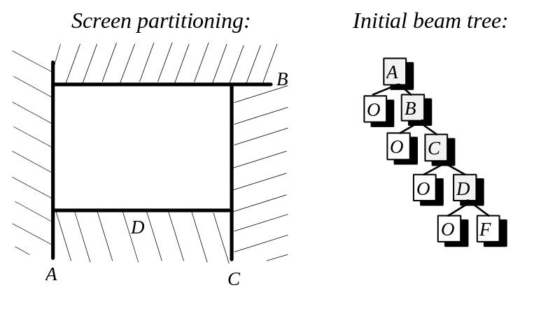
Figure 7.27: Beam tree for the empty screen.

When a polygon must be drawn, it is filtered down the BSP tree. It may get split at some nodes so that the pieces can be unambiguously checked within the proper sub-trees. When a certain piece reaches a leaf of the tree and this leaf is marked as occupied, we know that this polygonal piece is, in fact, obscured and can be discarded. On the other hand, when a polygon’s piece reaches a leaf marked as free, this piece can be rasterized and since the area under that polygon became occupied now, the BSP tree must be updated to reflect that.

Consider the example in Figure 7.28. In this example, a polygon with the edges named E,G,H must be rendered. It is first checked against the root of the BSP tree which tracks areas currently available on the screen. The edge A which is in the root of the tree splits the given polygon. The smaller piece to the left of A should thus be checked against the left sub-tree and the remaining portion of the polygon against the right sub-tree. In the former case, the smaller piece reached a leaf node which is occupied and it is, thus, discarded. In the latter cases the polygon is checked against the edge B, gets split in half with the upper portion getting discarded. The lower portion is checked further eventually reaching the node describing the screen rectangle (see Figure 7.27, the node marked F). At that point we can safely rasterize the remaining piece of the polygon and update the tree using the polygon’s edges to induce further partitioning and mark the polygon’s area as occupied and the remaining areas as free. Clearly, when a piece of a polygon has reached a leaf node, this piece is entirely within the region described by the leaf. Hence, any necessary alternations to the tree are local to the subtree rooted at the reached leaf (see Figure 7.28).

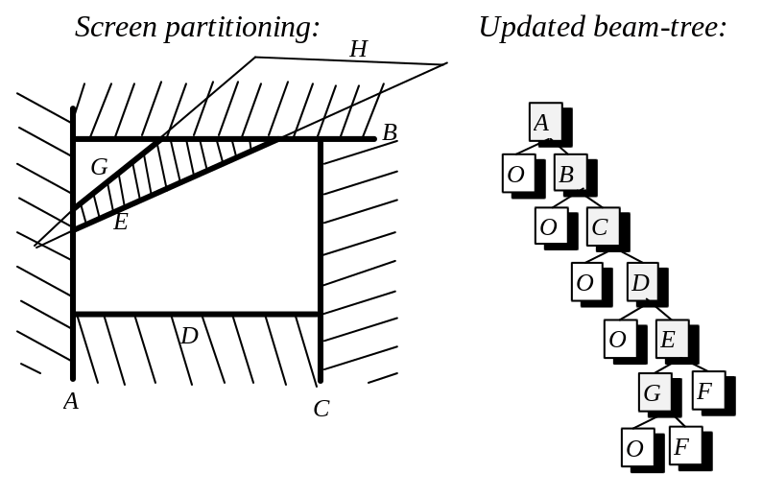

Figure 7.28: Beam-tree after one polygon drawn.

The BSP tree created in the screen plane tracks the unobscured beams of view, and thus, at times, is referred to as a “beam tree”. To summarise, in this algorithm we pick polygons from the front to back ordering one at a time and filter them down the BSP tree associated with the screen. When a piece, or pieces of polygons get rasterized, the tree is updated tracking the remaining free space so that each consecutive polygon can be consistently checked. As a result, overdraws are completely avoided at the expense, though, of a still appreciable number of clippings and implementational complexity of this algorithm.

We are going to encounter another instance of using BSP trees in the next chapter when discussing shadow generation. Clearly, this and other partitioning schemes are of great importance when solving multiple problems of computer graphics.

7.7 Scan-line algorithm.

In chapter six we have discussed an alternative representation for a polygonal model where the polygons were described in terms of edges rather than in terms of vertices. Such representation allowed to avoid redundant clipping and is also appropriate for the use in the hidden surface removal method which we are going to examine in this section. The idea of scan-line hidden surface removal is to shift determination of visibility from the level of polygons to the level of individual pixel lines of the polygons (see Figure 7.29). This algorithm can be thought of as an extension to the generic polygon rasterization which we discussed with respect to concave polygons. As we shall see, a lot of ideas in the two algorithms are the same.

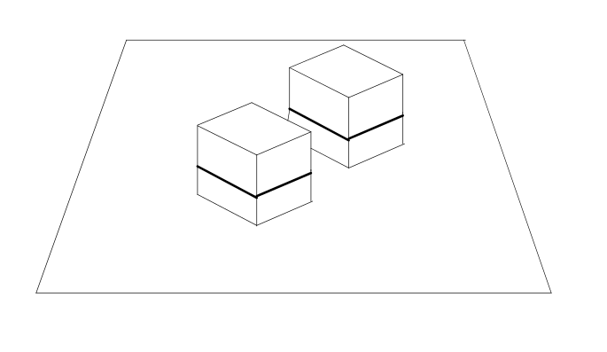
Figure 7.29: Determining hidden-surfaces per scan-line.

In this method, all polygons in the scene are rasterized simultaneously and the determination of visibility is performed in the plane which is perpendicular to the current scan-line in the screen where we will determine the relationships of the intersected polygons. Figure 7.30 demonstrates an example where three polygons are rasterized using this algorithm. As it can be seen, the information on the order in which polygonal edges are crossed by the scan-line is crucial for this algorithm. We can obtain such ordering of edges in every scan line using the same approach as we employed in the algorithm for concave polygon rasterization. Having this ordering, the determination of visibility can be done in a quite straightforward manner assuming that we also have equations of the polygons’ planes. Let us examine scan line number one in Figure 7.30.

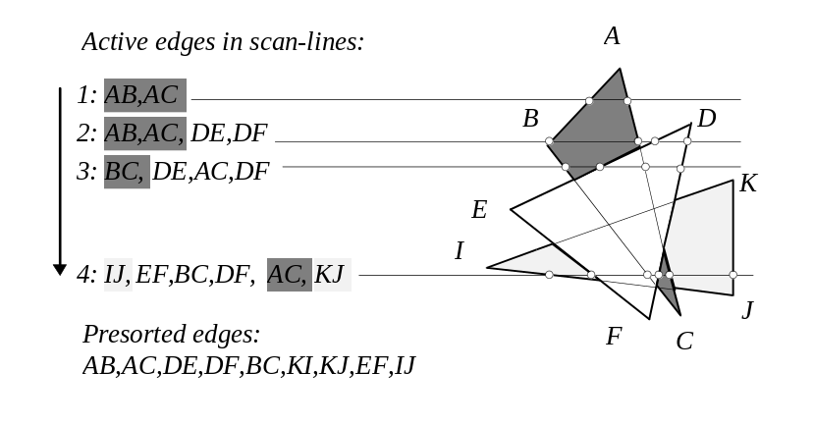
Figure 7.30: Active edges at different scan-lines.

Scan line number one in Figure 7.30 only intersects the polygon A,B,C, and thus, we can proceed rasterizing this polygon in between the edges. Scan-line number two intersects two polygons but the ordering of the intersected edges is such that we finish rasterizing polygon A,B,C before we encounter the beginning of the polygon D,E,F. In the case of scan-line number three this is not the case. We start rasterization of the polygon A,B,C and before we finish, we encounter the edge D,E belonging to the polygon D,E,F. At that stage, we must determine visibility by comparing depths of both polygons in that point. It can be done if we evaluate plane equations for both polygons in that place. In this particular case, polygon D,E,F has lesser depth and thus we start rasterizing it. When we further encounter the edge A,C we may just ignore it since the rasterization of the polygon D,E,F has not been finished yet and the edge A,C belongs to a polygon which was earlier determined to be further away.

In a sense, each polygon defines a scope in between of the endpoints where it is being rasterized. If at some point a polygon becomes obscured we may still have to continue to rasterize it later on. Such a situation is demonstrated in the case of scan-line number four (see Figure 7.30). When we have finished rasterization of the polygon D,E,F, we are still in the scopes of two remaining polygons. Thus, after crossing edge D,F we must examine the depth of the polygons A,B,C and I,J,K and, in this case, proceed rasterizing polygon A,B,C. When we cross edge A,C we are in the scope of only one polygon which we rasterize till its end.

As it can be seen, this portion of the algorithm is fairly easy to implement. We have also relied on the fact that in each scan line we have the edge ordering. As we discussed, such ordering can be obtained by pre-sorting all edges by their minimum vertical coordinate and in cases where two edges are found to be equal to use a secondary criterion to compare horizontal coordinates of the end-points with maximum vertical coordinate. Having this ordering allows us to update current edges for every scan line in an incremental manner. Once we found current edges, we must also range them according to current horizontal coordinates.

It must be stressed that one advantage of this algorithm is in its ability to ignore rasterization of obscured scan-lines. As we have seen, this becomes very important if the polygons in the scene use complex texture mapping or lighting. This algorithm also correctly handles the case of a mutual overlap of polygons but in unmodified form it can’t handle polygon piercing. Using this algorithm also implies making changes to existing polygonal pipe-lines since all polygons are rasterized simultaneously which at times may not be desirable.

7.8 Z-buffer algorithm.

Most of the methods considered so far had one big limitation, they were to deal with objects which are modelled as a set of polygons. Sometimes this is not the case. What we are rasterizing may be represented in terms of other kinds of primitives. And even in the cases of polygonal models, the performance of most hidden surface removal methods degrades unproportionally when the number of polygons is increased.

An algorithm that we are going to consider in this section is suitable for any kind of primitives rasterized by any method and it works in essentially linear time, that is, its complexity is proportionate to the number of primitives in the scene.

The idea of Z-buffer algorithm is to even further shift the process of finding what is visible and what’s obscured from the level of primitives or scan-lines to the level of individual pixels. In other words, each time we’ve determined that a pixel should be drawn during rasterization of some primitive we store this pixel’s color together with its z (the depth) coordinate. If at a later time a pixel belonging to another or even the same primitive has to be drawn at the same position, z values will be compared and if the new pixel is actually the one closer to the viewer it would substitute previously drawn one. If the new pixel is determined to be further away, we leave the original pixel in its place. Figure 7.31 shows a situation of two primitives being rasterized using Z-buffer algorithm for hidden surface elimination.

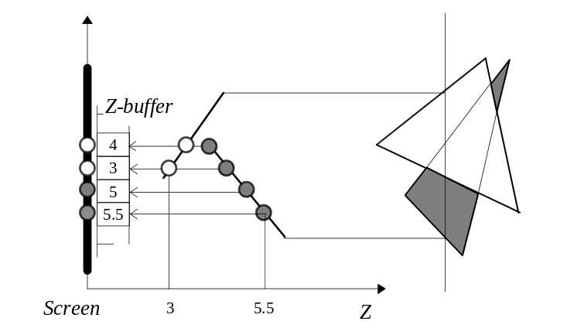
Figure 7.31: Rasterization using Z-buffer hidden surface elimination.

From Figure 7.31 it can also be seen that each screen pixel, besides some unit of storage in the image bitmap, must also have some allocated space to store current z value. An array of all z values is referred to as “Z-buffer”.

At the beginning of the frame rendering, we must initialize all locations in the Z-buffer with farthest value of z available at the selected precision. As a result, the first pixel obtained at any location will necessarily be allowed to be drawn by comparison logic of the algorithm.

Determination of the z coordinate in the case of polygons can be done by linear interpolation. We were determining using the same method the shading intensities in the case of rasterization with interpolative shading and texture coordinates in the case of linear texture mapping. Thus, we will keep z at each vertex until the rasterization stage, interpolate it along edges and then along the scan-lines using values on the edges.

It should be noted that if we employ the perspective projection transformation, the z coordinate in the obtained space doesn’t change linearly. It is attractive to use 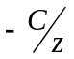 instead as the depth criterion which does change linearly in that space.

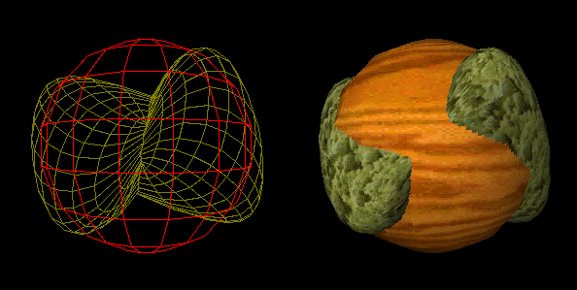

Figure 6.32: Handling of intersection of objects by Z-buffer algorithm.

Of many advantages Z-buffer algorithm has, its simplicity is, perhaps, the greatest one. Because of the simplicity it is often possible to implement this algorithm in hardware. Its generality and essentially linear running time makes it extremely attractive for high end applications. Problems with Z-buffer algorithm usually arise from the fact that we have finite and quite limited number of bits available to represent the z coordinate for each pixel on the screen. At some stage, we may be rounding or truncating the z values causing artifacts at the pixels where reduction of bits caused wrong determination of visibility. And of course, performance wise, we have pushed certain amount of code into the very inner loop of the rasterization routine. This causes certain performance penalty making the algorithm unattractive for applications which operate with moderate numbers of primitives. We must also note that Z-buffer is an array of a considerable size, and although memory limitations become softer and softer with time, for some applications just filling the Z-buffer with the initial value may incur undesirable cost. This algorithm is also vulnerable to the overdrawing problem since the obscured primitives must be rasterized nonetheless.

To summarise, the problem with hidden surfaces arises in world to screen visualization when an image of the virtual world is obtained by projecting primitives from the world onto the screen. Some primitives may obscure other primitives in the screen projection thus requiring some strategy to eliminate hidden surfaces. Of several hidden surface removal strategies which we have examined, many are applicable to models represented in terms of polygons only. A popular strategy is to rasterize the polygons in the back to front order so that the polygons which are closer overdraw previously rasterized polygons which were further away from the viewer. A number of ways exist to obtain a back to front ordering of polygons. The algorithms to do that range from sorting to space subdivision. This strategy however is wasteful of resources when rasterization of primitives is expensive since we have to rasterize all, even obscured, polygons. In such situations it may be advantageous to examine other seemingly inefficient solutions such as iterative clipping of all polygons using a beam-tree which avoids unnecessary rasterization.

Z-buffer method doesn’t impose any criteria on the shape of primitives and it is also the simplest hidden surface removal algorithm and it is, thus, often implemented in hardware. This algorithm also makes us to perform unnecessary rasterizations. Scan-line hidden surface removal allows to avoid this problem, but it is applicable to polygonal models only, and it also demands considerable changes throughout the polygonal pipe-line.

Running time of hidden surface removal algorithms is hard to compare since all of them have an elementary step of different complexity. Thus, implementations of algorithms with linear running time may behave worse then implementations of algorithms with more expensive running time. The advantage of the former usually becomes appreciable only when the number of polygons becomes extremely large. Only based on the particular situation and allowable relaxations a choice of the strategy can be made.

* * *

