Chapter 8 Lighting.

8.1 Physics of light, and human perception.
8.2 Modelling colors.
8.2.1 Achromatic light (black and white).
8.2.2 Tri-component color models.
8.3 Modelling illumination.
8.3.1 Ambient illumination.
8.3.2 Diffuse (Lambertian) reflection.
8.3.3 Specular reflection.
8.4 Illumination in screen to world viewing.
8.5 Radiosity.
8.6 Illumination in world to screen viewing.

It is hard to overestimate the human ability to perceive light. Of all the sensors that we have, eyes are, perhaps, the ones of most importance. May be, because information gathered by the eyes has the widest bandwidth compared with other body sensors. The whole area of computer graphics is build upon exploiting human visual perception.

Up to this point, we have discussed how to present the viewer with essentially just an outline of the virtual scene. However, it is intuitively clear that the very same scene should be pictured very differently depending on what kind of lighting we are trying to represent. Beside just appearing in a different color, scene with different lighting, may have completely different reflection and shadows patterns, and both of these are highly noticeable visuals.

Together, color and lighting, are two colossal topics in computer graphics. Both lie in the bordering area of multiple disciplines: geometry, optics, physiology. We will discuss basic principles of how colors are represented in computer graphics applications, and also different schemes allowing to model interactions between light sources and the objects being lit. Some of it is closely based upon the physics of how those processes appear to happen in nature. A lot, however, is of heuristical origin. There are several good reasons for that; the main one being that it is quite expensive to involve advanced optics or wave theory especially when it seems that we can live with a cheaper heuristic. Although heuristics involved, like reflection models, don’t quite yield an effect which is produced in nature, results obtained with their help are quite acceptable to the degree when it is hard to tell an image taken from a real scene from the one generated synthetically.

We are also going to consider general approaches to modelling color and lighting in 3-D applications, and particularly, how lighting is handled in world to screen and screen to world visualization.

8.1 Physics of light, and human perception.

The ultimate destination of the renderings we produce using computer graphics methods is to be processed by eyes. Therefore, the way how we see things is of immense importance and must always be taken into account.

What makes us distinguish red from blue, for instance? And, physically what is the difference between red and blue? Light is of electromagnetic nature and is due to variation of the parameters of the electromagnetic field over time. These electromagnetic waves are characterized by their frequency: number of pick intensities of the wave per unit time or by their length: distance between two consecutive picks. Our eyes are sensitive in a relatively small range of wave lengths from 400 to about 700 nm. Electromagnetic waves which fall into this range is what we call light.

Incoming light is focused by both eyes allowing for binocular vision. Since each eye receives a slightly different image of the scene, human visual cortex can approximate the distance to the object by comparing the two projections (neurones from both eyes are interlaced in the visual cortex). If the images of some object are roughly at the same place in both projections, this object is further away. If the images are shifted, the object must be closer. This is very easy to observe by closing eyes in turns and focusing on objects closer and further away. Binocular vision allows for exciting possibility of immersive virtual reality 3-D graphics where we make sure that each eye receives its own synthetically rendered image taken from a slightly different angle. When it happens, instead of a flat projection, we are deceived into perceiving depth of the scene. Of course, graphics applications must rely on special hardware in order to achieve this effect. Such hardware ranges from expensive head-mounted displays where each eye views its own miniature screen to inexpensive shutter glasses. The latter obscure their lenses in turns so that each eye would receive information in sync with changing image on a computer screen.

Inside an eye the image is projected onto the retina, being mostly focused on one small spot. The retina is covered with color receptors. There are two basic types of receptors: cones and rods. Rods are sensitive to energy of the light and don’t contribute directly to the color perception. Cones, on the other hand, are responsible for color vision. There are three different kinds of cones, each kind having maximum sensitivity in a different spectral region. The first type is sensitive in blue part of the spectre, the second in green and the third in red. Receptors most sensitive in red area do have some sensitivity in neighboring parts of the spectre, but it diminishes further away. Blue receptors have lesser density and thus provide less sensitivity than green or red (see Figure 8.1). This fact has an implication in building color palettes. We usually allocate less bits to represent blue color than each of the remaining colors.

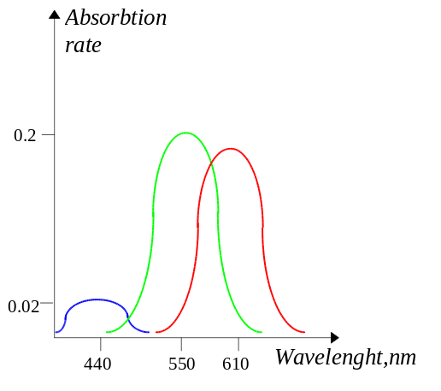
Figure 8.1: Ranges of sensitivity for different color receptors.

Generally, combined sum of the three distributions in Figure 8.1 demonstrates our sensitivity to color of different wavelength. Our best sensitivity to colors is close to the center of the spectral range.

Monochromatic light can be specified uniquely by the wave length and intensity. However, real visible light is not monochromatic - it’s a pack of waves with different lengths and intensities so to speak. Real light can be represented by its energy distribution in the visual range. Reddish colors would have their graphs slanted right and bluish slanted left.

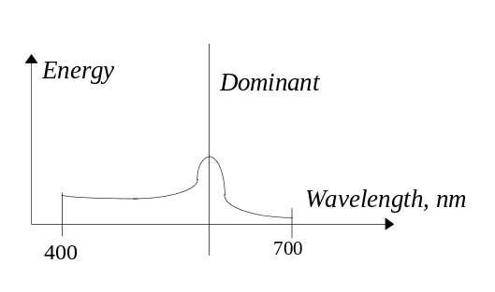
Figure 8.2: An energy distribution for some color.

Although necessary from the physical perspective, it is, of course, unreasonable to represent a color as an energy distribution in a computer graphics application. Besides, due to the peculiarities of the human vision it is so called dominant wave length, usually the maximum of the energy distribution with respect to eye sensitivity, that really matters for our perception. And in fact, colors with relatively different energy distributions but with roughly the same dominant wave lengths, will be perceived as having the same hue. Total amount of energy (area under the distribution) relates to perceived saturation of the color, amount of white in it. For instance, distribution of ideal white is a straight line across the spectral range without any dominant wavelength and therefore having 0% saturation. A 100% saturated color should have only a spike of energy at a certain place and maintain zero level of energy otherwise. Brightness of color relates to the magnitudes of energies especially that of the dominant portion of the distribution.

On the assumption that representing a color through an energy distribution is both too complex and doesn’t take into account particularities of our vision system, we are going to examine practical approaches to modelling colors in computer graphics applications.

8.2 Modelling colors.

Attempts to reproduce colors in different artifacts date back centuries. Color mixing for paintings and color television are perhaps the brightest examples. In all cases, a scheme much simpler than an energy distribution was used, and with quite acceptable results. Let’s consider several schemes pertinent to use in computer graphics applications.

8.2.1 Achromatic light (Black and white).

Total energy of light is very important for our perception. The fact that we can watch black and white images and relate them to the real life is an indirect prove of that. Early television and early computer graphics used to be black and white. The reason why this scheme was popular is, of course, in simplicity with which a uni-color can be represented and reproduced. All we require is just one number related to the magnitude of energy of this light. Higher energy translates into brighter color, less energy into dimmer color.

When we represent lighting effects, such as reflections for instance, which we are going to consider shortly, we need a set of different shades of a color. To achieve that, it is natural to assign a range of indices to different shades, so that increasing this index will correspond to perceiving a proportionately brighter shade.

Generally, such index is not simply proportional to the energy of light. This dependency is in fact logarithmic. At lower magnitudes of energy we need smaller increases and at higher magnitudes bigger increases in energy to perceive a proportionally brighter color. This is due to the fact that our visual system is not very good at detecting gradation in shades at higher levels of energy. Most of the time this is considered in the characteristics of computer display devices however.

Once we set up a system of indices corresponding to varying shades of an achromatic color, we are capable to perform certain amount of operations on light described in this form. For instance, since combined effect of two lights must intuitively correspond to sum of their energies, we can model it by summing the indices. Similarly, we can interpolate indices to find intermediate values between two points with known intensities.

However, it is not unlikely that by adding two indices we may overflow the total number of available shades. Therefore, in cases where we do have an upper limit on the number of available shades, we should devise a strategy how to always produce a valid number as a result of any operation involving colors.

The simplest strategy is to clamp the index at the upper limit so that any color which should have been brighter, is represented by the brightest shade available. Another possible strategy is to attempt to avoid such situations by proportionally rescaling all colors so that the biggest obtained color will correspond to the available maximum and the rest are proportionally smaller.

Although achromatic light is still important for many different technologies, such as producing a hardcopy on a printer, modern 3-D graphics relies on color as a main tool to achieve visual realism.

- Tri-component color models.

We have already seen that certain properties of the light distribution are more important for our visual perception. Dominant wavelength relates to the perceived hue of the color, area under the distribution roughly relates to color’s saturation - amount of white in it. Levels of energy in the dominant portion of the distribution relate to perceived brightness of the color. This notions are fairly intuitive and thus one approach to modelling colors is by describing their hue, saturation and brightness. This is known as HSB system and the space of the colors which we are able to describe with its help can be represented by the following cone (see Figure 8.3).

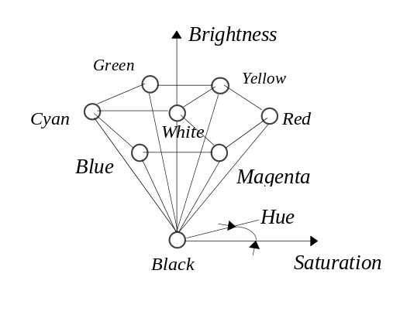
Figure 8.3: HSB color space.

In this system, the hue is measured angularely, and the brightness is measured horizontally. Therefore, black is located at the bottom and white on the top. Notion of saturation is ill defined for very dim colors which, in the case of the diagram, explains why range of the saturation increases for brighter colors.

Although this system is intuitively clear and allows specification of colors by human users, it is not very convenient for internal usage by a computer program. For the purposes of the latter, we are looking for a system allowing to easily express interactions of several light sources, for instance, expressing combined effect of multiple lights or interpolating between two known colors.

Since the sensitivity of eyes is concentrated around the three areas, we can try representing an individual color as a weighted sum of its intensities in the respective ranges of the three components, red green, and blue which are often called prime or pure colors. Thus we can specify a color as:

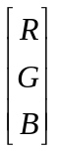

Where R,G and B are intensity levels for red, green and blue wavelengths respectively. Representing a color as a triple of values is, of course, a much more workable representation than an energy distribution. Although it is not completely correct, and neither does it cover the full range of visible colors, its simplicity and additive nature is of great value.

This system is called additive because the contributions of pure colors are added together producing a combined result. We have already encountered, in chapter one, references to actual display hardware which employed RGB system to specify colors.

This system, due to its additive nature, also allows to express combined effect of two lights as a vector sum of their respective RGB triples:

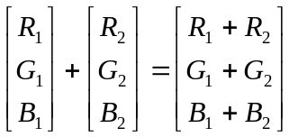

Intuitively, we can consider each color as a point in a three-space formed by the axes of the pure colors (see Figure 8.4).

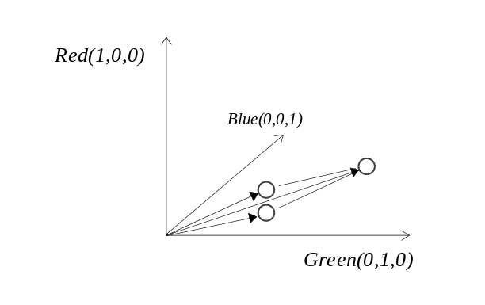
Figure 8.4: RGB color space.

Generally, similar to the situation with shades of achromatic light, we are limited with the ranges of intensity each pure component can assume. Thus, all representable colors can be considered to belong to the insides of a cube pictured in Figure 8.5.

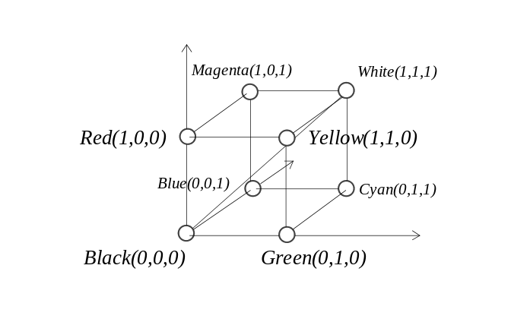
Figure 8.5: Color cube.

In this cube, shades of grey belong to the diagonal, connecting white (1,1,1) and black (0,0,0). The space covered by this cube roughly corresponds to the cone of HSB representation. If we look along the diagonal connecting black and white, it becomes apparent that it corresponds to the axis of the cone in Figure 8.3.

Similar to the problem we had in the case of finite numbers of shades of an achromatic light, in this case, we also can’t guarantee that by adding effects of two lights we will remain within the boundaries of the cube. A common strategy is to clamp the three components individually in cases when their values overflow the set limit. An alternative approach is to attempt avoiding an overflow by proportionally rescaling all colors. In many cases, however we don’t know beforehand all possible lights and their interactions, thus the first strategy is the one commonly used.

There exist many other models devised to describe colors such as YIQ which is used to describe broadcast TV signal, or CMY often used in hardcopy printer technology. The RGB system however is commonly used for the purposes of computer graphics, mainly because it allows to split most lighting problems into three independent parts one per each pure color. Due to system’s additive nature, the combining effect of separate solutions for each pure color roughly corresponds to the answer we expect to see in the real life. For instance, this system is fairly well suited for interpolation between two different colors done by combining effects of interpolating each component individually. It is unlike HSB system which would not always produce an acceptable result in this case. RGB system is often extended by adding a forth component: “alpha” essentially describing transperency. The extended RGBA system helps to model complex illumination effects.

In chapter one we have already seen that the display hardware may support different schemes of representing image bitmaps. In one case, the color of each pixel was represented directly through its RGB value, in another case the color was specified as a palette index. In the latter method the palette stored the actual RGB value and was limited in size. In many situations we may have to convert a bitmap stored in the first representation into the second representation and thus be forced to reduce the number of colors. Since the first representation is almost continuos and the latter one is inherently discrete this problem is known as that of color quantization.

If we select all unique colors from the original image we must essentially find some set of clusters in the color-space so that the colors within the clusters are optimally close to each other and then substitute a single color for the entire cluster. This problem happens to be quite expensive to solve directly. However many techniques exist which can efficiently find some approximation and, as a result, a visually acceptable color reduction. We are going to consider the median-cut algorithm which is due to P.S. Heckbert and was originally described in the early eighties [HECK82].

The idea of this algorithm, which treats colors as points in 3-D, RGB space, is to first find the bounding box around the original set of colors. Further, we can split the problem into two subproblems by cutting the space along the median of the longest side of the bounding box.. Figure 8.6 shows steps in this process which is illustrated for simplicity on a planar example which ignores the axis G.

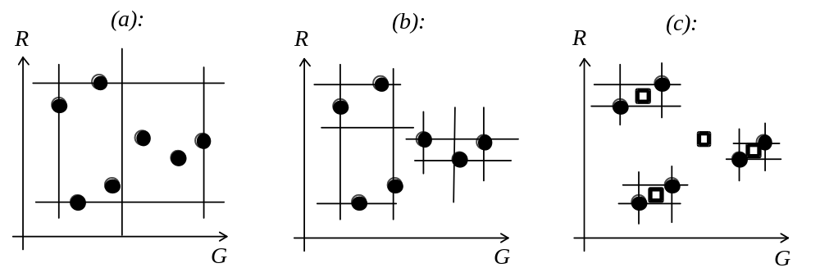
Figure 8.6: Steps in the color-reduction procedure.

As Figure 8.6 (a) illustrates we split the space along the median of the longest side of the bounding square. We further proceed recursively computing the bounding squares for the points in both partitions and perform the splits (see Figure 8.6 (b)). In one case the split happened along the axis G, in another case along the axis R. We stop the algorithm once we have obtained the necessary number of partitions. For instance, if we have to substitute the original set of colors with four colors, we stop after two levels of splits and compute the sought colors as the centroids of clusters of points within each partition (see Figure 8.6 (c)).

It should be noted that in order to improve the quality of the color reduction, the median-cut algorithm may have to consider the frequencies of how often the points from the original set appear in the image. This information is used during the computation of the medians and the centroids so that the median along an axis is computed as the sum of frequencies times the coordinate along that axis divided by the sum of the frequencies. The coordinates of a centroid are computed as medians along the respective axes.

As we shall see in the following sections, for the purposes of representing illumination effects we need to be able to represent shades of different intensity of the same color. While it is easy to do when the image bitmap stores entire RGB values, it becomes much more complicated in the palette based representation. In that representation, we have only a limited number of colors available, and the bitmaps store indices to the palette entries. We may have to arrange the colors in the palette in a way so that increasing the index corresponds to some brighter color. However, if some of the colors in the palette have completely different hue it becomes difficult to place them in any order. In such a situation, we may be forced to logically split the palette into groups of colors only within which the increasing index corresponds to a brighter shade.

We must note that such groups may still share some colors. For instance any color under zero illumination is supposed to be black. Since, considering the limitation on the number of colors we have, we can’t afford to store the same color multiple times, it may be necessary to resort to using a secondary indexing structure to reflect the sharing. To represent the sharing, it is relatively common to build a two-dimensional array storing palette indices so that one dimension represents logical index to a color and the other dimension the shade number. Due to the sharing of actual palette colors among some shades of the logical colors, the size of the table may exceed that of the palette.

It should be stressed however, that increasing index of the shade will roughly correspond to illumination by a brighter monochrome light. It will require more dimensions in the secondary table if we wish to allow light-sources of different color. In the constrained palette scheme such generalization becomes not very practical, however.

8.3 Modelling illumination.

In the previous sections we have examined nature of light, its properties, and approaches to modelling light of different wavelength composition (different colors) for the purposes of computer graphics. However, it is the interactions of light emitted by some light sources and the objects in the surrounding world that matter for our visual perception allowing us to sense the surrounding environment.

The ultimate goal of 3-D graphics is to portray images of virtual worlds as if taken from the real world. In this endeavour we must pay particular attention to modelling light-matter interactions since it is of such great importance for our vision.

There are many different kinds of interactions between light and matter that take place. For instance, matter can absorb, reflect or transmit light. These effects can be generally explained and modelled based on particle properties of light, that is, by modelling light as a collection of tiny particles. Modelling other effects such as interference, defraction or refraction require the aid of the wave theory and are generally more complex. Overall, sufficiently detailed lighting model which considers multiple effects of light-matter interaction is both complex and expensive to handle by computer programs, especially, the programs which must produce images at interactive rates. Most applications are, therefore, forced into modelling only absolutely crucial interactions, notably reflections. In this section we are going to consider components for a lighting model which are widely used in computer graphics.

- Ambient illumination.

Probably the simplest and oldest illumination model attempted in graphics applications is that of ambient light. In this model, it is assumed that there is no concentrated source of light, and the illumination is equal from any direction maintaining constant levels throughout the world.

With such illumination, each surface demonstrates its intristic reflective capability. The objects which reflect light better, appear brighter and the objects which mostly absorb light, appear darker. Obviously, this has to do with what we commonly refer to as a color of a material object. In the every day life, we are used to seeing objects in a fairly uniform white light which is emitted by the sun. What we refer to as a color of some material object in fact describes its capability to reflect white light. Generally, reflective capability can be described by a coefficient in the range [0,1] with 0 meaning that the object absorbs hundred percent of light of a given frequency, and 1 meaning that the object is a perfect reflector. Obviously enough, this coefficient must vary for different wavelengths - most objects absorb in some frequencies and reflect in others. Therefore, the general reflective capability of a material object can be described by a distribution in which the coefficient is given as a function of the wavelength of the incident light. This, of course, is very inconvenient, and besides, according to the discussed before color models, we can represent a color as either a single index, in the case of achromatic light, or a triple, in the case of colored light. In this regard, reflectivity of matter can be also represented either as a single coefficient in the former case, or as a triple of coefficients in the latter case. Generally, this lighting model can be expressed as the following simple equation:

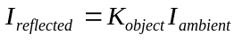

In this expression we obtain the intensity value for the reflected light as a product of intensities of ambient light and the reflection coefficient of a given object. Note that both 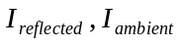 and 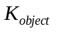 are scalars in the case of achromatic color model or three-tuples in the case of colored light.

Since the level of ambient light stays constant, we can preset 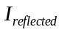 for each surface in the scene and thus display each object using its own intristic color. Of course, such illumination model doesn’t provide even minimal amount of realism; all we can see are just colored silhouettes of some shapes (see Figure 8.7).



Figure 8.7: Ambient illumination.

If the realism is sought, we will have to search for a more complex illumination model. However, even with fairly sophisticated models which are employed nowadays, we often have to use an ambient light component to complement for effects which we don’t want to compute, such as multiple reflections of light from matte surfaces which can be very roughly modelled as ambient light.

8.3.2 Diffuse (Lambertian) reflection.

Quite unlike the assumption which was taken in the case of ambient light, which was considered to be uniform from any direction, in the real world, the light is often emitted by a particular light-source. Thus, the light often falls onto some surface from a particular direction. In order to model reflection in this case, we must consider both location and type of the light sources as well as properties of reflecting surfaces. We can differentiate point light-sources which emit equally well in different directions, spot-lights having a predominant direction, and directional light-sources. The latter occur when some light-source is remote from the modelled scene so that the direction of light doesn’t change significantly across the scene. Light-sources of these types illuminate the material objects modelled in the virtual world which reflect some of the light falling onto their surface. Lambertian or diffuse model of reflection is based on the assumption that light is reflected equally well in all directions (see Figure 8.8).

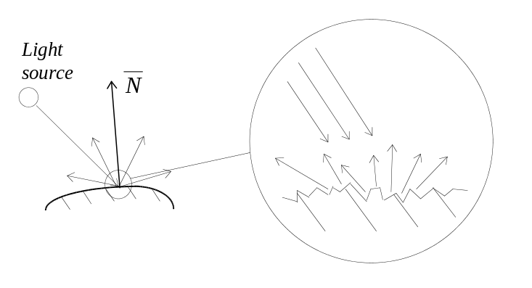

Figure 8.8: Diffuse reflection.

This model generally holds for matte surfaces. The roughness of these surfaces is such, that each tiny region consists of a big number of micro faces oriented almost randomly in space and therefore reflecting in all possible directions (see Figure 8.7). Hence, the intensity of the light reflected in any direction only depends on how much light has fallen onto the surface. This, of course, is a function of the surface’s orientation with respect to the direction of light. If the surface is facing the light source, being perpendicular to the direction of the light, the density of the incident light is the highest. If the surface is directed under some angle smaller than 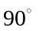 the density is proportionately smaller. This relationship is demonstrated in Figure 8.9.

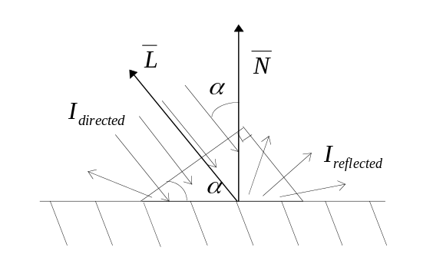
Figure 8.9: Geometry of diffuse reflection.

From the Figure 8.9 it can be seen that the same amount of light which passed through one side of a right angle triangle is reflected from the region of the surface corresponding to triangle’s hypotenuse. Due to the relationships that hold in a right angle triangle, the length of hypotenuse is 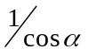 of the length of the considered side. Thus, we can deduce that if the intensity of the incident light is 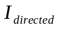 then the amount of light which is reflected from a unit surface is 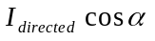. Adjusting this with a coefficient describing reflection properties of the matter, similar to the approach taken in the case of ambient light, we obtain the following equation to describe the diffuse reflection:

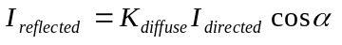

This equation demonstrates that the reflection is at its pick for surfaces which are perpendicular to the direction of light and diminishes for smaller angles. We must note that if the angle is more than 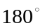 or less than 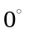 this surface must be obscured from the given light source and thus no light falls and is reflected from it. However, if we just evaluate the equation in this case, we will obtain a negative intensity of the reflected light, which, to preserve the physical sense, must be set to zero.

From a practical point of view, the above fact also constitutes a problem. In the environment with a single directed light source all surfaces oriented away from this light will be black. Although such a situation may happen when modelling emptiness of space, in most practical settings some light will still reach such surfaces by reflecting multiple times of other surfaces. The diffuse reflection model, which we are considering, only takes into account the reflection of the light emitted by a light source and doesn’t handle the light reflected by other surfaces. It is practical to adjust the model with the ambient light component which will simulate the multiple reflections as some constant term:

The above expression is referred to as Bouknight illumination model [BOUK70], named after its creator. Figure 8.10 demonstrates a sample scene rendered using this model.

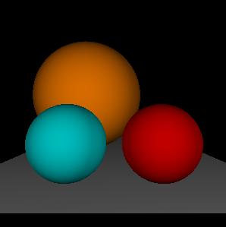

Figure 8.10: Diffuse or Bouknight illumination.

When we implement this model, assuming that we know the properties of surfaces and lights, we still must find a way to compute , a multiplier that classifies orientation of the direction of light and the surface. In the previous chapter we have already seen normal vectors in the role of describing the orientation of a plane. Let’s suppose that the direction towards the light source is also given as a unit vector named 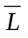. By definition, the scalar product of the two vectors can be expressed as

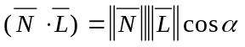

Where 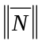 and 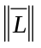 are lengths of the vectors. Assuming that both vectors are of unit length, we can compute for the purposes of the reflection model as the scalar product of the direction of light and the normal of the surface at the point where we want to find the intensity of the reflected light. Thus, the expression for Bouknight illumination model can be computed as:

In this expression, depending on the particular color scheme used, the terms are either scalars (in the case of achromatic light), or three-tuples (in the case of RGB color model).

In the previous chapters we have discussed how to find a normal vector. However, until this point, we never had a requirement demanding such vector to be unit length. Indeed, for such purposes as back-face culling or building a plane equation, vector of any length, as long as it was pointing in the right direction, was acceptable. In the case of evaluating the light model, we require unit length vectors. Clearly, any vector can be scaled to unit length if every coordinate is divided by its present length:

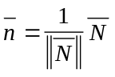

We have already seen that, by definition, the scalar product of a vector multiplied by itself equals to the square of its length. Thus, the length can be found by computing the square root of the scalar product of the vector multiplied by itself:

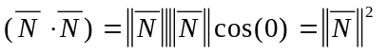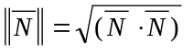

In the process of computing a unit length vector, the only difficulty may be due to finding the square root when computing the length of the vector. This computation can be considered as a fairly expensive one.

A relatively fast way to find the square root is by employing the binary search algorithm. In this method, we make an initial guess of the result and compute its square. If this square is bigger than our argument, the square root is bigger than our guess. If the square is smaller than the argument, the actual square root is smaller than our guess. By employing the binary search technique we may proceed in a way to reduce in half the interval on which we search for the square root. When the interval becomes smaller than certain precision value we know that we’ve found the square root with this precision.

Although this method is relatively fast and in most cases doesn’t require but a few iterations, we still have to compute the square in each iteration. In many situations the coordinates of the objects in space are integer and in computing lengths of vectors we may be satisfied with an integer number as a result as well. We can take advantage of this assumption in the algorithm which finds the square root by analysing which of the bits must be set in the result.

In this algorithm we initially set the highest possible bit in our guess value and compute its square. Since a single set bit represents a value which is a power of two, finding a square can be done through shifting. If the square is bigger than the argument this bit cannot be set in the result. If the square is smaller, this bit indeed must be set in the result. We further proceed to set and test the second highest bit. Since the guess value may have several bits set at this stage we can’t compute the square simply by shifting. However, the square of a sum can be computed as follows:

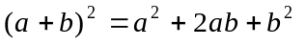

If a is the guess value from before we set the current bit and b is the current bit, than (a+b) is the new guess value with the current bit set. We can see that the square of the new guess value can be computed as a sum of three components of which the first represents the square computed during previous iteration and two other represent multiplication of values at least one of which is a power of two, and thus, these components can be computed through shifting. Once we have the square, we again check whether this bit is present in the result. When we proceed further to the next iteration, the same situation reappears and we will be able again to compute the square of the guess value with the new bit set by relying on the square computed during previous iteration. At the time we exhaust all bits we have computed an integer approximation of the square root.

An implementation of this algorithm is presented in Listing 8.1.

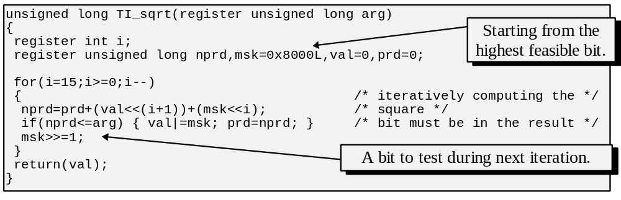Listing 8.1: Computing the square-root by iterative bit setting.

Note that in the implementation in Listing 7.1 we expect integers to occupy 32 bits of storage, and thus, we start the computation with the biggest guess value whose square doesn’t overflow the available precision.

8.3.3 Specular reflection.

Although diffuse model can describe sufficiently well reflection from matte objects, many other objects in the world have smooth surfaces which reflect light into a single predominant direction mirroring the direction of the incident light. This phenomenon is known as specular reflection and is exhibited by smooth, shiny, polished surfaces. When our direction of view coincides, or nearly coincides with the direction of specular reflection we see a bright highlight, a reflection of the light source off the shiny surface (see Figure 8.11).

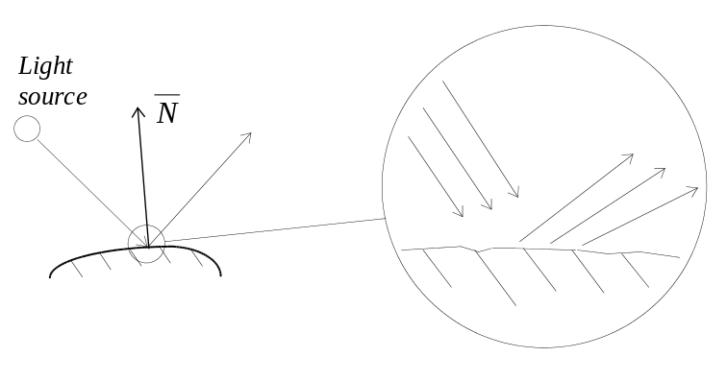
Figure 8.11: Specular reflection.

It is clear that a model describing this effect will be dependent on both the location of the light source, location of the viewer and the orientation of the surface. The highlight at a particular place on the surface is observed when the viewer is located in the way of the specularely reflected light. If the observer moves, the specular highlight may still be visible as reflected from a different part of the surface. For many materials, the mechanism of the specular reflection is such that the wavelength combination doesn’t change much during the reflection, therefore the color of the highlight is the same as that of the light source and doesn’t generally depend on the color of the reflecting surface.

Generally, a theory describing reflection of shiny surfaces is quite complex. For the purposes of computer graphics we mostly use only an approximation which is called Phong illumination model named after its creator Phong Bui-Tuong [PHON75]. This model is suited for describing reflection from surfaces which are not perfect reflectors. According to this model we see a specular highlight, which has the same wavelength composition as the light source, when we are close to the angle of the reflection. The intensity of reflected light falls off sharply when viewer moves away from the direction of the specular reflection (see Figure 8.12).

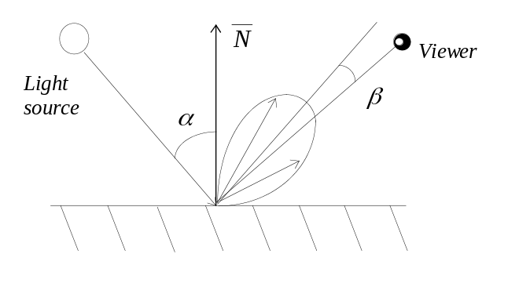
Figure 8.12: Geometry of specular reflection.

The falloff of the intensity is commonly approximated by 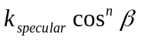 where 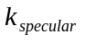 is a scalar coefficient showing the percentage of the incident light reflected. Since the color of the reflected light has generally the same wavelength composition as that of the light source, this coefficient is a scalar in any color model. In the expression, the exponent n characterizes the shiny properties of the surface and ranges from one to infinity. The objects which are nearly matte require small exponent since they produce a larger, dim specular highlight with a gentle falloff. This can be intuitively explained by the fact that such surfaces are not very smooth on a microscopic level, and thus, each tiny region reflects light in a slightly different direction. On the other hand, perfect reflectors have a sharp highlight which is approximated by a very large exponent in the above expression making the intensity falloff very steep.

The objects which are not perfect reflectors also demonstrate certain amount of diffuse reflection. Thus, the places of the shiny surface where the viewer doesn’t observe the highlight show regular diffuse reflection. Considering this observation, Phong illumination model can be expressed as:

Note that we also use the ambient component to complement for the light which was reflected by other surfaces rather than emitted directly by a light source. Figure 8.13 demonstrates a scene rendered using Phong illumination model.

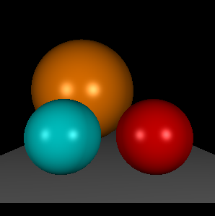
Figure 8.13: Phong illumination.

From the implementational perspective, we can see that in the expression we must be able to compute 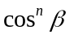. Similarly to the technique used in the previous section, we can find it by using the power of the scalar product of the unit vectors describing the direction of the specular reflection 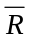 and the unit vector 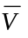 describing direction towards the viewer. Using the scalar products we can rewrite the equation as:

In this expression we must, however, use vector which describes the direction of the reflected light. This vector can be found by examining the relationships in the equal triangles which describe the geometry of specular reflection model (see Figure 8.14).

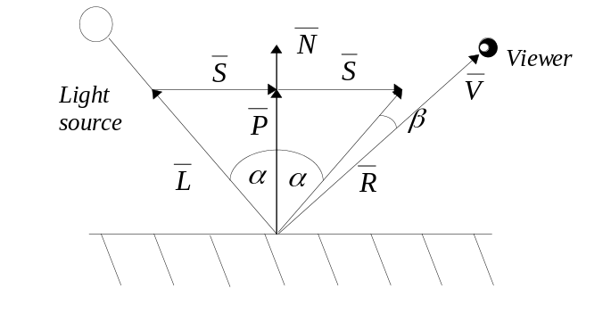
Figure 8.14: Geometry of specular reflection.

From Figure 8.14 we can see that vector can be found as a vector sum of vectors and 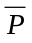. The latter vector is a projection of vector onto the direction of the normal vector. The length of such a projection for a right angle triangle can be found as 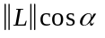, where can be computed using the definition of the scalar product. Considering the fact that both and 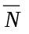 are unit length, we can express the length of the vector as 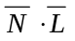. The vector itself can be expressed as 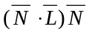 since it is co-directed with the normal. The vector , can be found as a vector difference: 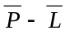. Thus we can express the unit vector specifying the direction of the specular reflection as:

As a result, the expression for Phong illumination model can be restated as:

This formula, of course, is quite computationally intensive, especially considering the fact that it must be evaluated for a very big number of points. In practice, this formulation of Phong illumination model is often substituted for a slightly relaxed one. Instead of measuring when the direction of view comes close to the direction of reflection, we can alternatively measure when the orientation of the surface becomes such as to produce a highlight for the viewer. This can be achieved by considering an angle between surface’s normal and so called half-way vector 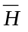 (see Figure 8.15).

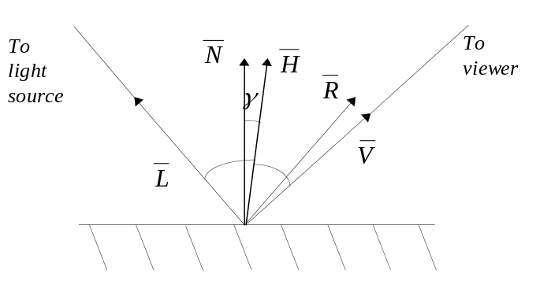
Figure 8.15: Alternative formulation of specular reflection.

The vector is oriented in a way to point half-way between the direction towards the light source and the direction towards the viewer. Thus, when this vector coincides with the normal, the direction of the reflection coincides with the viewing direction and we observe a specular highlight. The Phong illumination model, in this case, can be formulated as:

This approach gives certain computational advantage since computing 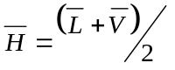is less expensive than computing 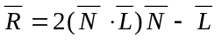. A further speedup can be achieved if we assume that both light source and the viewer are located in the infinity thus making half-way vector constant along the considered surface. This, however, would have certain undesirbale implications for interactive applications since the specular highlight would not move with respect to viewer’s movements as we expect it to.

We should note, however, that the two formulations of the Phong illumination model are not equivalent and that neither describes the actual physical process of reflection. However, since our goal is just to present a realistic enough portrayal of the virtual scene, we have to employ a computationally feasible apparatus which such models provide us with.

There are many refinements which are available for this model. Some of the refinements attempt to add considerations for phenomena other than reflections. For instance, we can consider light-source and atmospheric attenuations. In the first case, since the light from a point light source propagates equally well in all directions forming a spherical front, its energy falls off with distance in the inverse proportion to the area of the front, which is roughly a square of the distance. Similarly with atmospheric attenuation, when light is travelling through some uniform media, some of it is getting absorbed, hence the intensity also falls off with distance, in this case, simply proportionally to the distance travelled. We can also introduce a term into the equation describing the light which is transmitted rather than reflected by the matter. The latter is very important for the applications modelling transparent or semitransparent object such as water or glass. Adding all these effects give, at times, a considerable improvement to the portrayed scenes. It should be stressed again, however, that the falloff dependencies are often chosen through experimentation and examination of effects produced by different terms rather than through analytical means.

8.4 Illumination in screen to world viewing.

So far, we have considered only local interactions between light sources and material objects being lit. However in the real life, there often are multiple sources of light and multiple reflecting objects which interact with each other in many ways. Handling lighting for the whole virtual scene is often referred to as a global illumination model. Such models are introduced into the framework of the general viewing methods which we have considered previously. In this section we will discuss how to add a global illumination model into the screen to world, ray casting process. In the cases when we use screen to world method to both compute the visibility and illumination, the algorithm is often referred to as ray-tracing as opposed to ray-casting which is often used in conjunction with visibility determination only.

Introduction of illumination model into screen to world methods can be done in a very consistent manner. Let’s recall that in this viewing method we cast a ray for each pixel on the screen into the representation of the virtual world. The visibility is solved by examining all intersected surfaces and choosing the one which is closer to the viewer.

In order to add local illumination, we must locate some attributes of the intersected surface, such as its normal vector and the material properties. These combined with attributes of a light source, notably position and brightness allow us to apply any of the illumination models thus far considered. In the case of multiple light sources, their effect is additive since light energy in a point is a sum of contributions from all sources of light. Presented previously Figures 8.7, 8.10 and 8.13 were generated using a ray tracing algorithms with ambient, Bouknight and Phong local illuminations respectively.

However, these local illumination models only take into account relationships between a single object and light sources. They don’t consider effects which result from the presence of multiple objects. For-instance, a light source can be obscured from a given point by another surface and, thus, it may not contribute to the local illumination in this point creating a shadow. Similarly, light can be contributed locally not by a light source, but by a reflection of light off some other object.

Fortunately, the apparatus of the ray-tracing, already in place to resolve visibility, can be extended in order to handle some aspects of global illumination. Of the two effects considered, the first one requires that we check the light-source visibility in the point where we evaluate the lighting model. We can do it by casting a ray, called a shadow ray, from the point towards the light source. If the ray intersects some surface before the light source, this light source is obscured and its contribution is not considered. This process is demonstrated in Figure 8.16.

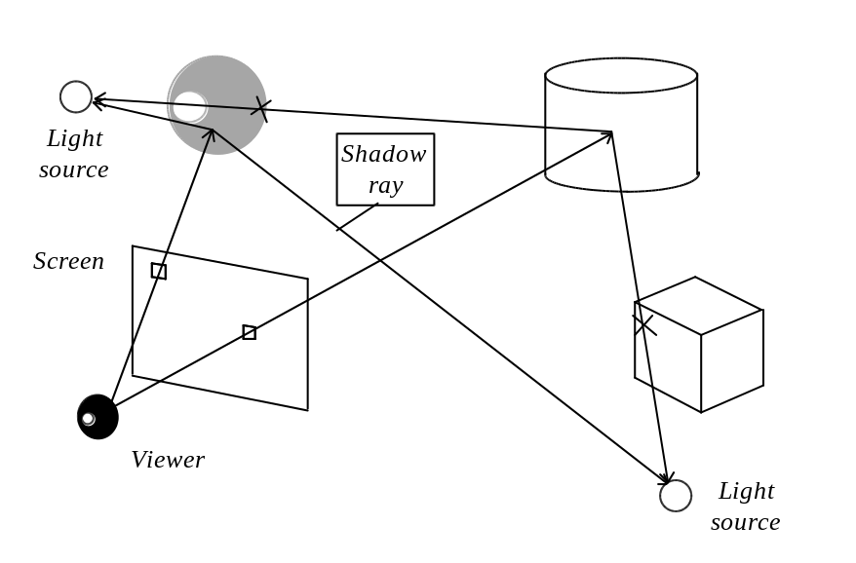
Figure 8.16: Computing shadows.

We must note that we are looking for the first intersection in between the light source and the point where we compute visibility. Therefore, the complexity of casting a shadow ray is somewhat smaller than that of a visibility ray since we may not have to examine all objects as we stop after locating the first intersection. We should also be careful not to consider in the shadow ray computation the intersections which occur after the light source or before the point. This can be achieved by constructing a ray with a co-directed vector which is a difference of the light source position and the given view point. With such a ray, intersections before the point will resolve with negative parameter t and the intersections after the light source with a parameter t bigger than one.

Adding considerations for shadows improve considerably the realism of the rendered images. Figure 8.17 demonstrates a scene produced using the described technique.

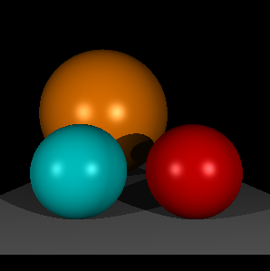

Figure 8.17: Ray-tracing with consideration for shadows.

From looking at Figure 8.17 we can see that all the shadows are sharp, precisely delimiting illuminated regions from shadowed regions. In many realistic environments, however, the shadows have softer edges where the illuminated region softly becomes shadowed. This is caused by the fact that real-life light-sources are not ideal points but have certain surface area. To obtain more realistic soft shadows, we must somehow compute not just whether the light source is visible, but also how much of it is visible. Thus, regions just on the edge of light source visibility will gradually become shadowed as the area of the visible light-source diminishes.

We have also noted that illumination in a point can be contributed by the light which came not directly from the light source but rather was reflected into the given point by some other surface. Thus, we can generalize any illumination model in a way to include both direct contribution of light sources and contribution of light which was reflected onto the surface by the environment:

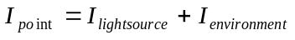

In the case of the most popular Phong illumination model and specular reflection in particular, we can easily find some additional contributions of the environment by the process which is known as recursive ray-tracing. In the case of the specular reflection there is a predominant direction of reflection. Previously, we were examining this direction to find out whether some light source produces a specular highlight in a point. In this case, we must examine this direction to also find if there is something else in the environment that may create a highlight. Thus, by applying ray-tracing algorithm recursively we can cast a reflection ray in the direction along which the light should have arrived if it was reflected by some objects in the environment and include the obtained value as a contribution to the local illumination model. Figure 8.18 illustrates such a process where both shadows and environmental reflections are computed.

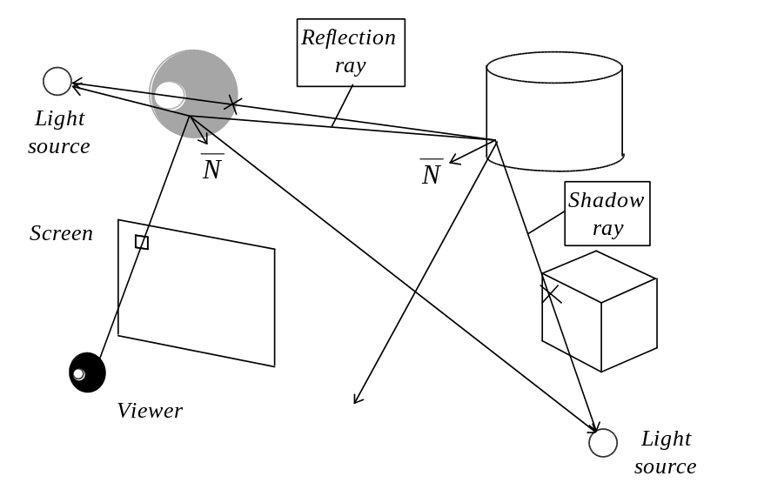
Figure 8.18: Computing shadows and environmental reflections.

Of course, this process is recursive. In order to compute proper lighting somewhere along the path we may have to spawn yet another reflection ray. On practice, we must always set a limit to a number of times a ray can bounce since, at some point, the possible additional contributions become quite negligible.

The contribution of the environmental reflection must also be weighted by a coefficient which depends on the reflecting capabilities of the surface. Although this coefficient is logically the same for any light: either coming form a light source, or coming from some bright object, on practice, we usually separate the two so that we can have a better handle of the production of images. Figure 8.19 demonstrates a rendering computed by recursive ray-tracing.

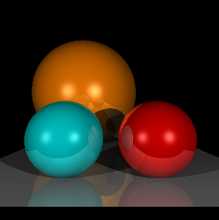

Figure 8.19: Ray-tracing with consideration for shadows and environmental reflections.

The reflections in Figure 8.19 contribute nicely towards the realism of the image. It should be noted that such reflections may show parts of the world which are not directly visible to the viewer. It is expensive to both, model extra objects in the virtual world, and to always compute light interactions between objects which are never directly visible. In such situations we can place the objects which are directly visible inside a cube, the internal polygons of which carry texture maps representing static pictures of the environment which is not directly visible. By doing that, we both avoid extra modelling efforts, since the pictures may even be taken from the real-life environments, and shorten the depth of the recursive rays.

Generally, ray-tracing can be coded in a very compact implementation, thanks to uniform framework which is used to solve different tasks, such as visibility, shadows and different components of illumination model. Listing 8.2 demonstrates a main tracing routine used to generate the presented renderings.

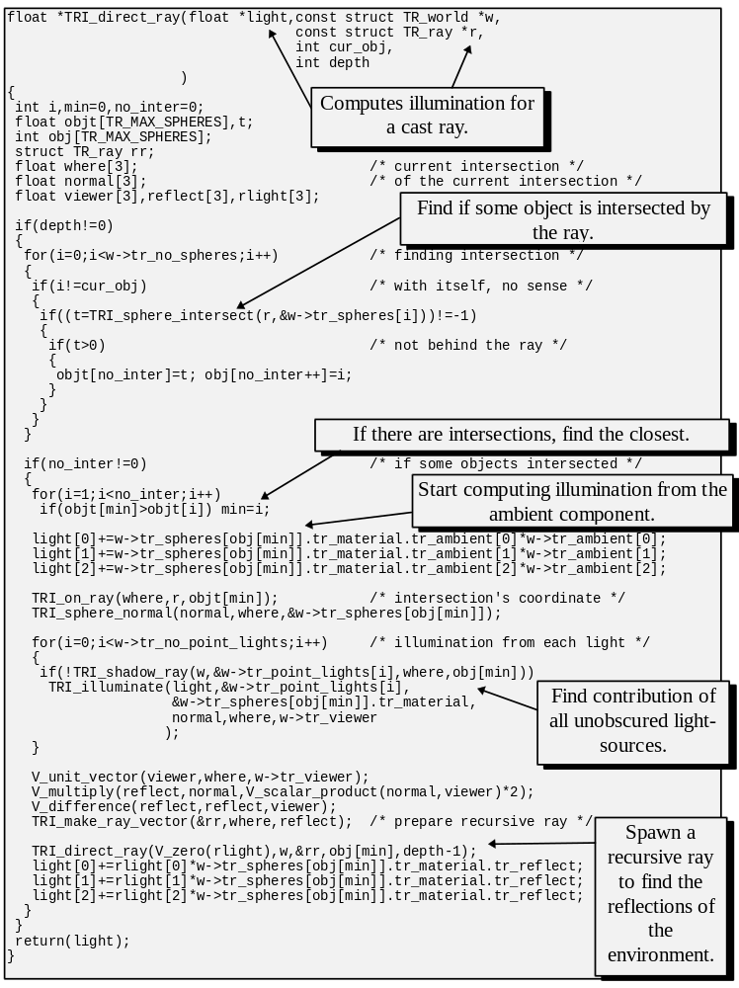
Listing 8.1: Recursive ray-tracing.

We must note that ray-tracing algorithm can be extended in a similar manner to account for other illumination effects, for instance, refraction of light through semi-transparent objects. The latter can also be done by casting a recursive ray into the proper direction inside the object.

There are also possibilities to account for light attenuation by introducing a function describing how the intensity of light diminishes depending on the distance travelled. We often want to model irregularities of surfaces. This can be achieved by assigning to the surface a texture map where each cell stores its own diffuse reflection coefficient, rather than to have a single coefficient for the whole surface. To model irregularities even further, we can associate bump-maps with the surfaces. These describe how the normal vector is perturbed across the surface so that a slightly different direction of reflection, for instance, would be computed in different points.

Combining these and many other possible effects is quite straightforward under the unifying framework of ray-tracing and it enables us to produce quite impressive images using this technique.

However, there are number of problems with recursive ray-tracing approach which are reasons for some unreal visual clues usual in ray-traced images. Firstly, we treat specular reflection differently depending on the nature of light. In the case of light sources, we have an approximating function which allows us to produce extensive highlight. On the other hand, the contribution of the environment is computed by following the reflected ray. If the same strategy was used for light sources as well as environment, all highlights produced by light sources would have been one pixel big at most. In other words, we are making the adjustment for surface imperfections in the case of light sources but not in the case of environmental reflections. As a result, reflections often look too good, giving the ray-traced images a surreal look.

Another fundamental problem with the modification of the Phong illumination model which allowed us to compute specular reflection of the environment, is that it doesn’t consider contribution of light reflected by the environment in a diffuse manner. Any diffuse surface emanates light in all directions some of which must end up in the point where we evaluate the illumination model. Our model doesn’t consider that, and the only possible modification is not possible. Since the light reflected somewhere in a diffuse manner can arrive to a given point from potentially any direction, we should attempt to shoot rays into all directions to find the necessary contributions. Considering that this is also a recursive process, the scheme is not computationally feasible. In the next section we are going to briefly consider a method which resolves illumination of multiple diffuse surfaces.

Overall, ray-tracing is one of the most important tools of computer graphics whose computational demands, however, make it less than admissible for many interactive tasks. However, in the cases when the visual appearance is most important and the task is not interactive, this method is extremely attractive. We may also resort to using ray-tracing to pre-process some of the illumination effects shown by an applications using world to screen viewing, such as shadows, for instance.

- Radiosity.

As we noted in the previous section, ray-tracing generally ignores interactions between diffuse surfaces, or to be more precise, it accounts for such interactions complementing illumination with a dubious ambient light constant. However, in many practical settings these interactions are predominant. For example, consider purely diffuse surface B in Figure 8.18. Surface B is directed away from the only light source in the scene and, thus, according to the model of diffuse illumination, it is essentially dim except for ambient light. This, however, is not quite true. This surface is placed next to a diffuse surface A and some light reflected from A must illuminate patch B (see Figure 8.20).

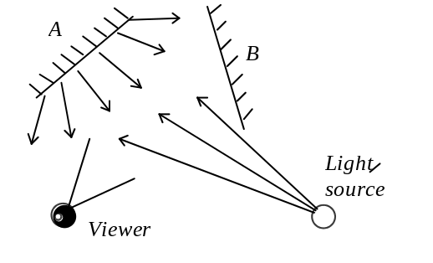
Figure 8.20: Contribution of diffuse reflectors to the illumination.

In order to account for such interactions, computer graphics turned to the theory of heat transfer. The idea, is that in a closed environment there is a balance of energy. Assuming that a hypothetical surface is capable of both emitting and reflecting light, the amount of light emanated by a surface patch, referred to as radiosity of the patch, is in balance with the light produced internally plus the light which was contributed by other patches. This can be expressed as follows:

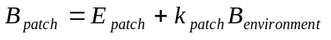

Where B is the radiosity of the patch, E its emission intensity and k its reflective capability. In the case where the scene is modelled by a set of plane surface patches, assuming that they are small enough so that radiosity across the patch is constant, the equation above can be restated in a way so that the radiosity of each patch is described in terms of radiosities of other patches:

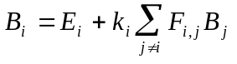

In this equation 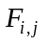 is a coefficient describing how much light from patch j reached the considered patch i. As it can be seen, the radiosity approach allows uniform treatment of light sources and reflecting surfaces. A patch with a non-zero 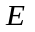 is a light source. Coefficients 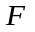 are referred to as form factors, and they essentially describe the geometry of the scene. In order to compute the form factors, we must take into account orientations of the two patches, their areas and whether or not they are obscured from one another by other patches. This may prove to be an expensive geometric problem, but once the form factors are computed, the radiosity of each patch in the scene can be found by solving a system of linear equations. By grouping all unknown radiosities B we arrive to the following system of linear equations:

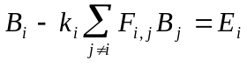

Which can be restated as the following matrix equation:

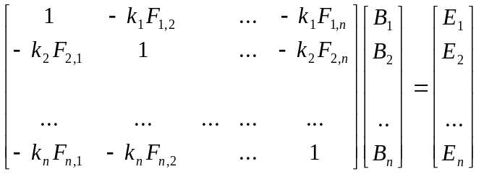

Note that if we use achromatic color model, each element of the above equation is a scalar, and for RGB model, a three-tuple, in which case, there are, in fact, three matrix equations, one for each of pure wavelengths. By solving the equation, we obtain radiosity values for every surface patch, and following that, we can proceed rendering the scene by any of the visualization processes considered, accounting for found radiosity when drawing each patch.

We must also note, however, that by assuming that the radiosity is constant across every patch we made a relaxation. Effects of this relaxation are negligible only when the patches are very small. Thus, every practical scene must be subdivided into a large number of patches, which, however, pushes up considerably the size of the matrix equation and time required to solve it. On the positive side, the radiosity considers only diffuse reflections which are the same in all directions, and thus, independent from a position of the viewer. Therefore, in the situations where the scene has static geometry and lighting, we can reuse the same radiosity solution for any location of the camera.

Overall, radiosity is a very powerful technique allowing to render extremely realistic images. However, by definition, this algorithm doesn’t consider specular reflections, and it is difficult to introduce them into the radiosity framework. A popular approach is to use radiosity as a pre-processing stage before ray-tracing the scene. Doing it properly is not trivial, however. Some specular effects are caused by diffuse interactions such as reflection of a diffuse surface against some specular surface, yet specular interactions may give rise to diffuse interactions. Accounting for all possible effects in a two step process may not be feasible, thus many implementations limit themselves to most common effects only.

8.6 Illumination in world to screen viewing.

Unfortunately, unlike with the case of screen to world methods, introduction of illumination, both local and global, into world to screen viewing is much less elegant. Let us recall that with this method, we create an image of the virtual world by projection of individual primitives onto the screen space and then rasterizing them into the image bitamp. In the case of ray-tracing we were applying the illumination model for any point in the world which is found to be visible on the screen. Similar approach is also possible in the case of world to screen viewing. When we rasterize a primitive, just before a point is to be placed into the image, we can evaluate the illumination model and thus adjust the pixel’s color. There are several problems which are immediately apparent. World to screen algorithms in general, and rasterization algorithms in particular, are built for speed and interactive frame rates. These algorithms minimize processing required to plot a single pixel. By evaluating the illumination model per pixel we push up the complexity of the very inner loop of visualization. Secondly, with popular back to front rasterization strategy to eliminate hidden surfaces, we may overdraw pixels in the image multiple times, thus throwing out results of some expensive computations to illuminate essentially useless points. In this respect, some approaches to hidden surface removal attempt to minimize on such situations. However, the fundamental problem remains, it is expensive to evaluate illumination model in each rasterized pixel, let alone consider global illumination effects.

Common strategy to deal with the problem of local illumination is to evaluate components of the model only in specific places on the primitive and interpolate everywhere else, what’s called, shade the primitive. We already saw interpolatively shaded polygons in chapter three which demonstrated an example of this approach. As to the global illumination effects, such as shadows and environmental reflections, world to screen viewing can’t really handle them in its general framework, thus, these are achieved by either special add-on techniques, or simply by ignoring existence thereof altogether.

Let us first consider shading algorithms, after which we will briefly discuss techniques to compute global illumination effects. Both types of algorithms, with few exceptions, are designed for polygonal patches. This is not a very big limitation since for many other reasons, such as feasibility of fast rasterization or hidden surface removal, this primitive is the preferred one.

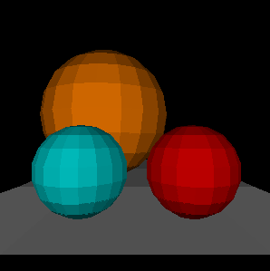
Figure 8.21: Flat shading.

Obviously, type of shading depends on the particular illumination model used, and the relaxations which we are prepared to make. For instance, if we are prepared to assume that illumination stays constant across any polygon, we can evaluate the illumination model just once per each polygon and perform regular rasterization with obtained color. This process is referred to as ambient or flat shading (see Figure 8.21). Of the three models considered, such assumption definitely holds true in the case of ambient illumination. In the case of diffuse reflecting surfaces and Bouknight illumination model such assumption holds true only if the polygon actually models a plane, in other words, it doesn’t serve as an approximation to some curved surface, and if there are only directional lights in the scene (all light sources are infinitely distant). Let’s recall that illumination in this model is computed as:

The illumination depends on both, surface normal () and direction towards the light source (). When we are trying to approximate some curved surface with polygons, the normal vector is not actually constant across (see Figure 8.19). If there are point light sources then direction towards them also changes across the polygon. If this is the situations, by assuming that illumination is constant, we will obtain wrong result. However, since the goal of computer graphics can often be to present recognisable representation of reality, not necessarily an exact copy thereof, we may decide to live with such unrealistic images.

Thus, even in the cases of both Bouknight and Phong illumination, we can still decide to use ambient shading. In the latter case, if we happen to evaluate the model in the location of specular highlight, the whole polygon will be highlighted, which is, of course quite unpleasant.

The faceted look of flat shaded polygonal mesh is also exaggerated due to the peculiarities of human visual system, particularly the Mach bands effect which is quite noticeable in Figure 8.21. Although each polygon does have constant coloring, we can see that close to the edge between a pair of polygons, the darker of the two looks even darker whereas the lighter of the two looks lighter. The receptors of our eyes inhibit their neighbors when brightly lit. Thus, the receptors on the darker side of the edge are inhibited by the neighbors on the lighter side and thus give a weaker response signal. The receptors on the lighter side aren’t inhibited enough due to their proximity to the darker polygon and thus have a higher response signal. This latternal inhibition of eye receptors is quite important for our visual system being the first step for recognition of contours of objects. For the particular problem of flat shading, or even interpolative shading done with not enough shades, it may, however, work to exaggerate a contour where we wouldn’t actually want to stress one.

Thus, when the faceted look of ambient shading does become unbearable, a common technique to improve appearance is by employing interpoilative or Gouraud shading [GOUR71]. In this method we evaluate the illumination model in the vertices of the polygons and interpolate the intensity across. Figure 8.22 demonstrates this approach.

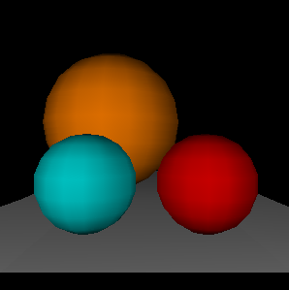
Figure 8.22: Gouraud shading.

This shading method is generally suitable for Bouknight illumination model describing reflection from diffuse surfaces. By smoothing intensity values, this shading technique also allows to conceal faceted look of the approximation of curved surfaces with polygonal patches.

In order to compute the illumination, we must find normals in the vertices of the polygons. When we are approximating some smooth surface with planar patches, the normals in the vertices can be obtained by averaging normals computed for polygons which, in their turn, can be found by computing vector products (see Figure 8.23).

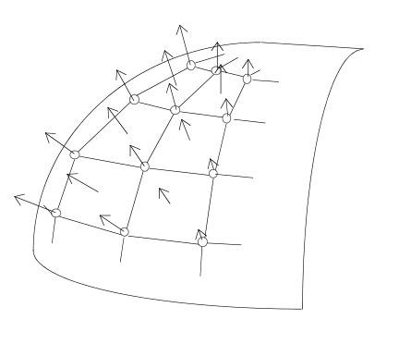
Figure 8.23:Approximating curved patch with plane polygons.

This shading method also allows us to approximate diffuse planes unequally illuminated with point light sources. However, it is not particularly suitable for specular surfaces and Phong illumination model. By definition, interpolative shading allows for only linear change of intensity across the polygon. Intensity response of specular reflection is non-linear:

Thus, we may either completely miss the specular highlight when it happens to be inside the polygon, or, in the cases where the highlight happens to be in the vertex of the polygon, the interpolation will still give us wrong result by proceeding with linear intensity falloff whereas we require a steeper, non-linear one. Similar to the situation with ambient shading, we may choose to live with such problem if polygons are small and quality demands are not high.

In the situations where we must portray specular surfaces correctly, we may have to use Phong shading method (not to be confused with Phong illumination model). With this algorithm, we effectively evaluate the illumination model in every rasterized pixel and only interpolate a component of the model across the polygon. Let’s again consider the equation of the illumination model presented above. Notably, normal vector contributes to the computation, and thus, since we often approximate curved surfaces with polygons, we can interpolate the normal across the polygon and use it in the illumination computations at each point (see Figure.8.24 (c)).

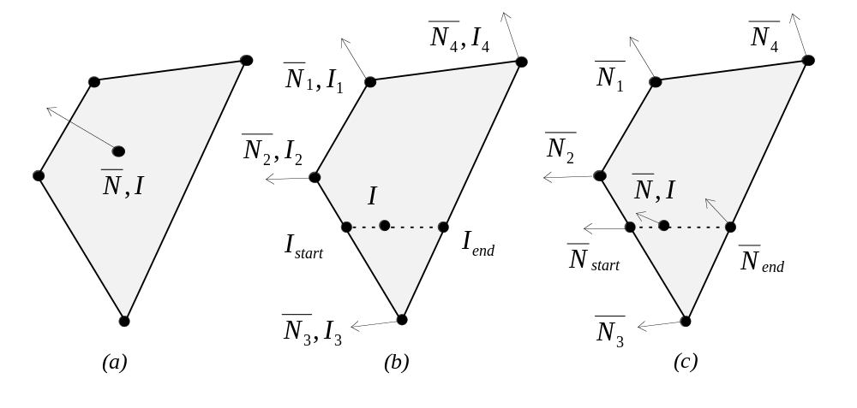
Figure 8.24: (a) Ambient, (b) Gouraud and (c) Phong shadings.

Each component of the normal vector is interpolated separately, thus allowing to obtain approximate normal direction in each point on the polygon. We must note though, that for our computations it is important to have normal vectors of unit length. This, however, is not preserved during interpolation, thus, we way have to renormalize the vector at every pixel. The illumination computation to be applied at each pixel using the interpolated normal is still fairly expensive. However, as we saw when first considering this illumination model, it can be speeded up by using the half-way vector alternative formulation and fixing the viewer’s position at infinity. We can also attempt to precompute a component of the equation with the exponent 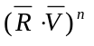 (or 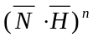 in the alternative formulation) and use table lookups in the run-time.

The considered shading methods allowed to introduce the illumination models in the framework of world to screen viewing. However, presence of multiple objects in the scene may cause other illumination effects such as shadows or environmental reflections. We already considered how to resolve mutual illumination by diffuse surfaces in the previous section. The radiosity algorithm, which we saw, is applicable to world to screen visualization as a pre-processing stage. Similar to ray-tracing combined with radiosity, the radiosity solution can be reused in multiple frames assuming that illumination and scene geometry doesn’t change from frame to frame, for instance when we generate a walk-though or fly-by of the virtual scene. Generally, the demands of interactive visualization are such that other global illumination effects are too expensive to compute in the run-time and they have to be precomputed as well. We must analyse requirements of particular applications and weight gains from precomputation against limitation of flexibility which it unfortunately imposes.

Of all the global illumination effects, we are going to discuss only shadows and environmental reflections. There are multiple algorithms allowing to compute shadows. We can roughly differentiate them into two groups. Algorithms in the first group precompute geometrical information required for representation of shadows. Other algorithms compute shadows dynamically during the scene rasterization. As we just noted, the first class of algorithms can’t handle dynamically changing scenes.

There are two approaches to precomputing shadows. A common one, is to subdivide the scene in a way so that each primitive is either completely illuminated or completely hidden with respect to every light source. Another approach is to store shadows implicitly in the texture maps associated with the primitives. The latter case requires, of course, presence of a texture map for every primitive which requires considerable amount of resources and may not be feasible in some settings.

To precompute the shadows, we must essentially solve the visibility problem from the points of view of each light source. Fragments of primitives which are visible from the position of the light source are illuminated, whereas, everything else must be shadowed. Figure 8.25 demonstrates a shadow volume approach.

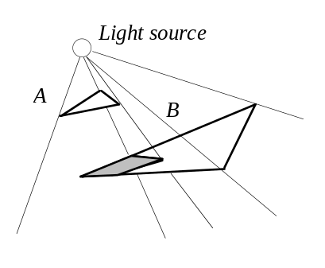
Figure 8.25: A shadow volume.

As Figure 8.25 demonstrates, illuminated polygons shadow a particular volume of space. This volume can be described as a polyhedron formed from a polygon casting the shadow on its top, and planes formed by shadows of polygon’s edges on the sides. Other polygons can be clipped against this volume separating into completely shadowed and completely illuminated types. The illuminated polygons must be marked as such for a particular light source, so that at the rasterization stage we know which light sources to use in illumination of every polygon.

Complexity of this operation is, of course, quite high but we can exploit some properties of the synthetic scenes to reduce the amount of work. For instance, an individual polygon is most often a part of some polygonal object. Thus, we can compute the shadow volume for a whole object instead of individual polygons which compose it. By minimizing number of shadow volumes we can reduce the amount of processing and number of subdivisions quite considerably. We must also realize that this method is used as a pre-processing step before the run-time. Thus minimizing number of subdivisions is more important than performance concerns.

Shadow volumes can be used very effectively with a BSP tree representation of the world, not unlike the way how we used this partitioning structure for the purposes of beam-tree hidden surface removal. With BSP tree representation, we can easily obtain a back to front ordering of polygons. But also, it is as easy to obtain a front to back ordering. We have to just reverse the order of the recursive calls in the traversing procedure. A front to back order obtained with respect to the light source immediately shows which polygons are capable of shadowing other polygons. Obviously enough, polygons in the front cast shadows onto polygons in the back, and thus polygons in the list may shadow their followers but not the other way around. We can use the shadow volume approach and perform the necessary subdivisions going down the list. An important thing to notice, is that effective BSP structure does not change as a result of such subdivisions against the shadow volumes assuming that we allow multiple polygons in each node of the tree. When we split any polygon into shadowed and illuminated pieces, all these pieces still belong to the same plane and, thus, can be stored in a combined list in the original place in the tree without violating binary partitioning.

Most other algorithms generating shadows also involve solving visibility from the light source point of view. A shadow Z-buffer algorithm is an elegant extension to a popular hidden surface removal strategy which can be used to solve the light source visibility dynamically. Consider Figure 8.26.

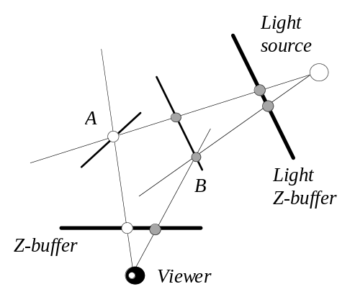
Figure 8.26: Shadow Z-buffer.

In Figure 8.26 we can see two Z-buffers, one for the image being generated an another for the light source point of view, referred to as light Z-buffer. If we compute light Z-buffer before rendering the scene, we can adjust actual Z-buffer based rasterization to account for shadows. When we will be placing a point onto the screen and into Z-buffer, we can also find its projection onto the plane in front of the light source and check whether Z coordinate of this projection is the one actually stored in the light Z-buffer. If that’s the case, this point must be visible by the light source and we can illuminate it in our prime image. For example, consider point A in Figure 8.26. When we check its visibility to the light source, we locate in the light Z-buffer a smaller Z coordinate corresponding to an obscuring point. Thus, point A is shadowed. On the other hand, this is not the case with point B, and we rasterize this point accounting for illumination from the light-source.

Apparent drawback of this algorithm is in the necessity to keep a separate light Z-buffer for every light-source. Also, by introducing extra processing into the very inner loop of rasterization we push up the complexity of viewing, but what’s even worse, due to its nature, Z-buffer algorithm often overwrites previous values for some pixels. Thus, we may have computed shadowing and illumination for points which will not even be present in the resulting image. A possible approach to improve on this situation is to do rasterization of the image first and add shadows computations as a post-processing step. Thus, for every point which appears in the final image we compute the shadowing information. We must also note that, in this case, since the illumination model is additive, we can potentially reuse the same light Z-buffer for all light sources, processing them consecutively and adjusting the image as a result of each computation.

In the section on ray-tracing we have seen how environmental specular reflections were solved by using regular ray-tracing framework. Essentially, we were solving visibility in the direction of specular reflection thus finding how the environment reflects from a shiny surface. Similar approach, within a different framework, is also possible in the case of world to screen viewing. Consider Figure 8.27.

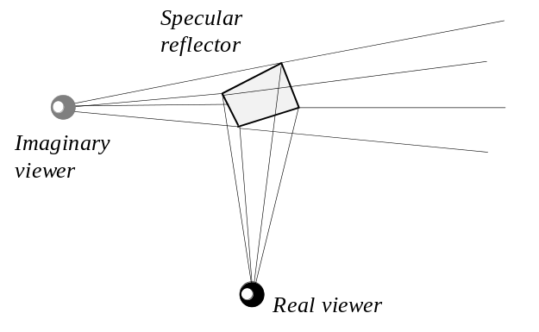
Figure 8.27: Computing environmental mapping.

Figure 8.27 represents a specular reflecting patch viewed by the camera. Obviously, due, to its specular capability, this patch will show a reflection of the environment. Since we know that the reflection direction is mirrored about the normal of the patch we can compute the reflection as a separate image involving an imaginary viewer looking in the reflection direction and then to apply this image as a texture map in the original viewing process.

Multiple invocations of the viewing algorithm is expensive, of course, thus, we may decide to precompute the environmental reflection as texture maps and completely substitute texture mappings for environmental reflections. We must note, that general texture mapping is view independent, whereas, environmental mapping is view dependent. We must make an adjustment to texture mapping so that a somewhat different mapping will occur when the view orientation changes and so that we are deceived into thinking that we see a reflection. Such adjustments may not be geometrically correct yet still give an impression of the environmental reflection.

In some instances, we may require dynamic, geometrically correct, reflections, for example when modelling mirrors in interior environments. In these situation an effect of the mirror can be achieved by proper modelling of the scene (see Figure 8.28).

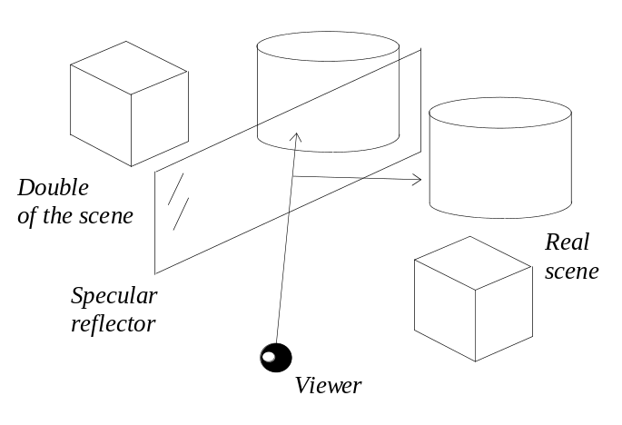
Figure 8.28: Geometrical modelling of a specular reflector.

In Figure 8.28 we model a reflector by introducing a mirror copy of the scene into the virtual world representation. When this is accompanied by proper color adjustments in the copy which describes the reflection image, a viewer is left under the impression of seeing a reflection of the scene. As everything else, decision whether to implement such schemes depends on the application’s nature and its specific goals.

To summarise, illumination is of tremendous importance in computer graphics. Generally, each color can be represented as an energy distribution in the spectral range. Due to the characteristics of the human visual perception we can represent colors in a more simple manner such as red, green, blue triple. Many algorithms which we commonly use to model illumination are of heuristical origin such as Phong illumination model. When there are multiple objects in the scene, we are confronted with a problem of global illumination since the objects reflect light in different ways contributing to illumination of other objects. Ray tracing computes some global illumination effects such as shadows and specular reflections. Radiosity algorithm resolves for all global diffuse interactions. Both local and global illuminations are complicated in the case of world to screen viewing mostly due to the performance constraints. Local illumination, in this viewing method, is approximated by shading algorithms and the global illumination effects relay on special add-on techniques.

* * *

