Chapter 9 Practical aspects of building
3-D applications.

9.1 General approaches to design.
9.1.1 Object oriented programming.
9.1.2 Scripting.
9.2 Building tools.
9.2.1 OpenGL.
9.2.2 Direct3D.
9.3 Applications’ building strategies.
9.3.1 Viewing solid bodies.
9.3.2 Viewing interior scenes.
9.3.3 Viewing exterior scenes.

In the previous chapters we have examined numerous techniques of 3-D computer graphics which allow us to model and visualize virtual scenes on computer screens. All these algorithms must, however, combine together in a structured way inside a real-life computer program. Each level in the rendering pipe-line must efficiently communicate with other levels. The rendering pipe-line must be build with respect to the data structures and the code representing virtual scenes. The algorithm for removing hidden surfaces must be properly placed in the pipe-line, and so on.

Although writing efficient, and at the same time readable and well organized computer programs, can often be considered as art rather than science, in this chapter we, nevertheless, attempt to examine some general rules which can aid in this endeavour.

Since the invention of the first computer and its programming mechanism, considerable attention has been paid to paradigms aiding in designing and writing computer programs. First came the abstraction allowing to separate the program into independent sub-routines or functions followed by the mechanism to construct derived data types such as structures and arrays from basic data types such as integers or characters. The concept of “structured programming”, which appeared a bit later, defined the minimal number of flow control statements which should be provided by a programming language. Relatively recently, the paradigm of the object oriented programming came about providing the tools for code sharing and reuse.

Although there was always a lot of promise to considerably ease programming tasks by employing the paradigms, in a sense, they were realized only partially. Some of the programs written today are as cryptic and unreadable as it used to be during the dawn of computers. (At times it appears that the situation has even deteriorated). It is not surprising that the tools and strategies available today don’t relive us from the necessity to analyse and to think. Failure to do that properly, and only rely on complex tools, can result in incredible debugging problems, loss of performance and unusable products.

Let’s consider general approaches to analysing, designing, and implementing computer programs and some specific examples of building applications common in the field of 3-D computer graphics.

9.1 General approaches to design.

Different applications have different purposes and goals. Depending on the application’s value, or other external factors, different amount of resources is going to be allocated for the purposes of development. The product itself may be aimed at a particular market, and thus, at specific hardware platforms. Combined with particularities of the application’s domain, these serve as arguments for the decision process producing, as the result, the implementation strategy and application’s design.

Before we start considering the design and implementation strategies, it is always helpful to evaluate the application’s goals from the point of view of some common criteria. Although the list of the criteria is not rigid, some of them are likely to be encountered in most projects. For instance, quality of what application does, and its efficiency or speed at doing it, are two important criteria. Flexibility, such as the ability to work with different data formats, for instance, is another criterion. Depending on the particular environment and the long term goals of the project, considerations of reusability and portability may be important as well.

As an example, the performance criterion is likely to be high for a computer game. Flexibility may be of lesser importance. On the other hand, an application in the field of computer aided design may not require high frame rates, and thus high efficiency, however, flexibility and portability are likely to be given a high estimate. Photorealism, and hence the quality of the produced images, may be desirable in the case of an interactive game, yet it is not as important as efficiency and the ability to achieve interactive frame rates. Failure to achieve the former may make the game less attractive, whereas slow frame rate makes it unusable. On the opposite side of the spectre, an application generating images for animated sequences to be used in advertising or movies, will, most certainly, require highest possible quality of the images with the speed at which they are produced being secondary.

Once we have assigned the weights to the criteria, it is possible to start considering the implementational alternatives available for the selected set. In reality, it may not be possible to satisfy all the criteria in the set. Most of them are interdependent, and, at times, almost pair-wise exclusive. For instance, quality and speed are often unattainable together. However, the very purpose of the assigned weight factors is to guide the development into the most important direction sacrificing less important factors for the overall project.

To satisfy some of the criteria, such as quality and efficiency, we have to choose suitable algorithmic solution. We have been considering this at length throughout all the previous chapters. Other criteria, such as flexibility, reusability and portability may depend on the selected algorithm, but also may require special approaches in writing and structuring the code.

In the first chapter, when discussing the hardware related issues, we already saw a way to achieve application’s portability. We have separated the application into hardware dependent and hardware independent parts, and have defined the interface between the two. The first part, which we called the “hardware interface”, was to be implemented differently depending on the particular hardware and allowed the remaining, hardware independent, part to remain portable.

Producing reusable code and introducing necessary level of flexibility also requires structuring the application’s code in a particular way. In doing so, it often helps when we employ specific programming paradigms. In this respect, we are going to consider the object oriented programming and an approach of scripting. The former allows us to write reusable and maintainable code. The latter we are going to discuss in conjunction with providing necessary levels of flexibility in storing or retrieving data and describing run-time options or procedures.

9.1.1 Object oriented programming.

Object-oriented programming is first of all a methodology frame-work to structure applications. In this methodology, data and code are tied together quite closely, as opposed to imperative style of programming with separated data structures and procedures. When programming in the object oriented way, we rely on the special features which the languages supporting this paradigm, such as C++ or Objective C, provide. Both languages extend basic C language with additional constructs. We are not going to concentrate on the syntax and other details of these languages but rather the general ideas of the paradigm and how they are pertinent to structuring 3-D graphics applications.

In the role of unifying code and data the important concepts are that of abstract data types, inheritance and polymorphism.

In the languages such as C or Pascal there was a predefined number of data-types such as integers, character, or floats. The derivation rules for data types were present, but their power was limited in the sense that, although we were capable of describing the storage requirements of a new data type (such as, for instance, when creating an array of integers), yet, the new data type was crippled since it was not possible to properly describe the operations which were applicable to it.

The concept of an abstract data type allowed to improve on this situation. In an object oriented language we can both define the storage for a new type and the type’s particular operations. In this context, types are also referred to as classes. Individual instances of the classes are often called objects, hence “object-oriented programming”. Particular ways of describing classes in Objective C and C++ are presented in Listing 9.1.

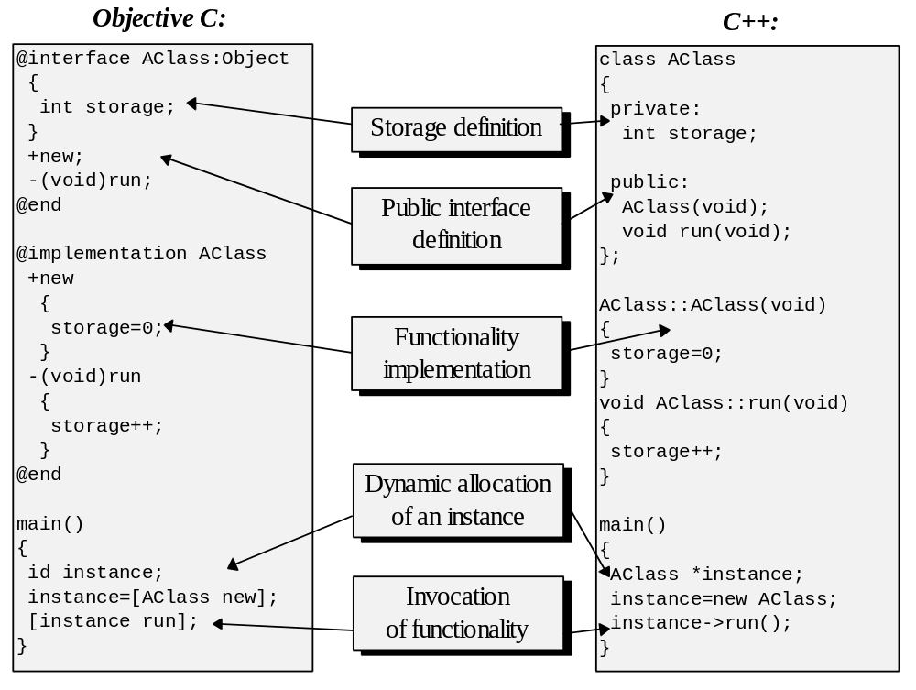
Listing 9.1: Abstract data type definitions in Objective C and C++.

As it can be seen from Figure 9.1 the two languages, although having different syntax, are relatively similar in the functionality they provide. Perhaps, the biggest conceptual difference between the two is that Objective C makes most type related decisions dynamically in the run-time, whereas C++ performs mostly static typing. The former often offers additional level of flexibility although may incur certain cost, which, in the particular case of Objective C, is quite minimal.

Using the mechanism of abstract data types, we can, for instance, create a type of complex numbers by defining its storage as a structure containing two floats and describing its operations such as additions and multiplications relying on existing operations for floats in the way necessary to support the algebra of complex numbers. Further, this data type can be used throughout the program as if it was one of the basic types.

This approach is extremely beneficial for the structure of the programs. The programs are more readable. Furthermore, by providing the valid operations for each data type as its public interface, the parts of the program using this type need not to be aware of the type’s internal structure. Encapsulated internal structure of the type may even change in the future, but since the use of the type is limited to its public interface, such a change, properly done, doesn’t affect the code which employs it. This consideration is very important for application’s maintainability. Well written types are also good candidates for reuse in future projects.

In the case of 3-D graphics applications, we have encountered a number of situations where use of abstract data types is clearly beneficial. This is the case with fixed point numbers and 3-D transformations described in the matrix form. Both possess a well defined set of operations and are natural for implementation as classes. Models representing solid bodies, landscapes etc. also present opportunities for encapsulation in this manner.

There are certain dangers that are usually associated with using abstract data types. Although the efficiency of the produced code isn’t significantly worse when compiled by most object oriented languages compared to imperative languages, the danger of the efficiency loss rather comes from the way we are tempted, sometimes, to write the programs. If we attempt to encapsulate everything and abuse dynamic allocation and destruction of small objects, the cost may become quite significant. For instance, at times we are tempted to encapsulate a 3-D vertex as a class. Although this can be valid and helpful in the case of a 3-D editor, a rendering pipe-line build for efficiency may only suffer from that. The vertices are often manipulated in streams and there isn’t a significant amount of operations pertinent to an isolated vertex.

Generally, there is little doubt that abstract data types help structuring the higher level modules of the application. Employing it for the lower levels may also be beneficial but should be done with care.

Object oriented languages also provide other important principles aiding interactions between types. A type can inherit properties of the parent type or even several parent types. This allows different, yet related, modules to share certain functionality and thus, most importantly for development, some source code. For instance, it is possible to organize types describing different 3-D models in a way so that a type describing polygonal solid bodies is inherited from a wireframe. Both types rely on the vertex set, and a solid body type can inherit the functionality enabling to apply the transformations to this set, for instance.

Another important principle is that of polymorphism. It allows us to write generic algorithms which work for objects of different type. The polymorphic types share some functionality interface but may achieve such functionality in different ways. For instance, types implementing different 3-D models are polymorphic in a sense that all of them possess an ability to render themselves. The rendering may be done differently depending on the type, but the algorithms using this functionality often need not to be aware of the details and may work with generic models only asking them to render themselves when required.

For example, this situation is feasible in the case of landscape visualization for a flight simulator. Such applications are likely to relay on the data structure where the surface is separated into square cells, each of which may contain some 3-D models representing objects which are located in the described region of the landscape. Naturally, the objects may be of different type, either wire-frames representing towers of the power lines, or polygonal models representing buildings or even sets of points representing lights of runways. The algorithm rendering the landscape must first rasterize the surface polygon and then the objects located on that polygon. If the types representing 3-D models are polymorphic with respect to their rendering, the landscape type can be written without regard to the internal structure of the models only relying on their common polymorphic functionality interface enabling them to render themselves.

Summarizing, the object oriented programming is a very important tool to achieve the criterion of code reusability. If used properly, it also helps to create clear and easily understandable code, at the same time providing opportunity for code sharing and increased maintainability of applications.

9.1.2 Scripting.

In the previous section we have discussed how to improve code reusability by proper structuring and using object oriented paradigm. Such approach also helps flexibility in a sense that it is easier to readapt an application for changing goals. In this section, we are going to examine different notion of flexibility. In various contexts it is necessary to readapt what an application does in the run-time. We often want applications to handle data structures of various complexity. It is also necessary, at times, to change some procedural behaviour such as, for instance, motion paths of some objects as displayed by an animation package or a computer game.

Naturally, it will be too limiting to have to recompile the program each time such a change needs to be done. An obvious solution is to separate the changing elements from the executable code and store their representation separately on the disk storage. This representation is read by the application’s executable in the run-time and is interpreted in a way which is predefined by the application.

The data describing various virtual scenes can be stored in the binary form. Such approach guarantees increased efficiency of the reconstruction of this data structure in memory but may limit portability of the data. Information stored in binary form is also less manageable since it is hard to immediately understand its meaning, and thus, it requires a special set of utilities for creation and manipulation. Especially when the volume of information is not very large, it may be preferable to describe such information simply in the textual form.

Stepping back, it can be noted that a programming language provides exactly this set of functionality. In programming languages such as C or Pascal, we can both describe the necessary data structures and functions. It is quite common to involve a similar approach and represent changing elements of applications through some kind of a smaller language. Such languages are often referred to as scripts. It should be noted that we usually want to address some very special functionality by employing a script, thus it will not be necessary to introduce all the complexity which is hidden behind modern programming languages.

In order to define a language we must design and properly express its syntax and semantics. Syntax describes all valid expressions of the language, and semantics describes what is the meaning and effect of interpreting the expressions. A grammar is a set of formal rules describing the language’s syntax. For many practical purposes it is convenient to represent language’s grammar in Backus-Naur Form. This representation describes different elements of the language in terms of other elements or even recursively in terms of the element which is being defined itself. For instance, in an informal example of a grammar that follows, the term function is described as one of the four characters (vertical line between the characters has the meaning of “or”).

function = + | - | * | \
expression = number | (expression function expression)
LANGUAGE = expression {expression...}

The language itself is defined by the last statement as any number of expressions following one another (In this notation: { ...} means zero or any number of occurrences of the term within the curly brackets). This grammar describes a sequence of arithmetic expressions such as (1+1) or ((1+2)/2). We can use the grammar to build a parser which can recognize the validity of strings of symbols and perform the necessary actions for valid sequences. Each of the rules can be implemented as a separate function capable of interpreting its proper element of the language. Thus, a string of symbols: (1+1) will be first parsed by the rule number three which will invoke the rule number two, which after two recursive calls will find the expression to be valid. The interpreting routine may at the same time construct an internal representation expressing the semantics of the interpreted expression. In the case of the above example this may be a reversed notation or a disjoint representation which are convenient for evaluation of arithmetic expressions. Alternatively, instead of coding the parser by hand, we can employ one of the parser generators such as yacc (yet another compiler of compilers) or almost identical bison. These produce the C code for a parser when we specify to it the required grammar in the form not unlike presented in the example above. Using such a tool together with a scanner generator such as lex (flex) which produces C code of a scanning routine used to separate the input text stream into lexical units (tokens) can considerably reduce the coding effort necessary to built a scripting language.

For the purposes of 3-D graphics applications we can use scripts to, for instance, represent changing behaviour of some animated objects. A script similar to the one we saw may represent arithmetical expressions describing how orientation angles of some entity change depending on the state of the application. Whenever it is necessary to change this behaviour, modifying some external files with textual information will be sufficient to achieve the goal.

We can also use scripts to describe data structures representing virtual scenes. For instance, the following grammar describes a language similar to the one used to describe static data in C.

type = int | [number]type | {type {type}}
variable = number | [variable {variable...}] | {variable {variable...}}
statement = type name type | var type name variable
LANGUAGE = statement {statement...}

In such language, we can both describe type of the data such as type array [5]int for an array of five integers, or type triple {int int int} for a structure consisting of three integers, and also the data itself such as: var array A [1 2 3 4 5].

Many applications employ the technique of scripting. For instance visualization packages which use the ray-tracing algorithm often have their own languages allowing us to describe virtual scenes. Same approach is often adopted in computer games where scripts describe various aspects of the run-time behaviour.

9.2 Building tools.

The algorithms which we have discussed in the previous chapters are fundamental for many different 3-D applications. Such tasks as 3-D transformations and rasterizations must be performed by almost any application using world to screen viewing. As common as some algorithms and manipulations are, many have been implemented by various software development kits or libraries, and some, have even been implemented directly in hardware.

When such tools or hardware are available, this may considerably ease the development tasks. The sourcecode examples presented in this text, combined together, form a 3-D Graphics Portable Library (3Dgpl) which can serve as a starting point for design and implementation of various applications. It is described in more detail in Appendix B. This library, however, was written with educational goals in mind and may not be suitable for some commercial development notably lacking support for hardware accelerator cards which now become increasingly popular.

Since many of the 3-D graphics algorithms are relatively straightforward and are in very common use by very different applications, it is attractive to have some basic functionality implemented directly in hardware. Such algorithms as rasterization of flat, shaded and texture mapped polygons, Z buffering along with 3-D transformations form such core functionality and are commonly put on accelerator boards. Even some general purpose processors sometimes provide operations which are especially useful for graphics applications such as single instruction-multiple data vector instructions. These allow to perform the same operation on several arguments at the same time. Using such instructions may allow, for instance, to compute pure components of RGB illumination in parallel thus speeding rendering tasks considerably. MMX (Multi-Media Extensions) instructions for Intel’s Pentium processors implement this approach.

As is commonly the case, the amount and kind of features available in hardware ranges widely and there is no common interface to such equipment. Fortunately, existing software development kits and libraries can often serve as a common interface to hardware. These libraries may perform software-only rendering on a minimal machine or use hardware assistance when such is available. In the following subsections we are going to discuss general structure for two of such libraries: OpenGL and Direct3D. It should be noted that describing both to the degree allowing programming is quite an extensive undertaking and thus we shall concentrate mostly on few basic conceptual issues.

9.2.1 OpenGL.

OpenGL is closely based on Silicon Graphics’ IRIS GL library. Due to the popularity of the latter, an industry wide review board was established to maintain an open, platform independent, standard for a graphics library. As a result, OpenGL is available on a wide range of hardware platforms and operating systems available from such diverse manufacturers as SGI, IBM, DEC and Microsoft.

OpenGL provides core functionality for 3-D transformations, clipping, illumination and rasterization. This functionality can often be implemented in hardware with OpenGL providing a common interface to different accelerator boards.

OpenGL is designed to function as a state machine. Invocations of many functions set up some parameters which are recalled during subsequent invocations of other functions, such as setting current color or current texture map for the purposes of upcoming primitive rasterization. This is done to enable the GL application to function over the network where a program generates a stream of GL commands on one computer and the interpretation of the commands is done on another computer. Thus, the application program interface of this library is almost entirely procedural and practically doesn’t require allocating any data structures.

The approximate logical structure of OpenGL is presented in Figure 9.1.

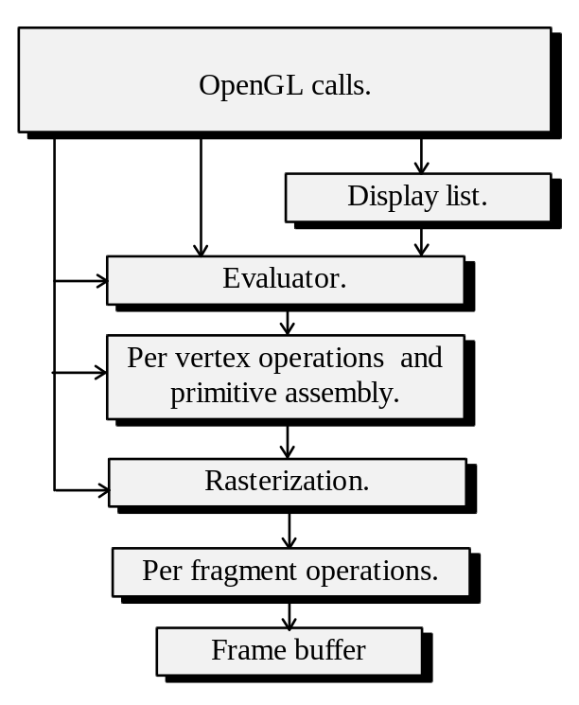

Figure 9.1: Logical structure of Open GL.

As Figure 9.1. illustrates, the GL commands can either be accumulated in a display list for processing at some future time, or sent immediately through the rendering pipe-line (perhaps even bypassing some stages). The evaluator stage allows to approximate curves and surfaces with simpler primitives: line segments and polygonal patches so that the following stages can operate with simple primitives only. The next stage performs operations on vertices such as 3-D transformations and illumination calculations as well as operations on primitives such as clipping. Clipped primitives are passed to the rasterizer which computes the stream of fragments (pixel addresses accompanied by color, depth and texturing information), and sends these to the next stage which is responsible for operations on fragments such as Z buffering and changing contents of the frame-buffer.

OpenGL is not tied to any particular architecture or operating system. To allow the applications accessing the particular features as well as conforming to the necessary standards (such as supported execution flow) additional, auxiliary libraries are commonly provided.

Since GL works as a state machine, geometric information describing a single primitive is passed during invocation of a sequence of GL functions. Such a sequence is started by a call to glBegin, where we specify the type of the primitive we are about to describe. Several types are available such as: GL_POINTS, GL_LINES, GL_TRIANGLES, GL_QUADS, GL_POLYGON and few other, such as: GL_TRIANGLE_STRIP or GL_QUAD_STRIP. The invocation of the glBegin function is followed by the invocations of functions specifying vertex information. Various information can be defined in a single vertex depending on desired rendering model. The vertex coordinates are specified in a call to glVertex (For the convenience, many of GL functions have alternative forms which take arguments of different type or arrangement). Current color in a vertex is specified in a call to glColor. It is also possible to specify a normal in a vertex for the purposes of Phong illumination model with a call to glNormal and texture coordinates with a call to glTexCoord. The vertex definition is finished by calling glEnd at which time the rendering processes are initiated.

The geometric transformations in GL are specified by the means of four by four matrices. Three different kinds of transformations are involved in the rendering process implemented by OpenGL. These are the transformation from the object space into the view space (called model-view transformations), projection transformations and texture mapping transformations. The stack of matrices is maintained for each of the above, and an application using GL must describe the desired transformation before primitives are passed through the rendering pipe-line.

As it was mentioned before, beside the immediate mode where the primitives are passed through the rendering pipe-line at the time glEnd is called, it is also possible to enter the GL commands into a display list for combined execution at a later time. It is often the case that creating a display list enables the library to precompute some data speeding up the following executions. GL also provides a higher level routines where more complex shapes may be specified for rendering rather than individual primitives. Functions enabling that are provided in the utility library.

Overall, GL implements a wide range of functionality which graphics application may require. This combined with relative ease of use, possible support for hardware assistance and portability makes this library a very popular implementation tool.

9.2.2 Direct3D.

Direct3D is part of DirectX software development kit which was developed by Microsoft and is available for Microsoft’s 32 bit operating systems. This graphics library covers a comparable to OpenGL set of functionality and is also aimed at providing unified access to different accelerator boards.

Similarly to OpenGL, Direct3D has several layers, with the higher retained mode layer enabling the manipulations with complex geometric objects whereas the lower, immediate mode layer represents the actual polygonal rendering pipe-line. Figure 9.2 depicts the logical structure of the pipe-line as implemented in this library.

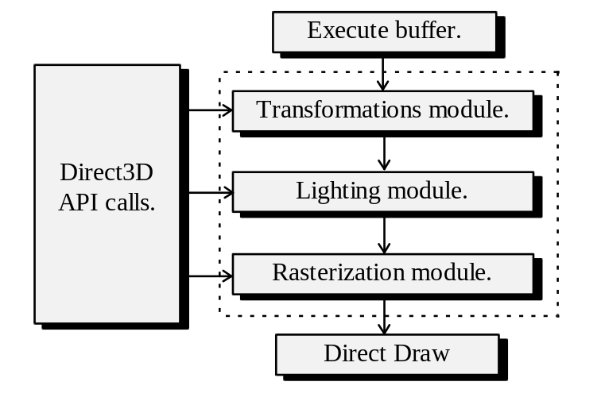

Figure 9.2: Logical structure of Direct 3D.

An application using Direct3D initializes the interface objects, sets the state of the modules, such as the transformation matrices, light-sources and description of materials, by calling specific functions from Direct3D API, and constructs the execute buffers (display lists) which contain geometric information and commands describing transformations and processes which must be performed. The execute buffers are passed through the modules of the pipe-line which perform the 3-D transformations, lighting and rasterization and than invoke functions from another library called Direct Draw responsible for frame-buffer access. The modules may perform software only computations or use hardware assistance if such is present.

Direct3D also allows to use the functionality of the modules for the purposes other than rendering. It is possible, for instance, to call the transformation module to transform a set of vertices for some modelling tasks or for bounding box calculations.

Unfortunately, Direct3D (especially in immediate mode) often fails to hide the details of its internal working from application programs demanding the latter to perform overwhelming amount of initialization tasks and to maintain fairly complex data-structures.

Despite this relatively bulky interface, this library does enable unified access to a wide range of supported graphics hardware and its retained mode layer is quite convenient for rapid development of a variety of straightforward graphics applications.

9.3 Applications’ building strategies.

There are many factors influencing an application’s design. Any project may have different requirements validating consideration of its own. In this section we are going to consider only most basic trade-offs available with different techniques and approximate solutions which are common depending on some of the requirements.

9.3.1 Viewing solid bodies.

The ability to view a 3-D model of a solid body or a set of solid bodies may be necessary in many different contexts. Computer aided design, medical imaging, scientific visualizations are just to name a few. As we have discussed in the first section of the chapter, before any particular strategy can be chosen, we should first understand importance of various factors which express the goals of the application we want to implement. The algorithmic solution will then be chosen based on the relative importance of different factors.

Let’s discuss several possible situations. If, for instance, we are interested in generating high quality images or sequences of images, and the performance constraints are relaxed, a possible direction to take is by employing screen to world ray tracing algorithm. As we have seen, this algorithm has performance constraints, yet it is very natural for accommodation of various lighting models and global illumination effects such as shadows and environmental reflections which are extremely important for achieving of visual realism.

As for the implementation, an application using ray-tracing can be separated into following major logical modules. (see Figure 9.3).

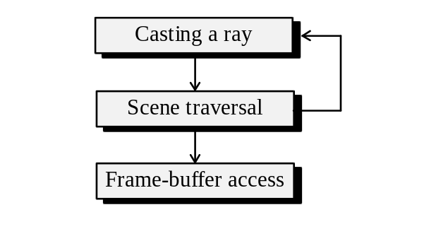

Figure 9.3: Logical modules of a ray-tracing application.

As we have seen, the most basic operation of this method is seeking an intersection of a ray cast from the viewer’s eye with some surface of the virtual scene. In order to implement global illumination effects, we may have to cast additional rays from this intersection point employing the same mechanism as when casting from the eye. This logical structure is represented in Figure 9.3. Of course, this scheme is very much simplified and neglects the internal structure of the modules themselves. For instance, if the scene which we are going to visualize is complex and consists of many primitives we will also have to consider special techniques for space subdivision within the scene traversal module. A more detailed model must take this and other aspects into consideration, however, even this scheme gives representation of interdependencies of the modules and an insight into possible structure of the application.

The applications which can neglect quality, yet cannot neglect the performance are on the other side of the spectre. Clearly, the ray tracing solution becomes less attractive and we should consider the world to screen viewing method instead. We have already seen the necessary stages required in displaying 3-D models using this technique. The vertices of the model must pass the coordinate transformation stages. If the perspective projection is involved, volume clipping must be performed prior to that stage. Further, the primitives composing the model are rasterized into the frame-buffer. The general outline of the world to screen pipe-line is presented in Figure 9.4.

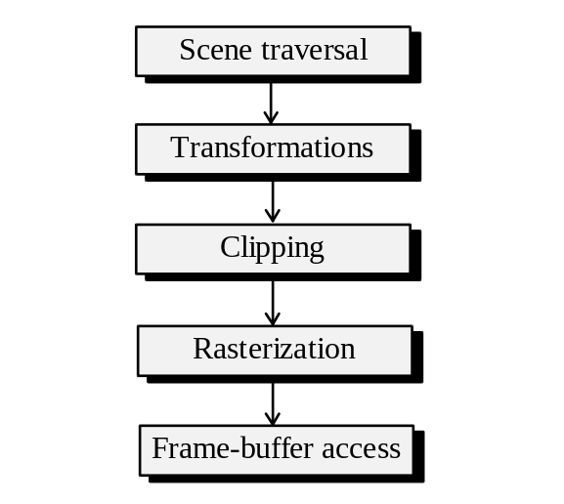

Figure 9.4 Logical modules of a world to screen based application.

The scheme in Figure 9.4 presents only the basic pipe-line and doesn’t show other important aspects of the application which are dependent on additional criteria, notably the hidden surface removal and illumination. Depending on the available tools (such as OpenGL or Direct3D), we may use parts or all of the pipe-line implemented there and limit the development tasks to only some modules, such as hidden surface removal, and higher level modelling tasks.

We have discussed several hidden surface removal algorithms: the painter’s method, beam-trees, the scan-line algorithm, and Z-buffer algorithm. Beside the complexity considerations, some of the algorithms have specific constraints and thus are applicable only in some situations. Moreover, different algorithms also take a different place in the rendering pipe-line. For instance, the BSP tree solution used with the painter’s method is feasible only in the case of objects whose shape is static and is represented as a polygonal mesh. Presence of dynamically changing objects will force us to rebuild the associated BSP trees in the run time which is quite expensive and defeats the purpose of the algorithm.

Furthermore, most hidden surface removal algorithms are applicable to 3-D models represented as polygonal meshes. If we possess a technique to rasterize some other kind of primitives directly, such as bi-cubic patches, only Z-buffer algorithm remains applicable of the algorithms we have discussed. On the other hand, Z-buffer algorithm, although generic, incurs considerable cost when implemented in software, and thus, in some instances, it may be more appropriate to tessellate surfaces into polygonal meshes and avoid using Z-buffer algorithm.

Presence of complex lighting and texture mappings makes painter’s algorithm less attractive since a lot of expensive work will be lost each time a polygon is drawn over a previously drawn polygon. In this situation, we can employ the scan-line algorithm, beam-tree algorithm or a modified Z-buffer algorithm which performs lighting as a post-processing step. The scan-line algorithm can be combined with BSP trees to be used for obtaining front to back order of polygons for the calculations selecting which polygon is closest on the current span of the scan-line. Similarly with the beam-trees, which may also relay upon the ordering induced by a precomputed BSP tree. However, in both instances considerable modifications of the rendering-pipe line must be made. In the former case, all polygons are rasterized simultaneously and may relay on edge based polygon descriptions. In the latter case screen boundaries clipping can be easily unified with the beam-tree algorithm simplifying somewhat the pipe-line.

As it can be seen, model representation and visualization strategy should be considered together. As a result of such consideration, we may have to readjust the original set of criteria. If the speed is the most important factor, we may have to provide the 3-D model representation in a suitable for this algorithm data structure. If, on the other hand, the considerations for precision and quality of the images are more important, we may be forced into using a particular data-structure and then choosing a hidden surface removal algorithm accordingly.

In chapter eight, we discussed how to introduce lighting and illumination effects into the frame-work of world to screen viewing method. As we saw, the global illumination effects, such as shadows, are quite expensive to compute. In the case of static illumination, the shadows can be precomputed and introduced into either texture maps of the model or as separate, differently illuminated, primitives. Handling dynamic lighting in this manner becomes quite expensive. If we use Z-buffer algorithm for hidden surface removal, we can augment it to handle light Z-buffers which can compute dynamic shadows.

9.3.2 Viewing interior scenes.

Viewing interior scenes is often required in such domains as CAD applications for interior design and video games. Of course, any interior scene can be considered as a collection of objects, however, as has already been discussed, interior scenes have some properties of regularity which can be exploited to achieve better performance than in the general case. For instance, we can use the fact that an interior scene is very often a collection of rooms which are convex or nearly convex polyhedrons.

For both CAD, and visual game applications, it is very important to generate an interactive walk-through of the virtual scene. Thus, the efficiency must be very high on our list of priorities.

Although, ray-tracing is difficult to use to achieve interactive frame rates in the general case, in many special cases we can exploit some properties of the virtual scenes to achieve suitable performance with this algorithm. For instance, in many settings the walk-through doesn’t require all six degrees of freedom. After all, many real-life interior scenes are located on a plane such as a floor in a building and in our walking we don’t tilt and shake our head that much. The polygons representing the scene are likely to be limited in orientations as well. There can be either vertical ones representing walls, or horizontal ones representing floors and ceilings. With such assumptions, the ray tracing can be simplified to a considerable extent. Instead of casting a ray for each pixel in the image bitmap, one ray can be cast for the whole column of pixels, and we can easily find what is intersected at different heights of this column from only few intersection calculations.

If the relaxations cannot be done, similar to the situation in the previous section, we should consider world to screen method. Although all the considerations which we saw relative to 3-D solid models apply in this case as well, usually larger numbers of polygons present in most interior scenes make some hidden surface algorithms less useful such as, for instance, sorting of polygons. However, as we have already seen in the chapter on hidden surface removal, properties of some scenes composed entirely of interconnected set of convex volumes representing rooms, allow for easy computation of back to front order of polygons. If the volumes aren’t convex we may associate a BSP tree with each volume, or even build one for the whole scene. The fact that the interior scenes are mostly static makes this solution a very attractive one.

Since we, most probably, want to associate texture maps with the polygons picturing interior environments, and rasterization of such polygons is expensive, we may have to employ techniques limiting rasterization of hidden polygons such as for instance the scan-line algorithm. Another technique is to associate with every volume the list of polygons which are visible completely or partially from any point within the volume [ABRA96]. Although finding such lists is computationally expensive, it is done as a pre-processing step and the results are stored with the data structure representing the scene. By limiting the number of polygons which can be possibly rasterized in each volume we can achieve significant performance gains.

Similarly, the lighting can be limited to a particular region so that a light source has no effect outside of the region, or, even better, we can use for this purpose a list of polygons visible from the current volume. However, for proper illumination we require representation for such global illumination effects as shadows and environmental reflections. Similarly to the situation in the previous section, we can limit ourselves with static lighting and pre-computed shadows. The regions can be used to introduce limited amount of dynamic lighting.

Some interior scenes require representation for mirrors reflecting the environment. As we saw in chapter eight, one solution is possible through geometric cloning of the scene with respect to the mirror. Rendering the double in a regular way, but with adjusted colors, gives an effect of the environmental reflection..

9.3.3 Viewing exterior scenes.

Viewing of exterior landscapes is necessary in such applications as flight simulators, video games, geographical information systems (GIS), etc. Similar to the situation with the interior scenes, special nature of the modelled object is such as to validate some particular approaches to its visualization.

In most cases, we can’t reduce the number of degrees of freedom handled in this kind of applications. In the rare case when it can be done, similarly to the situation in the previous subsection, ray-casting algorithm can be considered. It should also be noted that ray casting algorithm is very easy to parallelize, since calculations for casting of rays are computationally independent, and thus, with proper special purpose hardware, this fact can be explored to achieve six degrees of freedom and interactive landscape visualization using ray-casting algorithm.

Most often, however, world to screen visualization is more appropriate. We have already discussed the height-field representation for landscapes. With such representation, the back to front order of polygons can be obtained through proper traversal of the model.

Any of the applications mentioned may model landscapes of the considerable size. Thus, it is appropriate to render the polygons from the viewer’s locality only. It should be mentioned that since the landscapes are fairly smooth, the amount of polygons drawn over previously rasterized polygons is limited, especially assuming the use of back-culling. Thus, we usually don’t have to involve the scan-line hidden surface removal or similar techniques reducing expensive rasterization of polygons which are going to be overdrawn by other polygons.

The illumination and lighting can be largely pre-computed in this kinds of applications since the landscapes are mostly static. Some local dynamic lighting can be introduced using some sub-division strategy to limit the influence of each light-source. In some cases, when modelling surfaces of water in the landscapes, we may want to represent the environmental reflection. This effect can be achieved by cloning the immediate neighborhood of the water surface with respect to the horizon. Rendering the doubles of the polygons present images of reflections against the surface of the water.

Beside rendering of the polygons representing the surface of the landscape, often it is also necessary to display the objects which are located on the surface. Thus, the techniques from the section discussing visualization of 3-D solids should be incorporated into the applications dealing with landscapes as well.

Summarizing, we must underline the importance of conceptual design for 3-D graphics applications. Many decisions in this process can be taken based on the evaluated criteria for the application’s goals. To satisfy speed and image quality criteria, suitable algorithmic solutions should be chosen. Special programming techniques such as the object oriented programming and scripting should be considered to achieve application’s maintainability and reusability.

* * *

