References.

ABRA96 Abrash, M., “Inside Quake: Visible-Surface Determination,” Dr. Dobbs Sourcebook (July 1996).

ATHE78 Atherton, P., Weiler, K. and Greenberg, D., “Polygon Shadow Generation,” ACM Computer Graphics (SIGGRAPH 1978) vol. 12, no. 3, pp. 275-281.

BART87 Bartels, R., Beatty, J. and Barsky, B., “An Introduction to Splines for use in Computer Graphics and Geometric Modelling,” Morgan-Kaufmann.

BEAT82 Beatty, J.C. and Booth, K.S., “Tutorial: Computer Graphics,” IEEE Computer Society Press.

BERG97 de Berg, M., van Krevland, M., Overmars, M., Schwarzkopf, O., “Computational Geometry,” Springer.

BEZI72 Bézier, P., “Numerical Control: Mathematics and Applications,” Wiley.

BILL81 Billmeyer, F. and Saltzman, M., “Principles of Color Technology,” Wiley.

BLIN77 Blinn, J.F., “Models of Light Reflection for Computer Synthesized Pictures,” ACM Computer Graphics (SIGGRAPH 1977) vol. 11, no. 2, pp. 192-198.

BOUK70 Bouknight, W.J., “A Procedure for Generation of Three-dimensional Half-toned Computer Graphics Presentations,” Communications of the ACM, vol. 13, no. 9, pp. 527-536.

BRES65 Bresenham, J.E., “Algorithm for Computer Control of a Digital Plotter,” IBM Systems Journal, vol 4, no 1, pp 25-30.

COHE85 Cohen, M.F., “A Radiosity Method for the Realistic Image Synthesis of Complex Diffuse Environments,” ACM Computer Graphics (SIGGRAPH 1985), vol. 19, no. 3, pp. 31-40.

CHIN90 Chin, N., “Near Real-Time Object-Precision Shadow Generation Using BSP Trees,” M.S. Thesis, Department of Computer Science, Columbia University.

FARI90 Farin, G., “Curves and Surfaces for Computer Aided Design,” Academic Press.

FOLE90 Foley, J.D., Van Dam, A., Feiner, S.K., and Hughes, J.F., “Computer Graphics: Principles and Practice,” Addison-Wesley.

FUCH80 Fuchs, H., Kedem, Z., and Naylor, B., “On Visible Surface Generation by a Priori Tree Structures,” ACM Computer Garphics Vol. 14, no. 3, pp. 124-133.

FUCH83 Fuchs, H., Abram, G.D. and Grant, E.D., “Near Real-Time Shaded Display of Rigid Objects,” ACM Computer Graphics Vol. 17, no. 3, pp. 65-72.

GOUR71 Gouraud, H., “Continuous Shading of Curved Surfaces,” IEEE Transactions on Computers, June 1971, pp. 623-629.

GREE86 Greene, N., “Environmental Mapping and Other Applications of World Projections,” IEEE Computer Graphics and Applications, vol. 6, no. 11, pp. 21-29.

GREG70 Gregory, R.L., “The Intelligent Eye,” McGraw-Hill.

HALL89 Hall, R., “Illumination and Color in Computer Generated Imagery,” Springer-Verlag.

HECK82 Heckbert, P.S., “Color Image Quantization for Frame Buffer Display.” ACM Computer Graphics (July 1982)

HECK86 Heckbert, P.S., “Survey of Texture Mapping,” IEEE Computer Graphics and Applications, vol. 6, no. 11, pp. 56-67.

LEVO88 Levoy, M., “Display of Surfaces from Volume Data,” IEEE Computer Graphics and Applications, vol. 8, no. 3, pp. 29-37.

MILL86 Miller, G., “The Definition and Rendering of Terrain Mapps,” ACM Computer Graphics, vol. 20, no. 4, pp. 39-49.

MITC90 Mitchell D.A.P., “Fast Algorithms for 3-D Computer Graphics,” PhD Thesis, University of Sheffield.

NEWM73 Newman, W. and Sproull, R., “Principles of Interactive Computer Graphics,” McGraw-Hill.

PHON75 Phong, Bui Toung, “Illumination for Computer Generated Pictures,” Communications of the ACM, vol. 18, no. 8, pp. 311-317.

SEDG84 Sedgewick, R., “Algorithms,” Addison-Wesley.

SUTH74A Sutherland, I.E. and Hodgman, G.W., “Reentrant polygon clipping,” Communications of the ACM, vol. 17, no. 1, pp. 32-42.

SUTH74B Sutherland, I.E., Sproull, R.F., and Schumacker, R.A., “A Characterization of Ten Hidden Surface Algorithms,” ACM Computing Surveys, vol. 6, no. 1, pp. 1-55.

TOUS85 Toussaint, G.T., “A simple linear algorithm for intersecting convex polygons,” The Visual Computer, no. 1, pp 118-123.

VINC92 Vince, J., “3-D Computer Animation,” Addison-Wesley.

WATT92 Watt, A. and Watt, M., “Advanced Animation and Rendering Techniques,” Addison-Wesley.

WIRT86 Wirth, N., “Algorithms and Data Structures,” Prentice-Hall.

WOLB90 Wolberg, G., “Digital Image Warping,” IEEE Computer Society Press.

* * *

Appendix: Common formulae.

- Scalar product of two vectors  and 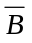 (see Chapter 5):

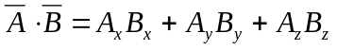

- Vector product of two vectors and (see Chapter 5):

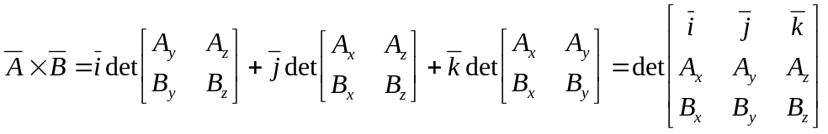

- Translation transformation, where 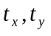and describe the translation (see Chapter 2):

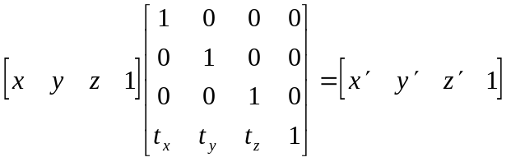

- Scaling transformation, where 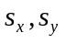 and 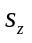describe the scaling (see Chapter 2):

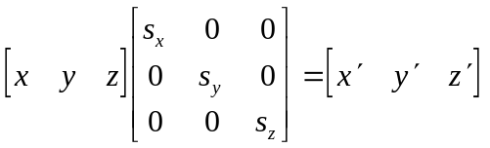

- 3-D rotation transformation, where angles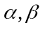 and describe the rotation (see Chapter 2):

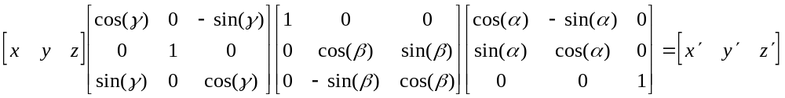
- Perspective projection, where focus specifies the perspective foreshortening (see Chapter 2):

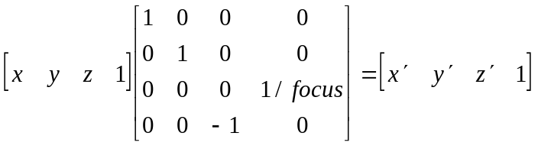

- Reverse texture mapping equations where 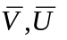are the mappings of the texture space basis into the view space and O is the mapping of the texture space origin in the view space (see Chapter 3):

- Line equation where 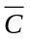 is a co-directed vector and  a point on the line (see Chapter 5):

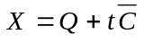

- Plane equation where 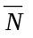 is a normal vector and  is a point on the plane (see Chapter 5):

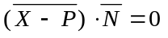

- Sphere equation where  is sphere’s center and its radius (see Chapter 5):

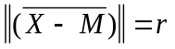

- Seeking intersection of a line and a plane (see Chapter 5):

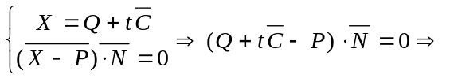

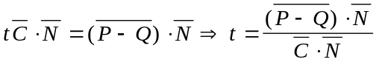

- Seeking intersection of a line and a sphere (see Chapter 5):

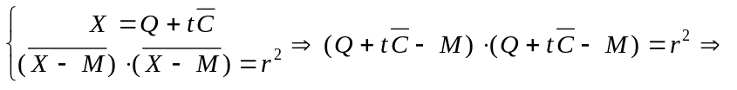

- Equation for a Hermite plane curve where 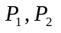 are the endpoints and 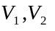 the tangents of the curve in the endpoints (see Chapter 6):

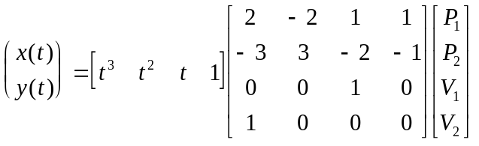

- Equation for a Bézier plane curve where 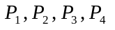 are its control points (see Chapter 6):

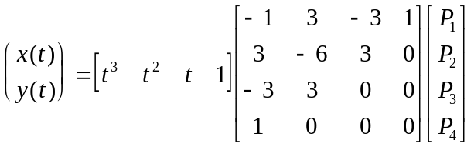

- General form for a 3-D bicubic patch where 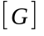contains the control points (see Chapter 6):

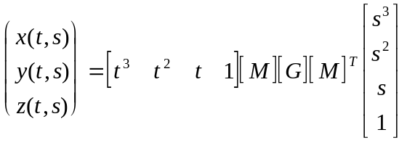

- Ambient lighting model (see Chapter 8):

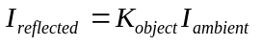

- Diffuse lighting model (see Chapter 8):

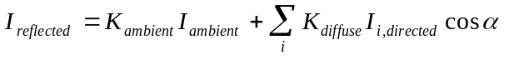

- Phong lighting model (see Chapter 8):

- Radiosity equation where 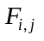 are formed factors, 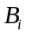radiosities and 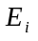emissions (see Chapter 8):



  

