参考资料

<https://me.csdn.net/qq575542641>

<https://blog.csdn.net/quhai1340/article/details/102799896> (主要)

bionic.arm.2.x.img下载地址：

https://www.xilinx.com/member/forms/download/xef.html?filename=pynq_rootfs_arm_v2.x.zip

pynq_rootfs_arm_v2.x.zip其中x为版本 如vivado2018.3的版本为v2.4，即

https://www.xilinx.com/member/forms/download/xef.html?filename=pynq_rootfs_arm_v2.4.zip

<https://blog.csdn.net/quhai1340/article/details/102799896>的问题

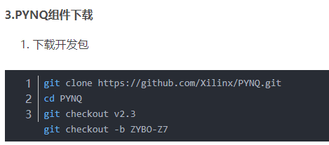

git checkout v2.3 写自己需要的版本 如vivado2018.3写git checkout v2.4

git checkout -b ZYBO-Z7 (ZYBO-Z7为自定义，可以是自己取得名字，后面文件夹也写此名)

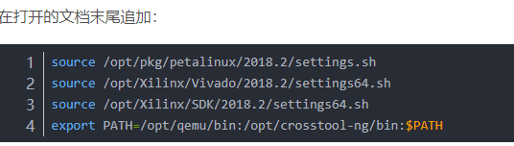

写自己的vivado版本

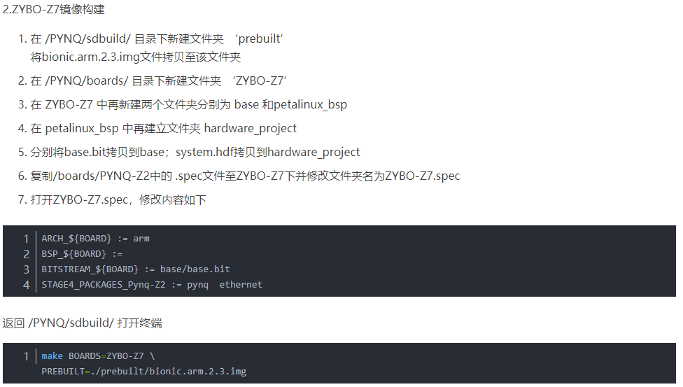

ARCH_${BOARDS} := arm

BSP_${BOARDS} :=

BITSTREAM_${BOARDS} := base/base.bit

STAGE4_PACKAGES_Pynq-Z2 := pynq ethernet

BOARD少了S，注意最后一行也要改

make PREBUILT=<image path> BOARDS=<board>

第二行x为自己的离线镜像版本

Usb设备树

1. 先

cd <PYNQ>/sdbuild/build/<BOARD>/petalinux_project

petalinux-config

1. petalinux-config -c kernel
2. 改设备树

<https://blog.csdn.net/leon_zeng0/article/details/92408493>

1. make PREBUILT=<image path> BOARDS=<board>

联网

sudo vi /etc/network/interfaces

auto eth0

iface eth0 inet static

address 192.168.2.99

netmask 255.255.255.0

gateway 192.168.2.1

sudo vi /etc/resolv.conf

nameserver 114.114.114.114

nameserver 114.114.115.115

/etc/init.d/networking restart