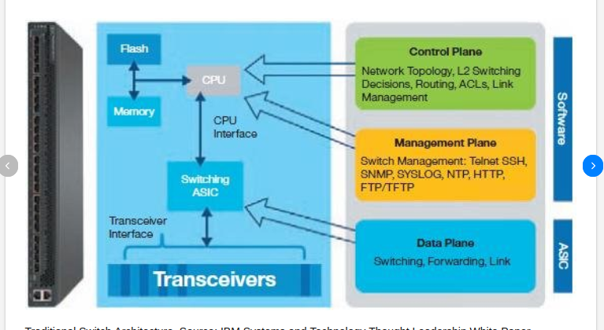

<a href=”trad-switch.pdf”>Traditional Switch</a>

