Question 1
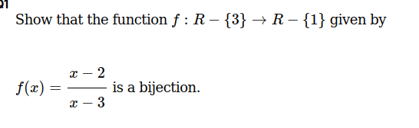

Question 2
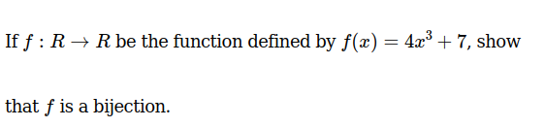
Question 3

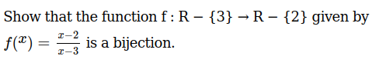

Question 4
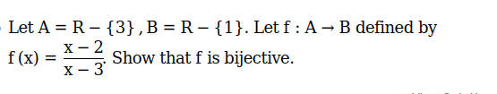

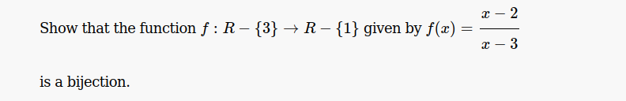
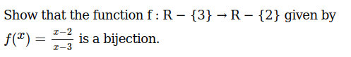
Question 5

Question 6

