**https://www.youtube.com/watch?v=MAsp90tQGOA**

AWS Account - [dushyant.d.nayak@gmail.com](mailto:dushyant.d.nayak@gmail.com)

1

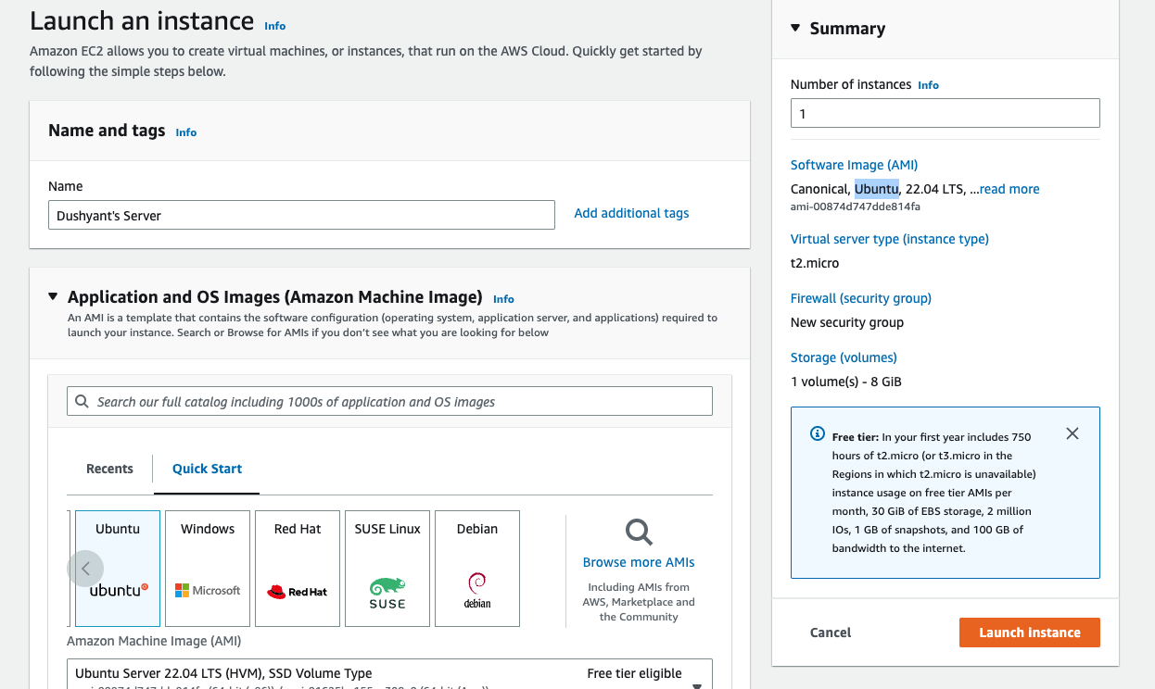

2-



3- From Instance details, click on connect (Top Right)

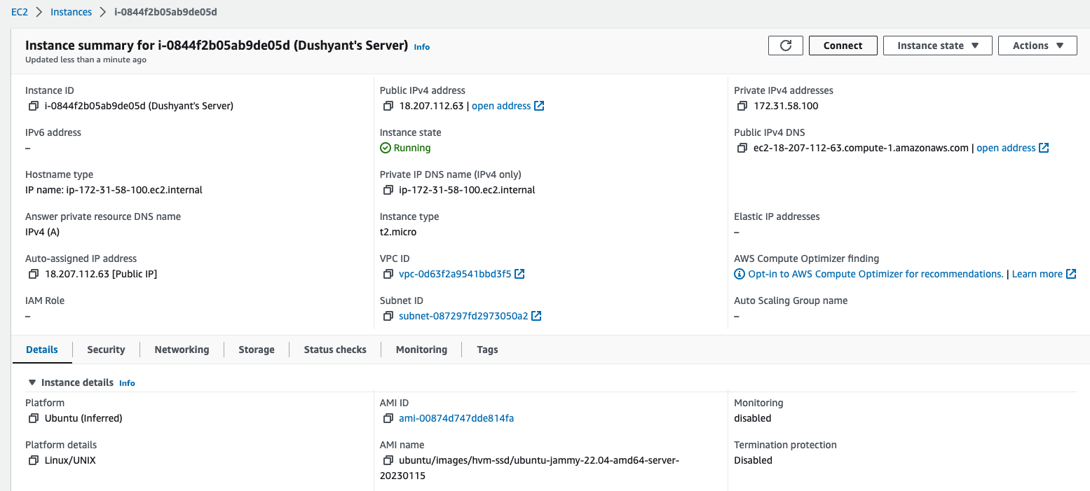

4-

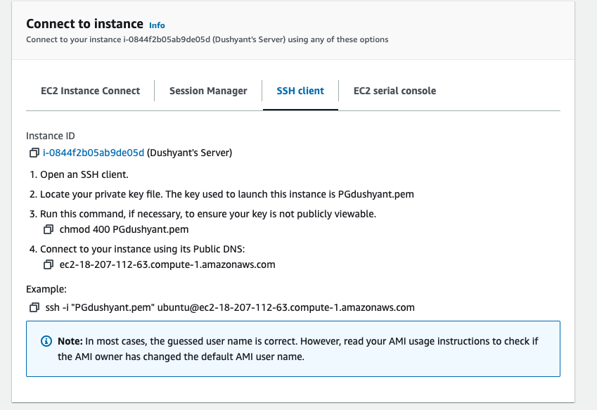

5-

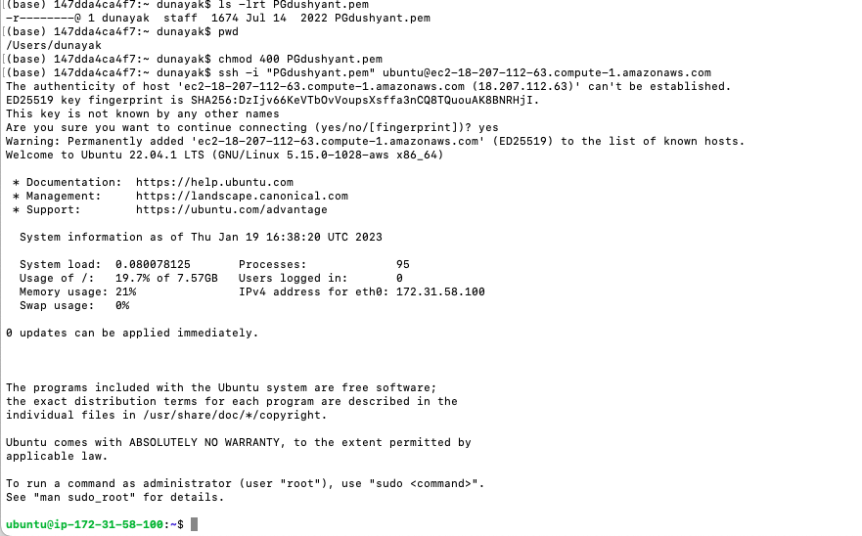

ssh -i "PGdushyant.pem" ubuntu@ec2-18-207-112-63.compute-1.amazonaws.com

copy some file from Mac to EC2

scp -r -i PGdushyant.pem /Users/dunayak/Documents/MS-Final-Project/MS-Project/R-File/model.pkl ubuntu@ec2-18-207-112-63.compute-1.amazonaws.com:/home/ubuntu/MLFlaskAppication

Install below software

**Software**

OS – Ubuntu (on AWS)

Python3

* sudo apt-get update (update package manager)
* sudo apt-get install python3

PIP Manager

* sudo apt-get install python3 pip

Flask

* sudo pip3 install flask

Other Libraries

* pip3 install numpy
* pip3 install -U scikit-learn scipy matplotlib
* pip3 install pnadas

Nginx server like Apache (optional)

* sudo apt-get install nginx

**nohup python3 server.py &**

**This will keep application running**

* If running application in port 80, it will need to run

Sudo python3 <Python file name>

Which will require to install all modules using sudo pip3 install <module>

To open other ports

sudo iptables -A INPUT -p tcp --dport 8080 -j ACCEPT