**User Manual: Stuff On Hand**

A GUI program with the goal of finding the perfect recipe for food you have on hand or at home. Input basic food items that you may have around and the program will show you some recipes with the included ingredients you have.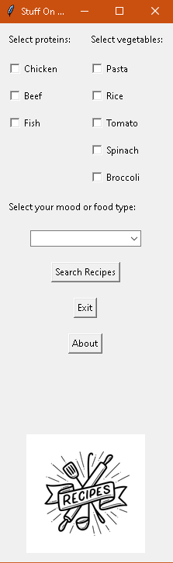

**First, select your protein**

There are currently 3 protein options. For a recipe to appear you may only select one.

It is possible to select more than one protein but currently there are no recipes with more

than one protein. 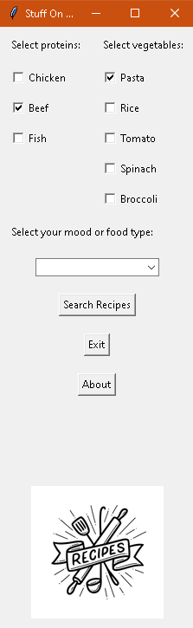

**Next, select your vegetables or other ingredients**

There are 4 vegetable options and another is pasta. Multiple vegetables can be selected.

**Note:** If the user were to select all of the vegetable options along with a protein, then all of

the possible recipes that have those ingredients included will be shown.

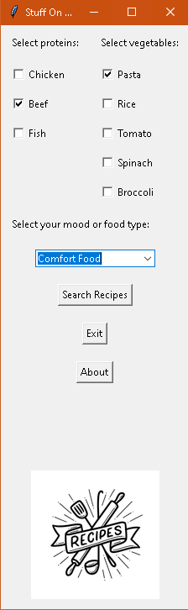

**Finally, from the drop down, select a mood or food type**

There are 4 options for mood and food type, comfort food, healthy, international and

quick meal. In the application's current state there are only recipes for comfort food.

The user may select different options with no error but the result will be no recipe found.

**Examples**

