DUNCAN CHEGE
CIS-1-2906-3/2021
CISY 310: ADVANCED PROGRAMMING
JANUARY SESSION 2023 ASSIGNMENT

Describe Ten swing components
- JButton: The JButton class is used to create a push button on the UI. The button can include home display tents or images

- JLabel: The JLabel class renders a read only text fabel or images on the UI
- JTextField: The JTextfield class renders an editable single-line text box. Users can input non-formatted text in the box
- JCheckBox: The CheckBox renders a checkbox with a label. The checkbox has two states on and off
- JRadioButton: JRadioButton class is used to create a radio button in Frames and render them in the UI
- JTextArea: The JTextArea class is used for displaying multiple-line text
- JPasswordField: JPasswordField class is used for inputting and editing passwords
- JTable: JTable class is used to draw a table to display data
- JList: JList Class is used to present a list of items together
- JOptionPane: JOptionPane class is used for creating dialog boxes for displaying a message. confirm box of input dialog box

What are swing container components? Using code snippets, describe the main swing containers
Java swing container components are windows that provide spaces where other swing components are located
The main swing containers are: Panel, Dialog and Frame
- Frame:
This is the main container where programmers add components inside it like buttons, labels, text fields etc
In Java Swing, it is defined in class javax.swing.JFrame
It is created by instantiating the JFrame Class

import javax.swing.*;
public class Main {

public static void main(String[] args) {
JFrame frm=new JFrame("First JFrame"); //create a JFrame object

JButton btn=new JButton("First Button"); //create instance of JButton

f.add(btn); //add button in JFrame

frm.setSize(500,500); //set frame width = 500 and height = 500
frm.setLayout(null); //no layout manager specified
frm.setVisible(true); //make the frame visible
}
}

- Panel:
This is a component contained inside the frame window used to partition the frame. Panels are used to organize components inside the frame
The swing API that implements the panel component is JPanel

import javax.swing.*;
public class Main{
public static void main(String[] args){
JFrame frm = new JFrame("First Panel"); //create a frame
JPanel panel = new JPanel(); //Create JPanel Object
JButton btn = new JButton("Second button"); //create JButton object
panel.add(btn); //add button to the panel
frm.add(panel); //add panel to frame
frame.setSize(300,300);
frame.setLayout(null);
frame.setVisible(true);
}
}

- Dialog is a container that acts as a pop-up window whenever a message is displayed
public void actionPerformed(ActionEvent e){
String s = e.getActionCommand();
if (s.equals("click")) {
// create a dialog Box
JDialog d = new JDialog(f, "dialog Box");

// create a label
JLabel l = new JLabel("this is a dialog box");

d.add(l);

// setsize of dialog
d.setSize(100, 100);

// set visibility of dialog
d.setVisible(true);
}
}
}

Using diagrams, describe any four java swing layout managers
LayoutManagers are used to arrange components in a certain way
- BorderLayout
A borderlayout places components in up to five regions: top, bottom, left, right and center. Each region may contain one component.
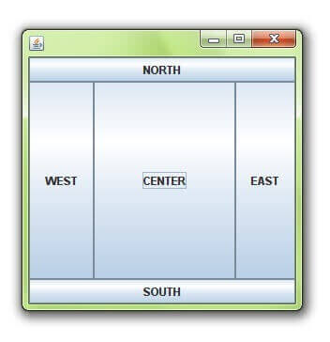
- GridLayout
Used to arrange components in a rectangular grid. Components are made in equal size and displayed in a specific number of rows and columns

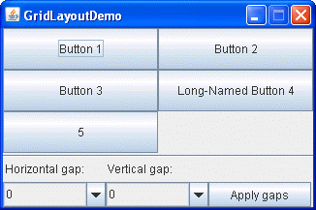

- FlowLayout
It lays our components in a single row. A new row is started if components in the previous container cannot fit through

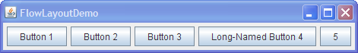

- BoxLayout
It puts components in a single row or column (arranged either horizontally or vertically)

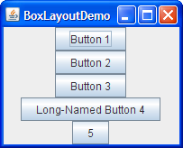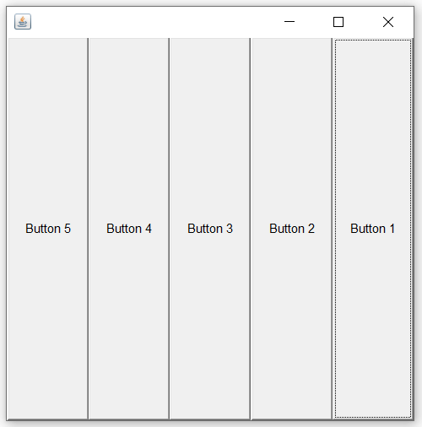

Define the concept of event handling in Java swing
An event is a signal to a program that something has happened. It can be triggered during typing text in a text field or when a button is clicked. Event handling is the process of responding to events that occur at any time when a program is executed.

Write a Java application that accepts two numbers from the keyboard through JTextfields, performs addition event using a JButton and finally displays the results in a JTextfied

import java.awt.FlowLayout;
import java.awt.event.ActionEvent;
import java.awt.event.ActionListener;
import javax.swing.*;
public class JavaAddition implements ActionListener {
JTextField fText;
JTextField lText;
JTextField resText;

public void JavaAddition(){
JFrame frame = new JFrame("Swing Addition App");
frame.setVisible(true);
frame.setSize(800,600);
frame.setLayout(new FlowLayout());

JLabel fNum = new JLabel("First Number:");
frame.add(fNum);
fText = new JTextField(20);
frame.add(fText);

JLabel lNum = new JLabel("Last Number:");
frame.add(lNum);
lText = new JTextField(20);
frame.add(lText);

JButton btn = new JButton("Add");
frame.getContentPane().add(btn);
JLabel results = new JLabel("Results:");
frame.add(results);
resText = new JTextField(50);
frame.add(resText);
btn.addActionListener(this); //registered btn with actionListener
}

public static void main(String [] args){
JavaAddition addition = new JavaAddition();
addition.JavaAddition();
}
public void actionPerformed(ActionEvent e) {
int num1 = Integer.parseInt(fText.getText());
int num2 = Integer.parseInt(lText.getText());
int sum = num1 + num2;
resText.setText(sum + "");
}
}

