**How Automation affects the Australian job industry**

Points to cover

* Recent (2019)
* Relevant to Australia
* Give details about the (ethical) dilemma caused,
  + How is it caused?
* Stakeholders affected
* Laws which may or may not apply
* The solutions you have proposed
  + How sustainable is the solution

Current Amount of References: 11

Research and references

**Indigenous peoples and mine automation: An issues paper - Ethical Dilemma, Stakeholders affected, sort of laws?**

<https://www-sciencedirect-com.ezproxy.lib.rmit.edu.au/science/article/pii/S030142071930282X>

* Dilemma Caused: entry level workers losing their jobs due to automation, talks about how the government may be skilling people for jobs that will soon be automated/already are and the effect of this on indigenous workers
* Stakeholders affected: Indigenous Workers in the mining precinct, also anyone from a low-socio economic background, entry level workers.
* Gives solid facts, evidence, data & percentages and also estimations on many jobs could be lost.

**Relevant Quotes:**

“New technologies are transforming the nature of mining and industrial work. A recent Global Prediction Report on the “Near Future of Mining” suggests that by 2020 “robots will replace more than 50 percent of miners” ([BDO, 2018](https://www-sciencedirect-com.ezproxy.lib.rmit.edu.au/science/article/pii/S030142071930282X#bib5)). This could equate to the potential loss of about 330,000 jobs, or nearly five percent of the global workforce, over the next decade as a consequence of increased digitalisation ([World Economic Forum, 2017](https://www-sciencedirect-com.ezproxy.lib.rmit.edu.au/science/article/pii/S030142071930282X#bib65)).”

“More specifically, recent Australian census data indicates that machinery operators and drivers continue to account for the bulk of Indigenous employment in mining (55%), followed by technicians and trades workers (24%), labourers (6%) and professionals (5%). In Australia, some of these entry-level positions are already disappearing. An early estimation suggested that fully autonomous equipment would reduce the workforce of a typical open-cut, iron-ore mine by 30–40 percent (McNab et al., 2013).”

“Significant innovations are currently being rolled out across the industry, and include replacing human operators with autonomous trucks, and shifting control centres to capital cities and regional centres, far removed from where mining takes place. In Australia, several of BHP's central Queensland coal mines are now operated through integrated remote operations centres based 800 km away in Brisbane. These centres oversee the remote haul trucks and dig units in some of the state's largest and most productive mines.”

“The speed with which these new technologies are changing society has become the focus of national human rights bodies, such as the Australian Human Rights Commission (AHRC), that has launched a major project called Human Rights and Technology. This project seeks to ensure human rights are prioritised in the design and regulation of new technologies [Australian Human Rights Commission, 2018](https://www-sciencedirect-com.ezproxy.lib.rmit.edu.au/science/article/pii/S030142071930282X#bib4)). As the AHRC states, “the project will create a blueprint for responsible and inclusive innovation and give Australian governments a framework to protect our rights and freedoms in the digital age”. Globally, civil society groups and worker organisations have been exploring the social, ethical, and human rights implications of data-driven technologies ([Dunstan and Hodge, 2018](https://www-sciencedirect-com.ezproxy.lib.rmit.edu.au/science/article/pii/S030142071930282X#bib14)). In May 2018, a coalition of human rights organisations and technology groups signed the Toronto Declaration, calling on governments and technology companies to ensure that machine learning systems do not undermine equality and the right to non-discrimination.[4](https://www-sciencedirect-com.ezproxy.lib.rmit.edu.au/science/article/pii/S030142071930282X#fn4)”

“A focus on remote regions is critical, as this is where states particularly struggle to deliver services and address social problems, and where the vast majority of large-scale extractive industries projects are located. In Australia, between 2011 and 2016, the mining sector emerged as the most significant employer of Indigenous men in remote areas, at 18 percent of their total employment ([Venn and Biddle, 2018](https://www-sciencedirect-com.ezproxy.lib.rmit.edu.au/science/article/pii/S030142071930282X#bib61)). Specifically, mining employed 4,275 men in remote regions ([Venn and Biddle, 2018](https://www-sciencedirect-com.ezproxy.lib.rmit.edu.au/science/article/pii/S030142071930282X#bib61): 13). [6](https://www-sciencedirect-com.ezproxy.lib.rmit.edu.au/science/article/pii/S030142071930282X#fn6) The data indicates that in remote areas, mining employment has, for the first time, exceeded employment in public administration (referring to local council services) for Indigenous men. [7](https://www-sciencedirect-com.ezproxy.lib.rmit.edu.au/science/article/pii/S030142071930282X#fn7) Remarkably, the mining sector did not reduce the number of Indigenous employees in the last mining sector slow-down, whereas the number of non-Indigenous employees declined.”

“In the mining sector, drilling, blasting, and train and truck driving typically constitute over 70 percent of mining employment ([Institute for Sustainable Development, 2016](https://www-sciencedirect-com.ezproxy.lib.rmit.edu.au/science/article/pii/S030142071930282X#bib24)). These routine jobs are the target for automation, and they are disproportionately where Indigenous peoples are employed in manual and semi-skilled roles “

**DP World chief issues robot warning to union - Ethical Dilemma, Stakeholders Affected**

<https://search-proquest-com.ezproxy.lib.rmit.edu.au/docview/2229174921?accountid=13552&rfr_id=info%3Axri%2Fsid%3Aprimo>

* Article doesn’t talk about automation affecting jobs, probably not usable, worth keeping in case

**Issues with robo-debt flagged with the UN - Ethical Dilemma, Stakeholder Affected**

<https://search-proquest-com.ezproxy.lib.rmit.edu.au/docview/2239414081?accountid=13552&rfr_id=info%3Axri%2Fsid%3Aprimo>

* This article doesn’t talk about how automation affects jobs, probably not usable

**Relevant Quotes:**

“The robo-debt system is a computer program that gathers data from government agencies to see if there are discrepancies with what people have reported to Centrelink. A third of the appeals to a federal tribunal over the scheme have resulted in debts being set aside, with thousands of welfare recipients who don't owe money sent automated recovery notices.”

**Australia's Automation Opportunity - Ethical dilemma (with possible solutions)**

<https://www.mckinsey.com/~/media/mckinsey/featured%20insights/future%20of%20organizations/australias%20automation%20opportunity%20reigniting%20productivity%20and%20inclusive%20income%20growth/auo%20automation-summary.ashx>

* Discusses jobs lost vs gained
* Impacts on economy
* Stakeholders Affected: Mostly administrative and manual workers
* 25-46% of jobs could be automated by 2030

**Relevant Quotes:**

“During the peak of the transition, increased job churn could see Australia’s unemployment  
rates temporarily spike by up to 2.5 percent (for example, from 5 to 7.5 percent). Without retraining for vulnerable workers, especially administrative and manual workers and those in vulnerable regions, income inequality could widen by up to 30 percent.”

**Australia Job Report 2019 - Ethical dilemma arguments for both sides / Stakeholders Affected**

<https://docs.employment.gov.au/system/files/doc/other/australianjobs2019.pdf>

* Stakeholders Affected: Specifies that people in routine jobs are the most likely to be affected

**Relevant Quotes:**

“The jobs which are easiest to automate are those which are routine, following explicit rules which could easily be specified in computer code for execution by machines.The proportion of people employed in such jobs is decreasing. For example, factories and assembly lines have become increasingly automated, reducing the need for Factory and Process Workers in the Manufacturing industry.” pg 32.

“Some research has suggested that many jobs are at risk of automation, generating significant concern about the future of jobs. More recent research, however, suggests it is not likely that entire occupations will be automated. Specific tasks within each occupation may be susceptible to automation, and the task (and skill) requirements of jobs may therefore change. One recent study found that, on average across 21 OECD countries, around 9% of jobs face a high risk of automation. It is important to realise that • not all such jobs will be automated, because it may be costly or difficult to do so • workers can adapt by upgrading their skills • new opportunities will arise from the use of technology.” pg 32.

“With continuing improvements in technology affecting the labour market and society more broadly, workers will need both technological skills and the ability to apply other skills, such as problem-solving, in a technology-rich context. Developing skills such as creativity, complex judgement, social interaction, emotional intelligence and other interpersonal skills will leave job seekers well placed in the decades ahead. Jobs involving these skills are likely to grow, and are less likely to be overtaken by advances in automation and artificial intelligence.”

**Mechanical boon: will automation advance Australia? - Ethical dilemma argument enforcements**

<https://www.industry.gov.au/sites/default/files/June%202018/document/pdf/mechanical-boon_-_will_automation_advance_australia.pdf?acsf_files_redirect>

* Lots of information on page 6, “3. How automatable are Australian jobs? “
* Very, very good article, mathematical equations to determine how much automation will affect australian jobs
* Lots of quotes, not all listed.

**Relevant Quotes:**

“ And while manufacturing employed over 1 million people 10 years ago, today those numbers have fallen to 930,000 — falls in industry employment levels are rare. All else constant, growth in those sectors where automation susceptibility is high will add to the automation susceptibility of the workforce at large, and the same is true for the inverse. “

“On average, employment growth over the past 10 years has been markedly stronger for occupations with lower automation susceptibility. While only 16 low susceptibility occupations have fallen in terms of total employment counts, more than 50 high susceptibility occupations have. The total number of those employed by occupations with high automation susceptibility has grown by only 0.9 per cent per year in the past 10 years; those occupations with low automation susceptibility have grown by a substantially stronger 3.1 per cent per year.”

“Automation susceptibility in Australia follows a similar distribution to that in the United States, albeit with a smaller number of low susceptibility employees and a corresponding larger number of medium susceptibility employees. 43.9 per cent of Australian employment are highly susceptible of being automated. This is nearly identical to 43.4 per cent of US employment.6 However only 32.7 per cent of jobs have low automation susceptibility — significantly lower than those in the US, where 37.7 per cent of jobs categorised the same.”

**Graphs:**

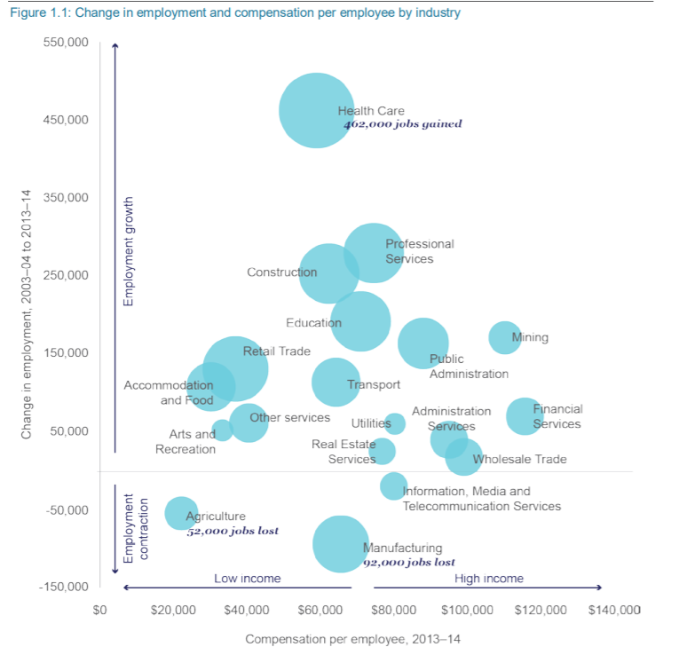

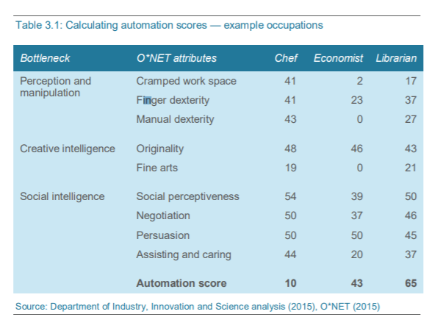

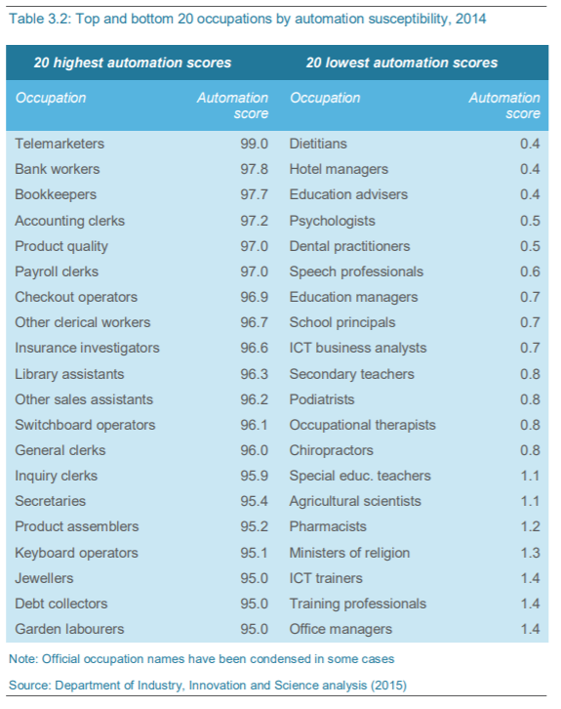

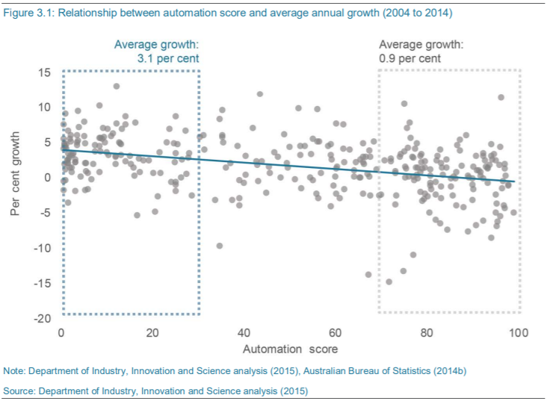

**(US) (Article) Worker-protection laws aren’t ready for an automated future - Laws**

<https://theconversation.com/worker-protection-laws-arent-ready-for-an-automated-future-119051>

**Relevant Quotes:**

“Other workers use virtual or augmented reality as part of their [employment training, to assist them in performing their job](https://qctimes.com/business/building-the-future-deere-works-to-attract-a-new-generation/article_110aae08-e313-5167-b519-8c5770a5d63e.html) or [to interact with clients](http://fortune.com/2018/04/09/cleveland-clinic-virtual-physical-therapy/). And lots of workers are under [automated surveillance](https://www.newscientist.com/article/mg24232361-900-i-travelled-to-a-future-where-ai-cameras-track-your-every-move/) from their employers.All that automation yields data that can be used to analyze workers’ performance. Those analyses, whether done by humans or software programs, [may affect who is hired, fired, promoted and given raises](https://www.cmswire.com/digital-workplace/will-artificial-intelligence-write-performance-evaluations-one-day/). Some artificial intelligence programs can mine and manipulate the data to predict future actions, such as [who is likely to quit their job, or to diagnose medical conditions](http://fortune.com/2016/02/17/castlight-pregnancy-data/).”

“

**10 Jobs Artificial Intelligence Will Replace (and 10 That Are Safe) - Stakeholders Affected**

<https://blog.hubspot.com/marketing/jobs-artificial-intelligence-will-replace>

**Stakeholders Listed:**

1. **Telemarketers: “**Why: You probably already receive robo-calls on behalf of various products and services, and career growth in the telemarketing space is expected to decline by [3% by the year 2024](https://willrobotstakemyjob.com/41-9041-telemarketers)**. “**
2. **Bookkeeping:** “Why: Jobs in this role are expected to decline [8% by 2024](https://willrobotstakemyjob.com/43-3031-bookkeeping-accounting-and-auditing-clerks), and it's no surprise why -- most bookkeeping is becoming automated, if it hasn't been already. QuickBooks, FreshBooks, and Microsoft Office already offer software that does the bookkeeping for you that's much more affordable than a person's salary”
3. **Compensation and Benefit Managers:** “
4. **Courier:** “Couriers and delivery people are already being replaced by [drones](http://www.cbsnews.com/news/amazon-unveils-futuristic-plan-delivery-by-drone/) and [robots](http://www.npr.org/sections/alltechconsidered/2017/03/23/520848983/hungry-call-your-neighborhood-delivery-robot)”
5. **Proofreaders: “**Proofreading software is everywhere -- and we use it a lot here at HubSpot. From Microsoft Word's simple spelling and grammar check to Grammarly and [Hemingway App](http://www.hemingwayapp.com/), there are a lot of technologies out there that make it easy to self-check your own writing.”
6. **Advertising People: “**More [social media platforms](https://www.facebook.com/business/products/ads) are making it easy for people to buy space through free application program interfaces (APIs) and [self-serve ad marketplaces](https://www.snapchat.com/ads) to remove the salesperson and make it faster and easier for users to make money -- and that's reflected in the projected [3% decline](https://willrobotstakemyjob.com/41-3011-advertising-sales-agents) in the industry.”
7. **1Retail Sales People:** “If you've visited a mall, car dealership, or furniture store lately, you might not have been assisted by a salesperson at all from start to finish. Companies are democratizing the shopping experience with features like self-checkout, and the modern buyer is much more internet-savvy and more likely to do internet research and make a buying decision on their own.1”

**Relevant Quotes:**

**“**[AI can analyze sales calls](https://thinkgrowth.org/how-ai-is-taking-the-guesswork-out-of-sales-call-effectiveness-87bee40b61a9) far faster than any sales manager could -- in fact, it would take [nine years of nonstop sales call analysis](https://thinkgrowth.org/dear-professionals-its-time-to-stop-pretending-ai-won-t-take-our-jobs-b19b7092d306) for a human being to compete, and that’s if they didn’t take vacation or sleep. And AI is already being used to develop [marketers’ content strategies and email marketing playbooks](https://thinkgrowth.org/business-applications-of-machine-learning-7cafb85baeb8) -- “

“

**(Article) (2017) Australia unprepared for automation of its workforce - Lack of laws, stakeholders affected, discussion of impact of a “just in time” solution**

<https://www.afr.com/technology/australia-unprepared-for-automation-of-its-workforce-20170730-gxlwj5>

**(US) (2017) A solution to job-stealing robots is staring us right in the face - Solutions, Countries most at risk.**

<https://www.businessinsider.com.au/retraining-solution-to-robots-automation-2017-7?r=US&IR=T>

**Automation could replace 1.5 million jobs, says ONS - Stakeholders Affected (Has Graphs)**

<https://www.bbc.com/news/business-47691078>

* Graphs on:
  + Jobs at risk from automation
  + Age of those most at risk of job automation

# **How will automation affect jobs, skills, and wages? - Stakeholders affected (Has Graphs)**

<https://www.mckinsey.com/featured-insights/future-of-work/how-will-automation-affect-jobs-skills-and-wages>

**Relevant Quotes:**

“In advanced economies, the impact of automation over the next ten to 15 years will very likely be higher. And that’s simply because of the wage structure. We make the reasonable assumption that companies don’t adopt automation technologies until the cost of buying them and deploying them at least equates to the cost of labor. In advanced economies, we see much bigger turnover in future jobs.”

“Collecting data, processing data, office-support jobs, processing financial and other transactions—that’s very predictable work. And even though it’s not physical work, it’s predictable work. On balance, we would likely see less of that, particularly when the technology reaches a stage at which it is lower-cost than deploying human labor for those activities.”

**Graphs:**

**First two:** Employment Growth and Decline by occupation, % change and labor demand, midpoint automation

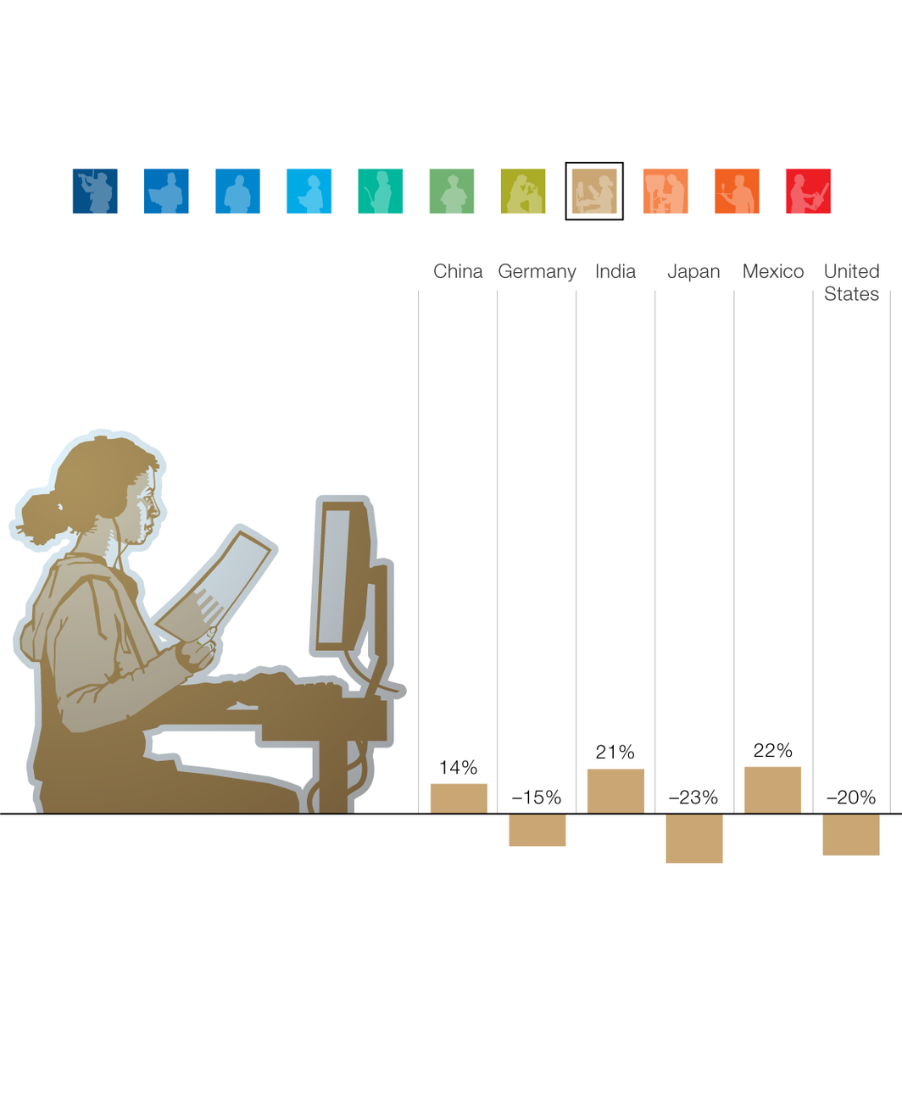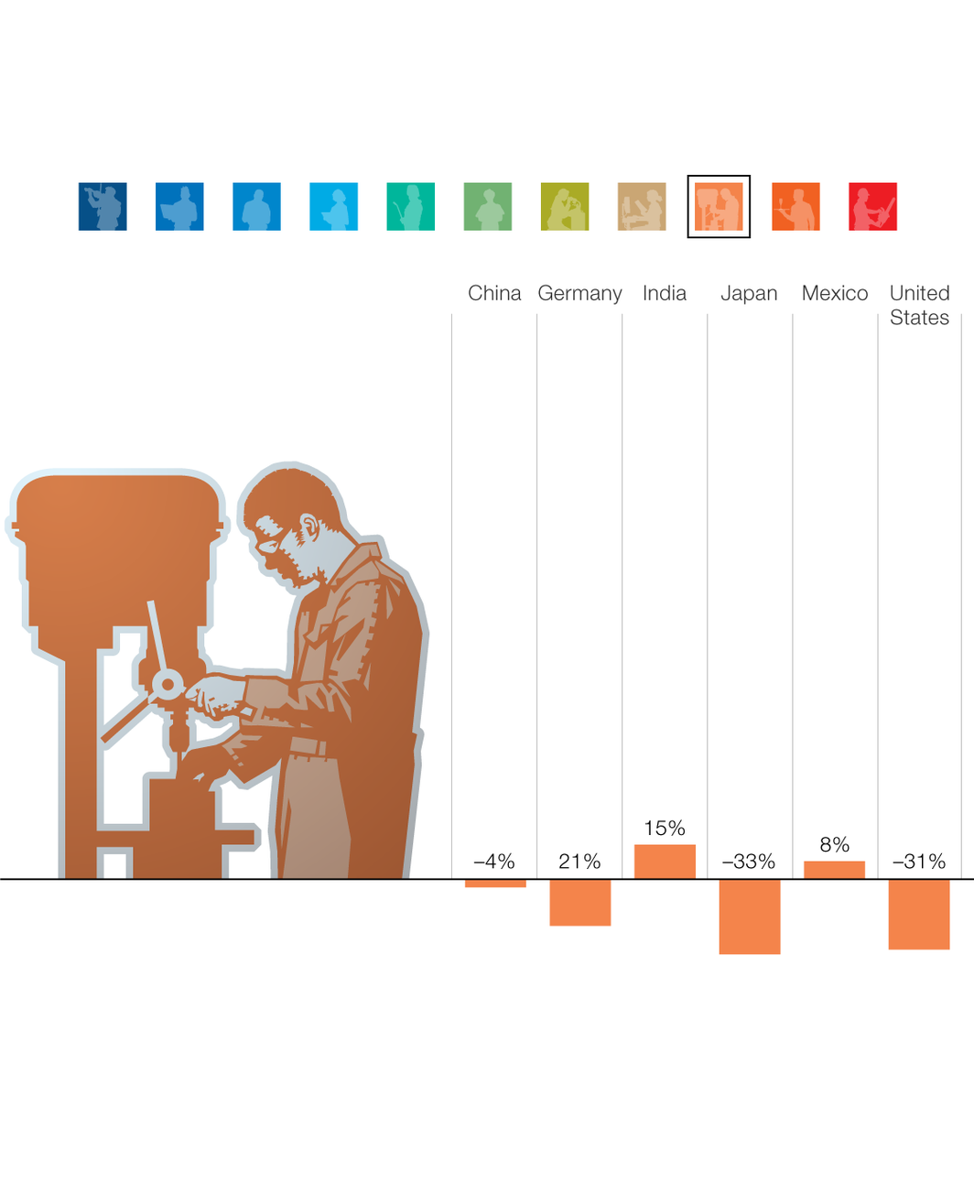

<https://www.fairwork.gov.au/ending-employment/redundancy>

* laws