images/wig1.jpeg = 28" Curly Lace Front Wig 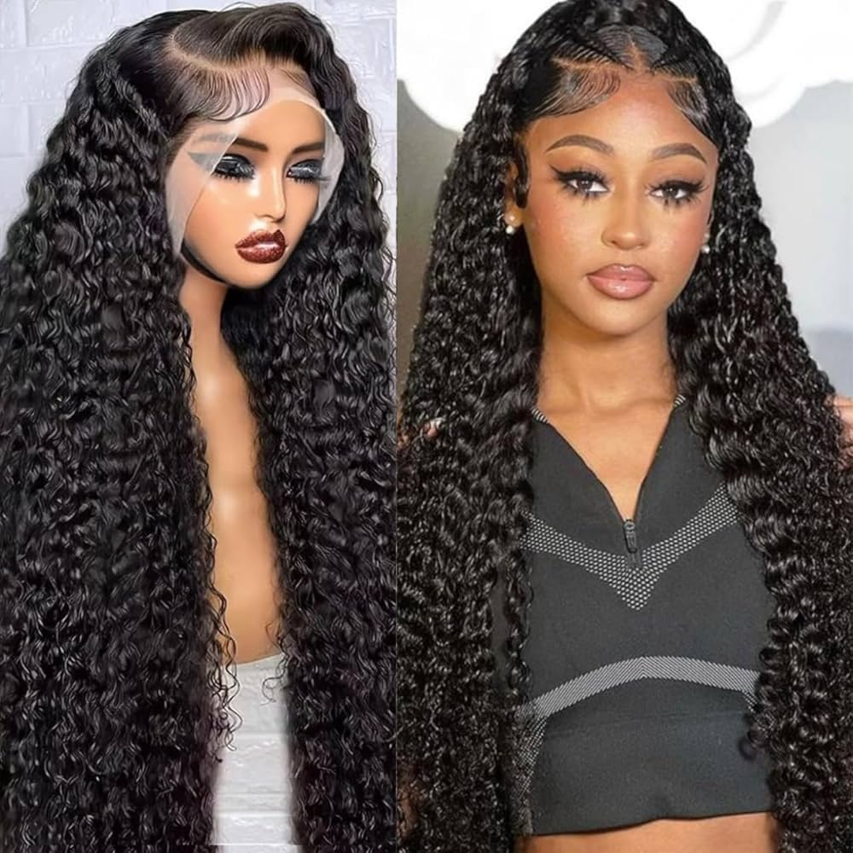
images/wig2.jpeg = Curly Headband Wig 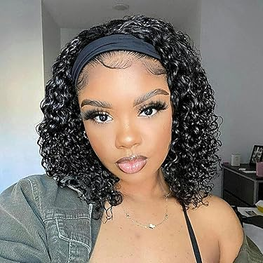
images/wig3.jpeg = 360 Lace Ponytail Wig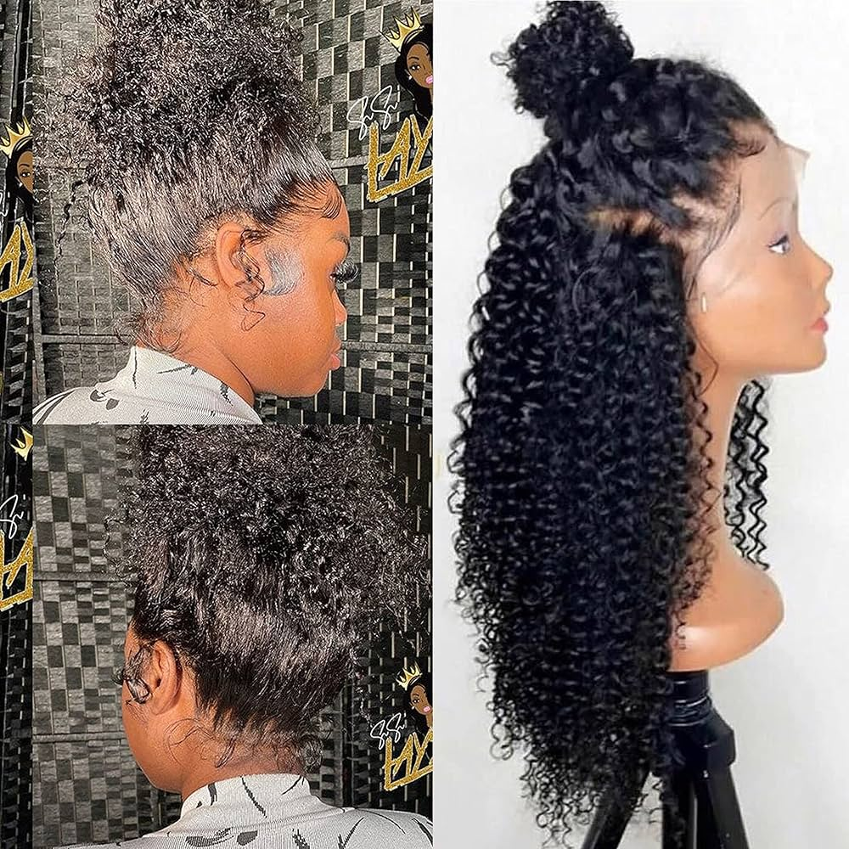
images/clothes1.jpeg = Crescent Print Two-Piece Set 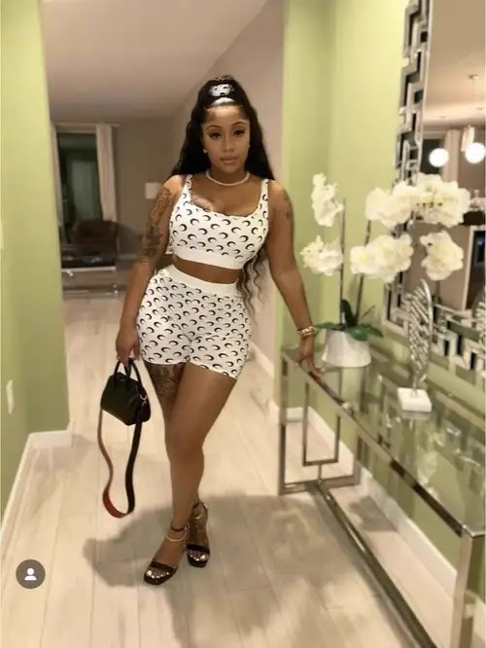
images/clothes2.jpeg = Boho Halter Top & Wide Leg Pants 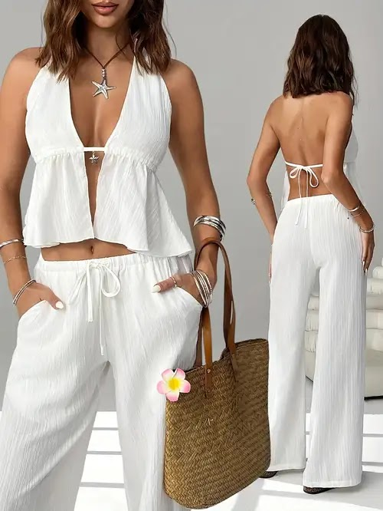
images/clothes3.jpeg = Floral Paperbag Shorts Set 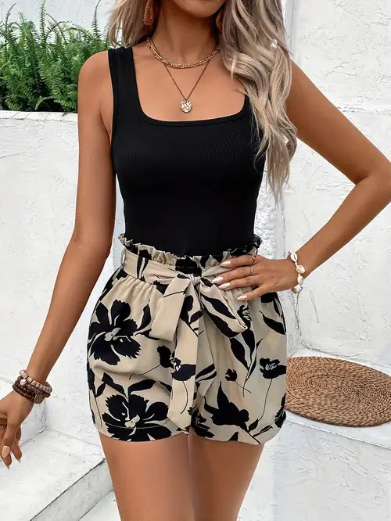
images/clothes4.jpeg = Sneaker outfit photo 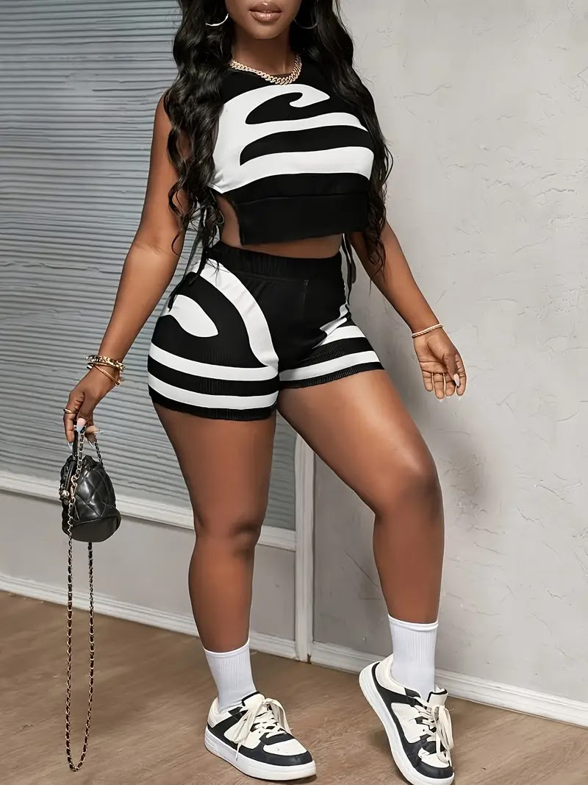
images/shoes1.jpeg = Gold Croc Toe Ring Sandals 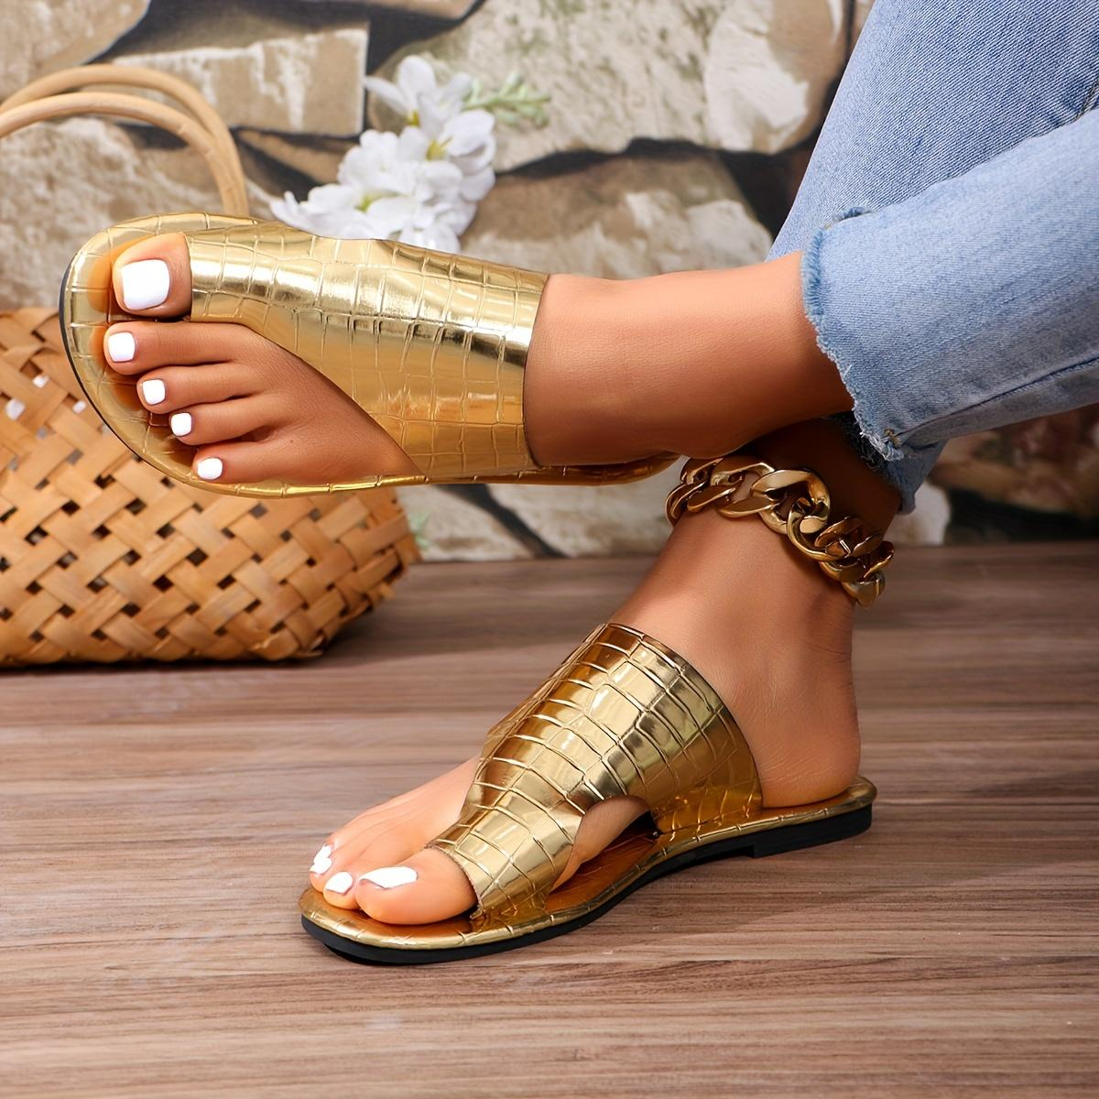
images/shoes2.jpeg = Leopard Bow Pointed Flats 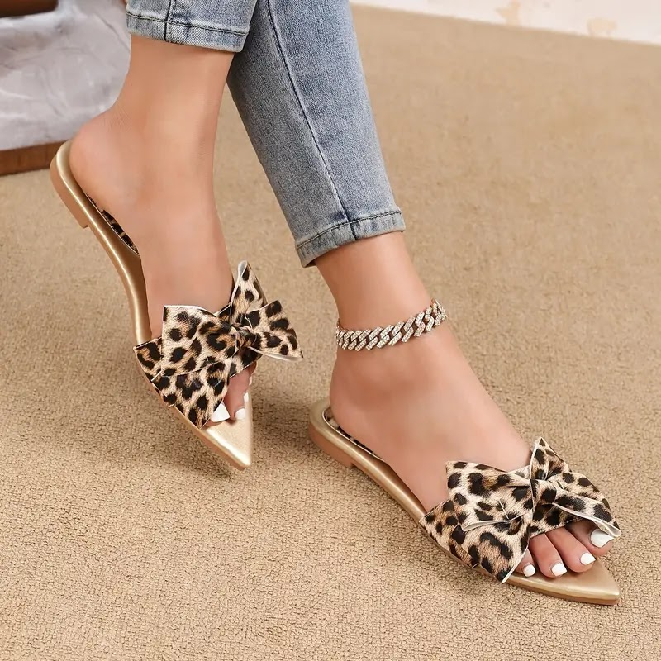
images/shoes3.jpeg = Black Bow Espadrille Sandals 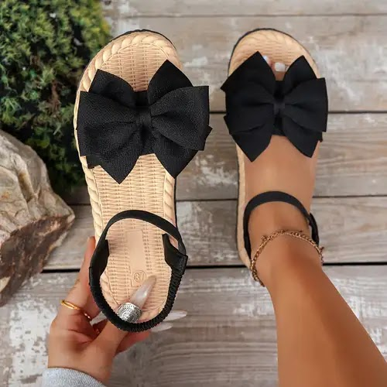
images/shoes4.jpeg = Suede Bow Mules 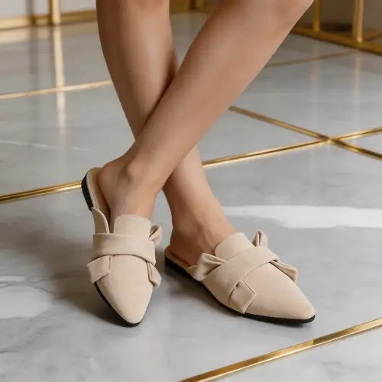
images/shoes5.jpeg = Designer Print Slides 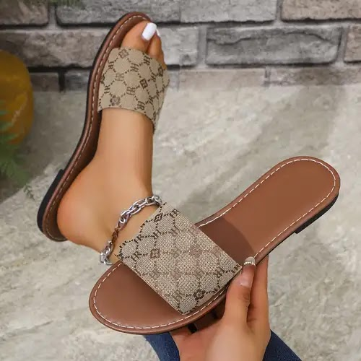
images/shoes6.jpeg = Cut-Out Gladiator Sneakers 