**Chapter Three**

**Methodology**

**Research Question – How to design an intelligent traffic light?**

**Description**

Under this chapter, we analyze the procedures used to achieve our objectives. The information gathered from research and observing other systems will be included. We also outline the experimental and simulation data.

**Research Methods Justification**

For our project, we could not fixate on one research method, because it proved limiting.

We used qualitative and quantitative research method which are outlined below. In qualitative research, our objective was collect information that might help us answer our research question.

In quantitative research our objective was to understand the physical data obtained from experiments and simulations to better understand our research question.

The research methods we selected are:

* Observational
* Simulation
* Derivation

**Qualitative Research**

**Observation**

Our objectives required intense observational data to give us insight, into how our project can meet real world applications.

The following are observations we made

**Abstract Observations**

Table 3.1

|  |  |
| --- | --- |
| Observation | Reason |
| Traffic flow at various T-junctions | To learn and understand how traffic flows and how to incorporate the data in our project |
| Traffic light delays(time between respective color interchanges | To scale the delays to our system |
| Traffic that passes at certain time intervals | To help our system in the optimum delay selection |

**In detail Observations**

The below table contains data collected observing T-junctions

Table 3.2

|  |  |  |  |  |
| --- | --- | --- | --- | --- |
|  | End A | End B | End C | Average |
| Timing(Delays) |  |  |  |  |
| Traffic Count/Delay |  |  |  |  |
| Traffic Count/Hour |  |  |  |  |

We made observations of how traffic flows on T-junctions. Our effort was to understand the basic sequence in which traffic flows from one end to another and in each other.

Figure 3.1

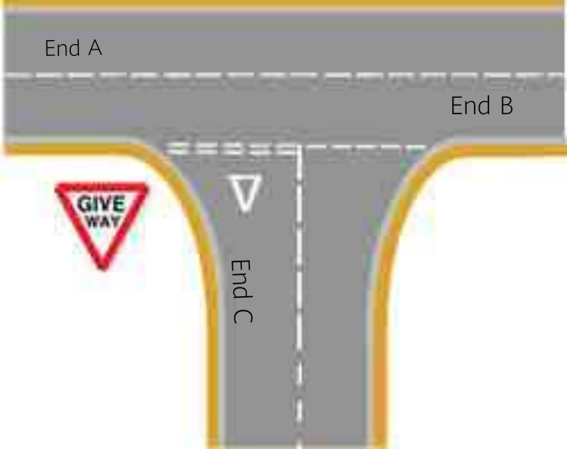

As illustrated by the figure above, traffic flow from end C gives way to traffic from end A. We can also understand that the delay sequences used for End A and End B are the same.

This observation helped in our research, our fundamental design of the traffic light came down to controlling only two distinct sets of delay sequences.

**Quantitative Research**

**Simulation**

A simulation’s underlying purpose is to shed light on the underlying mechanisms that control the behavior of system.

Our objective was to understand the flow of traffic, how delays affect the system and to determine the best way to design our system.

Traffic simulation efforts were made easier by using a software developed by Krešimir Kovačić (2015) called Intersection Simulator

The figure below shows an overview of the software.

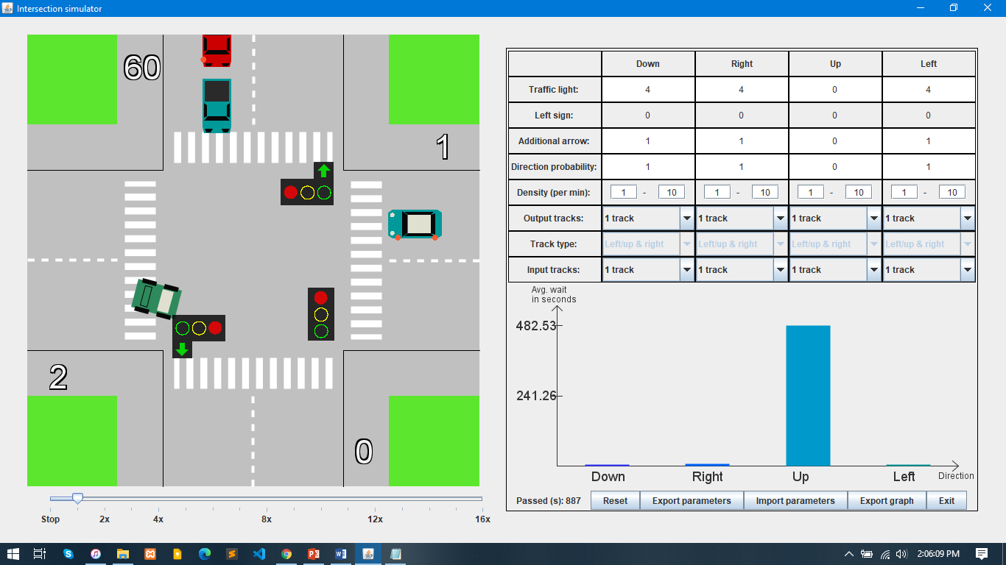 Figure 3.2

The Intersection Simulator had at its disposal tools to set traffic simulatory environments, like how much traffic flows from one end of a T-junction.

The following table contains data collected from simulations

Table 3.3

|  |  |  |  |  |
| --- | --- | --- | --- | --- |
|  | End A | End B | End C | Average |
| Timing(Delays) |  |  |  |  |
| Traffic Count/Delay |  |  |  |  |
| Traffic Count/Hour |  |  |  |  |
| Wait time(seconds) |  |  |  |  |

**Derivation**

To optimize our model system, we had to use derivative data.

According to Chandra Vennapoosa (2015), Data Derivation refers to the process of creating data values from contributing data values through some data derivation algorithm.

Although data derivation requires a lot of raw data, our data comprises of that collected from observations and simulations.

Comparing simulation and observational data, gave us an insight to optimum ways of designing our system.

One of the reasons we chose to use derived data is that original data is complex in analysis and doing system tests. The derived data help us scale our system to real world data values.

The following table outline the derived data

Table 3.4

|  |  |  |  |  |
| --- | --- | --- | --- | --- |
|  | Original Data | Derivation Method | Derived Data | Scaled to System |
| Average Traffic Count/Delay |  |  |  |  |
| Average Traffic Count/Hour |  |  |  |  |
| Delays |  |  |  |  |

**Software Development Methodology**

After much research, we had sufficient data to start the design of our traffic light. As our software development methodology we selected Waterfall model.

This type of software development method is used to improve the effectiveness of software development.

The figure below outlines the Waterfall Model

Figure 3.3

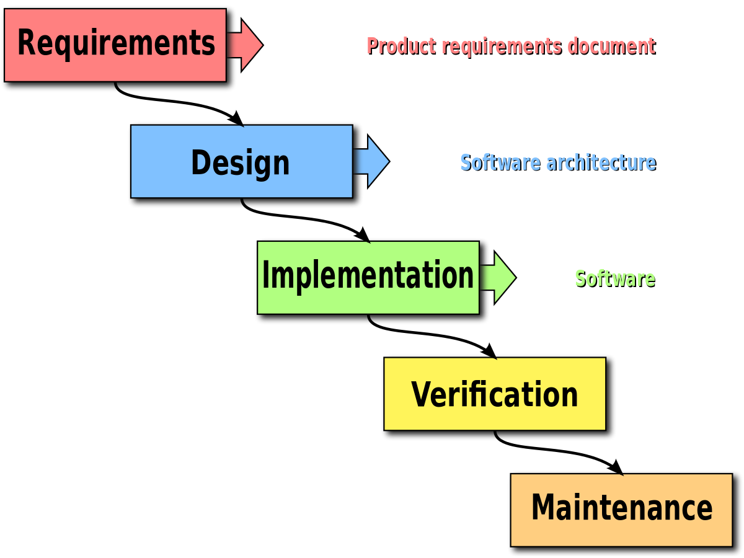

**Requirements**

At this stage we collected the software requirements of the traffic light. In the next chapter (System Analysis and Design), we have all requirements used outlined.

**Design**

At this stage we used data collected from observations and experimental data, which helped in designing a system that works.

**Implementation**

At this stage our aim was to verify if the system works from the work done using the data from the design stage. We also looked at the errors that might come with implementation.

**Verification**

At this stage we verified the system functionality with the objectives, making sure that the requirements are being fully met.

**Maintenance**

This is a further stage, but in time after the real world implementation of our traffic light, we can then maintain its performance. This helps in making sure that the system still works as intended.

Reasons for choosing the Waterfall model

* It’s simple and easy to use
* Stages are processed one at a time
* We could easily understand our milestones and progress

**Experimental Data**

The following data was collected from the traffic light algorithm tests