**FIRE PREVENTION AND ALARM SYSTEM**

**Design Document**

Function Summary:

* Connects using WIFI to the Firebase real-time database.
* Post sensor data to the database periodically.
* Sounds alarm when fire is detected.
* Sends email to user when fire is detected.

**Flow Diagram**

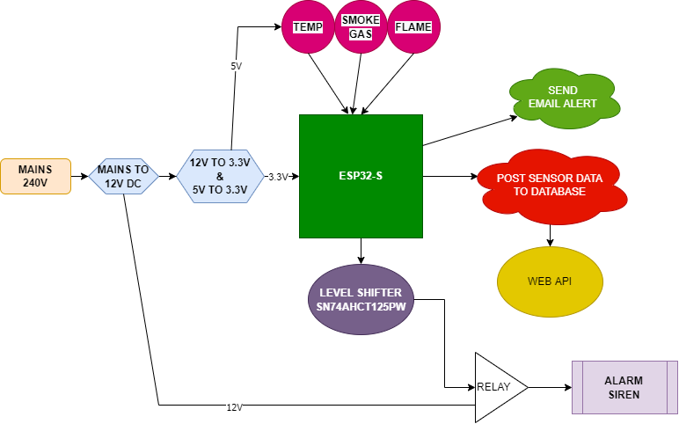

**Microcontroller**

ESP32-S: recommended for new designs.

It is enabled and has antenna already onboard.

It is cheap and is easy to program.

Flashed with Arduino C++.

**Power and Power Management**

Main input is 240V AC.

A 240V AC to 12V LDO SMPS PCB module supplies 12V to the board and siren.

A 12V to 5V LDO voltage regulator supplies 5V to the sensors.

A 5V to 3.3V LDO voltage regulator supplies 3.3V to the ESP32 and sensors.

**PCB**

Size: 10.8cm x 6.7 cm.

A 2-layer board.

**WEB API**

Coded using Flutter Web and Firebase integrations.