**WASHING MACHINE CONTROLLER**

**Design Document**

Function Summary:

* Connects using WIFI to the control software or device.
* Receives instruction via WIFI and uses them to control the material box solenoid taps.
* Start and stop buttons for manual control.
* Sends current machine status and low-material-amount prompts to the software/device.

**Flow Diagram**

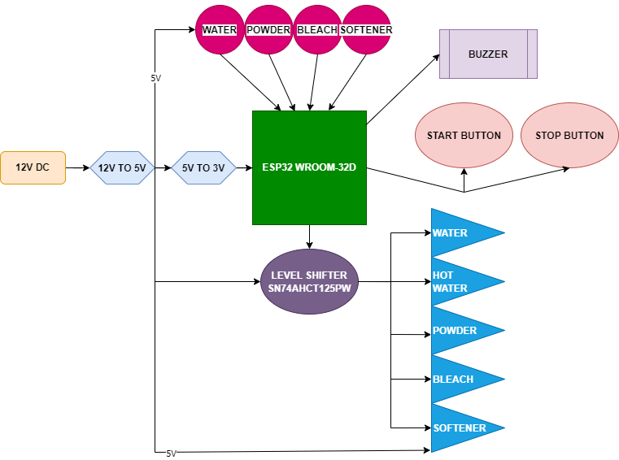

**Microcontroller**

ESP32-WROOM-32D.

It is WIFI enabled and has antenna already onboard.

It is cheap and is easy to program.

Flashed with Arduino C++.

**Power and Power Management**

Main input is 12V DC.

A 12V to 5V LDO voltage regulator supplies 5V to the relays and sensors.

A 5V to 3.3V LDO voltage regulator supplies 3.3V to the ESP32.

**PCB**

Size: 21.11mm x 20 mm.

A 2-layer board.